Looking at cells in more detail: Worksheet 1.3

*COMPLETE THE FOLLOWING TASKS IN YOUR BOOK. DO NOT WRITE ON THE SHEET. SHEET MUST BE HANDED BACK IN AGAIN TO BE RE-USED.*

1. Comparing microscopes

Read the following section, then compare and contrast optical and electron microscopes.

Light microscopes were invented in the sixteenth century. They rely on the use of light rays, which are reflected from a mirror, and then magnified by lenses before they reach our eye. Typically a light microscope can magnify an object by 1000 to 2000 times. It can be used to view living objects, and therefore show the natural movements of different organisms, including taking in of food and cell division. Images can only be seen in two dimensions, but colours can be visible and may be enhanced using stains. Sample preparation is cheap and easy, and no specialist training is needed.

The first electron microscope was invented in the 1930s. Electrons are bombarded onto the specimen, using high levels of energy. Elaborate and skilful techniques are required to prepare the sample. Often the specimen is dried and coated with gold; this means that living specimens cannot be used. Also the energy of the electron beam is very high, which would kill any living specimen. It is not possible to detect colours, but scanning electron microscopes produce a 3D image, with a much greater resolution. The magnification is up to two million times, so structures that cannot be seen with an optical microscope can be viewed. Electron microscopes can take up a lot of space; some need a whole room. They are very expensive to buy and require costly maintenance and repair.

1. **DRAW A TABLE IN YOUR BOOK TO COMPARE AND CONTRAST THE OPTICAL (LIGHT) MICROSCOPE AND THE ELECTRON MICROSCOPE**

2 What is inside a cell?

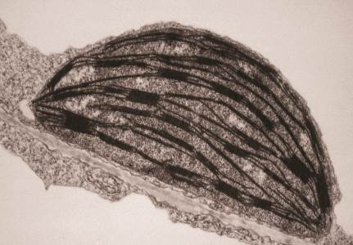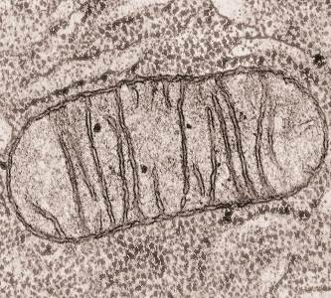

a b

1) Here are two structures found inside the cytoplasm as viewed with an electron microscope. (a = mitochondrion, b = chloroplast). Explain the function of these structures and state whether they come from an animal or plant cell, or if they could be in both.

2) Explain why these structures are not clearly visible with a light microscope.

3) What does the electron microscope reveal about these structures that would not be possible with a light microscope?

4) What can’t be determined about these structures from the electron microscope images?

3 Impact of the electron microscope

Copy and complete the following sentences:

If we still only had the light microscope, we would only be able to see…

The electron microscope has enabled us to…

4 Light or electron microscope?

Which of these specimens could be viewed by a light or electron microscope or both? Justify your answers.

1. Nucleus
2. Cell wall
3. Mitochondria
4. White blood cell ingesting a bacteria
5. Chloroplast
6. Embryo dividing
7. Sperm cell swimming
8. Ribosomes
9. Detailed structure of the cytoplasm
10. Fertilisation taking place