Gateways School

**Carbonyls**

**Revision PPQ Answers**

42 marks

**Q1.**

(a)     nucleophilic addition

**1**

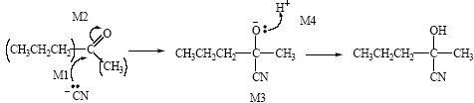

*Attack by HCN loses M1 and M2  
M2 not allowed independent of M1, but*

*allow M1 for correct attack on C+  
+C=O loses M2  
M2 only allowed if correct carbon attacked  
allow minus charge on N i.e. :CN–*

**4**

**M3** for completely correct structure not including lp

*allow C3H7 in M3*

**M4** for lp and arrow

*allow without –*

**1**

2-hydroxy-2-methylpentan(e)nitrile

*allow 2-hydroxy-2-methylpentanonitrile*

(b)     Product from **Q** is a racemic mixture/equal amounts of enantiomers

*if no reference to products then no marks;*

**1**

racemic mixture is inactive or inactive explained

*not* ***Q*** *is optically active or has a chiral centre etc*

**1**

Product from **R** is inactive (molecule) or has no chiral centre

**1**

**[9]**

**Q2.**

(a)     CH3OH + CH3CH2COOH → CH3CH2COOCH3 + H2O

**1**

(b)     (nucleophilic) addition–elimination NOT acylation

**1**

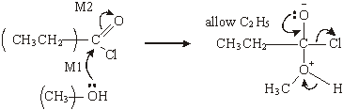

*ignore use of Cl– to remove H+*

*M3 for structure*

*M4 for 3 arrows and lone pair*

**4**

(c)

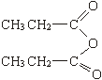

*allow C2H5 and –CO2–*

*allow CH3CH2COOCOCH2CH3*

***or*** *(CH3CH2CO)2O*

**1**

(d)     (i)      faster/not reversible/bigger yield/purer product/no(acid) (catalyst)  
required

**1**

(ii)     anhydride less easily hydrolysed or reaction less violent/exothermic  
no (corrosive) (HCl) fumes formed or safer or less toxic/dangerous  
expense of acid chloride or anhydride cheaper

*any one*

**1**

(e)     (i)      C8H8O2

**1**

(ii)     **any** two **from**

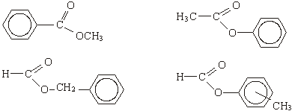

*Allow –CO2–      allow C6H5*

**2**

**[12]**

**Q3.**

(a)     (i)      propan(e)-1,2,3-triol or 1,2,3- propan(e)triol

*not propyl  
ignore hyphen, commas*

**1**

(ii)     soaps

*allow anionic surfactant  
not cationic surfactant  
not detergents, not shampoos*

**1**

(b)     (i)      (bio)diesel

*Allow fuel for diesel engines  
not biofuel, not oils*

**1**

(ii)

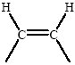

*ignore anything else attached except any more H atoms.*

**1**

(iii)     CH3(CH2)12COOCH3 + 21½O2 → 15CO2 + 15 H2O

***OR***

C15H30O2 or 43/2

***not*** *allow equation doubled*

**1**

**[5]**

**Q4.**

(a)     (i)      propyl methanoate **(1)**

*not propanyl*

*•    A wrong reagent or no reagent scores zero*

*•    An incomplete reagent such as silver nitrate for Tollens, or potassium dichromate loses the reagent mark, but can get both observation marks*

*•    penalise observations which just say colour change occurs or only state starting colour*

(ii)     *Reagent*: NaHCO3 **(1)***Observation with* ***C***: no reaction **(1)***Observation with* ***D***: effervescence **(1)**

*for* ***C*** *and* ***D****NOT Tollens*

|  |  |  |  |  |  |  |
| --- | --- | --- | --- | --- | --- | --- |
| Test | an identified (hydrogen) carbonate | acidified K2Cr2O7 | acidified KMnO4 | correct metal | UI or stated indicator | PCl5 |
| Observation with C | no reaction | goes green | goes colourless | no reaction | no change | no reaction |
| observation with D | bubbles or CO2 | no change | no change | bubbles or H2 | red or correct colour pH 3 – 6.9 | (misty) fumes |

**4**

(b)     (i)      *Reagent*: pentan-2-one **(1)**

*or 2-pentanone*

*but not pent-2-one or pentyl*

(ii)     *Reagent*: Tollen’s or Fehling’s **(1)**

*Observation with* ***E***: no reaction **(1)**

*Observation with* ***F***: silver mirror or red ppt **(1)**

         for **E** and **F**

|  |  |  |  |  |  |
| --- | --- | --- | --- | --- | --- |
| Test | Tollens | Fehlings or Benedicts | iodoform or I2/NaOH | acidified K2Cr2O7 | Schiff’s |
| observation with E | no reaction | no reaction | yellow (ppt) | no change | no reaction |
| observation with F | silver or mirror or grey or ppt | red or ppt not red solution | no reaction | goes green | goes pink |

**4**

(c)     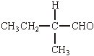 **(1)**

*must be aldehyde. Allow C2H5 for CH3CH2 otherwise this is the only answer*

**1**

**[9]**

**Q5.**

(a)     Melting range would be  
         wide (>3 deg C) / not sharp

*Allow melts over a range of temperatures.*

**1**

below / before the true m.p.

*Do not allow ‘above or below’.*

**1**

(b)     Temperature on thermometer not the same as the sample

*Allow sample heats up at a different / higher / lower rate than thermometer.*

**1**

**[3]**

**Q6.**

C

**[1]**

**Q7.**

B

**[1]**

**Q8.**

A

**[1]**

**Q9.**

B

**[1]**