Gateways School

**Aromatic chemistry**

**Revision PPQ Answers**

33 marks

**Q1.**

(a)     (i)      conc HNO3

**1**

conc H2SO4

*allow 1 for both acids if either conc missing*

**1**

HNO3 + 2H2SO4 → NO2+ + H3O+ + 2HSO4–

or HNO3 + H2SO4 → NO2+ + H2O + HSO4–

**1**

(iii)     electrophilic substitution CH3

**1**

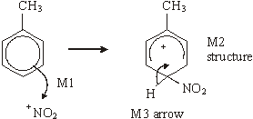

horseshoe must not extend beyond C2 to C6 but can be smaller  
+ must not be too close to Cl

**3**

(b)     Sn or Fe / HCl (conc or dil or neither)  
or Ni / H2 not NaBH4 LiAlH4

**1**

(c)     (i)     NH3

**1**

Use an excess of ammonia

**1**

(ii)     nucleophilic substitution

**1**

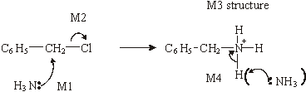

**4**

**[15]**

**Q2.**

(a)     CH3CH2COCl OR CH3CH2CClO OR propanoyl chloride  
OR (CH3CH2CO)2O OR propanoic anhydride  
penalize contradiction in formula and name e.g. propyl chloride

*could score in equation*

**1**

AlCl3 or FeCl3 or names

*could score in equation*

**1**

CH3CH2COCl + AlCl3 → CH3CH2CO+ + AlCl4–Allow RCOCl in equation but penalise above

*allow + on C or O in equation*

**1**

(b)

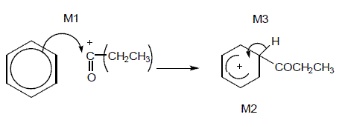

*M1 arrow from circle or within it to C or to + on C*

*Horseshoe must not extend beyond C2 to C6 but can be smaller + not too close to C1*

*M3 arrow into hexagon unless Kekule*

*allow M3 arrow independent of M2 structure*

*Ignore base removing H in M3*

**3**

(c)     Tollens or ammoniacal silver nitrate

**1**

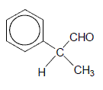

*penalise wrong formula*

**1**

**[8]**

**Q3.**

(a)     (i)      3(-120) − (-208) = -152 OR 3(120) − 208 = 152 (kJ mol−1)

*Must show working and answer and maths must be correct, but ignore sign*

**1**

(ii)     Electrons delocalised OR delocalisation (QOL)  
OR allow reference to resonance (QOL)

**1**

(b)     x, y, w *Must be in this order*

**1**

(c)     (i)      -240 (kJ mol−1) *Must have minus sign*

**1**

(ii)     between -239 and -121 (kJ mol−1) *Must have minus sign*

**1**

(iii)    Must specify which diene:

Proximity − for 1,3 C=C bonds are close together

*allow converse for 1,4 diene*

M1

**1**

Delocalisation − for 1,3 some delocalisation  
OR some overlap of electrons, π clouds or p orbitals

*allow converse for 1,4 diene*

M2

**1**

some extra stability for the 1,3- isomer

M3

**1**

**[8]**

**Q4.** B **[1]**

**Q5.** D **[1]**