## E-waste

## landfill ewaste

Electronic waste or e-waste is a huge problem around the world. Our old technology is often sent to landfill, not because it doesn't work, but simply because it has been replaced by a whizzy, all singing, all dancing, newer version.

The major problem with e-waste is that the toxic chemicals such as lead, arsenic and cadmium can leach into the soil over time. Then as rain washes it away, rivers and water supplies can be contaminated.

As a result most countries in the developed world have introduced strict regulations to prevent e-waste being dumped into landfill. Electronic components now have to be recycled.

In order to get around this, some countries have been sending their e-waste to less economically developed regions around the world where the regulations aren't as strict.

We hear of e-waste mountains where people (even children) spend their days in hazardous conditions salvaging some of the precious metals from the discarded electronic goods to sell for cash. This practice can have a huge detrimental effect on their health and safety.

**Sustainability**

What must not be forgotten when you look at the mobile phone in your hand is that every single part of that phone, at some point, had to come out of the ground.



The plastic, the glass, the precious metals, rare minerals, steel, copper and all the other material that make up your phone, at some point had to be dug up as raw material. This raw material was then processed, refined, transported and shaped into each component.

So it does not make much sense to throw away all that material, energy and effort into landfill, never to be seen again.

A better way is to re-use as much of it as possible. The word is '**sustainability**' - making as much use of our existing resources as possible.

There are three main ways to do this, often referred to as the "Three Rs"

1. **R**educe
2. **R**euse
3. **R**ecycle

**Reduce, Reuse, Recycle**

**Reduce**

Reducing the amount of waste produced is fairly easy to do personally - just buy less stuff, and throw less away! Don't replace devices that still work just because a new version has come out.

|  |
| --- |
| recycling ewaste |
| courtesy of [Wikimedia Commons](https://commons.wikimedia.org/wiki/File:DVO_4792) |

Computer systems can help reduce the amount of waste produced by making manufacturing more efficient. When less material and energy is used to produce an item, throwing it away will have less impact on the environment.

**Re-use**

Just because you are done with your mobile phone or computer doesn't mean that nobody else has a use for it. It's easier than ever to find someone willing to buy second-hand computer peripherals and devices using the internet, giving devices a new lease of life with a new owner.

There are a number of schemes that will re-distribute the items you donate for other people to use. Some are commercial companies and others are charities.

## Energy use

Another effect of computer systems on the environment is the sheer amount of electricity used to power up the billions of computers around the world.

The rise of social networking and handheld computers such as tablets and mobile phones has led to a much higher daily use of electricity by the average person.

Electricity tends to produce greenhouse gases because of the way it is generated. Technology is helping to reduce greenhouse gas emissions by allowing for more environmentally-friendly sources such as wind and solar. Still, the less electricity used, the better for the environment.

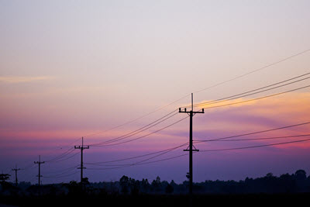

#### How Technology can help reduce energy use

* Many modern buildings have computer controlled systems in place that reduce the amount of energy they use.
* Solar panels to reduce the amount of electricity from the national grid
* Energy monitoring displays to help staff know what is using up the power
* Low energy LED lighting controls
* Water conservation systems to re-use water, especially in industrial factories
* Smart meters to help people at home keep track of their energy usage

## Data centres

Data centres are facilities used to house an organisation's IT operations and equipment. They can contain hundreds, even thousands of networked computers to store, process and distribute data.

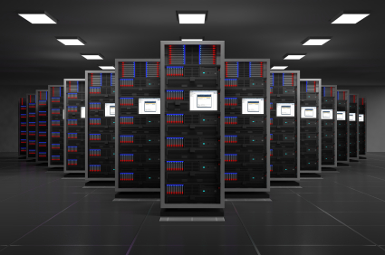

Data centres use a lot of energy to run the machines. They also generate a lot of heat, which requires even more power to manage. Data centres use about 3% of the global electricity supply, and is estimated to treble in the next decade. This will have a huge impact on greenhouse gas emissions.

They impact the environment in other ways, too. The buildings housing them need huge amounts of concrete, copper cabling and other materials. Often data centres are located in remote areas, requiring road extension and maintenance, and increasing the fuel consumption of employees. The computer components include rare and valuable materials.

E-waste is also an issue. To prevent downtime even with heavy use, the machines are replaced even when they still have plenty of 'life left in them'

Our consumption of online content is increasing, requiring ever more and ever larger data centres. Is there a case for rationing access to data in order to reduce the impact on our environment?

## Monitoring the Earth and its habitats

Our planet is now monitored 24/7 as never before. This is because of our increasing concern about our environment and climate change.

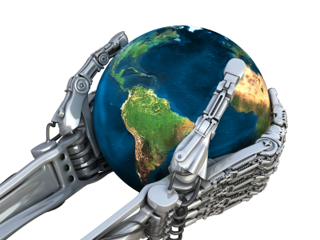

We use technology such as satellites, sensors and weather stations, to monitor and measure changes in the local and global environment. Some of the things which are monitored include the:

* state of the polar ice over time
* flow of ocean currents
* changing temperatures of the oceans
* alarming growth of deserts
* burning of primary jungles such as the Amazon
* tracking endangered species for conservationists
* state of crops and greenery around the planet

The reason for all this monitoring is that nations may then agree on the best way forward (or it seems more likely they disagree!) But at least the scientific data is there for them to argue over.

## Stakeholders

All of the issues discussed in these sections are viewed differently by different interest groups. The UK government is going to be concerned about very different things to the governments of developing countries, or to manufacturers of electronic devices, or even to the general public.

Each of these groups are stakeholders, in that they have a stake in the issue being discussed. You will be asked on the exam to consider scenarios from the viewpoints of different stakeholders. Who those stakeholders are will vary from issue to issue, but as a jumping-off point you can consider three: the **British government**, the **British public** and **British industry**. Other stakeholders for the environment, for example, might include environmental activists, foreign governments, international energy suppliers, etc.

## The British Government and the Environment

From the government's perspective they will want to ensure that the British economy keeps up with new technology. If we were to fall behind other countries this could have a huge impact on our ability to be competitive in the world markets.

The government will want to ensure that we are not totally reliant on other nations for our energy needs, especially when they can put prices up or limit supplies

The government will also be concerned with ensuring that the environment around the British isle is not damaged because of the impact we are having on our environment. Issues such as climate change, rising sea levels, burning fossil fuels etc will be something that they will monitor.

The government will also be responsible for ensuring that legislation and/or guidelines about recycling and e-waste are adhered to. The culture nowadays is to throw perfectly usable technology away. However, we can't keep throwing things away, landfill sites are already becoming overfull. So the government are trying hard to enforce strict recycling policies.

## Stakeholders - corporations

The legislation which is in place to help protect the environment makes manufacturing more expensive.

Businesses are not allowed to pollute the atmosphere with dangerous waste/chemicals. They have to dispose of all hazardous material in a safe manner. They must also have recycling policies in place and ensure that the whole business abides by them.



All of this costs money which lowers profits and can make products more expensive than similar ones that have been imported from countries that do not abide by the same rules.

On the plus side, the demand for more eco-friendly solutions does open up new markets for businesses.

## Stakeholders - individuals

The environmental legislation imposed on businesses means that their higher manufacturing costs have to be passed on to the consumer. Individuals therefore end up paying more for items that are produced by companies who abide by the legislation.



Many individuals care about the environment and many now recycle as much as possible. They want to ensure that future generations will have a pleasant and safe environment in which to live. It does take time to recycle, especially if a trip to a land-fill site is needed.

However, many individuals still have a blinkered view and only think about the 'here and now'. They see a new gadget and want it. They don't have any concept about the impact that the manufacturing process has on the environment. And they don't really think about the impact of e-waste.