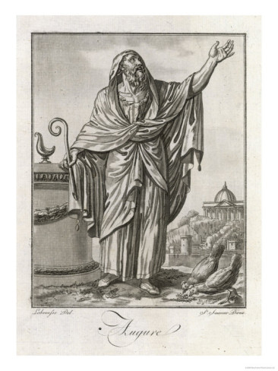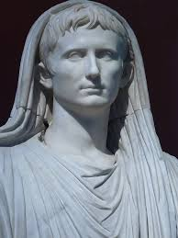

Augur

Flamen



***The augurs were part of a college of priests who took auspices, which was the reading of the flights of birds, animal behaviour and the direction of thunder to work out the will of the gods. The Romans would not engage in anything important without consulting these, be it during business or personal life, fighting a battle or getting married.***

***The augur carried a curved wand called a ‘lituus’, which they used to mark out a section of the sky (a ‘templum’) in which favourable or unfavourable bird signs were watched for.***

***The flamines were the most important group of priests (known as a college) in Rome. There were fifteen, led by the Pontifex Maximus, a lifelong post and elected from the existing flamines. From the time of Augustus, the position was held by the emperor. The Pontifex Maximus also took charge of the Sibylline Books, a collection of State oracles.***

***The flamines were in charge of the protection of Rome’s temples, supervised laws around burials and inheritance and oversaw the calendar, giving them control of the events in the city.***

***Each flamen was charged with supervision of a single deity’s cult; the three most important were the Flamen Dialis (chief priest of Jupiter), the Flamen Martialis (chief priest of Mars) and the Flamen Quirinalis (chief priest of Quirinus, a deity sometimes associated with Romulus, sometimes Janus). Another important one was created to look after the cult of the emperors.***

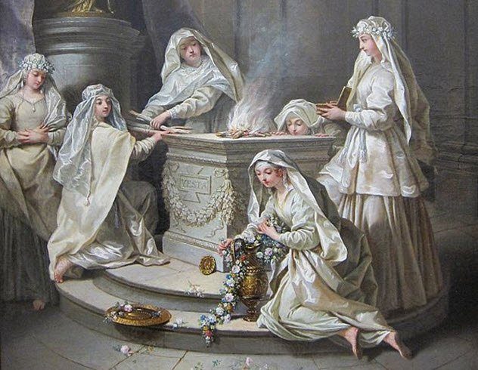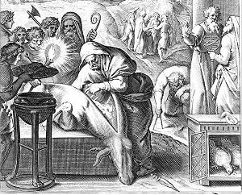

Vestal

Haruspex



***The Vestal Virgins were a college of six priestesses of Vesta, charged with looking after the goddesses sacred flame, a symbol of Rome itself.***

***The Vestals came from girls aged six to ten and would serve thirty years under a vow of chastity. They lived in a very impressive sanctuary***

***In the temple were placed important state documents, including the Sibylline Books, state treaties and the wills of high ranking Romans. The Vestals also made the ‘mola salsa’ (flour and salt mix) that was used in sacrifices.***

***Although they would be buried alive if they broke their chastity vow, they enjoyed privileges such as special seats at games, the right to own property, make wills, vote and intervene on behalf of one condemned to death. It was sacrilege to harm them and they even had their own ‘lictor’ (bodyguard).***

***The haruspices were priests who specialised in reading the entrails of an animal at a sacrifice and would be consulted at important events, such as during a festival or before a battle.***

***At a sacrifice, they first watched how an animal fell as it was killed. Then they observed the smoke and flames as the animal was burnt at the altar. Finally, and most importantly, they would inspect the animal’s organs. The most important was the liver and they brought a bronze model of a liver as a guide. The different parts of the liver meant different things and they checked for abnormalities, such as blood spots.***

Associated with a specific deity

Present at a sacrifice

Had special equipment

Organised into a college

Male

Interpreted the will of the gods

Involved with the Sibylline Books