

**Higher IGCSE (9 – 1) Revision Pack**

**Histograms**

**Name --------------------------------**

**Questions**

**Q1.**

The table shows information about the heights, in metres, of 45 of the world's tallest men.

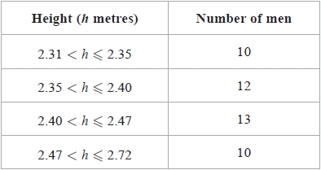

(a)  Use the information in the table to complete the histogram.

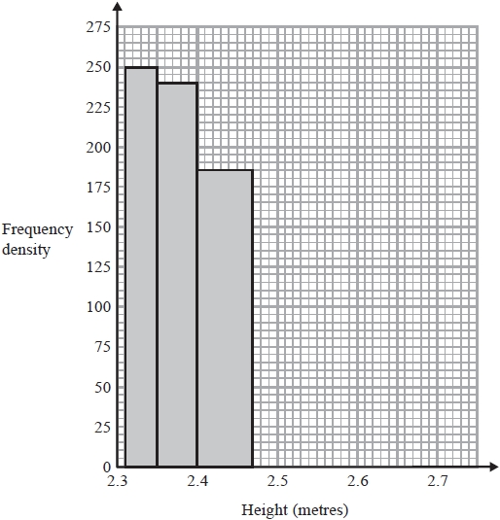

**(2)**

(b)  Find an estimate for the number of these men with height between 2.32 metres and 2.34 metres.

...........................................................

**(1)**

**(Total for question = 3 marks)**

**Q2.**

The incomplete table shows information about the times, in minutes, that runners took to   
complete a race.

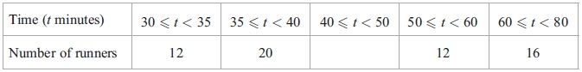

(a) Use the histogram to calculate the number of runners who took between 40 and 50   
minutes to complete the race.

...........................................................

**(2)**

(b) Complete the histogram for the remaining results.

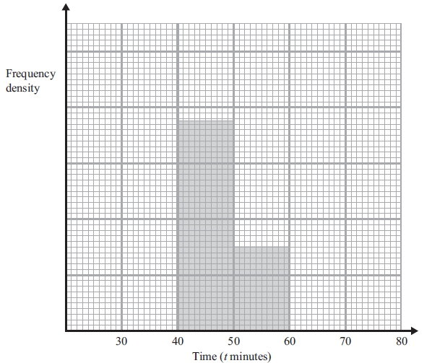

**(2)**

Runners who achieved a time between 37 and 48 minutes to complete the race were   
each awarded a silver medal.

(c) Calculate an estimate of the number of runners awarded silver medals.

...........................................................

**(2)**

**(Total for question is 6 marks)**

**Q3.**

The table gives information about the areas of some farms in France.

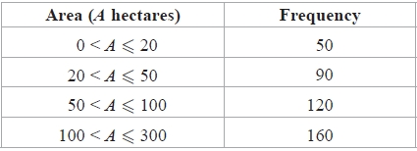

On the grid, draw a histogram to show this information.

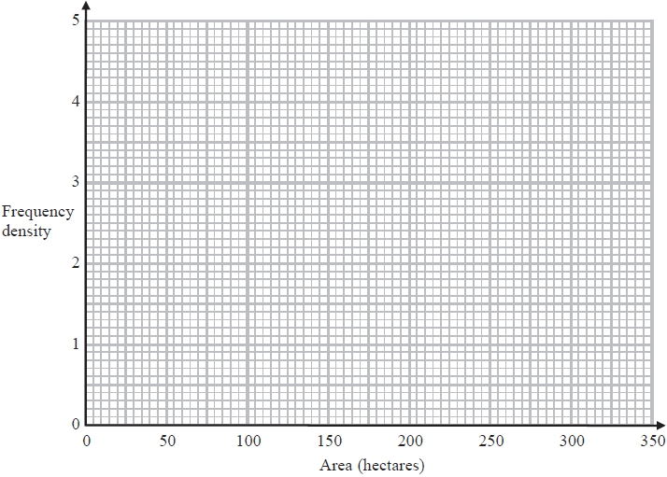

**(Total for question = 3 marks)**

**Q4.**

Loma grows tomatoes in her garden.   
The table shows information about the weights, in grams, of some of her tomatoes.

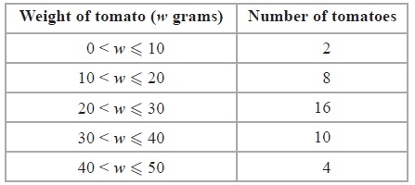

(a)  Work out an estimate for the total weight of these tomatoes.

........................................................... grams

**(3)**

Loma also grows potatoes.   
The incomplete histogram shows information about the weights, in grams, of some of her potatoes.

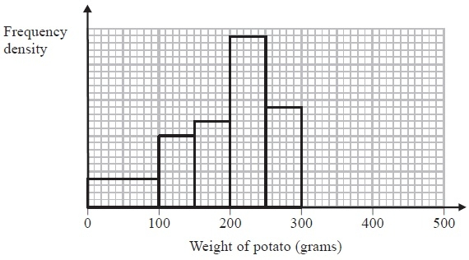

There were 10 potatoes with weights between 100 grams and 150 grams.

(b)  How many potatoes had weights less than 100 grams?

...........................................................

**(2)**

There were 12 potatoes with weights between 300 grams and 450 grams.

(c)  Show this information on the histogram.

**(2)**

**(Total for Question is 7 marks)**

**Q5.**

The table shows information about the times, in minutes, that 100 shoppers spent in a supermarket.

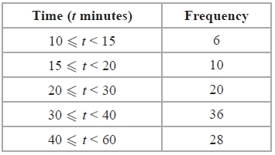

Draw a histogram to show this information.

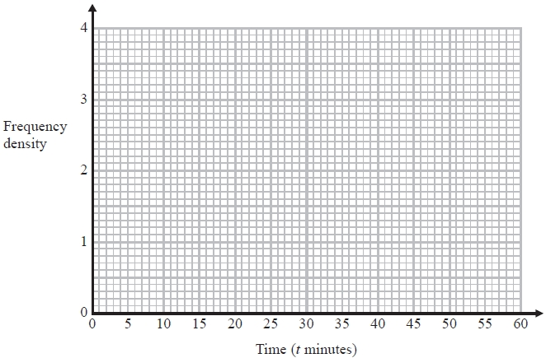

**(Total for Question is 3 marks)**

**Q6.**

The table shows information about the time, in minutes, spent on homework by each of  
 32 pupils in one night.

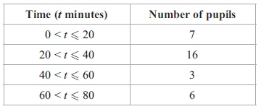

(a) Calculate the percentage of the 32 pupils who spent more than 60 minutes on their   
homework.

...........................................................%

**(2)**

(b) Calculate an estimate for the total time spent on homework by the 32 pupils.

...........................................................minutes

**(3)**

**(Total for question = 5 marks)**

**Q7.**

The incomplete histogram and table give information about the ages of people living in  
 a village.

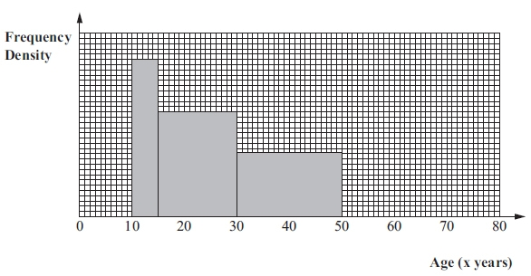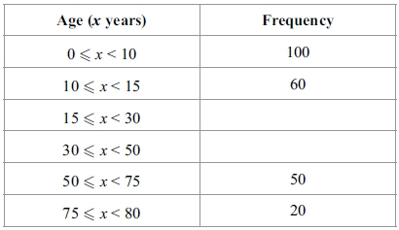

(i) Use the histogram to complete the table.

(ii) Use the table to complete the histogram.

**(Total for question = 4 marks)**

**Q8.**

The incomplete table and histogram show information about the lengths of time,  
*t* minutes, students spent waiting for their school bus one morning.

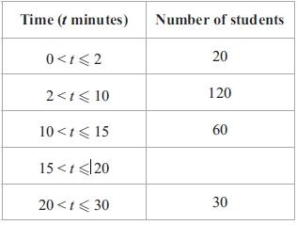

(i) Use the histogram to complete the table.

(ii) Use the table to complete the histogram.

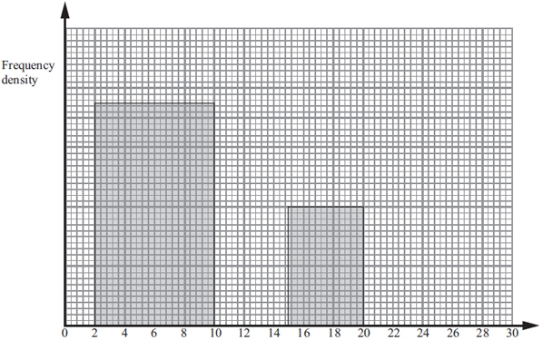

Time (*t* minutes)

**(Total for question = 4 marks)**

**Q9.**

The table shows information about the times, in minutes, that some people took to  
 complete a sudoku puzzle.

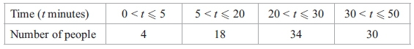

Complete the histogram for this information.

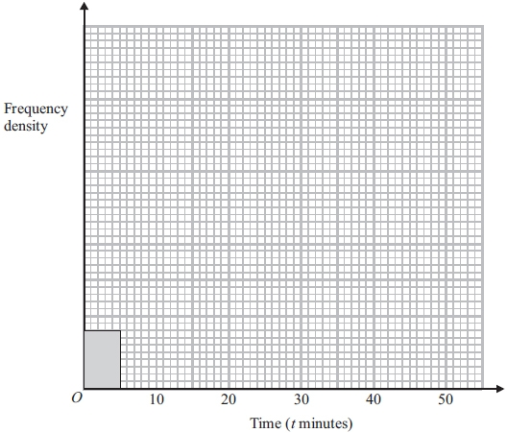

**(Total for question = 3 marks)**

**Q10.**

Miss Cook asked each student in her class how long it took them, in minutes, to travel to school that morning.

The incomplete histogram shows information about the times it took the students who took no more than 30 minutes to travel to school.

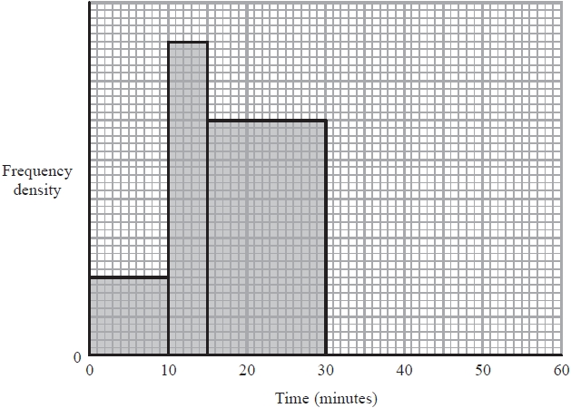

9 students took between 15 minutes and 30 minutes to travel to school.

(a)  How many students took no more than 30 minutes to travel to school?

...........................................................

**(2)**

12 students took between 30 and 55 minutes to travel to school.

(b)  Use this information to complete the histogram.

**(2)**

**(Total for question = 4 marks)**

**Q11.**

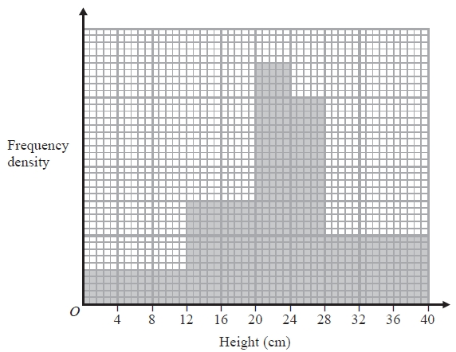

The histogram gives information about the heights of some plants.

There are 360 plants with a height of 20 cm or less.

Work out the number of plants with a height of more than 20 cm.

...........................................................

**(Total for question = 3 marks)**

**Q12.**

The histogram shows information about the times, *t* minutes, patients spent at a doctors'  
 surgery on one day.  
 No patient spent more than 40 minutes at the surgery.

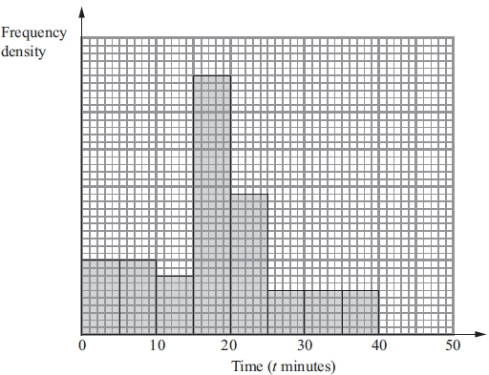

(a) Calculate the percentage of the patients who spent between 25 and 40 minutes at the   
surgery.

...........................................................%

**(3)**

(b) 16 patients spent between 10 and 15 minutes at the surgery.

Calculate the total number of patients at the surgery that day.

...........................................................

**(2)**

**(Total for question = 5 marks)**

**Q13.**

The table gives information about the time taken by each of 600 people to reach their holiday destination.

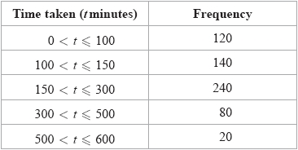

(a)  Use the information in the table to complete the histogram.

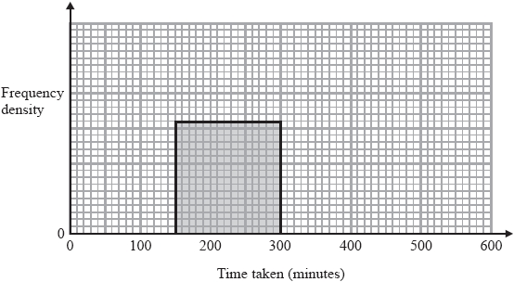

**(3)**

(b)  Work out an estimate for the number of people who took more than 200 minutes to reach their holiday destination.

...........................................................

**(2)**

**(Total for question = 5 marks)**

**Q14.**

400 people are asked to guess the weight of a large cake.   
The table shows information about the weights they guess.

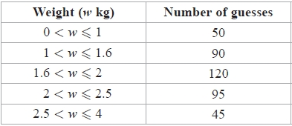

Use the information in the table to complete the histogram.

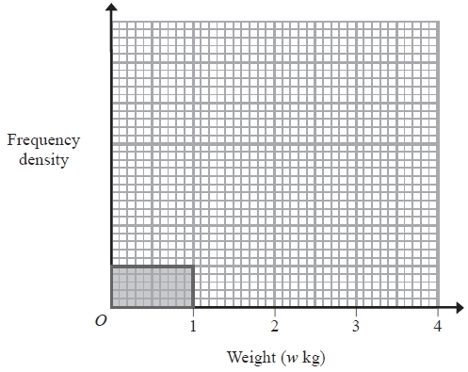

**(Total for question = 3 marks)**

**Q15.**

The table gives information about the times, in minutes, some people waited in the accident and emergency department at a hospital.

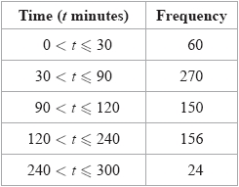

On the grid, draw a histogram for this information.

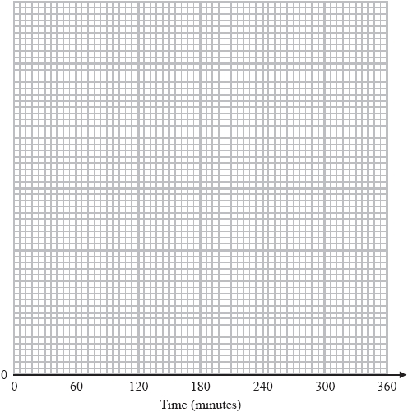

**(Total for question = 3 marks)**

**Q16.**

The histogram shows information about the times, *t* hours, for which some cars were left  
in a car park.

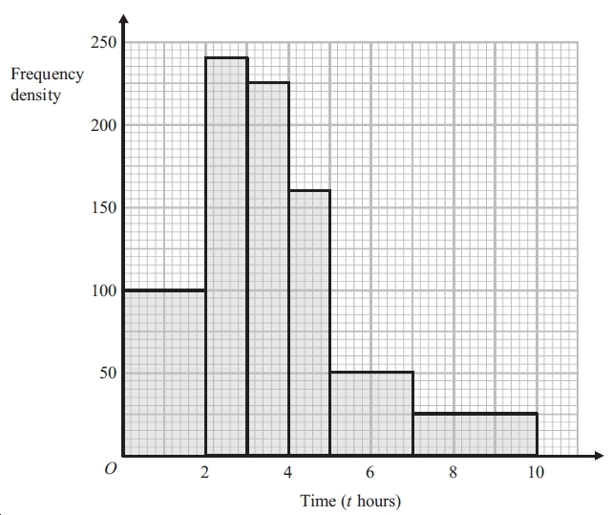

Calculate an estimate for the number of cars which were left in the car park for between  
4.5 hours and 8 hours.

...............................

**(Total for question = 3 marks)**

**Q17.**

The histogram shows information about the times, *t* minutes, customers spent in a post office.

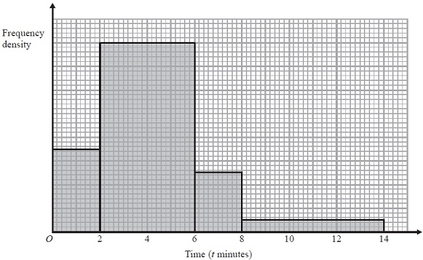

28 customers spent 2 minutes or less in the post office.   
Calculate an estimate for the number of customers who spent between 5 and 14 minutes in the post office.

...........................................................

**(Total for Question is 3 marks)**

**Q18.**

The incomplete histogram shows information about the heights of a group of children.

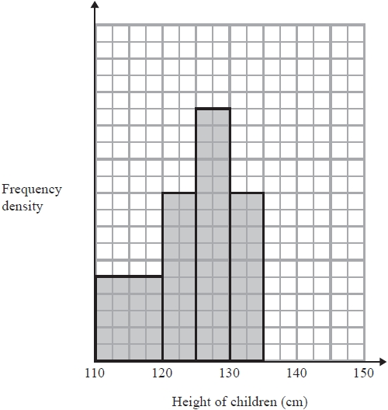

There were 10 children with heights between 130cm and 135cm.

(a)  How many children had heights between 110cm and 130cm?

...........................................................

**(3)**

There were 6 children with heights between 135cm and 145cm.

(b)  Show this information on the histogram.

**(1)**

**(Total for question = 4 marks)**

**Q19.**

The histogram shows information about the times taken by a telephone call centre to answer incoming calls.

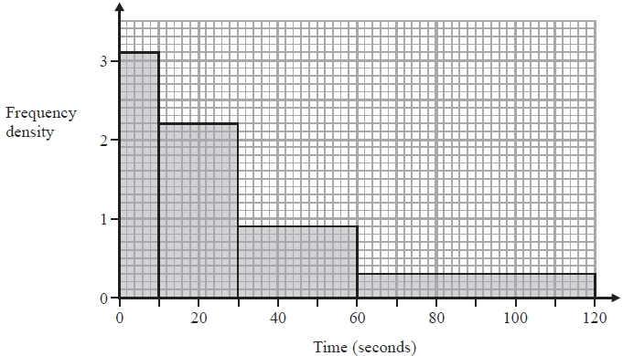

Work out an estimate for the percentage of calls that are answered in less than 40 seconds.

........................................................... %

**(Total for Question is 3 marks)**

**Q20.**

The histogram shows information about the heights of some tomato plants.

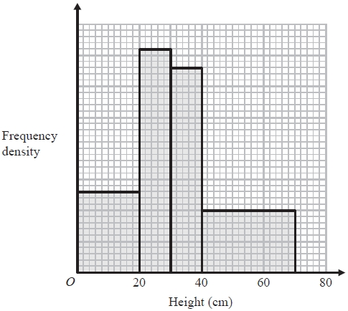

26 plants have a height of less than 20 cm.

Work out the total number of tomato plants.

...........................................................

**(Total for question = 3 marks)**

**Q21.**

The histogram shows information about the times taken by 160 cyclists to complete the Tour de France cycle race.

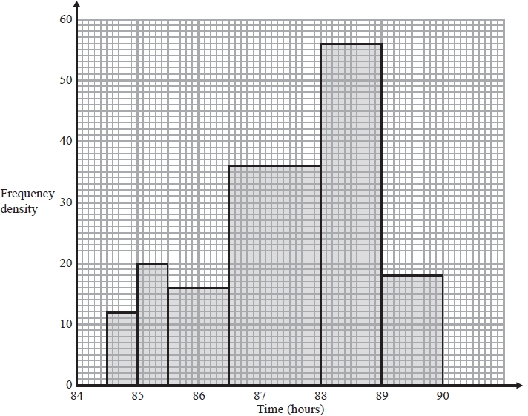

6 cyclists took less than 85 hours.

(a)  Work out an estimate for the number of the 160 cyclists who took less than 86 hours.

...........................................................

**(2)**

(b)  For these 160 cyclists, work out an estimate for the time taken by the cyclist who finished in 50th position.

........................................................... hours

**(2)**

**(Total for question = 4 marks)**

**Q22.**

The incomplete histogram and the incomplete table show information about the ages of people watching a film in a cinema.

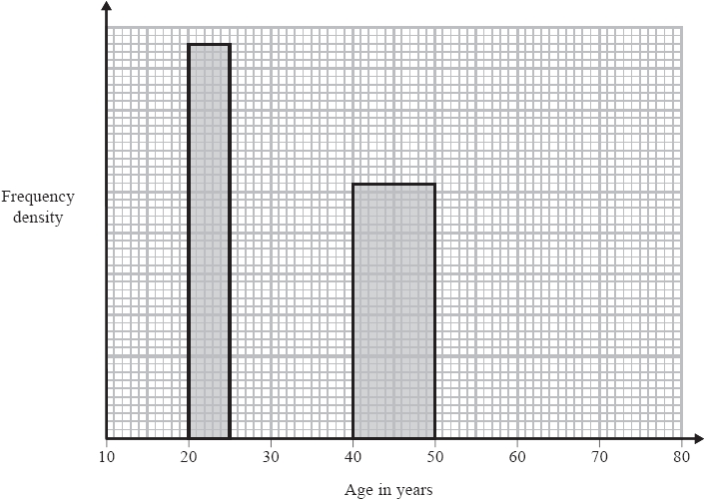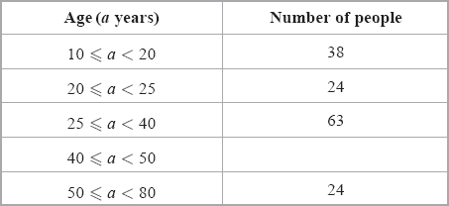

(a)  Use the histogram to complete the table.

**(2)**

(b)  Use the table to complete the histogram.

**(2)**

**(Total for question = 4 marks)**

**Q23.**

150 people took part in a survey.   
The histogram shows information about the ages of these people.

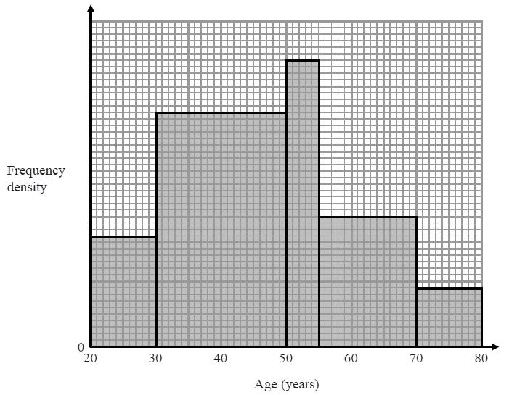

Work out how many of these 150 people are aged between 50 years and 55 years.

...........................................................

**(Total for question = 4 marks)**

**End of questions**