

**Foundation IGCSE (9 – 1) Revision Pack**

**Bounds (Foundation)**

**Name --------------------------------**

**Questions**

**Q1.**

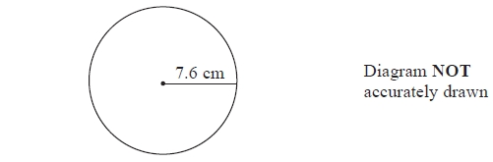

(a)   A circle has a radius of 7.6 cm.   
Work out the area of the circle.   
Give your answer correct to 3 significant figures.

........................................................... cm2

**(2)**

The radius, 7.6 cm, is correct to 1 decimal place.

(b) (i)   Write down the upper bound of the radius.

........................................................... cm

(ii)   Write down the lower bound of the radius.

........................................................... cm

**(2)**

**(Total for Question is 4 marks)**

**Q2.**

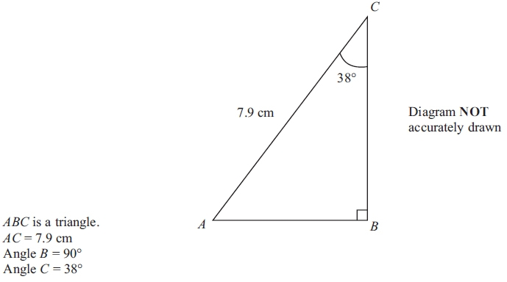

(a) Calculate the length of *BC*.   
Give your answer correct to 3 significant figures.

........................................................... cm

**(3)**

(b) The size of angle *C* is 38º, correct to 2 significant figures.

(i) Write down the lower bound of the size of angle *C*.

........................................................... °

(ii) Write down the upper bound of the size of angle *C*.

........................................................... °

**(2)**

**(Total for question = 5 marks)**

**Q3.**

The diagram shows a solid cylinder.

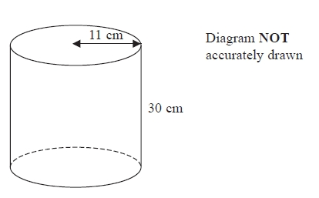

The cylinder has a height of 30 cm and a radius of 11 cm.

(a)  Work out the **total** surface area of the cylinder.   
       Give your answer correct to 2 significant figures.

...........................................................cm2

**(4)**

(b)  The height of the cylinder is 30 cm, correct to the nearest centimetre.

(i)  Write down the lower bound of the height of the cylinder.

...........................................................cm

(ii)  Write down the upper bound of the height of the cylinder.

...........................................................cm

**(2)**

**(Total for question = 6 marks)**

**Q4.**

The length of a fence is 137 metres, correct to the nearest metre.

Write down

(i) the lower bound for the length of the fence,

........................................................... metres

(ii) the upper bound for the length of the fence.

........................................................... metres

**(Total for question = 2 marks)**

**Q5.**

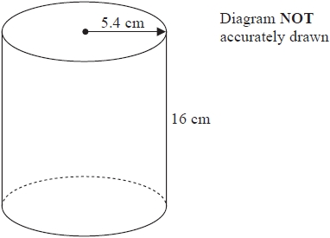

A cylinder has radius 5.4 cm and height 16 cm.

(a)  Work out the volume of the cylinder.   
Give your answer correct to the nearest whole number.

........................................................... cm3

**(2)**

The radius 5.4 cm is correct to 2 significant figures.

(b)  (i)  Write down the upper bound of the radius.

........................................................... cm

(ii)  Write down the lower bound of the radius.

........................................................... cm

**(2)**

**(Total for question = 4 marks)**

**Q6.**

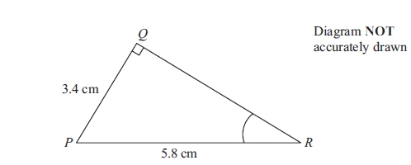

Triangle *PQR* has a right angle at *Q*.

*PQ* = 3.4 cm and *PR* = 5.8 cm

(a) Work out the size of angle *QRP*.   
Give your answer correct to 1 decimal place.

........................................................... °

**(3)**

The length 5.8cm, of *PR*, is correct to 2 significant figures.

(b) (i) Write down the upper bound of the length of *PR*.

........................................................... cm

(ii) Write down the lower bound of the length of *PR*.

........................................................... cm

**(2)**

**(Total for question is 5 marks)**

**Q7.**

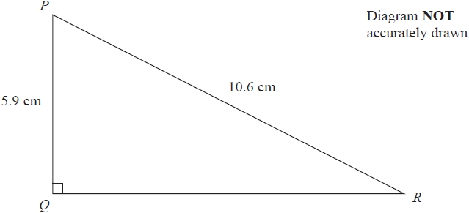

(a)  Work out the length of *QR*.

Give your answer correct to 3 significant figures.

........................................................... cm

**(3)**

(b)  Work out the size of angle *PRQ*.

Give your answer correct to 1 decimal place.

........................................................... °

**(3)**

The length of a line is 12.4 cm correct to one decimal place.

(c)  Write down the upper bound for the length of the line.

........................................................... cm

**(1)**

**(Total for question = 7 marks)**

**Q8.**

Harley's house has a value of £160 000 correct to 2 significant figures.

(a)   (i)   Write down the least possible value of the house.

£ ...........................................................

**(1)**

(ii)  Write down the greatest possible value of the house.

£ ...........................................................

**(1)**

The value of Rita's house increased by 5%.   
Her house then had a value of £210 000

(b)   Work out the value of Rita's house before the increase.

£ ...........................................................

**(2)**

**(Total for question = 4 marks)**

**Q9.**

A number, *y*, is rounded to 2 significant figures.

The result is 0.46

Write down the error interval for *y*.

...........................................................

**(Total for question = 2 marks)**

**Q10.**

(a)  Find the value of the reciprocal of 1.6

Give your answer as a decimal.

...........................................................

**(1)**

Jess rounds a number, *x*, to one decimal place.   
The result is 9.8

(b)  Write down the error interval for *x*.

...........................................................

**(2)**

**(Total for question = 3 marks)**

**Q11.**

Lyn measures the length, *x* cm, of a piece of string as 3.5 cm correct to the nearest millimetre.

Write down the error interval for *x*.

...........................................................

**(Total for question = 2 marks)**

**Mark Scheme**

Q1.

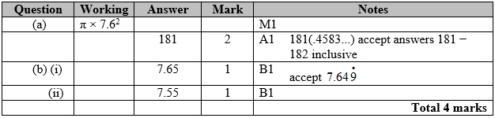

**Q2.**

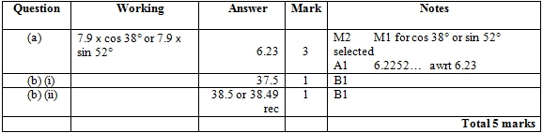

**Q3.**

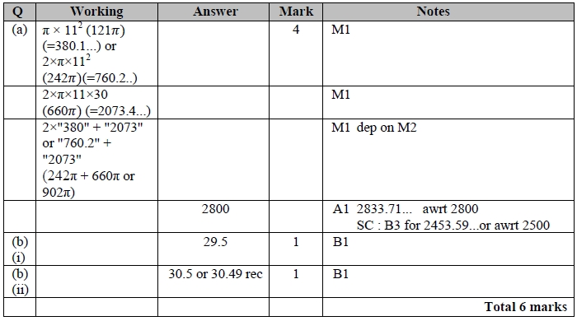

**Q4.**

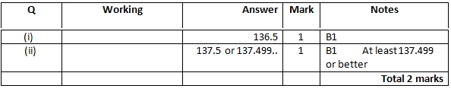

**Q5.**

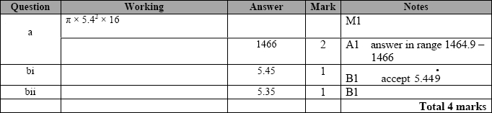

**Q6.**

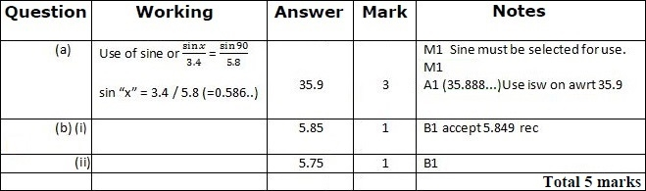

**Q7.**

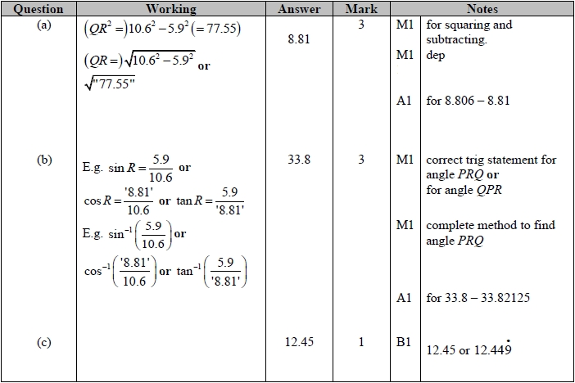

**Q8.**

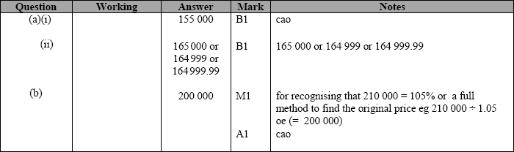

**Q9.**

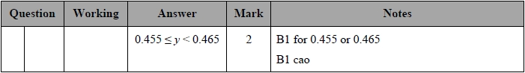

**Q10.**

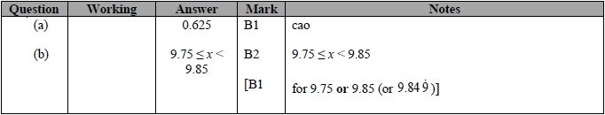

**Q11.**

