

**Higher IGCSE (9 – 1) Revision Pack**

**Construction, scale drawing and bearings**

**Name --------------------------------**

**Questions**

**Q1.**

Use ruler and compasses to construct the bisector of angle *ABC*.  
 You must show all your construction lines.

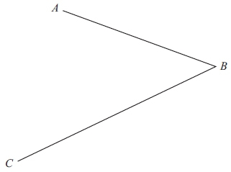

**(Total for question = 2 marks)**

**Q2.**

The lengths of the sides of a rhombus are 6 cm.   
The length of the longer diagonal of the rhombus is 10 cm.   
*AB* is a side of the rhombus.

**Construct** an accurate, full-size drawing of the rhombus.   
You must show all construction lines.



**(Total for question is 4 marks)**

**Q3.**

Use ruler and compasses only to construct the perpendicular bisector of line *AB*.   
You must show all your construction lines.

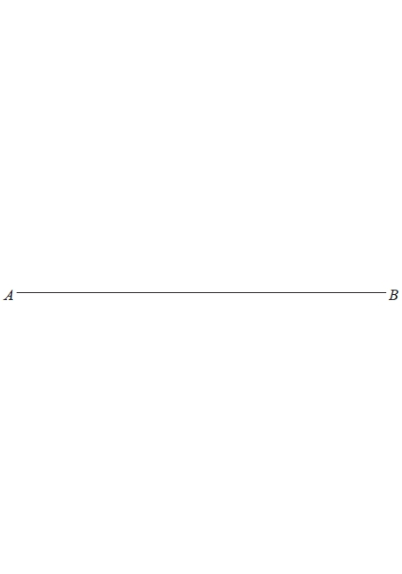

**(Total for question = 2 marks)**

**Q4.**

Use ruler and compasses to construct the bisector of angle *ABC*.   
You must show all your construction lines.

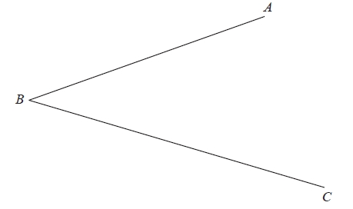

**(Total for Question is 2 marks)**

**Q5.**

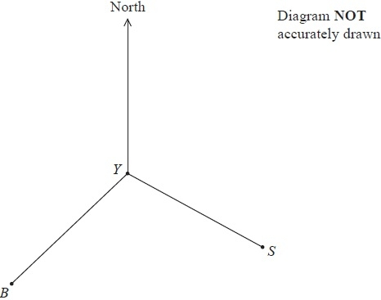

The diagram shows the positions of a yacht *Y*, a ship *S* and a beacon *B*.   
The bearing of *B* from *Y* is 228°

(a)  Find the bearing of *Y* from *B*.

...........................................................°

**(2)**

The bearing of *S* from *Y* is 118°

(b)  Find the size of the angle *BYS*.

...........................................................°

**(1)**

(c)  Given also that *BY* = *SY*, find the bearing of *S* from *B*.

...........................................................°

**(2)**

**(Total for Question is 5 marks)**

**Q6.**

The diagram shows two points *S* and *T*.   
The bearing of *T* from *S* is 043°

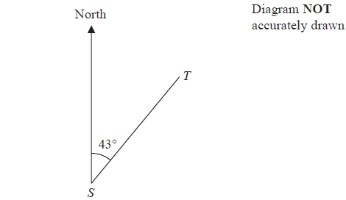

Work out the bearing of *S* from *T*.

...........................................................°

**(Total for question = 2 marks)**

**Q7.**

There is a World Peace Bell in South Korea.

At its widest, the bell has a circular cross section with a diameter of 2.5 m.

(a)  Work out the circumference of a circle with diameter 2.5 m.

Give your answer correct to 3 significant figures.

........................................................... m

**(2)**

The World Peace Bell in South Korea has a height of 4.7 m.   
At its widest, the bell has a circular cross section with a diameter of 2.5 m.

A scale model is made of the bell.   
At its widest, the scale model has a circular cross section with a diameter 10 cm.

(b)  Work out the height of the scale model.

Give your answer in centimetres.

........................................................... cm

**(2)**

**(Total for question = 4 marks)**

**Q8.**

Louis makes a model of a plane.

The wingspan of the model is 50 centimetres.   
The wingspan of the real plane is 80 metres.

(a)  Work out the scale of the model.

Give your answer in the form 1: *n*

1: ...........................................................

**(2)**

The length of the real plane is 72 metres.

(b)  Work out the length of the model.

Give your answer in centimetres.

........................................................... centimetres

**(2)**

**(Total for question = 4 marks)**

**Q9.**

The diagram shows an accurate scale drawing of part of the boundary of a field.   
The complete boundary of the field is in the shape of a quadrilateral *ABCD*.

*AB* = 300 metres.   
*BC* = 230 metres.   
Point *B* is due north of point *C*.

The scale of the diagram is 1 cm to 50 metres.

The bearing of *D* from *C* is 260°   
*AD* = 480 metres.

Complete the scale drawing of the boundary of the field.   
Mark the position of *D*.

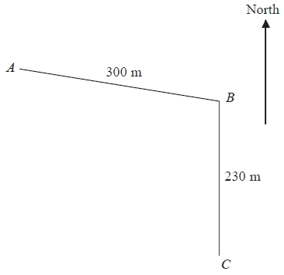

**(Total for Question is 2 marks)**

**Q10.**

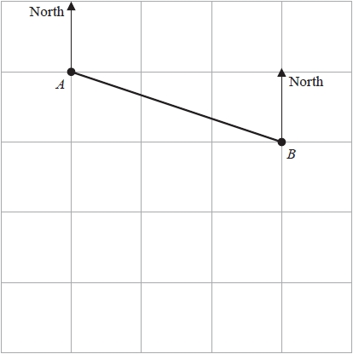

The diagram shows point *A* and point *B* on a map.   
The point *C* is due south of *A*  
The bearing of *C* from *B* is 235°

(a)  Mark the point *C* on the map.

**(2)**

The bearing of a point *D* from *B* is 168°

(b)  Find the bearing of *B* from *D*

........................................................... °

**(2)**

Gordon measures a length on the map as 6.3 cm correct to 1 decimal place.

(c)  Write down the lower bound for this length.

........................................................... cm

**(1)**

**(Total for question = 5 marks)**

**Q11.**

Rob is making a scale model of the Solar System on the school field.   
He wants the distance from the Sun to Jupiter to be 8 metres on his scale model.

The real distance from the Sun to Jupiter is 7.8 × 108 kilometres.

(a)   Find the scale of the model.   
Give your answer in the form 1: *n*, where *n* is written in standard form.

1: ...........................................................

**(3)**

Rob wants to put the position of a space probe on the scale model.   
The real distance of the space probe from the Sun is 1.9 × 1010 kilometres, correct to 2 significant figures.

(b)   Work out the maximum distance of the space probe from the Sun on the scale model.   
Give your answer in metres.

........................................................... m

**(3)**

**(Total for Question is 6 marks)**

**Q12.**

The scale of a map is 1 : 25 000  
On the map, the distance between two railway stations is 22 cm.

Work out the real distance between the two railway stations.  
Give your answer in kilometres.

...............................km

**(Total for question = 3 marks)**

**Q13.**

The ocean liner Queen Mary 2 is the longest of its type.   
It has a length of 345 metres.

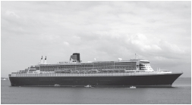

A scale model is made of the Queen Mary 2   
The scale of the model is 1 : 200

Work out the length of the scale model.   
Give your answer in centimetres.

........................................................... cm

**(Total for question = 3 marks)**

**Q14.**

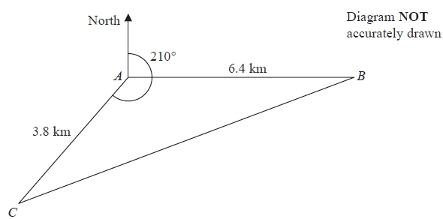

*A*, *B* and *C* are 3 villages.   
*B* is 6.4 km due east of *A*.   
*C* is 3.8 km from *A* on a bearing of 210°

Calculate the bearing of *B* from *C*.   
Give your answer correct to the nearest degree.   
Show your working clearly.

........................................................... °

**(Total for Question is 6 marks)**

**Q15.**

The diagram shows the positions of two towns, *A* and *B*.

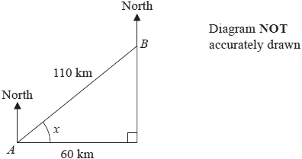

The distance from *A* to *B* is 110 km.   
*B* is 60 km east of *A*.

(a)  Work out the size of angle *x*.

Give your answer correct to 1 decimal place.

........................................................... °

**(3)**

(b)  Work out the bearing of *B* from *A*.

Give your answer correct to the nearest degree.

........................................................... °

**(2)**

The distance from *A* to *B* is 110 km correct to 2 significant figures.

(c) (i)  Write down the lower bound for the distance from *A* to *B*.

........................................................... km

(ii)  Write down the upper bound for the distance from *A* to *B*.

........................................................... km

**(2)**

**(Total for question = 7 marks)**

**Q16.**

*A*, *B* and *C* are three towns.

The bearing of *B* from *A* is 105°   
The bearing of *C* from *B* is 230°

The distance of *C* from *A* is 180 km.   
The distance of *C* from *B* is 95 km.

Calculate the distance of *B* from *A*.   
Give your answer correct to 3 significant figures.

........................................................... km

**(Total for question = 5 marks)**

**Q17.**

Wendy travelled on the Eurostar train from St Pancras station to the Gare du Nord station.  
 The Eurostar train travelled a distance of 495 km.  
 The journey time was 2 hours 15 minutes.

Work out the average speed of the Eurostar train in kilometres per hour.

...........................................................km/h

**(Total for question = 3 marks)**

**Q18.**

The average speed for an aeroplane flight from Dubai to London is 750 km/h.   
The flight time from Dubai to London is 7 hours 18 minutes.

(a)  Work out the flight distance from Dubai to London.

........................................................... km

**(3)**

(b)  Change 750 kilometres per hour to a speed in metres per second.   
       Give your answer correct to the nearest whole number.

........................................................... m/s

**(3)**

**(Total for question = 6 marks)**

**Q19.**

The currency in Bangladesh is the taka.   
1 pound (£) = 119 taka

(a)  Change 3500 taka to pounds.

Give your answer correct to 2 decimal places.

£ ...........................................................

**(2)**

The currency in Thailand is the baht.   
1 pound (£) = 52 baht

(b)  Change 8500 baht to taka.

Give your answer correct to the nearest whole number.

........................................................... taka

**(3)**

An aeroplane takes 2 hours and 24 minutes to fly from Bangkok to Dhaka.   
The aeroplane flies a distance of 1534 km.

(c)  Work out the average speed of the aeroplane.

Give your answer in kilometres per hour correct to 3 significant figures.

........................................................... kilometres per hour

**(3)**

**(Total for question = 8 marks)**

**Q20.**



Find the pressure exerted by a force of 810 newtons on an area of 120 cm2  
Give your answer in newtons/m2

newtons/m2 ...........................................................

**(Total for question = 3 marks)**

**Q21.**

On Monday, Nalim made a journey.  
 On Tuesday, she made the same journey.  
 Her average speed on Tuesday was 25% greater than her average speed on Monday.

Calculate the percentage reduction in the time her journey took on Tuesday compared  
 with Monday.

...........................................................%

**(Total for question = 3 marks)**

**Q22.**

Bhavik left his home at 12 00 to cycle to Sam's house.  
 On the way Bhavik stopped for a rest, and then continued his journey.  
 The distance-time graph shows his journey.

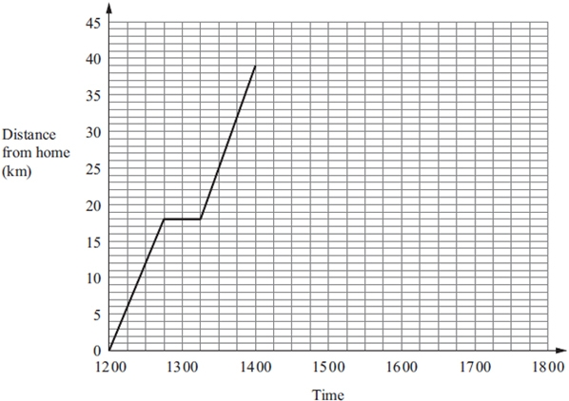

(a) (i) For how many minutes did Bhavik stop for a rest?

...........................................................minutes

(ii) After his rest, how many more kilometres did Bhavik cycle to Sam's house?

...........................................................km

**(2)**

(b) Bhavik stayed at Sam's house for 2 hours.   
He then cycled back to his home.  
He arrived home at 17 15.

Show all this information on the graph.

**(2)**

(c) Write down the times at which Bhavik was 24 kilometres from his home.

...........................................................

...........................................................

**(2)**

(d) Work out the average speed, in kilometres per hour, of Bhavik's journey from Sam's   
house back to his home.

Give your answer correct to 1 decimal place.

...........................................................km/h

**(3)**

**(Total for question = 9 marks)**