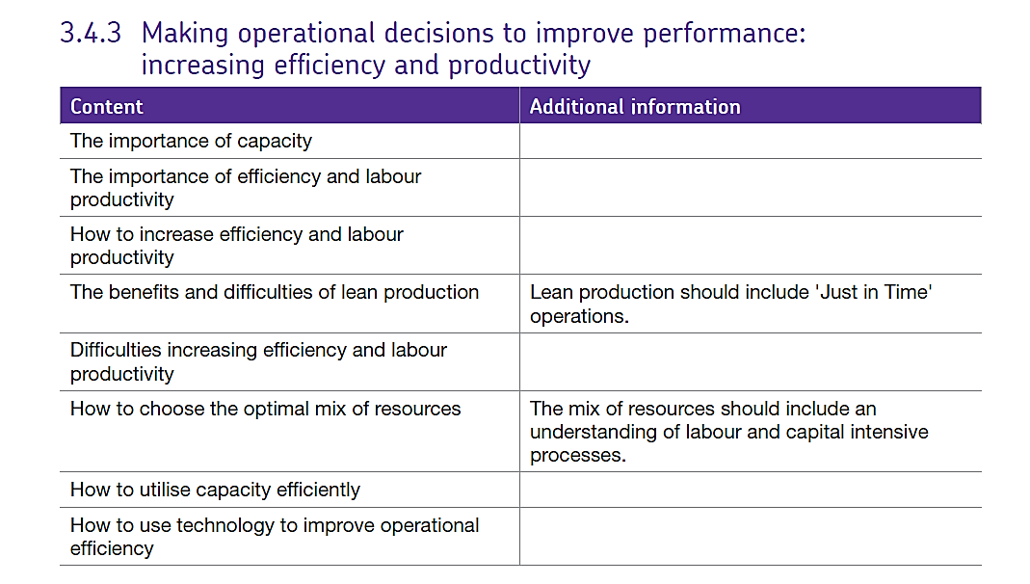3.4.3 Efficiency and lean production

# The importance of using capacity efficiently

The capacity of the business is the maximum amount of output the business can produce in a given time. This will depend upon the resources of the business including all factors of production, if the resources in the business are not fully used, then resources are wasted and unit costs will increase.

However, if the business is working to full capacity, it is less flexible when it comes to accepting unexpected orders or dealing with surges in demand. So, the business must ensure that they have the right level of capacity to meet customer demand and to look ahead to what may occur in the future.

**If capacity utilisation is low a business can:**

* Try to improve marketing to boost sales. For example, it might reduce the selling price or improve the promotional mix.
* Reduce capacity by **downsizing** (also known as **rationalising**). This may involve selling off parts of the business and closing down production lines. However, this must be done with caution as it would be hard to reverse.

**If there is insufficient capacity to meet demand a business can:**

* Outsource to other producers.
* Find a way to reduce demand in the short term – for example, by increasing the selling price. Alternatively, it might operate a waiting list.
* Increase productive capacity by investing in more equipment / production facilities – as long as they’re sure the increase in demand is permanent otherwise the business will be left with capacity they are unable to use in the longer term.

# Increasing labour productivity

Another way to increase efficiency is to improve the labour productivity. Clearly, if a business can achieve more output from a given number of employees, then assuming that wages and salaries stay the same, the average cost per unit will fall.

For example, if 100 employees produce 200 units with a labour cost of £2,000 then:

* Labour productivity = 200/100 = 2 units per employees
* Unit cost of labour is £2000 / 200 = £10 per unit

Now, if those 100 employees now produce 400 units but labour costs stay the same then:

* Labour productivity = 400/100 = 4 units per employee
* Unit cost of labour is £2000/400 = £5 per unit

Therefore, the labour cost has fallen as productivity has increased

## How to increase labour productivity

To increase labour productivity a manager may:

* Invest in technology so employees have access to more equipment to help them complete their tasks more efficiently.
* Improve the training of employees so they are more skilled when carrying out their jobs.
* Change the way the work is organised and the design of jobs to improve the flow of work and reduce time waiting to complete tasks.
* Change the way employees are rewarded to provide more incentives.

## Difficulties in increasing labour productivity

* If the focus is purely on increasing output per employee, the quality of that output may suffer. For example, an increase in labour productivity in a call centre might mean more telephone calls are taken. But, it may also mean less time is spent with each customer and the quality of the customer experience suffers as a result.
* An increase in labour productivity without an increase in demand will mean that less labour is then required. For this reason, workers may object to the emphasis on labour productivity because they will see it as a way of reducing staff numbers.
* If labour productivity increases, employees may feel that they should be rewarded financially and demand an increase in wage rates. As a consequence of this, an increase in labour costs might offset the increase in labour productivity.

# Increasing efficiency by choosing the optimal mix of resources

A business will use a combination of factors of production (land, labour, capital and enterprise) in order to produce goods or provide services. Clearly, different organisations use these factors of production in varying combinations. A supermarket for example, would have very different combinations of factors of production than would a farmer.

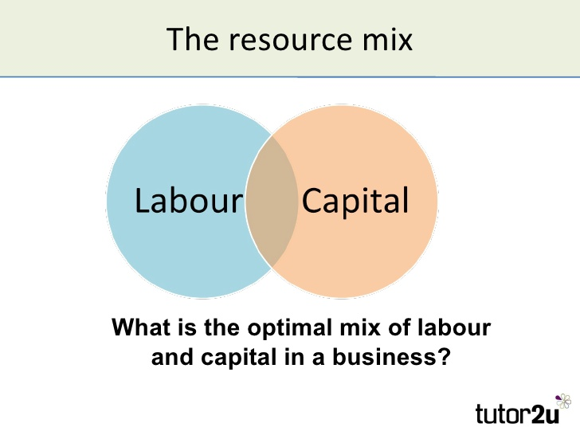Some processes are **capital intensive** meaning that they may use machinery and advanced technology in production. On the other hand, some businesses are very **labour intensive** because they depend heavily on labour to produce the product or provide the service. A hairdressing business for example is very labour intensive.

In order to be efficient, the business must combine the resources available to it to maximise efficiency and this is called the ‘optimal’ (the best) mix of resources.

The optimal mix will depend upon:

* The processes involved – for example high volume repetitive tasks can easily be undertaken by machinery. However, creative ideas and design type work will be more labour intensive.
* What is affordable and achievable given the financial state of the business and the mix of skills available to the business?
* The type of market facing the business – for example, a business providing products to a mass market in high volume is more likely to be capital intensive. However, the business is more likely to be labour intensive if the market is niche or if the business caters for local demand.

# Lean Production.

**Lean production aims to keep stock and waste to a minimum**, but **ensuring quality of inputs as well as process and therefore outputs,** thus maximising production.

Lean production is an approach to management that focuses on **cutting out waste**, whilst **ensuring quality**. This approach can be applied to all aspects of a business – from design, through production to distribution.

Lean production aims to cut costs by making the business more efficient and responsive to market needs.

This approach sets out to **cut out or minimise activities that do not add** value to the production process, such as holding of stock, repairing faulty product and unnecessary movement of people and product around the business.

The lean approach to managing operations is really about:

* Doing the simple things well
* Doing things better
* Involving employees in the continuous process of improvement …and as a result, avoiding waste

The concept of lean production is an incredibly powerful one for any business that wants to become and/or remain competitive. Why? **Because waste equals cost**

Less waste therefore means lower costs, which is an essential part of any business being competitive. The pioneering work of Toyota (a leader in lean production) identified different kinds of waste which can be applied to any business operation.

|  |  |
| --- | --- |
| Type of waste | Description |
| Over-production | Making more than is needed – leads to excess stocks |
| Waiting time | Equipment and people standing idle waiting for a production process to be completed or resources to arrive |
| Transport | Moving resources (people, materials) around unnecessarily |
| Stocks | Often held as an acceptable buffer, but should not be excessive |
| Motion | A worker who appears busy but is not actually adding any value |
| Defects | Output that does not reach the required quality standard – often a significant cost to an uncompetitive business |

The key aspects of lean production are:

* Time based management
* Simultaneous engineering
* Just in time production (JIT)
* Cell production
* Kaizen (Continuous improvement)
* Quality improvement and management (Quality circles and TQM)

## **Time-based management**

Concentrates on **minimising development times** for products and cutting down time spent waiting for other jobs to be finished. Some firms will practice “**Simultaneous engineering**” where the materials are being cut and prepared while the design process is still ongoing. This requires the firm to have very strict procedures and exact processes.

Critical path analysis is a way of analysing the time spent “hanging around” between jobs and then rescheduling jobs so that they take the minimum time. This may mean that workers can be redeployed for some of the time.

## **Cell production**

Splits the flow production line into a number of self-contained units. Each team or ‘cell’ is responsible for a significant part of the finished article and, rather than each person only carrying out only one very specific task, team members are skilled at a number of roles, so it provides a means for job rotation.

Cell production is a form of team working and helps ensure worker commitment, as each cell is responsible for a complete unit of work, which Herzberg would view as part of **job enrichment.**

Cells would usually have responsibility for organising work rotas within the cell, for covering holiday and sickness absences and for identifying recruitment and training needs. Cells deal with other cells as if they were customers, and take responsibility for quality in their area.

Kaizen (or ‘continuous improvement’) is an approach of **constantly introducing small incremental changes** in a business in order to improve quality and/or efficiency.

This approach assumes that employees are the best people to identify room for improvement, since they see the processes in action all the time. A firm that uses this approach therefore has to have a culture that encourages and rewards employees for their contribution to the process.

Kaizen can operate at the level of an individual, or through Kaizen Groups or Quality Circles which are groups specifically brought together to identify potential improvements. This approach would also be compatible with Team working or Cell Production, as improvements could form an important part of the team’s aims.

# Just in time (“JIT”)

JIT manufacturing means that a firm only produces what is required, in the correct quantity and at the correct time.

This means that stock levels of raw materials, components, work in progress and finished goods can be kept to a minimum. In a firm which is not using JIT, stock is held in the warehouse as a buffer – in the diagram below this is at 200 units.

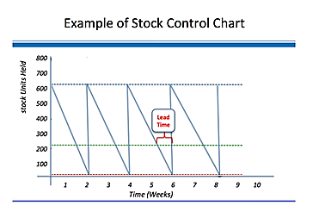With JIT there is no buffer stock, therefore if stock does not arrive on time the firm will run out of components and production will stop.

This requires a carefully planned scheduling and flow of resources through the production process. Modern manufacturing firms use scheduling software to plan production.

Supplies are delivered right to the production line only when they are needed. For example, a car manufacturing plant might receive exactly the right number and type of tyres for one day’s production, and the supplier would be expected to deliver them to the correct loading bay on the production line within a very narrow time slot.

The main advantages and disadvantages of JIT can be summarised as follows:

|  |  |
| --- | --- |
| **Advantages** | **Disadvantages** |
| Lower stock holding means less storage space which saves rent and insurance costs | There is little room for mistakes as minimal stock is kept for re-working faulty product |
| As stock is only obtained when it is needed, less working capital is tied up in stock | Production relies on suppliers, if stock is not delivered on time, the production schedule can be delayed |
| There is less likelihood of stock perishing, becoming obsolete or out of date | There is no spare finished product available to meet unexpected orders, because all product is made to meet actual orders. |
| Avoids the build-up of unsold finished product |  |
| Less time is spent on checking and re-working - the emphasis is on getting it work right first time |  |

# The benefits and difficulties of lean production

Benefits:

* Reduced lead times can be achieved - customers receive orders faster.
* Shorter product development times
* Higher quality / lower fault rate
* Workers are empowered so more motivated
* Lower average cost due to higher efficiency and lower stock –holding levels.

Difficulties

* Stock-outs may occur
* May be hard to deal with sudden large orders – can lack flexibility
* There is little margin for error so mistakes could be costly requires very good communication internally and externally with suppliers

## <http://www.tutor2u.net/business/blog/improving-productivity-through-training-lean-production-the-unipart-way>

## How to use technology to improve operational efficiency

The firm can use any of the following ways to utilise technology in production and try to improve

efficiency.

* Robotics
* Automation
* Planning / CAD/CAM
* Computer-based quality control
* Rapid-prototyping (3D printing)
* EPOS
* ICT-based communications
* ICT-based flexibility e.g. offering homeworking/ teleworking, up-skilling / multi-skilling of employees.

# How to choose the optimal mix of resources

The production operations of any business combine two factor inputs:

* **Labour** – i.e. management, employees (full-time, part-time, temporary etc)
* **Capital** – i.e. plant & machinery, IT systems, buildings, vehicles, offices

The relatively importance of labour and capital to a specific business can be described broadly in terms of their "**intensity**" (or to put it another way, significance).

## Labour-intensive production relies mainly on labour

**Labour intensive examples include:**

* Food processing (e.g. ready meals)
* Hotels & restaurants
* Fruit farming / picking
* Hairdressing & other personal services
* Coal mining

**In labour intensive operations**

* Labour costs higher than capital costs
* Costs are mainly variable in nature = lower breakeven output
* Firms benefit from access to sources of low-cost labour

## Capital-intensive production relies mainly on capital / machinery

**Capital intensive examples include:**

* Oil extraction & refining
* Car manufacturing
* Web hosting
* Intensive arable farming
* Transport (airports, railways etc)

**In capital intensive operations**

* Capital costs higher than labour costs
* Costs are mainly fixed in nature = higher breakeven output
* Firms benefit from access to low-cost, long-term financing