**REVISION 2 – Equation of lines, calculus and functions**

**Q1.**

*A* is the point with coordinates (1, 3)   
*B* is the point with coordinates (−2, −1)

The line **L** has equation 3*y* = 4 − 2*x*

Is line **L** parallel to *AB*?   
Show your working clearly.

**(Total for question = 3 marks)**

**Q2.**

The straight line **L** has equation 2*y* + 7*x* = 10

(a)  Find the gradient of **L**

...........................................................

**(2)**

(b)  Find the coordinates of the point where **L** crosses the *y*-axis.

( ................ , ................ )

**(1)**

**(Total for question = 3 marks)**

**Q3.**

(a)  The straight line **L** passes through the points (0, 12) and (10, 4).   
Find an equation for **L**.

...........................................................

**(3)**

(b)  Find an equation of the straight line which is parallel to **L** and passes through the point (5, −11).

...........................................................

**(2)**

**(Total for Question is 5 marks)**

**Q4.**

(a) Find the gradient of the line with equation 3*x* + 4*y* = 10

...........................................................

**(3)**

(b) Find the coordinates of the point of intersection of the line with equation 3*x* + 4*y* = 10   
and the line with equation 5*x* − 6*y* = 23  
Show your working clearly.

(.............................. , ..............................)

**(5)**

**(Total for question is 8 marks)**

**Q5.**Here is the graph of   *y* = h (*x*)

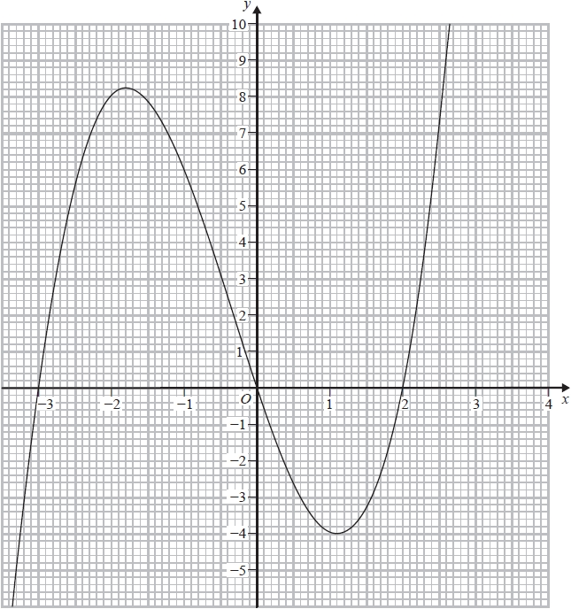

(a)  Use the graph to find an estimate for the gradient of the curve  *y* = h (*x*)  at  (–1,6)

...........................................................

**(3)**

(b)  By drawing a suitable straight line on the grid, find an estimate for the solution of the equation   h (*x*) = 7 – 2*x*

Give your answer correct to 1 decimal place.

...........................................................

**(2)**

The equation   h (*x*) = *k*   has 3 different solutions for   *a* < *k* < *b*

(c)  Use the graph to find an estimate for the value of *a* and the value of *b*.

*a* = ...........................................................

*b* = ...........................................................

**(2)**

**(Total for question = 7 marks)**

**Q6.**

Point *A* has coordinates (5, 8)   
Point *B* has coordinates (9, –4)

(a)  Work out the gradient of *AB*.

...........................................................

**(2)**

The straight line **L** has equation *y* = –4*x* + 5

(b)  Write down the gradient of a straight line that is perpendicular to **L**.

...........................................................

**(1)**

**(Total for question = 3 marks)**

**Q7.**

Triangle *HJK* is isosceles with *HJ* = *HK* and



H is the point with coordinates (−4, 1)   
*J* is the point with coordinates (*j*, 15) where *j* < 0   
*K* is the point with coordinates (6, *k*)

*M* is the midpoint of *JK*.   
The gradient of *HM* is 2

Find the value of *j* and the value of *k*.

*j* = ...........................................................

*k* = ...........................................................

**(Total for question = 6 marks)**

**Q8.**

*ABCD* is a kite with *AB* = *AD* and *CB* = *CD*.

*B* is the point with coordinates (10, 19)   
*D* is the point with coordinates (2, 7)

Find an equation of the line *AC*.   
Give your answer in the form *py* + *qx* = *r* where *p*, *q* and *r* are integers.

...........................................................

**(Total for question = 5 marks)**

**Q9.**

Line **L** has equation 4*y* – 6*x* = 33   
Line **M** goes through the point *A* (5, 6) and the point *B* (−4, *k*)

**L** is perpendicular to **M**.

Work out the value of *k*.

**(Total for question = 4 marks)**

**Q10.**

The diagram shows parts of the graphs of *y* = f(*x*) and *y* = g(*x*).

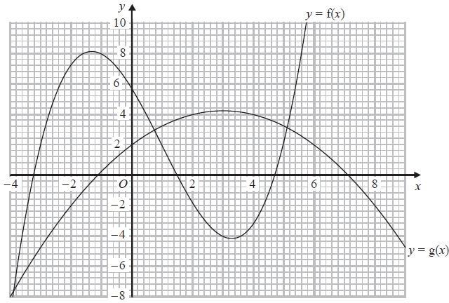

(a)  Find g(0)

...........................................................

**(1)**

(b)  Find gf(−1)

...........................................................

**(2)**

(c)  Calculate an estimate for the gradient of the curve *y* = f(*x*) at the point on the curve where *x* = 3

...........................................................

**(3)**

**(Total for question = 6 marks)**

**Q11.**

The diagram shows a solid cuboid.

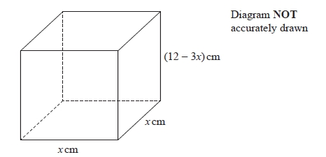

The total surface area of the cuboid is *A* cm2

Find the maximum value of *A*.

...........................................................

**(Total for question = 5 marks)**

**Q12.**

*ABCED* is a five-sided shape.

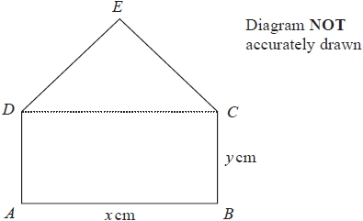

*ABCD* is a rectangle.   
*CED* is an equilateral triangle.

*AB* = *x* cm      *BC* = *y* cm

The perimeter of *ABCED* is 100 cm.   
The area of *ABCED* is *R* cm2

(a)  Show that



**(3)**

(b) (i)  Find the value of *x* for which *R* has its maximum value.



Give your answer in the form where *p* and *q* are integers.

*x* = ...........................................................

**(2)**

(ii)  Explain why the maximum value of *R* is given by this value of *x*.

.............................................................................................................................................

.............................................................................................................................................

**(1)**

**(Total for question = 6 marks)**

**Q13.**

A particle *P* moves along a straight line that passes through the fixed point *O*

The displacement, *x* metres, of *P* from *O* at time *t* seconds, where *t*≥ ≥ 0 , is given by

*x* = 4*t*3 − 27*t* + 8

The direction of motion of *P* reverses when *P* is at the point *A* on the line.

The acceleration of *P* at the instant when *P* is at *A* is *a* m/s2

Find the value of *a*

*a* = ...........................................................

**(Total for question = 5 marks)**

**Q14.**

A particle is moving in a straight line which passes through a fixed point *O*.  
 The displacement, *s* metres, of the particle from *O* at time *t* seconds is given by

*s* = 10 + 9*t*2 − *t*3

(a) Find an expression for the velocity, *v* m/s, of the particle at time *t* seconds.

*v* = ...........................................................

**(2)**

(b) Find the time at which the acceleration of the particle is zero.

...........................................................seconds

**(2)**

**(Total for question = 4 marks)**

**Q15.**

*y* = *x*3 − 4*x*2 + 4*x* + 3



(a)  Find

...........................................................

**(2)**

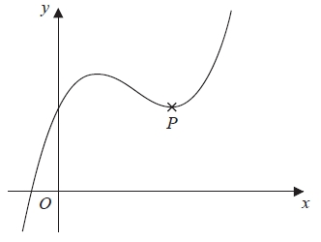

The diagram shows a sketch of the curve with equation *y* = *x*3 − 4*x*2 + 4*x* + 3   
The point *P* is a turning point on the curve.

(b)  Work out the coordinates of *P*.   
       Show clear algebraic working.

(............................. , .............................)

**(4)**

(c)  Write down the range of values of *x* for which the curve has a negative gradient.

...........................................................

**(2)**

**(Total for question = 8 marks)**

**Q16.**

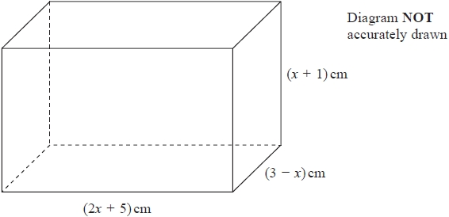

The diagram shows a cuboid of volume *V* cm3

(a)  Show that *V* = 15 + 16*x* − *x*2 − 2*x*3

**(3)**

There is a value of *x* for which the volume of the cuboid is a maximum.

(b)  Find this value of *x*.   
Show your working clearly.   
Give your answer correct to 3 significant figures.

*x* = ...........................................................

**(5)**

**(Total for question = 8 marks)**

**Q17.**

A solid, **S**, is made from a hemisphere and a cylinder.

The centre of the circular face of the hemisphere and the centre of the top face of the cylinder are at the same point.

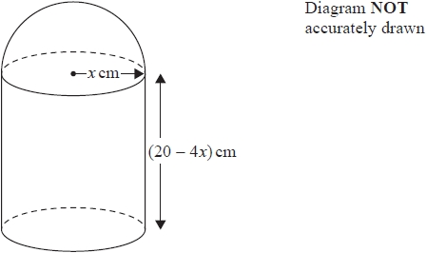

The radius of the cylinder and the radius of the hemisphere are both *x* cm.   
The height of the cylinder is (20 – 4*x*) cm.

The volume of *S* is *V* cm3 where V =



Find the maximum value of *y*.   
Show clear algebraic working.

...........................................................

**(Total for question = 5 marks)**

**Q18.**

The curve *C* has equation



(a)  Find



**(2)**

(b)  Find the range of values of *x* for which *C* has a negative gradient.

**(3)**

**(Total for question = 5 marks)**

**Q19.**

A particle *P* moves along a straight line.   
The fixed point *O* lies on this line.

The displacement of *P* from *O* at time t seconds, *t* ≥ 1, is *s* metres where



The velocity of *P* at time *t* seconds, *t* ≥ 1, is *v*m/s

Work out the distance of *P* from *O* at the instant when *v* = 0

........................................................... m

**(Total for question = 5 marks)**

**Q20.**

The curve **C** has equation *y* = *ax*3 + *bx*2 – 12*x* + 6 where *a* and *b* are constants.

The point *A* with coordinates (2, –6) lies on **C**  
The gradient of the curve at *A* is 16

Find the *y* coordinate of the point on the curve whose *x* coordinate is 3   
Show clear algebraic working.

*y* = ...........................................................

**(Total for question = 6 marks)**

**Q21.**

A particle *P* is moving along a straight line that passes through the fixed point *O*. The displacement, *s* metres, of *P* from *O* at time *t* seconds is given by

*s* = *t*3 − 6*t*2 + 5*t* − 4

Find the value of *t* for which the acceleration of *P* is 3 m/s2

*t* = ...........................................................

**(Total for question = 4 marks)**

**Q22.**



The point *A* is the only stationary point on the curve with equation where *k* is a constant.



Given that the coordinates of *A* are

find the value of *a*.   
Show your working clearly.

*a* = ...........................................................

**(Total for question = 5 marks)**

**Q23.**

A farmer has 120 metres of fencing.   
He is going to make a rectangular enclosure *PQRS* with the fencing.   
He is also going to divide the enclosure into two equal parts by fencing along *MN*.

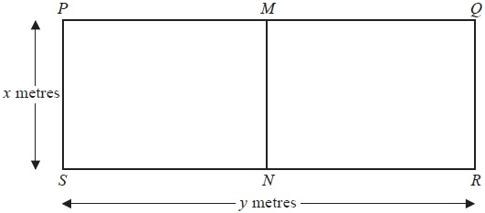

The width of the enclosure is *x* metres.   
The length of the enclosure is *y* metres.

(a)  (i)  Show that *y* = 60 − 1.5*x*

The area of the enclosure *PQRS* is *A* m2

(ii)  Show that *A* = 60*x* − 1.5*x*2

**(3)**

(b)  Find



...........................................................

**(2)**

(c)  Find the maximum value of *A*.

*A* = ...........................................................

**(3)**

**(Total for Question is 8 marks)**

**Q24.**

A particle *P* is moving along a straight line.   
The fixed point *O* lies on this line.

At time *t* seconds where *t* ≥ 0, the displacement, *s* metres, of *P* from *O* is given by

*s* = *t*3 + 5*t*2 – 8*t* + 10

Find the displacement of *P* from *O* when *P* is instantaneously at rest.

Give your answer in the form where *a* and *b* are integers.



........................................................... metres

**(Total for question = 5 marks)**

**Q25.**



(a) Find f(10)

...........................................................

**(1)**

(b) State which values of *x* must be excluded from a domain of *f*

...........................................................

**(2)**

The diagram shows part of the graph of *y* = g(*x*)

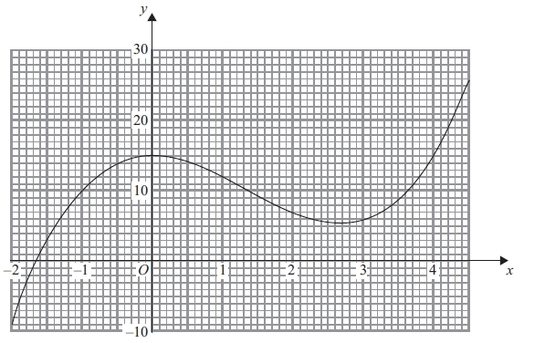

(c) Find g(2)

...........................................................

**(1)**

(d) Find fg(0)

...........................................................

**(2)**

(e) One of the solutions of g(*x*) = *k*, where *k* is a number, is *x* = 1

Find the other solutions.   
Give your answers correct to 1 decimal place.

...........................................................

**(3)**

(f) Find an estimate for the gradient of the curve at the point where *x* = 3.5   
Show your working clearly.

...........................................................

**(3)**

**(Total for question is 12 marks)**

**Q26.**

The function f is such that f(*x*) = 5 + 6*x* – *x*2 for *x* ≤ 3

(a)  Express 5 + 6*x* – *x*2 in the form *p* – (*x* – *q*)2 where *p* and *q* are constants.

...........................................................

**(2)**

(b)  Using your answer to part (a), find the range of values of *x* for which f –1(*x*) is positive.

...........................................................

**(5)**

**(Total for question = 7 marks)**

**Q27.**

The functions f and g are defined as

f(*x*) = 5*x*2 − 10*x* + 7              where *x* ≥ 1

g(*x*) = 7*x* − 6

(a)  Find fg(2)

...........................................................

**(2)**

(b)  Express the inverse function f−1 in the form f−1 (*x*) = ...

f−1 (*x*) = ...........................................................

**(4)**

**(Total for question = 6 marks)**

**Q28.**

g is the function with domain *x* ≥ –3 such that g(*x*) = *x*2 + 6*x*

(a)  Write down the range of g–1

**(1)**

(b)  Express the inverse function g–1 in the form g–1 : *x*



g–1 : *x*



**(4)**

**(Total for question = 5 marks)**

**Q29.**

f is the function such that f(*x*) = 4 – 3*x*

(a)  Work out f(5)

**(1)**

g is the function such that



(b)  Find the value of *x* that cannot be included in any domain of g

**(1)**

(c)  Work out fg(−1.5)

**(2)**

**(Total for question = 4 marks)**

**Q30.**

The function f is such that f (*x*) = 3*x* – 2

(a)  Find f (5)

...........................................................

**(1)**

The function g is such that g(*x*) = 2*x*2 – 20*x* + 9 where *x* ≥ 5

(b)  Express the inverse function g–1 in the form g–1(*x*) = ...

g–1(*x*) = ...........................................................

**(4)**

**(Total for question = 5 marks)**

**Q31.**

The functions f and g are such that

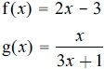

(a)  State the value of *x* that cannot be included in any domain of g

...........................................................

**(1)**

(b)  Find gf(*x*)

Simplify your answer.

gf(*x*) = ...........................................................

**(2)**

(c)  Express the inverse function g−1 in the form g−1(*x*) = ...

g−1(*x*) = ...........................................................

**(3)**

**(Total for question = 6 marks)**

**Q32.**

The function f is defined as



(a)  Find f(10)

...........................................................

**(1)**

(b)  Express the inverse function f–1 in the form f–1 : *x*→ ...

f–1 : *x*→ ...........................................................

**(3)**

**(Total for question = 4 marks)**

**Q33.**

The function f is such that f(*x*) = *x*2 – 8*x* + 5 where *x* ≤ 4

Express the inverse function f–1 in the form f–1(*x*) = ...

f–1(*x*) = ...........................................................

**(Total for question = 3 marks)**

**Q34.**

The functions f and g are such that

f(*x*) = *x*2 − 2*x*     g(*x*) = *x* + 3

The function h is such that h(*x*) = fg(*x*) for *x* ≥ −2

Express the inverse function h−1(*x*) in the form h−1(*x*) = ...

h−1(*x*) = ...........................................................

**(Total for question = 5 marks)**

**Q35.**

The function g is defined as



(a)  Express the inverse function g−1 in the form



...........................................................



**(4)**

(b)  State the domain of g−1

...........................................................

**(1)**

**(Total for question = 5 marks)**

**Mark Scheme**

Q1.

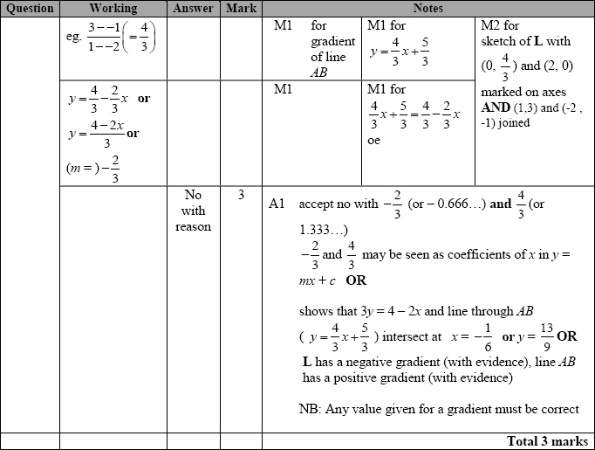

**Q2.**

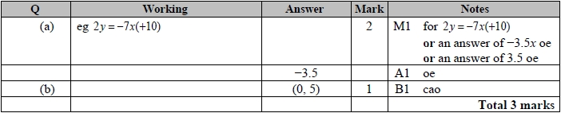

**Q3.**

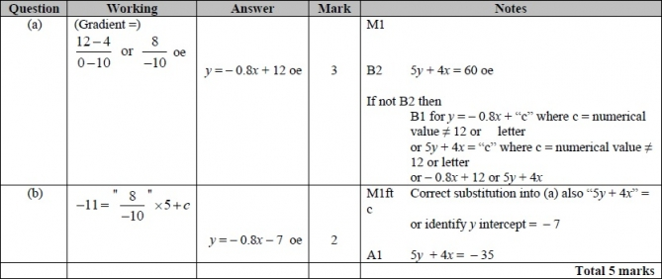

**Q4.**

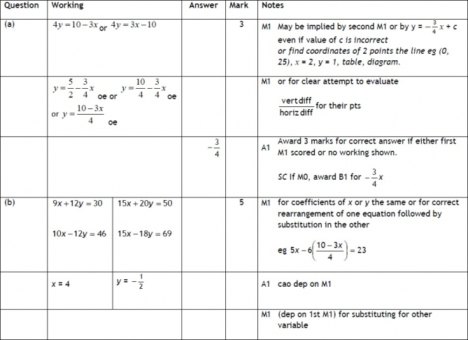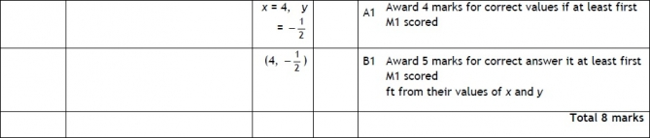

**Q5.**

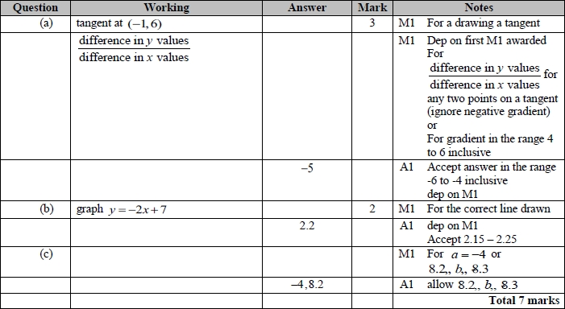

**Q6.**

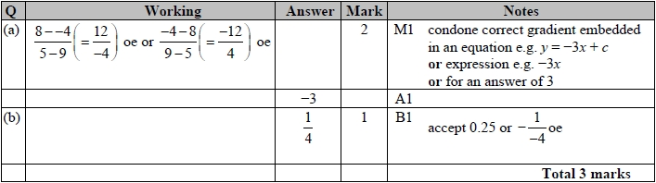

**Q7.**

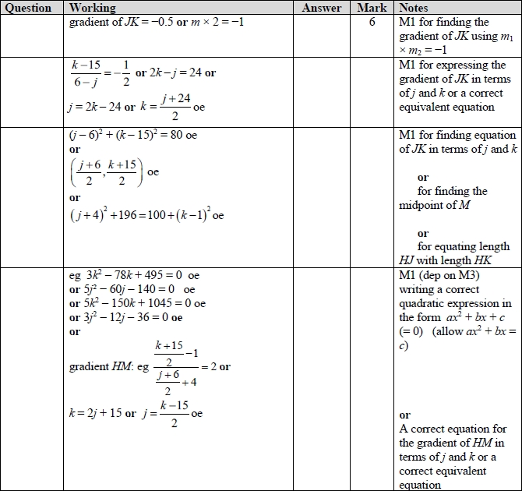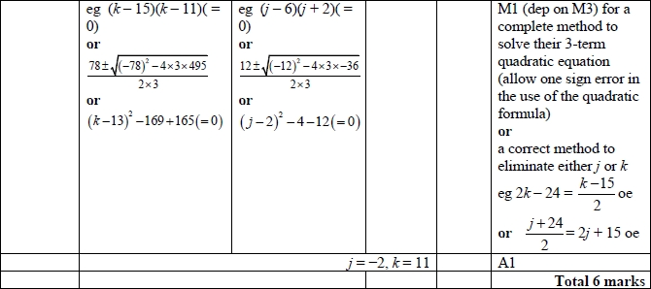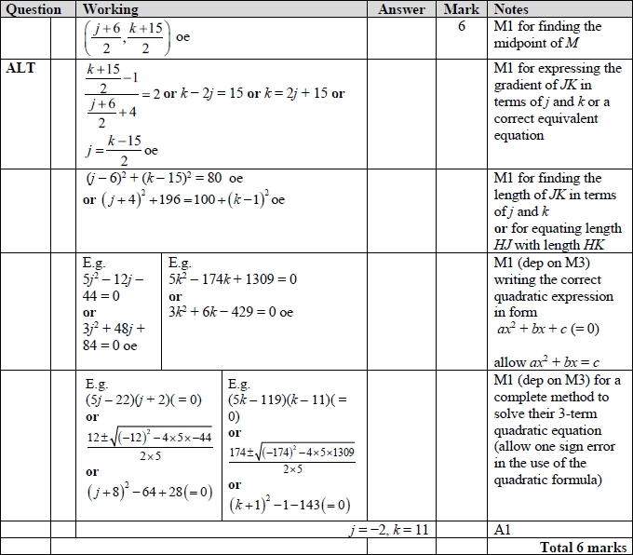

**Q8.**

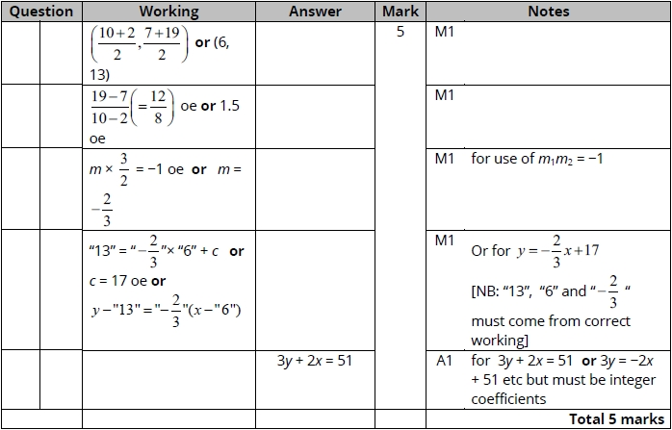

**Q9.**

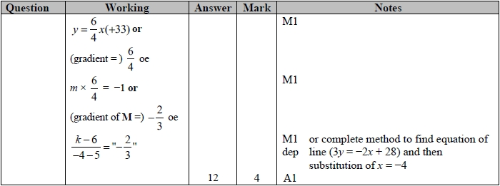

**Q10.**

Apart from c, where the mark scheme states otherwise, the correct answer, unless clearly obtained by an incorrect method, should be taken to imply a correct method.

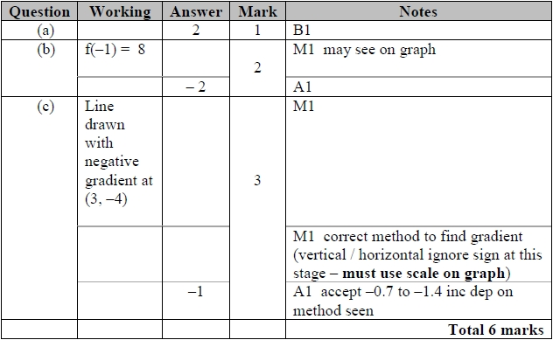

**Q11.**

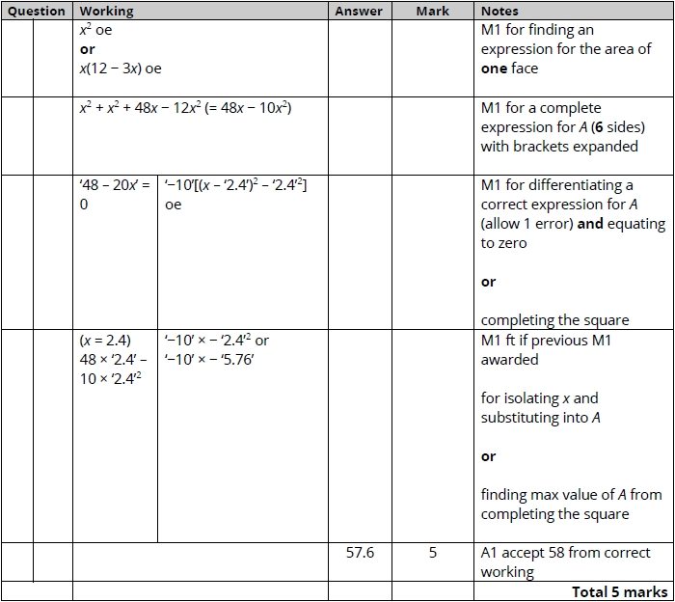

**Q12.**

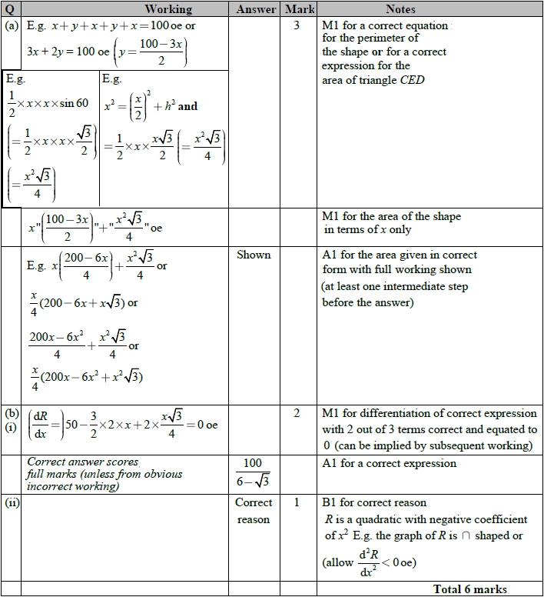

**Q13.**

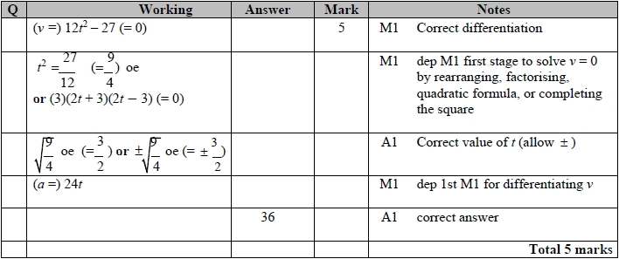

**Q14.**

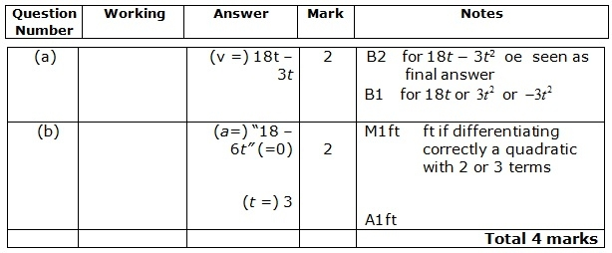

**Q15.**

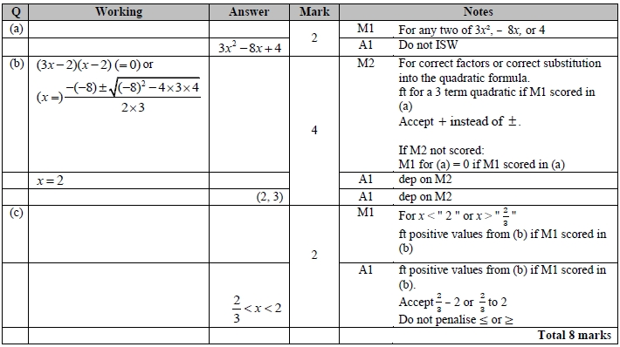

**Q16.**

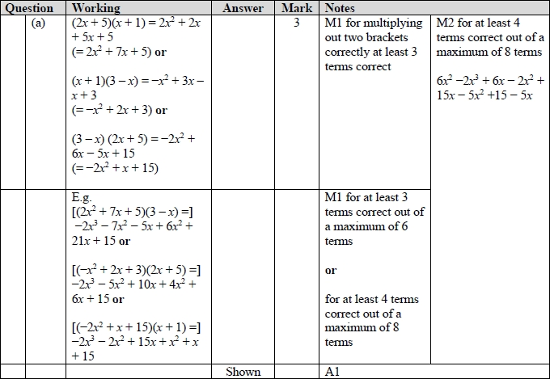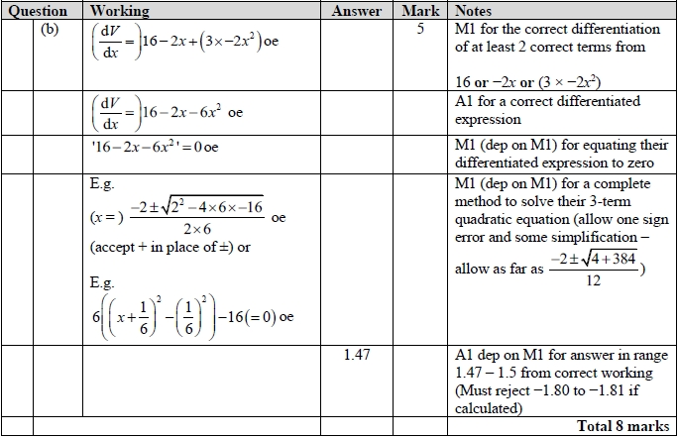

**Q17.**

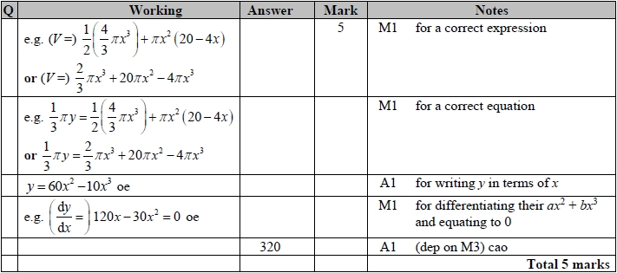

**Q18.**

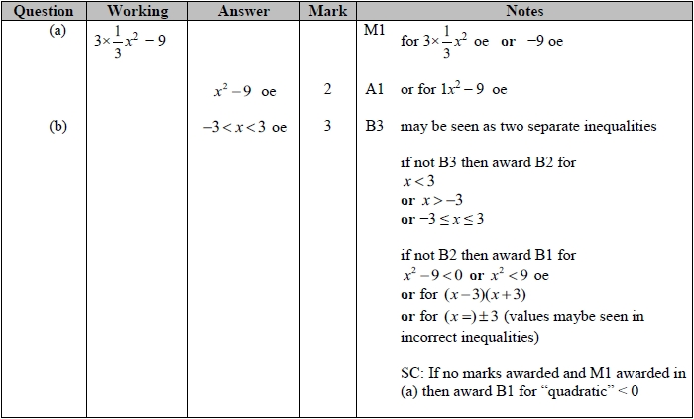

**Q19.**

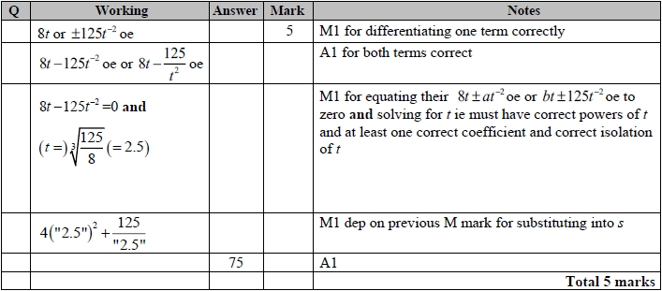

**Q20.**

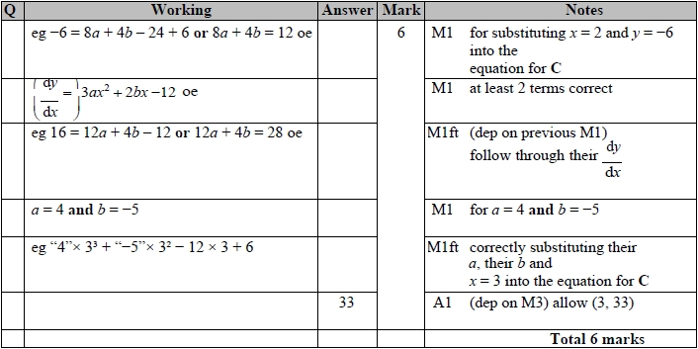

**Q21.**

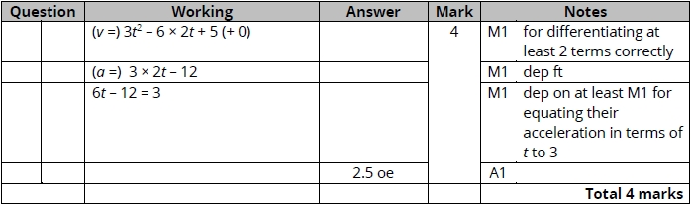

**Q22.**

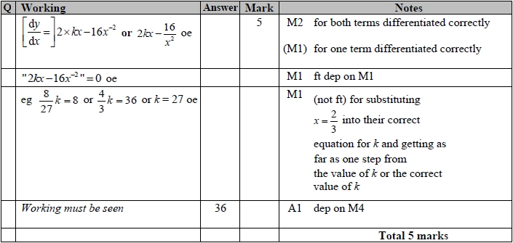

**Q23.**

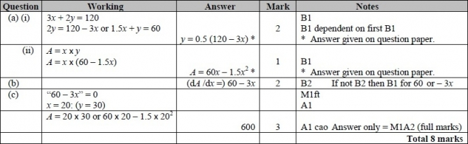

**Q24.**

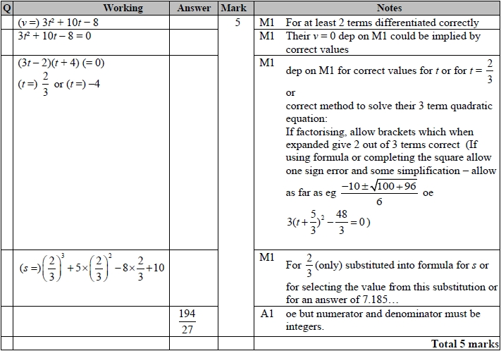

**Q25.**

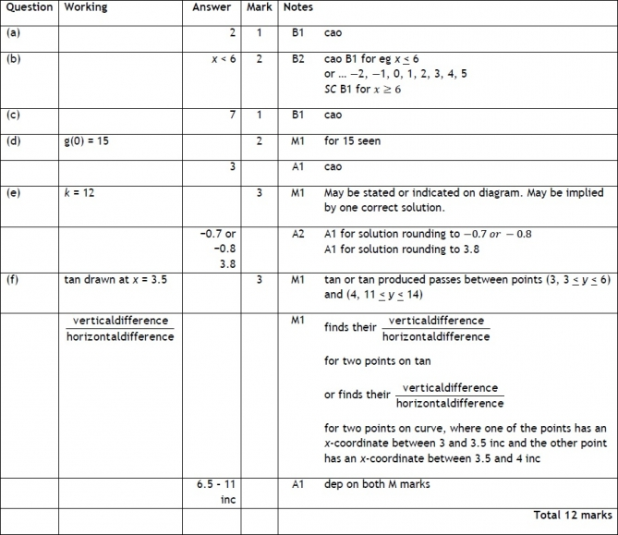

**Q26.**

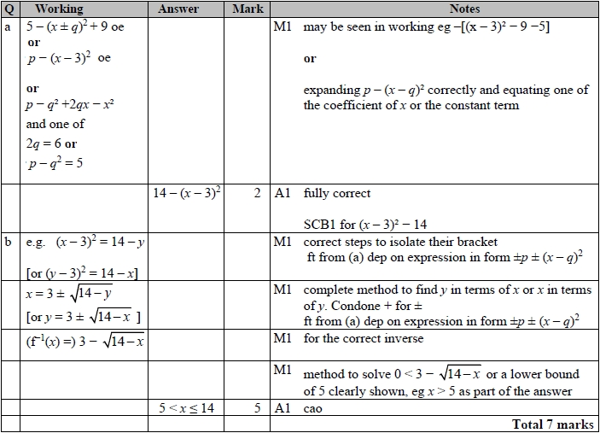

**Q27.**

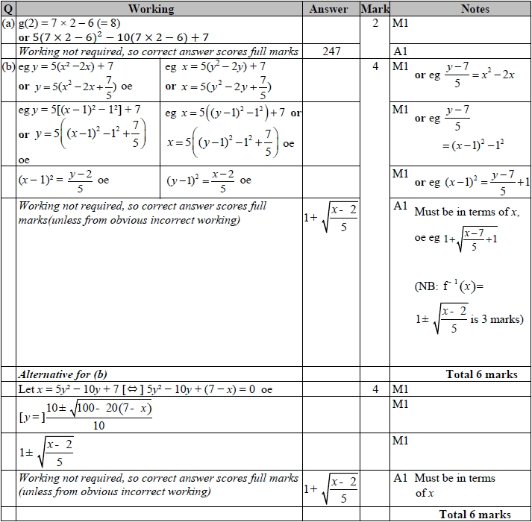

**Q28.**

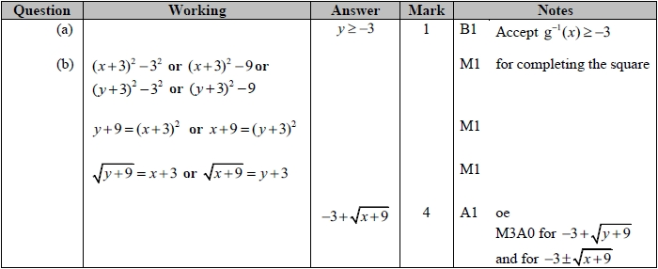

**Q29.**

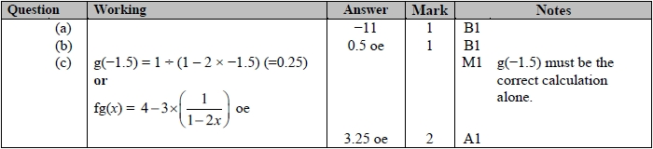

**Q30.**

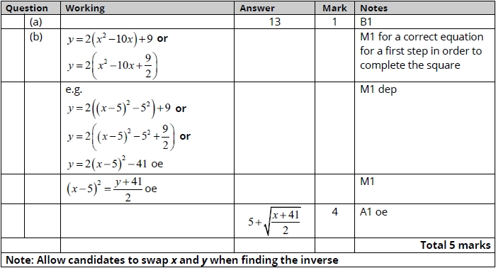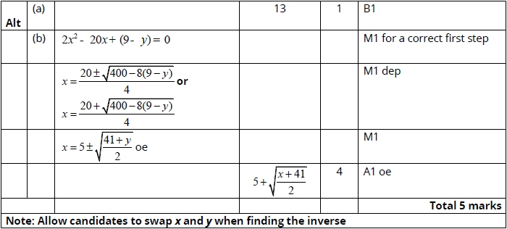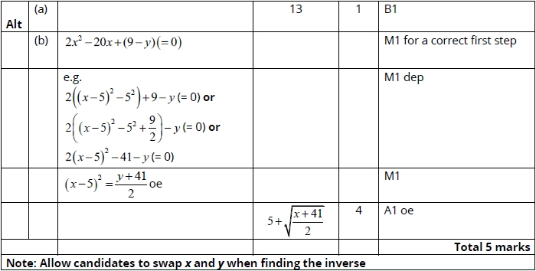

**Q31.**

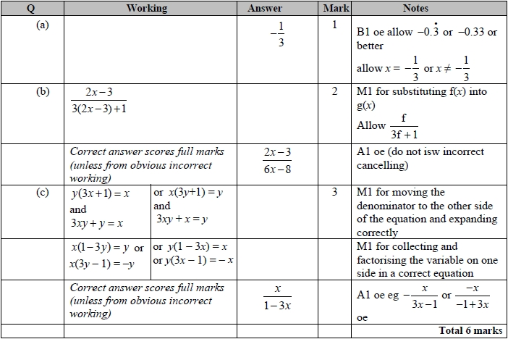

**Q32.**

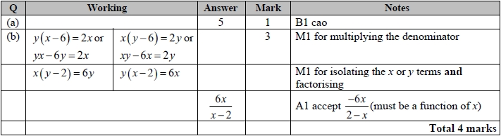

**Q33.**

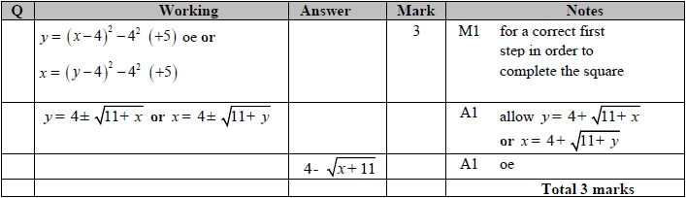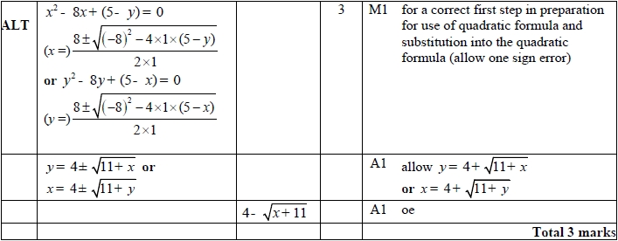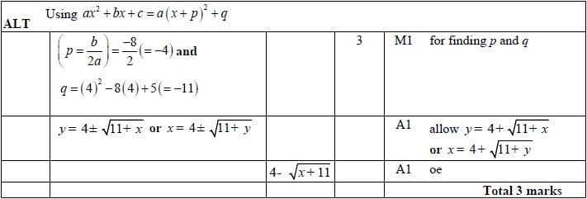

**Q34.**

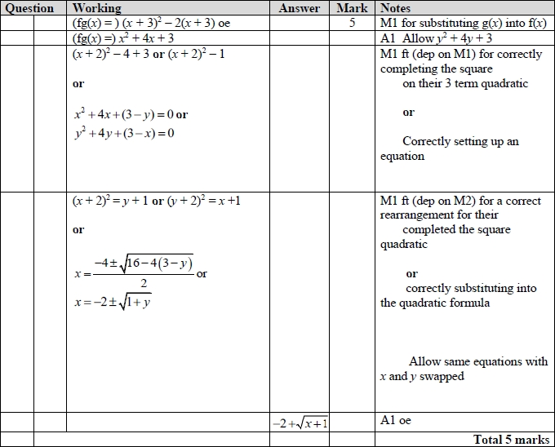

**Q35.**

