**3.1.6 Equilibria**

Many reactions reactants completely used up then the reaction stops, it goes to completion.

reactant → products e.g. 2Mg + O2 → 2MgO

Yield refers to any product on the RHS even for a reversible reaction

Some reactions are reversible:

forward

reactant products e.g. NH4Cl HCl + NH3



backward

|  |  |  |
| --- | --- | --- |
| ←  Backward/reverse reaction or moves to left hand side (LHS) | Reversible reaction | →  Forward reaction or  moves to right hand side (RHS) |

Examples of reversible reactions

***Demo: Briggs-Raucher oscillating clock***

Complex reaction that involves the generation of iodine, starch is added to show the presence of this is, giving the distinctive blue colour. This reaction oscillates as the iodine is produced (blue) then reacts again to give iodate ions (colourless).

*No need to know the method or equation, it’s just a fun demonstration.*

|  |  |
| --- | --- |
|  | Video link: Reaction demo only  CTL+ CLICK |
| Video link: Reaction information  CTL+ CLICK |

***Demo: Heating ammonium chloride***

Ammonium chloride is a solid white compound (NH4Cl) which decomposes upon heating to form two colourless gases – hydrogen chloride (HCl) and ammonia (NH3). When these are made they are able to react to re-form the white solid ammonium chloride at the top of the test tube where it is cooler.

|  |  |  |  |  |
| --- | --- | --- | --- | --- |
|  |  |  |  | Video link: Reaction demonstration  CTL+ CLICK |
| **Reversible reaction**: | NH4Cl (s) HCl (g) + NH3 (g) | | | |

***Demo: Heating hydrated CuSO4 & adding water to anhydrous CuSO4***

|  |  |  |  |
| --- | --- | --- | --- |
|  | |  | Video link: Reaction demonstration  CTL+ CLICK |
| blue hydrated CuSO4.5H2O | | heating removes water  to give white anhydrous CuSO4 |
|  | | | |
| **Reversible reaction**: | CuSO4.5H2O (s) CuSO4 (s) + 5H2O (l) | | |

**Dynamic equilibrium**

***Definition***:

**Closed system –** no transfer of mass in or out of the system (i.e. reactants or products)

transfer of energy is allowed

|  |
| --- |
| If these reactions occur in a **closed system** as soon as the products formed they react to re-form the reactants, so a **mixture** of **reactants** and **products** is obtained. Eventually the **proportion** of the components **remains** **constant**.  It is then called a **dynamic** **equilibrium** or said to be **in equilibrium**. |

|  |  |  |
| --- | --- | --- |
| This is easy to understand by thinking about a **physical** process such as **water** **evaporating**. If the water was a **puddle** in the **open**, the water would evaporate and eventually **disappear**. |  | liquid water  water vapour  H2O(l) H2O(g) |

|  |  |
| --- | --- |
| However, if the water was in a **closed system**. At first the water would **evaporate** and the **volume** of **liquid** would **reduce** with the number of vapour molecules in the **gas** phase **increasing**. As more molecules enter the gas phase **condensation** **will occur** and some gas molecules will start to re-enter the liquid phase. |  |
| After a time the **rate of evaporation and condensation** will become **equal** and the **level** of **liquid** water will **stay the same**, as will the number of molecules in the liquid and gas phase.  **Evaporation and condensation** are **still going on** but at the **same rate**. This is called **dynamic equilibrium**. |  |
| liquid vapour  H2O(l) H2O(g) | |

The same happens in a **chemical reaction**, so when the reaction is **occurring** in **both** **directions**, it is said to be **dynamic** and since **both reactions** are at the **same rate** the **concentrations** of reactants and products **remains constant** – a **chemical equilibrium** is established.

***Definitions***:

**Dynamic –** both the forwards and backward reaction are **occurring at the same time** and at the **same** **rates**

**Equilibrium – concentrations** of the reactants and products remain **constant**



***Analogy – treadmill***

It’s important to note that an **equilibrium mixture** can be **any proportions** of reactants and products, **not necessarily half and half**. The **proportions** can **change** **depending** on the **conditions** of the reaction, such as **temperature, pressure and concentration**. But at any given condition the proportions do not change.

**Conditions for equilibrium to occur:**

* Only in a *closed system (*i.e.if no reactants or products are removed)
* Can be *approached from either direction* (i.e. reactants to products or products to reactants) and the final equilibrium position will be same (as long as the same conditions are used)
* Reached when *rate of opposing reaction is the same* as forward reaction
* Know it’s reached when *macroscopic properties do not change* (i.e. concentration, colour, pressure etc)
* Reactants and products are *present at all times*
* The reaction is dynamic – *reaction continues in both directions* and at the *same rate*
* *Concentrations* of reactants and product *remain constant.*

**Representing** **equilibria on graphs**

The rate of a reaction can be graphed, either showing how the **concentration** of the reactants and products changes with time or how the **rate** of the reaction changes.

|  |  |
| --- | --- |
|  |  |
| **Dynamic equilibria** is reached when the **rates** of the **forward** and **backward** reactions are the **same**. | The concentration of reactant and product changes as the reaction initially progresses. The **concentrations remain constant** when **equilibrium** is reached but the **concentrations do not have to be the same**. |

***Starter: 8.1 - Dynamic equilibria***

***Sheet: Graphing equilibrium reactions***

**Le Chatelier’s principle**

It is important to understand how **changing conditions** can **affect the equilibrium position**, particularly for **industrial** processes that involve reversible reactions as a mixture of reactants and products will be produced. It is possible to **change the position of equilibrium** and so **change the proportion of reactants and products** to give a **greater yield of products**.

The quantitative effect of changing reaction conditions can be **predicted** using the   
**Le Châtelier’s principle**

***Definition***: **Le Châtelier’s principle** states that a system at equilibrium will respond to oppose any change imposed on it.

|  |  |  |
| --- | --- | --- |
| If the amount of **reactant is** **increased**, the position of the **equilibrium** **moves** to the **left**, the **backward** reaction is **faster** so the amount of **reactant** is **decreased**. | A reversible reaction is like an escalator by **changing the conditions the position of equilibrium can be moved**. | If the amount of **product** is **increased**, the position of the **equilibrium** **moves** to the **right**, the **forward** reaction is **faster** so the amount of **product** is **decreased**. |
|  |  |  |

If any **factor is changed** which affects the equilibrium mixture, the **position of equilibrium** will **move** so that it **opposes the change**.

**Examples:**

* **Increase concentration** – equilibrium moves to **decrease** it
* **Decrease concentration** – equilibrium moves to **increase** it
* **Add a chemical** – equilibrium moves to **get rid** of it
* **Remove a chemical** – equilibrium moves to **make more**
* **Make it hotter** – equilibrium moves to **cool** it (endothermic reaction)
* **Make it colder** – equilibrium moves to **heat** it (exothermic reaction)
* **Raise the pressure** – equilibrium moves to **lower** it (side with fewer moles)
* **Lower the pressure** – equilibrium moves to **raise** it (side with more moles)

Changing concentration

If the **concentration** of a **reactant** is **increased**, or the **concentration** of a **product** **decreased** by **removing** it, the equilibrium **moves** to **oppose the change** and the **forward** reaction is **favoured** giving **more** **product**.

**Example CGP126**

2SO2(g) + O2(g) 2SO3(g)



If the **concentration** of sulphur dioxide or oxygen is **increased**, the additional reactants will react and the **equilibrium position will shift to the right**, resulting in an **increased yield** of sulphur trioxide. Similarly if the concentration of **sulphur trioxide is increased**, the **equilibrium** **moves** to the **left** and the **backwards** reaction goes **faster** to remove the sulphur trioxide.

Changing overall pressure

Pressure changes only affect reactions involving **gases** when there are a **different number of molecules** on either side of equation. **Increasing** the total **pressure** means there are **more molecules** in a **given volume**, so it is equivalent to changing the concentration of a solution.

If the **total pressure** on the system is **increased**, Le Châtelier’s principle predicts that the position of **equilibrium** will **move** to **decrease** the pressure, so it will **move** in the direction with **fewer moles** of gas and lowering the total pressure. It will also **increase the rate**.

If the pressure is **decreased** the reverse will happen, it will also **affect** the **rate** of thereaction**,** making it **slower**.

**Example CGP126**

2SO2(g) + O2(g) 2SO3(g)



total moles = 3 total moles = 2

The total number of moles of gaseous reactants is three and total number of moles of products is four. So at a given temperature the amount of **products** can be **increased** by **increasing** the overall **pressure**, so the **system responds** to oppose the change by **moving** the equilibrium to the **right** to produce **less moles** of gas, in an attempt to reduce the pressure.

**Example: nitrogen oxide /dinitrogen tetraoxide**

**2 NO2(g)** N2O4(g)



brown colourless

total moles = 2 total moles = 1

**Increasing the pressure** will cause the system to **oppose** it by moving in the **forward** direction where there is only **one mole**, so the amount of **dinitrogen tetraoxide** will **increase** and the mixture will become **paler**. **Decreasing the** pressure will cause the system to **oppose** it by moving in the **backward** direction where there are **2 moles**, so the amount of **nitrogen** **dioxide** will **increase** and the mixture will become **darker**.

**Example: hydrogen & iodine**

If a reaction has the **same number of moles** on both sides, the position of equilibrium can’t be changed by altering the pressure as any change in **pressure affects both sides equally**.

H2(g) + I2(g) 2HI(g)



total moles = 2 total moles = 2

Changing temperature

Reversible reactions will be **exothermic** in **one direction** and **endothermic** in the **other direction**. The **size** of the **enthalpy** is the **same** in **both directions** but the **sign changes**. A **change in temperature** **alters** the **rate** of **both reactions**, so the time to reach equilibrium will changed. However, the rates of forward and backward reactions are changed by **different amounts** so the position of **equilibrium** is **altered.**

An **increase** in temperature is **opposed** by **moving** the position of **equilibrium** either to the left or right, in order **to absorb** the added **heat** **energy**. The opposite is true if the temperature is decreased.

So:

* **Increasing** temperature favours **endothermic** reaction as the system **absorbs extra energy**; however this also affects the **rate** of the reaction, making it **faster**.
* **Decreasing** temperature favours **exothermic** reaction – system **gains energy** from reaction, however this also affects the **rate** of the reaction, making it **slower**.

**Example**

H2(g) + I2(g) 2HI(g) ΔH = -9.6 kJ mol-1



At 298K, the equilibrium lies far to the **right** so there is a **high** percentage of **hydrogen iodide**. In this **exothermic** reaction **heat** energy is **evolved**, so **increasing** the **temperature** will cause the system to **remove** the extra **energy** by **moving** in the **endothermic** direction, resulting in a **lower yield of product**.

**Example**

N2(g) + O2(g) 2NO(g) ΔH = 180 kJ mol-1



At 298K, the equilibrium lies far to the **left** so there is a **low** percentage of **nitrogen oxide**. In an **endothermic** reaction **heat** energy is **taken in**, so **increasing** the **temperature** will cause the system to **remove** the extra **energy** by **moving** in the **exothermic** direction, resulting in a **higher yield of product**.

***Demo: Investigating Le Châtelier’s principle***

***Concentration***

**[Co(H2O)6]2+** + 4 Cl- **[CoCl4]2-** + 6H2O



pink blue

Add Cl- move to reduce it more cobalt chloride produced blue

Add H2O move to reduce it more hexaaqua cobalt produced pink

***Temperature***

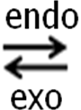

**[Co(H2O)6]2+** + 4 Cl- **[CoCl4]2-** + 6H2O

pink blue

Heat up the mixture move to reduce it more cobalt chloride produced blue

Cool down the mixture move to reduce it more hexaaqua cobalt produced pink

Summary:

|  |  |  |
| --- | --- | --- |
| [Co(H2O)6]2+ solution |  | [CoCl4]2- solution |
|  |  |
| water added | chloride ions added |
| cool | heat |

***Task: Complete the summary table***

|  |  |  |  |  |
| --- | --- | --- | --- | --- |
| **Reaction enthalpy** | **Change in temperature** | **Position of equilibrium** | **Yield of product** | **Rate of attainment of equilibrium** |
| exothermic | increased | left | decreases | faster |
| exothermic | decreased | right | increases | slower |
| endothermic | increased | right | increases | faster |
| endothermic | decreased | left | decreases | slower |

***Starter: 8.2 – Le Châtelier’s Principle Q5***

***Application: CGP128 PQ1-2***

***Fact recall: CGP128 Q1-4***

Catalysts

The addition of a **catalyst** has no **effect** **on composition** of the equilibrium **mixture**, so the **yield** will **remain** the **same** due to an **equal** **increase** in the **rate** of the **forward** and **backward** reaction, which are equal at equilibrium. However, the position of equilibrium is reached **quicker** because **catalysts increase the rate** of reactions. So they are still **important** in reversible reactions, they **lower energy consumption**.

***Sheet: Equilibrium problems***

***Sheet: Equilibria multi-choice***

**Industrial processes**

A number of industrial processes involve reversible reactions and may have **low yields** so there is a need to apply Le Châtelier’s principle. By altering the conditions it is possible to **increase** the **yield** but this can then **affect** the **rate** of reaction and **increase** **costs** as well as having **safety** implications so a **compromise** is needed.

**Catalysts important:**

* increase the rate
* lower energy use

Ethanol production

– used as motor fuel

– made into cosmetics, drugs, detergents, inks

C2H4(g) + H2O(g) C2H5OH(g) ΔH = -46kJ mol-1



|  |  |  |
| --- | --- | --- |
| ***Applying Le Chatelier’s principle to give best yield of ethanol*** | ***Problems*** | ***Compromise*** |
| Low temperature | Slow rate | Higher temperature to speed up reaction |
| Catalyst used to increase rate of reaction further |
| High pressure | Increased cost  – to build & to run  Safety  Ethene polymerised | Lower pressure to reduce costs |
| Increase amount of steam | Dilutes catalyst |  |

|  |  |
| --- | --- |
| **Conditions**:  300OC  6500 kPa  Catalyst - phosphoric acid (H3PO4) | **Yield**:  5%  unreacted ethene separated & recycled until ~95% |

Methanol production

– used as chemical feedstock, fuel for Indycars

– made into terylene, Perspex, added to petrol

CO(g) + 2H2(g) CH3OH(g) ΔH = -90kJ mol-1



|  |  |  |
| --- | --- | --- |
| ***Applying Le Chatelier’s principle to give best yield of methanol*** | ***Problems*** | ***Compromise*** |
| Low temperature | Slow rate | Higher temperature to speed up reaction |
| Catalyst used to increase rate of reaction further |
| High pressure | Increased cost  – to build & to run  Safety | Lower pressure to reduce costs |

|  |  |
| --- | --- |
| **Conditions**:  400OC  5000 kPa  catalyst - mixture copper, zinc oxide & aluminium oxide | **Yield**:  5-10% |

Ammonia production

– used to make fertilisers (ammonium nitrate, ammonium sulphate), nylon, dyes, explosives, polyurethane

N2(g) + 3H2(g) 2NH3(g) ΔH = -92kJ mol-1



The raw materials are:

* Air – provides the **nitrogen** by fractional distillation
* Natural gas – provides the **hydrogen** through the following reaction

CH4(g) + H20(g) → CO(g) + 3H2(g)

The nitrogen and hydrogen are then fed into the reactor in a 3:1 ratio and passed over an iron catalyst.

|  |  |  |
| --- | --- | --- |
| ***Applying Le Chatelier’s principle to give best yield of ammonia*** | ***Problems*** | ***Compromise*** |
| Low temperature | Slow rate | Higher temperature to speed up reaction |
| Catalyst used to increase rate of reaction further |
| High pressure | Increased cost  – to build & to run  Safety | Lower pressure to reduce costs |

Almost all ammonia is made using the **Haber process**, developed by German chemist Fritz Haber and chemical engineer Carl Bosch. It allowed Germany to make explosives and fertilises during the First World War.

|  |  |  |
| --- | --- | --- |
| **Conditions**:  400OC  20,000 kPa  catalyst – iron  (small lumps to increase surface area)  ***Video: Ammonia***  ***Sheet: The Haber process***  ***Fact recall: CGP129 Q1***  ***Sheet: Equilibria exam questions***  ***Sheet: Equilibria PPQ1-3*** | **Yield**:  15%  mixture cooled, NH3 liquefies,  N2 & H2 recycled until ~98% |  |
|  | | *Graph showing yield ammonia produced at different temperatures & pressures* |

**The equilibrium constant**

It is useful to know whether a reversible reaction **at equilibrium** is more to the right-hand side or to the left-hand side. Whether it has a **greater quantity** of **reactants** or **products**. This can be **determined mathematically** by working out the **concentration** of the **reactants** and **products** at **equilibrium** and putting the values into an **equation** to give a **numerical** value for the **equilibrium constant, Kc.**

The value of **Kc indicates whether the equilibrium lies to right or left**:

**Kc < 1** equilibrium lies to **LHS**

**Kc > 1** equilibrium lies to **RHS**

An **easy way to remember** this is the put Kc under a reversible reaction and look at the less than or greater than sign.

REACTANTS PRODUCTS



Kc < 1 Kc > 1

For any reaction that reaches equilibrium an equation can be written:

The lower-case letters represent the **stoichiometric coefficients** (i.e. mole)

aA + bB dD + eE



Providing the **temperature** is **constant** then the expression **is constant**, and the constant is referred to as **Kc**.

Square brackets **[ ]** mean **concentration**

Powers represent the **moles**

Remember: [P]

[R]

Kc = [D]eqmd [E]eqme

[A]eqma [B]eqmb

This expression can be applied to any reversible reaction and **Kc** is called the **equilibrium** **constant** and is **different** for **different reactions**.

***Definition***:

The **equilibrium constant** for a reaction is obtained by multiplying together the concentrations of the products, each raised to the power of its coefficient in the stoichiometric equilibrium equation, and dividing this by the concentrations of the reactants, each also raised to the appropriate power.

The **equilibrium constant will change with temperature** and can be **calculated from the concentrations** at constant temperature of the **reactants** and **products** in the **equilibrium** mixture.

**Example CGP130**

For the formation of hydrogen iodide, write the equilibrium constant.

H2(g) + I2(g) 2HI(g)



Kc = [HI]2

[H2] [I2]

A later example looks at calculating the value for Kc and working out it’s units.

Units of Kc

Since **Kc varies with temperature** the **units** will **also vary** and so they **must be worked out** for each reaction by cancelling out the units of each term.

For example:

2A + B C



Remember [ ] means concentration

Unit for concentration is mol dm-3

So Kc = [C]

[A]2 [B]

Units are obtained by simplification:

(~~mol dm~~~~-3~~) = 1 = mol-2 dm6

(mol dm-3)2 (~~mol dm~~~~-3~~) (mol dm-3)2

If there are an **equal number of moles** of both sides of the equation then **Kc has no units**.

A + B C + D



same number moles so cancel out

So Kc = [C] [D] (~~mol dm~~~~-3~~) (~~mol dm~~~~-3~~) no units

[A] [B] (~~mol dm~~~~-3~~) (~~mol dm~~~~-3~~)

Since the expression for **Kc involves** the **stoichiometric coefficients** of the equilibrium equation, the **numerical values** of **Kc** and also its **units** are **linked** uniquely **to the equation** from which it was defined.

So, if the above **equation was doubled** then the **value** of **Kc is the square** of the previous equation.

4A + 2B 2C



So Kc = [C]2 = Kc2 (compared to the first Kc)

[A]4 [B]2

And the units obtained:

(~~mol dm~~~~-3~~)2 = 1 = mol-4 dm12

(mol dm-3)4 (~~mol dm~~~~-3~~)2 (mol dm-3)4

The equilibrium constant for the **reverse reaction** is the **reciprocal** of the original equilibrium constant:

C 2A + B



So Kc = [A]2 [B] = 1 (compared to the first Kc)

[C] Kc

With units:

(mol dm-3)2 (~~mol dm~~~~-3~~) = (mol dm-3)2 = mol2 dm-6

(~~mol dm~~~~-3~~)

***Starter: 2.1 – Equilibrium constant Kc***

Calculating amounts at equilibrium

The following principles will help when carrying out calculations for equilibria:

* At the **start** of the reaction there will be an **initial number of moles of reactants** and **an initial number of moles of products** (this could be zero but may not)
* Once **equilibrium** is reacted some of the **reactants** will have **converted** into **products** and so there will be a **reduction in reactant moles** and an **increase in product moles by the same amount**
* **Molar ratios apply** both **initially** and when calculating the **change of reactants and products**, i.e. lost and gained
* **Moles at equilibrium** calculated and put into equilibrium constant, Kc.

Follow this order when calculating:

**I**nitial moles

**C**hange in moles

**E**quilibrium moles

**Example**

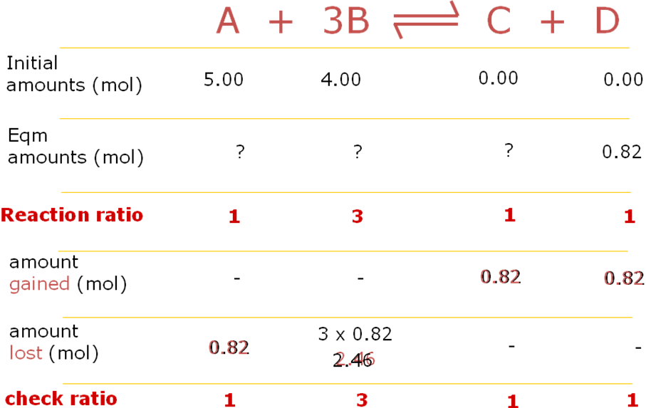

Moles at equilibrium:

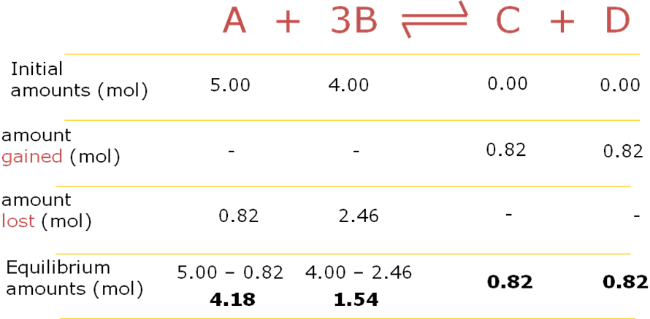

***Sheet: Equilibrium quantities 1 & 2***

Calculating the value of Kc

The **value of Kc** is **found by experiment** for any particular reaction at a given temperature. **Kc has units** so they **must be calculated** with the equilibrium equation.

**Rules** to be followed when carrying out these calculations:

1. Write **equation**

If only moles given must divide by total volume or use V to calculate concentration.

1. Work out equilibrium **moles**  
   Work out equilibrium **concentration**
2. Substitute concentration at equilibrium into **Kc expression**.

**Example**

Equilibrium concentrations:

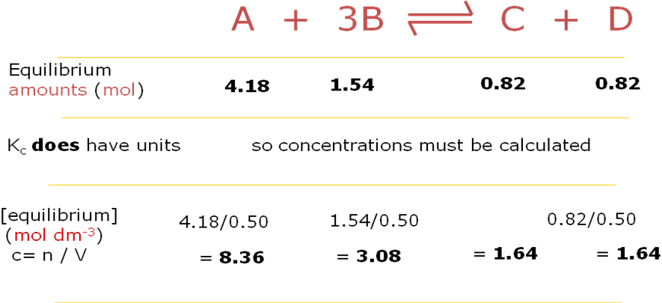

Equilibrium constant, Kc

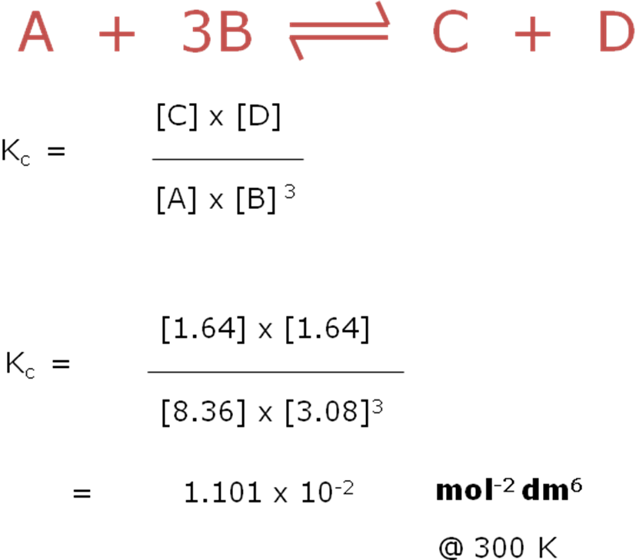

**Example CGP130**

For the formation of hydrogen iodide, the equilibrium concentrations are:

HI = 0.80 mol dm-3, H2 = 0.10 mol dm-3, I2 = 0.10 mol dm-3 at 640K. What is the value of the equilibrium constant at this temperature? Give the units for Kc.

H2(g) + I2(g) 2HI(g)



Kc is >1 so equilibrium lies to right

Kc = [HI]2 (0.80)2 = **64.0**

[H2] [I2] (0.1 x 0.1)

Units Kc = (~~mol dm~~~~-3~~)2 They all cancel out so **no** **units**

(~~mol dm~~~~-3~~) (~~mol dm~~~~-3~~)

**Example CGP**

2.0 mol phosphorous(V) chloride vapour are heated to 500K in a vessel of volume 20dm3 that contains 0.2 mol chlorine gas. The **equilibrium mixture contains 1.2 mol chlorine**. Calculate the value of the equilibrium constant Kc for the decomposition of phosphorus(V) chloride into phosphorus(III) chloride. Determine the equilibrium constant and give its units.

PCl5(g) PCl3(g) + Cl2(g)



*Initial moles (given):*

PCl5 ninitial 2.0 mol

PCl3 ninitial 0 mol

Cl2 ninitial 0.2 mol

*Change in moles:*

Cl2 nchange 1.2 - 0.2 = 1.0 mol (increase)

*Equilibrium moles:*

Cl2 neqm = 1.2 mol given in question

PCl3 (= Cl2) neqm 0.0 + 1.0 = 1.0 mol increased by 1.0 mol

PCl5 neqm 2.0-1.0 = 1.0 mol decreased by 1.0 mol

*Easy method the show working out (using ICE):*

PCl5(g) PCl3(g) + Cl2(g)



**I**nitial: 2.0 0 0.2

**C**hange: -1.0 +1.0 **1.2** – 0.2 = +1.0

**E**quilibrium: 2.0 – 1.0 = 1.0 0.0 + 1.0 = 1.0 1.2

*Equilibrium constant:*

Kc = [PCl3] [Cl2]

[PCl5]

The total volume is known so able to calculate concentration and work out a value for Kc which has units

*Equilibrium concentration (c = n/v dm3):*

[Cl2] ceqm 1.2/20 = 0.06 mol dm-3

[PCl3] ceqm 1.0/20 = 0.05 mol dm-3

[PCl5] ceqm 1.0/20 = 0.05 mol dm-3

Kc = 0.05 ~~mol dm~~~~-~~3 x 0.06 mol dm-3 = **0.06 mol dm-3**

0.05 ~~mol dm~~-3

***Task: Determine the equilibrium constant and give its units***

Ethyl butanoate (an ester) can be hydrolysed by reacting it with water.

CH3CH2CH2COOCH2CH3 + H2O ⇌ CH3CH2CH2COOH + CH3CH2OH  
  
Exactly 1 mol of ethyl butanoate and 2 mol of water were reacted initially and the mixture allowed to reach equilibrium. The total volume was 500 cm3. After this time the **equilibrium mixture was analysed and found to contain 0.3 mol of butanoic acid**.   
Calculate *K*c for the equilibrium at this temperature.

*Initial moles (given):*

ester ninitial 1.0 mol

water ninitial 2.0 mol

acid ninitial 0

ethanol ninitial 0

*Change in moles:*

acid 0.3 - 0 = 0.3 mol (increase)

Equilibrium moles:

ester neqm 1.0 - 0.3 = 0.7 mol decreased by 0.3 mol

water neqm 2.0 - 0.3 = 1.7 mol decreased by 0.3 mol

acid neqm 0.3 mol given in question

ethanol neqm 0 + 0.3 mol increased by 0.3 mol

*Using ICE:*

CH3CH2CH2COOCH2CH3 + H2O ⇌ CH3CH2CH2COOH + CH3CH2OH

**I**nitial: 1.0 2.0 0 0

**C**hange: -0.3 -0.3 **+ 0.3** + 0.3

**E**quilibrium: 1.0 – 0.3 = 0.7 2.0 + 0.3 = 1.7 0.3 0 + 0.3 = 0.3

*Equilibrium concentration (c = n/v dm3):*

[ester] ceqm 0.7/500 x 10-3 = 1.40 mol dm-3

[water] ceqm 1.7/500 x 10-3 = 3.40 mol dm-3

[acid] ceqm 0.3/500 x 10-3 = 0.60 mol dm-3

[ethanol] ceqm 0.3/500 x 10-3 = 0.60 mol dm-3

*Equilibrium constant:*

Kc = [CH3CH2CH2COOH] [CH3CH2OH]

[CH3CH2CH2COOCH2CH3] [H2O]

Kc = 0.60 ~~mol dm~~~~-~~3 x 0.60 ~~mol dm~~-3 = **7.56 x 10-2 (no units)**

1.40 ~~mol dm~~-3 x 3.40 ~~mol dm~~-3

Kc is <1 so equilibrium lies far to left

***More challenging Task: Determine the equilibrium constant and give its units***

200g ethyl ethanoate (Mr = 88.0) and 7.0g water (Mr = 18.0) are refluxed; at **equilibrium the mixture contains 0.25mol ethanoic acid**.

CH3COOC2H5(l) + H2O(l) CH3COOH(l) + C2H5OH(l)



*Initial moles (n= m/Mr):*

ethyl ethanoate ninitial 200/88.0 = 2.27 mol

water ninitial 7.0/18.0 = 0.39 mol

*Equilibrium moles:*

ethanoic acid (given) neqm 0.25 mol

ethanol (= ethanoic acid) neqm 0.25 mol

ethyl ethanoate neqm 2.27 - 0.25 = 2.02 mol

water neqm 0.39 - 0.25 = 0.14 mol

*Using ICE:*

CH3COOC2H5(l) + H2O(l) CH3COOH(l) + C2H5OH(l)



**I**nitial: 2.27 0.39 0 0

**C**hange: -0.25 -0.25 + 0.25 + 0.25

**E**quilibrium: 2.27 – 0.25 = 2.02 0.39 - 0.25 = 0.14 0 + 0.25 = 0.25 0.25

*Hint: No volume is given so use V for the total volume to work out the concentrations.*

*Equilibrium concentration (c = n/v dm3):*

[CH3COOC2H5] ceqm 2.02/V mol dm-3

[H2O] ceqm 0.14/V mol dm-3

[C2H5OH] ceqm 0.25/V mol dm-3

[CH3COOH] ceqm 0.25/V mol dm-3

*Equilibrium constant:*

Kc = [C2H5OH] [CH3COOH]

[CH3COOC2H5] [H2O]

Kc = (0.25/~~V~~) ~~mol dm~~~~-~~3 x (0.25/~~V~~) ~~mol dm~~-3 = **0.22 (no units)**

(2.02/~~V~~) ~~mol dm~~-3 x (0.14/~~V~~) ~~mol dm~~-3

Kc is <1 so equilibrium lies to left

*Comment*

The volume, V cancels but take care they don’t always, so must put them in. The concentration units also cancel as there are equal numbers of moles on both sides of the equilibrium equation.

***Task: Equilibrium quantities 1***

***Task: Equilibrium quantities 2***

Using Kc to find concentrations

If the value of Kc is known, then an unknown concentration at equilibrium can be found by following these steps:

1. Put all known values into the equilibrium expression
2. Re-arrange the equation and solve it to find the unknown values.

This example uses Kc to work out the amount of a reactant needed to give a required amount of product.

**Example CGP132 Q2**

Under certain circumstances the following equilibrium is established:

2SO2 + O2 2SO3



At a certain temperature the equilibrium concentration for the three reagents were found to be:

SO2 = 0.250 mol dm-3 O2 = 0.180 mol dm-3 SO3 = 0.360 mol dm-3

Write the expression for K*c* for this reaction and calculate its value.

K*c* = [SO3]2

[SO2]2 [O2]

K*c* = (0.360)2 (~~mol dm~~~~-3~~~~)~~~~2~~

(0.250)2 (0.180) (~~mol dm~~~~-3~~~~)~~~~2~~ (mol dm-3)

K*c* = **11.52 mol-1 dm3**

**Example CGP132**

When ethanoic acid was allowed to reach equilibrium with ethanol at 25oC, it was found that the equilibrium mixture contained 2.0 mol dm-3 ethanoic acid and 3.5 mol dm-3 ethanol. The Kc of the equilibrium mixture is 4.0 at 25oC. What is the concentration of the other components?

CH3COOH(l) + C2H5OH(l) CH3COOC2H5(l) + H2O(l)



Kc = [CH3COOC2H5] [H2O]

[C2H5OH] [CH3COOH]

*Substitute:*

4.0 = [CH3COOC2H5] [H2O]

2.0 x 3.5

*Re-arrange:* [CH3COOC2H5] [H2O] = 4.0 x 2.0 x 3.2 = 28.0

*From the equation: [CH3COOC2H5] = [H2O] so:* √28.0 = 5.3 mol dm-3

[CH3COOC2H5] = **5.3 mol dm-3**

[H2O] = **5.3 mol dm-3**

***Task: How many moles of hydrogen cyanide are required to produce 1.00 mol of product at equilibrium if we start with 4.00 mol of propanone? The reaction is carried out in 2.00 dm3 of ethanol and Kc = 30.0 mol-1 dm3.***

*Hint: No moles HCN given so use x for initial number of moles.*

CH3COCH3 + HCN CH3C(CN)(OH)CH3



propanone hydrogen cyanide 2-hydroxy-2-methylpropanenitrile

ninitial 4.00 x 0

neqm 4.00-1.00 = 3.00 x-1.00 1.00

*Concentrations at equilibrium:*

ceqm 3.00/2.00 (x-1.00)/2.00 1.00/2.00 mol dm-3

*Equilibrium expression:*

Kc = [CH3C(CN)(OH)CH3]

[CH3COCH3] [HCN]

30.0 = 1.00/2.00 ~~mol dm~~~~-3~~

(3.00/2.00) ~~mol dm~~~~-3~~ (x-1.00/2.00) mol dm-3

Cancelling through and rearranging:

30 x (3/2) (x-1) = 1 30 x 3/2 x (x-1) = 1

2 2

45 x (x-1) = 1 45x – 45 = 1 45x = 46 x = 46/45 HCN = **1.02 mol**

Comment

So, to obtain 1 mol of product we must start with 1.02 mol HCN, if the volume is 2.0 dm3.   
The volume of this example does make a difference because this reaction does not have the same number of moles of products and reactants.

***Sheet: Kc calculations***

***Sheet: Stretch & challenge – Equilibria problems***

***Application: CGP132 PQ1-2***

**Factors affecting the equilibrium constant**

**Changing** the **conditions** of a system can **change** the **position** of the **equilibrium**, and so the **value of Kc** but **not all** factors **affect** the **equilibrium constant**. The effect of changes in the reaction conditions can be **predicted using Le Chatelier’s principle**.

***Definition***: **Le Châtelier’s principle** states that a system at equilibrium will respond to oppose any change imposed on it.

**Factors:**

* Temperature – does affect
* Concentration or pressure – does not affect
* Catalyst – does not affect

Change in temperature

**Changing** the **temperature** **changes** the **value** of the **equilibrium constant**. Kc will increase or decrease depending on whether the reaction is exothermic or endothermic.

**Exothermic reactions**

Heat is given out so an **increase in temperature** will be opposed by **absorbing** the **heat** and **shifting** the **equilibrium** in the direction of the **endothermic** reaction, i.e. to the left giving a **lower concentration** of products.

**Example - Exothermic**

Consider the effect of a change in temperature on the exothermic equilibrium reaction:

H2 + I2 2HI ΔHθ = -9.6 kJ mol-1



The following values of Kc have been found:

|  |  |  |
| --- | --- | --- |
| **Temperature/K** | **Equilibrium constant Kc** | **How does Kc change?** |
| 298 | 794 | **Kc decreases with increasing temperature** |
| 500 | 160 |
| 700 | 54 |

As the **temperature increases** the equilibrium shifts in the **backward** direction giving **less product**. Looking at the equilibrium expression shows why K*c* decreases.

As [HI] decreases the [H2] and [I2] increase so K*c* decreases

Kc = [HI]2

[H2] [I2]

**Endothermic reactions**

Heat is given taken in so an **increase in temperature** will be opposed by **absorbing** the **heat** and **shifting** the **equilibrium** in the direction of the **endothermic** reaction, which in this case is to right giving a **higher concentration** of products.

**Example - Endothermic**

Consider the effect of a change in temperature on the endothermic equilibrium reaction:

N2 + O2 2NO ΔHθ = +180 kJ mol-1



The following values of Kc have been found:

|  |  |  |
| --- | --- | --- |
| **Temperature/K** | **Equilibrium constant K*c*** | **How does Kc change?** |
| 298 | 4 x 10-31 | **Kc increases with increasing temperature** |
| 500 | 5 x 10-13 |
| 700 | 1 x 10-5 |

As the **temperature increases** the equilibrium shifts in the **forward** direction giving **more product**. Looking at the equilibrium expression shows why K*c* decreases.

As [NO] increases the [N2] and [O2] decrease so K*c* increases

Kc = [NO]2

[N2] [O2]

**Summary:**

* In an **exothermic** reaction **increasing** the **temperature** will **decrease Kc**
* In an **endothermic** reaction **increasing** the **temperature** will **increase Kc**

The effects of the changes in temperature on equilibria can be summarised:

|  |  |  |  |  |
| --- | --- | --- | --- | --- |
| **ΔH for reaction** | **Change in temperature** | **Shift in equilibrium** | **Yield of product** | **Kc** |
| exothermic | increase | LHS | decrease | decrease |
| exothermic | decrease | RHS | increase | increase |
| endothermic | increase | RHS | increase | increase |
| endothermic | decrease | LHS | decrease | decrease |

The general rule is that if the **equilibrium constant increases** in value the **equilibrium moves** to the **right**, i.e. in the forward direction giving **more products**. And vice versa.

Equilibrium moved to **LEFT** then Kc is **LESS**.

Change in concentration (or pressure)

Remember that at a **given temperature** the **equilibrium constant is fixed**. If the **concentration** of any one species **changes** then the concentration of all the other species will change to keep the value of **Kc constant**.

**Example**

Consider the ester hydrolysis:

CH3COOC2H5 + H2O CH3COOH + C2H5OH



*If equilibrium didn’t move*

*Increased [H2O] causes increased denominator value*

*Kc decreases indicating move to LHS*

*Yield decrease*

The equilibrium constant is:

Kc = [CH3COOH] [C2H5OH]

[CH3COOC2H5] [H2O]

If **more water is added** the **equilibrium** is **displaced** to the **right** to restore the **original value of Kc** and the **yield** of **products** at equilibrium is **increased**.

The concentrations in the equilibrium equation are affected as follows:

* An increase in [H2O] is countered by a decrease in [CH3COOC2H5] – some of the ester reacts with the added water and there is an increase in [CH3COOH] and [C2H5OH]
* If more CH3COOH or C2H5OH are added the equilibrium yield of CH3COOC2H5 and H2O are increased.

Using a catalyst

***Definition***: **A catalyst** alters the rate of a reaction by providing an alternative reaction path with a lower activation energy.

Catalysts have **no effect on the value of Kc** and therefore the position of equilibrium. They **affect the rate of both the forwards and backward reaction equally** by reducing the activation energy for reactions. The **equilibrium position** and **yield** are **not changed**. But they **do affect the rate at which equilibrium is reached**, it will be **reached quicker**, which is important in industrial processes.

K*c* and the position of equilibrium

The **size** of the **equilibrium constant** can tell you about the **composition** of the **equilibrium** **mixture**.

|  |  |
| --- | --- |
| K*c* = [products]  [reactants] | So:   * **Kc >1** (products greater than reactants) – equilibrium is to the **right** * **Kc <1** (reactants greater than products) – equilibrium is to the **left** * **Kc >1010** – considered to **go to completion** * **Kc >10-10** – considered to **not go at all** |

***Starter: 2.3 – Le Chatelier & Kc (Task: Power point – Answer 2nd floor)***

***Sheet: Kc and industry***

***Application: CGP134 PQ1-2***

***Fact recall: CGP134 Q1-3***

***Exam questions: Oxford p122-123 Q1-5***