**3.1.5 Kinetics**

Kinetics is the study of factors that affect the **rate of chemical reactions**. There is a large **variation in reaction rates** and they can be speeded up or slowed down by **changing the conditions**.

**Collision theory**

Particles (molecules, atoms or ions) in liquids, solutions and gases are **constantly** **moving** and **colliding** with each other, however **most collisions don’t lead to a reaction**. For a reaction to occur the particles of one substance must **collide** with the other with **sufficient energy to break bonds** in the reactants, this is called the **activation energy** (Ea) and the particles need to be in the **correct orientation** (i.e. between parts of the molecules that are going to react).

***Definition***: **Activation energy (Ea)** is the minimum energy needed for a reaction to occur.

An **enthalpy diagram** shows the activation energy for a reaction, the amount varies. So reactions with **low activation energy** will **happen easily** and those with high **activation energy** may need an **input of energy** to get them started.

***Demo: Match***

|  |  |  |
| --- | --- | --- |
| Enthalpy diagram | Activation energy | Orientation |
|  |  |  |

The species that exists at top of curve is called a **transition state or activated complex** (some bonds are being made and some are being broken); because it has extra energy it is **unstable**.

* If a reaction has **high activation** energy the reaction will be **slow**.
* If a reaction has **low activation** energy the reaction will be **fast**.
* Both **exothermic** and **endothermic** reactions **need activation energy**.

**Most collisions do not lead** to a reaction because the particles have **insufficient energy**.

According to collision theory, **to increase the rate of reaction** you need to **increase** the number of **successful collisions in a given period of time** i.e. **increase** the **frequency of successful collisions** by:

* + giving particles **more kinetic energy** – *increase temperature*
  + having **more particles** present in a **given volume** (of solution or gas) – *increase concentration or pressure*
  + **lower the activation** energy – *use a catalyst*.

**Maxwell-Boltzmann distribution**

The **particles** in an gas, liquid or solution are **always moving at different speeds**, a few will be moving slowly, a few very fast but most will be somewhere in between. The **energy** of a particle **depends on its speed**, so particles also have a **range of energies**.

***Analogy: People shopping – some will walk fast; some slow and most will walk at a moderate speed.***

|  |  |  |
| --- | --- | --- |
| **Slow movement**  **Low energy** | **Medium movement**  **Medium energy** | **Fast movement**  **High energy** |
|  |  |  |

They are therefore in **constant motion**, **colliding** with **each other** and the sides of their **container**, such collisions are said to be **elastic;** i.e. **no energy is lost** in the collisions it is only **transferred** from one particle to another.

By plotting energy against number of particles with that energy the **spread of energies** can be clearly seen. This type of curve is called a **Maxwell-Boltzmann distribution**. It is named after James Clark Maxwell and Ludwig Boltzmann.

|  |  |
| --- | --- |
| 3 | It has these features: |
| 4  5  2  1 | 1. The **area** under the curve represents the **total number of molecules** in the sample. 2. Curve starts at **0,0** because **no particles** have **zero energy.** 3. Peak shows that **most particles** have **intermediate** **energy**, this is the maximum point of the curve. 4. **Average** **energy**, Ē **not** **same** as **most probable** energy (Emp). 5. **Few** have very **high energy** (no upper limit), the curve approaches zero **asymptotically** at high temperatures (it never meets axis). |

Activation energy

For a reaction to start there **must be sufficient energy to start breaking bonds**. The area under the graph to the **right of the activation energy line** represents the number of **particles** **with sufficient energy** to react i.e. the number of molecules **with energy that is equal to or greater than the activation energy**.

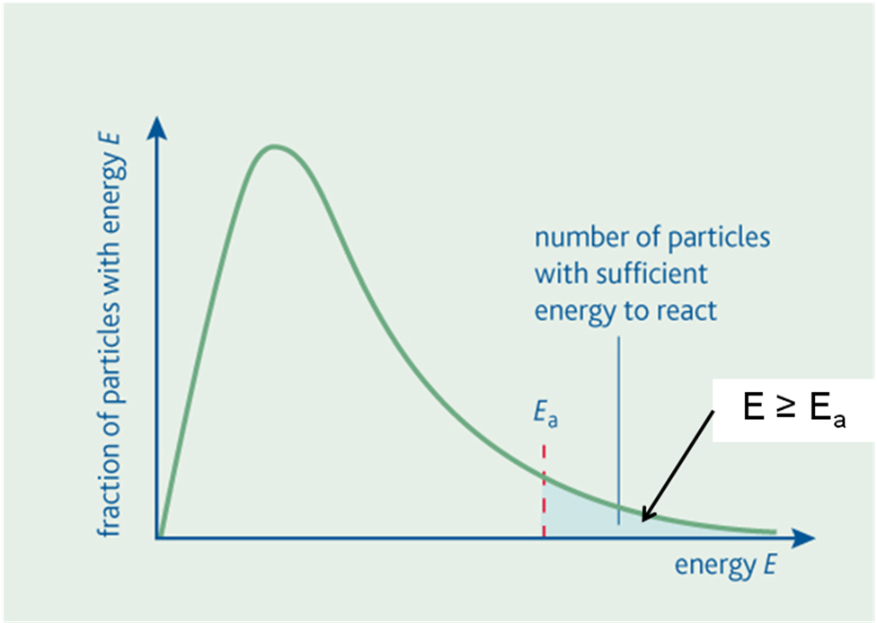

This explains why **most exothermic reactions do not occur spontaneously at room temperature**. So **fuels can be stored safely**, but it only takes a spark to provide enough activation energy to start the reaction, then the **heat from the initial reaction** is enough to **supply the activation energy** for further reactions.

***Demo: Match***

**Factors that affect the rate of reactions**

* **Temperature** – increases speed of particles, giving more kinetic energy and *more successful collisions* in a*given period of time*
* **Surface** **area** – more particles are available to collide resulting in *more successful collisions* in a *given period of time*
* **Concentration** – more particles present in a given volume, resulting in *more successful collisions* in a *given period of time*
* **Pressure** – applies to gases only, more particles present in a given volume, resulting in *more successful collisions* in a *given period of time*
* **Catalyst** – a substance that changes the rate without being chemically changed by providing an *alternative route* for the reaction with a *lower activation energy*.

***Show animation – changing conditions: http://www.kscience.co.uk/animations/collision.htm***

Effect of temperature

**Temperature** is the **only factor** that **changes** the shape of **Maxwell-Boltzmann curve**. Increasing the temperature will give the molecules **more kinetic energy** so they will move faster. The **total number of molecules** is still the **same** so the **area** under the two curves is the **same**.

|  |  |
| --- | --- |
|  | ***Task: Changing the temperature***  ..\Maxwell Boltzmann model.xls |

An **increase** in **temperature** will **increase** the **rate** of a reaction because the **mean kinetic energy** is **proportional to temperature**. At **higher temperatures** **particles** will **move more** quickly because they have **more kinetic energy** and so will be involved in **more successful collisions in a given period of time**. Only particles with **energy equal to** or **above** the **activation energy** will react. At higher temperatures **more molecules** will have **energy** **that is equal to or greater than the activation energy**.

|  |  |
| --- | --- |
|  | Although the shape of the **Maxwell-Boltzmann curve changes with temperature**. The **activation** **energy remains at the same amount**; it’s just the number of particles with energy above this value that changes.  The **shaded area** on the right represents the **particles** which have **energy greater than** the **activation energy** at each temperature. |

It’s clear to see that at **higher temperatures** there are **many** **more particles** with **energy greater** **than the activation energy**, so a **higher percentage of successful collisions** will occur in a **given period of time** resulting in a **faster reaction**.

At **higher temperatures** the **peak** of the curve is **lower**, and moves to the **right**, so the **number of particles** with **very high energy increases**. The **total area** under the curve **remains the same**, as it represents the total number of particles and these don’t changed with temperature.

This graph shows that change in the rate of a reaction as the temperature is increased.

|  |  |
| --- | --- |
|  | **Small increases in temperature** result in **large increases in the rate** of a reaction, in fact every 10oC rise will double the rate of reaction as the number of particles with E ≥ Ea is much higher.  There is an **exponential increase**.  ***Application****: Food ‘goes off’ if it’s left at room temperature storing it at lower temperatures slows down the chemical reactions that cause it to go off.* |

|  |  |
| --- | --- |
| **Low temperatures** | **Higher temperatures** |
| * Peak higher * Moves to left * No. of particles with high E decreases * Less particles have E ≥ Ea * So rate decreases due to **decrease** in **successful collisions in a given period of time** | * Peak lower * Moves to right * No. of particles with high E increases * More particles have E ≥ Ea * So rate increases due to **increase** in **successful collisions in a given period of time** |
| Remember:  Temperature d**e**creases moves to l**e**ft | Remember:  Temperature **i**ncreases moves to r**i**ght |
| **Total area under the curve is same as it represents total number of particles** | |

***Starter: 7.2.1 – Sketching Maxwell-Boltzmann***

***Starter: 7.2.2 – The importance of Maxwell-Boltzmann***

***CGP116 PQ1***

Effect of concentration

Increasing the concentration **increases** the number of particles in a **given volume**, the particles are **closer together** so will **collide more frequently** resulting in an **increase** in the number of **productive collisions in a given period of time**.

Particle diagrams show this:

|  |  |
| --- | --- |
| Low concentration | High concentration |
|  |  |

The Maxwell-Boltzmann curve changes too to show a **greater number of particles** which **increases** the number of **particles** with **energy equal to or greater** than the **activation** **energy**. Provided the **temperature** is the **same** the particles **will have the same amount of energy,** it’s just the number that increases.

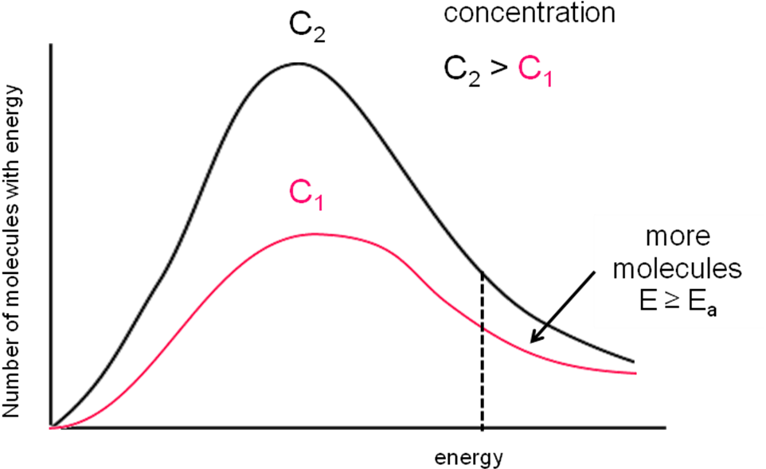

***Fact recall: CGP116 Q1-4***

Effect of pressure

Pressure in gases is caused by the gas molecules colliding with the sides of the container. Increasing the pressure **increases** the number of molecules in a **given volume**. This has the same effect as increasing the concentration; the particles are **closer together** so will **collide more frequently** resulting in an **increase** in the number of **productive collisions in a given period of time**.

Particle diagrams show this:

|  |  |
| --- | --- |
| Low pressure | High pressure |
|  |  |

The Maxwell-Boltzmann curve changes too to show a **greater number of molecules** which **increases** the number of **particles** with **energy equal to or greater** than the **activation** **energy**. Provided the **temperature** is the **same** the molecules **will have the same amount of energy,** it’s just the number that increases.

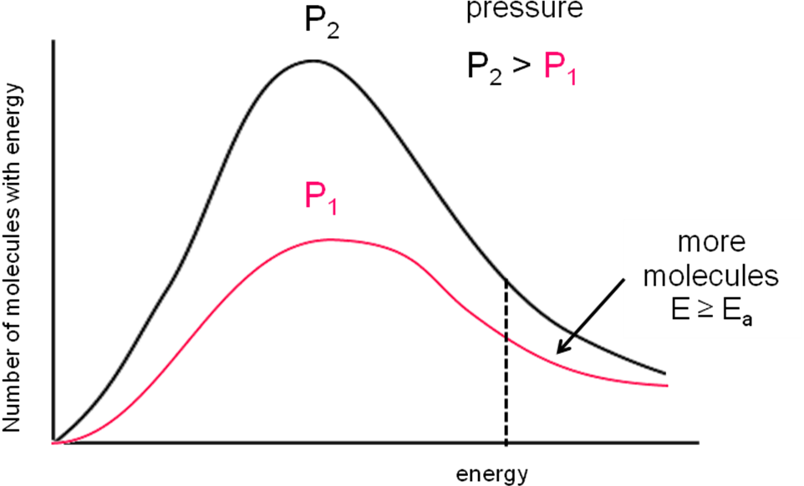

Effect of surface area

When one **reagent is solid** the **rate** of the reaction with a gas or solution can be **increased** by breaking the **solid into smaller pieces**. This **increases the surface area** and allows **more successful collisions in a given period of time**.

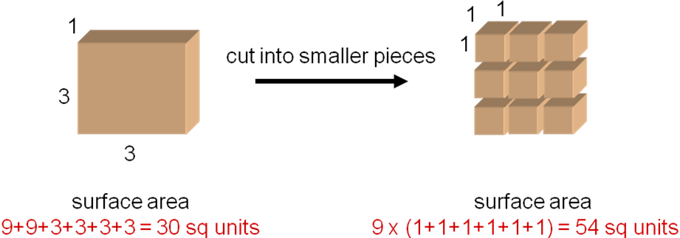

***Demo: Plasticine block***

***Demo: Rates and rhubarb (if time)***

When **ionic solids** are **dissolved** in water, the **ions** are **completely** **separated** and so the **rate** of reaction is **increased** even further, the reaction may become **almost instantaneous**. **Precipitates form** as soon as the solutions are mixed, since the **free ions** can **easily collides** and react.

***Demo: Reaction – Pb(NO3)2 + KI →*** ***PbI2 + KNO3 (solids & solutions)***

|  |  |
| --- | --- |
| Solids – slower – smaller surface area | Solutions – instant – larger surface area |
|  |  |

**Catalysts**

*Definition*: A **catalyst** affects the rate of a reaction without being chemically changed itself.

They are usually used to **speed up reaction** and so are important in industry as using a catalyst can be more **cost effective** than increasing the concentration, temperature or pressure even if the catalyst is expensive, because it isn’t used up. These are called **positive catalysts**. Some catalysts **slow down** reactions; these are called **negative catalysts** or **inhibitors**.

Classifications of catalysts:

* **Heterogeneous** - catalyst is in a **different phase** to the reactants (usually solid catalyst and liquid or gas reactants)
* **Homogeneous** - catalyst is in **same phase** asthe reactants (usually solutions).

Different catalysts work in different ways and tend to be **specific** to a particular reaction.

***Demo: Hydrogen peroxide (with washing up liquid & manganese dioxide)***

**Examples of heterogeneous catalysts:**

**Links:**

**3.1.6 – Equilibria**

**Making ammonia**

**3.3.2 – Alkanes**

**Catalytic convertors**

* Platinum & rhodium in catalytic convertors in cars
* Iron in the Haber process
* Aluminium oxide & silicon dioxide zeolites in cracking of hydrocarbons
* Nickel in hardening fats with hydrogen.

**Examples of homogeneous catalysts:**

* Hydrogen ions in the formation of esters.

How catalysts work

An **enthalpy level diagram** shows the effect a catalyst has on a reaction.

|  |  |
| --- | --- |
|  | The **activation energy is lowered** if a catalyst is used.  Different catalysts will give rise to a different value for the activation energy.  A catalyst has **no effect on the enthalpy** of **reaction**, as according to Hess’s law the enthalpy of a reaction is **independent of the route** it’s only dependent on the initial and final states of the reaction. |

***Demo: Catalyst reaction – potassium sodium tartrate and hydrogen peroxide***

**Catalysts increase** the **rate** of a reactionbecause they **provide an alternative route** with **lower activation energy.** By **reducing the activation energy** of a reaction there will be **more particles with energy equal to or greater than the activation energy** so the rate will be faster.

A catalyst increases the rate of a reaction by providing an **alternative route** with a **lower activation energy**.

This is shown clearly in the Maxwell-Boltzmann distribution. There is a **lower Ea with a catalyst (Ecat)** so many more reactants with E ≥ Ea.

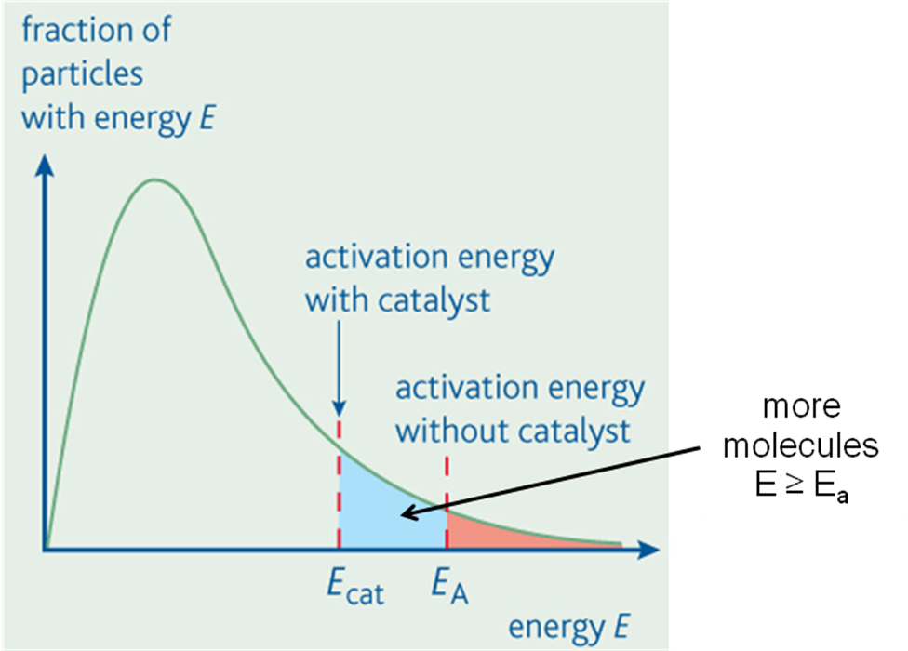

**Analogy – getting to the other side of a mountain:**

|  |  |
| --- | --- |
|  | * Climb over the mountain – without a catalyst * Tunnel through mountain – with a catalyst |

***CGP118 PQ1***

***Fact recall: CGP118 Q1-2***

**Measuring reaction rates**

***Definition***: **Rate of reaction** is the change in concentration of a substance in unit time.

The **units** are **mol dm-3 s-1**.

**Rate of reaction = amount reactant used or product formed**

**time**

To **measure** the rate of a reaction its progress must be followed by either measuring the **decrease of the reactants** or the **increase of the products**. Different factors can be changed and their effect on the rate measured.

|  |  |
| --- | --- |
|  |  |

These are some of the techniques used, they can be either a **continuous** method or they just measure the **initial rate** of a reaction.

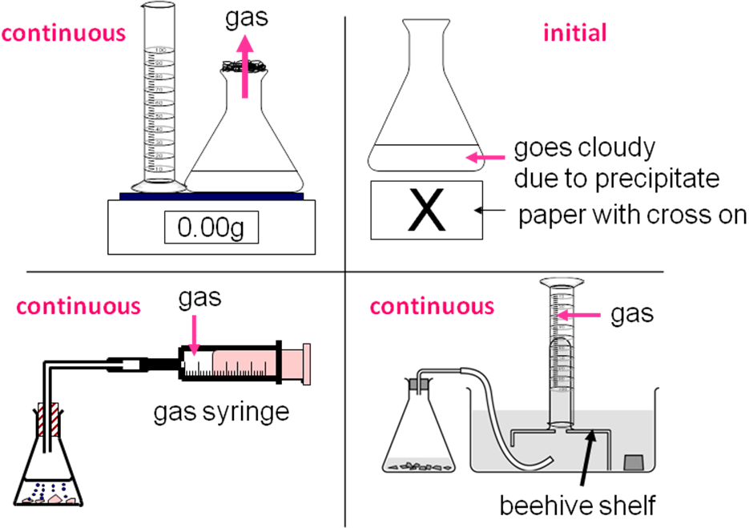

When a graph is plotted of the **concentration of a reactant or product against time**, the **rate** of the reaction at a **particular time** is given by the **gradient** of the graph at that time.

|  |  |
| --- | --- |
|  | Drawing tangents and working out the difference in the concentration and time at different points on the curve the **rate at any particular point in time** can be determined.  The slope of the **gradient gets less** as the **reaction slows** down with time. |

As the **reaction proceeds** the concentration of reactants decreases so the **rate decreases**. The **rate** is therefore at its **greatest** at the **start** of a reaction, as shown by the **steepest gradient** when there is a **high concentration of reactants**. The **rate** falls to **zero** at **the end** of the reaction.

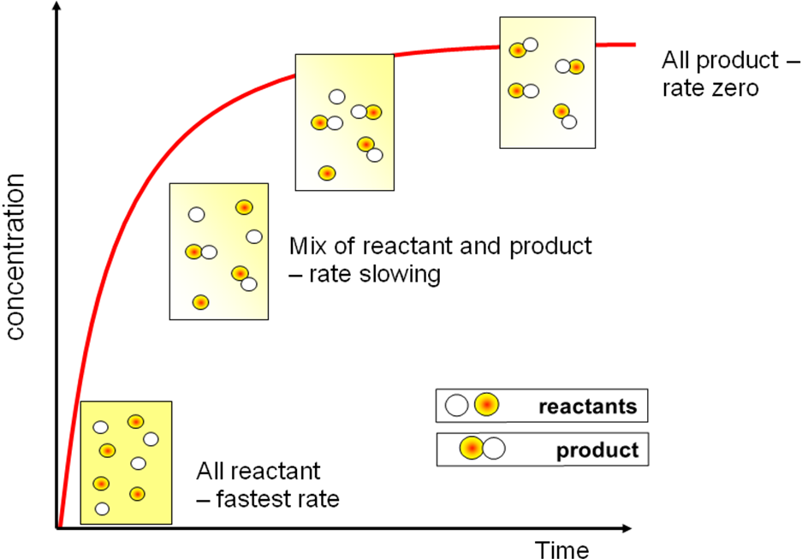

Changing factors and rates graphs

|  |  |
| --- | --- |
| **Temperature**  Increasing or decreasing the temperature **only affects the rate**; the amount of product is not affected. |  |

|  |  |
| --- | --- |
| **Concentration or mass**  Increasing or decreasing the concentration of a reactant **will affect the rate**, and will result in a **lower or greater amount of product**.  Changing the mass of a reactant will also affect the amount of product. |  |

|  |  |
| --- | --- |
| **Surface area**  Changing the surface area **affects the rate** but the **amount of product** made will **always** be the **same** provided the same quantities of reactants were used each time. |  |

***Starter: 7.1 – Collision theory***

***Sheet: Relative reaction rates***

***CGP121 PQ1***

***Fact recall: CGP121 Q1-2***

***Required practical 3:*** Investigation of how the rate of a reaction changes with temperature (Initial rate - identify variables to be controlled).

Na2S2O3(aq) + 2HCl(aq) → 2NaCl(aq) + S(s) + SO2(g) + H2O(l)

***Practical***: Investigation of how the rate of a reaction changes with concentration (continuous method - identify variables to be controlled)

CaCO3(s) + HCl(aq) → CaCl2(aq) + H2O(l) + CO2(g)

***Power point: AS Kinetics exam questions*** ***..\AS Kinetics exam questions.ppt***

***Sheet: Kinetics questions***

***Sheet: Kinetics PPQ1-3***

***Homework: Oxford p104-105 EPQ1-4***