**3.3.3 Halogenoalkanes**

**AS Link:**

**3.3.1 - Introduction to organic chemistry**

**3.1.3 - Bonding**

**3.3.1 - Introduction to organic chemistry**

**3.3.2 - Alkanes**

There aren’t many naturally occurring halogenoalkanes, but **many are synthesised** to give products such as PVC (window frames / drain pipes), Teflon (clothing / non-stick pans), anaesthetics, refrigerants, aerosol propellants and solvents.

**Halogenoalkanes** have a **hydrocarbon** skeleton with **one or more halogen** (fluorine, chlorine, bromine or iodine) in place of a hydrogen atom.

***Show: Model***

**Properties:**

* Bond polarity – the C⎯X bond is **polar** so should be written **Cδ+⎯Xδ-** because halogens are more electronegative than carbon. The **electronegativities** of the halogens get **less down the group**, so the **bonds become less polar**.   
  ***C-F > C-Cl > C-Br > C-I***
* Bond enthalpy – the C⎯X bond enthalpy **reduces down the group**, i.e. the **bonds get weaker** because going down the group the **halogen atoms get larger** so the shared **electrons** in the C⎯X are **further** from the **halogen nucleus**.   
  ***C-F > C-Cl > C-Br > C-I***
* Solubility – **insoluble in water**, the **Cδ+⎯Xδ-** is not polar enough to make it soluble in water; the main intermolecular forces are dipole-dipole and van der Waals’ so they will mix with hydrocarbons.
* Boiling point – this **increases** with **increasing chain** length **and** as we go **down** the halogen **group**. This due to increased van der Waals’ forces due to a greater number of electrons in the molecule. Boiling point is higher than a similar straight-chain hydrocarbon, this is due to an **increased molecular mass** and because they are **more polar**.

***C-F < C-Cl < C-Br < C-I***

**General formula** CnH2n+1**X** **X** = F, Cl, Br, I

Shortened to R-**X**

Depending on the environment of the halogen they are classified as:

|  |  |  |
| --- | --- | --- |
| **Primary** | **Secondary** | **Tertiary** |
| 1o | 2o | 3o |
| -RCH2X | -R2CHX | -R3CX |
|  |  |  |
| 1 alkyl | 2 alkyl | 3 alkyl |

***Task: Name the following & identify the type***

|  |  |  |
| --- | --- | --- |
|  | 1-chlorobutane | **Remember**:  If more than one halogen is present, list alphabetically  1o |
|  | 2-chlorobutane | 2o |
|  | 2-chloro-2-methylpropane  2-chloromethylpropane | 3o |
|  | 1-chloro-2-methylpropane  1-chloromethylpropane | 1o |

**Nucleophilic substitution**

Nucleophiles

Nucleophiles are reagents that **attack** and **form bonds** with **positively charged or partially positive carbon** atoms.

***Definition***:

**Nucleophile** is an **electron pair donor** that forms covalent or co-ordinate bond

A nucleophile is either:

* a **negatively charged ions** with a **lone pair of electrons**
* molecule with a **lone pair of electrons** (situated on an electronegative atom) which can be used to form a covalent bond

To summarise, **nucleophiles** are species with a **lone pair** of electrons which can be used to **form a bond** by **donating** its **electrons** to an **electron deficient atom**.

***Starter: 5.1.6 – Electrophiles & nucleophiles***

Some **common nucleophiles** are:

|  |  |  |
| --- | --- | --- |
| Hydroxide ion | Cyanide ion | Ammonia |
| **:**OH¯ | **:**C≡N¯ | **:**NH3 |
|  |  |  |
| negative charge | negative charge | neutral |

They will each **replace the halogen** in a halogenoalkanes by nucleophilic substitution.

Halogen atoms are **more electronegative than carbon** so this results in a **polar bond**, which is **susceptible to attack by nucleophiles**. When a **nucleophile attacks** the **carbon-halogen** bond **breaks** and a **halide** ion is **released**. The **nucleophile replaces** the **halogen** in a **substitution** reaction, so it’s called a **nucleophilic substitution** reaction.

***Fact recall: CGP203 Q1-5***

Nucleophilic substitution reactions

Nucleophilic substitution reactions are **useful** because they **introduce** a ne**w functio**nal **group** into an organic compound.

**General equation** - using :Nu- to represent the nucleophile and X the halogen:

RCH2⎯X + :Nu- → RCH2⎯Nu + :X-

**Mechanism**:

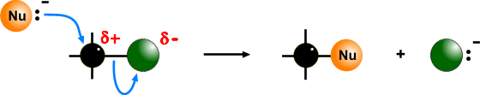

The **lone pair of electrons** is **attracted** **towards** the partially charged **carbon atom**. The curly arrow starts at the lone pair and goes towards the **Cδ+**. The **electron pair** in the **C-X** bond then **moves** to the **halogen** atom, **making a halide ion**. This is the **leaving group**.

Halogenoalkanes are **insoluble** in **water** so both reactants are **dissolved in ethanol**.

You can **learn the basic pattern of the mechanism** then **apply different nucleophiles**. Each uses **different conditions** and gives a **different product**.

# Hydroxide ions negatively charged

# **Nucleophile**: **:**OH-

# **Reactant**: halogenoalkane + aqueous NaOH (or KOH)

# **Conditions**: warm aqueous

**Product**: alcohol e.g. ethanol

**Equation**: R-CH2X + OH- → R-CH2OH + X-

**Example**: C2H5Br + OH- → C2H5OH + Br-

# **Mechanism**:

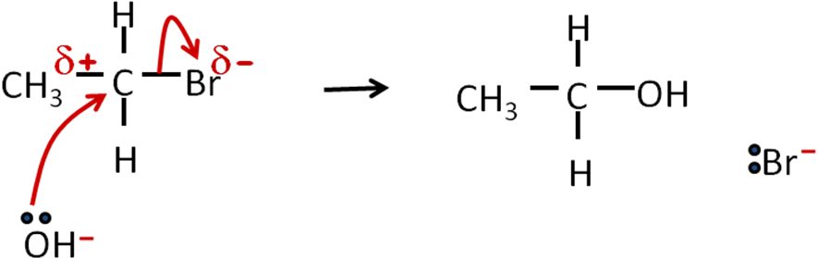

bromoethane ethanol

***Task: Nucleophilic substitution summary – hydroxide ions***

# Cyanide ions negatively charged

# **Nucleophile**: **:**CN-

Nucleophilic substitution with **cyanide** ions **adds** an extra **carbon** to the chain, which can be **advantageous**.

# **Reactant**: halogenoalkane + KCN

# **Conditions**: warm aqueous/alcoholic

**Product**: nitrile e.g. propanenitrile

Compounds of the homologous series **RCN** with functional group **–CΞN** are called **nitriles**

N.B. Extra carbon from CN- is counted in chain for nitrile

**Equation**: R-CH2X + CN- → R-CH2CN + X-

**Example**: C2H5Br + CN- → C2H5CN + Br-

# **Mechanism**:

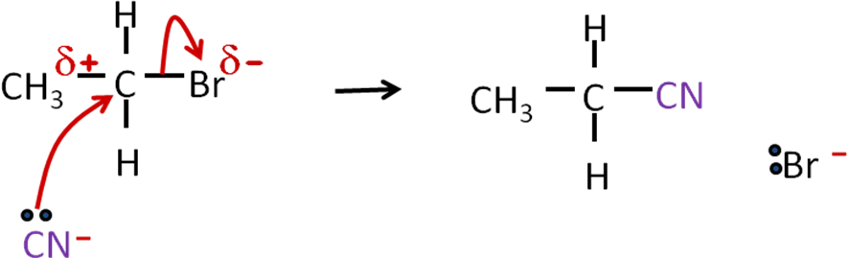

bromoethane propanenitrile

***Task: Nucleophilic substitution summary – cyanide ions***

# Ammonia neutral molecule

# *(needs 2 moles NH3 to remove hydrogen from ammonia once its attached to the halogenoalkane, leaving an amine group –NH2)*

# It produces an **amine** which has a **lone pair of electrons** on the **nitrogen**, so it is also a **nucleophile** which can take part in **nucleophilic substitution** reactions.

# **Nucleophile**: **:**NH3

# **Reactant**: halogenoalkane + ammonia

# **Conditions**: warm **excess** ammonia under pressure

Primary amines contain the **NH2** functional group

# **Product**: primary amine e.g. ethylamine

**Equation**: R-CH2X + **2**NH3 → R-CH2NH2 + NH4X

**Example**: C2H5Br + **2**NH3 → C2H5NH2 + NH4Br

# **Mechanism**:

N.B.

**2 stages so 2 mole NH3**

1st NH3 acts as a nucleophile

positive ion intermediate

2nd NH3 acts as a base accepting a proton

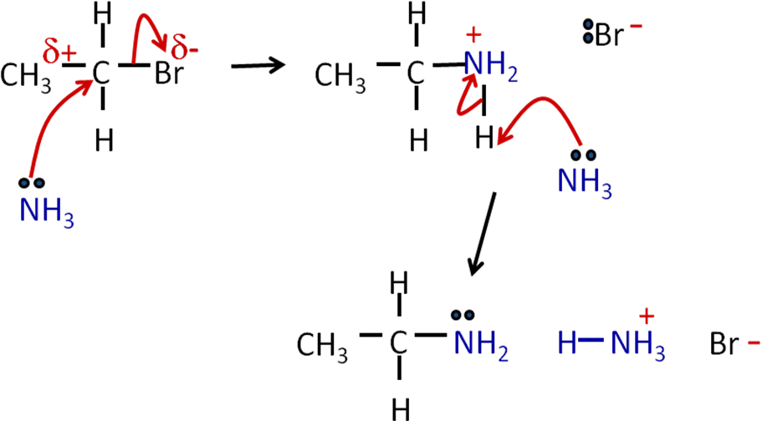

bromoethane ethylamine ammonium bromide

***Task: Nucleophilic substitution summary – ammonia***

Using **excess ammonia minimises further substitution reactions** of primary amine to secondary amines, tertiary amines or quaternary ammonium salts.

# Classification of amines

# Don’t get these muddled up with the classification of halogenoalkanes. **Amines** are **classified** by **how many** **hydrogen atoms** are **bonded** to the **nitrogen** atom (not the number of carbon atoms joined to the carbon adjoining the nitrogen)

|  |  |  |  |
| --- | --- | --- | --- |
| **Primary** | **Secondary** | **Tertiary** | **Quaternary** |
| 1o | 2o | 3o | 4o |
| -CNH2 | -CNRH | -CNRR | -CN+RRR |
|  |  |  |  |
| 2 hydrogens | 1 hydrogen | No hydrogen | Positive ion |

# ***Task: Complete the following equations & mechanisms, give the conditions & naming the product***

# **Iodomethane + sodium hydroxide**

Equation: CH3I + OH- →CH3OH + I- methanol

Conditions: Warm aqueous NaOH

Mechanism:

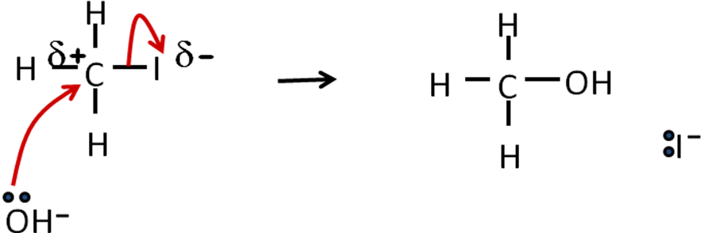

# **Bromomethane + potassium cyanide**

Equation: CH3Br + CN- →CH3CN + Br- ethanenitrile

Conditions: Warm aqueous/alcoholic KCN

# Mechanism:

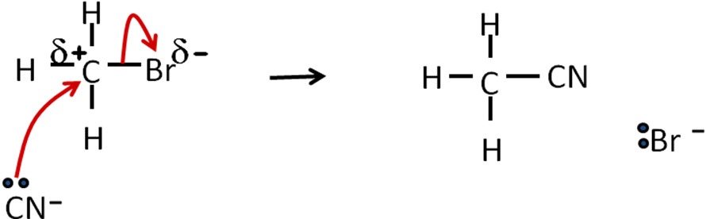

# **Chloromethane + ammonia**

Equation: CH3Cl + **2**NH3 →CH3NH2 + NH4Cl methylamine

Conditions: Warm excess NH3 slight pressure/sealed container

# Mechanism:

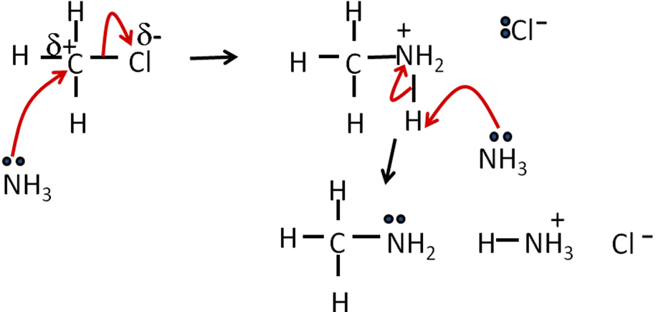

***Starter: 5.3.1 Substitution reactions***

***Task: Nucleophilic substitution – unanimated***

***Application: CGP208 PQ1-4***

***Fact recall: CGP208 Q1-5***

Reactivity of halogenoalkanes

The **strength** of the **carbon-halogen bond** **determines** the **reactivity** of the molecule, as the **C-X bond needs to break**. The **rate** of the substitution is **dependent** on the **strength** of the **carbon-halogen bond**. Although C-F is a very polar bond it is very unreactive because it’s so strong.

# **Rate** depends on:

# **Strength** of bond: **R-F > R-Cl > R-Br > R-I**

# Gives order of reaction rate: **R-I > R-Br > R-Cl > R-F**

# **Type** of Halogenoalkanes

# Gives order of reaction rate: **3o >2o >1o**

The **rate** of the reaction with different halogenoalkanes can be **determined** by adding **silver nitrate** and **timing** the **production** of the **silver halide precipitate**.

**AS Link:**

**3.2.3 – Group 7 (Test for halides)**

|  |  |  |  |
| --- | --- | --- | --- |
| **Silver fluoride** | **Silver chloride** | **Silver bromide** | **Silver iodide** |
| No precipitate |  |  |  |

# ***Prac: Nucleophilic substitution***

# ***Compare the rates of hydrolysis of primary, secondary and tertiary chloroalkanes***

# **Elimination reactions**

Halogenoalkanes **typically** react by **nucleophilic substitution** (conditions: warm weak **aqueous** KOH), but under **different conditions** (hot stronger KOH in **ethanol**) they can undergo a different reaction with the **elimination** of the **halide** to **produce** an **alkene** and a hydrogen halide.

In **nucleophilic substitution** the **hydroxide** **ion** was acting as **nucleophile** but under different conditions the **hydroxide can also act as base** (proton, H+ acceptor).

**General equation**:

This is a useful way to produce **alkenes**

RCH2CH2⎯X + :OH- → RCH=CH2 + H2O + :X-

base

**Mechanism**:

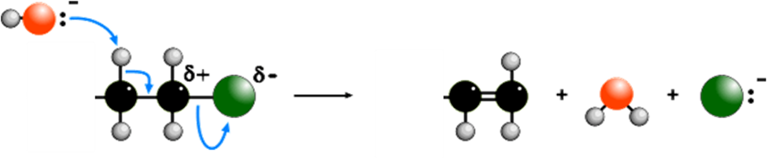

The **base attacks** the **hydrogen** on the **carbon atom adjacent** to the **carbon attached** to the **halogen**.

**Summary:**

* **OH-** uses a lone pair to form **bond with a hydrogen** (slightly δ+) bonded to carbon next to C-X
* Electron pair from C-H bond becomes part of a C-C to **form a double bond**
* Halogen takes a pair of electrons from C-X bond (**heterolytic fission** - unequal splitting) i.e. both electrons go to halogen so it becomes a **halide** **ion.**

Elimination reaction

# **Base**: OH-

**AS Link:**

**3.3.5 – Alcohols   
(elimination to make alkenes)**

# **Reactant**: halogenoalkane

# **Conditions**: hot ethanol (no water present)

# **Product**: alkene e.g. ethene

**Example**: 2-bromopropane + potassium hydroxide → propene + potassium bromide + water

CH3CHBrCH3 + OH- → CH3CH=CH2 + Br- + H2O

**Mechanism**:

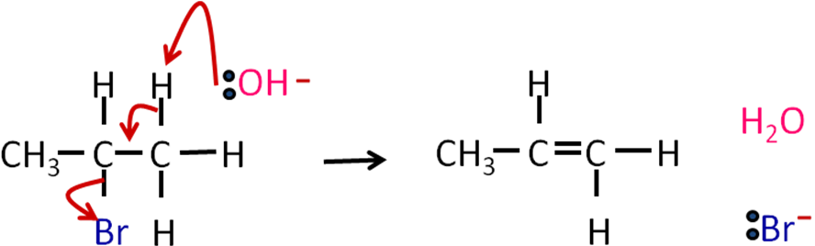

# ***Task: Complete the following equations & mechanisms, give the conditions & naming the product***

bromoethane + potassium hydroxide → ethene + potassium bromide + water

C2H5Br + KOH → C2H4 + KBr- + H2O

# Conditions: hot ethanol (no water present)

Mechanism:

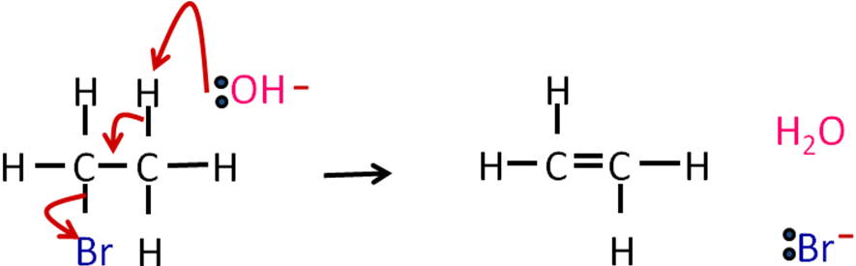

***Sheet: Dodgy mechanisms – halogenoalkanes***

***Task: Elimination – unanimated***

Isomers

In some cases, where there is an **asymmetrical** halogenoalkane a **mixture of isomeric alkenes** can be produced, this depends on the halogenoalkanes uses as the starting reagent.

|  |  |  |  |
| --- | --- | --- | --- |
|  | | | |
|  |  | |  |
|  |  | |  |
|  | | | |
| position iosmers  structural isomers | | E/Z iosmers  stereoisomers | |

**Substitution or elimination?**

Both these reactions can occur at the same time (concurrently), they are **competing** reactions. Which reaction occurs **depends on the type of halogenoalkane and conditions used**, so changing these can favour one reaction over the other.

**Primary** halogenoalkanes tend to react by **substitution**; whereas **tertiary** ones tend to prefer **elimination**. **Secondary** Halogenoalkanes react equally by **both** mechanisms.

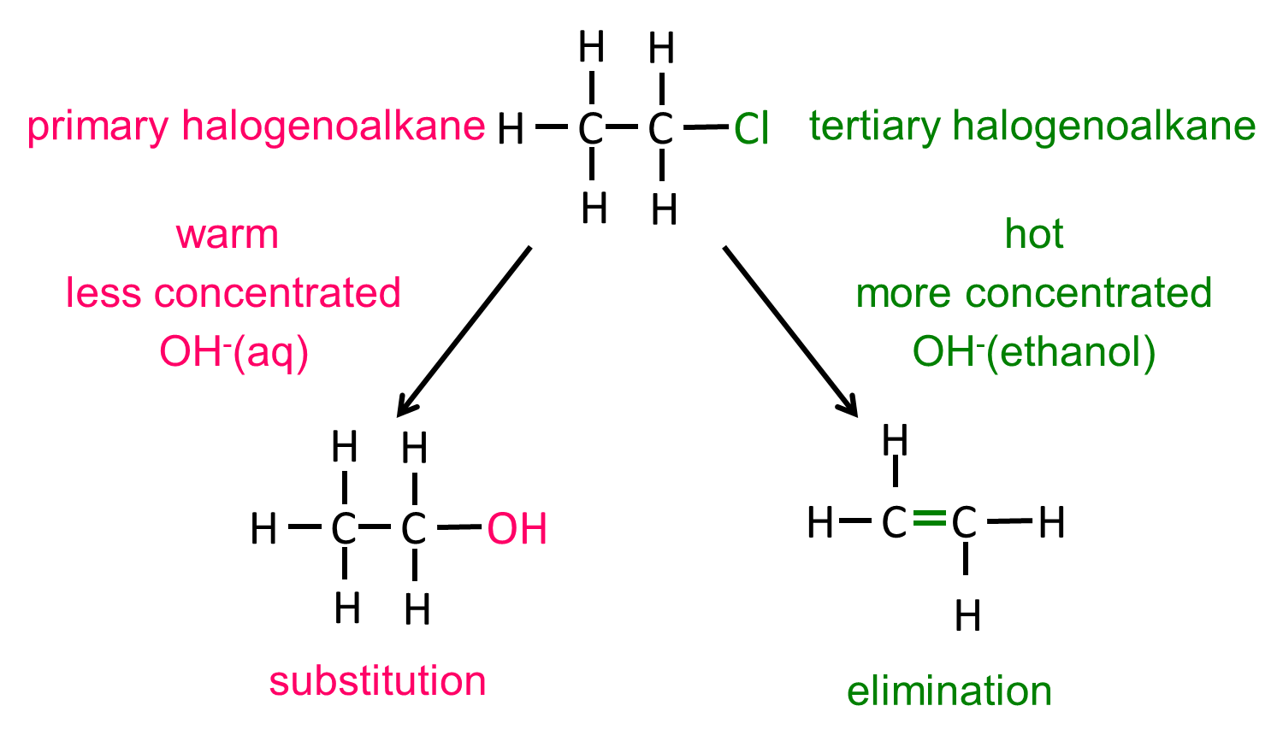

|  |  |
| --- | --- |
| **Substitution** | **Elimination** |
| Primary Halogenoalkanes (RCH2X) | Tertiary Halogenoalkanes (R3X) |
| Secondary Halogenoalkanes (R2CHX) | Secondary Halogenoalkanes (R2CHX) |
| Less concentrated base  Aqueous conditions  OH- (aq) | More concentrated base  Alcoholic conditions  OH- (ethanol) |
| Lower temperature | Higher temperature (under reflux) |
| **alcohol** | **alkene** |

***Starter: 5.3.2 Halogenoalkanes – substitution v elimination***

***Application: CGP210 PQ1***

***Fact recall: CGP210 Q1-3***

**The ozone layer**

|  |  |
| --- | --- |
|  | **Ozone** or trioxygen, **O3**, is an **allotrope** of **oxygen** and is formed naturally in the upper atmosphere and provides a **protective layer** of gas that **prevents harmful ultra-violet** radiation **reaching earth**. It **absorbs** **UV radiation** which causes the **ozone** molecules to be **decomposed**. |
| You don’t need to know the structure of ozone |

**Formation**:

|  |  |
| --- | --- |
|  |  |

**UV radiation** from the sun **breaks down oxygen molecules** into two oxygen atoms (radicals). These oxygen **radicals** then **react** with **more oxygen** to make **ozone**.

**Decomposition**:

|  |  |
| --- | --- |
|  |  |

**UV** **radiation** can also **decompose** **ozone** into an **oxygen molecule** and an **oxygen radical**, which can react with more ozone to **produce oxygen**.

So presence of ozone in atmosphere is maintained.

Problem with using halogenoalkanes

**Toxicity**

Many chloroalkanes were commonly used but they have since been discovered to be **toxic** and so are **not allowed to be used**.

Examples are:

* 1,1,1-trichloroethane (CH3CCl3) - dry-cleaning solvent & thinner for correction fluid
* Tetrachloromethane (CCl4) - dry-cleaning

**Effect of CFC’s on the ozone layer**

A specific group of halogenoalkanes called **chlorofluorocarbons** (**CFCs**) were first introduced in the 1930s by an American, Thomas Midgely. He famously demonstrated their non-toxicity and non-flammability by inhaling a lungful then exhaling it to extinguish a flame. This **inertness** and the fact that they are **volatile** made them ideal as **solvents**, **refrigerants coolant** gases and **aerosol propellants**.

|  |  |
| --- | --- |
| However, they have since become **controversial**. They easily **escape into the atmosphere** where they **remain** because they are relatively unreactive. Research by different groups has provided evidence to show they can be **toxic** and **affect the atmosphere**. Legislation now exists that **bans the use** of CFCs. |  |

|  |  |
| --- | --- |
| Under normal circumstances **CFCs** are **very** **unreactive** because the **C-Cl** and **C-F** bonds are **strong**. However, in the 1970s it was discovered that the **ozone layer was thinner** over **Antarctica**, this lead to research and it was discovered that the **CFCs** were causing the **deletion** of the **ozone**. |  |
|  |  |
| This led to politician meeting in Canada and the **Montreal protocol** being drawn up which **bans the use of CFCs** globally; it came into force on 1st January 1989. However, some **CFCs** still **remain** in the **atmosphere**, but it is **repairing itself**. | |

Depletion of the ozone layer

When **ultraviolet** (**UV**) radiation in the upper atmosphere **hits CFCs** it causes the **C–Cl bonds to break** homolytically (uneven split) with the **formation** of **chlorine atoms**.

CCl3F → Cl• + •CCl2F

The **C-F bond is stronger** and **does not break**.

These **chlorine free-radicals** then **catalyse** the **decomposition** of **ozone**. So even small amounts deplete the ozone.

Cl• + O3 → ClO• + O2

ClO• + O3 → Cl•+2O2

**Chlorine radicals are removed** in the first reaction and **then re-formed**, so overall they are **not used up** but **act as a catalyst** for the decomposition of ozone.

For every 1 mole CFCs  
2 moles O3 are decomposed

Adding the 2 equations together gives: 2O3 → 3O2

CFC substitutes

Chemists have now developed alternative **chlorine-free** compounds **substitutes**.

Initially hydrochlorofluorocarbons (**HCFCs**) were developed, although these still contain chlorine atoms they are less stable and **decompose more easily** in the lower atmosphere due to C-H bonds.

The second generation of compounds were hydrofluorocarbons (**HFCs**), which do not have a C-Cl bond and the **C-F bond** is **stronger** so **isn’t broken by UV** radiation and don’t form free-radicals that cause damage to the ozone layer. They aren’t completely free of environmental problems as they are a green house gas. So a fourth generation of compounds is being developed such as using ammonia gas in refrigerants.

***Starter: 5.2.7 – Ozone layer***

***Sheet: Halogenoalkanes PPQ 1-4***

***Exam questions: Oxford p214-215 Q1-3***