Year 1 Sociology

**Paper 1: Education with Theory and Methods**



Education

Booklet 1: The Role and Function of the Education System and its relationship to the economy and to class structure

Name:\_\_\_\_\_\_\_\_\_\_\_\_\_\_\_\_\_\_\_\_\_\_\_\_\_\_\_\_\_Class:\_\_\_\_\_\_\_\_

Specification Content:

**What you need to know for Education in your Paper 1 exam:**

You will be expected to:

* The role and functions of the education system, including its relationship to the economy and to class structure
* Differential educational achievement of social groups by social class, gender and ethnicity in contemporary society
* Relationships and processes within schools, with particular reference to teacher/pupil relationships, pupil identities and subcultures, the hidden curriculum, and the organisation of teaching and learning
* The significance of educational policies, including policies of selection, marketisation and privatisation, and policies to achieve greater equality of opportunity or outcome, for an understanding of the structure, role, impact and experience of and access to education; the impact of globalisation on educational policy.

|  |  |  |  |  |
| --- | --- | --- | --- | --- |
| **Questions may be based specifically on the following areas:** | Do I have completed Notes? | Have I made revision Notes? | Have I memorised this info? | Have I practised exam style questions? |
| Functionalist explanations of the role and functions of the education system: Durkheim; Parsons; Davis and Moore |  |  |  |  |
| Evaluation of the functionalist view of education |  |  |  |  |
| New Right explanations of the role and functions of the education system: Chubb and Moe |  |  |  |  |
| Evaluation of the New Right view of education |  |  |  |  |
| Marxist explanations of the role and functions of the education system e.g. in relation to ideological state apparatuses, reproduction of social class inequality, legitimation of social class inequality: Althusser; Bowles and Gintis; Willis |  |  |  |  |
| Evaluation of the Marxist view of education |  |  |  |  |

Exam Structure:

**This topic will appear on Paper 1 at A Level**

The A-level Paper 1 will be 2 hours long, contain 80 marks and be worth a third of your A Level. You will be assessed via short answer and extended writing questions in the following areas:

* [](http://www.google.co.uk/url?sa=i&rct=j&q=&esrc=s&source=images&cd=&cad=rja&uact=8&ved=0ahUKEwiH17rsm6rNAhUMBcAKHYIYCW0QjRwIBw&url=http://firearmsafetycanada.com/?page_id=12&psig=AFQjCNEdDWy4gaTupewTvc6I4kTb1sWMrQ&ust=1466086461052204)**Education**: short answer and extended writing worth 50 marks
* **Methods In Context**: extended writing worth 20 marks
* **Theory and Methods**: extended writing worth 10 marks

**Functionalist Perspective of Education**

C:\Users\seedac\AppData\Local\Microsoft\Windows\Temporary Internet Files\Content.IE5\KAL53214\MC900055098[1].wmf

**TASK: What can you remember about Functionalism? Try to summarise this theory using the words below.**

C:\Users\seedac\AppData\Local\Microsoft\Windows\Temporary Internet Files\Content.IE5\KAL53214\MC900383552[1].wmf

consensus interdependent functions everyone agreement structuralist

Functionalists see education as an important agency of socialization, helping to main social stability through a development of value consensus, social harmony and social cohesion.

*What does this value consensus mean? How do you think education teaches this?*

…………………………………………………………………………………………………………………………………………………………………………………………………………………………………………………………………………………………………………………………………………………………………………………………………………………………………………………………………………………………………………………………………………………………………………………………………………………………………………………………………………………………………………………………………………………..

Education is seen as playing a key role in preparing young people for adulthood, citizenship and working life, providing them with the means for improving their lives and life chances through upward social mobility, and preparing them for a rapidly changing society.

The key theorists in this area that you need to know about are:

* **Durkheim**
* **Parsons**
* **Davis and Moore**

[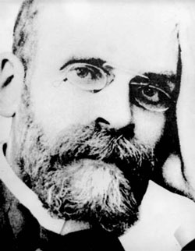](http://www.google.co.uk/url?sa=i&rct=j&q=emile%20durkheim&source=images&cd=&cad=rja&docid=hi7CbrpLpXdafM&tbnid=eF19gkBZCaNNJM:&ved=0CAUQjRw&url=http://dpintrosociology.wordpress.com/readings/&ei=dMnnUezWMqfX0QWmr4CQCA&bvm=bv.49478099,d.ZG4&psig=AFQjCNGIJoolwacwl07iCdFf2Mv9inYcQQ&ust=1374231271224136)

1. Emile Durkheim

The French sociologist Emile Durkheim, the founder of functionalist sociology, suggested that education had two main functions:

* Creating social solidarity
* Teaching specialist skills

|  |  |
| --- | --- |
| Creating Social  Solidarity | Teaching  Specialist Skills |
| Social solidarity is about individuals having a sense of belonging, feeling as though they are part of a single ‘body’ or community. Social solidarity is necessary for the functioning of society because without it social life and cooperation would not be possible because each individual would pursue their own selfish desires. This prevents **anomie** – a state of chaos (people lack a shared set of norms to guide behaviour). The education system helps to create social solidarity by transmitting society’s culture – its shared beliefs and values – from one generation to the next. This is achieved by both a **hidden curriculum** and actual subjects leant at school (overt curriculum), e.g. Citizenship and PSHE. This unites or ‘glues’ people together..  **How might schools help to create social solidarity? (Clue: identify those features which make school life like a ‘society in miniature’, preparing people for life wider society?)**  …………………………………………………………………………….  …………………………………………………………………………….  …………………………………………………………………………….  …………………………………………………………………………….  ……………………………………………………………………………. | Modern industrial economies have a complex division of labour which requires people to have specialist knowledge and skills in order to produce goods and services. Education teaches individuals the knowledge and skills they need to play their part in the social division of labour.  **Can you think how else school might help to produce good employees?**  ……………………………………………………………………..  ……………………………………………………………………..  ……………………………………………………………………..  ……………………………………………………………………..  ……………………………………………………………………..  …………………………………………………………………….. |

How does this link to socialisation?

The school provides the context where children can learn how to cooperate with people who are neither their kin nor their friends; this prepares them for adult life. For example, in school they have to interact with other members of the school community according to a fixed set of rules much as they will have to interact with others according to society’s rules. Durkheim also suggested that school rules should be strictly enforced and that children should understand why they are being punished. He believed this would help individuals to exercise self-control and respect the interests of society as a whole.

[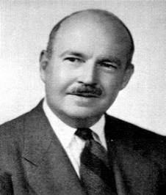](http://www.google.co.uk/url?sa=i&rct=j&q=talcott%20parsons&source=images&cd=&cad=rja&docid=3pH6AglTyiDm4M&tbnid=AGNmLD3PZ1U91M:&ved=0CAUQjRw&url=http://www.nndb.com/people/811/000113472/&ei=r8nnUc3ZEcWb1AWCx4C4Bg&bvm=bv.49478099,d.ZG4&psig=AFQjCNEv1LZGDdJb_Nt7txBXQBJEXDz2KQ&ust=1374231335896659)

1. Talcott Parsons

Parsons (1961) sees the school as the **‘focal socialising agency’** in modern society.

He suggests that the family and society operate on different principles and that the school acts as a bridge between the family and wider society, helping children to learn how to cope with the real world.

**Imagine you have only ever experienced living in a family and you’ve had no contact with outside society until now, you’ve just got a job; what would you find different?**

………………………………………………………………………………………………………………………………………………………………………………………………………………………………………………………………………………………………………………………………………………………………………..

C:\Users\seedac\AppData\Local\Microsoft\Windows\Temporary Internet Files\Content.IE5\KAL53214\MC900202616[1].wmfEducation

Society

The Family

Parsons suggested that education had two main functions:

* Promoting meritocracy
* Selecting and allocating people for future work roles

Meritocracy:

Parsons believes the education main function of education is to achieve **meritocracy** in our society – where jobs and pay are allocated on the basis of people’s individual talents, abilities, qualifications and skills.

Within the family the child is judged by ……………………………………….. standards: rules that apply only to that particular child. Also, within the family the child’s status is …………………………….…….. which means fixed from birth.

However, outside the family the child is judged by …………………………………………………. as the same laws apply to everyone (e.g. all sitting the same exam). In schools and the wider society, a child’s status is …………………………………

universalistic achieved particularistic ascribed

**How does school support this idea of ‘achieved status’?**

…………………………………………………………………………………………………………………………………………………………………………………………………………………………………………………………………………………………………………………………………………………………………………

This brings us onto a key principle called ‘**meritocracy’** which means that everyone is given an equal opportunity and an individual is rewarded for their own efforts. Parsons supports the idea that school is based on meritocratic principles.

**How is hard work rewarded within schools?**

…………………………………………………………………………………………………………………………………………………………………

**Parsons believes that rewards are necessary-why do you think this is?**

…………………………………………………………………………………………………………………………………………………………………………………………………………………………………………………………………………………………………………………………………………………………………………

**How is hard work rewarded within the workplace?**

………………………………………………………………………………………………………………………………………………………………………………….

Selecting and allocating pupils to suitable work roles

\\staidansapps\apps\MSIs\Network Software\officepro\disc2\PFiles\MSOffice\Clipart\standard\stddir1\bd07139_.wmfParsons also suggested that schools perform the function of **selecting and allocating pupils to suitable work roles**. By assessing their skills and abilities schools help match them to the job they are most suited to. For example, someone who is good at biology and chemistry and who enjoys working with others may be advised to become a doctor whereas someone who is good at practical subjects such as DT may be advised to become a builder or plumber.

1. C:\Users\seedac\AppData\Local\Microsoft\Windows\Temporary Internet Files\Content.IE5\A2E74Z7U\MC900231446[1].wmfDavis and Moore

‘You can be an accountant, you’re good with numbers.’

Davis and Moore (1945) agree with the view that the main function of education is the **allocation of roles**, however, they go further and look at the link between education and social inequality.

They suggest that inequality is necessary to ensure that the most important roles in society are filled by the most talented people.

C:\Users\seedac\AppData\Local\Microsoft\Windows\Temporary Internet Files\Content.IE5\LIZ2RT7T\MC900412600[1].wmfCan you think what these roles might be?

They suggest that the rewards attached to these roles encourage everyone to compete for them enabling society to then select the most talented people.

Why is this necessary, what might happen without the high rewards?

The education system plays a key part in this process since it acts as a proving ground for ability where individuals can show what they do. It ‘**sifts and sorts us’** according to our ability.

Shultz (1971) developed the theory of **human capital**, which suggests that a meritocratic education system is good for the economy as the success of a modern economy is dependent on its ability to use its human capital (its workers’ skills) effectively. A meritocratic education system enables people to be allocated to jobs best suited to their abilities. Education provides a properly trained, qualified and flexible labour force to undertake a wide range of different jobs which arise from the specialised division of labour in a modern economy. This makes effective use of their skills and maximizes productivity.

Vocational education and training (VET)

This involves work related study (e.g. apprenticeships), mostly in a school or college whereby learners acquire job specific knowledge on the job or in work like situations, preparing them for their future work roles. The functionalists see this in a beneficial way as it helps boost the economy.

*How does this support Davis and Moore’s function of education?*

**Evaluation of the Functionalist Perspective on Education**



|  |  |
| --- | --- |
| Evaluation point | Which part of the functionalist theory does it challenge? How? |
| Functionalists see education as a process that instils shared values of society, yet Marxists would claim that education transmits a culture that benefits the ruling class not society as a whole. Like other institutions, its role is to reinforce capitalist ideology and to maintain and justify class inequality. |  |
| Dennis Wrong (1961) argues that the functionalists have an ‘over-socialised view’ of people as puppets of society. Functionalists wrongly imply that pupils passively accept all they’re taught and never reject school’s values. |  |
| Hargreaves (1982) argues that education in modern Britain fails to transmit shared values, promote self-discipline, or cement social solidarity. In reality British education emphasizes individual competition through the exam system rather than encouraging social solidarity. |  |
| Some would question the claim that schools are meritocratic, for example, there’s doubt over whether the educational system grades people in terms of ability, it’s argued that intelligence has little effect on educational attainment and it’s more to do with gender, ethnicity and class. Furthermore, the relationship between academic credentials and occupational reward is not particularly strong. High achievers at schools don’t necessarily get the best paid jobs. |  |
| Melvin Tumin (1953) criticizes the circularity of their argument - ‘How do we know if a job is important?’ Because it’s highly rewarded. ‘Why are some jobs more highly rewarded than others?’ Because they’re more important.   * Doesn’t actually say what makes a job an important job. |  |
| The New Right argue that the state education system fails to adequately prepare people for work because state control discourages competition and choice. |  |
| Feminists believe that the education system only benefits men. One of the ways is does this is through a curriculum that is more suited to males. |  |

**The New Right Perspective of Education**

The New Right is a conservative political perspective, it has influenced Conservative policies but also those of New Labour. The New Right believes that some people are naturally more talented than others. They favour a meritocratic education system where competition is encouraged and serves the needs of the economy by preparing young people for work. Also, they believe education should socialize children into shared values, such as competition, and instil a sense of national identity to ensure a stable and united society.

However, they argue that the current education system fails to achieve these goals as it is governed by the state. They claim that the state imposes uniformity and disregards local needs (‘one size fits all’); they suggest that the *consumers* have no say. State schools are therefore inefficient and unresponsive, and schools that waste money or get poor results are not answerable to their consumers. This means lower standards of achievement for pupils, a less qualified workforce and consequently a less prosperous economy.

The solution, according to The New Right, is to create an education market called **marketization**, by giving the consumer more choice schools will have to compete with each other encouraging diversity and an improvement in standards.

**Define what is meant by the term marketization**

………………………………………………………………………………………………………………………………………………………………………………………………………………………………………………………………………………………………………………………………………………………………………..

1. Identify at least three similarities between The New Right perspective on education and the functionalist perspective.
2. Who do you think the passage is referring to when they use the term ‘consumers’?
3. According to The New Right, what are the two main problems with the current education system?

Chubb and Moe

**The New Right in America:** Chubb and Moe (1990) are supporters of the New Right and their idea of marketization. They state that education controlled by the state and local authorities (local councils) is ineffective in producing a highly skilled workforce. They are critical of the state of the American education system, arguing that:

* The state education system has failed to meet the needs of disadvantaged groups such as ethnic minorities and people from lower social classes, consequently failing to create equality of opportunity.
* The state education system fails to produce pupils with the skills needed by the economy.
* Private schools deliver higher quality education because, unlike state schools, they are answerable to paying the consumers – their parents.

Their evidence…

Chubb and Moe compared the achievement of 60,000 pupils from low-income families in 1,015 state and private high schools.

They also carried out a survey of parental attitudes to schooling and case studies of ‘failing’ schools apparently being ‘turned around’.

Their evidence showed that pupils from low-income families consistently do about 5% better in private schools than in state schools.

On the basis of their research, Chubb and Moe call for the introduction of a market system in state education that would put the control in the hands of the consumers (parents and local communities). They argue there should be a free market in education, with a range of different types of independently managed schools and colleges, run like private businesses, tailored to, answerable to, and shaped b7y the wishes and needs of local communities of parents and students. Competition for students and funding, combined with a free choice of school for parents/students, will lead to a more efficient education system delivering a better value for the taxpayer who funds the education. This marketization of education will provide a more skilled and qualified workforce.

To introduce a market in state education, Chubb and Moe propose a system in which each family would be given a voucher to spend on buying education from a school of their choice. This would force schools to become more responsive to parent’s wishes, since the vouchers would be the schools’ main source of income. Like private businesses, schools would have to compete to attract ‘customers’ by improving their ‘product’.

**And what about the state?**

The New Right still sees two roles for the state;



*What ‘framework’ is present in Britain that enables schools to compete with one another? i.e. what criteria or sources could parents use when deciding where to send their children?*

The New Right believe that education should strengthen national identity, they would argue that pupils should be taught Britain’s positive role in world history and that Christian acts of worship should be encouraged since Christianity is Britain’s main religion. Generally they oppose multi-cultural education that reflects the cultures of different ethnic groups in Britain.

*What recent introduction to the curriculum would The New Right be particularly supportive of?*

**Evaluation of the New Right Perspective on Education**

* The real cause of low educational standards is not state control but social inequality and inadequate funding of state schools.

*Chubb and Moe used pupils from low-income families, can you think of an alternative reason why these pupils did better in private schools?*

* Gerwitz (1995) and Ball (1994) both argue that competition between schools benefits the middle class, who can use their cultural and economic capital to gain more access into schools.

*Explain what this means – does this support or challenge the New Right?*

* The New Right’s proposal is contradictory; on the one hand they call for parental choice to shape the schools to meet local needs and increase diversity, yet on the other hand they argue for state to impose a national curriculum for all schools to follow. It’s difficult to ‘meet local needs’ when they are restricted to a set curriculum.
* Marxists would argue that education does not reinforce a shared national culture but rather imposes and justifies the culture of a dominant minority ruling class and devalues the culture of the working class and ethnic minorities.

**The Marxist Perspective of Education**

**TASK***: Fill in the missing words*

Functionalism and Marxism are both ....................................... theories; however, while functionalists see education as benefiting ......................................., Marxists would claim that education only benefits the ruling class. While functionalists believe society operates on the principle of .......................... ............................, Marxists emphasise the................................ that exists between the................................................. (the owners of the means of production) and the............................................. (the working class). The proletariat are ……………………….. by the bourgeoisie but fail to recognise this as ruling class .................................... is reinforced by society’s institutions, including the education system.

conflict proletariat everyone value consensus

Bourgeoisie ideology structuralist exploited



**Important Note!**

The Marxist perspective differs from the others in that they believe that society is like this but they don’t agree with it and think it should change!

The power of the bourgeoisie derived from their ownership of the means of production. The means of production forms the economic base or infrastructure of society. Because they controlled the economic base, the bourgeoisie were able to control the other, non-economic institutions of society (superstructure) such as the media, the family, religion and education.

Marxists see education primarily as a means of social control, encouraging young people to be conformists, to accept their social position and not to do anything to upset the current patterns of inequality in power, wealth and income. Marxists emphasise that education reproduces existing social class inequalities, and passes them on from one generation to the next. At the same time, it does this by giving the impression that those who fail in education do so because of their lack of ability and effort, and only have themselves to blame. In this way, people are encouraged to accept the position they find themselves in after schooling, even though it is disadvantages arising from social class background that create inequalities in educational success.

The key theorists in this area that you need to know about are:

* **Louis Althusser**
* **Bowles and Gintis**
* **Paul Willis**
* **Pierre Bourdieu**

1. [](http://www.google.co.uk/url?sa=i&rct=j&q=&esrc=s&source=images&cd=&cad=rja&uact=8&ved=0CAcQjRxqFQoTCIfT65mah8YCFcmP2wod2AUAvA&url=http://en.wikipedia.org/wiki/Louis_Althusser&ei=WkR5VYe-Esmf7gbYi4DgCw&bvm=bv.95277229,d.ZGU&psig=AFQjCNGNpVoEVW-hMlriMa7nUgizhcEhvA&ust=1434097108656247)**Louis Althusser: the ideological state apparatus**

Louis Althusser (1971) suggested that the state consists of two elements or ‘apparatuses’ which serve to maintain the dominance of the bourgeoisie.

**TASK**: *match up which of the following you think are part of the RSA and ISA?*

Religion Police Education Mass Media Army Courts

**Education as part of the Ideological State Apparatus**

According to Althusser, education performs two functions:

* **Reproduces** class inequality by failing each new generation of working-class pupils. Education also reproduces the necessary technical skills to form an efficient and obedient labour force.
* **Legitimates** (justifies) class inequality by producing ideologies (a set of beliefs and ideas) that disguise its true cause. The function of ideology is to persuade workers to accept that inequality is inevitable and that the working class deserve their subordinate position in society – to prevent the working class from rebelling against their exploitation. If they accept these ideas, they are less likely to challenge or threaten capitalism (creating a false class consciousness)

1. **Bowles and Gintis**

Bowles and Gintis (American Marxists) argue that capitalism requires a workforce with the kinds of attitudes, behaviour and personality-type suited to their role as alienated and exploited workers willing to accept hard work, low pay and orders from above. From this, they argue that the main function of education is:

**‘To reproduce an obedient workforce with the attitudes and skills needed in order to accept their position in capitalist society.’**

Bowles and Gintis argue that education produces an obedient workforce in two ways:

* Through a hidden curriculum of schooling and the correspondence, or very close similarity, between the social relationships at school and work – in particular, the way schooling operates in the ‘long shadow of work’
* Through the role of the education system helping to maintain, legitimate or justifying the system of social inequality and the class structure of in capitalist society. This will help people come to terms with their position and reduce discontent and opposition to inequality.

**The Correspondence Principle and the hidden curriculum**

Bowles and Gintis point out that there are close parallels between school and work in capitalist societies, they call this the **‘correspondence principle’**; the relationships and structures (i.e. control and organisation) in education mirror those in the workplace. This operates through a **hidden curriculum**-all the ‘lessons’ that are learnt in school without being directly taught, they are just accustomed simply by attending school. This helps prepare working-class pupils for their role as exploited workers in the future, reproducing the workforce capitalism needs and perpetrating class inequality from generation to generation.

Work

School

|  |  |  |
| --- | --- | --- |
| **Hierarchy** of authority among teachers and between teachers and students. |  |  |
| C:\Users\seedac\AppData\Local\Microsoft\Windows\Temporary Internet Files\Content.IE5\KLGNTMR5\MC900060201[1].wmf |  | **Alienation** through lack of control over production e.g. when, where and how. |
| **Extrinsic satisfaction** – students are rewarded in terms of the grades they get rather than through enjoyment of the subject or learning in general. |  |  |
|  |  | **Fragmentation** of work through the division of labour into small, meaningless tasks. |
| **Competition and division** among students, e.g. to come top of the class or to be put into a higher stream. |  |  |

**The Myth of Meritocracy: legitimation of class inequality**

According to functionalists such as Parsons, the education system is **meritocratic**, that is, everyone has an *equal opportunity* to succeed and that rewards and status are based on *ability and effort*, consequently those who are the most able and most hardworking *deserve* the most rewards.

However, Bowles and Gintis argue that the idea of education being meritocratic is a **myth** and that this concept is promoted as part of the **ruling class ideology**. The proletariat will never achieve the same status as the bourgeoisie as high income is not purely based on academic achievement it’s to do with other things such as family and social class background. People from upper and middle-class backgrounds (and who are white and male) tend to obtain higher qualifications and better jobs than working-class children of similar ability.

Why do you think the bourgeoisie want the proletariat to believe that education (and society) is meritocratic?

C:\Users\seedac\AppData\Local\Microsoft\Windows\Temporary Internet Files\Content.IE5\8Y88F3QC\MC900441902[1].wmfBowles and Gintis also argue that the education system is characterised by inequality and repression. Capitalism doesn’t need everyone to fulfil their academic potential or become highly qualified because if they did this would challenge the distribution of employment, profit and power in capitalist society. Instead capitalism requires most people to be educated **just enough** to become dutiful workers, citizens and consumers, but **not enough** to understand, or seriously challenge the prevailing economic and social system – this will make it less likely that they will seek to overthrow capitalism.

The education system justifies poverty through what is known as

**‘The poor are dumb’ theory of failure.**

What is this?

……………………………………………………………………………………………………………………………………………………………………………………………………………………………………………………………………………………………………………………………………………………………………….

Samuel Bowles and Herbert Gintis (1976) **‘Schooling in Capitalist America’**.

Bowles and Gintis studied 237 New York high school students. They measured student’s personality traits using a questionnaire then compared the results of these with students’ school grade averages and exam scores.

They found a correlation between personality traits valued by employers, such as docility, passivity and obedience, and high scores at school whereas those students who showed independence and creativity tended to gain low grades.

*How does this support their views of education?*

They also analysed the relationship between intelligence, educational attainment and occupational reward. Within a sample of individuals with average IQs they found a wide range of variation in educational attainment.

*What does this suggest?*

However, they did find a direct relationship between educational attainment and family background, suggesting that this is the most important factor in determining an individual’s level of academic success.

A similar relationship was reported between IQ, occupational reward and family background.



**Exam Tip**

**This is a vital study which is useful for answering either a 20 mark question (AS level) or 30 mark (A level) about the Marxists view of the function of education**

1. **Pierre Bourdieu**

Pierre Bourdieu (1977) regards a key role of the education system in capitalist societies as legitimising (justifying) class inequalities and reproducing class structure. He proposed the idea of **cultural capital** – this is the knowledge, attitudes, values, language, tastes and abilities that the middle class transmit to their children. He argues that the education system is systematically biased in favour of the culture of the middle classes, as the system is defined by, and for, the middle classes. Bourdieu suggests that this results in the middle classes succeeding by default rather than due to greater ability. Working-class pupils, in comparison, do not in general possess a cultural capital, so the educational failure of the majority of these pupils in inevitable.

**Criticisms of Althusser, Bowles and Gintis and Bordeau:**

* Bowles and Gintis ignore some the influences of the formal curriculum. This does not always seem to be designed to promote the ideal employee for capitalism, and to develop uncritical, passive and unquestioning conformist behaviour. For example, the Humanities and subjects like Sociology produce critical thinkers.

*Why does this challenge Bowles and Gintis work?*

* Employers often complain that the education system does not produce the well qualified and conformist workers with suitable skills that Marxist writers suggest it does.

*What Marxist theorist does this challenge and why?*

* There is a lack of detailed research into schools. Althusser and Bowles and Gintis, for example assume the hidden curriculum is actually influencing pupils, but pupils are not passive recipients of education, and often pupils have little regard for teachers’ authority and school rules and discipline (as Willis’ research below shows)
* Traditional Marxist theories are **deterministic** – they assume that people have no real ability to make choices or have control over what happens to them, and they don’t really explain how and why many working-class pupils *are* successful in education.

**Neo-Marxist view of education**

* **Paul Willis**

Paul Willis (1977) ‘*Learning to Labour’* research, helps to overcome some of the weaknesses of more traditional Marixst approaches like those of Bowles and Gintis and Althusser. Willis developed a Neo-Marxist view of education – new versions of Marxism, which are strongly influenced by the works of traditional Marxism, but disagree with some aspects of them and incorporated an *interactionist perspective* to fit contemporary society.

His research suggests that schools are not as successful as Bowles and Gintis propose in terms of producing docile workers who are fooled into believing the ‘*myth of meritocracy’*. Rather Willis claims that working class pupils are able to resist such attempts to indoctrinate them. Willis was a Marxist but he also took an interactionist approach as he was interested in studying the meanings the pupils gave to their experiences.

Willis (1997) ‘**Learning to Labour: How Working Class Kids Get Working Class Jobs**’

Willis studied a group of 12 working class boys from a small industrial town. He followed them over their last 18 months at school and their first few months in work.

He used a range of techniques including observation and participant observation in class, around the school and during leisure activities. He also used group discussions, informal interviews and diaries.

Willis noted that the ‘lads’ had formed their own counter-school culture that was opposed to the values of the school. They attached little or no value to academic work and referred to the boys who did conform as ‘ear’oles’ and cissies. Instead the lads valued manual work as they felt this conformed to their strong masculine identity. During school they occupied themselves by disrupting lessons, playing truant and generally trying to act defiant in the face of the school’s rules and values. The ‘lads’ rejected the school’s meritocratic ideology that working-class pupils can achieve middle-class jobs through hard work, as they saw this as a ‘con’.

When Willis followed the ‘lads’ into work he saw strong similarities between the counter-school culture and the shop-floor culture. The same sexist attitudes and lack of respect for hierarchy were present and the ‘lads’ continued in their attempts to gain freedoms and have a ‘laff’.



**Exam Tip**

**Including neo- Marxism in an essay will give you a better chance of accessing the top band. You could discuss how Neo-Marxism is different from the original theories of Karl Marx and use Willis’ study to strengthen your argument**

Willis’ findings appear to challenge the Marxist view presented by Bowles and Gintis as the lads didn’t appear to have **false class consciousness** – they were aware that meritocracy was a myth and that they didn’t have the same opportunities as other pupils. However, they also help explain why the lad’s counter-school culture results in them slotting in to the low-paid, low-skill jobs that the bourgeoisie and capitalism needs them to fulfil.

For example:

* By rebelling against the school’s values and playing truant the ‘lads’ fail to gain substantial qualifications which means that they are only able to acquire unskilled jobs.
* Having been accustomed to boredom and to finding ways of amusing themselves in schools, they don’t expect satisfaction from work and are good at finding diversions to cope with the tedium of unskilled labour.

For Willis, the irony is that by helping them resist the school’s ideology, the lads’ counter-culture ensures that they are destined for the unskilled work that capitalism needs someone to perform.

**Evaluation of the Marxist Perspective on Education**

* Marist approaches are useful in exposing the ‘myth of meritocracy’. They show the role that education plays as an ideological state apparatus, serving the interests of capitalism by reproducing and legitimating class inequality.
* Marxist views see too tight a link between education and the economy, and exaggerate the extent to which schools provide a ready, willing and qualified labour force.

**Do the other perspectives support or challenge the Marxist’s view of the function of education? Explain why/why not?**

Functionalism:

New Right:

Feminism:

**Further evaluation of the Marxist Perspective:**

**TASK**: *below are some further evaluation points of the Marxist’s view of education. Colour-code the boxes with the following point:*

**➀ Bowles and Gintis exaggerated the correspondence between education and work.**

**➁ Bowles and Gintis failed to provide adequate evidence to support their theory.**

**➂ People are not fooled by the myth of meritocracy.**

**➃ Marxists take a ‘class first’ approach and ignore other kinds of inequality.**

M.S.H. Hickox (1982) points out that compulsory education was introduced long after the beginning of industrialization. Therefore for a long time capitalists employed people whose attitudes and values had not been moulded by education, however, this did not hinder the development of capitalism.

**➄ Willis’ research was too narrow in focus.**

They assumed the hidden curriculum was influencing pupils but did not carry out detailed research into life within schools.

A sample of 12 boys from one school is not large enough to draw any firm conclusions from, especially as they weren’t even representative of the typical pupils at that school.

A study by Richard Scase found that only 2.5% of a sample of English workers expressed the view that educational qualifications were an important factor in determining social class. Most placed greater emphasis on family background and economic factors. This suggests education does not legitimate inequality.

Nowadays capitalist employers’ value team working skills, however, the education system discourages development in this area as the exam system requires that people compete with each other as individuals.

Blackledge and Hunt suggest that there are a variety of subcultures in schools with many falling somewhere in between the extremes of being totally conformist and totally committed to a counter-school culture.

Critical modernists such as Raymond Morrow and Carlos Torres (1998) argue that society is now more diverse than simply consisting of a working class and a middle class. Non-class inequalities such as ethnicity, gender and sexuality are equally as important.

Willis’ (1977) study showed that working class pupils were aware that meritocracy was a myth and that they didn’t have the same opportunities as other pupils.

Madeleine MacDonald (1980) argues that Bowles and Gintis ignore the fact that schools reproduce patriarchy as well as capitalism.

David and Reynolds (1984) point out that much of the formal curriculum in schools does not promote the development of the ideal employee under capitalism. Many subjects encourage the development of critical awareness. Indeed it could be argued that in studying Bowles and Gintis, their argument is undermined!

Reynolds (1984) also points out that traditional academic subjects continue to have a higher status than more vocational qualifications.

**Real-World Application:**

**Vocational Education and Training (VET) and the development of human capital:**

[](http://www.google.co.uk/url?sa=i&rct=j&q=&esrc=s&source=images&cd=&cad=rja&uact=8&ved=0CAcQjRxqFQoTCLqPn6jQh8YCFSYo2wodLDkATw&url=http://blog.pearson.com/oecd-report-highlights-role-of-vocational-education/&ei=GH15VbqjAabQ7Aas8oD4BA&bvm=bv.95277229,d.ZGU&psig=AFQjCNHTXGfD0DKErzuDxKjTsVyfGNuMvQ&ust=1434111636134967)Schools have introduced vocational education and training (VET) – work related study; which aims to increase human capital and prepare young people for work and making education meet the needs of the economy. Functionalists and New Right see this in a beneficial way, as helping to boost the economy. Marxists tend to view vocational education largely as second-rate education for those from working-class backgrounds, concerned with producing passive and conformist workers to support a profit-making capitalist society, while the middle-class enjoy a more academic education leading to well-paid positions of power and influence in society.

The main focus of VET in Britain is to:

* Improve the quality of basic skills of the workforce for 14-18 years old. Teaching work-related skills will aim to reduce the amount of unemployment for 16-24 year olds.
* Ending the status division between academic and vocational qualifications so they all have more value in the labour market.

VET includes work experience programmes for school and college students; expansion of post-16 education e.g. training schemes, work based NVQs, BTECs, apprenticeships; improving ICT and literacy numeracy skills in schools which employers value and most employers feels that school leavers lack.

All these changes are designed to produce a more flexible and qualified labour force, fitting education to the needs of employers, enabling young people to adapt to a rapidly changing economy in a **globalised** world.

*Why do you think VET is good for our economy?*

*What are the criticised of vocational education?*

[](http://www.google.co.uk/url?sa=i&rct=j&q=&esrc=s&frm=1&source=images&cd=&cad=rja&uact=8&ved=0CAcQjRw&url=http://jbrunetfoto.net/els-meus-ulls-als-teus-ulls/&ei=QlxwVb3QOMfr7Ab8woKgAg&bvm=bv.94911696,d.ZGU&psig=AFQjCNGs759j8UDMrfTUVK0GgakJ-ZqH0w&ust=1433513346104570)**Eye on the exam…**

1. Explain what is meant by ‘myth of meritocracy’ (2 marks)

……………………………………………………………………………………………………………………………………………………………………………………………………………………………………………………………………………………………………………………………………………………………………………………………………………………………………………………………………………………………………………………………………………………………………………………………………………………..

1. Outline two functions the education system may perform according to functionalists (4 marks)

………………………………………………………………………………………………………………………………………………………………………………………………………………………………………………………………………………………………………………………………………………………………………………………………………………………………………………………………………………………………………………………………………………………………………………………………………………………………………………………………………………………………………………………………………………………………………………………………………………………………………………………………………………………………………………………………………………………………………………………………………………………………………………………………………………………………………………………………………………………………………………………………………………………………………………………………………………………………………………………………………………………………………………………………………………………………………………………………………………………………………………………………………………………………………………………………………………………………………………………………

1. Outline **three** ways in which the correspondence principle operates within the school (6 marks)

……………………………………………………………………………………………………………………………………………………………………………………………………………………………………………………………………………………………………………………………………………………………………………………………………………………………………………………………………………………………………………………………………………………………………………………………………………………………………………………………………………………………………………………………………………………………………………………………………………………………………………………………………………………………………………………………………………………………………………………………………………………………………………………………………………………………………………………………………………………………………………………………………………………………………………………………………………………………………………………………………………………………………………………………………………………………………………………………………………………………………………………………………………………………………………………………………………………………………………………………………………………………………………………………………………………………………………………………………………………………………………………………………………………………………………………………………………………………………………………………………………………………………………………………………………………………………………………………………………………………………………………………………………………………………………………………………………………………………………………………………………………………………………………………………………………………………………………………………………………………..

**10 mark questions:**

In the Paper 1,2 and 3 exam you could have two types of 10 mark questions. They will either be written:

* Outline and explain **two**…. (10 marks)
* Applying material from **Item A**, analyse **two**…. (10 marks)

e.g.

1. [](http://www.google.co.uk/url?sa=i&rct=j&q=&esrc=s&source=images&cd=&cad=rja&uact=8&ved=0ahUKEwjcx9X3r_fUAhWHvhQKHTWPAAMQjRwIBw&url=http://clipartix.com/thumbs-up-clipart-image-1312/&psig=AFQjCNEp0QMnruLLNmhrVGD-uuOhoilNQQ&ust=1499523882339254)Outline and explain **two** ways in which the functions of the education system may affect pupils’ educational achievement (10 marks)

**AO1**: One function of the education system is…..

**AO1** – What is the function (e.g. meritocracy)

**AO2** – How does this affect pupils’ educational achievement?

**AO2**: This affects educational achievement because…

**AO1**: Another function of the education system is…..

**AO2**: This affects educational achievement because…

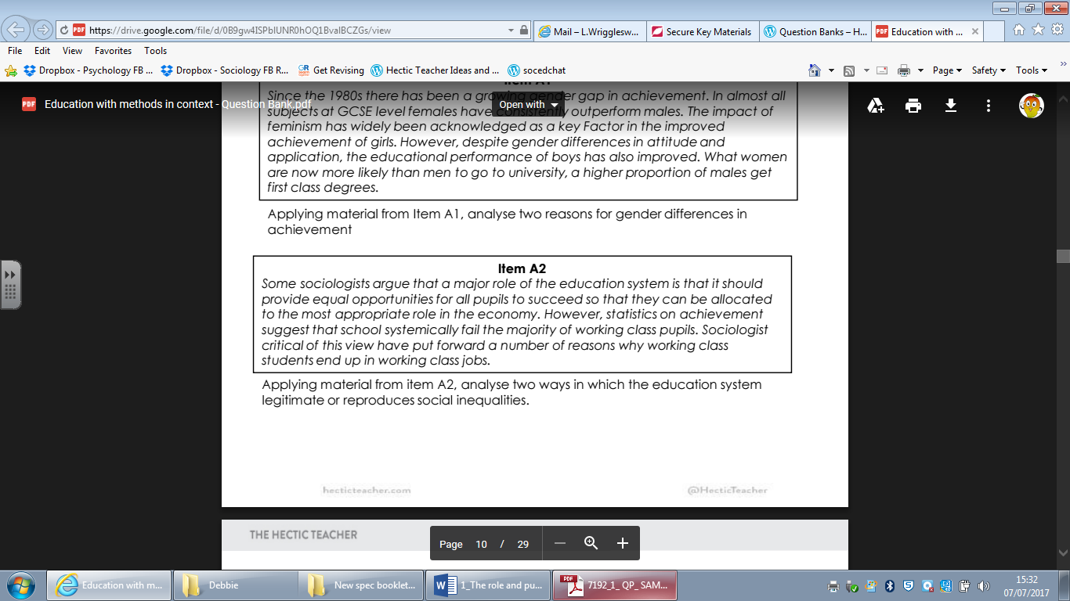

**AO1:** What information can I select from the item? What knowledge backs this up?

**AO2:** – How can I use this information to explain how education legitimates or reproduces social inequalities?

*(10 marks)*

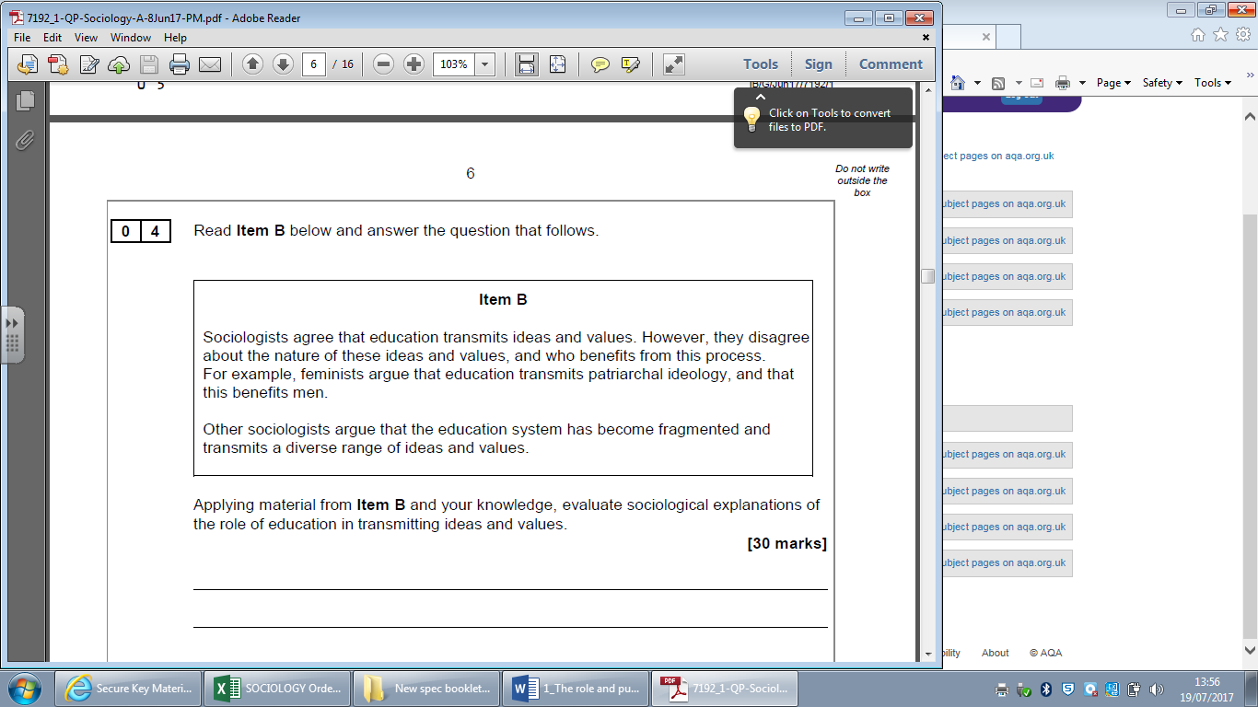Examiners Advice:

[](https://www.google.co.uk/url?sa=i&rct=j&q=&esrc=s&source=images&cd=&cad=rja&uact=8&ved=0ahUKEwiCjLels5XVAhXBvxQKHarQBzwQjRwIBw&url=https://www.ttiblakemore.com/product/tc91z-super-j-catfish-hook-black-nickel/&psig=AFQjCNEPRubGI4tnVt2J3F7-ab_-e0dyAg&ust=1500555578987017)Q4. Spend about **45 minutes** on this question. The focus of the question is how education transmits ideas and values. Start off looking at the Item and highlight. These are your ‘**hooks’** which you need to use e.g. feminists. “*Your knowledge*” should be referring to anything outside the item e.g. functionalism.

For evaluation, offer a debate between the perspectives over what values these perspectives believe education transmits e.g. feminists transmitting a “patriarchal society” versus functionalism transmitting a value consensus of shared norms and values.

Remember to include an introduction, AO1, AO2, AO3 paragraphs (4/5) and a conclusion