GCSE Religious Studies



# Paper 2: Thematic Studies

# Peace and Conflict

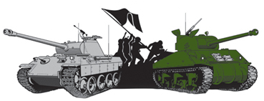

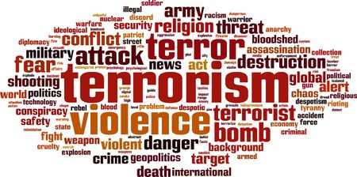

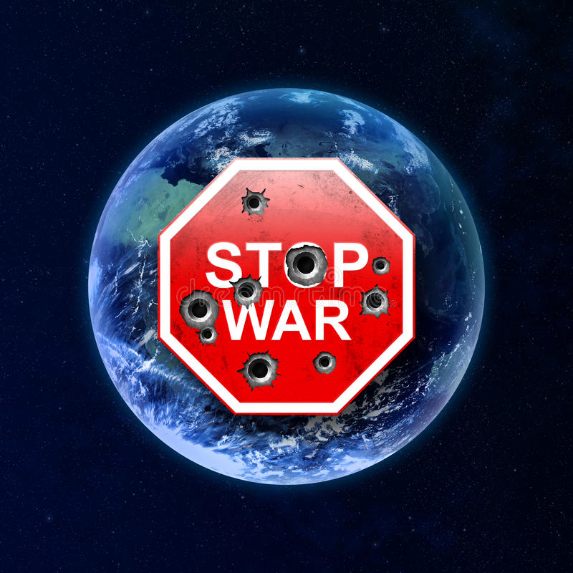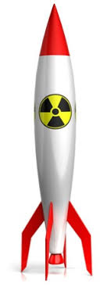

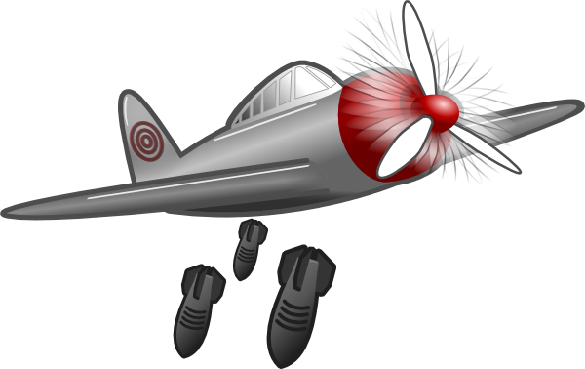

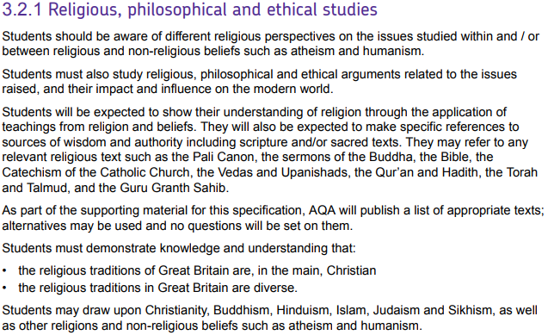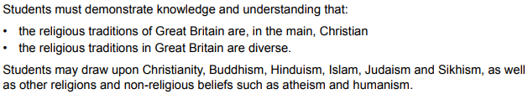

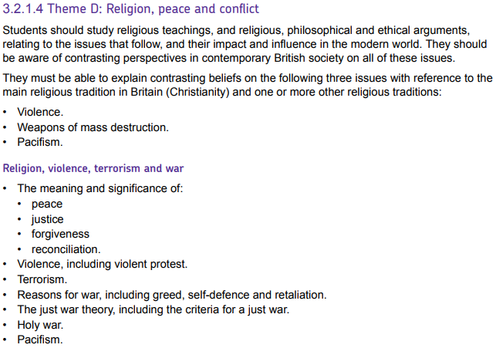

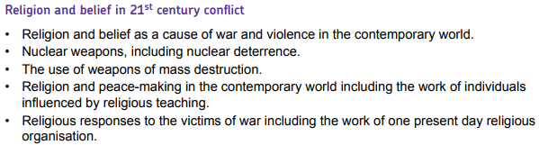



|  |  |
| --- | --- |
| **Key Term** | **Definition** |
| **Biological Weapons** | Weapons that having living organisms or infective material that can lead to disease or death. |
| **Chemical weapons** | Weapons that use chemicals to poison, burn or paralyse humans and/or destroy the natural environment. |
| **Forgiveness** | Showing mercy and pardoning someone for what they have done wrong. |
| **Greater Jihad** | A Muslim’s spiritual struggle within oneself against sin. |
| **Greed** | Selfish desire for something. |
| **Holy War** | Fighting for a religious cause. |
| **Jihad** | Arabic word meaning ‘struggle’. |
| **Justice** | Bringing about what is right and fair. |
| **Just War** | A war which meets the internationally accepted criteria of fairness. Initially proposed by St. Thomas Aquinas. |
| **Lesser Jihad** | The outward struggle (holy war) to defend Islam. |
| **Nuclear weapons** | Weapons (usually bombs) that utilise a nuclear reaction cause damage and death. |
| **Pacifism** | A belief in peace and non-violence. |
| **Peace** | An absence of conflict. |
| **Protest** | A demonstration of disapproval to bring about change. |
| **Reconciliation** | A sacrament in the Catholic Church; when individuals restore their relationship following conflict. |
| **Retaliation** | Deliberately harming someone as a response to them harming you. |
| **Riot** | An unplanned protest that involves violence. |
| **Self-defence** | Acting to prevent harm to yourself. |
| **Terrorism** | A planned action intended to cause death or serious harm to civilians with the purpose of achieving political change. |
| **Violence** | Actions that threaten or cause physical harm to someone. |
| **War** | Fighting between nations to resolve issues between them. |
| **Weapons of mass destruction** | Weapons that can kill large numbers of people and/or cause great damage. |

Peace, Justice, Forgiveness and Reconciliation.

Christians believe that, when considering war, we should be guided by the principles of **peace, justice, forgiveness** and **reconciliation.**

Peace

Peace is often defined as the absence of war. War is always considered to be a bad thing and therefore we should always, ultimately be striving for peace. The Bible often looks forward to a time when God will bring peace. The Prophet Isaiah wrote:

*“He will judge between the nations and will settle disputes for many peoples. […] Nation will not take up sword against nation, nor will they train for war anymore.”*

Justice

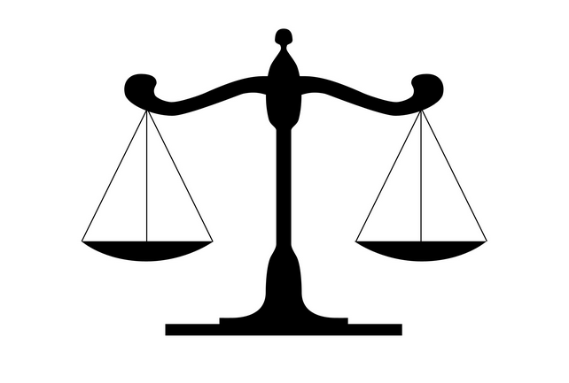Justice is bringing about what is right and fair. This is a key concept within Christian view of war and violence, that ultimately justice must prevail. The aim of war must be to establish justice which is the restoration of fairness.

Christians also believe that the quote above from Isaiah shows that ultimately God will bring about justice in the world.

A lack of justice can also be understood as being a cause of violence and war. A feeling of injustice can lead to conflict as people seek to create a fairer world.

Forgiveness

Forgiveness does not necessarily mean that no action is taken to right the wrong, the principle of justice is also important, but Christians believe that forgiveness is important for living peacefully following conflict. Forgiveness is a core concept in Christianity and one that Jesus repeatedly emphasises (see page 16 in the Crime and Punishment booklet for more detail). Christians believe that forgiveness plays a crucial role in securing **reconciliation**.

Reconciliation

Reconciliation must follow conflict. Reconciliation is much more than just apologising and/or **forgiving**, it involves a conscious and active effort to rebuild a relationship. Sometimes a huge amount of work is needed to avoid further conflict but this is essential for trying to maintain future **peace**. Reconciliation is considered a sacrament within the Catholic Church, such is the emphasis placed on this principle.

Notes:

Violent Protest

The right to protest is considered to be a fundamental democratic freedom. The UK’s 1998 Human Rights Act protects this right:

*Article 10: Everyone has the right to freedom of expression. This right shall include freedom to hold opinions and to receive and impart information and ideas without interference by public authority.*

*Article 11: Everyone has the right to freedom of* ***peaceful*** *assembly and to freedom of association with others.*

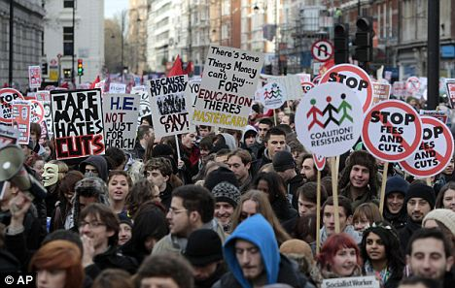If the protest involves a procession or a march, the police must be told at least six days before it takes place. The police can then request alterations to the route or even apply to a court for an order to ban the march should they believe it will result in violence.

Despite protecting citizens’ right to protest, Article 11 clearly states that such protests must be **peaceful.**

In 2014, Michael Brown, an unarmed black teenager, was shot and killed by a white police officer. Following this and the later decision not to prosecute the officer, riots broke out in protest against the perceived systemic racism and police brutality against black people in America. Windows were smashed, looting took place and several buildings were set alight. Protesters chanted:

*“No justice, no peace!”*

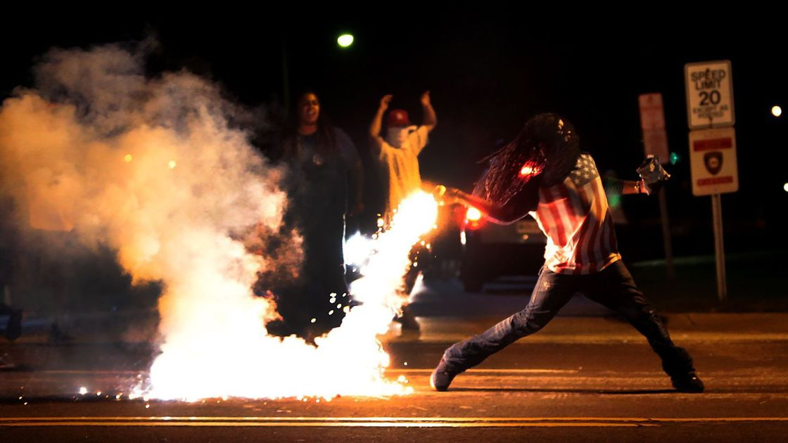

Peaceful protest was an important part of the Civil Rights movement in the USA in the 1950s and ‘60s. One of the movement’s leaders, Martin Luther King, organised peaceful rallies to protest about racial and social inequalities which eventually led to equal rights legislation being passed:

*“Violence is immoral because it profits from hatred. It destroys unity and makes the brotherhood between people impossible.”*

**Martin Luther King**

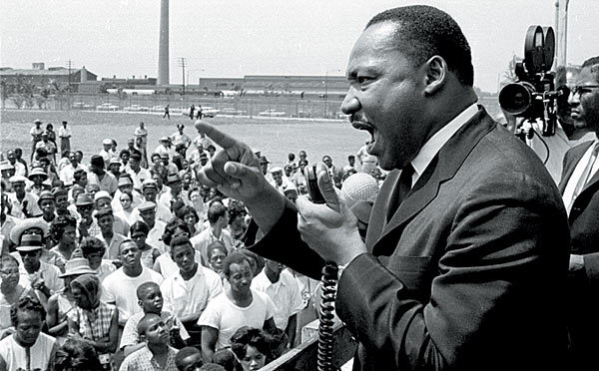

Terrorism

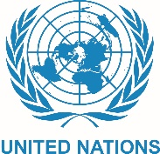The United Nations defines terrorism as:

*“A planned action intended to cause death or serious harm to civilians with the purpose of achieving political change.”*

**The crucial distinction between terrorism and other forms of violent activism is the targeting of civilians.**

In recent years, terrorism has taken many forms including mass shootings and suicide bombings. Terrorists believe that public acts of violence will raise awareness of their cause and push authorities into giving into their demands.

**(You need to be able to give specific examples of terrorism and, using the teaching below, explain how religions would view terrorism)**

Religious Beliefs about Violence

*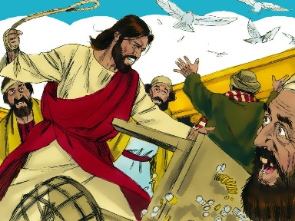“*[Jesus] *made a whip out of cords, and drove all from the temple area, both sheep and cattle; he scattered the coins of the money changers and overturned their tables.”* **John 2:15**

*“Do not take revenge on someone who wrongs you. If someone strikes you on the right cheek, turn to him the other also.”* **Matthew 5:39**

*"Jesus said... ‘all who live by the sword will die by the sword.'”* **Luke 22:51**

*”Do not kill each other, for Allah is merciful to you. If any of you does these things, out of hostility and injustice, We shall make him suffer fire.”* **Qur’an 4:29-30**

*“There is cause to act against those who oppress people and transgress in the land against justice… though if a person is patient and forgives, this is one of the greatest things.”* **Qur’an 4:36-37**



Add in any more reasons for

war you can think of.

Self-defence/defence of others

Many countries are prepared to go to war to defend the values, beliefs, ways of life and ultimately the lives of people under attack from other nations.

Greed

Greed can lead countries to go to war in order to control resources such as oil, wealth, land etc.

Religion/Holy War

The Old Testament contains many references to God helping the Jews to establish themselves in the Promised Land by winning battles.

More recently, wars have been fought to spread religion and convert those in other countries e.g. the Crusades.

Reasons for war

Just War

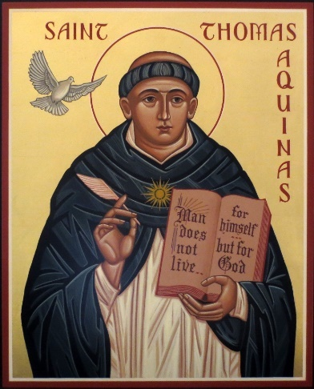In the 13th Century, Thomas Aquinas formalised Christian ideas about the morality of war and put forward a set of conditions which, when met, would justify engaging in war.

The conditions can be split in to two categories, both with Latin names:

* **Jus ad bellum:** the conditions under which the use of military force is justified.
* **Jus in bello:** how to conduct a war in an ethical manner.

**Jus ad bellum**

* War must be a last resort: all other ways of resolving conflict must have been exhausted first.
* The war must have a just cause.
* The war must be declared by a legitimate authority.
* The intention of war must be to ultimately establish peace.
* There must be a reasonable chance of success.

**Jus in bello**

* The methods used in war must be proportional to achieve success.
* Civilians must not be targeted, and civilian casualties must be minimised.

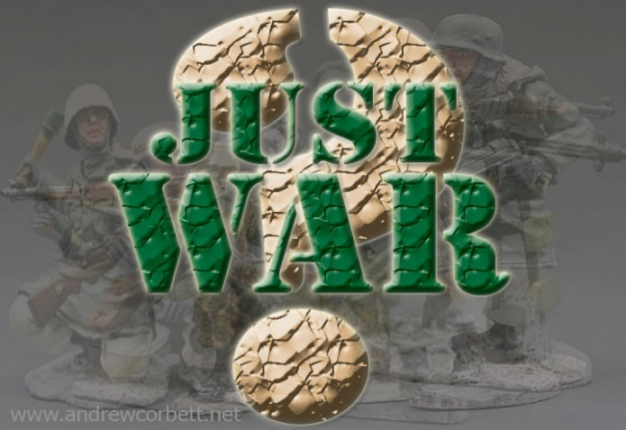

Jihad

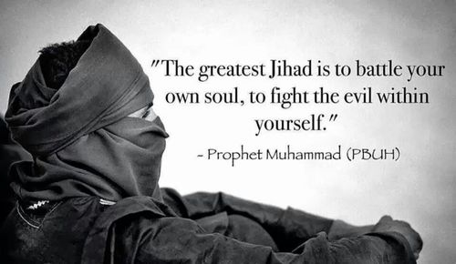

The Arabic word **‘Jihad’** translates as ‘to strive or struggle in the way of Allah’. When we hear this word used on the news, it is usually in reference to what Muslims call **‘lesser Jihad’**. This is the outward struggle to defend Islam, often taking the form of Holy War.

By contrast, the Prophet Muhammad teaches that the **‘greater Jihad’** is the personal spiritual struggle or effort of every Muslim to follow the teachings of Allah (God) in their own lives e.g. overcoming things such as anger greed, pride and hatred; forgiving someone who has hurt them; working for social justice etc.

There is no specific theory of just war in Islam but Muslims tend to accept the conditions put forward by Aquinas. The Qur’an states though that Muslims may not start a war, it can only be justified in defensive terms:

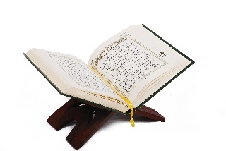

*“And fight for the cause of Allah those who fight you. But do not be aggressive, surely Allah does not like the aggressors.”*

Qur’an 2:190

The first Islamic Caliph (leader), Abu Bakr, added some additional rules to govern how Muslim armies must engage in war:

*“Know that the evil of war is swift, and its taste bitter.”*

Hadith

* Children, women and old men must not be killed
* Dead bodies must not be mutilated
* Natural resources of the enemy must not be destroyed because they will be needed in the future.
* Animals must not be harmed unless for food.

Although fighting can be justified under these conditions, Muslims believe that avoiding war will always be preferable (see right).

Nuclear War and Weapons of Mass Destruction

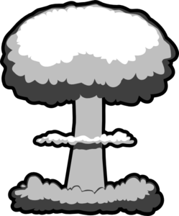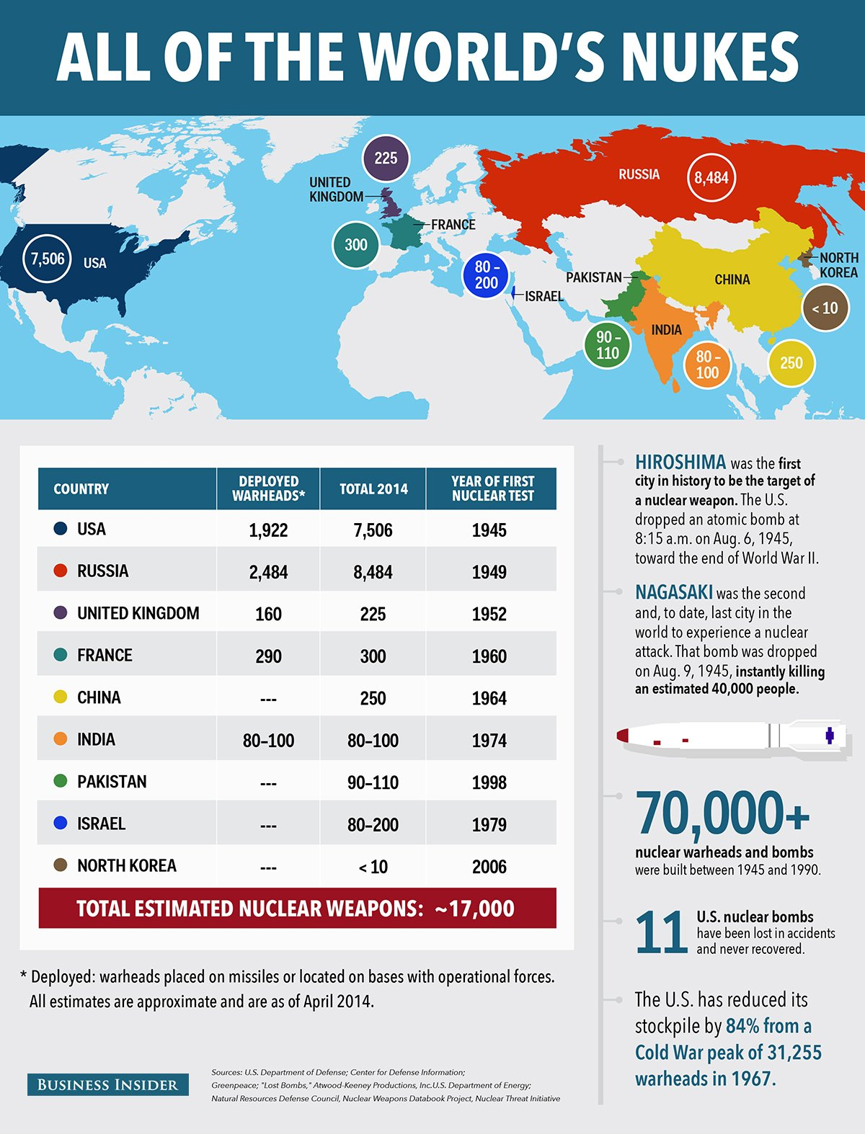In 1945, the US forces dropped atom bombs (an early form of nuclear weapon) on the Japanese cities of Hiroshima and Nagasaki. The extraordinary devastation and loss of life led to the surrender Japan’s surrender, effectively ending World War II.

In 1970 the Nuclear Non-Proliferation Treaty came into force to prevent the spread of nuclear weapons beyond the existing nuclear nations: USA, UK, China, France and Russia. It has been adhered to by 191 countries but India, Israel, Pakistan and North Korea have not accepted the treaty and have since developed weapons.

Many argue that the possession of these nuclear weapons actually helps to ensure peace by acting as a **deterrent** for would-be aggressors because of the fear of a nuclear response. Those that make this argument would point to the period of relative peace since World War II and the fact that this has coincided with the existence of a nuclear deterrent.

Some argue that the weapons themselves are not a problem, although *using* them would be another matter entirely.

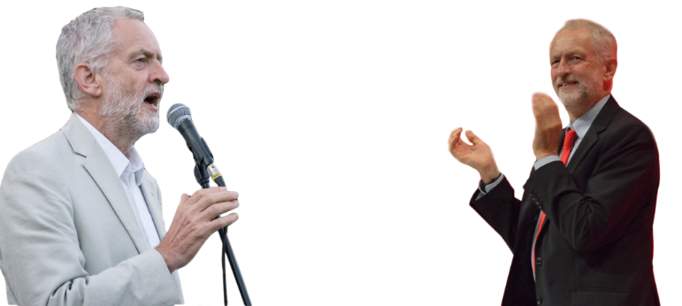

*“I am opposed to the use of nuclear weapons. I am opposed to the holding of nuclear weapons. I want to see a nuclear-free world.*

Others, such as Labour leader Jeremy Corbyn, believe that possessing nuclear weapons cannot be justified. They argue that using nuclear weapons could *never* be justified, even in response to a nuclear attack by an aggressor, due to huge numbers of civilians that would be killed.

Many also argue that the money spent by governments on nuclear weapons could be used on better projects.

These same arguments are also applied to other **weapons of mass destruction**:

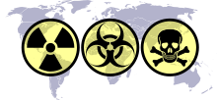**Chemical weapons** are weapons containing lethal chemicals that, when released, cause death. In 1993, the Chemical Weapons Convention (CWC) made the production and use of chemical weapons illegal worldwide. However, since then they are believed to have been used in Iraq and Syria.

**Biological weapons** introduce harmful bacteria and viruses into the air, food chain or water supply. During the First World War, the German Army developed anthrax, glanders, cholera, and a wheat fungus specifically for **use** as **biological weapons** and used them against enemies.

Religious Views on Weapons of Mass Destruction

Christians may differ on their views on the *possession* of WMDs as a deterrent, although they are virtually united on their view on their use. Speaking on behalf of a consortium of UK churches, Steve Hucklesby said:

*“Faith groups in the UK are united in their conviction that any use of nuclear weapons would violate the sanctity of life and the principle of dignity core to our faith traditions.”*

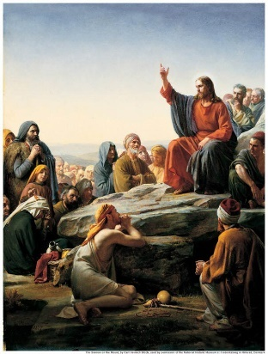Many Christians believe in possessing nuclear weapons because they act as a **deterrent** to war and thereby maintain peace. Some point to Jesus’ teaching in the Sermon on the Mount to support this view:



*“Blessed are the peacemakers, for they shall be called the children of God.”*

Many Christians believe strongly in nuclear disarmament. **The Christian Campaign for Nuclear Disarmament (CCND)** is a group of Christians who work to try and achieve worldwide nuclear disarmament.

They produce regular newsletters, organise events to raise awareness and promote the need to pray for peace.



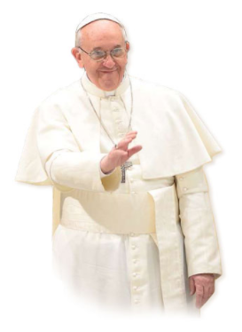Pope Francis agrees:

*“There is an urgent need to work for a world free of nuclear weapons in full application of the Non-Proliferation Treaty, in letter and in spirit, with the goal of a complete prohibition of these weapons.”*

Muslims and Christians agree that the use of WMDs would violate the conditions of a ‘just war’ because they target civilians and the force used is not proportional:

*“Fight in God’s cause against those who fight you, but do not overstep the limits: God does not love those who overstep the limits.”*

**Qur’an 2:190**

**(Remember that the religious teachings about violence on page 7 can also be applied to this issue)**

Pacifism and Peacemaking

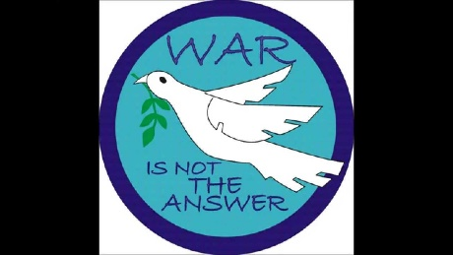

Pacifism is the belief in non-violence. Pacifists believe that war and violence is never justified and that conflicts should be settled peacefully.

As we have seen, many Christians believe violence and war to be justified in certain situations, but some Christians believe that using violence is always wrong.

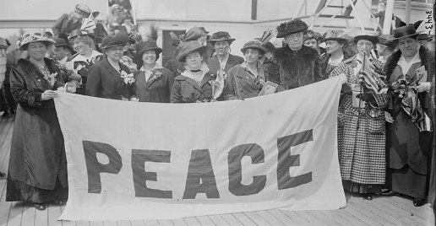Pacifists strongly believe that it is best to work at preventing war from becoming a possibility. They would argue that is always better to try to identify and resolve the root causes conflict, rather than resorting to violence. Instead of fighting, pacifists would focus on promoting justice and human rights in order to avoid conflict arising in the first place.

Christianity and Pacifism

Many Christian pacifists take their example from Jesus and believe he was a non-violent person:



*“Do not take revenge on someone who wrongs you. If someone strikes you on the right cheek, turn to him the other also.”* **Matthew 5:39**

*"Jesus said... ‘all who live by the sword will die by the sword.'”* **Luke 22:51**

The Religious Society of Friends, commonly known as Quakers, are a Christian denomination who believe in pacifism. A clear example of this came during the First and Second World Wars when, despite the government’s policy of conscription, Quakers refused to fight for the army. These people were known as **conscientious objectors** and many faced punishment for their defiance.

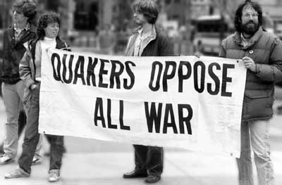Although unprepared to fight in the war due to their beliefs, many joined the war effort in non-combat roles such as doctors, nurses, cooks and mechanics. These were often still dangerous jobs and some conscientious objectors lost their lives but they did so in the knowledge that they had not contributed to the violence.

**Vera Brittain** was a Christian pacifist. She worked during WWII as a fire warden and by travelling around the country raising funds for the **Peace Pledge Union**'s food relief campaign.

During the war, she circulated a booklet ‘*Massacre by Bombing’* in which she spoke out against the saturation bombing of German cities.

Islam and Pacifism

Although Islam advocates for peace, it is rarely considered to be a **pacifist** religion. The Islamic duty of (lesser) Jihad means that violence is not only accepted but mandated in defence of the faith when under attack. The Qur’an clearly states that violence is, at least sometimes, necessary:

***“Fighting has been ordained for you****, though it is hard for you. You may dislike something although it is good for you, or like something because it is bad for you: Allah knows, and you do not.”*

**Qur’an 49:9**

Despite this, it is clear that peace is crucial principle within Islam and should be strived towards in all circumstances. The Qur’an commands that if peace is offered then it must not be refused:

*“But if they incline towards peace, you must also incline towards it and put your trust in God.”*

**Qur’an 8:61**

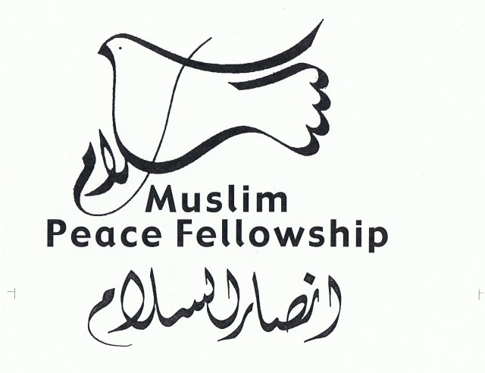The Muslim Peace Fellowship is a gathering of peace and justice-oriented Muslims of all backgrounds who are devoted to the theory and practice of Islamic nonviolence. They state their objectives as:

* Work against injustice and for peace.
* To affirm the commitment to peace on behalf of all Muslims.
* Explore and deepen our understanding of Islamic teachings about peace and non-violence.

Amongst other things, the Muslim Peace Fellowship participates in conferences and publications in order to achieve their objectives.

Religious responses to victims of war

Casualties are an unavoidable part of war. In addition to the harm that is caused to those directly involved in fighting, harm is also caused to their families and friends as well as the infrastructure of the country.

For example, if the main wage earner is killed in war, their family may struggle financially without them. Equally, if a place of work is destroyed, earning opportunities for lots of people are diminished. If the land or water supplies become destroyed or polluted, starvation could follow for those who live in the surrounding area.

|  |  |
| --- | --- |
| Image result for world vision | Related image |
| Image result for caritas | Image result for islamic relief |

Notes:

Possible exam questions

Question 1: (1 mark)

1) Which one of the following is not a reason for war?

A) Self-defence. B) Greed. C) Retaliation. D) Forgiveness.

1) Which word expresses the religious ideal that there should be no violence in the world?

Question 2: (2 marks)

2) Give two ways in which religious believers help victims of war.

2) Give two religious beliefs that show that violence is wrong.

Question 3: (4 marks)

3) Explain two similar religious beliefs about pacifism.

3) Explain two contrasting beliefs in contemporary British society about weapons of mass destruction.

3) Explain two religious beliefs about terrorism.

Question 4: (5 marks)

**You must** refer to scripture or sacred writings in your answer.

4) Explain two religious beliefs about forgiveness.

4) Explain two religious beliefs about justice.

4) Explain two religious beliefs about what constitutes a just war.

Question 5: (12 marks)

Evaluate the statement. In your answer you should:

• refer to Christian teaching

• give developed arguments to support this statement

• give developed arguments to support a different point of view

• reach a justified conclusion.

5) ‘War is never right.’

5) ‘There are no good reasons for countries to possess nuclear weapons.’

5) ‘Violence is never the answer.’