Extrapolation.

Extrapolation refers to the ability to use currently available data to predict future sales.

There are many different ways of extrapolating data but in A Level Business we are only required to look at a basic method which assumes that there is a consistent % change in sales over a time period. And that the current trend will continue

Here we can see that the even though there was an anomaly in 2009, the general trend is still upwards and has continued to rise steadily.

1. What does the data show you about the worldwide market for cosmetics (3 marks)

____________________________________________________________________________________________________________________________________________________________________________________________________________________________________________________________________________________________________________

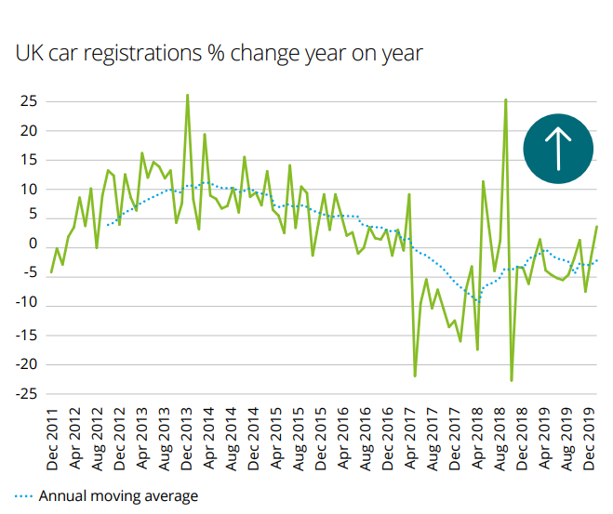Here we can see the UK car registration data from 2011 – 2019.

Although the actual sales are erratic the trendline is much smoother and gives car manufacturers a much better indication of what is happening in their market.

A forecaster would try to project forward (extrapolate) the figures to see the levels of future car sales - they will try to extend the trend line as shown below.

The trendline shows a dip between ____________________ and _________________ but recently there has been a rise suggesting sales are ________________.

[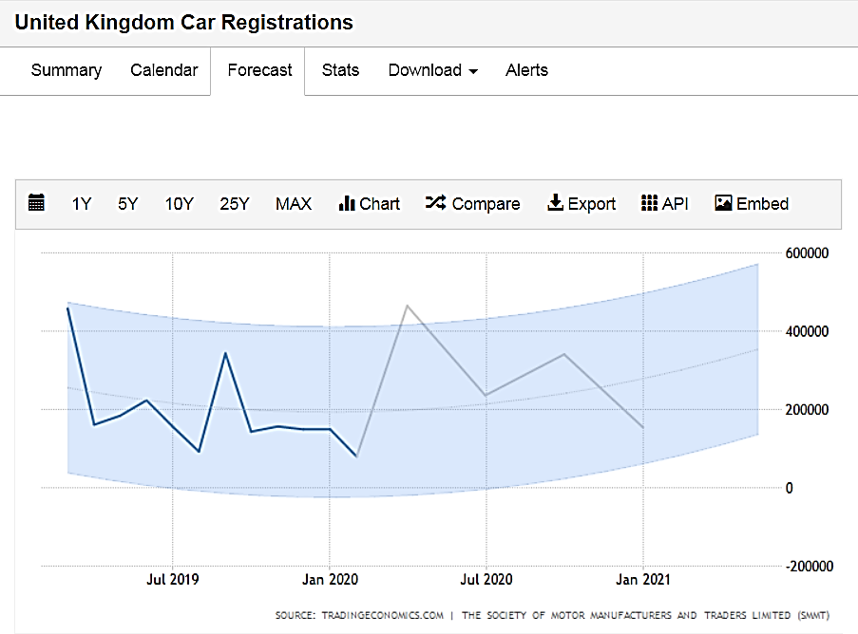](https://tradingeconomics.com/united-kingdom/car-registrations)