**4.2.1 Aerobic & Anaerobic Respiration**

**Respiration: Principles**

* Cellular respiration is an **exothermic reaction** which is continuously occurring in living cells
* The chemical process of cellular respiration releases energy
* The energy transferred supplies all the energy needed for living processes to occur within cells and organisms as a whole
* Organisms need energy for:
  + **Chemical reactions** to build larger molecules from smaller molecules
  + **Muscle contraction** to allow movement
  + **Keeping warm** (to maintain a constant temperature suitable for enzyme activity)

[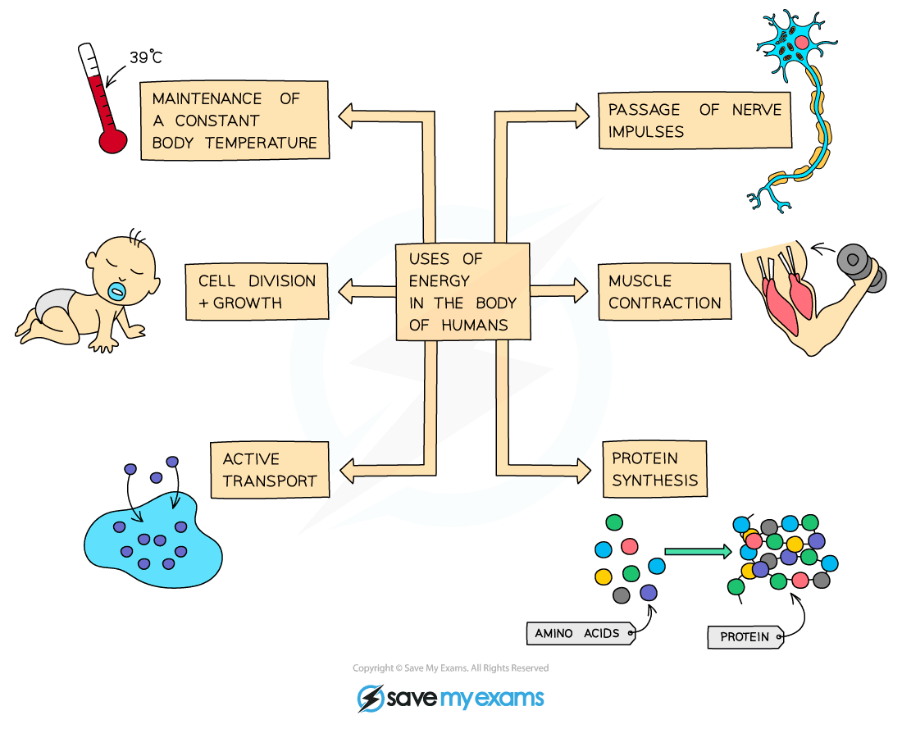](https://cdn.savemyexams.co.uk/wp-content/uploads/2020/01/Uses-of-energy-in-the-human-body.png)

***Uses of the energy released from respiration***

**Aerobic Respiration**

* Respiration in cells can take place **aerobically** (using oxygen) to transfer energy; glucose is reacted with oxygen in this process
* The equations that summarise the chemical reactions of respiration that release energy from glucose are:

[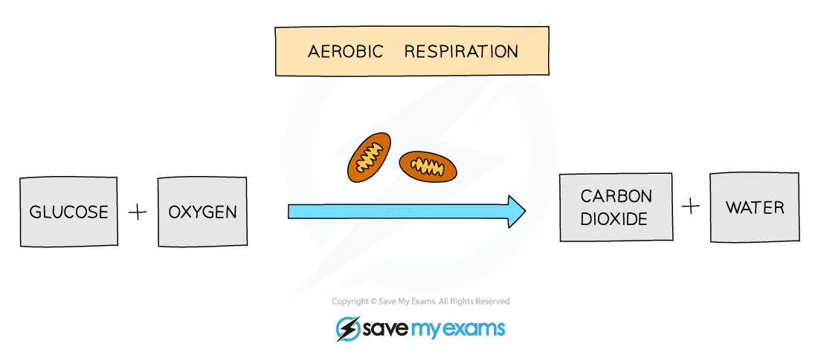](https://cdn.savemyexams.co.uk/wp-content/uploads/2020/01/Word-equation-for-aerobic-respiration.png)

***Word equation for aerobic respiration***

[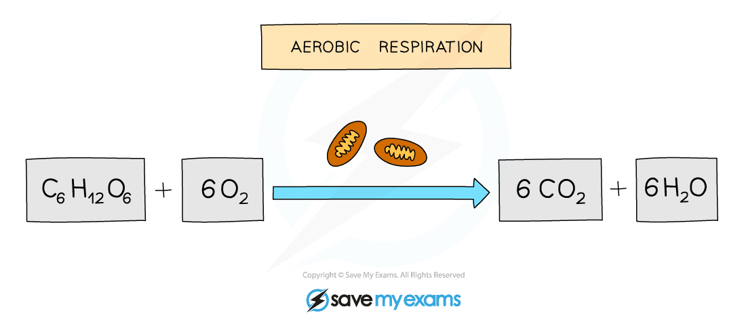](https://cdn.savemyexams.co.uk/wp-content/uploads/2020/01/Balanced-equation-for-aerobic-respiration.png)

***Balanced symbol equation for aerobic respiration***

* Aerobic respiration uses oxygen and most of the reaction takes place in the **mitochondria** (these are shown above the arrow in the equations)

**Anaerobic Respiration in Animals**

* Respiration in cells can take place anaerobically (without oxygen), to transfer energy; it simply involves the incomplete breakdown of glucose into lactic acid
* This occurs when the body can’t supply enough oxygen for aerobic respiration, such as during vigorous exercise
* Anaerobic respiration is represented by the equation:

[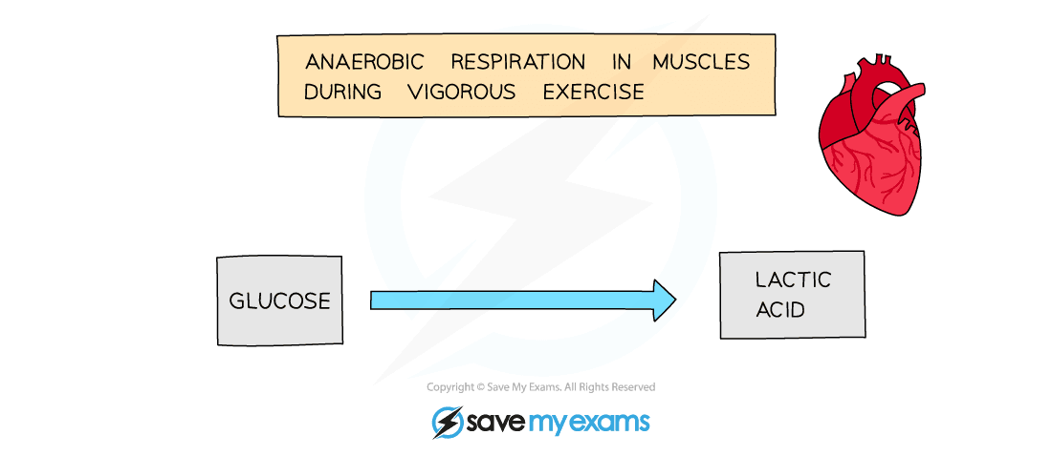](https://cdn.savemyexams.co.uk/wp-content/uploads/2020/01/Word-equation-for-anaerobic-respiration-in-animals.png)

***Word equation for anaerobic respiration in animals – some bacterial cells respire in this way too***

* As the oxidation of glucose is incomplete in anaerobic respiration much less energy is transferred than in aerobic respiration
* Anaerobic respiration takes place without the need of oxygen

**Anaerobic Respiration in Plants & Yeast**

* Plants and yeast can respire without oxygen as well, breaking down glucose in the absence of oxygen to produce ethanol and carbon dioxide
* Anaerobic respiration in yeast cells is called **fermentation**
* Fermentation is economically important in the manufacture of bread (where the production of carbon dioxide makes dough rise) and alcoholic drinks (as ethanol is a type of alcohol)

[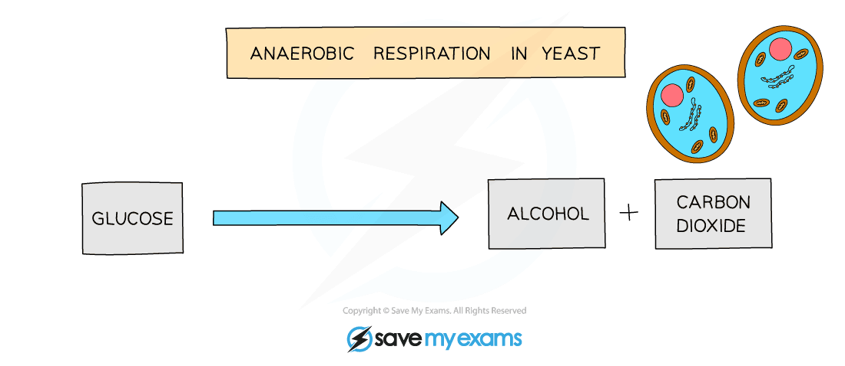](https://cdn.savemyexams.co.uk/wp-content/uploads/2020/01/Word-equation-for-anaerobic-respiration-in-yeast.png)

***The process outlined above is the same in plants***

**Comparing Anaerobic & Aerobic Respiration**

* You need to be able to compare the processes of aerobic and anaerobic respiration with regard to the need for oxygen, the differing products and the relative amounts of energy transferred:

[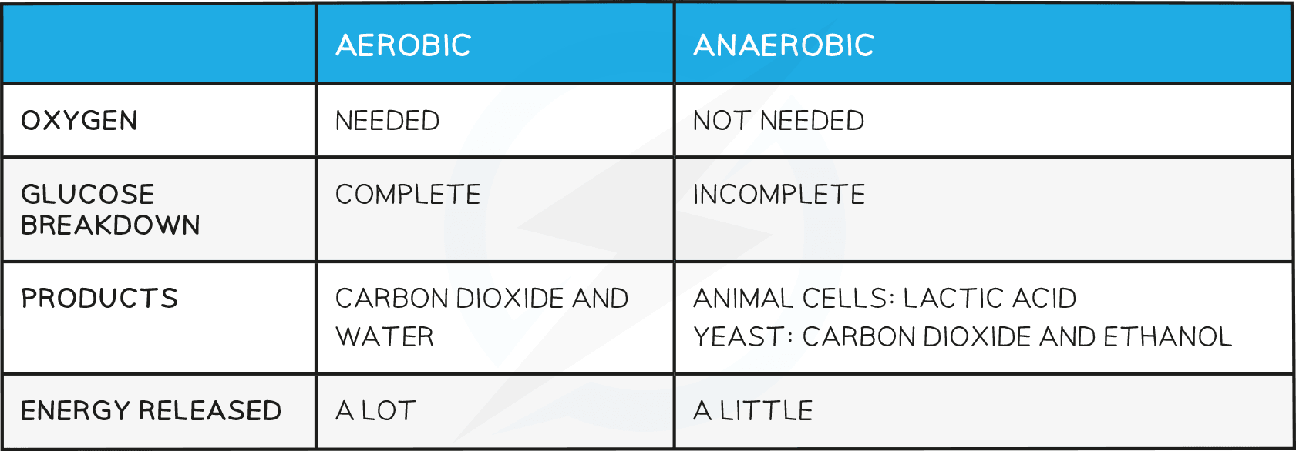](https://cdn.savemyexams.co.uk/wp-content/uploads/2020/05/Anaerobic-Respiration-table.png)

**Exam Tip**

Remember that cellular respiration is not breathing; it is a chemical process of transferring energy from glucose in all living cells.

**Effect of Exercise**

* In order for an individual to be able to move, their muscles need to contract, which requires energy from respiration
* When exercising, the number of muscle contractions increases, therefore there is a greater energy demand, which means that the muscles need a greater supply of oxygen for aerobic respiration
* The human body reacts to the increased demand for oxygen in a number of ways:
  + The breathing rate and breath volume increase during exercise to increase the amount of oxygen absorbed into the bloodstream by diffusion, and the amount of carbon dioxide removed
  + The heart rate increases
* These reactions increase the supply of oxygenated blood to the muscles
* If exercising vigorously, the body may not be able to supply sufficient oxygen to the muscles to meet the demand for energy
* In this situation, some of the energy supplied to the muscles comes from **anaerobic respiration**, which is the incomplete breakdown of glucose without oxygen
* This releases much less energy than aerobic respiration and results in the formation of **lactic acid** as glucose is incompletely oxidised
* An “**oxygen debt**” is created after exercising in this way; it is a debt as “extra” oxygen is needed to react with the lactic acid produced via anaerobic respiration
* This is why an individual still breathes heavily at an increased rate (with a higher heart rate than usual) after exercising vigorously
  + “Extra” carbon dioxide also has to be removed from the body
* During long periods of vigorous activity, muscles become fatigued and stop contracting efficiently as a result of increased levels of lactic acid building up

**Investigations into the effect of exercise on the body**

* It is relatively simple to investigate the effects of exercise on the body in the classroom
* Breathing rate can be measured by counting the number of breaths per minute, while heart rate can be measured by taking a pulse
* Either can be measured before and after an activity is performed and the results plotted on a bar chart
  + It is important that the time over which breathing rate and pulse rate are measured is consistent, and that individuals fully recover (rest) before starting a new activity

**Higher Tier Only**

**Oxygen Debt**

* The body can deal with lactic acid in one of two ways
* It can be oxidised (reacted with oxygen) to form carbon dioxide and water – the same products formed in aerobic respiration
* Alternatively, blood flowing through the muscles transports the lactic acid to the liver where it is converted back into glucose
* Remember the “oxygen debt” is the amount of extra oxygen the body needs after exercise to react with the accumulated lactic acid and remove it from the cells

SOURCE: https://www.savemyexams.co.uk/notes/gcse-combined-science-trilogy-biology-aqa-new/4-bioenergetics/4-2-respiration/4-2-1-aerobic-anaerobic-respiration/