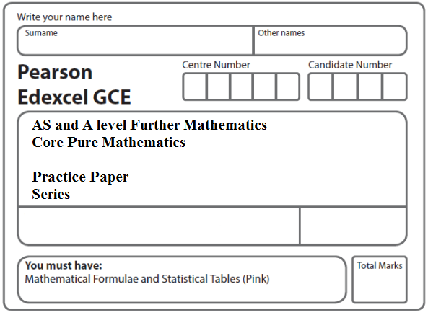

**Instructions**

* Use black ink or ball-point pen.
* If pencil is used for diagrams/sketches/graphs it must be dark (HB or B).
* Fill in the boxes at the top of this page with your name, centre number and candidate number.
* Answer all the questions and ensure that your answers to parts of questions are clearly labelled.
* Answer the questions in the spaces provided – there may be more space than you need.
* You should show sufficient working to make your methods clear. Answers without working may not gain full credit.
* Inexact answers should be given to three significant figures unless otherwise stated.

**Information**

* A booklet ‘Mathematical Formulae and Statistical Tables’ is provided.
* There are 10 questions in this question paper. The total mark for this paper is 80.
* The marks for each question are shown in brackets – use this as a guide as to how much time to spend on each question.
* Calculators must not be used for questions marked with a * sign.

**Advice**

• Read each question carefully before you start to answer it.

• Try to answer every question.

• Check your answers if you have time at the end.

• If you change your mind about an answer, cross it out and put your new answer and any working underneath.

**1.** Show, using the formulae for  and , that

 = *n*(2*n* + 1)(2*n* – 1), for all positive integers *n*.

**(Total 5 marks)**

**___________________________________________________________________________**

**2.** (*a*)Using the formula for write down, in terms of *n* only, an expression for



**(1)**

(*b*)Show that, for all integers *n*, where *n* > 0,



where the values of the constants *a*, *b* and *c* are to be found.

**(4)**

**(Total 5 marks)**

**___________________________________________________________________________**

**3.** (*a*) Using the formulae for  and , show that



for all positive integers *n*.

**(5)**

(*b*) Hence show that



where *a* and *b* are integers to be found.

**(3)**

**(Total 8 marks)**

**___________________________________________________________________________**

**4.** (*a*) Use the standard results for  and  to show that

 = *n*2(*n* + 2*n* + 13)

for all positive integers *n*.

**(5)**

(*b*) Hence find the exact value of

.

**(2)**

**(Total 7 marks)**

**___________________________________________________________________________**

**5.** (*a*) Use the results for ,  and , to prove that

 = *n*(*n* + 1)(*n* + 2)(*n* + 7)

for all positive integers *n*.

**(5)**

(*b*) Hence, or otherwise, find the value of



**(2)**

**(Total 7 marks)**

**___________________________________________________________________________**

**6*.***(*a*) Use the standard results for  and  to show that



**(5)**

(*b*) Calculate the value of .

**(3)**

**(Total 8 marks)**

**___________________________________________________________________________**

**7.**(*a*) Use the standard results for  and  to show that



**(6)**

(*b*) Hence show that



where *a* and *b* are constants to be found.

**(3)**

**(Total 9 marks)**

**___________________________________________________________________________**

**8*.***(*a*) Use the standard results for  and  to show that



for all positive integers *n*.

**(6)**

(*b*) Hence show that



where *a*, *b* and *c* are integers to be found.

**(4)**

**(Total 10 marks)**

**___________________________________________________________________________**

**9.** (*a*) Use the results for and to show that

 = *n*(2*n* + 1)(2*n* – 1)

for all positive integers *n*.

**(6)**

(*b*) Hence show that

 = *n*(*an*2 + *b*)

where *a* and *b* are integers to be found.

**(4)**

**(Total 10 marks)**

**___________________________________________________________________________**

**10.** (*a*) Prove by induction

 = *n*2(*n* + 1)2.

**(5)**

(*b*) Using the result in part (*a*), show that

 = *n*(*n*3 + 2*n*2 + *n* – 8).

**(3)**

(*c*) Calculate the exact value of .

**(3)**

**(Total 11 marks)**

**TOTAL FOR PAPER: 80 MARKS**