Gateways School

**Aromatic chemistry**

**Revision PPQ**

33 marks

**Name: ______________________________ Date: __________**

**Q1.**

The following reaction scheme shows the formation of two amines, **K** and **L**, from methylbenzene.

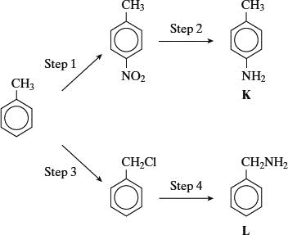

(a)     (i)      Give the reagents needed to carry out Step 1. Write an equation for the formation from these reagents of the inorganic species which reacts with methylbenzene.

*Reagents* ______________________________________________________

*Equation* ______________________________________________________

(ii)     Name and outline a mechanism for the reaction between this inorganic species and methylbenzene.

*Name of mechanism* _____________________________________________

Mechanism

**(7)**

(b)     Give a suitable reagent or combination of reagents for Step 2.

___________________________________________________________________

**(1)**

(c)     (i)      Give the reagent for Step 4 and state a condition to ensure that the primary amine is the major product.

*Reagent* _______________________________________________________

*Condition* ______________________________________________________

(ii)     Name and outline a mechanism for Step 4.

*Name of mechanism* _____________________________________________

*Mechanism*

**(7)**

**(Total 15 marks)**

**Q2.**

Consider compound **P** shown below that is formed by the reaction of benzene with an electrophile.

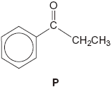

(a)     Give the **two** substances that react together to form the electrophile and write an equation to show the formation of this electrophile.

___________________________________________________________________

___________________________________________________________________

___________________________________________________________________

___________________________________________________________________

___________________________________________________________________

**(3)**

(b)     Outline a mechanism for the reaction of this electrophile with benzene to form **P**.

**(3)**

(c)Compound **Q** is an isomer of **P** that shows optical isomerism. **Q** forms a silver mirror when added to a suitable reagent.

Identify this reagent and suggest a structure for **Q**.

___________________________________________________________________

___________________________________________________________________

___________________________________________________________________

___________________________________________________________________

___________________________________________________________________

**(2)**

**(Total 8 marks)**

**Q3.**

Equations for the hydrogenation of cyclohexene and of benzene, together with the enthalpies of hydrogenation, are shown.

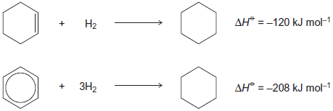

(a)     (i)      Use these data to show that benzene is 152 kJ mol−1 more stable than the hypothetical compound cyclohexa−1,3,5−triene.

______________________________________________________________

______________________________________________________________

______________________________________________________________

______________________________________________________________

**(1)**

(ii)     State, in terms of its bonding, why benzene is more stable than cyclohexa−1,3,5−triene.

______________________________________________________________

______________________________________________________________

______________________________________________________________

______________________________________________________________

**(1)**

(b)     Three carbon−carbon bonds are labelled on the structures shown.

These bonds are of different lengths.

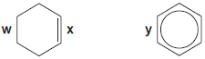

Write the letters **w**, **x** and **y** in order of **increasing** bond length.

___________________________________________________________________

**(1)**

(c)     The structures of two cyclic dienes are shown.

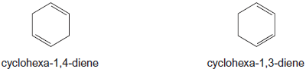

(i)      Use the enthalpy of hydrogenation data given opposite to calculate a value for the enthalpy of hydrogenation of cyclohexa−1,4−diene.

______________________________________________________________

______________________________________________________________

**(1)**

(ii)     Predict a value for the enthalpy of hydrogenation of cyclohexa−1,3−diene.

______________________________________________________________

**(1)**

(iii)    Explain your answers to part (i) and part (ii) in terms of the bonding in these two dienes.

______________________________________________________________

______________________________________________________________

______________________________________________________________

______________________________________________________________

______________________________________________________________

______________________________________________________________

**(3)**

**(Total 8 marks)**

**Q4.**

The relative molecular mass (*M*r) of benzene-1,4-dicarboxylic acid is

**A**       164

**B**       166

**C**       168

**D**       170

**(Total 1 mark)**

**Q5.**

1,3-dinitrobenzene can be prepared by heating nitrobenzene with a mixture of fuming nitric acid and concentrated sulphuric acid. The reaction can be represented by the following equation.

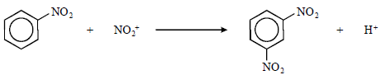

If the yield of the reaction is 55%, the mass of 1,3-dinitrobenzene produced from 12.30 g of nitrobenzene is

**A**       16.90 g

**B**       16.80 g

**C**       9.30 g

**D**       9.24 g

**(Total 1 mark)**