**Marcus Porcius Cato Uticensis – Cato the Younger 95-46 BC**

Born into a noble plebeian family in Rome, Cato the Younger was to stand as the voice of Roman traditionalists and to become the leading figure among the optimates.

He served as quaestor, tribune and praetor, always striving to preserve the traditional order of the Roman state.

He was uncompromising, formidable and unspoken in his conservative beliefs about the central role of the nobiles and the senate.

He took every opportunity to thwart what he perceived to be the unacceptable face of personal ambition embodied by populist individuals – notably Julius Caesar.

He committed suicide following the defeat of his army against Caesar at Thapsus in 46.

Discuss the implications and significance of the underlined words in this summary.

**The influence of Stoic philosophy**

Cato’s death symbolised the death of the Republic, which he had loyally if short-sightedly sought to uphold with unbridled vigour all his life: under the Principate [i.e. the Empire] he was idealised as a martyr of Republican liberty and a paragon of Stoic virtues.

*Scullard*

As you study Cato, consider the evidence for idealising him both as ‘a martyr of Republican liberty’ and as ‘a paragon of Stoic virtues’.

What counter-arguments could you raise?

Principles: knowledge, free will, moral rectitude, self-control, endurance of hardships, rising above pleasure and pain, removal from public and political life

How did the Romans combine these principles with their own values?

Why did these principles appeal to Cato and how did he use them to stand against what was going on in the Rome of his day?

Zeno, Greek philosopher (3rd century BC), founder of Stoicism

Watch this video about Stoicism and answer the questions:

<https://www.youtube.com/watch?v=Watnu7MdWpU>

1. What similarities does the speaker point out between Cato and Socrates?

2. What is the central principle of Stoicism and who is the only philosopher said to have achieved it?

3. Why did Stoicism appeal so much to Cato in the age in which he lived?

4. What do you think the speaker means by describing Cato as the ‘gadfly of Julius Caesar’?

5. Cato pursued the principles of Stoicism ‘not through books, but through example’, seeing them as to be ‘lived rather than written’. How did he do this, and how successfully?

6. What were Cato’s vices? How do these conflict with his Stoic ideals?

7. What was the only moment of Cato’s life when his philosophy is said to have abandoned him?

8. How was Cato’s service as military tribune in 67 different from that of typical tribunes?

9. How did Stoicism influence Cato’s final action against Julius Caesar?

10. How did Cato’s suicide turn him into an icon?

11. What do you think the speaker means by the ‘conflict between Cato the myth and Cato the man’?

12. How does the anecdote of the May festival illustrate the speaker’s point that ‘Cato was applauded and admired, but no one bothered to follow him’?

13. How did Julius Caesar show that Cato, and Cato alone, had got under his skin?

14. What does Cato’s legacy show about the myth surrounding Cato’s life?

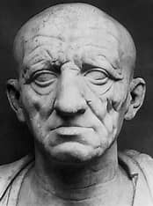Marcus Porcius Cato the Elder – Cato the Censor 234-149 BC

* Great grandfather of Cato the Younger – austere and morally upright, landowner and soldier;
* Climbed each rung of the cursus honorum – consul in 195, censor in 184;
* Believed his political duty was to preserve Rome’s culturally declining ancestral customs;
* Source: Plutarch (Greek biographer, AD 46-120), *Lives of the Noble Greeks and Romans*:

Cato the Younger lived, like his great grandfather, extremely frugally, learning to tolerate harsh physical conditions and studying hard.

He divorced his first wife, Atilia (with whom he had two children), for rumoured adultery; he later married another noblewoman, Marcia, who was of excellent reputation and also bore him two children.

Here is an example of his strong sense of unemotional reasoning and his loyalty to amicitia: despite his fondness for Marcia, Cato handed her over to his close optimate friend Hortensius, whose marriage was childless. After Hortensius’ death, Marcia returned to live with Cato.

How might this story illustrate how Cato approached politics?

Why might we need to be a bit cautious of using Plutarch as a historical source here?

As for the tenets of the Stoics, they could support doctrines quite distasteful to Roman Republicans, namely monarchy or the brotherhood of man. The Stoic teaching indeed was nothing more than a corroboration and theoretical defence of certain traditional values of the governing class in an aristocratic and Republican state.

*Syme*

Syme is warning us here to be cautious in seeing Stoicism as a clear philosophical principle in Rome. Rather, figures such as Cato cherry-picked the aspects of Stoicism which they could use to create a moral ‘Roman’ ideal from a Greek idea.

* Try to identify aspects of Cato’s life that appear to belong to a Roman ‘Stoic’ philosophy, and look also for examples of behaviour that do not.
* How useful are categories such as ‘Stoic’ or ‘populist’ when discussing politics in the late Roman Republic?

**Stoicism and Politics: uneasy bedfellows?**

Cato’s Stoic principles informed much of his decision-making: unmoved by emotive arguments, he stuck to his principles and political idealism, even when they went against his own personal interest. Consider:

* When he ran for the office of military tribune in 68, Cato was said to be the only candidate who did not resort to bribery of the electorate. This form of political corruption was rife in Republican Rome, but in Cato’s Stoic eyes, bribery represented an immoral lack of respect for the constitution and a lack of self-belief and determination as the best man for the job. He was elected nevertheless and was famed for living on an equal footing with his men, sharing the same food, work and quarters and rejecting the more luxurious lifestyle that went with his office. Leading from the front and renowned for the extreme discipline he expected as much of his men as he did of himself, he commanded the devoted loyalty of his legion.
* In 63, Cato supported the prosecution of the successful consular candidate, Lucius Licinius Murena, for bribery. Unfortunately for Cato, however, Murena was defended by … guess who … Cicero! Cicero won Murena’s case for him by arguing that the stability of the state was more important than the morals of the elected consul. Cicero praised Cato’s nobility, oratory and integrity, but also mocked his extreme Stoicism.
* In 60, Cato proposed and had passed two decrees against agents of bribery. But, in 51, he failed in his bid for the consulship, primarily because of his adamant refusal to gain support through bribery.

Plutarch records that Cato’s defeat in his campaign for the consulship was due to exasperation of the common folk, who were angry at his aloofness and refused to partake in the usual bribery that surrounded elections. … Cato believed that he had given offence to the people but he would not, however, change himself to accommodate them, and would not seek the consulship further. While the people might have applauded Cato for his moral integrity … this did not translate to votes for his consulship.

*Marin*

Do you consider Cato’s refusal to resort to bribery a political mistake?

Marin illustrates the key criticism consistently made of Cato: his stubborn determination to stick inflexibly to his principles meant that he failed both to achieve the full influence and power of which he was capable, and to prevent those hostile to his political aims, notably Julius Caesar, from fulfilling their own personal ambitions.

**Cato and the Optimates**

Three weapons the nobiles held and wielded, the family, money and the political alliances of amicitia. … Marriage with a well-connected heiress therefore became an act of policy and an alliance of powers, more important than a magistracy, more binding than any compact of oath or interest. … The noble was a landed proprietor, … but money was scarce, yet he required ready cash at every turn … Hence debts and corruption at Rome, oppression and extortion in the provinces. …

The competition was fierce and incessant. … Amicitia was a weapon of politics, not a sentiment based on congeniality. … Such were the men who directed in war and peace the government after Sulla, owing primacy to birth and wealth, linked by ties of kinship and reciprocal interest. They called themselves Optimates.

The ramifications of this oligarchy were pervasive, … but they lacked both principle to give inner coherence and courage to make the reforms that might save and justify the rule of class and privilege. … They stood sorely in need of a leader.

[In 63, speaking for the death penalty imposed by the consul, Cicero, on the Catilinarian conspirators] the speech and authority that won the day was Cato’s. Aged thirty-three and only quaestorian in rank, this man prevailed by force of character. Cato extolled the virtues that won empire for Rome in ancient days, denounced the undeserving rich and strove to recall the aristocracy to the duties of their station. This was not convention, pretence or delusion. Upright and austere, a ferocious defender of his own class, a hard drinker and an astute politician, the authentic Cato, so far from being a visionary, claimed to be a realist of traditional Roman temper and tenacity, not inferior to the great ancestor whom he emulated almost to a parody, Cato the Censor. But it was not character and integrity only that gave Cato the primacy before consulars: he controlled a nexus of political alliances among the nobiles.

*Syme*

* How did the Optimates reflect the traditional values of the Roman aristocracy?
* What problems did they face by the time of Cato in the 1st century BC?
* Identify three factors which drove Cato to champion the optimate cause (consider his family background, his political philosophy and the rise of populares individuals).
* How much of an optimate ‘insider’ was Cato? Compare him to Cicero: how much of an ‘outsider’ was he?

Timeline: Cato’s political offices and allegiance to the Optimates

|  |  |  |
| --- | --- | --- |
| 67 | Military tribune |  |
| 64 | Quaestor |  |
| 63 | Trial of Murena  Catilinarian Conspiracy  Recall of Pompey to Rome to ‘clean up’ any remaining supporters of Catiline | Cato stands against Murena on charge of bribery, but Cicero wins Murena’s case. Cicero, in Cato’s eyes, was a brilliant orator and supporter of conservative political ideals, but, as a novus homo, was socially, and so politically, inferior. Later, in 50, Cato was one of the few men in the senate to refuse public honour being granted to Cicero as governor of Cilicia: though he praised Cicero’s ‘rectitude, equity, clemency and good faith’, Cicero was furious that Cato had refused this honour.  Cicero as consul, having uncovered the conspiracy of Catiline to overthrow the senate, argued that the conspirators should be put to death for treason. This was unheard of for Roman citizens and, according to the contemporary historian Sallust, the majority of the senate did not agree with the sentence of capital punishment. But Cato spoke so eloquently and with such authority and conviction that the senate was moved to almost complete agreement: attempted treason was the same as treason itself – the men should be put to death. The motion was passed.  Cato shared in the optimate suspicion of Pompey, who had bypassed the established order of the cursus honorum to attain the consulship (too young) in 70 through his military prestige and the adoration of the people. Cato’s suspicion continued as Pompey was awarded imperium by two tribunes, representing the support of the urban masses: Gabinius in 67 (to rid the Mediterranean of pirates and stablise the corn supply) and Manilius in 66 (to defeat Mithridates in the east). Cato tried, unsuccessfully, to block Pompey’s recall, distrusting such a popular and militarily powerful individual. |
| 62 | Tribune of the Plebs | Why did Cato, a leader of the optimate cause, decide to run for a non-compulsory magistracy with its notorious association with perceived radicals like Tiberius Gracchus? Though curtailed by Sulla, the powers of the tribunate had been restored by Pompey and Crassus as consuls in 70, and tribunes through the 60s had agitated the ruling elite through a series of extortion and bribery trials and vetoes. Marin identifies 3 factors:   * Family tradition: Cato’s great uncle, as military tribune in 122, had presented bills to undermine the politics of the radical tribune of the plebs, Gaius Gracchus. Cato was keen to show how the office of tribune of the plebs could be used properly, working alongside the senate, as had Cato’s uncle, who was tribune of the plebs in 91. He therefore took care to put his proposals before the senate first rather than taking them straight to the tribal assemblies. * Desire to curry popular favour: Cato used his position as tribune to improve the economic position for the plebs, by introducing a law reducing the price of grain and extending the corn dole to double the original eligible group. By carrying these measures through the senate, he showed the senate to be sympathetic to the current hardships of the urban poor. * The tribunate carried very real power: only those of plebeian status could hold the office of tribune, precluding patricians such as Julius Caesar and offering Cato a good opportunity to establish his public standing and influence.   Contrary to its radical associations, therefore, and unlike Cicero, who did not stand for the tribunate because it seemed to stand for opposition to the traditional authority of the senate, Cato used the tribunate not only to enhance his own status and power, but as a force to strengthen the status quo of the political and social structures, extending the traditional role of patronage. |
| 60 | Further opposition to Pompey  Opposition to Caesar  First Triumvirate | Cato and the optimates closed ranks against Pompey, preventing the allocation of land to his long-serving veterans and blocking the ratification of his treaties in the East.  Caesar had asked for a military triumph in recognition of his subjugation of Gaul, and for the right to campaign in his absence for the consulship since he could not enter Rome while still holding military imperium. Cato and the optimates refused the latter request, hoping Caesar would choose the triumph, but Caesar thwarted them by forgoing the triumph and entering Rome to campaign (successfully) for the consulship instead.  Cato and the optimates consistently tried to block the measures of the popularis trio as they combined the wealth of Crassus, the military prestige of Pompey and the political and military prowess and popularity of Caesar to achieve the immediate political desires of each. |
| 58 | Cato removed from Rome by tribune Clodius - sent to annex Cyprus | Clodius represented the antithesis of everything that Cato stood for: Clodius’ record of public behaviour (mutiny, incest, sacrilege, affairs with married noble women, adoption into the plebeian order so he could stand as tribune to stir up trouble in the senate) made him an obvious antagonist to any Roman Stoic. Clodius dealt with Cato’s disapproval as soon as he became tribune by having him sent away to Cyprus, thus also supporting the triumvirate by keeping him out of Rome. |
| 54 | Praetor | Cato tried to clamp down on electoral bribery, but largely failed as voters were more interested in being able to continue receiving cash bribes. He also continued to show his hostility towards Caesar through the 50s, from threats of prosecution for illegal behaviour on campaign to influencing the senate not to agree to Caesar’s request. |
| 52 | Pompey as sole consul | When riots in Rome led to the consular elections in 53 being cancelled, Cato showed a rare moment of pragmatism by backing the proposal for Pompey to be elected sole consul for 52. Though this was unconstitutional, the alternative, proposed by Pompey, was for Caesar to be elected in his absence as consul alongside him. The optimates decided that Pompey as sole consul was the lesser of two evils. |
| 51 | Cato campaigns but fails to be elected consul |  |
| 50 | Curio as tribune proposes that both Caesar and Pompey should have over their imperium so they could return to Rome | Proposal vetoed by Cato and the optimates: civil war seemed inevitable. Pompey was offered extraordinary imperium over all the armies in Italy to protect the Republic, thus being forced to choose between alliance with Caesar and militarily championing the optimate cause, with tradition and the Roman Republic on his side. |
| 49 | Civil War | Cato and the optimates followed Pompey, whom they had opposed for decades. This showed the breakdown of the concept of the ‘optimates’ as politicians were forced instead to choose between two powerful individuals outside of the optimate cause. |
| 46 | Battle of Thapsus  Cicero publishes eulogy in praise of Cato  Caesar publishes his pamphlet ‘Anti-Cato’ | Republican forces defeated, Cato commits suicide rather than submit to Caesar’s rule.  Despite their earlier differences, Cato and Cicero shared their belief in the traditional values of Rome and the Republic, and had fought on the same side in the Civil War.  A cruel and vindictive piece of writing, reflecting Caesar’s long-standing deep anger and frustration with Cato |

Cato was the optimates’ most dangerous weapon when confronting the rise of individuals who were prepared to gain power through unconventional means, as demonstrated by the unequivocal and principled stances he took up from the second half of the 60s.

Consider this statement with reference to the notes above.

The death of Cato: Guerin, 1797

How did Cato’s suicide reflect his Stoic principles?

How does this statement show both Cicero’s admiration for Cato and his perception that he was unrealistic in his ideals?

With the best of intentions and the highest regard for the republic, he acts as though he lives in Plato’s republic rather than the sewers of Rome.

*Cicero*

Discuss to what extent you agree or disagree with the following statements:

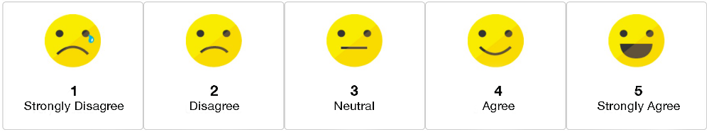Cato was incapable of compromise.

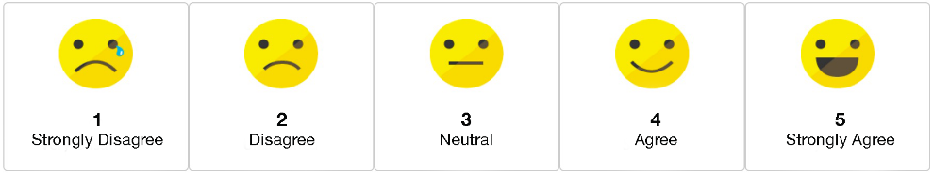Cato’s extreme and inflexible principles meant he acted in defiance of a turbulent period of political revolution.

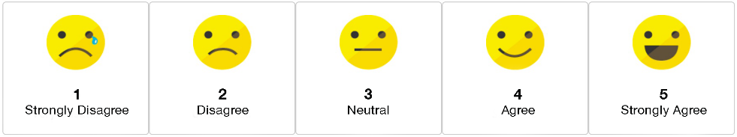Cato’s approach to politics was governed entirely by his determination to block all requests to the senate from self-seeking individuals.

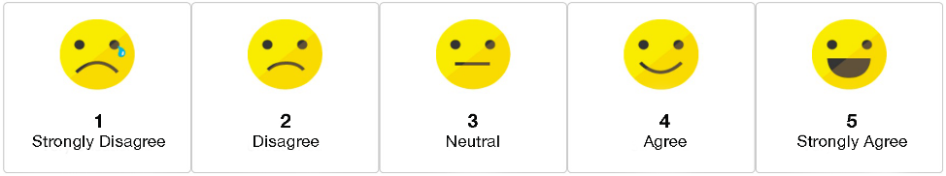

Cato was blinded by his principles and could not replace dogmatism with pragmatism.

Cato’s determination to preserve the outdated oligarchy of the optimates led him to exacerbate the demise not only of the optimates but of the Republic as a whole.

Cato’s dogmatic determination to prevent Crassus, Pompey and Caesar from gaining any ground in their ongoing individual ambition, particularly in cases they had brought constitutionally to the senate, pushed them to form the First Triumvirate, which signalled the end of the Roman Republic.