***The* Aristeia *of Achilles – Books 20-21***

*Read both these books of the Iliad carefully in order to include as much detail as possible*:

*How do the gods divide into two hostile groups after hearing Zeus’ words at the start of Book 20?*

***Achaeans Trojans***

*How do the following gods intervene throughout these books (give lots of detail)?*

***Apollo***

***Poseidon***

***Hephaestus***

*What impression do you get of Aeneas from book 20?*

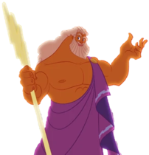

Aeneas

*Keep a track of all the people killed by Achilles on his rampage:*

*What do you think Achilles’ greatest moments were during these two books?*



