**The Aeneid – Book 6**

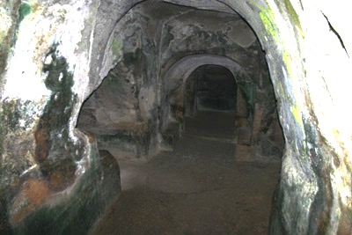

**Read lines 1-33**

What details at the start of this Book suggest that Virgil has brought his audience to a real place?

Location:

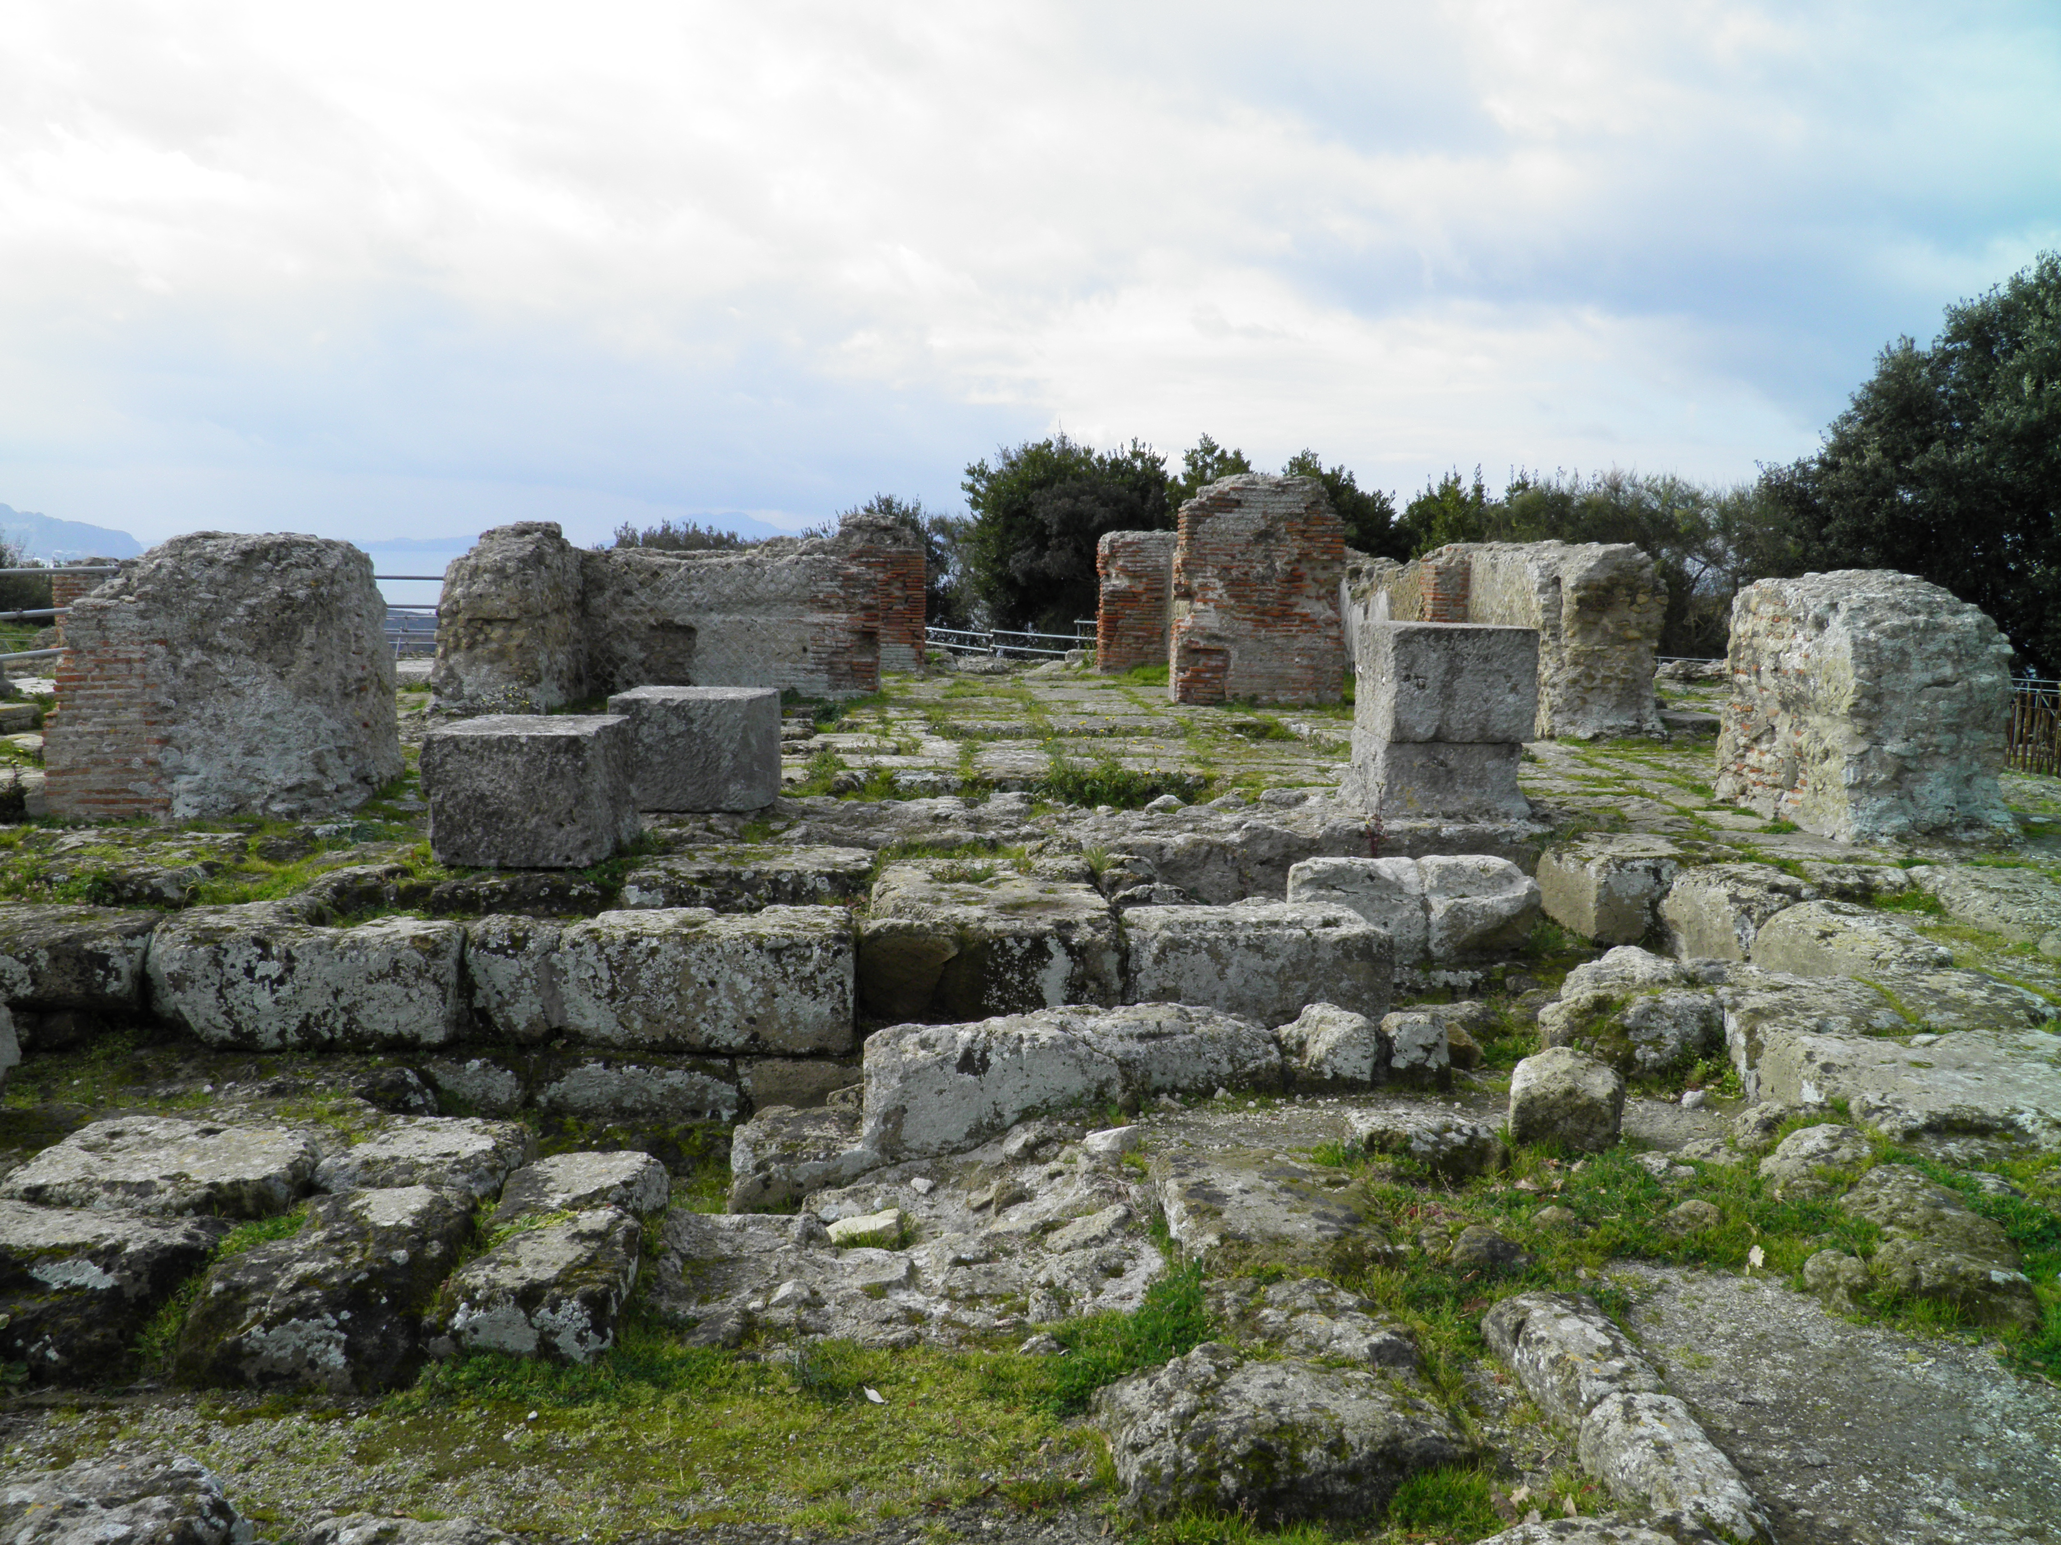

Location:

Virgil uses a type of description called ‘*ecphrasis’*, detailing a work of art set within a narrative poem. What two other examples have you met so far?

*Iliad:*

*Aeneid*:

What is depicted on each door of Apollo’s temple?

**Side 1**

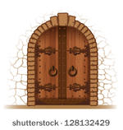

**Side 2**

How is the story on the doors related to the story of their creation?

Why do you think the labyrinth myth is a suitable parallel for what is to come in this Book?

**Read lines 34-149**

Annotate this picture with all the signs that the Sibyl is possessed by Apollo:

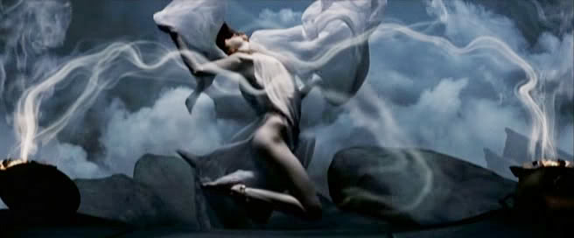

What has Apollo done to help the Trojans in the past?



What does Aeneas ask of…

…Apollo?

… the other (hostile) gods?

…the Sibyl?

How are the following events alluded to in this passage?

|  |  |
| --- | --- |
| **Event** | **Quote** |
| Augustus dedicated a new marble temple to Apollo on the Palatine Hill in 28 BC. |  |
| The Sibylline books, containing prophecies about Rome’s future, were placed in this temple with priests to look after them. |  |
| The *Ludi Apollinares* (Apollonian Games) were instituted in 212 BC, during the Second Punic War. |  |

Collect quotes that show how Virgil feels war is tragic:



How are the following features of the war to come later in the *Aeneid* reflected in features of the Trojan War?

|  |  |
| --- | --- |
| **Future War** | **Trojan War** |
| Fought around the river Tiber and its tributary the Numicius |  |
| The chief opponent will be Turnus, son of the nymph Venelia. |  |
| Lavinia, daughter of Latinus, was betrothed to Turnus but is given to Aeneas instead. |  |

How does Aeneas use the following arguments to be allowed to see his father in the Underworld?

* He had great care for his father:
* He wouldn’t be with the Sibyl if it was not for him:
* Others in the past have been allowed similar things:

How does the Sibyl paint a daunting picture of the Underworld?

Complete the following diagram for what Aeneas must do to enter the Underworld:

**Read lines 150-212**

What are the parallels between the story of Misenus and that of Elpenor in the Odyssey?

How is the discovery of the golden bough shown in a folkloric way?

* The Discovery:
* The tree itself:

**Read lines 213-236**

Compare the funeral of Julius Caesar with the funeral of Misenus in the *Aeneid*:

Additional details in the *Aeneid:*

Parallel quotes from the *Aeneid:*

When the funeral was announced, a pyre was erected in the Campus Martius near the tomb of Julia, and on the rostra a gilded shrine was placed, made after the model of the temple of Venus Genetrix; within was a couch of ivory with coverlets of purple and gold, and at its head a pillar hung with the robe in which he was slain…The bier on the rostra was carried down into the Forum by magistrates and ex-magistrates; and while some were urging that it be burned in the temple of Jupiter on the Capitol, and others in the Hall of Pompey, on a sudden two beings with swords by their sides and brandishing a pair of darts set fire to it with blazing torches, and at once the throng of bystanders heaped upon it dry branches, the judgment seats with the benches, and whatever else could serve as an offering…the veterans of the legions [offered] the arms with which they had adorned themselves for the funeral; many of the women too, offered up the jewels which they wore and the amulets and robes of their children.

[Suetonius, *Life of Caesar*, 84]

**Read lines 237-263**

Collect quotes to explain how Virgil creates a daunting impression of the Underworld:

|  |  |
| --- | --- |
| **Quote:** | **Explanation:** |
|  |  |
|  |  |
|  |  |
|  |  |
|  |  |
|  |  |
|  |  |

**Read lines 264-385**

Why do you think Virgil himself asks permission to describe the Underworld from the ‘*Chthonic’* deities?

|  |  |
| --- | --- |
| **What concepts does Virgil personify?** | **Why are they found in the Underworld?** |
| **Why are the significant to Virgil’s own experience?** | **What relevance do they have to the wider themes of the *Aeneid*?** |

Which mythical monsters appear:



Annotate the following picture of Charon:

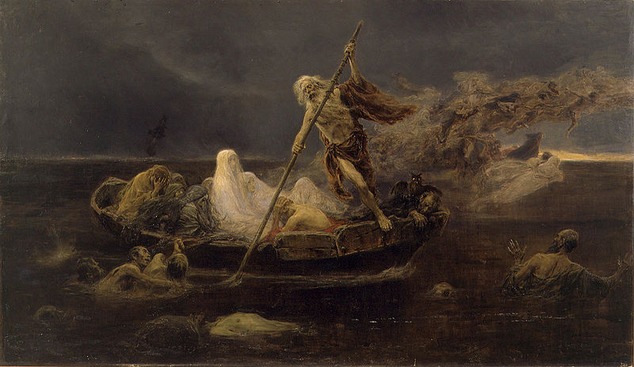

***Extension:*** Read *The Odyssey*, 11.36-43. What parallels can you find between this passage and Virgil’s depiction of the flocking shades?

What do we learn about swearing by the River Styx? What does that reveal about this particular oath?

Complete the following for passage beyond the Styx:

|  |  |
| --- | --- |
|  | Reason for denial: |
| Penalty charge: |
| Signed: Charon |

Complete the following for Palinurus’ fate:

|  |  |
| --- | --- |
|  | **X 3** |
|  |  |
|  |  |
|  |  |

What do we learn about Virgil’s view on Fate from the following quotes?

‘Apollo has not deceived you and no god drowned me in the sea.’

‘You must cease to hope that the Fate of the gods can be altered by prayers.’

How does the Sibyl’s promise to Palinurus contribute to our understanding of Virgil’s views of…

…divine signs?

…honouring the dead?

…immortality through memory?

…contemporary references?

**Read lines 386-426**

Why does Virgil mention heroes who have been to the underworld for a second time (here: Hercules, Theseus and Pirithous; previously: Orpheus, Pollux and Hercules)?

Annotate this picture with as many quotes as you can that show Charon and the Styx are full of despair:

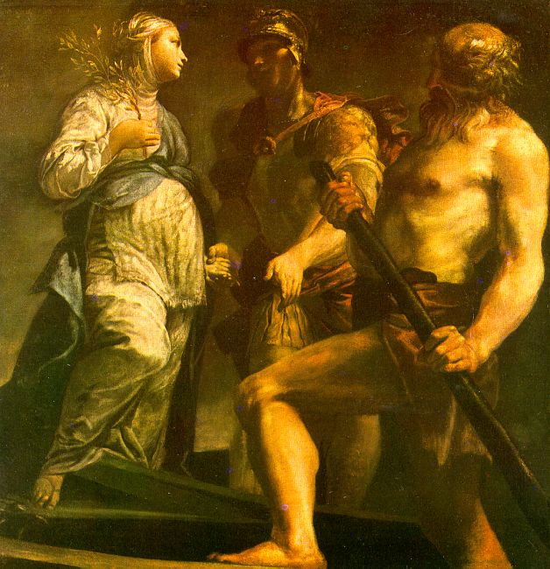

How does Virgil emphasise the size and ferocity of Cerberus?

**Read lines 427-548**

What types of people inhabit this ‘Limbo’ area of the Underworld?

|  |  |
| --- | --- |
| **Type of people** | **Description of their Underworld existence** |
| 1) |  |
| 2) |  |
| 3) |  |
| 4) |  |
| 5) |  |

Why does Virgil include the seven women from Greek mythology before Dido appears?

Find parallel quotes from Aeneas’ meeting with Dido’s ghost and explain what effect these have:

|  |  |  |
| --- | --- | --- |
| **Previous Quote** | **Book 6 Quote** | **Effect** |
| ‘It was not my own will that I search for Italy.’  [Book 4] |  |  |
| ‘the messenger of the gods…brought commands from Jupiter himself.’ [Book 4] |  |  |
| ‘Is it me you are running away from?’ [Book 4] |  |  |
| ‘It was the Caucasus that fathered you on its hard rocks.’  [Book 4] |  |  |
| ‘[Ajax] made no reply but went away into Erebus to join the souls of the other dead.’ [*Odyssey*, 11] |  |  |

Why do you think Virgil likes to use the following formula when introducing both Dido and Deiphobus?

How are the following characterised in Deiphobus’ account?

|  |  |
| --- | --- |
| **Deiphobus:** | **Aeneas:** |
| **Helen:** | **The Greeks:** |

How does Virgil create a vivid description of Tartarus?

|  |  |
| --- | --- |
| **Quote:** | **Explanation:** |
|  |  |
|  |  |
|  |  |
|  |  |
|  |  |
|  |  |
|  |  |

**Read lines 549-627**

|  |  |  |  |  |
| --- | --- | --- | --- | --- |
| **Named Individuals** | | | **Groups of Sinners** | |
| **Individuals** | **Fate** | **Mythological Parallel** | **Group** | **Fate** |
| Titans |  | Hesiod describes how they were cast into Tartarus by Zeus | Fraudsters |  |
| Sons of Aloeus [giants named Otus and Ephialtes] |  | Hyginus states they were bound to columns by snakes |
| Salmoneus |  | According to Hyginus, he was struck dead by Zeus’ thunderbolt. |
| Tityus |  | Fate first described in the *Odyssey* | Those who abused their families (hated brothers, beat fathers, defrauded dependents, kept money, adulterers) |  |
| The Lapiths, Ixion and Pirithous |  | Tantalus suffers Pirithous’ punishment in the *Odyssey*. According to Apollodorus, Pirithous was bound with snakes. Pindar states that Ixion was stretched out on a wheel. |
| Theseus |  | Apollodorus states that Theseus was bound with snakes until rescued by Heracles | Other sinners (supported tyrants for bribes, incest with daughters) |  |
| Phlegyas |  | Other Roman writers tell how Apollo killed Phlegyas after he set fire to his temple. |

Why do you think Virgil mimics some traditions and changes others?

What is the relevance of the categories of sinners added by Virgil?

**Read lines 628-752**

What impression of Elysium (‘land of joy’) do we get from this passage?

**Idealised version of life on earth**

**Types of people found here**

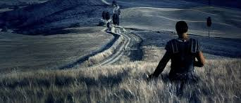

What does this tell us about Roman values?

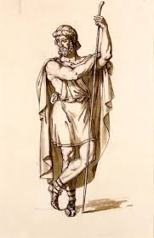What do we learn about the relationship between Aeneas and Anchises? See how many of the words below you can include in your description and use quotes if necessary.

**Word Bank**

*dutiful longing concern affectionate*

*proud advice enduring relief*

***Extension:*** How do lines 698-702 compare to *The Odyssey* Book 11, lines 205-214?

Annotate this diagram for Virgil’s views of creation, life and death:

How does Virgil’s view of the afterlife differ from that of Homer?

**Read lines 753-903**

What line does Anchises say that signifies he has taken over as a Aeneas’ guide from the Sibyl?

For the parade of future Romans, find quotes from Virgil that allude to the deeds of each:

|  |  |  |
| --- | --- | --- |
| **Hero** | **Event(s)** | **Quote(s)** |
| Silvius | Successor of Ascanius/Iulus who rules in Alba Longa. |  |
| Procas, Capys, Numitor, Silvius Aeneas | Military prowess of the Alban Kings. |  |
| Romulus | Foundation of Rome by the son of Mars, 753 BC |  |
| Numa | 2nd King of Rome, from the town Cures, known for religious reforms and peaceful law-giving |  |
| Tullus Hostilius | Warrior king who reintroduced Roman military ambitions |  |
| Junius Brutus | Expelled the Tarquins to found the Republic, serving as one of the first two consuls (510 BC). Executed one of his sons for trying to restore the the Tarquins. |  |
| Marcus Furius Camillus | Dubbed a ‘second Romulus’, he recaptured the legionary standards lost to the Gauls in 390 BC |  |
| Titus Manlius Torquatus | Executed his own son for dispbeying orders in 340 BC. |  |
| Publius Decius Mus | Father and son of same name, both said to have given their own lives to secure Roman victory (in 340 and 295 BC). |  |
| Gaius Atilius Regulus | Known as ‘Serranus’ (‘the Sower’). He was called to be consul whilst working on his farm in 257 BC |  |
| Marcus Claudius Marcellus the Elder | Consul five times who killed a Gallic chieftain in single combat, becoming the third Roman to gain the *Spolia Opima.* |  |
| Quintus Fabius Maximus ‘Cuncator’ | Gained the name ‘Cuncator’ (‘the Delayer’) for his delaying tactics against Hannibal, 217-216 BC. |  |
| Scipio Africanus Maior | Defeated Hannibal at the Battle of Zama, 202 BC. |  |
| Ameilius Paullus | Defeated King Perses of Macedonia in 168 BC. Perses claimed to be a descendent of Achilles |  |
| Scipio Africanus Minor | Destroyed Carthage of 146 BC. |  |
| Lucius Mummius | Sacked Corinth in 146 BC |  |
| Gaius Fabricius Luscinus | Fought against king Pyrrhus of Epirus, rejecting the gifts offered by Pyrrhus. |  |
| Julius Caesar and Pompey | Caesar brought his army from Gaul to fight Pompey’s legions from the East. Caesar defeated him at the battle of Pharsalus in 48 BC. |  |
| Augustus | Expansion of Roman Empire to its greatest extent by Virgil’s day  Capture of Egypt after the battle of Actium, 31 BC  Peace and prosperity restored after the civil wars following Julius Caesar’s death. |  |
| Marcus Claudius Marcellus the Younger | Augustus’ nephew and adopted son (in 25 BC). He died in his teens in 23 BC. |  |

What do we learn about what the Romans valued and how they honoured their heroes from this pageant?

What qualities does it appear the Romans disapprove of from this pageant?

Why do you think this parade ends in tragedy?

How does Aeneas exit the Underworld? What does this remind you of in Homer? What is odd about this choice of exit?