**3.3.11 Amines**

**AS Link:**

**3.3.3 – Halogenoalkanes (nucleophilic substitution)**

**A level link:**

**3.1.2 – Acids and bases (Brønsted-Lowry base)**

**3.3.9 – Carboxylic acids & derivatives (nucleophilic addition-elimination)**

**3.3.10 – Aromatic compounds**

**3.3.12 – Polymers (polyamides)**

**3.3.13 – Amino acids, proteins and DNA (amino acids)**

**Introduction**

**Amines** are produced **from ammonia**, with one or more **hydrogen** atoms **substituted** for an **alkyl** or **aryl** (aromatic) group. Amines are **very reactive compounds**, so they are useful as intermediates in synthesis (the making of new molecules).

**Primary, secondary** and **tertiary** amines exist where it refers to the number of **substituents** (R-groups) **attached** to the **nitrogen** atom. **Primary** amines have **one** R-group, **secondary** **two** R-groups and **tertiary** **three** R-groups. If the nitrogen has **four R-groups** bonded to it it’s called a **quaternary ammonium salt**, this is **not an amine**.

***Task: Draw structures***

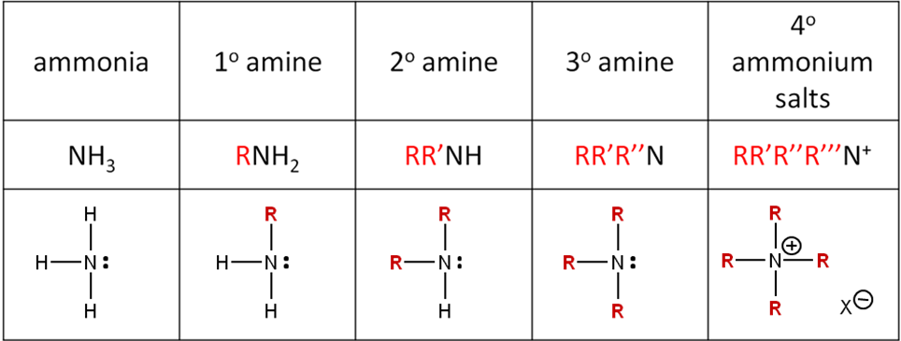

In **aromatic** compounds the **NH2** group is **attached** **directly** to the **benzene** ring to form **phenylamine**.

***Starter: 6.1 – Classifying amines and amides***

Naming amines

They are named using the **suffix – amine**. If other groups are present then the **prefix** **amino-** is used. The **R-groups** can be **identical** or **different** and can include benzene.

| **Type** | **General formula** | **Example** | **Structural formula** |
| --- | --- | --- | --- |
| Primary amines | RNH2 | ethylamine CH3CH2NH2 |  |
| Aromatic amine |  | phenylamine  non-systematic name is aniline |  |
| Secondary amines | RR’NH | ethylmethyl amine |  |
| Tertiary amines | RR’R’’N | trimethylamine  (CH3)3N |  |
| Quaternary ammonium salt | RR’R’’R’’’N+ | tetramethylammonium chloride  (CH3)4N+Cl- |  |

Different **substituents are listed alphabetically**, for example methylpropylamine, CH3(C3H7)NH.

***Task: Name or draw the amines (displayed formula)*** ***& classify***

1. CH3CH2NH2 ethylamine 1o
2. Dimethylamine (CH3)2NH 2o
3. (CH3)3N trimethylamine 3o
4. Ethylpropylamine CH3CH2(C3H7)NH 2o
5. C4H9(C2H5)NH butylethylamine 2o

Amides

Amides are derivatives of carboxylic acids; they contain the functional group –CONH2.

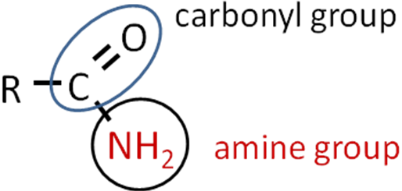

The **carbonyl group pulls electrons away from the nitrogen atom** so they have different properties.

The suffix -amide is used to name them and the prefix is from the acyl group (R-C=O).

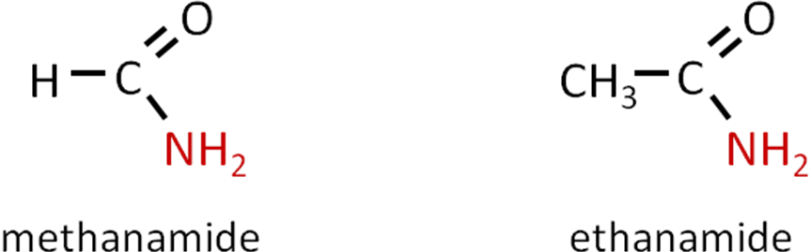

If an **alkyl group** is **attached** to the **nitrogen** in place of one of the hydrogen atoms then **N-substituted** amides are formed.

|  |  |
| --- | --- |
|  | N.B. The nitrogen is bonded to the carbon in the carbonyl group |

Naming them is similar to amides with the **addition of N-alkyl** at the beginning.

When naming think of the system of naming esters – it follows that same pattern

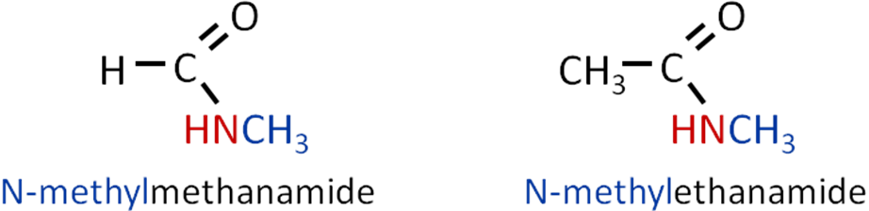

***Application: CGP212 PQ1-3***

***Fact recall: CGP212 Q1-3***

General properties

***Task: What do you know about ammonia?***

**Properties of amines**

* Bonding – covalent with one lone pair
* Shape – pyramidal with bond angle 107o due to lone pair repulsion
* Solubility – highly soluble in water due to H-bonding
* Boiling point – low, gas at RT (-33oC)
* Reactions – basic/alkaline (red litmus turns blue), nucleophile

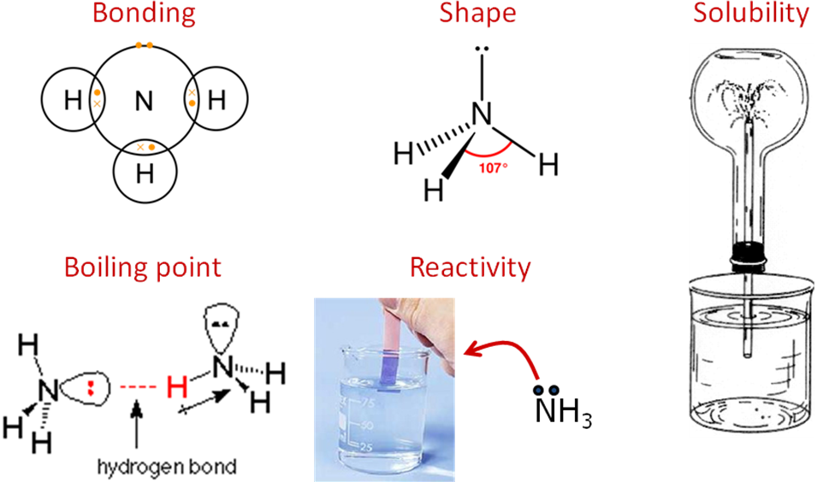

***Task: Predict the properties of amines***

**Properties of amines**

* Bonding – covalent with one lone pair
* Shape – pyramidal with bond angle 107o due to lone pair repulsion
* Solubility
  + chain length up to C4 very soluble in water & alcohol due to H-bonding
  + phenylamine insoluble due to benzene ring – almost same density as water
* Boiling point – low (weaker H-bonding than corresponding alcohol)
  + methylamine & ethylamine – gases
  + longer chains volatile liquids – fishy smell   
    (rotten fish & animals di & tri-amines from decomposition of proteins)
* Reactions – base, nucleophile

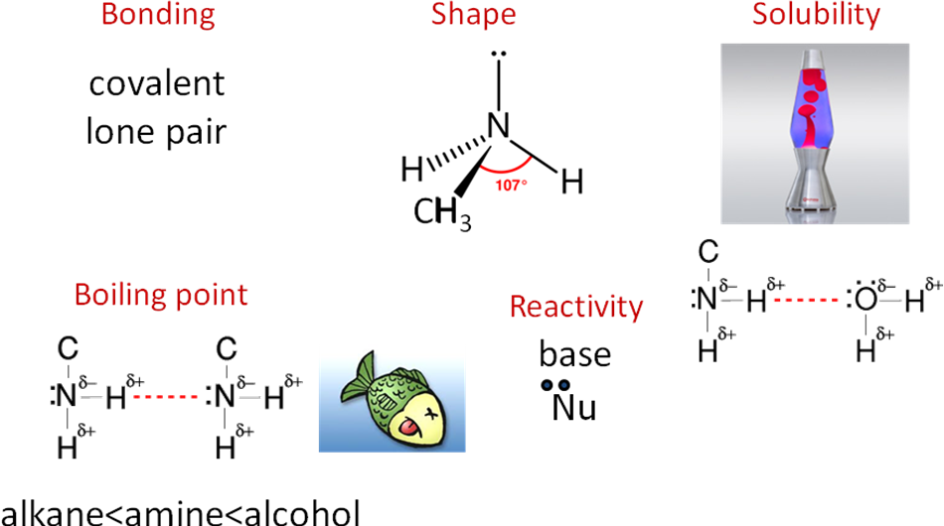

**Base properties of amines**

Ammonia and amines can **accept protons** (H+) so act as **Brønsted-Lowry** bases; this is due to the lone pair of electrons on the nitrogen atom which can form a co-ordinate bond with the hydrogen ion. They are also **Lewis bases** as they can **donate** a **lone-pair**.

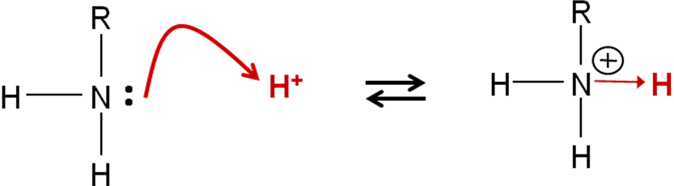

They are **weak bases** and the **strength** of the base depends on **how well the lone pair accepts a proton**. The **electron pair** will be **more available** to bond if the **electron density** is **greater** and that **depends** on which **groups** are bonded to the nitrogen.

The **more likely** the nitrogen **accepts** a **proton** the **stronger** the base.

Base strength

**Carbocations stability**

Electrophilic addition to unsymmetrical alkenes with HBr or H2SO4 can produce two possible products with the major product being formed via the **most stable carbocation.**

|  |  |  |  |
| --- | --- | --- | --- |
|  | 1o | 2o | 3o |
|  | | | |

***Task: What makes the carbocation more stable?***

Order of stability **3o>2o>1o** due to **inductive** (electron-releasing) **effect** of the alkyl groups

***Task: Ammonia & amines - put in order of base strength & explain why***

Prediction:

|  |  |  |  |  |
| --- | --- | --- | --- | --- |
| Ammonia | 1o | 2o | 3o | *Theoretically expect this order but in reality 3o amine is not as strong a base as  2o amine because it is less soluble in water.* |
|  | | | |

Alkyl groups **push electrons towards** the **nitrogen**; they have a **positive** **inductive effect** which is **greater** **than hydrogen**. This **increases the electron density on the nitrogen** **atom** making it a **better electron pair donor**. The **more alkyl groups** attached to the nitrogen the **higher the electron density on nitrogen**, so the **stronger** the **base**.

***Task: Where do you think an aromatic amine will appear?***

**Aromatic groups withdraw electrons away from the nitrogen atom** because the lone pair overlaps with the delocalised electrons. The **lone pair on the nitrogen** is **partly delocalised** into the benzene ring, this **decreases the electron density** so it is a **weaker base** than ammonia.

|  |  |
| --- | --- |
| Alkyl amine | Aromatic amines |
| Stronger | Weaker |
| Positive inductive effect - pushed towards | Negative inductive effect - withdraw away |
|  |  |

So, order to learn: **aromatic amines < NH3 < 1o < 3o< 2o**

|  |  |  |  |  |
| --- | --- | --- | --- | --- |
| Aromatic amine | Ammonia | 1o | 2o | 3o |
|  | | | | |

*It’s in this order because 3o amine is not as strong a base as 2o amine because it is less soluble in water.*

***Sheet: Base strength of amines***

**Reactions of amines**

**Amines have a lone pair** of electrons, so it may be used to **form a bond with**:

* **H+ ion**

– it is then acting as a **base** (proton acceptor)

* **electron-deficient carbon atom**

– it is then acting as a **nucleophile** (electron pair donor) in

* + **nucleophilic substitution** reactions with halogenoalkanes
  + **nucleophilic addition-elimination** reactions with acyl chlorides

Reactions as bases

* Amines react with acids to form salts

amine + acid → ammonium salt

* The products are ionic crystalline structures

***Task: Complete equations & name product***

|  |
| --- |
| 1. **ammonia + hydrochloric acid**   NH3 + HCl → NH4Cl ammonium chloride |
| 1. **ethylamine + hydrochloric acid** |
| 1. **methylamine + nitric acid** |
| 1. **diethylamine + sulphuric acid** |

Reactions as nucleophiles

Ammonia and amines act as **nucleophile** due to them being **electron-pair donors**, the **lone pair of electrons** will **attack partially positively carbon** atoms. So they take part in **nucleophilic substitution** reactions with **halogenoalkane** to **form amines** and **nucleophilic addition-elimination** reactions with **acyl chlorides** to **form amides**.

**Nucleophilic substitution**

# Nucleophile: NH3 (or amine)

# Reactant: halogenoalkane

# Conditions: warm **excess** ammonia in sealed container (under pressure)

# Product: primary amine e.g. ethylamine

Equations: 1. NH3 + RX → [RNH3]+ + X- nucleophile

2. [RNH3]+ + X- + NH3 → RNH2 + [NH4] X base

**primary**

Overall equation: **2**NH3 + RX → RNH2 + NH4X **N.B. 2 x NH3**

Example: CH3CH2Br + **2**NH3 → CH3CH2NH2 + NH4Br

# Mechanism:

# Alkylation reaction produces **alkyl ammonium ion intermediate**, then 2nd NH3 removes proton to produce amine

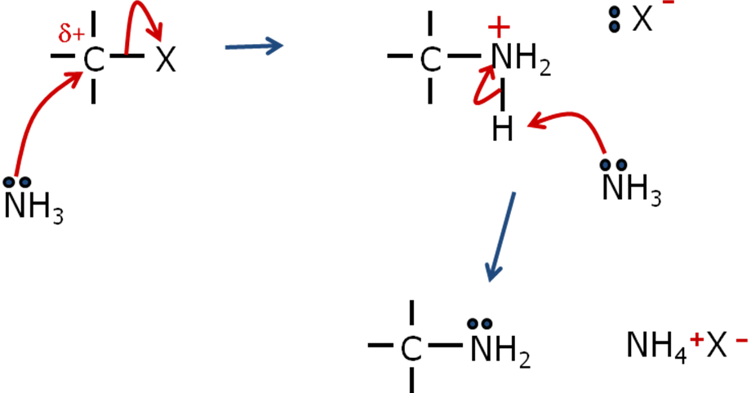

**Further substitution reactions**

The **primary amine** formed is also a **nucleophile**, it **competes** with the ammonia and **further substitution** is possible producing a dialkyl ammonium salt and then a **secondary amine**.

The de-protonation (removal of hydrogen from nitrogen) can be by ammonia or amine – depends on the relative concentrations.

**More likely to be the ammonia because it would be in higher concentration.**

Equations: RNH2 + RX → [R2NH2]+ + X-

**primary**

[R2NH2]+ + X- + NH3 → R2NH + NH4X

**secondary**

The process continues so a **secondary amine** can then **produce a tertiary amine**.

Equations: R2NH + RX → [R3NH]+ + X-

**secondary**

[R3NH]+ + X- + NH3 → R3N + NH4X

**tertiary**

And **tertiary amine** can then **produce a quaternary ammonium salt**.

Equations: R3N + RX → [R4N]+ X-

**tertiary quaternary salt**

This summaries the reactions:

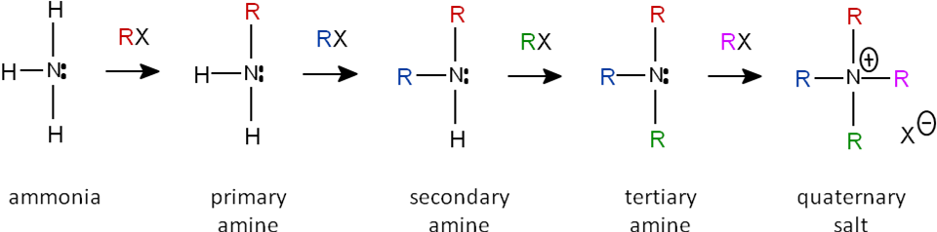

The mechanisms are identical. Reactions often result in a **mixture of 1o, 2o, 3o amines and 4o ammonium salt** being produced, so it’s not an effective way to make an amine, as **purity is an issue**.

***Task:***

***How could the products be separated?*** Fractional distillation (cost involved)

***How can a better yield of 1o amine be produced?*** Excess NH3

***How can a better yield of 4o ammonium salt be produced?*** Excess halogenoalkane

***Task: Work out the products formed, show mechanisms and name the products***

1. a) Give all organic products formed from methylamine (CH3NH2) and chloroethane (CH3CH2Cl)



ethylmethylamine diethylmethylamine triethylmethyl ammonium chloride

2o 3o 4o

b) Show mechanism for the formation of the tertiary amine in this reaction

Can use NH3 as the base

N.B. secondary amine is a stronger base than ammonia



2. Give all organic products formed from diethylamine (CH3CH2)2NH and 2-bromopropane



**Nucleophilic addition-elimination**

Ammonia and primary amines react with **acyl chlorides** and **acid anhydrides** to form **amines** and **N-substituted amides**, respectively in acylation reactions.

|  |  |  |  |
| --- | --- | --- | --- |
| Nucleophiles: |  |  |  |
| ammonia |  | 1o amine |
| Reactants: | acyl chloride or acid anhydride | | |
| Products: |  |  |  |
| amide |  | N-substituted amide |

Conditions: Room temperature and pressure

Equations: RCOCl + **2**NH3 → RCONH2 + NH4Cl

(RCO)2O + **2**NH3 → RCONH2 + RCOONH4

NB Excess ammonia needed to react with H+

RCOCl + RNH2 → RCONHR + HCl

(RCO)2O +RNH2 → RCONHR + RCOOH

General mechanism: (only need to be able to draw the mechanisms for acyl chlorides)

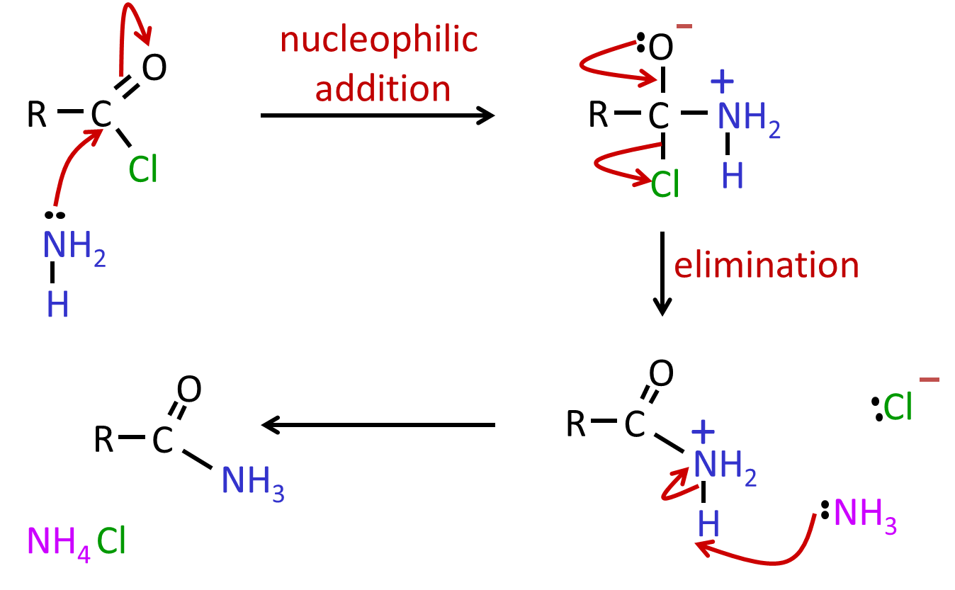

**Synthesis of amines**

The following methods can be used:

1. **Nucleophilic substitution** (halogenoalkane & ammonia) to give **alkyl amines**   
   – can lead to a mixture of 1o, 2o and 3o amines
2. **Nucleophilic substitution** (halogenoalkane & cyanide ion) followed by **reduction of nitriles** to give **primary amines**

*Reducing agent: Lithium aluminium hydride (LiAlH4) or hydrogen with a nickel catalyst (H2/Ni)*

1. **Electrophilic substitution** (benzene & conc. nitric acid plus conc. sulphuric acid catalyst) followed by **reduction of nitrobenzene** to give **aromatic amines**

*Reducing agent: Tin with hydrochloric acid (Sn/HCl) or iron with hydrochloric acid (Fe/HCl)*

Nucleophilic substitution

This method is **not usually used** due to the difficulties already described with the amines produced reacting again due to **further substitution**, giving a **mixture of products** so **purity is an issue**. The **desired amine could be separated**, **but** this is **time-consuming** and **expensive**.

Nucleophilic substitution followed by reduction

This is commonest way as it gives a **purer product** and is usually done in two steps:

**Step 1 - Reaction of halogenoalkane with HCN/KCN – nucleophilic substitution**

Nucleophile: CN- (cyanide ion)

Reactant: halogenoalkane + potassium cyanide

Conditions: aqueous ethanol

Product: nitrile

Equation: RX + CN- → **RC≡N** + X –

**Step 2 - Reduction of nitrile**

|  |  |
| --- | --- |
| The **nitrile** can be **reduced** using a **strong reducing agent** such as lithium aluminum hydride (LiAlH4) in dry ether, followed by dilute acid. **Sodium tetrahydridoborate (NaBH4) is not powerful** enough to reduce nitriles. |  |

# Reactant: nitrile + LiAlH4

# Conditions: dry ethoxyethane (ether) CH3CH2OCH2CH3

Product: primary amine

# Equation: RC≡N + 4[H] → **RCH2NH2**

Lithium aluminum hydride is too expensive to use in industry so catalytic hydrogenation is carried out using hydrogen and a nickel catalyst at a high temperature.

# Reactant: nitrile + H2

# Conditions: Ni catalyst & high temperature

Product: primary amine

# Equation: RC≡N + 2H2 → **RCH2NH2**

# **N.B. Final amine has one more C than the original halogenoalkane.**

***Task: Give two synthetic paths to making butylamine. Give equations for all reactions.***

a) CH3CH2CH2CH2Cl + 2NH3 → CH3CH2CH2CH2NH2 + NH4Cl

b) CH3CH2CH2Cl + KCN → CH3CH2CH2CN + KCl

CH3CH2CH2CN + 4[H] → CH3CH2CH2CH2NH2

Electrophilic substitution followed by reduction

|  |  |
| --- | --- |
| **Phenylamine** is the **simplest aryl amine** and it’s the starting point of many other chemicals. Its non-systematic name is aniline. |  |

# It’s made in industry using benzene produced from crude oil and is usually prepared by the reduction of nitro compounds in a 2 step process.

# **Step 1 - Producing nitrobenzene by electrophilic substitution**

# Benzene reacts with concentrated nitric acid in the presence of a concentrated sulphuric acid catalyst.

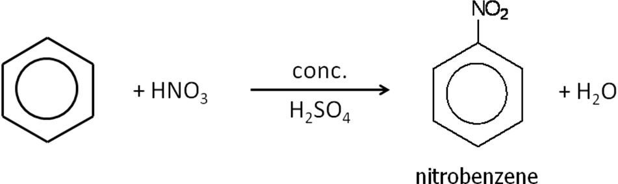

# ***Task: Show mechanism for this reaction***

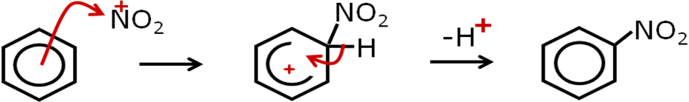

# **Step 2 - Producing phenylamine by reduction**

# Nitrobenzene is reduced using tin and HCl as the reducing agent, they form hydrogen.

# Reactant: nitrobenzene + Sn/HCl (lab) or Fe/HCl (industry) followed by NaOH (to liberate the amine from the salt that is formed)

# Conditions: acid added a little at a time under reflux

# Product: phenylamine

# Equations: ArNO2 + 6 [H] → ArNH2 + 2H2O

# Example: C6H5NO2 + 6 [H] → C6H5NH2 + 2H2O

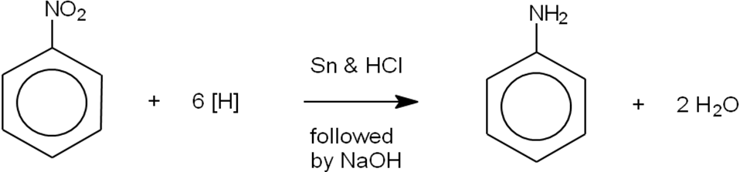

Since reaction is carried out in HCl the **salt C6H5NH3+ Cl- is formed** so NaOH is added to act as a **base and remove a proton** forming the ammonium ion:

# C6H5NH3+ Cl- + NaOH →C6H5NH2 + NaCl + H2O

**Distillation** is used to **separate** the **organic product** from the salt solution.

***Application: CGP216 PQ1-3***

***Fact recall: CGP216 Q1-4***

# **Uses of amines**

**Amines** are **used to** manufacture:

* Nylon
* Polyurethane foam

**Aromatic amines** are **used to** manufacture:

* Dyes
* Drugs

**Quaternary ammonium** compounds **used to** manufacture **cationic surfactants**:

* Hair and fabric conditioners
* Detergents

|  |  |
| --- | --- |
| They have **long hydrocarbon chains** which are insoluble in water but will bind to non-polar substances such as grease and a **positively charged organic group** which is soluble in water.  e.g. (CH3)2N[(CH2)16CH3]2+ Cl- |  |

This makes them useful as detergents as they can form **micelles**.

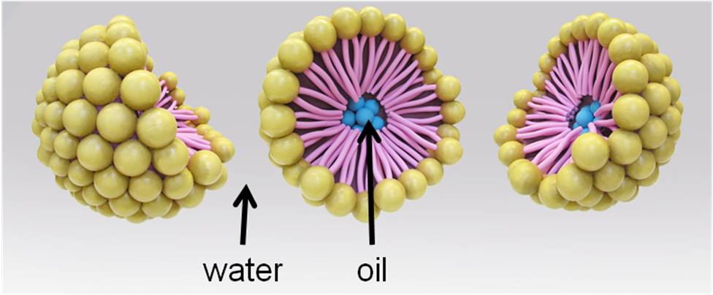

**Wet hair** and **fabrics** have **negative charges**, so a **positive cation will attract** to them **forming a coating** that **prevents build up of static electricity**. Keeping **surface** of hair or fabric **smooth** and prevents ‘flyaway’ hair.

***Exam questions: Oxford p190-191 Q1-7***