

**Marking Scheme**

**Change of Subject of Formulae**

Q1.

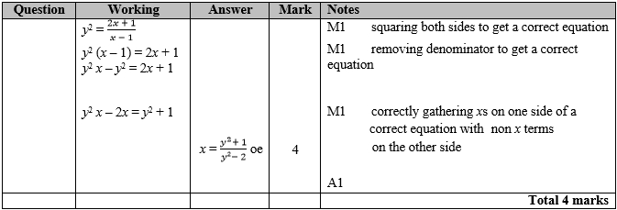

**Q2.**

The correct answer, unless clearly obtained by an incorrect method, should be taken to imply a correct method.

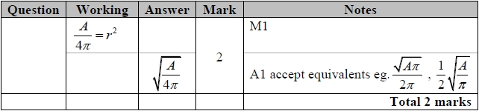

**Q3.**

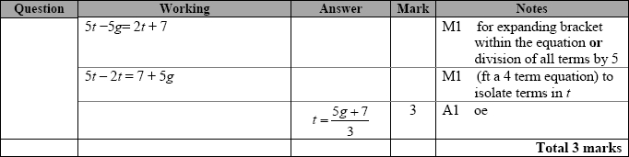

**Q4.**

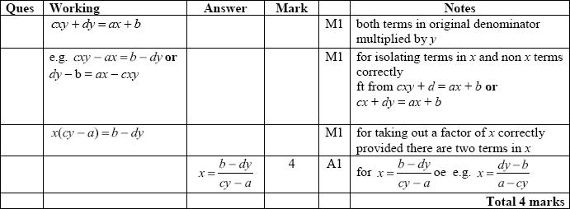

**Q5.**

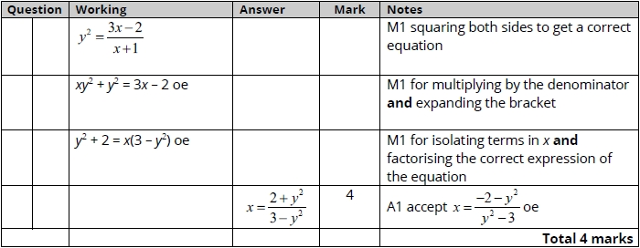

**Q6.**

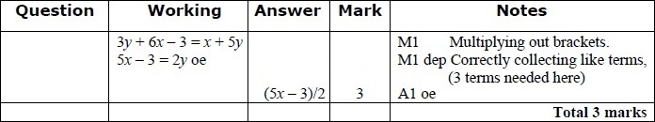

**Q7.**

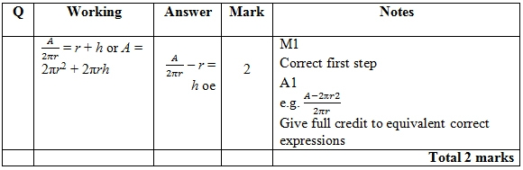

**Q8.**

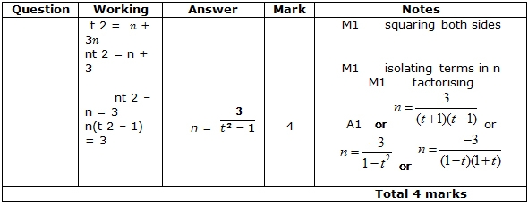

**Q9.**

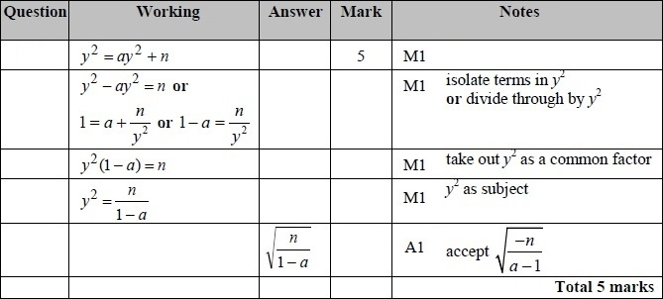

**Q10.**

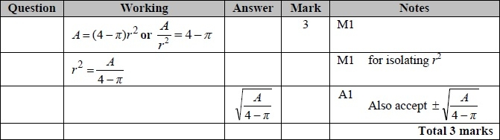

**Q11.**

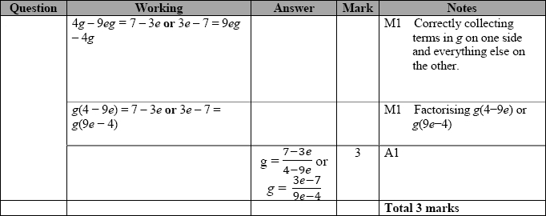

**Q12.**

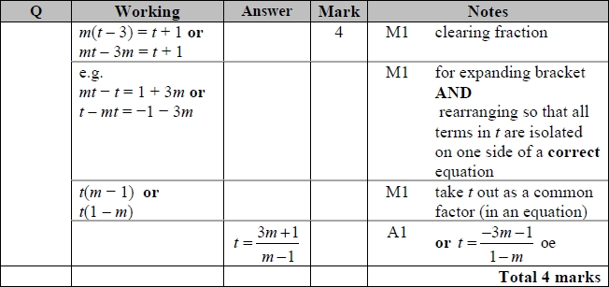

**Q13.**

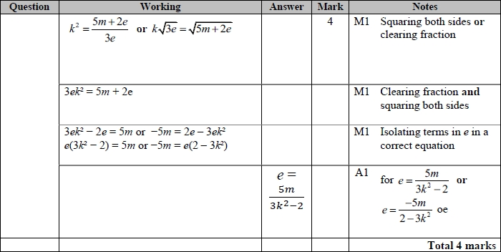

**Q14.**

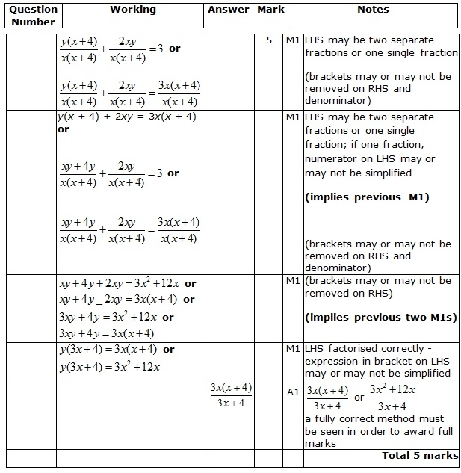

**Q15.**

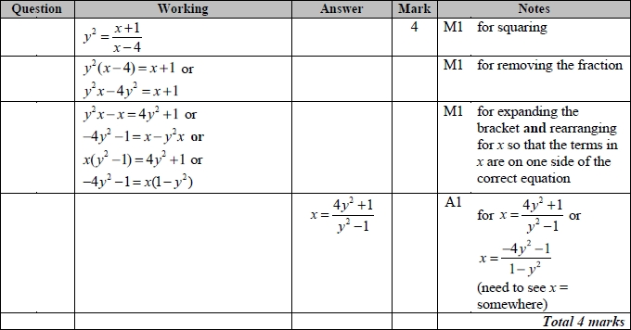

Question 16 and 17 currently unavailable. Speak to your Maths teacher.