POLITICS OF THE LATE REPUBLIC – Booklet of Questions

Paper layout:
Section A
Source A: extract from in Verrem or one of Cicero’s letters
- One or more short answer questions relating to the passage (2 or 3 marks in total);
- One 10-mark stimulus question related to the passage.
Ideas Question: sentence in bold type introducing an idea or concept you have studied
- One or two short answers questions related to the idea (2 or 3 marks – making a total of 5 marks with short answer questions on Source A);
- One 10-mark question related to the idea sentence.
Shorter Essay Question: statement for discussion
- One compulsory question – 20 marks
- Title will invite you to draw on material you have used in the source and/or ideas question above.
Section B
30-mark Essay Question
- Choice of two essays – only answer one!
- Needs structured and balanced argument on both sides of question (see planning grid below)
- Must include knowledge of modern scholarship – see quotes below for ideas – when planning essays, use all the references in your ‘Newsflash’ documents.

A SOURCE QUESTIONS – IN VERREM I
General discussion questions
- How important was the setting in which Cicero’s speech was delivered, and to what extent do you think the speech reflects this? Refer directly to the text for your evidence.
- How important to Cicero are his ideals of devotion to the Roman state and Roman values? Refer directly to the text for your evidence.
- To what extent would you consider this a politically important speech? Give reasons for your view.
1.
The thing which was desired most of all, O Judges, and which alone was thought to be the foremost factor in allaying the unpopularity of your order and the dishonour of the courts, seems, at this crucial time for the republic, to have been offered to and bestowed upon you; not by human counsel, but almost by divine influence. For now, a belief has become established, which is both destructive for the republic, and dangerous for you. The rumour is spreading, not only among the Roman people, but also among foreign nations, that in these courts as they exist now, no wealthy man, however guilty he may be, can possibly be convicted.
Now, in this time of crisis for your order and your judgements, when there are men prepared to try to kindle the unpopularity of the senate even further with speeches and the proposal of new laws, Gaius Verres has been brought to trial as a criminal. He is a man already condemned in everyone’s opinion by his life and actions, yet acquitted by the magnitude of his wealth, according to his own hope and public boast. I have undertaken this case as prosecutor, O Judges, with the greatest good will and expectation of the Roman people; not so that I might increase the unpopularity of the senate, but so that I might relieve it from the dishonour which I share with it. For I have brought a man before you whose case will enable you to restore the lost reputation of your courts, return to favour with the people of Rome, and satisfy foreign nations: a man, the embezzler of public funds, the abuser of Asia and Pamphyliae, the thief of the city’s rights, and the shame and ruin of the province of Sicily.
Chapters 1-2
1. What official position had Cicero held in Sicily? [1]
2. How does Cicero create a sense of crisis in these opening lines of in Verrem 1? Explain your answer using evidence from the passage. [10]

2.
Now, in this time of crisis for your order and your judgements, when there are men prepared to try to kindle the unpopularity of the Senate even further with speeches and the proposal of new laws, Gaius Verres has been brought to trial as a criminal. He is a man already condemned in everyone’s opinion by his life and actions, yet acquitted by the magnitude of his wealth, according to his own hope and public boast. I have undertaken this case as prosecutor, O Judges, with the greatest good will and expectation of the Roman people; not so that I might increase the unpopularity of the Senate, but so that I might relieve it from the dishonour which I share with it. For I have brought a man before you whose case will enable you to restore the lost reputation of your courts, return to favour with the people of Rome, and satisfy foreign nations: a man, the embezzler of public funds, the abuser of Asia and Pamphyliae, the thief of the city’s rights, and the shame and ruin of the province of Sicily.
Chapter 2
Cicero, in Verrem I.2
- In what year was this speech delivered? [1]
- What societal rank were the judges to whom Cicero refers in this passage? [1]
- What impression of the public opinion of the Roman Senate does this passage provide? [10]

3.
And, to say nothing of the dishonours and disgraces of his youth, what else happened in his quaestorship (the first step of honour); except that Gnaeus Carbo was robbed of public money by his own quaestor? That the consul was plundered and betrayed? His army deserted? His province abandoned? The religious duties and rites assigned to him by lot were violated? His lieutenancy was the ruin of all Asia and Pamphylia, provinces in which he pillaged many homes, most of the cities and all of the temples. This was when he renewed and repeated his former crime as a quaestor against Gnaeus Dolabella; when he not only deserted him at a time of peril, but even attacked and betrayed the man to whom he had been lieutenant and proquaestor, and whom he had brought into disrepute with his crimes.
… When this man was praetor, the Sicilians held neither their own laws, nor the decrees of our senate, nor common rights. Each person in Sicily has only as much left as either escaped the notice of that most avaricious and lustful man, or was left behind due to him being sated.
No legal decision was concluded for three years, unless it was in accordance with his will. No man’s property was safe; even if it had been given to him by his father and grandfather, he was deprived of it on that man’s command. Countless sums of money were taken from farmers’ property via new and nefarious system. The most faithful allies were included in the number of enemies; Roman citizens were tortured and killed like slaves; the greatest criminals were acquitted in court through bribery; the most honest men with the greatest integrity were prosecuted while absent, condemned and exiled without the chance to speak in their defence. The most fortified harbours, the greatest and most secure cities were left open to pirates and thieves; the sailors and soldiers of Sicily, our allies and friends, died of hunger; the best and most useful fleets, to the great disgrace of the Roman people, were lost and destroyed.
Chapters 11 + 13
1. For how long, in years, was Verres the governor of Sicily? [1]
2. Give two duties of a governor. [2]
3. How successfully does Cicero highlight Verres’ failures as a governor? Explain your answer with reference to the source. [10]

4.
[42] O trials worthy of being recorded! O splendid reputation of our order! When the allies of the Roman people are unwilling that trials for extortion should take place, which were instituted by our ancestors for the sake of the allies. Would that man ever have had a favourable hope of his own safety, if he had not conceived in his mind a bad opinion of you? On which account, he ought, if possible, to be still more hated by you than he is by the Roman people, because he considers you like himself in avarice and wickedness and perjury.
[43] And I beg you, in the name of the immortal gods, O judges, think of and guard against this; I warn you, I give notice to you, of what I am well assured, that this most seasonable opportunity has been given to you by the favour of the gods, for the purpose of delivering your whole order from hatred, from unpopularity, from infamy, and from disgrace. There is no severity believed to exist ill the tribunals, nor any scruples with regard to religion; in short, there are not believed to be any tribunals at all. Therefore we are despised and scorned by the Roman people; we are branded with a heavy and now a long standing infamy.
Chapters 42-43
- To whom is Cicero referring when he says, ‘our order’? [1]
- According to Cicero, why might the Roman allies not want extortion trials to take place? [2]
- How does Cicero emphasise the state of crisis of the Roman Republic in this passage? [10]

5.
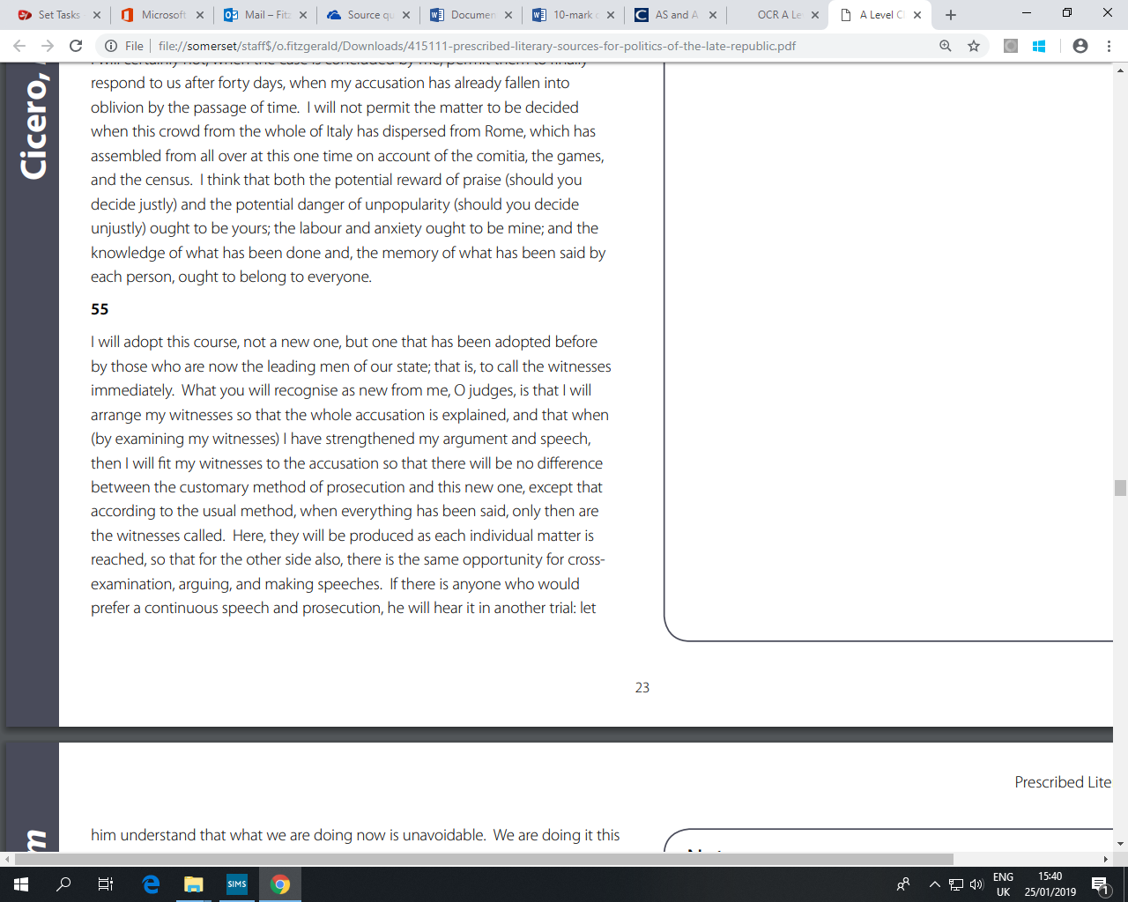

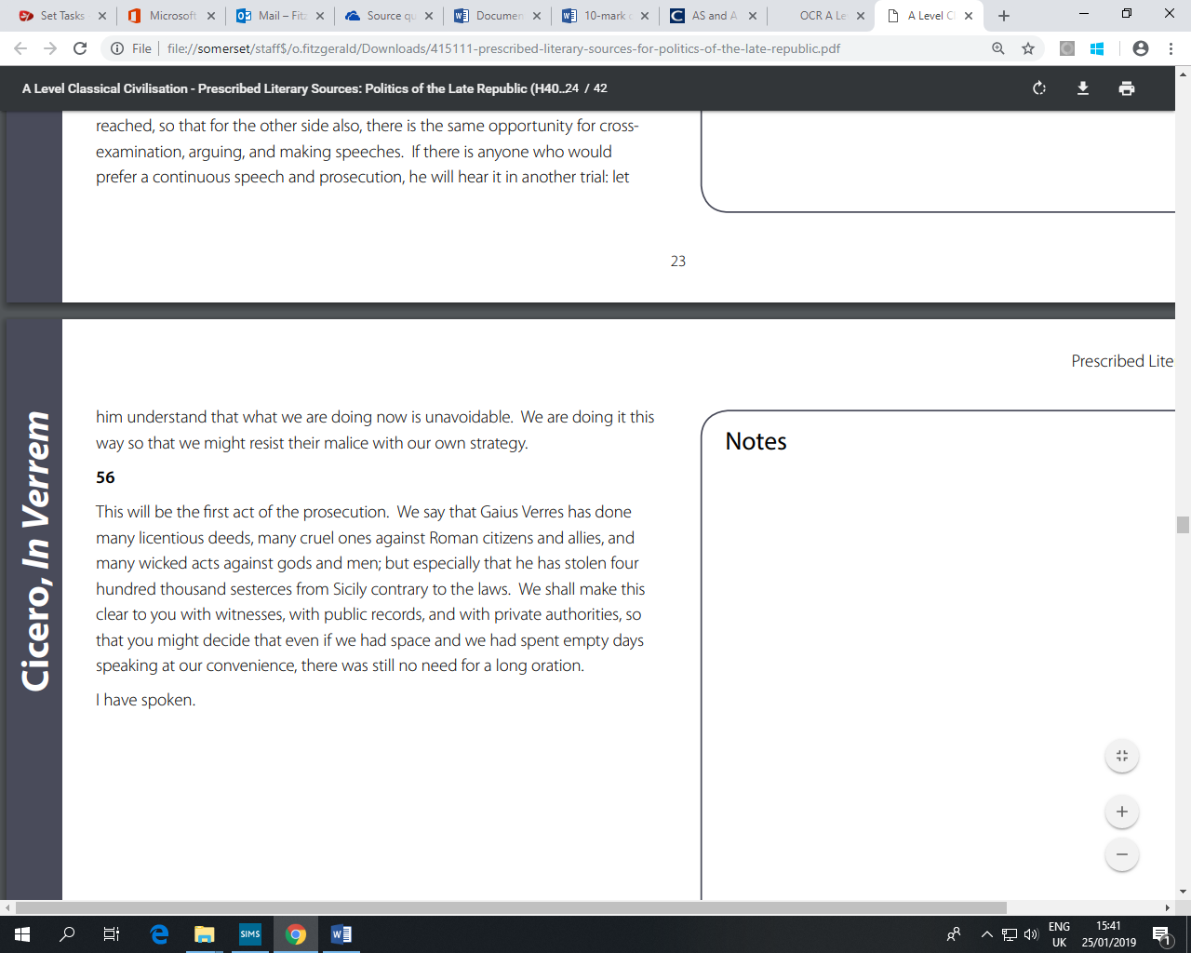

Chapters 55-56

- What is special about ‘this course’ which Cicero explains in this passage? [2]

- How is this an effective way to end his first speech against Verres? [10]

B SOURCE QUESTIONS – LETTERS
General discussion questions
- In what ways was letter-writing important to Cicero’s political life?
- How much of a window onto Cicero’s political idealism do we get from reading this sample selection of letters? Refer to the texts of the letters for evidence.
- Are some of Cicero’s letter more trustable historical sources than others? Explain your view with direct reference to texts of the letters.
1.

To His Friends 5.7: To Pompey – 62 BC
From your official dispatch, I – along with everyone else – take incredible pleasure. For you have given us that strong hope of peace of which I, trusting so completely in you, was assuring everyone. But I must inform you that your old enemies – now posing as your friends – have received a stunning blow by this despatch, and, being disappointed in the high hopes they were entertaining, are thoroughly distressed. The private letter to me contained a somewhat slight expression of your affection, yet I can assure you it gave me pleasure. There is, however, nothing in which I find greater satisfaction than in the knowledge of serving my friends. And, if on any occasion I do not meet with an adequate return, I am not at all sorry to have the balance of kindness in my favour. I feel no doubt that even if my extraordinary enthusiasm on your behalf has failed to unite you to me, the interests of the state will certainly create a mutual attachment and coalition between us.
To leave you in no doubt of what I missed in your letter, I will write with the candour which my own disposition and our common friendship demand. I did expect some congratulation in your letter on my achievements, both for the sake of the ties between us and that of the republic. This I presume to have been omitted by you for fear of hurting anyone’s feelings. But let me tell you; what I did for the salvation of the country is approved by the judgement and testimony of the whole world. When you return home, you will know the great wisdom and courage I showed, and you – a much greater man than Africanus was – will find it easy to admit me – one who is not much inferior to Laelius – into association in politics and friendship.
1. Where was Pompey sending his ‘official dispatch’ from? [1]
2. ‘I did expect some congratulation in your letter on my achievements … from a fear of hurting anyone’s feelings.’
a) What are the ‘achievements’ that Cicero is referring to? [1]
b) Who might have disapproved or had their feelings hurt if Pompey had congratulated Cicero? [1]
3. What impression of Cicero’s relationship with Pompey does this letter create? Explain your answer with reference to the source. [10]

2.

To His Friends 2.11: To Caelius – 50 BC
Would you have ever thought it possible that my words would fail me, and not only the oratorical sort, but common vernacular language? They do fail me, and for this reason: I am extraordinarily anxious about what will be decided about the provinces. It is surprising how I long for Rome, you cannot believe how I long for my friends, in particular yourself. As for the province, it bores me, either because I have gained fame, to such an extent I do not desire to increase it, rather to fear its reversal; or, because is not is worthy of a man of my dignity, who before can and has borne heavier burdens to serve the state; or because I fear great war hanging over us, that I seem likely to escape if I leave on the appointed day.
Now, about the panthers; it is being carefully attended to, as per my orders, by those who are accustomed to hunting them. There are, however, very few, and those there are, I am told, complain that in my province they are the only living creatures for whom traps are set. So it has been decided that they should leave the province for Caria. But still, attempts are being made, in particular by Patiscus. Whatever comes to hand will be yours, but how many it will be, I do not know. By the Gods, your aedileship is of great concern to me. This day reminds me of it, because I write this on the day of the Megalensia itself. I would like you to write carefully about the entire political situation, for I shall regard that which I get from you to be the most trustworthy information.
1. Where was Cicero when he sent this letter and what was he doing there? [2]
2. Why would Caelius want panthers? [1]
3. What image of Cicero does this letter provide? Explain your answer with reference to the text. [10]

3.

To Atticus 8.8: To Atticus - Formiae, 23rd February 49 BC
Oh what a dishonourable and therefore miserable thing! For I feel that misery lies mainly or solely in dishonour. He developed Caesar, then he suddenly began to fear him; he rejected all offers of peace; he made no preparations for war; he left Rome; he was to blame for the loss of Picenum; he confined himself in Apulia; he went to Greece; leaving us all without a word, or letting us in on his extraordinary plan upon which so much depended. Suddenly, a letter came to him and his Consuls from Domitius. It seemed to me to be as though the light of honour flashed from Pompey’s eyes, and the real man he ought to be exclaimed:
“So let them scheme as they must,
And attempt every trick,
Yet right is on my side.”
But Pompey bids a long goodbye to honour, and proceeds for Brundisium. As for Domitius, they say upon hearing this, he and those with him surrendered. Oh, what a terrible business! I am too distressed to write much more – I hope for your letters.
1. Whom did Cicero meet at Formiae in March 49 BC? [1]
2. Which side did Cicero join in the Civil War of 49-48 BC? [1]
3. Describe what happened to Pompey at Pharsalus in 48 BC. [1]
4. Explain what this letter reveals about Cicero’s opinion of Pompey. [10]

4.

To Atticus 14.4: To Atticus - Lanuvium, 10th April 44 BC
Now, what do you think I hear in Lanuvium? In contrast, I suspect there in Rome you hear news every day. Things are boiling up, if Matius talks like that, what do you think the rest will do? On my part I am sorry that what has happened is unprecedented in a state; that freedom has been restored without a free state. It is horrible what talk and threats there are. Also, I am afraid of wars in Gaul and where Sextus will end up.
Yet come all, the Ides of March console us. Our heroes achieved all they were able, gloriously and magnificently. The things which remain, they require men and money; of which we have none. This from me to you – if you have any news (for I expect you hear some every day) send it to me. If you have nothing, nevertheless do not interrupt our custom. I shall not.
1. Why was Cicero at Lanuvium? [1]
2. Name one person to whom Cicero is referring when he says ‘our heroes’. [1]
3. Explain how Cicero shows his own desperation in this letter. [10]
C 10-mark IDEAS QUESTIONS – Grouped as far as possible by topic
Republican government and the cursus honorum
In the Late Republic Rome’s system of government relied on politicians competing to hold various offices known as the cursus honorum.
a) Which office was originally created to protect the interests of the common man? [1]
b) Identify one feature of the office of dictator which was unusual during this time. [1]
c) Analyse how fair you consider the organisation of political offices was for the Roman people. [10]

It has been said that Roman voters could not bring themselves to elect a man to political office unless his family had long been associated with major events in the history of the Roman Republic.
a) What was a ‘novus homo’? [1]
b) Name a ‘novus homo’. [1]
c) How did the structure of Roman society, in particular the systems of patronage and ‘amicitia’, make it more difficult for a ‘novus homo’ to make his way in politics? Explain with reference to the ‘novus homo’ you have named above.

First Triumvirate
From approximately 60 BC to 53BC Julius Caesar and two other men acted as an unofficial, political alliance often referred to as the ‘First Triumvirate’.
a) Who were the two other members of the Triumvirate? [2]
b) Explain what actions taken by Caesar, whilst a member of the Triumvirate, would be in keeping with the ideals of a popularis. [10]

Cicero’s career and ideals
Cicero successfully prosecuted Gaius Verres in 70 BC, for corruption during the three years Verres was governor of Sicily.
a) In which city did the prosecution of Verres take place? [1]
b) Give two reasons why Cicero took on the case to prosecute Verres. [2]
c) Explain how Cicero made the trial as much about the Republic as about Verres. [10]

Cicero’s political career was not a typical one for a member of the Roman elite.
a) State two ways in which Cicero’s career was not typical. [2]
b) Explain to what extent Cicero’s actions remain consistent with his political ideals during his career. [10]

Becoming a consul was often the high point of a Roman’s career.
a) In which year did Cicero hold the consulship? [1]
b) Name two key events that involved Cicero that year in Rome. [2]
c) To what extent was becoming consul the high point of Cicero’s career? [10]

Cicero and Civil War
From 52BCE to 45BCE Rome slid into and then endured a period of Civil War.
- What action by Caesar marked the start of the war? [1]

- Who was in charge of the Republican forces? [1]

- Explain what actions taken by Cicero in this period were in keeping with his political principles. [10]

Cato
Cato the Younger was known for his Stoic principles and for championing the cause of the Optimates.
a) After which battle did Cato commit suicide? [1]
b) Give one reason for his action. [1]
c) Explain how Cato applied his Stoic principles to his politics throughout his career. [10]

The office of ‘tribune of the plebs’ was not a compulsory rung on the ladder of the cursus honorum, but was of key importance in the politics of the 1st century BC.
a) What was the highest position of political office that Cato held, and in what year did he serve in that office? [2]
b) Explain the potential reasons why Cato stood as tribune in 62 BC. Consider that role of the tribune at that time and Cato’s aims and beliefs. [10]

Julius Caesar and Civil War
Julius Caesar in many ways followed a model Roman Republican statesman’s career: he became quaestor in 69, aedile in 65, praetor in 62 and consul in 59.
a) How many times did Caesar hold the consulship during his lifetime? [1]
b) What important position of religious authority did Julius Caesar hold from 63 BC? [1]
c) In what ways did Julius Caesar’s career deviate from the traditional model of a Republican career? [10]

Julius Caesar’s actions throughout his career were motivated by a selfish desire for power.
a) Where was Caesar based in 49 BC and what action of his precipitated the civil war? [2]
b) What office did Caesar create for himself at the start of 44 BC? [1]
c) Explain the opposition faced by Caesar in Rome which arguably forced his hand in declaring civil war. [10]
D 20-mark essay questions (‘shorter essay’ – 1 compulsory question)
This will be based on a statement for discussion. You will be expected to use the printed source (Verres speech or one of the letters) as a starting point, but to link this to your knowledge of the whole context. I have included for each question the source printed on the paper for you to refer to.

Political and social structure
1. Assess to what extent the political careers of Verres and Pompey demonstrated that Roman politicians had to follow a fixed career path.
Use Against Verres I, chapters 11 + 13, as a starting point and justify your response.
2. ‘Without patronage and ‘amicitia’, a politician in the late Republic could not be successful.’ Assess how true this is in the cases of Cicero and Cato.
Use Cicero’s letter To Caelius – Laodicea, 50 BC, and your knowledge of the careers of Cicero and Cato, as starting points and justify your response.
3. ‘Outside of the senate, the people of Rome were politically powerless.’ Explain to what extent you agree with this view.
Use the opening and closing chapters of Against Verres I, and Cicero’s letters To Curio – Rome, 53 BC and To Atticus – Formiae, March 49 BC, and your knowledge of Roman politics and social hierarchy, as starting points and justify your response.

Cicero’s letters
4. ‘In his correspondence with Atticus, Cicero was interested only in politics which took place in Rome.’ Explain to what extent you agree with this view, based on the letters which you have read.
Use Cicero’s letter To Atticus – Formiae, 23rd February 49 BC as a starting point and justify your response.

Cicero, Caesar and the Civil War
5. ‘Cicero’s political principles inevitably drove him to Pompey’s side in the Civil War of 49 BC.’ To what extent do you think this is a fair assessment?

Use Cicero’s letter To Caesar - Formiae, 19th or 20th of March 49 BC, and your understanding of Cicero’s political beliefs, as starting points and justify your response.
6. ‘Cicero and Caesar were always in disagreement and opposed to each other.’ To what extent do you think this is a fair assessment?

Use Cicero’s letter To Pompey – Rome, 62 BC, and your knowledge of the aims and ideas of the First Triumvirate, as starting-points and justify your response.
7. ‘Cicero’s political ideals meant that he felt only joy at the assassination of Caesar.’ Explain to what extent you agree with this view.
Use Cicero’s letter To Atticus – Lanuvium, 10th April 44 BC as a starting point and justify your response.
8. ‘The civil war that broke out in 49 BC was Julius Caesar’s fault.’ To what extent do you agree with this statement?
Use Cicero’s three letters written in 49: To Caesar – Formiae, March 49; To Atticus – Formiae, February 49; To Atticus – Formiae, March 49 and your knowledge of the relationships between Caesar and other key political players as your starting points and justify your response.

30 Mark Question Planning Grid

Introduction: | Context; define key terms from the question; link to broad themes and issues; set out what you will cover briefly on both sides; possibly give your opinion.
POINT 1 | Point linked to argument, Answering The Question (ATQ), priority? (i.e. how important)
Evidence for point 1 (give at least 3 preferably 4 specific examples from different parts of the text)
Engagement with secondary literature | Scholar+ view + how it links to your argument – use of phrase bank e.g. ‘I agree with’
Concluding sentence
POINT 2 | Point linked to argument, Answering The Question (ATQ), priority? (i.e. how important)
Evidence for point 2 (give at least 3 preferably 4 specific examples from different parts of the text)
Engagement with secondary literature | Scholar+ view + how it links to your argument – use of phrase bank e.g. ‘I agree with’
Concluding sentence
POINT 3 | Point linked to argument, Answering The Question (ATQ), priority? (i.e. how important)
Evidence for point 3 (give at least 3 preferably 4 specific examples from different parts of the text)
Engagement with secondary literature | Scholar+ view + how it links to your argument – use of phrase bank e.g. ‘I agree with’
Concluding sentence
Possible further points? | Point linked to argument, Answering The Question (ATQ), priority? (i.e. how important)
Evidence for point 1 (give at least 2, preferably 3 specific examples from different parts of the text)
Conclusion | Draw together strands of argument; give own opinion
Make sure you have a balanced discussion.
E 30-mark questions
Use the planning grid above and remember that for the 30 mark question, you must engage critically with secondary material. Ideas for secondary sources on all topics are printed at the end of this document, but you can use others, too – particularly those printed in your big ‘newsflash’ booklet.

Key individuals
1. Evaluate how far the key players in Roman politics between 63BCE and 44BCE were motivated by ambition rather than ideals. Discuss at least two key players. [30]
2. ‘The attitudes of a few individuals, rather than a flawed system of government, led to the downfall of the res publica.’ Assess how true you consider this statement to be by discussing at least two individuals. [30]
3. ‘Cato’s Stoic principles meant that he never achieved the highest office, while Caesar’s opportunism allowed him to do so.’ Discuss to what extent you agree with this view. Justify your response. [30]
4. ‘Caesar and Cicero were killed primarily because of their political ideals.’ Explain to what extent you agree with this statement. Justify your response. [30]
5. ‘Cato was the real champion of the Optimates, Pompey only used them for his own benefit.’ Assess to what extent you agree with this statement. Justify your response.
[30]

The First Triumvirate
6. Assess to what extent the attitudes of Cicero and the members of the First Triumvirate were completely incompatible. Justify your response. [30]

Cicero
7. How consistent are Cicero’s political principles across the range of his correspondence that you have read? [30]
8. ‘In both his oratory and his correspondence, Cicero cared more about the form and style of his writings than about facts and truth.’ Discuss to what extent you have found this to be the case. [30]
9. ‘Cicero was driven by personal ambition more that principle.’ To what extent do you agree with this opinion? Justify your response. [30]
10. To what extent would you agree that Cicero had strong principles, but lacked good judgement? Justify your response. [30]
11. Assess to what extent you would agree that Cicero’s opposition to Verres and Catiline was as much about his own political career as it was about the wrongdoings of these men. Justify your response. [30]
12. ‘Cicero’s attitude towards Mark Antony represented his political views which were expressed throughout Cicero’s career.’ Discuss to what extent you have found this to be the case. Justify your response. [30]

The Civil War
13. ‘The outbreak of civil war in 49BCE was more a result of the beliefs and principles of the key players than practical considerations’. To what extent do you agree with this statement? You should consider at least two of the key players in your answer. [30]
14. Who do you think was responsible for the outbreak of civil war in 49? What did each individual or group stand to gain? [30]

Secondary source quotes

Patronage
‘The speeches against Verres, a few years later, show how many prominent Sicilians Cicero claimed as his friends, and how many communities paid him honours.’ ‘Cicero’ - Rawson
‘[r]eal power does not always reside where it officially appears to belong’ (Scullard – From the Gracchi to Nero, p.6)
On private armies: ‘it would fall to individual generals to provide for their troops, and ultimately, reward them with booty and the possibility of land upon retirement.’ (P. Marin, Blood in the Forum, p.23)

Amicitia
Syme describes amicitia as ‘a weapon of politics’ (Ronald Syme - ‘Roman Revolution’, pp. 12, 13)
Syme defines the optimates as ‘linked by ties of kinship and reciprocal interest’ (Ronald Syme - ‘Roman Revolution’, p. 12)
‘[r]eal power does not always reside where it officially appears to belong’ (Scullard, From the Gracchi to Nero, p.6)

Cicero
on Cicero’s dealing of the Catilinarian Conspiracy: ‘The People responded to the speech with unbounded enthusiasm. It is Sallust, no great lover of Cicero, who tells us this.’ ‘Cicero’ – Rawson (p. 81)
on Atticus:
[He owned] ‘a circle of friends larger than any man’s in Rome’ (K. Tempest, Cicero, p. 82)

Cato
On Stoicism: ‘As for the tenets of the Stoics, they could support doctrines quite distasteful to Roman Republicans, namely monarchy or the brotherhood of man. The Stoic teaching indeed was nothing more than a corroboration and theoretical defence of certain traditional values of the governing class in an aristocratic and Republican state.’ (R. Syme, The Roman Revoltuion, p. 57)
‘While the people might have applauded Cato for his moral integrity [of not resorting to bribery] . . . this did not translate to votes for his consulship.’ (P. Marin, Blood in the Forum, p. 144)
‘The rise and fall of Cato exemplifies the disintegration not only of an optimate faction struggling to preserve the ruling right of an oligarchy that had successfully reigned for centuries, but the crumbling of the Roman Republic as a whole.’ (OCR textbook, p. 122)
‘His [Cato’s] death symbolized the death of the Republic, which he had loyally if short-sightedly sought to uphold with unbridled vigour all his life: under the Principate [i.e. the Empire] he was idealized as a martyr of Republican liberty and a paragon of Stoic values.’ (Scullard, From the Gracchi to Nero, p. 14)
On Clodius and Cato (from the OCR textbook): ‘Marin, pp.120-125, has argued convincingly that Clodius was not in the sway of the triumvirate and acted far more independently of them than has previously been believed. She also notes that despite sporadic antagonism between the two. Clodius did not seem to hold any long-term grudge against Cato who, for example, was not identified as a target of Clodius’ gang in Rome in the 50s. She argues also that the office selected for him in Cyrpus may well have been welcomed by Cato who had no official magistracy in Rome in 58, and would have seen it as an opportunity to shine as it demanded his administrative excellence and would confer great influence on his position on his return to Rome.’

Pompey
‘His [Pompey’s] career embodied everything that the oligarchy opposed and yet they were responsible for granting him many of his exceptional appointments. He was a catalyst in the breakdown of the republic, and yet his friendship was eagerly sought by the conservative Cicero and he died in 48 leading the republicans. His whole career was a paradox.’ (P. Bradley, Ancient Rome, p. 365)

Caesar
‘The republic, Caesar is reported to have observed, ‘is a mere name, without form or substance’. This could of course simply have been the contemptuous remark that it is often taken to have been, signaling that he felt free to do whatever he wished; equally, it might have meant that, in his view, there was nothing ‘sacred’ about the way that the government had been carried out in the early days; just as the republic’s institutions had evolved to meet changing needs in the past, so they should be able to continue to do in the present and the future.’ (D. Shotter, The Fall of the Roman Republic, p. 81)
‘Some modern historians such as Scullard have identified a turning point in the year 46 when Cato committed suicide rather than capitulate to living under Caesar’s Republic.’ (OCR textbook, p. 132)
‘Caesar was slain for what he was, not for what he might become.’ (R. Syme, p. 56)
‘The assumption of a Dictatorship for life seemed to mock and dispel all hope of a return to normal and constitutional government. (R. Syme, p. 57)
‘It is all too easy to label the assassins as fanatic adepts of Greek theories about the supreme virtue of tyrannicide.’ (R. Syme, p. 57)
‘[to Brutus it seemed that Caesar] was an ominous type, the monarchic aristocrat, recalling the kings of Rome and fatal to any Republic.’ (R. Syme, p. 58)
‘They [the Liberators] stood, not merely for the traditions and the institutions of the Free State, but very precisely for the dignity and the interests of their own order.’ (R. Syme, p. 59)
‘Of the twenty known names of the conspirators, nine had fought with Pompey, seven with Caesar, whilst the remaining four had been with Caesar in Gaul. This mixture of immediate backgrounds reflects well the nature of Caesar’s problem of trying to satisfy a variety of interests between 48 and 44, as well as his failure to find an acceptable solution.’ (D. Shotter, The Fall of the Roman Republic, p. 88)
‘he [Cicero] did not hate the dictator as a man. But he did hate the fact that Caesar had no desire to restore the Republic.’ (K. Tempest, Cicero, p. 180-181)

The First Triumvirate
the ‘ultimate origin of the civil war of 49’ (Scullard)
‘Mutual fear, not affection, was what had provided the triumvirate with cement, as no one partner could stand up to the other two.’ (Tom Holland)
The First Triumvirate was ‘not at heart a union of those with the same political ideals and ambitions,’ but one where ‘all [were] seeking personal advantage.’ (Goldworthy)

Political factions and the Republic
[There is] ‘no good reason to deny that [Tiberius Gracchus] aimed at a disinterested social and economic reform’ (Scullard, From the Gracchi to Nero, p.37)
On the cause of the fall of the Roman Republic:
‘In vain – reckless ambition had ruined the Roman State and baffled itself in the end.’ (R. Syme, p. 56)
‘The rule of the nobiles . . . was an anachronism in a world-empire.’ (R. Syme, p. 59)

Cicero’s letters
Cicero in Letters: Epistolary Relations of the Late Republic – Peter White (2012)
‘In letters to at least three quarters of his nearly one hundred correspondents, Cicero expressly refers to ties of friendship.’ (p.123)
‘Cicero was reacting and contributing to events before they had been emplotted into the historical narrative that we know, and with a less informed idea than we have of the direction in which events were moving. But in that respect, weak as his position may now look to us, he operated on roughly the same footing as Antony, Octavian, Lepidus, Plancus, Brutus, Cassius, and the rest. Each of them was working the levers available to him without foreknowledge of the results.’ (p.139)
Prior to the letter to Plancus in our prescribed sources, Cicero wrote another letter to Plancus which tried to steer him away from Antony. About this letter, White writes: ‘He wants Plancus to renounce the politics of the Caesarian era and to conform again to the spirit of Republican government. This letter is an exercise in political reeducation. As Cicero puts it in the case of another unreformed Caesarian, he is attempting to “make a good man” out of Plancus.’ (p.153)
‘Though it would be naïve to think that the corpus [of letters] ever reveals to us the real Cicero, it does reveal his favourite repertoire.’ (p.170)

