|  |
| --- |
| Name: _______________________________________________ |
|  |
|  |
|  |
|  |
| **Osmoregulation** |
|  |
| **Date:** |
|  |
|  |
|  |
|  |
| **Time:** 40 minutes |
|  |
| **Total marks available:** 36 |
|  |
| **Total marks achieved:** ______ |
|  |
|  |
|  |
|  |
|  |
|  |
|  |
|  |
|  |
|  |
|  |
|  |
|  |
|  |
|  |
|  |
|  |
|  |
|  |
|  |
|  |
|  |
|  |
|  |
|  |
|  |

**Questions**

**Q1.**

Mammals produce urea as a nitrogenous waste product.

The table shows the concentrations of molecules and ions in the blood plasma of the kidney, in the filtrate produced in Bowman's capsule and in the bladder.

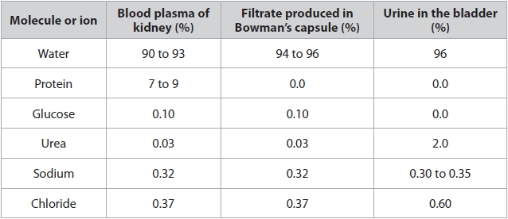

(i)  Name the process by which this filtrate is produced in Bowman's capsule.

**(1)**

.............................................................................................................................................

(ii)  Analyse the data to explain the difference between the protein and the other molecules or ions in the filtrate in Bowman's capsule.

**(3)**

.............................................................................................................................................

.............................................................................................................................................

.............................................................................................................................................

.............................................................................................................................................

.............................................................................................................................................

.............................................................................................................................................

.............................................................................................................................................

.............................................................................................................................................

(iii)  Urea and chloride ions both become more concentrated as they pass from Bowman's capsule to the urine in the bladder.

Calculate how many more times urea becomes concentrated compared with chloride ions.

**(3)**

Answer ...........................................................

(iv)  Analyse the data to explain the glucose concentration in the bladder.

**(2)**

.............................................................................................................................................

.............................................................................................................................................

.............................................................................................................................................

.............................................................................................................................................

(v)  Explain how the loop of Henlé is involved in the production of concentrated urine.

**(5)**

.............................................................................................................................................

.............................................................................................................................................

.............................................................................................................................................

.............................................................................................................................................

.............................................................................................................................................

.............................................................................................................................................

.............................................................................................................................................

.............................................................................................................................................

.............................................................................................................................................

.............................................................................................................................................

.............................................................................................................................................

.............................................................................................................................................

.............................................................................................................................................

.............................................................................................................................................

.............................................................................................................................................

.............................................................................................................................................

.............................................................................................................................................

.............................................................................................................................................

.............................................................................................................................................

.............................................................................................................................................

.............................................................................................................................................

.............................................................................................................................................

**(Total for question = 14 marks)**

**Q2.**

Mammals produce urea as a nitrogenous waste product.

Bowman's capsule (renal capsule) in the kidney is involved in the excretion of urea in mammals.

Name the cluster of blood capillaries enclosed by Bowman's capsule.

**(1)**

.............................................................................................................................................

**(Total for question = 1 mark)**

**Q3.**

Mammals produce urea as a nitrogenous waste product.

Describe how urea is produced in mammals.

**(2)**

.............................................................................................................................................

.............................................................................................................................................

.............................................................................................................................................

.............................................................................................................................................

.............................................................................................................................................

.............................................................................................................................................

**(Total for question = 2 marks)**

**Q4.** If untreated, high blood pressure can cause kidney damage.

The diagram shows a Bowman's capsule and the glomerular capillaries in a human's kidney.

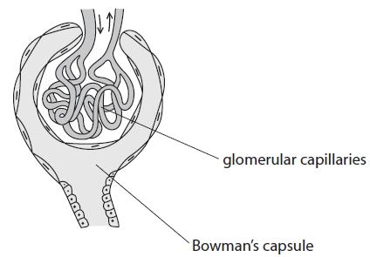

The table shows the hydrostatic pressure in the glomerular capillaries and in the Bowman's capsule. It also shows the oncotic pressure of the blood in the glomerular capillaries.

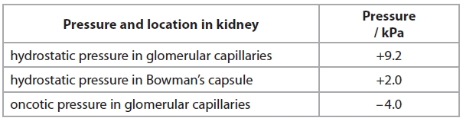

a) Use the data from the table to explain why glomerular filtrate is produced.

**(2)**

.............................................................................................................................................

.............................................................................................................................................

.............................................................................................................................................

.............................................................................................................................................

.............................................................................................................................................

.............................................................................................................................................

 b)Explain how water is reabsorbed in the loop of Henle.

**(4)**

.............................................................................................................................................

.............................................................................................................................................

.............................................................................................................................................

.............................................................................................................................................

.............................................................................................................................................

.............................................................................................................................................

.............................................................................................................................................

.............................................................................................................................................

.............................................................................................................................................

.............................................................................................................................................

.............................................................................................................................................

.............................................................................................................................................

.............................................................................................................................................

.............................................................................................................................................

.............................................................................................................................................

.............................................................................................................................................

**Q5.** The photograph below shows a desert mammal.

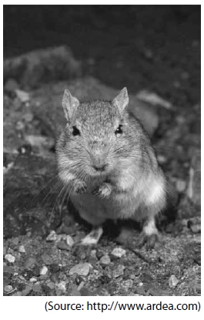

Some desert mammals do not drink water. They obtain water from the food they eat and from respiration.

(a)  Explain how water is formed in respiration.

**(2)**

.............................................................................................................................................

.............................................................................................................................................

.............................................................................................................................................

.............................................................................................................................................

(b)  The table below shows the percentage of plant roots and insects in the diet of two different species of desert mammal.

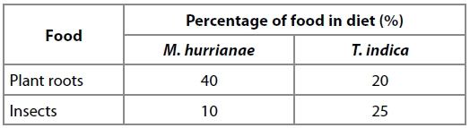

(i)  The desert mammals eat 8 g of food in one day. Calculate how many more grams of insects are eaten by *T. indica* than by *M. hurrianae*.

**(2)**

Answer ........................................................... g

(ii)  Which species has kidneys that will produce the most concentrated urine?   
Justify your answer.

**(2)**

.............................................................................................................................................

.............................................................................................................................................

.............................................................................................................................................

.............................................................................................................................................

(c)  Which row of the table below shows the correct changes to the concentration of sodium ions as fluid moves along the descending and ascending loop of Henle?

**(1)**

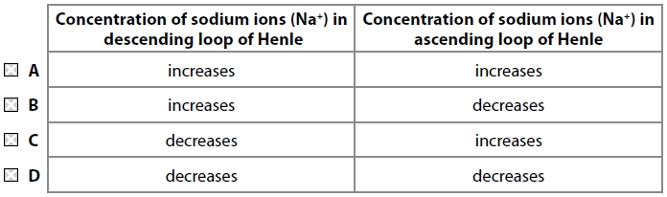

(d)  The concentration of urine is controlled by osmoreceptors and the secretion of ADH.

Which row of the table below shows the location of the osmoreceptors and the correct level of ADH secretion in a desert mammal that produces concentrated urine?

**(1)**

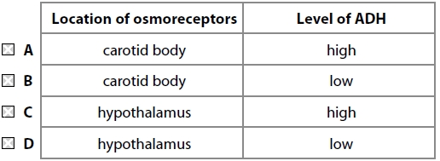

(e)  Explain how the nephrons of desert mammals enable them to survive in a dry environment.

**(4)**

.............................................................................................................................................

.............................................................................................................................................

.............................................................................................................................................

.............................................................................................................................................

.............................................................................................................................................

.............................................................................................................................................

.............................................................................................................................................

.............................................................................................................................................

**(Total for question = 12 marks)**

**Q7.**

Which of the following is correct when an individual becomes dehydrated?

**(1)**

   **A**    decreased secretion of ADH and decreased permeability of the collecting duct

   **B**    decreased secretion of ADH and increased permeability of the collecting duct

   **C**    increased secretion of ADH and decreased permeability of the collecting duct

   **D**    increased secretion of ADH and increased permeability of the collecting duct

**Examiner's Report**

Q1.

***(i)***

Most candidates were able to successfully name this process as ultrafiltration.

***(ii)***

Most candidates appreciated that molecular size was the reason why some molecules appeared in the filtrate and others did not. Simply stating that protein is a big molecule or that urea is a small molecule was insufficient. Candidates needed to relate molecular size to the difficulty in passing through the barriers that exist at the Bowman's capsule. Candidates also needed to understand that full marks are not going to be given if the answer only contains a description. The only mark available for description in this question was that smaller molecules have the same concentration in the plasma and filtrate.

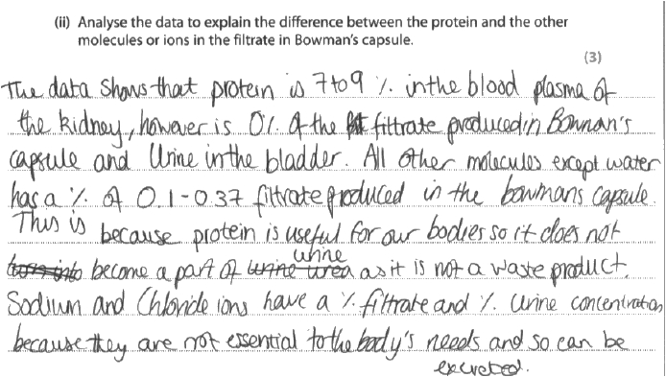

**Results Plus: Examiner Comments**

This answer has no marking points evident. The candidate simply describes the concentrations and fails to appreciate that the questions demands an explanation.

**Results Plus: Examiner Tip**

When asked to explain, credit is given for a biological reason – not for describing by putting the data into words.

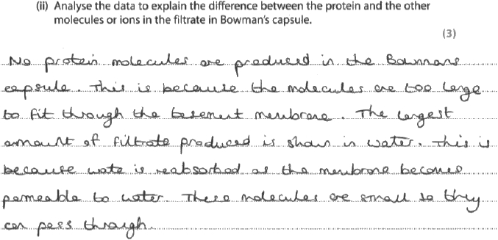

**Results Plus: Examiner Comments**

This candidate scores 2 marks for explaining why protein is not found in the filtrate and that smaller sized molecules are found in the filtrate. The only idea missing from the answer is the observation that smaller molecules have the same concentration in the plasma and filtrate.

**Results Plus: Examiner Tip**

Full marks cannot be gained if you only describe when you are asked to explain.

***(iii)***

This question challenged many candidates. There were three stages involved in getting the correct answer: calculation of the increase in urea concentration; calculation of the increase in chloride concentration, and finally, calculation of how many times more concentrated urea is than chloride. Many subtracted rather than divided to calculate the increase in concentrations, and continued to subtract thereafter. The correct answer was automatically credited with full marks but was only credited if it was expressed to no more than two decimal places. The same logic was applied to allowing for marks in the working if the correct answer was not evident.

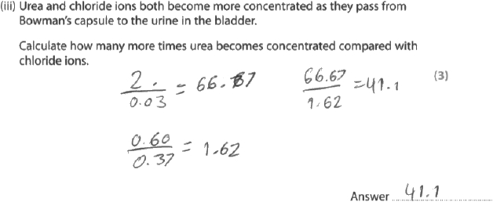

**Results Plus: Examiner Comments**

The answer of 41.1 was not one of the four acceptable answers but 66.67 and 1.62 were acceptable in the working, so this candidate gained 2 marks. If candidates are working to 2 decimal places, their answer should be expressed to 2 decimal places.

**Results Plus: Examiner Tip**

Always show your working because marks can be credited even if the final answer is not correct.

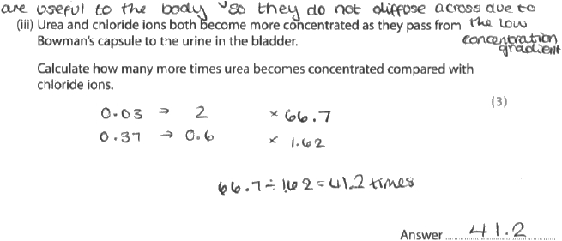

**Results Plus: Examiner Comments**

This response gained all 3 marks regardless of any working shown, as 41.2 is one of the four acceptable answers.

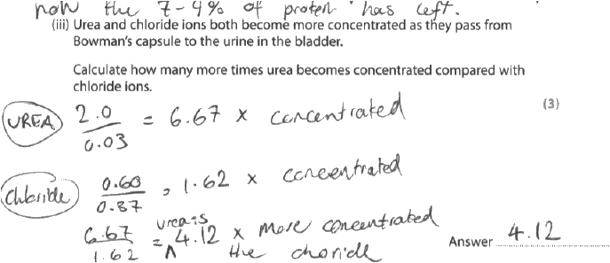

**Results Plus: Examiner Comments**

The answer of 4.12 is incorrect. Although this candidate has divided, the value of 6.67 is incorrect but the value of 1.62 is acceptable, and it is for this working that 1 mark is awarded.

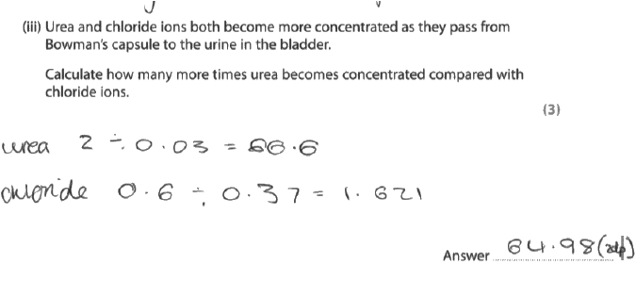

**Results Plus: Examiner Comments**

This candidate scored zero because the answer is incorrect and the working gives values that have inappropriate rounding. Had this candidate divided 66.6 by 1.621 to give an answer, one mark would have been available.

***(iv)***

This question asked for an explanation for the fact that there is no glucose in the bladder. Credit was given for answers that discussed the reabsorption of glucose by active transport at the proximal convoluted tubule.

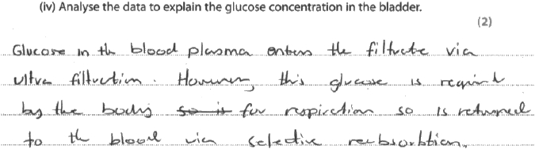

**Results Plus: Examiner Comments**

This answer gains one mark for reference to reabsorption.

**Results Plus: Examiner Tip**

The first two sentences are not needed. Candidates need to be precise with their answers.

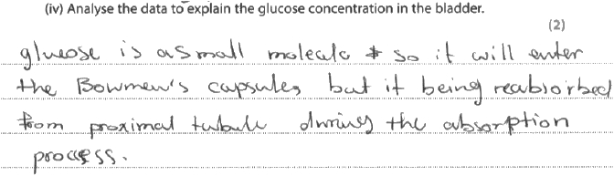

**Results Plus: Examiner Comments**

This is a better answer because it also points out the location of the reabsorption.

***(v)***

This question tested understanding of the role of the loop of Henle in producing concentrated urine. The mark scheme credited ideas relating to events at the ascending limb and collecting duct. Most candidates gained a few marks but only the best responses explained five of the six available ideas in the mark scheme in a concise manner.

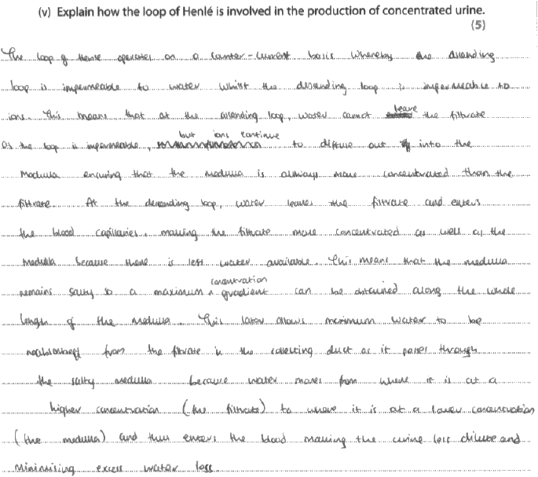

**Results Plus: Examiner Comments**

This is a typical example of an answer that lost credit because it lacked detail and precision. The marks were awarded for knowing the ascending limb is impermeable to water and that the medulla has a low water potential.

Marking point 4 was not given because the term 'multiplier' is absent. Marking point 1 is not awarded because the ions are not named and the process of diffusion is incorrect. Marking point 6 is not given because the term 'osmosis' is not evident. The collecting ducts are mentioned, but not their permeability.

**Results Plus: Examiner Tip**

Appreciate that marking points often have more than one idea that must be satisfied before the mark is awarded. So, detail and precision are essential.

**Q2.**

Most candidates were able to recall that the cluster of blood capillaries in the Bowman's capsule is the glomerulus. However, to gain the mark, the term had to have the correct spelling.

**Q3.**

This question asked candidates to describe how urea is produced in mammals. Credit was given for appreciating that deamination was involved, that ammonia combines with carbon dioxide and that urea is eventually produced in the ornithine cycle. A significant number of candidates failed to read this question carefully and wrote about urine production instead of urea production.

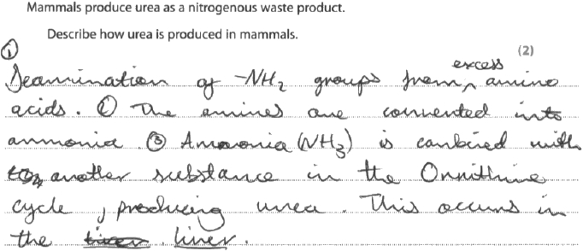

**Results Plus: Examiner Comments**

This candidate understands that deamination is involved but fails to link ammonia to carbon dioxide. However, the second mark was awarded for appreciating that urea is produced in the ornithine cycle.

**Q4.**No Examiner's Report available for this question

**Q5.**No Examiner's Report available for this question

**Q6.**No Examiner's Report available for this question

**Q7.**No Examiner's Report available for this question

**Mark Scheme**

Q1.

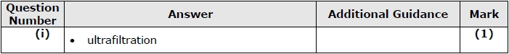

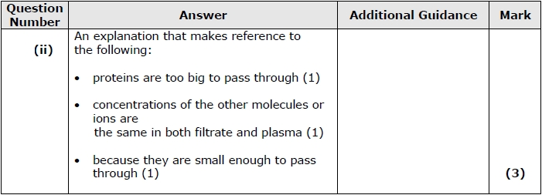

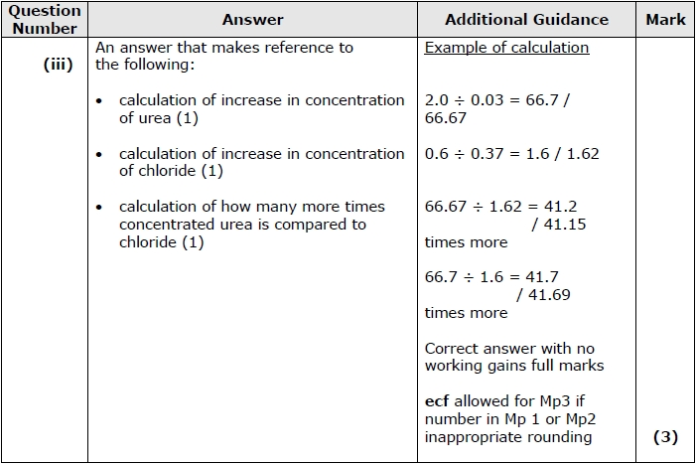

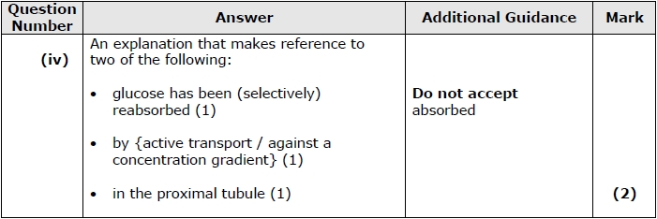

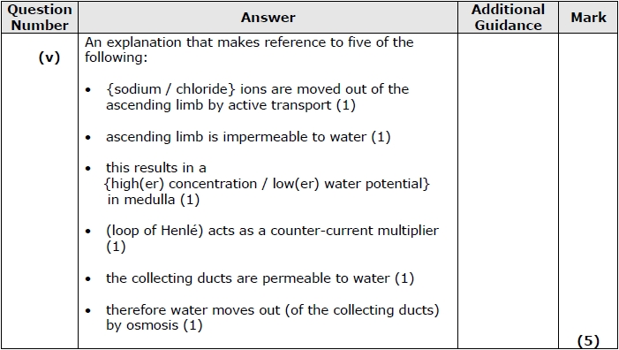

**Q2.**

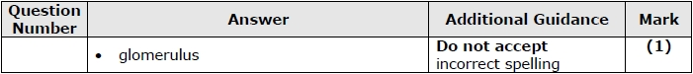

**Q3.**

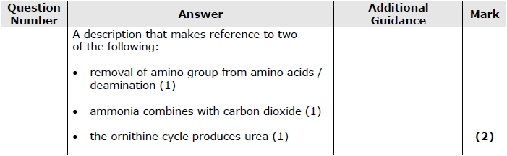

**Q4.**

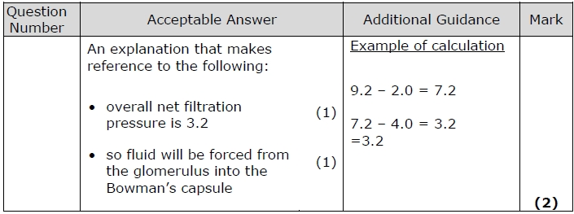

**Q5.**

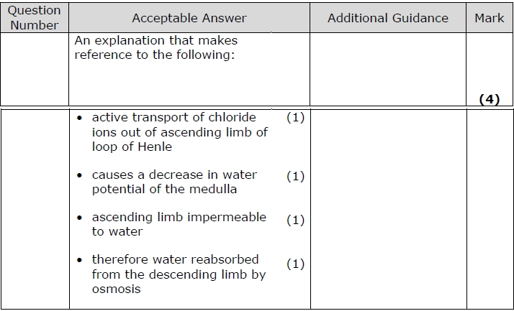

**Q6.**

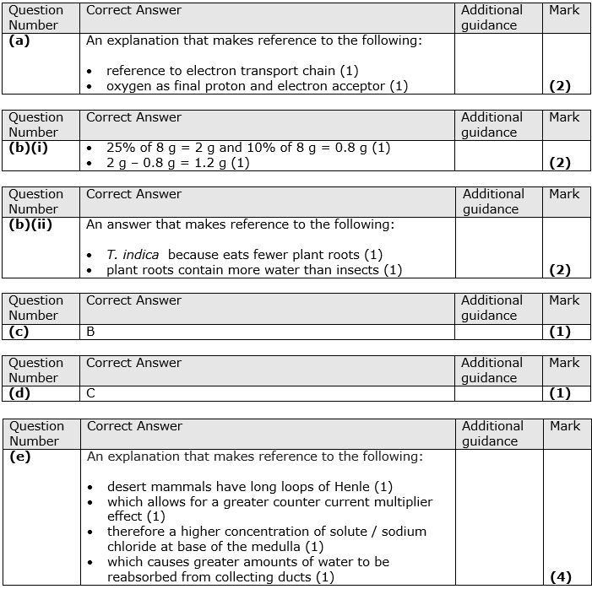

**Q7.**

