**Revision - Vectors**

**Q1.**

The diagram shows parallelogram *ABCD*.

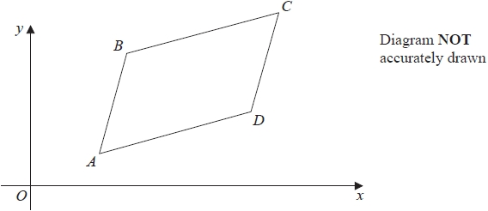

The point *B* has coordinates (5, 8)

(a)  Work out the coordinates of the point *C*.

( ................ , ................ )

**(3)**

The point *E* has coordinates (63, 211)

(b)  Use a vector method to prove that *ABE* is a straight line.

**(2)**

**(Total for question = 5 marks)**

**Q2.**

The diagram shows triangle *OAB*

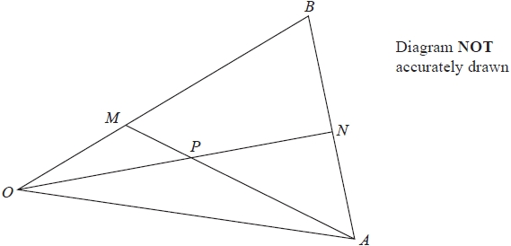

*M* is the point on *OB* such that *OM* : *MB* = 1 : 2   
*N* is the midpoint of *AB*  
*P* is the point of intersection of *ON* and *AM*

Using a vector method, find as a simplified expression in terms of **a** and **b**  
Show your working clearly.



...........................................................



**(Total for question = 5 marks)**

**Q3.**

*OACB* is a trapezium.

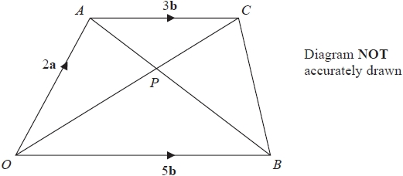

The diagonals, *OC* and *AB*, of the trapezium intersect at the point *P*.

Find and simplify an expression, in terms of **a** and **b**, for   
Show your working clearly.



...........................................................



**(Total for question = 5 marks)**

**Q4.**

*OAB* is a triangle.



The point *C* lies on *OA* such that *OC* : *CA* = 1 : 2   
The point *D* lies on *OB* such that *OD* : *DB* = 1 : 2

Using a vector method, prove that *ABDC* is a trapezium.

**(Total for question = 3 marks)**

**Q5.**

Here are two vectors.

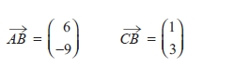

Find the magnitude of



...........................................................

**(Total for question = 3 marks)**

**Q6.**

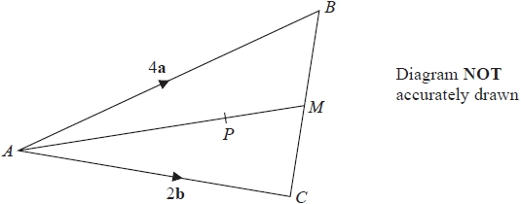

*ABC* is a triangle.   
The midpoint of *BC* is *M*.   
*P* is a point on *AM*.

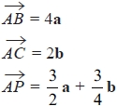

Find the ratio *AP* : *PM*

...........................................................

**(Total for question = 3 marks)**

**Q7.**

*OAB* is a triangle.

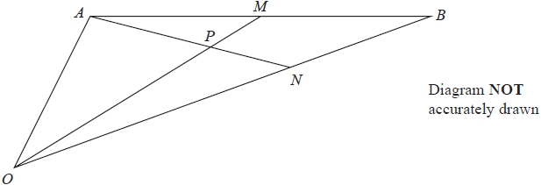

*M* is the midpoint of *AB*.   
*N* is the point on *OB* such that *ON* : *NB* = 2 : 1

*P* is the point on *AN* such that *OPM* is a straight line.

Use a vector method to find *OP* : *PM*  
Show your working clearly.

...........................................................

**(Total for question = 6 marks)**

**Q8.**

*ABCDEF* and *GHIJKL* are regular hexagons each with centre *O*.

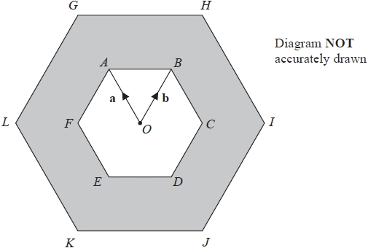

*GHIJKL* is an enlargement of *ABCDEF*, with centre *O* and scale factor 2



(a)  Write the following vectors, in terms of **a** and **b**.

Simplify your answers.



...........................................................

**(1)**



...........................................................

**(2)**



...........................................................

**(2)**

The triangle *OAB* has an area of 5 cm2

(b)  Calculate the area of the shaded region.

........................................................... cm2

**(3)**

**(Total for question = 8 marks)**

**Q9.**



*OAN*, *OMB*, *APB* and *MPN* are straight lines.

*OA* : *AN* = 1 : 4

*OM* : *MB* = 1 : 1

** = 2**a** ** = 2**b**

By using a vector method, find the ratio *AP* : *PB*

Give your answer in its simplest form.

.......................................................

**(Total for Question 25 is 5 marks)**

**___________________________________________________________________________**

**Q10.**

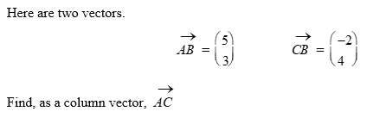

.......................................................

**(Total for Question 10 is 2 marks)**

**Q11.**

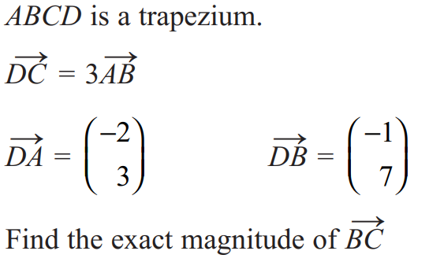

.......................................................

**(Total for Question 11 is 5 marks)**

**Q12**

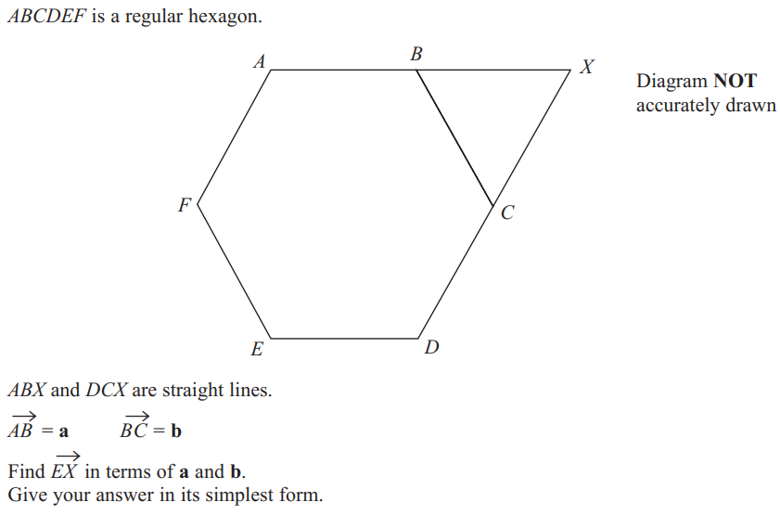

.......................................................

**(Total for Question 12 is 4 marks)**

**Q13**

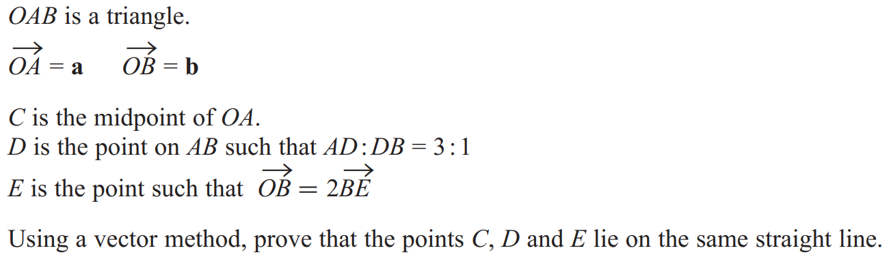

**(Total for Question 13 is 5 marks)**

**Q14.**

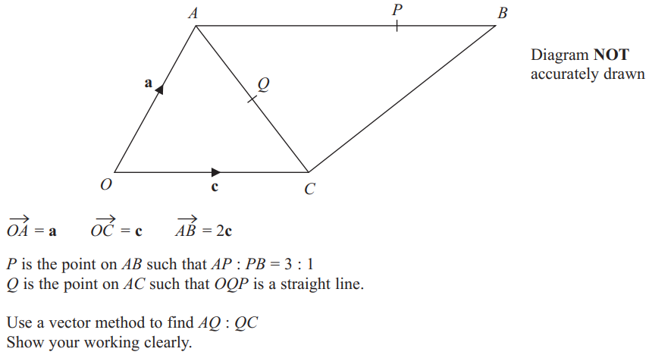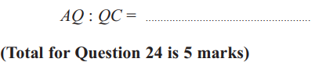

**Q15.**

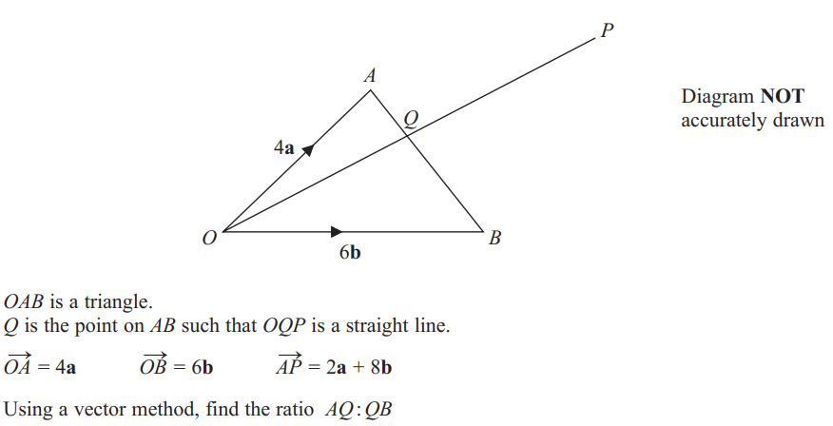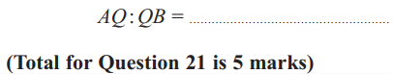

**Q16.**

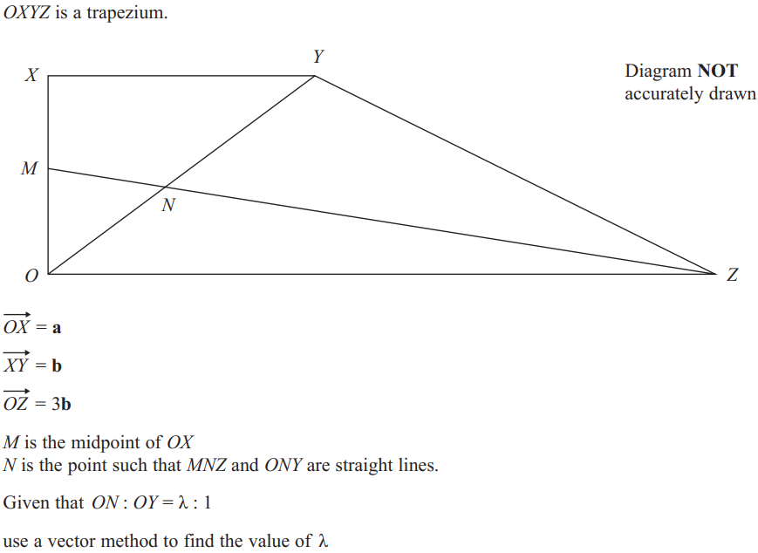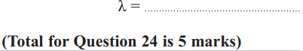

**Q17. (Mock)**

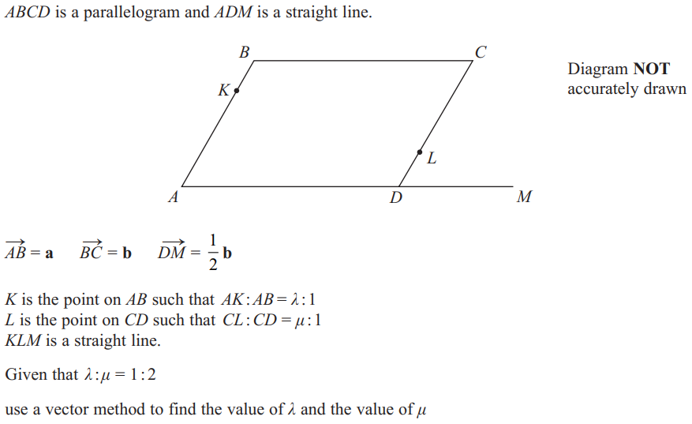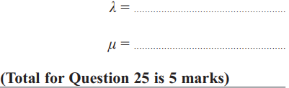

**Q18.**

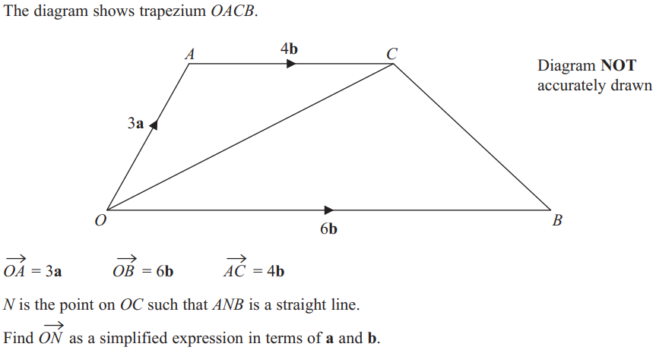

(Total for Question 26 is 5 marks)

**Mark Scheme**

**Q1.**

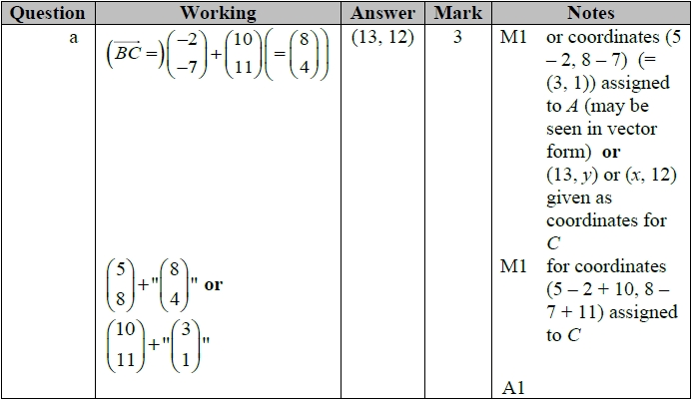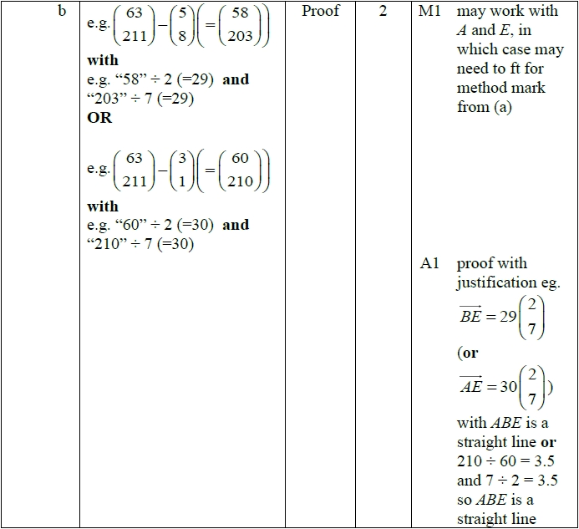

**Q2.**

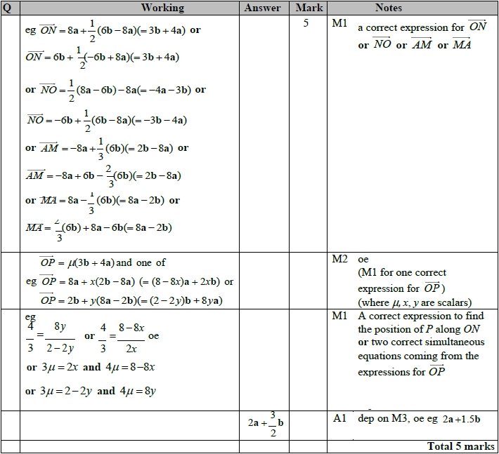

**Q3.**

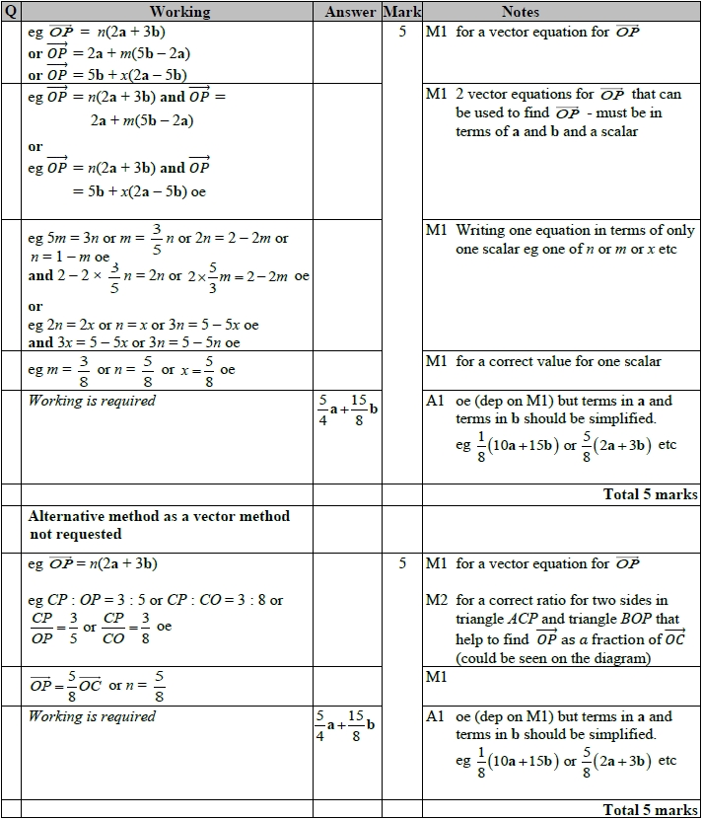

**Q4.**

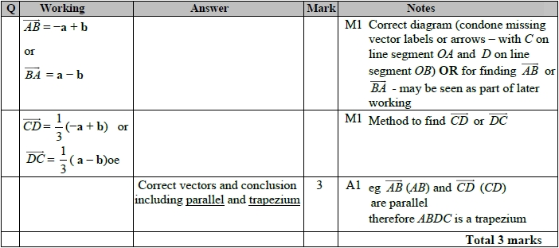

**Q5.**

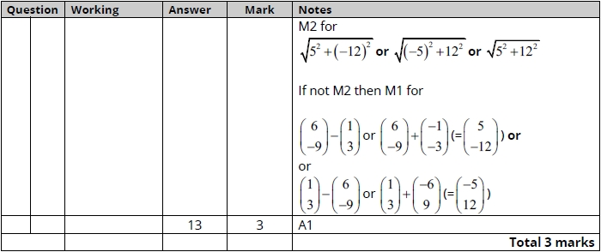

**Q6.**

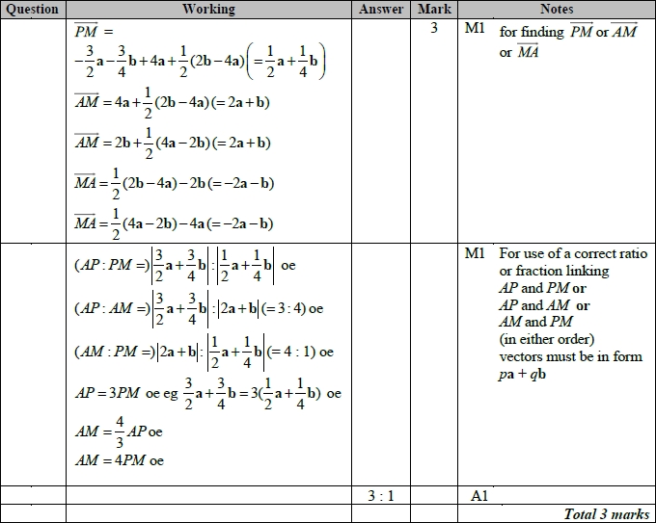

**Q7.**

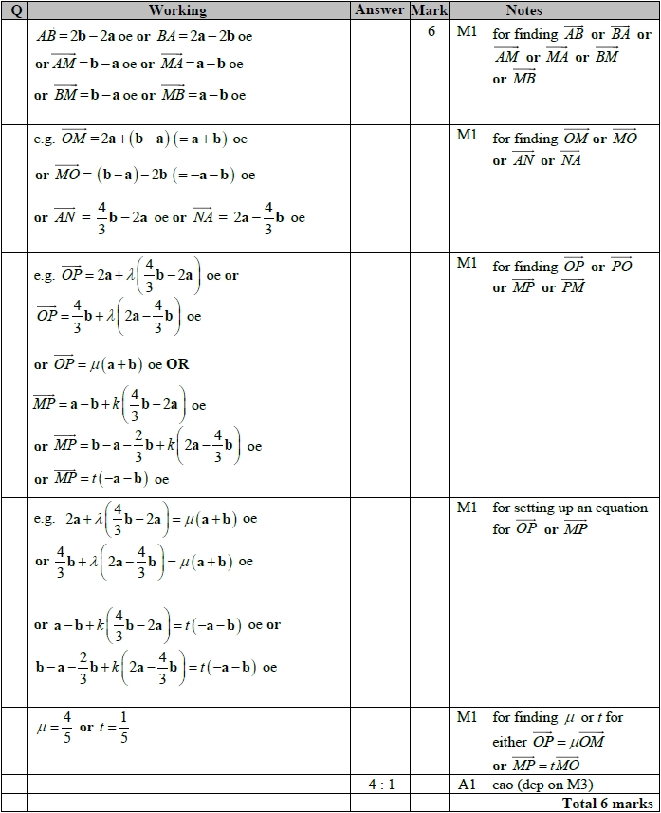

**Q8.**

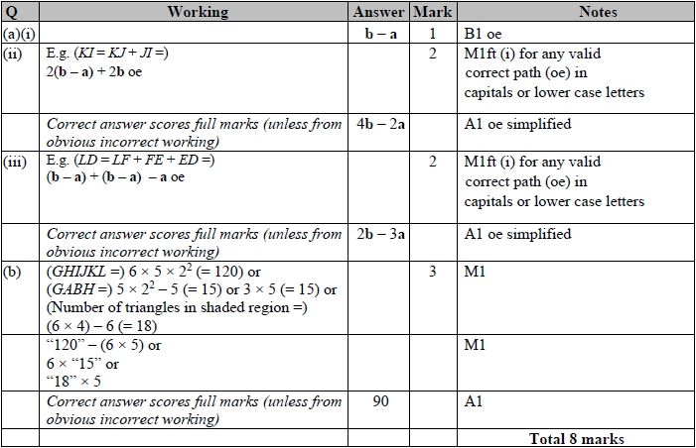

| Q9 |  | or  or |  | 5 | M1 | for finding or or or |
| --- | --- | --- | --- | --- | --- | --- |
|  |  | eg  and  or eg  and  or eg  and  or eg  and  or eg  and  or eg  and |  |  | M2 | for writing eg or or or in two different ways in terms of **a** and **b**  (M1 for writing eg or or or in one way)  These may be written as eg in place of |
|  |  | eg  and  (from 1st)  or eg  and  (from  2nd)  or eg  and  (from )  or eg  and  (from  1st)  or eg  and  (from  2nd)  or eg  and  (from ) |  |  | M1 | dep M3 for writing a pair of equations using their variables.  (1st) leads to  (2nd) leads to  leads to  (1st) leads to  (2nd) leads to  leads to |
|  |  |  | 4 : 5 |  | A1 | cao |
|  |  |  |  |  |  | **Total 5 marks** |

**Q10**

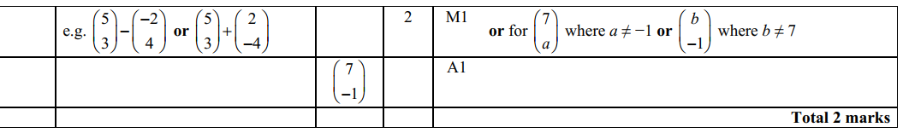

**Q11**

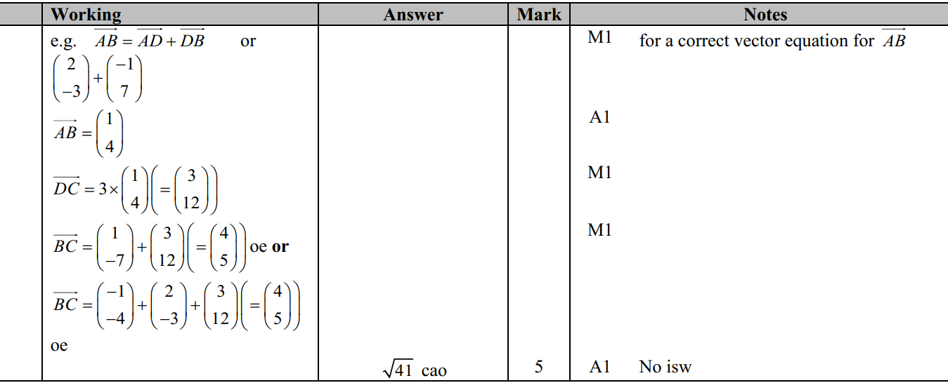

**Q12**

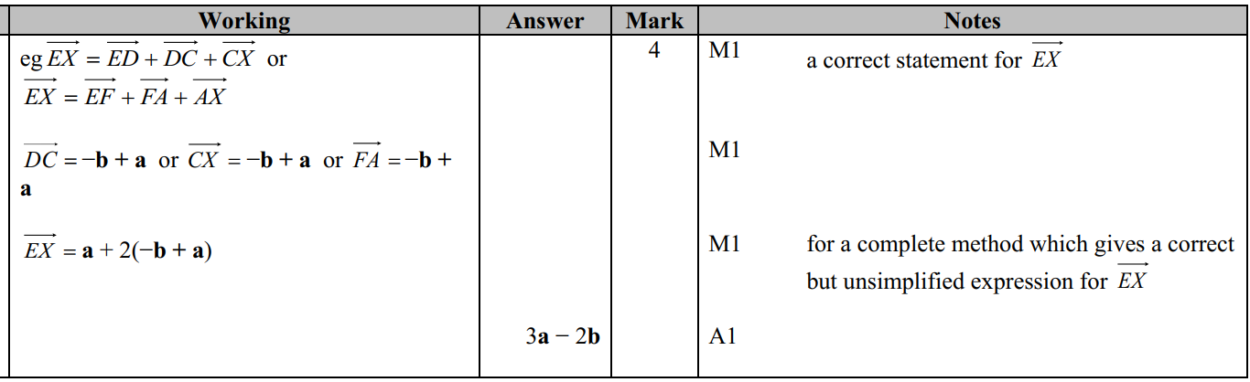

**Q13.**

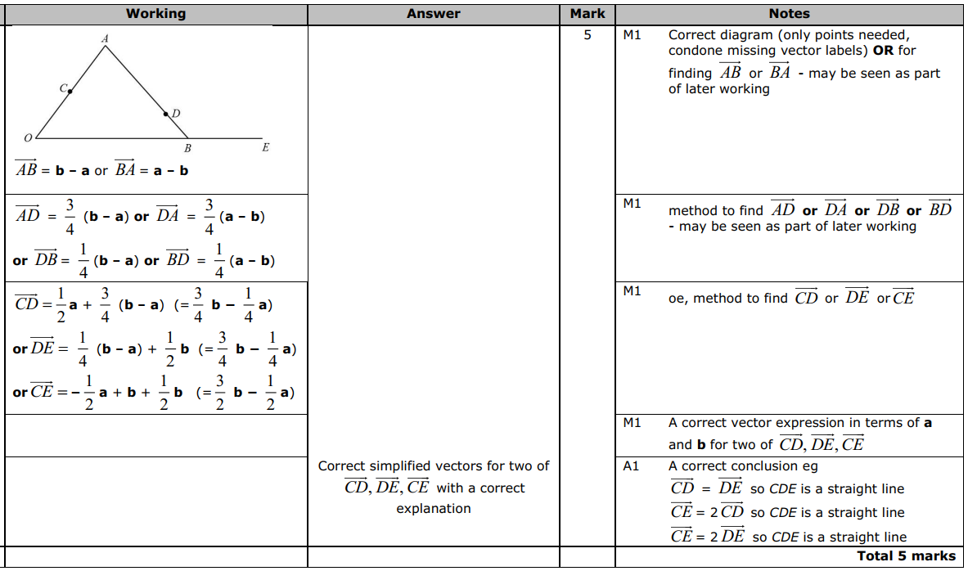

**Q14**

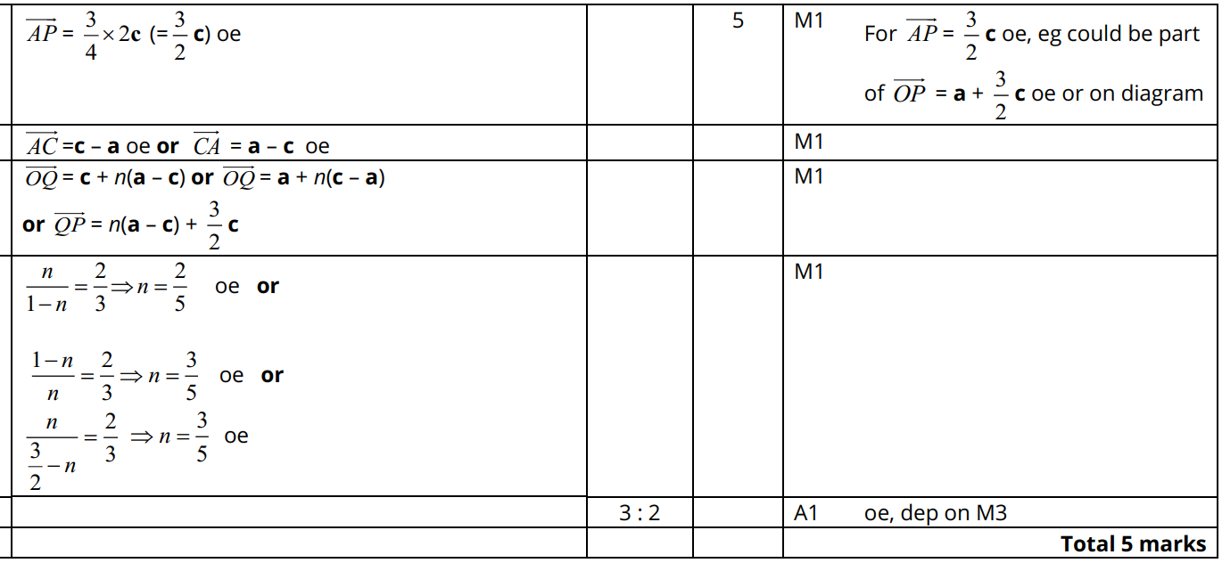

**Q15**

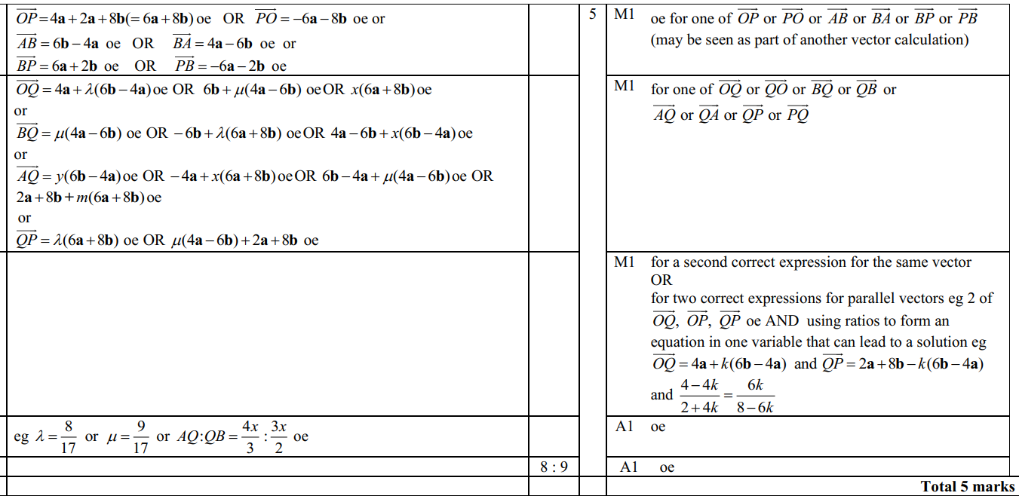

**Q16**

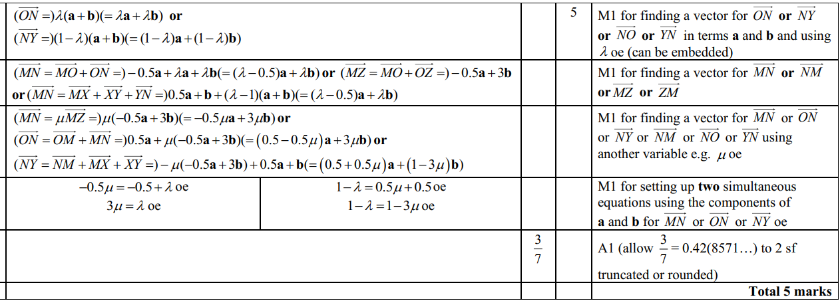

**Alternatively**

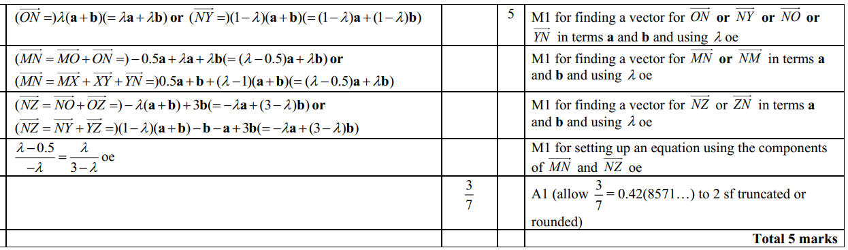

**Q17.**

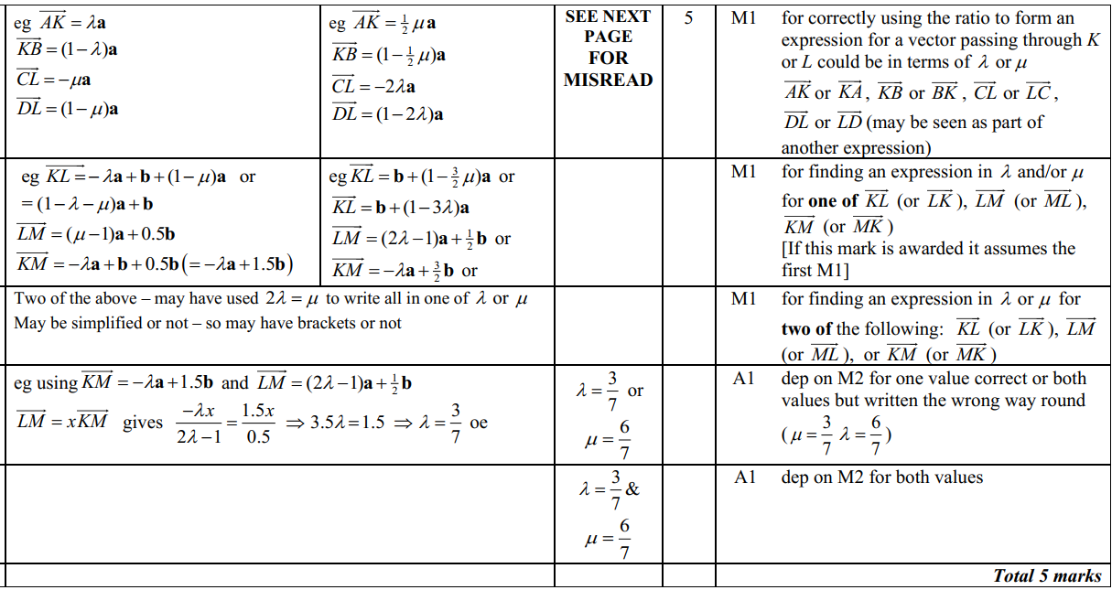

**Misread**

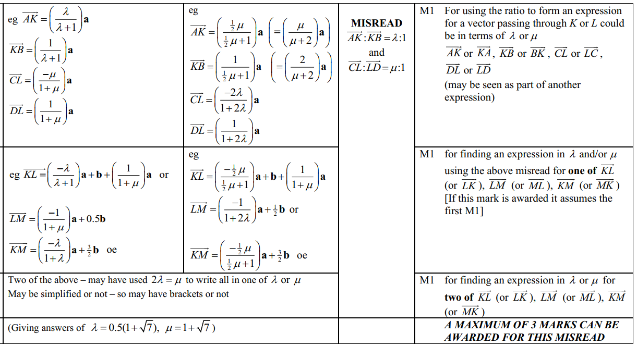

**Q18**

