|  |  |
| --- | --- |
| A picture containing text, several  Description automatically generated  virgil – aeneid 12  Introduction | This is a guide to take you through the English translation of this extraordinary finale to this wondrous epic poem. The whole book is prescribed in translation for A Level, with lines 728-952 to be read in Latin. |

**Virgil – The *Aeneid***

(Roman numerals refer to books.)

c12th century BC

Trojan War, Aeneas’ escape from Troy (II), arrival in Latium and battle to establish future Romans through alliance of Trojans and Latins (VII-XII), foundation of first city – Alba Longa.

753 BC

Foundation of the city of Rome by Romulus – see prophecy I and shield VIII for depictions of the Romulus and Remus story.

753-510 BC

Rome ruled by 7 kings (VI – pageant) – first king Romulus, last king Tarquinius Superbus, who is banished by Brutus (VI – pageant), who establishes the Roman Republic.

509-45 BC

Roman Republic – ruled by 2 consuls, elected annually, and the senate – the great age of the toga (I - prophecy)!

key events in roman history seen in the *aeneid*

**Background**

Publius Vergilius Maro was born in 70 B.C. and wrote the *Aeneid* at the end of his life. He had not finished revising it when he died in 19 B.C. and left orders in his will for it to be destroyed - which, luckily for us, his executors ignored. Virgil was writing during the reign of the Emperor Augustus, who had brought peace and prosperity to Rome after long and turbulent years of civil war. Virgil, in terms meant to inspire the Romans of his own day, praises the character of Aeneas, the Trojan prince who set out from the destruction of Troy at the end of the Trojan War with a divine mission to found a new Troy: Rome. Virgil makes the trials, struggles and triumphs of Aeneas' journey symbolic of the achievements of Augustus and contemporary Rome – apparently. But scholars still debate whether the *Aeneid* is pro-Augustan – or whether Virgil’s sympathy with the characters who oppose Aeneas’ mission makes the poem more double-edged. Consider this as you read…

**Summary of the story**

The *Aeneid* tells the story of the migration of the survivors of the Trojan War, led by Aeneas, from Troy to Italy, their long wanderings on the way and the war which they had to fight on their arrival in Italy. The story embraces many events and seven years of time, including the fall of Troy and the Trojans' final victory in Italy and all that came between.

Book I starts with the Trojans just off the coast of Sicily and nearly at their destination (Italy), when a storm (sent by the goddess Juno, who hates the Trojans) blows them off course to Carthage, on the coast of North Africa. The Queen of Carthage, Dido, welcomes them with sympathy and kindness, and, in Book II, Aeneas tells her the story of the terrible last hours of Troy and his difficult adventures since. Dido and Aeneas fall in love, but Aeneas is reminded by a message from Jupiter, delivered by the messenger god Mercury, of his divine mission to found Rome. In Book IV, Aeneas abandons Dido to sail for Italy. Virgil shows huge sympathy for Dido, who kills herself, calling for a future avenger from Carthage to punish the Romans (Virgil's Romans would have recognised this instantly as Hannibal, who brought Rome almost to its knees during the Punic Wars of the 3rd century B.C.).

After a stop in Sicily, where Aeneas holds funeral games for his father, Anchises, and another in Cumae on the bay of Naples, from where Aeneas descends to the Underworld and sees a pageant of future Roman heroes, including Augustus himself (Book VI), the Trojans land in Latium. They are welcomed by the Latin king, Latinus, who sees Aeneas as the fulfilment of an oracle prophesying that his daughter, Lavinia, would marry a stranger from abroad, who was to be the founder of a great nation. Signs from the gods confirm that Aeneas is the one.

However, the goddess Juno, who is hostile to the Trojans, starts a war between the Latins and the Trojans by working on the feelings of Turnus, king of the Rutuli and formerly suitor for Lavinia's hand. After an incident during a hunt, two of the Latins are killed and war breaks out. Aeneas is visited again by his mother, the goddess Venus, who brings him armour she has commissioned for him from Vulcan: Virgil describes in great detail the shield, on which are engraved scenes of Rome's future glory (Book VIII).

27 BC – AD 14

Octavian becomes Augustus, Rome’s first emperor. Virgil hails his reign as a period of peace, expansion and civilisation (see the great prophetic sections in I, VI, VIII, XII) – but is also sympathetic to the personal cost of Rome’s glory. Try to see something of the perspective of Rome’s enemies through the sufferings and struggles of many of the characters in the *Aeneid* whom circumstances make simply to get in the way of Aeneas’ mission…

[Sidebar Title]

49 BC

Julius Caesar crosses the Rubicon – civil war against Pompey and the senate (numerous references to horrors of civil war, e.g. I - picture of Bellona, VI – picture of Discord).

45-44 BC

Caesar declared Dictator, effectively ending the Republic – he is then assassinated by Brutus (descendant of the first Brutus, who established the Republic – VI), leaving further political chaos and Civil War between Caesar’s heir, Octavian, and Marc Antony.

31 BC

Battle of Actium - Octavian defeats Antony and Cleopatra (VIII - vivid description on Aeneas’ shield), ending long years of Civil War. Virgil symbolises this with references to the shutting of the gates of the temple of Janus, which were left open during war (I, VI, VIII).

[Sidebar Title]

Aeneas leaves the Roman camp and sails up the River Tiber to Pallanteum (the site of the future Rome) to seek an alliance with the enemy of the Latins, King Evander. During Aeneas' absence, Turnus attacks the Trojan camp and sets fire to their ships. Aeneas has told the Trojans not to do battle outside their camp and both sides dig in. The young Trojan warriors Nisus and Euryalus disobey Aeneas’ orders and launch a heroic but ultimately doomed mission against Turnus and the Rutuli (Book IX).

Books VIII-XII are full of fighting between the Trojans and the Latins. There are heroes on both sides: Pallas, son of the Arcadian king Evander, is slain by Turnus (Book X); the Volscian maiden warrior Camilla slays many Trojans with her bow and arrows before being slain herself (book XI). In the end, however, it all comes down to single combat between Aeneas and Turnus (Book XII). Jupiter and Juno prophesy the greatness of the future Rome, which will unite Trojans and Latins, descended from Aeneas and Lavinia. All that is left is Aeneas' victory over Turnus, which is double-edged: the poem ends with Aeneas killing Turnus in angry vengeance for the death of Pallas. Rome's future is secured, but the honour *(pietas)* it demands comes at a terrible cost.

Following the turbulent political situation you will see in Cicero, Virgil reflects the relative peace and prosperity of the subsequent *pax Augusta*. Julius Caesar traced his ancestry through the Julian clan back to Aeneas’ son, Iulus, thus claiming descent from the goddess Venus. As Caesar’s adopted son and heir, this ancestry also therefore applied to Augustus, whose achievements as Rome’s first Emperor Virgil is praising through Aeneas’ story. Consider how Virgil celebrates in the *Aeneid* the key events in Rome’s history listed in the panels on this page and the previous page. But consider also the characters who apparently oppose Rome’s mission – Dido, Camilla, Turnus… Why does Virgil present them with such colour and compassion? Does the *Aeneid* present a clear message about Rome, or is it more subtle? That these questions are still hotly debated by scholars after 2000 years shows just what an amazing poem this is!

Podcasts: In Our Time on the Augustan Age: <https://www.bbc.co.uk/programmes/b04jlygw>

In Our Time on the *Aeneid*: <https://www.bbc.co.uk/programmes/p003k9c1>

Latin text to buy: <https://www.bloomsbury.com/uk/virgil-aeneid-xii-a-selection-9781350059214/>

Translations: Virgil *The Aeneid* – translated by W.F. Jackson Knight (Penguin Classics, ISBN 0-14-044051-8)

This is the translation I will be working from in class, so it would be easiest for us all to have the same one.

Virgil *The Aeneid* – translated by David West

(Penguin Classics, ISBN 978-0140449327)

This is also an excellent translation and we have this one in the school library.

Poetry in Translation site – poetry to explore online in all languages – highly recommended! Here is A.S. Kline’s verse translation of the *Aeneid* (as well as Virgil’s other poems, the *Eclogues* and *Georgics*): <https://www.poetryintranslation.com/PITBR/Latin/Virgilhome.php>

Read as much as you can of the *Aeneid* over the Summer. We will be reading the last section of Book 12 in Latin. The rest of Book 12 is prescribed to be read in English, so you should read the whole book! Here are some ideas to help:

**A Guide to the Factions of the War in Italy**

|  |  |  |  |
| --- | --- | --- | --- |
| **Turnus’ Army** | | **Aeneas’ Army** | |
| **Latinus** | | **Aeneas** | |
| People: | The Latins of Latium | People: | Trojan exiles |
| Capital: | Laurentum | Capital: | In search of one |
| Motivations: | Latinus does not wish to fight himself, believing that the gods have decided Aeneas must marry his daughter, Lavinia. | Motivations: | Aeneas has been offered Lavinia as a bride by Latinus. He wants to forge a peace with the Italians but is forced to fight Turnus. |
| **Turnus** | | **Evander** | |
| People: | The Rutulians | People: | The Arcadians |
| Capital: | Ardea | Capital: | Pallanteum |
| Motivations: | Turnus was the primary suitor of Lavinia before Aeneas arrived. He now feels he must fight for her and has assumed control of the Latins as Latinus steps down. | Motivations: | Evander had known Anchises and learnt that he shared a common ancestry with Aeneas. He sends his army under the command of his son, **Pallas**. |
| **Mezentius** | | **Tarchon** | |
| People: | The Etruscans | People: | The Etruscans |
| Capital: | Argylla | Capital: | Tarchna |
| Motivations: | Mezentius had been exiled by his people for his cruelty. He is a guest friend of Turnus and goes to war with him alongside his son, **Lausus**. | Motivations: | Tarchon commands the Etruscan league of cities (including some Ligurians too). They are wishing to bring Mezentius to justice. |
| **Other Italians** | |  | |
| The following people also contribute to Turnus’ army:   * Some other Etruscans * The Sabines * The Samnites * The Volsci, led by **Camilla** | |

|  |  |  |  |
| --- | --- | --- | --- |
| ***BOOK 12 - summary*** | | | |
| Turnus prepares to fight Aeneas 1 - 220 | Turnus agrees to single combat *1 - 110* | In their defeat Turnus feels eyes of all Latins are on him. Tells King Latinus that he will fight Aeneas in single combat. L tries to dissuade him, but T more fiercely determined. Amata begs him not to go, but T says not free to refuse. He arms himself in rehearsal for the next day's combat. Aeneas also prepares for the coming single combat. | 1 - 110 |
| Oaths sworn *110 - 220* | Troops on both sides prepare to watch single combat. Juno tells Juturna (Turnus’ sister) that she herself can do no more; if Jut. can do anything, she has authority from Juno to act. The two parties proceed to the battle area. Oaths sworn, first by A, then by L on behalf of Turnus. | 110 - 220 |
| Truce Broken *220 - 310* | Rutulians (Turnus’ people) are uneasy about the single combat. Jut, disguised as Camers, urges them to break the truce. Omen of eagle interpreted by Tolumnius to mean that the Rutulians must attack to save Turnus. Fighting breaks out. | 220 - 310 |
| Aeneas and Turnus kept apart *310 - 610* | Aeneas wounded 310 - 440 | Aeneas tries to prevent his men from breaking treaty, but is wounded by arrow from unknown source. So T excitedly leads men to battle, & fighting resumed. | 310 - 380 |
| The wounded Aeneas is helped back to camp. The physician Iapyx cannot remove the arrow-head, but Venus intervenes & with supernatural potions causes the arrow-head to come out and wound to heal. Aeneas immediately arms for battle. | 380 - 440 |
| Aeneas pursues Turnus. Juturna intervenes *440 - 550* | Rutulians are terrified as Aeneas rushes into battle. He pursues Turnus and Turnus only. Juturna intervenes in guise of Metiscus, Turnus' charioteer, and keeps Turnus away from Aeneas. Messapus attacks Aeneas and realising that Turnus won't meet him A begins to attack enemies indiscriminately. | 440 - 500 |
| In general battle which ensues A & T deal death all around them. | 500 - 550 |
| A attacks Laurentum; Amata commits suicide. *550 - 610* | Venus puts into Aeneas' mind idea of attacking Latin capital. Urges on men, & they move to attack. Panic within the city. | 550 - 590 |
| Queen Amata driven to utter despair by sight of Trojans attacking, blaming self for imminent disaster commits suicide by hanging. | 590 - 610 |
| Aeneas kills Turnus *610 - 950* | Turnus wants single combat again *610 - 700* | Turnus hears the noise of lamentation from the capital. Juturna tries to persuade him to stay away from A but he now insists that he must go to face him. News is brought of siege of the city and death of Am. Turnus at first is rooted to the ground, bewildered then he rushes to the capital and calls on his friends to cease fighting & leave him to single combat with A. | 610 - 700 |
| Fight begins, Oleaster *700 - 800* | A moves to fight T & and combat begins. Throw spears without effect & close combat. T strikes Aeneas with sword, but shatters. T had in hurry taken charioteer's sword by mistake. A chases T as they pass stump of oleaster sacred to Faunus. A tries to regain spear sticking in root. F prevents him pulling it out, & meanwhile Jut gives T own sword. V promptly restores A's spear to him, they stand again facing each other for battle. | 700 - 800 |
| Gods. Aeneas kills Turnus *800 - 950* | In Olympus Jupiter orders Juno to stop interfering against Trojans. She yields, but begs Latins may keep language & dress, & not become Trojans; that Rome be great because of Italian virtues. Jup agrees & promises Romans will be over all peoples & worship Juno. | 800 - 840 |
| Jupiter sends one of the Furies down to the battlefield, in the shape of an owl, in order to terrify Turnus by flitting in front of his face, and to convince Juturna that she must withdraw. Juturna laments her helplessness, & finally leaves battlefield. | 840 - 890 |
| A threatens T; T replies that he is not afraid of A, only of gods. He tries to throw a huge rock at A, but his strength fails him; he is like a man in a dream. A hurls his spear and wounds T in thigh. T begs for mercy, and A is on the point of granting it when he catches sight of the belt of Pallas which T is wearing. In fury and anger he kills his suppliant enemy. | 890 - 950 |

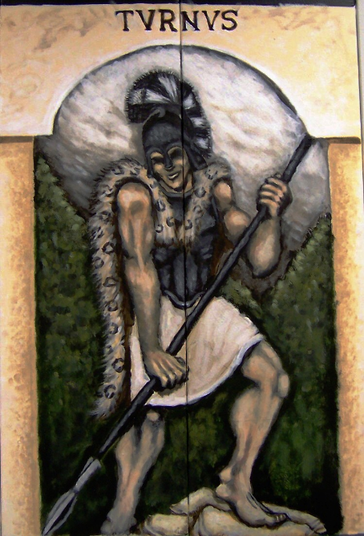**Lines 1-110** – **Turnus agrees to single combat**

Fill in details on who Turnus is, why he is hostile to Aeneas, and why he argues that he should now face him in single combat.

**Turnus’ character** Consider:

* Lion simile;
* Tone of his speeches;
* Sense of honour;
* Feelings towards Amata and Lavinia.

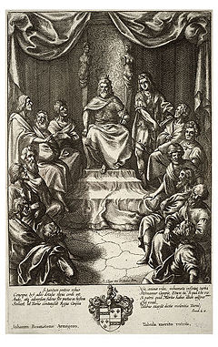

**Latinus** Who is he and how have he and his people been involved in the war?How does he try to dissuade Turnus from fighting?

Armour Label Turnus and Aeneas with the vivid descriptions of their armour. Why does Virgil describe it in such detail? Remember for later the significance of Turnus’ sword. Look back at Book 8 and explain ‘clad in the arms which his mother had brought to him’.

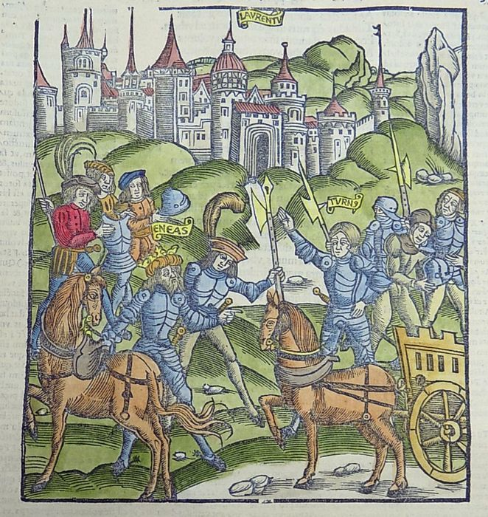

**Lines 110-220 – Oaths sworn**

Scene-setting What does the first sentence add to the narrative?

Who’s who? Arrange these peoples, people and gods in the correct army, adding details where helpful:

Italians army of Troy and Etruria Mnestheus Asilas Messapus Juno Laurentine host Trojan host Juturna Latinus Ascanius/Iulus Evander

|  |  |
| --- | --- |
| **Rutulians (Turnus)** | **Trojans (Aeneas)** |
|  |  |

Juno What do the following sentences in her speech mean and/or imply about the outcome of the battle and the future of Italy:

|  |  |
| --- | --- |
| *Nymph, pride of the rivers, and very dear to my heart* |  |
| *Learn, Juturna, a grief, which must be yours* |  |
| *wherever … the Fates allowed success to Latium, I have protected Turnus and your walled city* |  |
| *now I see the young prince engage in battle with a destiny weaker than his foe’s* |  |
| *the day of the Fates and malevolent force draw near* |  |
| *I cannot look with my own eyes on this truce and on this combat. But you, if you have the daring to give your brother some more potent aid, go forward … It is with my sanction that you will dare.* |  |

Outcomes Fill in the possible outcomes of the single combat, and how each king will react to each:

**Lines 220-310 – Truce broken**

How did the truce arise? Look back at Turnus’ speech to his messenger in the first section.

How does Juturna incite the Rutulians to return to the fight? Choose three quotes which seem particularly persuasive:

Who are the following?

Camers

Arcadians

Etruscans hostile to Turnus

Laurentines

Latins

Italians

Temple of Juturna, goddess of fountains - Rome

The omen

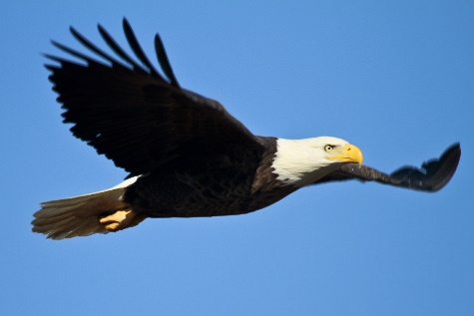Set out what happens, and how it is interpreted by Tolumnius.

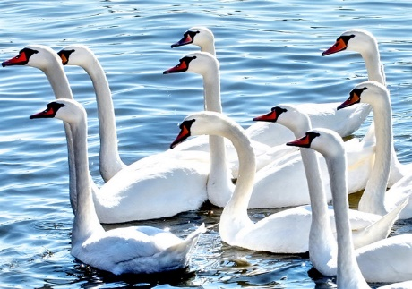

[This Photo](https://www.flickr.com/photos/edgarbarany/2671013451/) by Unknown Author is licensed under [CC BY-SA-NC](https://creativecommons.org/licenses/by-nc-sa/3.0/)

The battle

Choose three descriptions of deaths and say what makes them particularly dramatic/gory/vivid.

**Lines 310-440 – Aeneas wounded**

*Aristeia* ‘excellence’ (Greek – *aristos =* ‘best’) an epic description of a hero’s

finest moments in battle

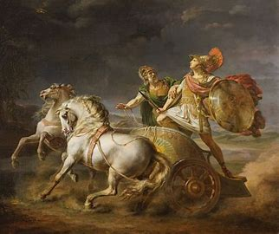Compare the *aristeiai* of Diomedes and Achilles in Homer’s *Iliad* with that of Turnus here:

**Diomedes – *Iliad* 5**

Such was the furious combat. As for [**Diomedes**](https://www.poetryintranslation.com/PITBR/Greek/IlindexBCDE.php#Diomedes), none could have said which army Greek or Trojan he fought for, since he stormed over the plain like a raging winter torrent that sweeps away the dykes in its swift flood. Close-built embankments and the walls of fertile vineyards fail to hold its onset driven by Zeus’ storm and before it the proud works of men all tumble to ruin: so the dense ranks of the Trojans were routed by Tydeus’ son, giving way to him despite their numbers.

Yet when glorious [**Pandarus**](https://www.poetryintranslation.com/PITBR/Greek/IlindexOP.php#Pandarus), Lycaon’s son, saw Diomedes rage across the plain, routing the army ahead, he swiftly bent his curved bow, and aimed at him, striking him firmly, as he ran, on the right shoulder-plate of his cuirass, so the sharp arrow pierced clean through, and the armour ran with blood. Pandarus cried aloud in triumph: ‘On now, brave Trojans, you horse-prickers! The best of the Greeks is hurt, and that arrow means he’s done for, if Lord [**Apollo**](https://www.poetryintranslation.com/PITBR/Greek/IlindexA.php#Apollo), born of Zeus, truly blessed my journey here from [**Lycia**](https://www.poetryintranslation.com/PITBR/Greek/IlindexFGHILMN.php#Lycia).’

So he boasted, but the swift shaft failed to down Diomedes, who drew back to the shadow of his chariot, where he called to [**Sthenelus**](https://www.poetryintranslation.com/PITBR/Greek/IlindexRSTUWXZ.php#SthenelusCapaneus), [**Capaneus**](https://www.poetryintranslation.com/PITBR/Greek/IlindexBCDE.php#Capaneus)’ son: ‘Quick, my lad, down here, and pull this bitter dart from my flesh.’

Leaping from the chariot, as he spoke, Sthenelus touched ground beside him and pulled the sharp arrow from his shoulder, so the blood soaked through the woven tunic. Then, Diomedes of the loud war-cry prayed to [**Athene**](https://www.poetryintranslation.com/PITBR/Greek/IlindexA.php#Athene): ‘[**Atrytone**](https://www.poetryintranslation.com/PITBR/Greek/IlindexA.php#Atrytone), hear me, aegis-bearing child of Zeus! If ever with kindly thought you stood by my father in the heat of battle, so now once more, Athene, show your love. Let me kill this man, bring him in range of my spear, who wounded me without warning, boasts of it, and shouts I am not long for the bright light of day.’

He prayed so that Pallas Athene heard, lightening his limbs, his feet and hands, and speaking her winged words in his ear: ‘Courage, Diomedes, I have filled your arteries with your father’s strength, that indomitable strength of [**Tydeus**](https://www.poetryintranslation.com/PITBR/Greek/IlindexRSTUWXZ.php#Tydeus), shield-wielding horseman. I have driven the mist that veiled them from your eyes what’s more, so you may know both men and gods. Now, if an immortal comes here to test you, among those deathless ones strike only at Aphrodite, Zeus’ daughter, if it be she who risks the battle: since her you may wound with a thrust of your keen blade.’

Bright-eyed Athene departed with those words, and Diomedes once more took his place at the front. Eager though he had been to fight before, his courage now was tripled, like a lion wounded but not killed, as it leaps the fence, by a shepherd as he guards his sheep. He angers it, but now cannot aid them, and has to hide behind walls, while the helpless flock is scattered, downed in heaps together, till the furious creature leaps from the fold. In such a fury great Diomedes attacked the Trojans.

**Achilles – *Iliad* 22**

While [Hector] stood there thinking, [**Achilles**](https://www.poetryintranslation.com/PITBR/Greek/IlindexA.php#Achilles), peer of Ares, approached, the plumes of his helmet nodding, brandishing the mighty spear of [**Pelian**](https://www.poetryintranslation.com/PITBR/Greek/IlindexOP.php#Pelion) ash in his right hand, high above his shoulder, his bronze armour blazing like fire or the rising sun. Now [**Hector**](https://www.poetryintranslation.com/PITBR/Greek/IlindexFGHILMN.php#Hector) was gripped by fear and, trembling at the sight of him, afraid to stand his ground by the gate, set off running. Achilles, confident in his own speed, pursued him. Like a hawk, swiftest of birds, swooping on a timorous dove in the mountains, darting towards her with fierce cries as she flees, eager to seize her, so Achilles ran and Hector fled as fast as he could in terror, below the Trojan wall. …

[**Achilles**](https://www.poetryintranslation.com/PITBR/Greek/IlindexA.php#Achilles) chased [**Hector**](https://www.poetryintranslation.com/PITBR/Greek/IlindexFGHILMN.php#Hector) relentlessly, and he could no more escape than a fawn, that a hound starts from a mountain covert. Chased through glade and valley it may cower for a while in some thicket, but the dog tracks it down, running strongly till he gains his quarry. So Achilles chased Hector. …

**A**[**thene**](https://www.poetryintranslation.com/PITBR/Greek/IlindexA.php#Athene) deceived Hector with her words and her disguise, and led him on till he and [**Achilles**](https://www.poetryintranslation.com/PITBR/Greek/IlindexA.php#Achilles) met. [**Hector**](https://www.poetryintranslation.com/PITBR/Greek/IlindexFGHILMN.php#Hector) of the gleaming helm spoke first: ‘I will not run from you, as before, son of Peleus. My heart failed me as I waited for your attack, and three times round Priam’s city we ran, but now my heart tells me to stand and face you, to kill or be killed. Come let us swear an oath before the gods, for they are the best witnesses of such things. If Zeus lets me kill you and survive, then when I’ve stripped you of your glorious armour I’ll not mistreat your corpse, I’ll return your body to your people, if you will do the same for me.’

Swift-footed Achilles glared at him in reply: ‘Curse you, Hector, and don’t talk of oaths to me. Lions and men make no compacts, nor are wolves and lambs in sympathy: they are opposed, to the end. You and I are beyond friendship: nor will there be peace between us till one or the other dies and sates Ares, lord of the ox-hide shield, with his blood. Summon up your reserves of courage, be a spearman now and a warrior brave. There is no escape from me, and soon Athene will bring you down with my spear. Now pay the price for all my grief, for all my friends you’ve slaughtered with your blade.’ So saying he raised his long-shadowed spear and hurled it. …

With this, he drew the sharp blade at his side, a powerful long-sword, and gathering his limbs together swooped like a high-soaring eagle that falls to earth from the dark clouds to seize a sick lamb or a cowering hare. So Hector swooped, brandishing his keen blade. Achilles ran to meet him heart filled with savage power, covering his chest with his great, skilfully worked shield, while above his gleaming helm with its four ridges waved the golden plumes [**Hephaestus**](https://www.poetryintranslation.com/PITBR/Greek/IlindexFGHILMN.php#Hephaestus) placed thickly at its crest. Bright as the Evening Star that floats among the midnight constellations, set there the loveliest jewel in the sky, gleamed the tip of Achilles sharp spear brandished in his right hand, as he sought to work evil on noble Hector, searching for the likeliest place to land a blow on his fair flesh.

Now, the fine bronze armour he stripped from mighty [**Patroclus**](https://www.poetryintranslation.com/PITBR/Greek/IlindexOP.php#Patroclus) when he killed him covered all Hector’s flesh except for one opening at the throat, where the collarbones knit neck and shoulders, and violent death may come most swiftly. There, as Hector charged at him, noble Achilles aimed his ash spear, and drove its heavy bronze blade clean through the tender neck, though without cutting the windpipe or robbing Hector of the power of speech. Hector fell in the dust and Achilles shouted out in triumph: ‘While you were despoiling Patroclus, no doubt, in your folly, you thought yourself quite safe, Hector, and forgot all about me in my absence. Far from him, by the hollow ships, was a mightier man, who should have been his helper but stayed behind, and that was I, who now have brought you low. The dogs and carrion birds will tear apart your flesh, but him the Achaeans will bury.’

Then Hector of the gleaming helm replied, in a feeble voice: ‘At your feet I beg, by your parents, by your own life, don’t let the dogs devour my flesh by the hollow ships. Accept the ransom my royal father and mother will offer, stores of gold and bronze, and let them carry my body home, so the Trojans and their wives may grant me in death my portion of fire.’

But fleet-footed Achilles glared at him in answer: ‘Don’t speak of my parents, dog. I wish the fury and the pain in me could drive me to carve and eat you raw for what you did, as surely as this is true: no living man will keep the dogs from gnawing at your skull, not if men weighed out twenty, thirty times your worth in ransom, and promised even more, not though Dardanian Priam bid them give your weight in gold, not even then will your royal mother lay you on a bier to grieve for you, the son she bore, rather shall dogs, and carrion birds, devour you utterly.’

Then Hector of the gleaming helm spoke at the point of death: ‘I know you truly now, and see your fate, nor was it mine to sway you. The heart in your breast is iron indeed. But think, lest the gods, remembering me, turn their wrath on you, that day by the [**Scaean**](https://www.poetryintranslation.com/PITBR/Greek/IlindexRSTUWXZ.php#ScaeanGates) Gate when, brave as you are, [**Paris**](https://www.poetryintranslation.com/PITBR/Greek/IlindexOP.php#Paris) kills you, with [**Apollo**](https://www.poetryintranslation.com/PITBR/Greek/IlindexA.php#Apollo)’s help.’

Death enfolded him, as he uttered these words, and, wailing its lot, his spirit fled from the body down to [**Hades**](https://www.poetryintranslation.com/PITBR/Greek/IlindexFGHILMN.php#Hades), leaving youth and manhood behind. A corpse it was that noble Achilles addressed: ‘Lie there then in death, and I will face my own, whenever Zeus and the other deathless gods decide.’ …

So saying, he found a way to defile the fallen prince. He pierced the tendons of both feet behind from heel to ankle, and through them threaded ox-hide thongs, tying them to his chariot, leaving the corpse’s head to trail along the ground. Then lifting the glorious armour aboard, he mounted and touched the horses with his whip, and they eagerly leapt forward. Dragged behind, Hector’s corpse raised a cloud of dust, while his outspread hair flowed, black, on either side. That head, once so fine, trailed in the dirt, now Zeus allowed his enemies to mutilate his corpse on his own native soil.

Turnus Find 3 points of comparison in Virgil’s description of Turnus’ *aristeia*.



Aeneas wounded and healed

**Aeneas’ character - notes**

Make a story-board of Aeneas’ wounding and healing, showing the men and gods involved. What impression do we get of Aeneas’ character in his wounding and in his return to fighting?

**Lines 440-550 – Aeneas pursues Turnus, Juturna intervenes**

Death for death For each hero, list their conquests and pick your favourite quotes for their most gory slaying and the best description of their *aristeia.*

**Turnus**

Conquests

Best slaughter

Best *aristeia*

**Aeneas**

Conquests

Best slaughter

Best *aristeia*

Juturna Find 3 ways in which Juturna shows her sisterly care for Turnus. At least one of them must involve her supernatural powers as a goddess!

Spring of Juturna – Roman Forum

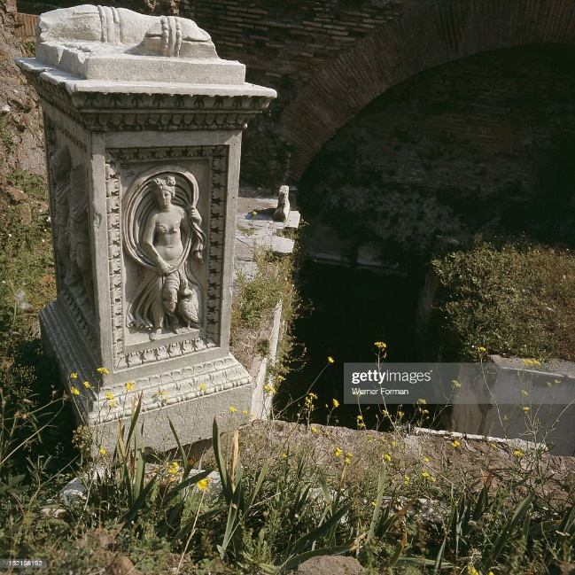

**Lines 550-610 – Aeneas attacks Laurentum, Queen Amata commits suicide**

How is Venus involved in Aeneas’ decision to attack Laurentum?

The attack on Laurentum

Compare Aeneas’ words to Latinus as he committed himself to single combat against Turnus earlier with his words now. Is he going back on his word, or is there any justification for his actions?

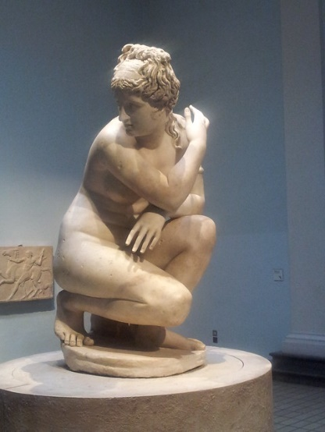

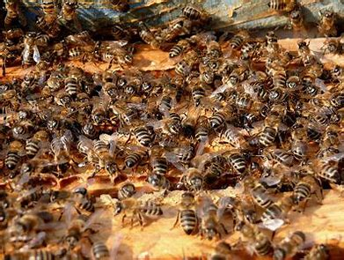What does the bee simile add to the description of the Latins’ reaction to the Trojans’ attack?

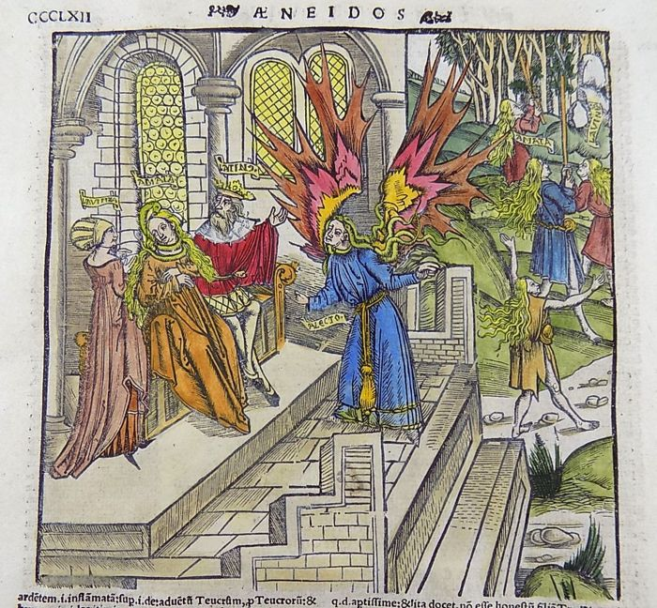

The death of Amata

Why does the queen see herself as responsible for Turnus’ supposed death? Look back at Book 7, lines 312-470; Book 11, lines 213-224; and Book 12, lines 55-85.

Allecto maddens Amata – Book 7

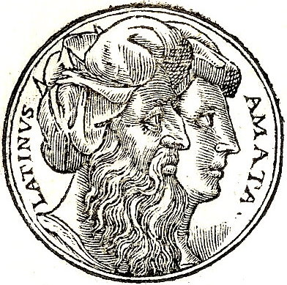How does Virgil create pathos in his descriptions of:

* Amata:
* Lavinia:
* Latinus?

**Lines 610-700 – Turnus wants single combat again**

Consider these words describing or spoken by Turnus. Add quotes from the rest of this section which explain why he feels as he does and/or which illustrate his character.

“Sister, never again shall you see me forget my honour. But first, I entreat you, let me do this one mad deed before I die. … Right requires none but me to atone for the truce on your behalf, Rutulians, and find decision by the sword.”

“Sister, at this very moment Fate is prevailing over us. … Let us follow where God and our own hard fortune call. I am resolved to meet Aeneas hand to hand, and bear whatever bitterness death may hold for me.”

In that one heart together there surged a mighty tide of shame, madness and misery blending, love tormented by passion for revenge, and valour which knew itself true.

**Lines 700-800 – Fight begins, Oleaster**

A tree, a sword and a spear

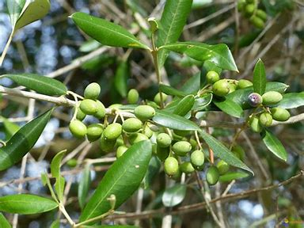

What is an oleaster and how does it feature in the narrative?

Chart what happens to Turnus’ sword:

Explain the description of Aeneas’ weapons as “divine weapons forged by Vulcan himself”. Look back at Book 8, lines 360-450 and 600-731.

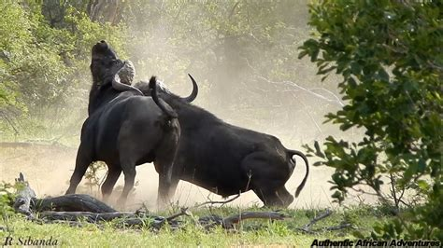

Explore the detail and effect of the similes in this section:

|  |  |
| --- | --- |
| Aeneas – like a mountain |  |
| Aeneas and Turnus – like bulls – fighting |  |
| Aeneas – like a hunting dog |  |
| Turnus – like a trapped deer |  |

Weighed in the balance

Compare the picture of Jupiter here with that of Zeus in *Iliad* 8:

All morning, while the sacred light of day grew stronger, volleys of missiles from either side reached their mark, and warriors died. But when the sun had reached the zenith, the [**Father**](https://www.poetryintranslation.com/PITBR/Greek/IlindexRSTUWXZ.php#Zeus) took his golden scales, and placing mortal fates in either pan, one for the horse-taming Trojans, one for the bronze-clad Greeks, grasping the balance, raised it by the middle. Down it sank on the Achaean side, spelling doom for them. Their pan settled on the fertile earth, while the Trojans’ rose towards the wide heavens. Then Zeus himself thundered aloud from [**Ida**](https://www.poetryintranslation.com/PITBR/Greek/IlindexFGHILMN.php#Ida), and sent a lightning bolt through the Greek army. Seeing it, they were dumbfounded, and terror seized them all.

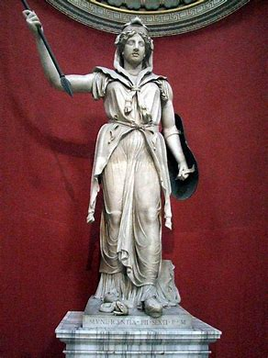**Lines 800-840 – Jupiter and Juno**

How does Jupiter allay Juno’s fears? Assess these quotes in terms of Rome’s future:

|  |  |
| --- | --- |
| *You yourself know … that it is the right of Aeneas to be raised to Heaven as a God of Italy, and that Destiny has allotted to him an exalted place among the stars.* |  |
| *Jupiter Supreme, it is because this your desire is known to me that against my own will I have forsaken Turnus, and departed from Earth. … I withdraw, and I leave the battle, for I hate it now.* |  |
| *Let them conclude a peace, sealed with a marriage of fair hope …* |  |
| *Command not Latins, in a land which is their own, to change their ancient name, to become Trojans …* |  |
| *Command none to speak a different tongue or wear another garb.* |  |
| *Let there be Latium still … let there be the Roman breed drawing power from Italian manliness. Troy has fallen, and fallen permit her, and her name, to stay.* |  |
| *That which you wish, I give. … The ancient folk of Italy shall retain the speech of their forefathers and their way of life; and their name shall be as now it is.* |  |
| *I shall make all to be Latins of a single speech.* |  |
| *… nor shall any nation celebrate your rites so devoutly as they.* |  |

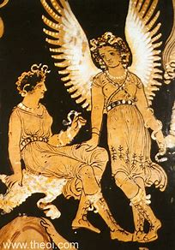**Lines 840-890 – Juturna withdraws**

How does Virgil create a vivid picture of the Furies?



How does Virgil create sympathy for Juturna? How might this affect our view of Turnus, Aeneas and Rome?

**Lines 890-950 – The death of Turnus**

Make a storyboard charting the events leading to Turnus’ death:

Explain the significance of these statements:

|  |  |
| --- | --- |
| *I fear only Gods, and especially the hostility of Jove.* |  |
| *Enjoy the fortune which falls to you. … You have conquered; ,,, Lavinia is yours to wed.* |  |
| *… if you yourself had in Anchises such a father as mine – I beg of you, take pity on Daunus in his old age, …* |  |
| *… he saw slung over his shoulder the accursed baldric of Pallas and his belt, … the trophy was fatal to him. … “Are you to be stolen hence out of my grasp, you who wear spoils taken from one whom I loved? It is Pallas, only Pallas, who by this wound which I now deal makes sacrifice of you; he exacts this retribution, you criminal, from your blood.”* | *for the story of Pallas and his belt, see: book 8, lines 450-590; book 10, lines 350-540; book 11, lines 29-58. |
| *Saying this and boiling with rage he buried his blade full in Turnus’ breast. His limbs relaxed and chilled; and the life fled, moaning, resentful, to the Shades.* |  |

