Year 2 Sociology

**Paper 3: Crime and Deviance with Theory & Methods**

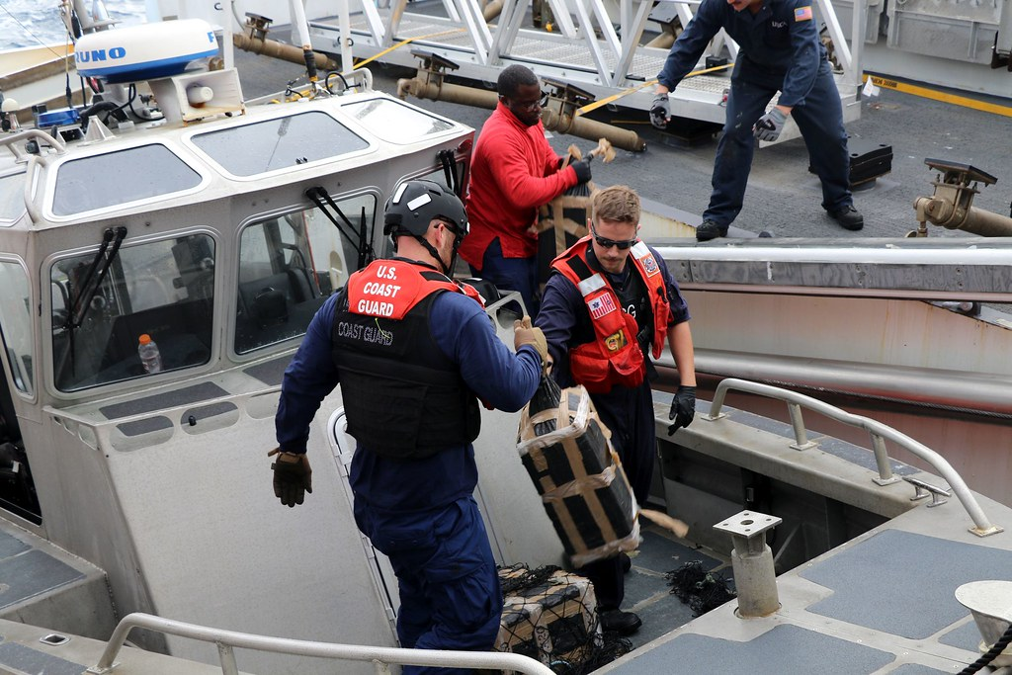

 Booklet 7 part 1

Globalisation and crime in contemporary society; the media and crime; green crime; human rights and state crimes.

Part 1 – globalisation.

Name ______________________________

Specification Content:

What you need to know for **Crime and Deviance** in your Paper 3 exam.

Students are expected to be familiar with sociological explanations of the following content:

* globalisation and crime in contemporary society; the media and crime; green crime; human rights and state crimes

|  |  |  |  |  |  |
| --- | --- | --- | --- | --- | --- |
| **Questions may be based specifically on the following areas:** | | Do I have completed Notes? | Have I made revision Notes? | Have I memorised this info? | Have I practised exam style questions? |
| Globalisation | Globalisation and crime in contemporary society, eg transnational organised crime, global criminal organisations, global capitalism and crimes of the powerful.  **Castells, Held, Taylor, Hobbs & Dunningham, Glenny** |  |  |  |  |
| Media | The media and crime, eg media representations of crime, the media as a cause of crime and moral panics.  **S.Cohen, Young, Jewkes, McRobbie & Thornton** |  |  |  |  |
| Green crime | Green crime, eg types of green crime and green criminology.  **South, Beck, White** |  |  |  |  |
| Human rights | Human rights and state crimes, eg war, genocide and torture, and human rights abuses.  **McLaughlin, H & J Schwendinger** |  |  |  |  |

Exam Structure:

**These topics will appear in paper 3 of the A’Level.** 2 hour written exam 80 marks in total (50 for this bit)

* 33.3% of A-level

Crime and Deviance: short answer and extended writing, 50 marks (4 marks, 6 marks, 10 marks, 30 marks)

What is globalisation?

Held suggests that there has been a globalisation of crime. There is an interconnectedness of crime across national borders and transnational organised crime. In fact globalisation creates new opportunities to commit crime. Such as cyber crime.

Castells (1998) argues that the global criminal economy is now worth over 1 trillion per year.

Examples?

This economy depends on supply and demand. There is demand for these products in the rich west. But this economy could not function without the supply side. The supply is linked to the globalisation process

Give some examples

Some of this globalisation of crime is linked to new insecurities and new ‘risk consciousness’. This means that the things that people in the west may worry about are not just local but global. For example, the increased movement of people (asylum seekers, economic migrants) may make people paranoid about the risks of crime and disorder and the need to improve borders.

These fears may not be rational – they are likely to come from the media which exaggerates our view of the threats we face.

Globalism, capitalism and crime

Ian Taylor from a socialist perspective writes about how globalisation has led to changes in patterns and extent of crime. Because globalisation is open to market forces there is greater inequality and rising crime.

This is at both ends of the social spectrum.

Transnational corporations have moved manufacturing to low-wage countries (remember gender and crime topic? Simon Winlow, bouncers as globalisation and de-industrialisation) has led to less ‘macho’ jobs for working class men in the UK)

What do you notice about these pictures?

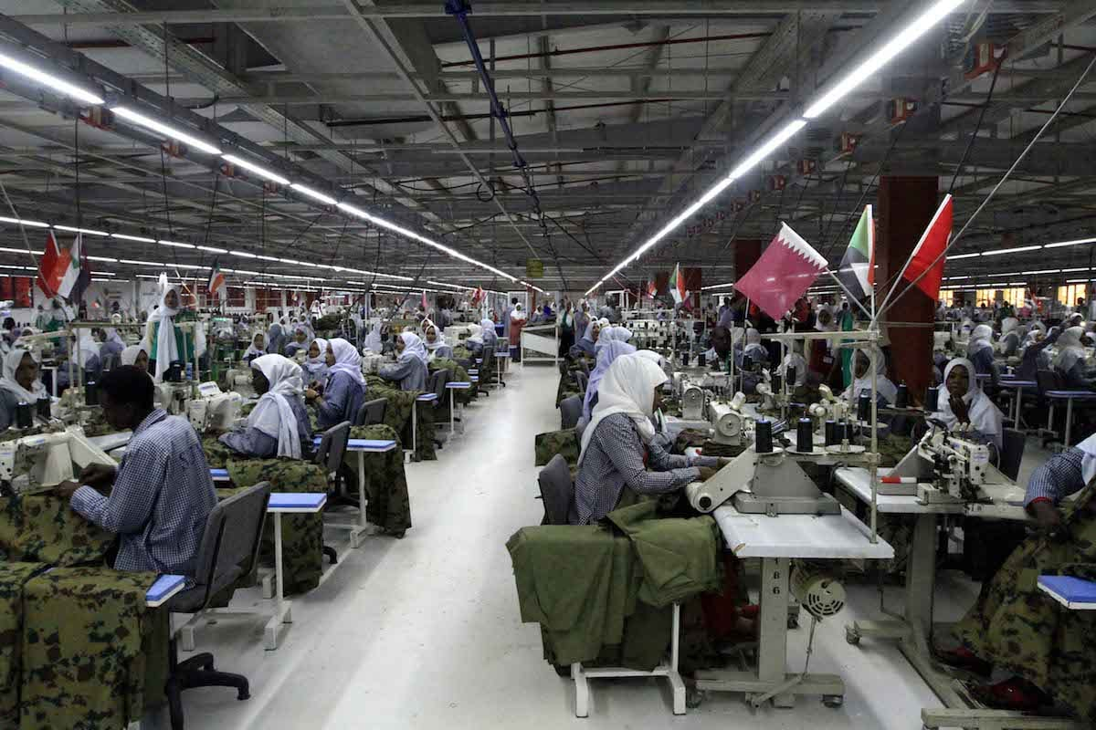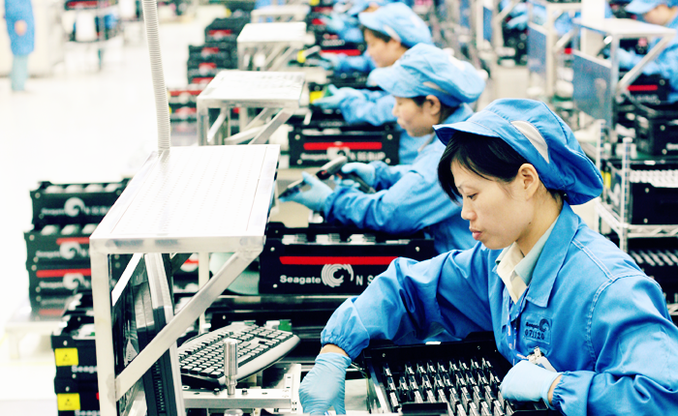

At the bottom of society

The effect of this is job insecurity, unemployment and poverty. As this is not regulated as is global, local governments may have little control over their own economies meaning for example they cannot create jobs or raise taxes.

The global media encourages a materialistic culture so inequalities are widened and more may turn to crime, especially the poor.

Lack of legitimate job opportunities destroys self-respect so individuals look for illegitimate opportunities.

At the top of society

There are criminal opportunities on a grand scale for elite groups. For example, as markets are less regulated there are opportunities for insider trading and movement of funds.





[This Photo](https://commons.wikimedia.org/wiki/File:SMirC-thumbsdown.svg) by Unknown Author is licensed under [CC BY-SA](https://creativecommons.org/licenses/by-sa/3.0/)

Taylor’s theory is useful as it links global trends in capitalist economy to changes in the pattern of crime.

BUT it does not adequately explain how the changes make people behave in criminal ways. Not all poor people turn to crime.

Patterns of criminal organisation

Remember Winlow’s study about the bouncers? Globalisation and de-industrialisation have created new criminal opportunities as a local level. Hobbs and Dunningham carry out a similar study of a post-industrial town. They found crime is organised in a way that links to economic changes brought by globalisation. Instead of large scale ‘Mafia’ type organisations, they look at local informal criminal networks centred around a central ‘hub’.

‘Glocal’ is the term they give to this. Crime is organised locally but has global connections. These networks can be loose and flexible and will vary from place to place influenced by global factor such as availability of drugs from abroad. They argue that changes connected to globalisation have led to changes in patterns of crime.

NEW = loose networks of flexible opportunistic, entrepreneurial criminals.

OLD = rigid hierarchical gang structure

It is not very clear from Hobbs and Dunningham whether the pattern above is new or that older structures have disappeared. Perhaps the two have always co-existed. This small study may not be generalisable elsewhere.



[This Photo](https://commons.wikimedia.org/wiki/File:SMirC-thumbsdown.svg) by Unknown Author is licensed under [CC BY-SA](https://creativecommons.org/licenses/by-sa/3.0/)

McMafia

Misha Glenny looks at what he calls ‘McMafia’. This refers to organisations that emerged in Russia and Eastern Europe following the fall of communism.

Before 1989 the Soviet Union (Russia) controlled a lot of Eastern Europe. When this broke up and countries got independence, regulations to do with the economy were dropped except for natural resources like oil which stayed at soviet prices (often a 40th of the world market price). Those with money could buy oil, gas, diamonds etc for next to nothing and sell them abroad for enormous profits.

People with money were often former communist officials and KGB generals. They became rich quickly and became known as ‘oligarchs’ – Russia’s new capitalist class.

Meanwhile the collapse of the communist state cause chaos and disorder. To protect their wealth these capitalists turned to ‘mafias’ which had begun to spring up which were often based on alliances between old KGB men and ex-convicts. Russian mafias helped the Russian capital class get into the world economy and Russian Mafia could build links with the rest of the world.

Watch the Ted talk ‘The real story of McMafia’ and answer the questions.

1. What does Misha Glenny identify as the commercial success story of the last 20 years?

2. What percentage of the world’s GDP did organised crime account for in 2009 (the year that the film was made)?

3. What is the other name Glenny gives to McMafia?

4. What event does Glenny identify as key to the increase in cross-border crime?

5. What were some of the problems of the changes that occurred after 1989?

6. Who are the ‘midwives of capitalism’?

7. What happened after the collapse of communism in Eastern Europe?

8. Who were the privatised law enforcement agencies?

9. Why did Glenny start his research into organised crime in the Balkans?

10. What crimes were emerging from this area?

11. How many people were involved in global crime?

12. Where were the zones of distribution?

13. Where were the zones of consumption?

14. Where do the zones of production tend to be and what threats do they face?

15. What is the primary driver of international organised crime?

16. How do smugglers make money on cigarettes?

17. How much money was lost by Britain as a result of the work of the smugglers?

18. How were the gangsters able to get away with their trade?

19. What do the international criminals do with their money and how is this made easier by globalisation?

20. How much money did Bernie Madoff steal?

21. Why has the production of drugs moved location? Why is this going to present a problem? Demand? Increased regulation?

22. How have the organised criminals changed their interests to adjust to the economic recession?

23. According to Glenny, why is cyber-crime so easy to carry out?

24. How have the internet and organised global crime contributed to the spread of malaria?

Summary of how globalisation has affected crime

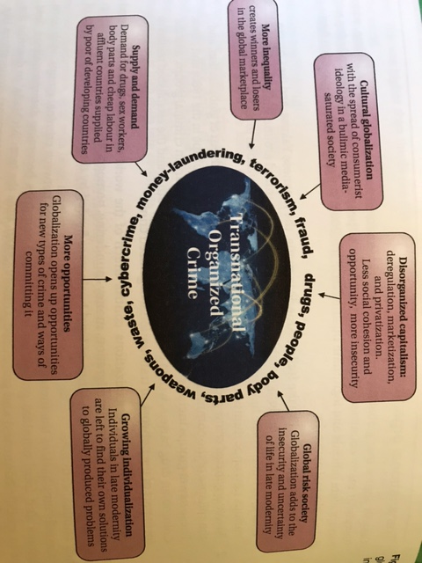

Evaluation of globalism and crime.

This is a valuable area of study as it focusses on new, dramatic and serious forms of crime. BUT its secretive and complex nature mean that it is a difficult are for sociologists to investigate.

Statistics are unavailable. Secondary sources often have to be relied on so this research may not be **valid.** Research many be dangerous. Some may say research into local crime which concern people more and have more impact on daily lives.

Global crime is easy to exaggerate. It will be more significant in some areas of the world than others. As globalisation has allowed for more crime it has also allowed for an increase in global law enforcement meaning in some ways lives of offenders are more difficult.

 Eye on the exam…..

4 marks   
Outline two ways in which globalisation has affected crime

6 mark

Outline three types of crime that have grown as a result of globalisation

10 marks

Read **the text** in the box below and answer the question that follows.

Globalisation is the process by which the world is becoming increasingly interconnected. One cause of increased interconnectedness is the development of the internet and global communications technology. Globalisation is further developed by the deregulation of financial markets and the availability of cheap air travel. One impact of globalisation is an increase in inequality between rich and poor countries.

Applying material from **the text** above, analyse **two** reasons why globalisation may lead to an increase in crime.

30 mark

Read box Item B below and answer the question that follows. Item B The increased interconnections across the globalised world have created new opportunities for crime and also new types of crime. For example, the rise of new technology has led to the development of cybercrime. Marxists argue that reduced control over finance and corporations has led to increased insecurities, inequalities and crime. However, others have argued that globalisation has enabled more effective ways of tackling crime. For example, states may cooperate in tackling international crimes such as green crimes and human rights abuses.

Applying material from Item B and your knowledge, evaluate the view that globalisation has led to increased levels of crime. [30 marks]