**3.3.5 Alcohols**

**AS Link:**

**3.1.3 – Bonding**

**3.3.1 – Introduction to organic chemistry**

**3.3.4 – Alkenes**

**Introduction**

Ethanol is the **oldest social drug**; it can be derived from the **fermentation** of sugars in fruits to give **alcoholic drinks**. If taken in moderation it can give the **feeling of well-being** and reduce normal inhibitions. It is a **nervous system depressant** (interferes with synapses) so larger quantities give rise to a loss of balance, poor hand-eye

co-ordination and impaired vision. Very large quantities **can be fatal**. Excessive long-term use can lead to **addiction**.

**General formula**: CnH2n+1OH

**Functional group name**: hydroxyl

**Shape**: oxygen has 2 bonding and 2 lone pairs which repel giving a bond angle for the C-O-H of ~105O   
(rather than 109.5 for a perfect tetrahedron)

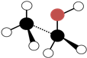

***Demo: Model alcohol***

Physical properties

Alcohols have a **higher boiling point** than **alkanes** of **similar molecular mass**. This is because of **hydrogen bonding** occurs between the molecules due to the –OH group. This also makes the **shorter chain** alcohols **soluble in water** as they can form hydrogen bonds with the water molecules.

|  |  |
| --- | --- |
| Higher boiling point | Soluble in water |
|  |  |

Naming

The root name is based on the alkane, with the ‘e’ removed. The **functional group** is usually given the **suffix –ol**. If **other** functional **groups** are present then the hydroxyl group is given the **prefix hydroxy-**. Chains longer than ethanol need a **number** to show where the –OH group is attached and the **name is split** between the alkane and

–ol. If there are **more than one –OH** group then **diol** and **triol** are used.

***Task: Name & draw displayed formula***

CH3CH2CH2OH propan-1-ol

CH3CH(OH)CH3 propan-2-ol  
***Task: Name the following alcohols***

|  |  |  |
| --- | --- | --- |
| Ethanol | Butan-1,4-diol | Propan-1,2,3-triol |
|  |  |  |

Classification

Alcohols are classified according to the **number of alkyl** groups **bonded** to the **carbon** that is bonded to the **–OH** group.

|  |  |  |
| --- | --- | --- |
| **Primary** | **Secondary** | **Tertiary** |
| 1o | 2o | 3o |
| -RCH2OH | -R2CHOH | -R3COH |
|  |  |  |
| 1 alkyl | 2 alkyl | 3 alkyl |

N.B. These are like haloalkanes and carbocations, but remember amines are classified according to hydrogen atoms are bonded to the nitrogen atom.

***Application: CGP226 PQ1-2***

***Fact recall: CGP226 Q1-2***

Other homologous series

**AS Link:**

**3.3.1 – Introduction to organic chemistry**

These series all contain a **carbonyl group** C=O.

***Models: Aldehydes, ketone, carboxylic acid***

|  |  |  |  |  |  |  |
| --- | --- | --- | --- | --- | --- | --- |
| **Homologous series** |  | | **General formula** | **Name:  prefix or suffix** | **Functional group** | **Example** |
| *aldehyde\** |  | | *CH3(CH2)nCHO*  *When naming 1st carbon is the carbonyl group* | *– al* | *R–CHO*  O  R*–*C  H | *ethanal*  *CH3CHO* |
| *ketone\** |  | | *CH3(CH2)nCO(CH2)nCH3*  *Carbonyl group can be on different carbons so may need to put number*  *e.g. 2-pentanone* | *Suffix*  *- one*  *Prefix*  *oxo-* | *R–COR’*  *R*  *C O*  *R* | *propanone*  *CH3COCH3*  *3-oxobutanoic acid*  *CH3COCH2COOH* |
|  | | \**Aldehyde & ketone are functional group isomers of each other* | | | | |
| *carboxylic acid* |  | | *CH3(CH2)nCOOH*  *When naming 1st carbon is the carbonyl group* | *- oic acid* | *R–COOH*  O  R*–*C  OH | *ethanoic acid*  *CH3COOH* |

***Sheet: Nomenclature 2***

**Distinguishing between classes of alcohols**

Using acidified potassium dichromate

|  |  |  |  |  |  |
| --- | --- | --- | --- | --- | --- |
| **Reagent** | **1o alcohol** | | **2o alcohol** | | **3o alcohol** |
| **Potassium dichromate (acidified)**  *This reaction was used in the first roadside breathalysers to test for alcohol levels* | orange → green  dichromate(VI) ions → chromium(III) ions | | | | no visible change |
|  | → | |  |  |
| ***acidified*** *potassium dichromate is a strong oxidising agent for both 1o & 2o alcohols*  *so the*  *potassium dichromate is reduced* | | | | *not easily oxidised oxidation would require the breaking of a C-C bond* |
| Oxidation: 1o alcohol + [O] → carboxylic acid + water  Oxidation: 2o alcohol + [O] → ketone + water  Reduction: Cr2O72+ + 14H+ + 6e- → 2Cr3+ + 7H2O | | | |  |

***Prac: Testing alcohols***

This test **doesn’t distinguish** between **primary** and **secondary** alcohols so a further test is needed. Two different reagents can be used to **identify** a **primary** and **secondary alcohol**. These are also used to identify an **aldehyde** and **ketone**, see later.

Using Tollens’ reagent

|  |  |  |  |
| --- | --- | --- | --- |
| **Reagent** | **1o alcohol**  **aldehyde** | | **2o alcohol**  **ketone** |
| **Test with Tollens’**  *This reaction was used to make the first mirrors* | complex ion [Ag(NH3)2]+  oxidises the 1o alcohol & aldehyde  complex ion reduced to give  **SILVER MIRROR** |  | no silver mirror |
| *Tollens’ is oxidising agent*  *colourless Ag(I) ion reduced to metallic silver*  *alcohol/aldehyde oxidised to carboxylic acid* | *Tollens’ is unable to oxidise*  *2o alcohol or ketone* |
| Reduction: Ag+ (aq) + e- → Ag (s)  colourless → silver metal |
| ***How to prepare***  ***(Not tested on)*** | *Add a few drops of dilute NaOH to silver nitrate solution*  *A brown precipitate forms initially*  *Add ammonia solution until the precipitate just disappears leaving a colourless solution – ligand substitution gives the silver ammonia complex* | | |

|  |  |  |  |
| --- | --- | --- | --- |
| **Reagent** | **1o alcohol**  **aldehyde** | | **2o alcohol**  **ketone** |
| **Test with Fehling’s** | complex ion copper(II)  oxidises the 1o alcohol & aldehyde  complex ion reduced to give  **RED PRECIPITATE** |  | no red precipitate |
| *Fehling’s is oxidising agent*  *deep blue Cu(II) ion reduced to*  *red Cu(I) oxide*  *alcohol/aldehyde oxidised to carboxylic acid* | *Tollens’ is unable to oxidise*  *2o alcohol or ketone* |
| Reduction: Cu2+ (aq) + e- → Cu+ (s)  deep blue soln → red ppt |
| ***How to prepare***  ***(Not tested on)*** | *Add a few drops of Fehling’s B (potassium sodium tartrate & NaOH) to Fehling’s A (CuSO4 solution)*  *A blue precipitate forms initially*  *Continue adding Fehling’s B until the precipitate disappears leaving a deep blue solution – ligand substitution occurs to give the tartrate complex of Cu2+* | | |
| *potassium sodium tartrate* |  | | |

***Prac: Testing aldehydes & ketones***

**Ethanol production**

**AS Link:**

**3.1.6 – Equilibria** (ethanol production)

**3.3.3 – Halogenoalkanes** (nucleophilic substitution (OH-) of halogenoalkanes using to alcohols)

**3.3.4 – Alkenes** (hydration of alkenes to alcohols)

Alcohols are very important in industrial chemistry because they are useful as intermediates. They are easily made and easily converted into other products.

**Uses**:

* Intermediates to manufacture other organic chemicals – drugs, detergents
* Solvents
* Fuels
* Alcoholic drinks (ethanol)
  + Beers and wines by fermentation produces solutions of ethanol between 3-15%
  + Spirits by distillation to give more concentrated solutions – 30-50%

**Ethanol can be manufacture by two main methods:**

|  |  |  |
| --- | --- | --- |
| **Method** | **Hydration of ethene** | **Fermentation** |
| **Reaction** | C2H4 (g) + H2O (g) C2H5OH (g) | C6H12O6 (aq) → 2C2H5OH (aq) + 2CO2 (g) |
| **Raw material** | Crude oil | Sugar beet or sugar cane |
| **Type** | Finite | Renewable |
| **Reactants** | Ethene  Steam | Glucose |
| **Conditions** | High temperature  High pressure  Catalyst: Conc. phosphoric acid (H3PO4) | Low temperature ~35OC  Atmospheric pressure  Anaerobic  Catalyst: Enzymes in yeast |
| **Rate** | Fast | Slow |
| **Quality** | Pure (100%) | Impure aqueous solution (~15%) |
| **Process**  **Costs** | Continuous process  Higher energy costs  Expensive equipment  Lower labour costs | Batch process  Lower energy costs  Inexpensive equipment  Higher labour costs |
| **Information** | Ethene is obtained from the thermal cracking of fractions separated from crude oil.  Preferred method, however as it uses ethene obtained from crude oil it may become less popular as oil supplies run out.  A reversible reaction with low yield but unreacted ethene recycled until 95% yield.  Only synthesised for industrial use. | Slow rate is a compromise as enzymes are ineffective at higher temperature, but lower temperature uses less energy.  High levels of alcohol (>15%) cause the enzymes to stop functioning so fermentation stops.  Air is kept out to prevent oxidation of the alcohol to ethanoic acid (vinegar).  Distillation is required if a more concentrated solution is needed. |

Fermentation of glucose

|  |  |
| --- | --- |
| Fermentation is an exothermic process, carried out by **yeast** in **anaerobic conditions**. Enzymes on the yeast convert **carbohydrates** from plants **into** **sugars** and then **into** **ethanol** during **anaerobic** **respiration**. |  |

The rate of the reaction is **affected by temperature**, if it is **too low the rate is slow** but if the temperature is **too high the enzymes are denatured** and so can’t function. So the temperature used is a compromise.

***Sheet: Making ethanol***

Hydration of ethene – electrophilic addition reaction

**AS Link:**

**3.3.5 – Alcohols** (dehydration of alcohols to produce alkenes)

***Definition***: **Hydration reaction** –addition of water to a molecule

**Reactants**: alkene + water (steam) N.B. Water is a weak electrophile

**Conditions**: high temperature, high pressure & catalyst (conc. H2SO4 – provides H+ ions)

**Product**: alcohol

**Equation**: CnH2n + H2O C2H2n+1OH



CH2=CH2 + H2O CH3CH2OH

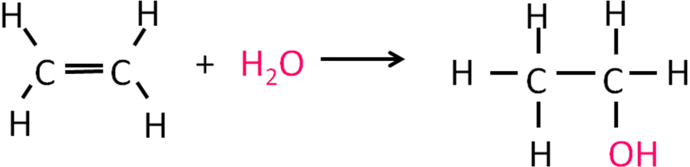

**Mechanism**: Electrophilic addition

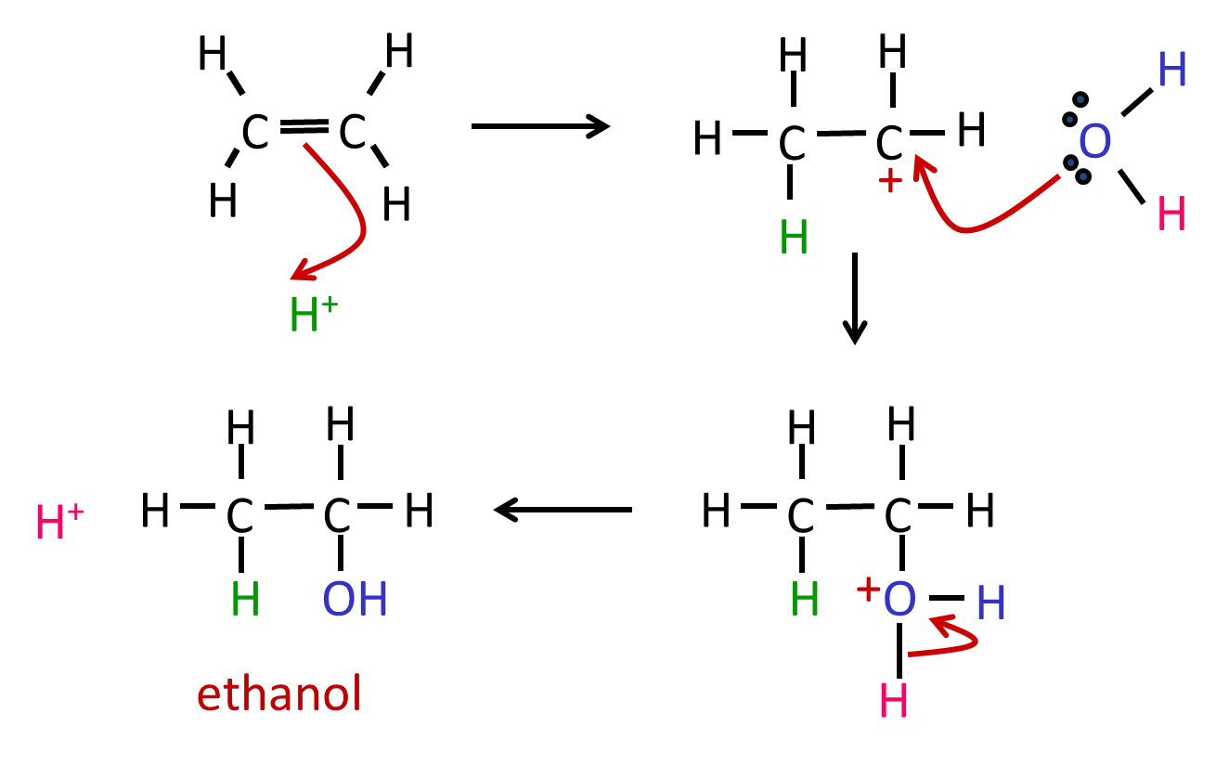

from the acid catalyst

catalyst re-generated

**Notes**: H+ ion from acid catalyst is added onto alkene initially then water molecule reacts with carbocation and H+ ion is eliminated from water.

***Task: Alcohol production - hydration ethene summary***

Biofuels

***Definition***: **Biofuel –** a fuel **made** **from** renewable **biological material**

If the ethanol is **produced from crops,** it is a **biofuel**. This **contrasts** with **fossil fuels** which took **millions of years** to form so are **non-renewable**. Biofuels won’t run out, so they are more **sustainable**.

***Definition***: **Carbon-neutral** is a process in which the **same amount** of **carbon dioxide** is **absorbed** from the air **as given out**.

There is no net change in carbon dioxide.

Burning of any **carbon-containing fuel** will **release** the **carbon dioxide** into the atmosphere, which has been associated with **global warming**.

Ethanol made by **fermentation** is sometimes referred to as **carbon neutral**. This means that the **carbon dioxide released** during **combustion** is **balanced** by the **carbon dioxide absorbed** during **photosynthesis**. So, there are **no net emissions of carbon dioxide**.

***Task: Write out equations for removal & release of CO2 from/into the atmosphere – how many moles of CO2 are removed & released?***

|  |  |
| --- | --- |
| **Removal of CO2 from atmosphere** | **Release of CO2 into atmosphere** |
| *Photosynthesis:*  6CO2 + 6H2O → C6H12O6 + 6O2  6 mole CO2 removed per 1 mole glucose | *Fermentation:*  C6H12O6 → 2C2H5OH + 2CO2  2 mole CO2 released per 1 mole glucose  *Combustion:*  1 mole of ethanol  2C2H5OH + 6O2 → 6H2O + 4CO2  2 moles of ethanol  2C2H5OH + 6O2 → 6H2O + 4CO2  4 mole CO2 released per 2 mole ethanol |
| **Total: 6 moles CO2 removed** | **Total: 6 moles CO2 released** |

However, the argument concentrates on the chemistry of fuel use and production and there are **other carbon costs** associated with this process.

**Energy used that will release carbon dioxide**:

|  |  |
| --- | --- |
| * machinery to harvest the crops * transporting the crops * processing the crops to produce the biofuel * transporting the biofuel to fuel stations | these use fuel which when burnt releases CO2 |

So it is **not truly carbon-neutral**.

Issues with biofuels

***Task: List the advantages and disadvantages of using biofuels***

|  |  |
| --- | --- |
| **Advantages** | **Disadvantages** |
| * Made from renewable sources * Burning only releases same amount of carbon dioxide that was taken during growth i.e. carbon neutral | * Land used to grow crops may:   + lead to further deforestation   + reduce the land available to grow crops for feeding people   + increased use of fertilisers causes environmental problems * Modification of car engines may be needed to allow them to run on ethanol   (most cars already capable of running on ethanol or biodiesel) |

***Application: CGP233 PQ1***

***Fact recall: CGP233 Q1-5***

**Reactions of alcohols**

Combustion

***Demo: Burning ethanol***

Alcohols undergo **complete oxidation** when they **burn** provided **enough oxygen** is present. So they make **good fuels**. They produce water and carbon dioxide.

N.B. alcohols contain oxygen when balancing

C2H5OH (l) + 3O2 (g) → 2CO2 (g) + 3H2O (l)

Methylated spirits is ethanol with a little bit of poisonous methanol added plus a purple dye. This is so that it can be sold without tax and makes it unfit to drink.

Dehydration – elimination reaction

**AS Link:**

**3.3.5 – Alcohols** (hydration alkenes to produce alcohols)

**3.3.3 – Halogenoalkanes** (elimination using OH- base to give alkene & hydrogen halide)

Dehydration of alcohols occurs by an elimination reaction.

**Elimination** reactions are ones in which a **small molecule** **leaves** the parent molecule. With **alcohols** this is **always** **water**, made up from the **–OH group** and **hydrogen** from the carbon next to it. The **elimination of water** means that thesereactions of alcohols are always **dehydration reactions** to **form alkenes**.

H

R

R

H

C

C

+ H2O

R

H

H

C

C

H

OH

R

**Alcohols** can be **dehydrated** if reacted with an **excess** of **hot** **sulphuric** **acid** catalyst or by **vaporising** them and passing them over **hot** **aluminium** **oxide** catalyst, forming an **alkene**.

# **Reactant**: 2o or 3o alcohol

Primary alcohols don’t undergo dehydration because a primary carbocation is formed which is unstable

# **Conditions**: hot & catalyst (**conc**. H2SO4)

**Product**: alkene

**Equation**: R(OH)R → RC=CR + H2O

**Example**: CH3CHOHCH3 → CH2=CHCH3 + H2O

propan-2-ol propene

**Mechanism**: Elimination

Mechanism:

from the acid catalyst

catalyst re-generated

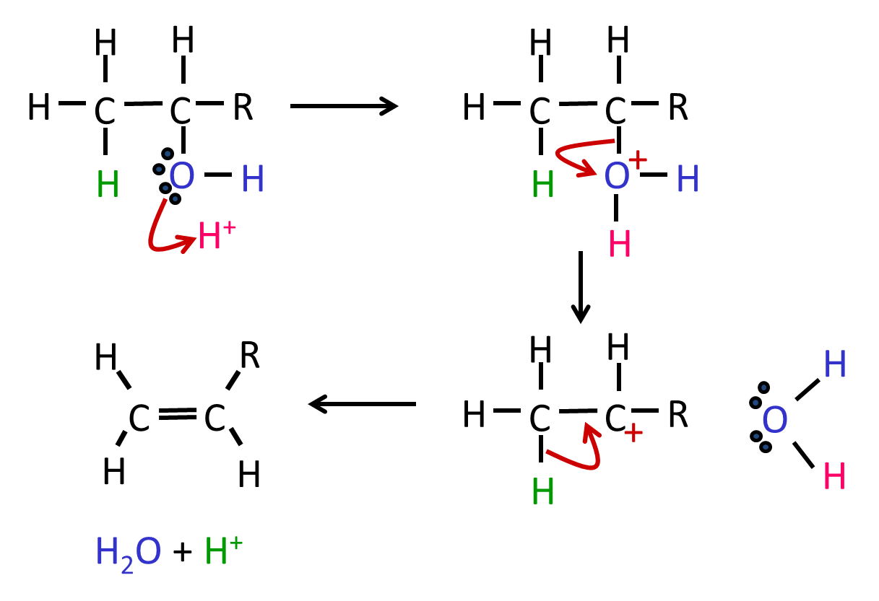

***Task: Dehydration of alcohols summary***

If the alcohol is a longer molecule and **asymmetrical** then a mixture of **isomeric alkenes** will be produced because the double bond can go either side of the carbon where the hydroxyl group is attached. If the **hydroxyl group** is at the **end** of the alcohol, then the **double bond** can **only** form in **one position**, so **no isomers** are formed.

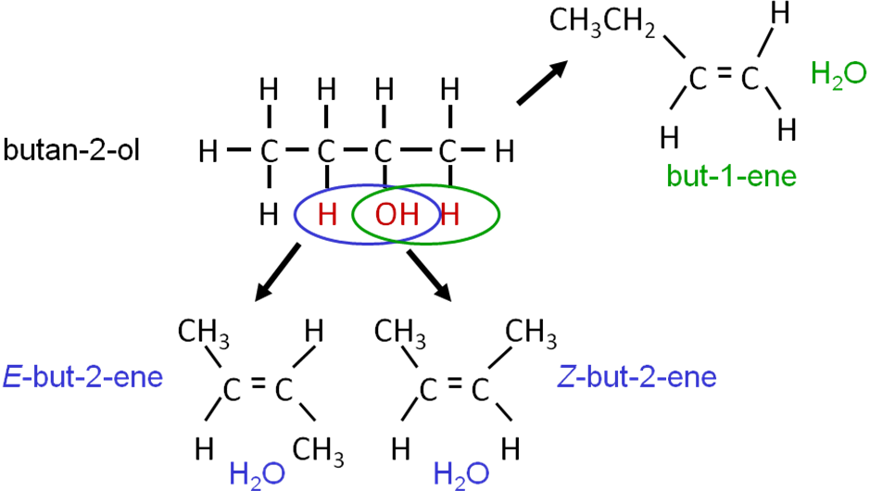

***Task: Draw mechanisms to produce each type of isomer***

***Application: CGP229 PQ1***

***Fact recall: CGP229 Q1-3***

Purifying the product of a reaction

|  |  |
| --- | --- |
| Organic reactions often **produce more than one product**, so the **main product** is **impure** and needs to be **isolated** from the mixture. **Distillation** is a technique that can be used to **separate** different **substances** with **different boiling point**.  ***Videoclip: RSC Distillation***  ***Required practical 5:*** Distillation of a product from a reaction |  |

Oxidation

Combustion is an oxidation reaction that is usually complete oxidation but alcohols can also be **oxidised gently** and to allow them to be oxidised in **stages**.

**Interesting information:**

Ethanol is oxidised to ethanal in the body, then an enzyme (aldehyde oxidase) converts the ethanal to ethanoic acid which is used by the body as a source of energy. The aldehyde is the chemical responsible for a hangover as it builds up.

The **oxidising agent** used is **acidified potassium dichromate(VI)**, K2Cr2O7. The orange **potassium dichromate(VI)** ion is reduced to the **green chromium(III) ion**, Cr3+.

The products depend on the **type of alcohol** used:

* **1o alcohols** oxidised to **aldehydes** then **carboxylic acids**
* **2o alcohols** oxidised to **ketones** only
* **3o alcohols** not oxidised using acidified potassium dichromate (needs a stronger oxidising agent)

Testing the products of oxidation

**AS Link:** Test for primary & secondary alcohols

|  |  |  |
| --- | --- | --- |
| **Product** | **Aldehyde** | **Ketone** |
| Tollens’ reagent | Silver mirror | No visible change |
| Fehling’s reagent | Red precipitate | No visible change |

Primary alcohols

**Primary alcohols** can be oxidised to **aldehydes** and **further oxidation** can occur to give a **carboxylic acid**.

**[O]** is used as a simplification for an oxidant or oxidising agent in organic equations

***Partial oxidation***

# **Reactant**: 1o alcohol + **acidified** potassium dichromate(VI) (K2Cr2O7)

# **Conditions**: **warm** & catalyst (**dilute** H2SO4) & **distillation**

**Product**: aldehyde

N.B. The equations must still **balance** for oxygens

**Equation**: R-OH + [O] → RCHO + H2O

**Example**: CH3CH2OH + [O] → CH3CHO + H2O

ethanal

**Experimental details**:

The aldehyde is immediately **distilled** off to **prevent further oxidation**.

|  |  |  |
| --- | --- | --- |
| **Aldehydes** have a **lower boiling** point than **alcohol** or **carboxylic acids** which both have **hydrogen bonds**. | Aldehyde is removed as it forms | ***Demo: Partial oxidation of alcohol to form aldehydes*** |
|  | *Distillation apparatus* |  |

***Video clip - Reflux***: <https://www.youtube.com/watch?v=b6xFAEkjmGg>

To produce **carboxylic acids** the reaction mixture must be **boiled** **vigorously** to **oxidise** it **completely**.

***Complete oxidation***

# **Reactant**: 1o alcohol + excess **acidified** potassium dichromate(VI) (K2Cr2O7)

# **Conditions**: **hot** & catalyst (**concentrated** H2SO4) & **reflux**

**Product**: carboxylic acid e.g. ethanoic acid

**Equation**: R-OH + **2**[O] → RCOOH + H2O

N.B. Twice as much oxidising agent is used to make carboxylic acid

**Example**: CH3CH2OH + **2**[O] → CH3COOH + H2O

**Experimental details**: The reaction mixture is heated under **reflux** so that the **aldehyde** **condenses** back into the mixture (prevents it escape) and **gets oxidised** to the **carboxylic acid**. After 20 minutes the carboxylic acid can be distilled off.

|  |  |  |
| --- | --- | --- |
| The **aldehyde** **evaporates** then **condenses** back into the flask, this is called **refluxing**. It is then **completely** **oxidised** to the **carboxylic acid**. |  | ***Prac: Oxidation of alcohol*** |
|  | *Reflux apparatus* |  |

**Summary**

|  |  |
| --- | --- |
| H3C  H  OH  C  H  H3C  O  C  H  H3C  O  C  OH  [O]  [O]  alcohol  aldehyde  carboxylic  acid  [O]  [O]  alcohol in excess no reflux  1o  ethanol  ethanal  ethanoic  acid  [O]  [O]  H2O  H2O | **Interesting information:**  Alcoholic drinks such as wine and beer that are left exposed to air go off. The ethanol is oxidised to carboxylic acid by enzymes present in bacteria. However, bacteria can’t survive in concentration >20% so drinks high in alcohol don’t oxidise and can be kept open longer. |

Secondary alcohols

# **Secondary alcohols** can be oxidised to **ketones**, using **acidified** **potassium dichromate(VI)** (K2Cr2O7). These have **no hydrogen atoms attached** to the **carbonyl** (C=O) carbon in the **ketone** so they **cannot easily be oxidised further**.

+ H2O

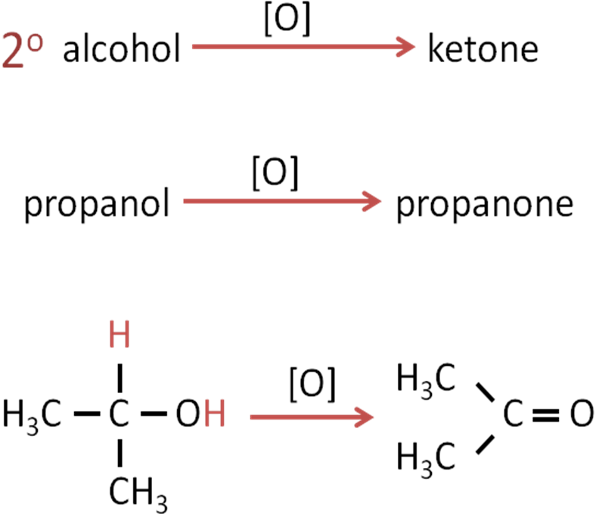

Tertiary alcohols

Tertiary alcohols **not easily oxidised** because oxidation would **require** the **breaking** of a **C-C bond**, rather than a C-H bond, so a **stronger oxidising agent** would be **needed**. This is the same reason why ketones don’t oxidise any further.

**Oxidation summary**

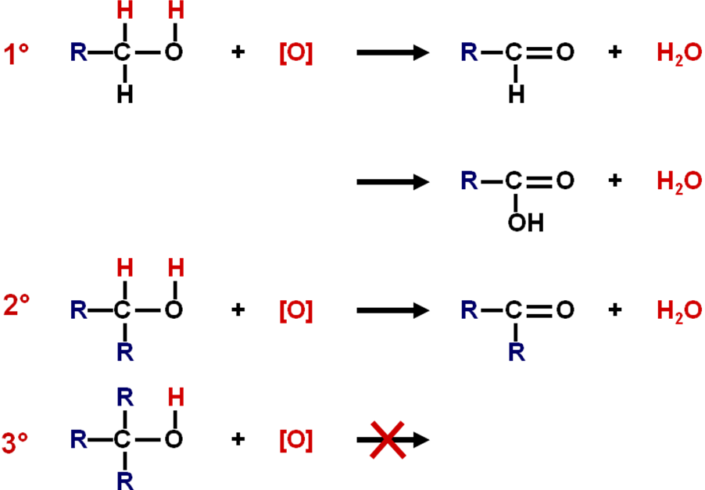

***Starter: 5.3.3 - Alcohols***

***Starter: 5.3.4 – Alcohols as intermediates***

***Application: CGP237 PQ1***

***Fact recall: CGP237 Q1-3***

***Sheet: Alcohols PPQ 1-3***

***Exam questions: Oxford p240-241 Q1-6***