3.9.1 Strategic methods: how to pursue strategies

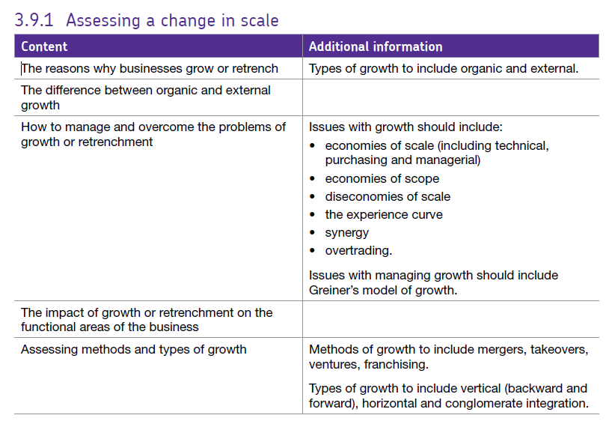

# Why do firms grow or retrench?

**Reasons why businesses grow**

Growth is an important objective for many businesses; it provides a great deal of benefit for various stakeholders. For example, growth can result in greater profitability which will please shareholders.

**The difference between organic and external growth**

Growth can be achieved either internally (known as organic growth) or externally. Which type of growth chosen will depend on a number of factors?

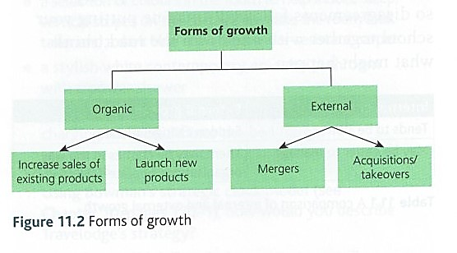

# Methods of growth

Growth of the firm can be internal (organic) or external (inorganic).

Internal growth is known as **organic growth** and comes from increased sales of existing products onto the market. This kind of growth takes a long time and cannot be guaranteed.

The main ways of achieving organic growth are:

* As an **imitator** – seeing what other firms do well and using it as a model for the firm’s growth.
* As an **inventor** – usually through technology, the firm grows by inventing new products and offering service which is superior to competitors.
* As an **insider** – growth is driven by customer relations and powerful branding e.g. M&S
* As an **illuminator** – growing by seeing and exploiting gaps in the market, trying to obtain first mover advantage.

Firms which grow well by organic means generally;

* have products which are focussed on consumer needs
* 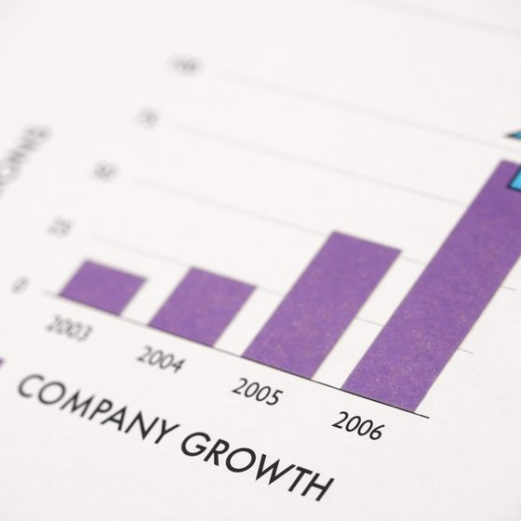focus on what can be delivered quickly and efficiently

**Organic growth is usually pursued because a firm wishes to grow in a steady and closely managed way**. This type of growth can be achieved by increasing the sales of products either in new or existing markets or launching new products. **A firm is likely to prefer organic growth when:**

* The business is in the early stages of development and has not fully established itself in the marketplace.
* The firm’s products are highly technical or individual.
* The costs of growth need to be spread out over a period of time.

Finance for investment and expansion accompanying organic growth usually comes from the retained profit resulting from existing activities, from borrowing or by attracting new investors. As a result, this type of business growth tends to be relatively slow and less risky than external growth.

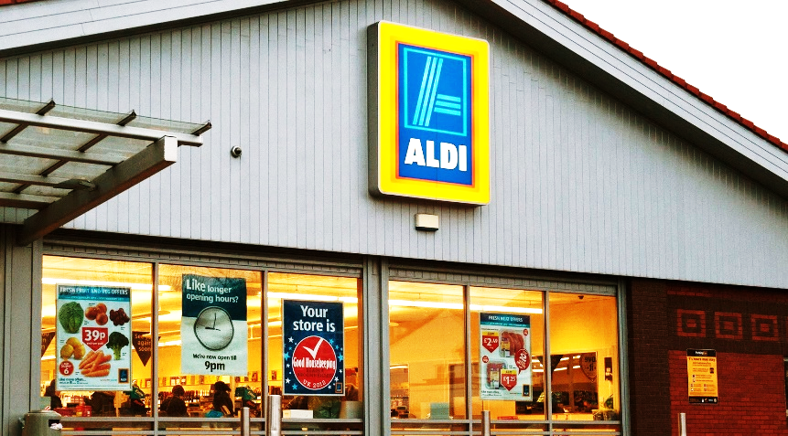However, internal growth is gradual and slower and the problems associated with cultural clash are avoided. The downside of course is that internal growth is much slower and this may be a problem in a fast moving business environment. But organic growth certainly is less destabilising for the business than the sudden growth associated with external growth.



**Examples of firms growing organically include Everyman Cinemas and Aldi.**

## External growth tends to be via integration which is the combining together of two or more companies in the form of a merger or a takeover (acquisition).

Mergers are far less common than takeovers.

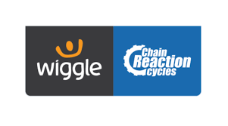There are different types of merger:

Horizontal: Two firms in the same industry and the same stage of production join together e.g. Wiggle and Chain reaction cycles (Wiggle-CRC group) which happened in 2016.

Lateral: the merging of 2 firms with related products

Vertical: forward or backward – onto the next stage in production, or back to the last one. E.g. if Whitbread buying a chain of pubs would be vertical, forward integration, but buying a hop farm would be vertical, backward integration.

Conglomerate: 2 firms in completely different areas join together. This may be to spread risk and / or explore different opportunities.

Mergers occur when two businesses believe and jointly agree that they can increase their combined profit, or achieve their other objectives, by merging their businesses together. This is often referred to as a friendly merger.

# Acquisitions or Takeovers

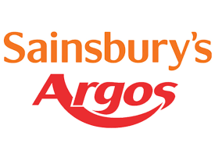This occurs where one company buys another.

Takeovers (acquisitions) occur when the acquiring firm (the firm who wishes to take over the company) offer the company’s current shareholders more money for the shares they hold than is possible if they were to sell them on the current stock market. Once the acquiring company has gained sufficient shares, they can complete the takeover. This is often referred to an **aggressive or hostile takeover**.

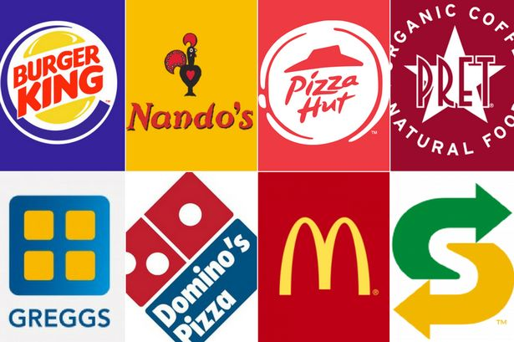

Another way to grow a business is through **franchising**.

# Franchising

Franchising arises when a **franchisor** grants a licence (**franchise**) to another business (**franchisee**) to allow it trade using the brand / business format. Some of the UK’s biggest companies are franchises.

**The franchisor**is the business whose sells the right to another business to operate a franchise – they may run a number of their own businesses, but also may want to let others run the business in other parts of the country.

A franchise is bought by the **franchisee. O**nce they have purchased the franchise they have to pay a proportion of their revenue (or sometimes profits) to the franchiser on a regular basis. The franchiser may provide training, management expertise and national marketing campaigns. They may also supply the raw materials and equipment.

Buying a franchise a good way of an individual setting up a business because:

* The new business does not have to establish itself in the same way that a sole trader might have to.
* They will have the support of a tried and tested business model, often with a national marketing campaign behind them

### Benefits to the Franchisor

The main advantages to the franchisor of growing a business using franchising include:

* A classic growth strategy for a proven business format
* Enables much quicker geographical growth for a relatively low investment
* Still have the option to open locations that are operated by the Franchisor
* Capital investment by franchisees is an important source of growth finance

### Benefits to the Franchisee

The main advantages of setting up as a franchisee include:

* The franchisee is given support by the franchisor. This includes marketing and staff training. So starting a business in this way requires less expertise and is less lonely!
* The franchisee may benefit from national advertising and being part of a well-known organisation with an established name, format and product
* Less investment is required at the start-up stage since the franchise business idea has already been developed
* A franchise allows people to start and run their own business with less risk. The chance of failure among new franchises is lower as their product is a proven success and has a secure place in the market

### Drawbacks to the Franchisee

The potential disadvantages of setting up as a franchisee are:

* Cost to buy franchise – can be very expensive.
* Have to pay a percentage of revenue to the business you have bought the franchise from.
* Have to follow the franchise model, so less flexible. You would probably be told what prices to set, what advertising to use and what type of staff to employ.

# Joint venture.

A joint venture (JV) is a separate business entity created by two or more parties, involving shared ownership, returns and risks. Joint ventures are different from takeovers and mergers in that the risks and returns of the business formed as the joint venture are shared by the parties involved. Usually this is a 50:50 share, although that doesn't have to be the case.

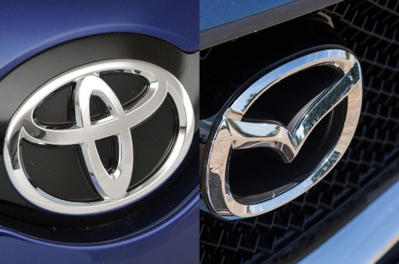The parties involved in a joint venture are usually looking to benefit from complementary strengths and resources brought to the venture, as well as sharing the risks and rewards involved.

Joint ventures are often used as a method of one business entering international markets. Indeed, in some cases, this is a requirement of firms entering certain industries in some countries. **Mazda and Toyota gave recently agreed to work on their electric vehicles together.**

### Potential Benefits of Using Joint Ventures as a Method of Growth

JV partners benefit from each other's expertise and resources (e.g. market knowledge, customer base, distribution channels, R&D expertise). Each JV partner might have the option to acquire in the future the JV business based on agreed terms if it proves successful

Reduces the risk of a growth strategy - particularly if it involves entering a new market or diversification

### Potential Drawbacks of Using Joint Ventures as a Method of Growth

Risk of a clash of organisational cultures - particularly in terms of management style.

The objectives of each JV partner may change, leading to a conflict of objectives with the other

In practice, there turns out to be an imbalance in levels of expertise, investment or assets brought into the venture by the different partners

# Management buy-outs

A business is acquired by its managers. The managers for a holding company which then buys all the shares of the target firm.

Usually arise due to;

* the business is no longer part of the core and is being sold off
* The parent company is in trouble and needs to sell assets
* The owner is going to retire
* A receiver has been brought in to sell the firm

External growth will often encounter problems since it entails the joining together of different companies. Even companies in the same sector, providing the same or similar products or services, may have a very different way of operating and a different management style and culture. This is often referred to as a **culture clash** and has been responsible for the poor performance of a number of mergers over the years.

## Financing growth.

Firms usually have to borrow or issues share in order to grow. Organic growth is possible through a combination of retained profit and borrowing from banks etc, but most large firms issue shares and re-value shares in order to grow. Sometime firms can get grants or can find a partner for a joint venture where both firms contribute funds.

## 

## Scan_20161030 (5).jpgEffects of growth

Planning and forecasting – must be co-ordinated otherwise the firm will become inefficient and diseconomies of scale will arise.

Marketing – Research must be carried out to ensure that the developments are in the best interests of the consumers and that the target market is big enough to bring in higher profits.

HRM – there may be a case for re-organising or rationalising the workforce and, as some people will not be happy about the change, there will also be a certain amount of difficulty in industrial relations.

Production – the firm may have to relocate, reorganise production or change purchasing techniques, they may even have to change production methods e.g. from batch to flow.

## Economies of scope

A proportionate saving gained by producing two or more **distinct goods**, when the cost of doing so is less than that of producing each separately.

## Experience curves

An experience curve shows the idea that the more experienced the firm is at making a product, the better; faster and cheaper it is able to make it.

## Synergy

Cost savings derived from groups working together rather than working separately. Synergy is a key concept associated with external growth. Synergy happens when the value of two businesses brought together is higher than the sum of the value of the two individual businesses. In other words, when synergy happens, 1 + 1 = more than 2 – usually as a result of savings or additional revenues which can be generated through the merger or acquisition.

There are two main kinds of synergy:

**Cost synergy:** where cost savings are achieved as a result of external growth

**Revenue synergy:** where additional revenues are achieved as a result of external growth

## Overtrading

This involves producing goods based on anticipated income rather than actual income – assuming the funds will come into the business if the money doesn’t come in the firm could go bankrupt.

## Effect of growth on cash flow; risks of over trading

Most firms have to borrow in order to grow, unless they have a large amount of retained profit or can sell off assets. This can lead to an immediate increase in the firm’s outgoings, but naturally there will be a time lag before the firm’s income is also higher. This can lead to cash flow problems.

Overtrading occurs where a firm spends money it hasn’t got in order to generate more sales. This is a gamble and if it doesn’t pay off, then the firm will become insolvent as its liabilities will have risen considerably, but income will not.

Greiner's Growth Model

This model predicts the six phases and five crises that businesses may experience as they grow.

Greiner says that as firms grow they move through each of these phases, at the end of the phase the firms go through a period of revolution – a time when things are not functioning properly in the firm, this leads to a crisis point forcing them to change how they are operating if they are to continue to grow successfully - this leads them into the next phase.

If a firm doesn’t want to get any bigger it can just stay in the phase it has reached – the crises arise if the firm is still trying to grow.

The phases of the Greiner Growth Model are illustrated below:

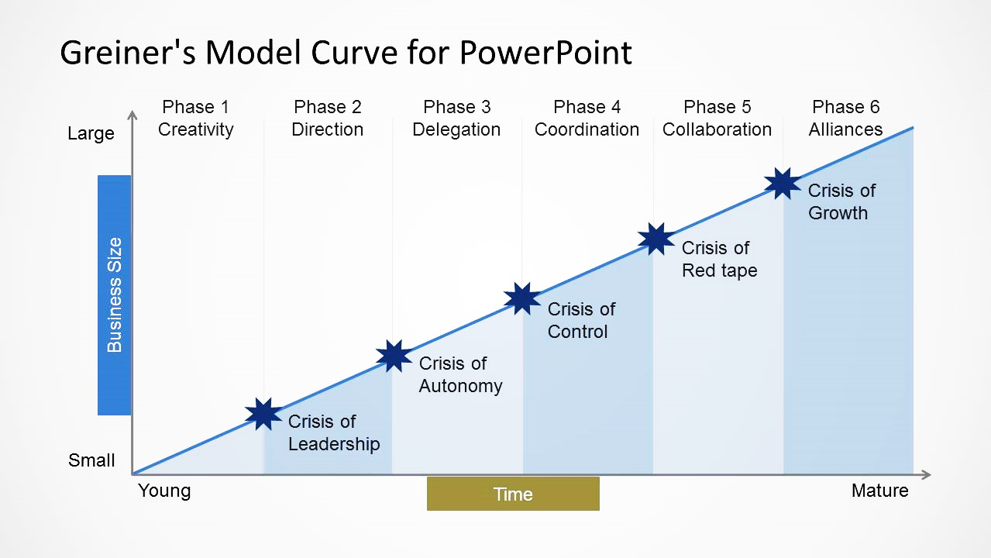

The five predicted crises of growth according to the model are:

1. **Growth Phase: Creativity**

**The business is started and the entrepreneur is putting their energy into making the firm successful**

1. **Growth Phase: Direction** – caused by crisis of **Leadership**

Informal communication starts to fail, business now too big for leader to get involved in everything

1. **Growth Phase: Delegation** – caused by crisis of **Autonomy**

Business now has functional management but founder / leader still struggling to let go

1. **Growth Phase: Coordination** – caused by crisis of **Control**

More formal management structures in place but new layers of hierarchy needed to keep control

1. **Growth Phase: Collaboration** – caused by crisis of **Red Tape**

A dangerous growth in organisational bureaucracy slowing decision-making & missing external changes

1. **Growth Phase: Alliances** – caused by crisis of **Growth**

Growth slowing as business runs out of ideas, alliances are sought (including new business owners)

What can we learn about the challenges of growing a business if, for a moment, we assume that Greiner's Growth Model is valid?

* Growth is hard
* Growth poses many management and leadership challenges (crises)
* Leadership and organisational structure have to evolve to reflect the growth of a business
* Businesses that don’t adjust as they grow will face lower growth than those that do

### Criticisms of Greiner's Growth Model

* Like most models – it is simplistic
* Not every business will suffer crises as it grows – many adapt easily without suffering any obvious panics or crises
* The model doesn’t really take account of the pace of growth, particularly in an increasingly dynamic external environment

## Changes in ownership / Impact of new ownership

There can be many **side effects of changes** in ownership of the firm. These include:

* Management reorganisation – may get a different boss with a bad reputation or different expectations.
* Problem of adjustment from boss to leader/manager; the nature of a ‘boss’ is different to that of a ‘manager’. Brainstorm ‘boss’ tasks and ‘manager’ tasks.
* change in during growth management structure/ hierarchy; can lead to anxiety and confusion about situations, may decrease productivity in the short term.
* Risk of loss of direction and control – must have a plan which is clearly being implemented otherwise things can easily drift without anyone checking on them.
* Employees may have differing expectations; depending on age / experience of workforce they may be quite hostile to change of management; motivation will need to be considered.

# Retrenchment

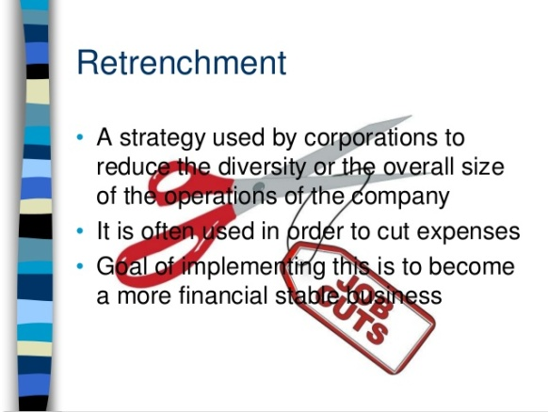

Retrenchment is the opposite of business growth and involves the cutting back of an organisation’s scale of operations. Poor performance or poor economic conditions may cause a business to reduce its size or **retrench**.

For example, weak demand due to recession might cause a business to concentrate production on a narrower range of products or concentrate production in fewer locations.

Strong competition from a rival business might mean that a business needs to close down production facilities. Sometimes, a business that has diversified *too much* may retrench because it decides to refocus on a narrower range of activities so that it can reap the benefits of **specialisation** (concentrate on what it is relatively good at). Unfortunately, retrenchment often involves job losses and all the uncertainly associated with that for the remaining staff.

[**http://www.tutor2u.net/business/reference/retrenchment-video**](http://www.tutor2u.net/business/reference/retrenchment-video)