**Culturing microorganisms (biology only)**

Bacteria multiply by simple cell division (binary fission) as often as once every 20 minutes if they have enough nutrients and a suitable temperature. Bacteria can be grown in a nutrient broth solution or as colonies on an agar gel plate. Uncontaminated cultures of microorganisms are required for investigating the action of disinfectants and antibiotics.

* Petri dishes and culture media must be sterilised before use to kill unwanted microorganisms.
* The inoculating loops used to transfer microorganisms to the media must be sterilised by passing them through a flame
* The lid of the Petri dish should be secured with adhesive tape to prevent microorganisms from the air contaminating the culture, and stored upside down to stop condensation drops falling onto the agar surface.

In school and college laboratories, cultures should be incubate at a maximum temperature of 25°C to reduce the likelihood of the growth of pathogens that might be harmful to humans.

The cross-sectional areas of colonies or clear areas around colonies can be calculated using the formula πr². This is useful in measuring the area of bacterial growth or the inhibition of bacterial growth due to the effect of an antibiotic or antiseptic. This helps to interpret the results of the petri dish experiments e.g. the relative effectiveness of different antibiotics acting under the same experimental conditions on the same bacteria - fair test conditions!

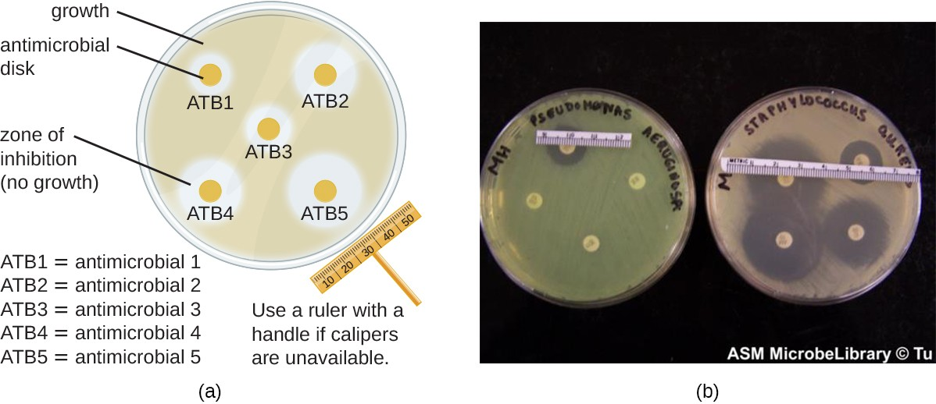

**4.3.2 Monoclonal antibodies (biology only) (HT only)**

**Producing monoclonal antibodies**

Monoclonal antibodies are produced from a single clone of cells. The antibodies are specific to one binding site on one protein antigen and so are able to target a specific chemical or specific cells in the body.

They are produced by stimulating mouse lymphocytes to make a particular antibody. The lymphocytes are combined with a particular kind of tumour cell to make a cell called a hybridoma cell. The hybridoma cell can both divide and make the antibody. Single hybridoma cells are cloned to produce many identical cells that all produce the same antibody. A large amount of the antibody can be collected and purified.

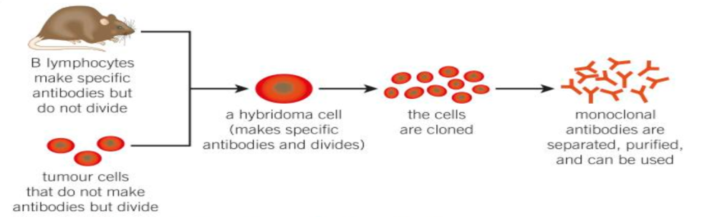

**Uses of monoclonal antibodies**

Monoclonal antibodies can be used in many ways. Some examples include:

* for diagnosis such as in pregnancy tests
* in laboratories to measure the levels of hormones and other chemicals in blood, or to detect pathogens
* in research to locate or identify specific molecules in a cell or tissue by binding to them with a fluorescent dye
* to treat some diseases: for cancer the monoclonal antibody can be bound to a radioactive substance, a toxic drug or a chemical which stops cells growing and dividing. It delivers the substance to the cancer cells without harming other cells in the body.

Monoclonal antibodies although useful but ethical issues must be considered

Monoclonal antibodies create more side effects than expected. They are not yet as widely used as everyone hoped when they were first developed

**4.3.3 Plant disease (biology only)**

**Detection and identification of plant diseases (HT only)**

Plant diseases can be detected by:

* stunted growth
* spots on leaves
* areas of decay (rot)
* growths
* malformed stems or leaves
* discolouration
* the presence of pests.

Identification can be made by:

* Reference to a gardening manual or website
* Taking infected plants to a laboratory to identify the pathogen
* Using testing kits that contain monoclonal antibodies.

Plants can be infected by a range of viral, bacterial and fungal pathogens as well as by insects.

Some of them include tobacco mosaic virus as a viral disease, black spot as a fungal disease and aphids as insects.

Plants can be damaged by a range of ion deficiency conditions:

* stunted growth caused by nitrate deficiency
* chlorosis caused by magnesium deficiency.

Nitrate ions are needed for protein synthesis and therefore growth, and magnesium ions are needed to make chlorophyll.

**Plant defence responses**

Plants have physical and chemical plant defence responses.

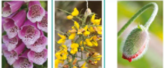Physical defence responses to resist invasion of microorganisms include:

* Cellulose cell walls.
* Tough waxy cuticle on leaves.
* Layers of dead cells around stems (bark on trees) which fall off.

Chemical plant defence responses include:

* Antibacterial chemicals.
* 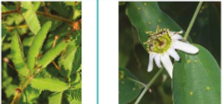Poisons to deter herbivores.

Mechanical adaptations include:

* Thorns and hairs deter animals.
* Leaves which droop or curl when touched.
* Mimicry to trick animals.