

**Marking Scheme**

**Surds (Parts 1 and 2)**

**PART 1**

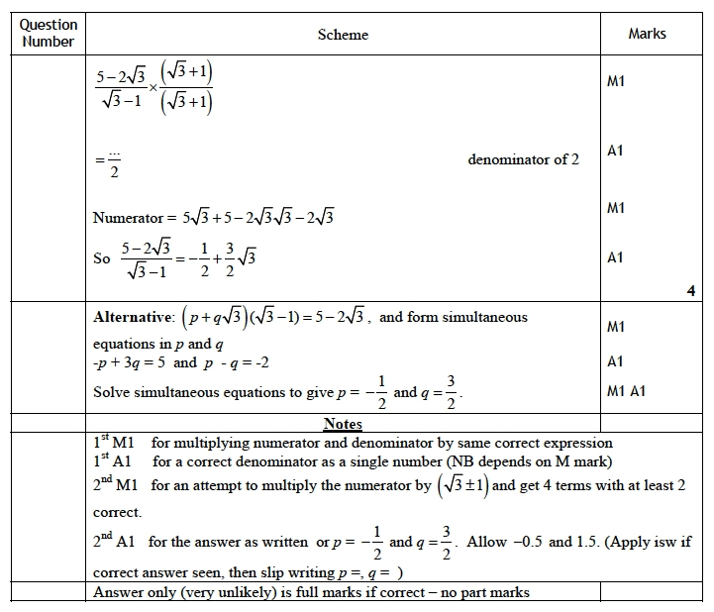

**Q3.** 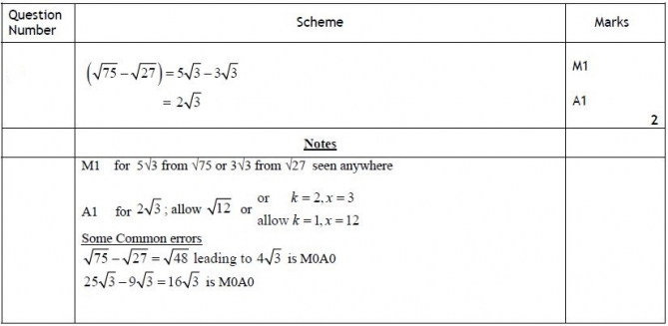

**Q4.**

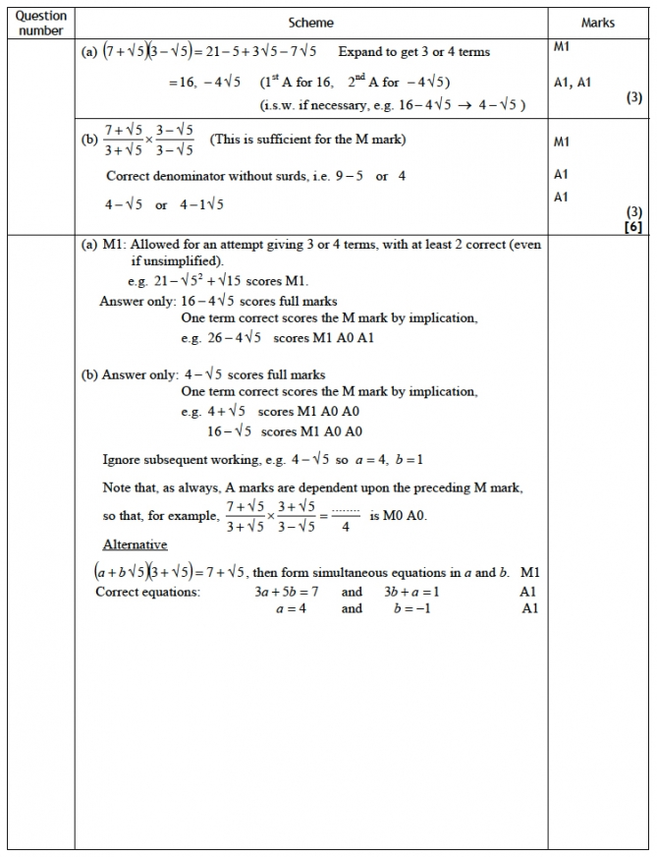

**Q5.**

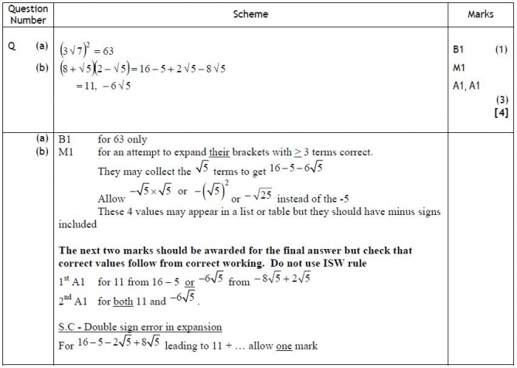

**Q6.**

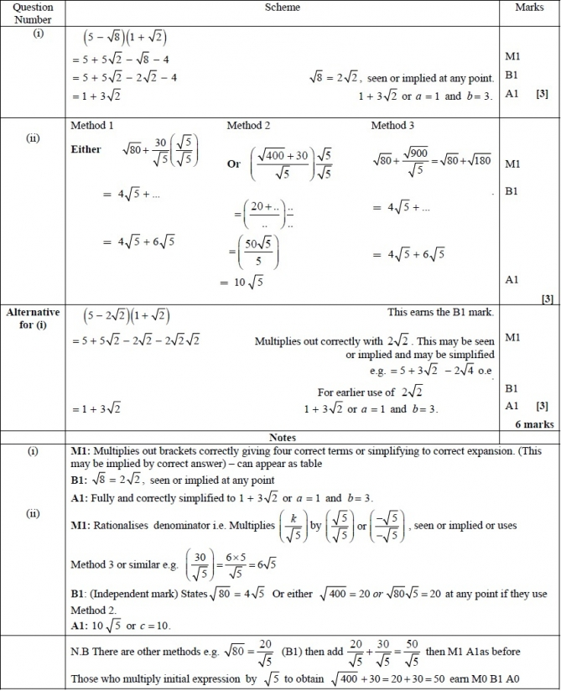

**Q7.**

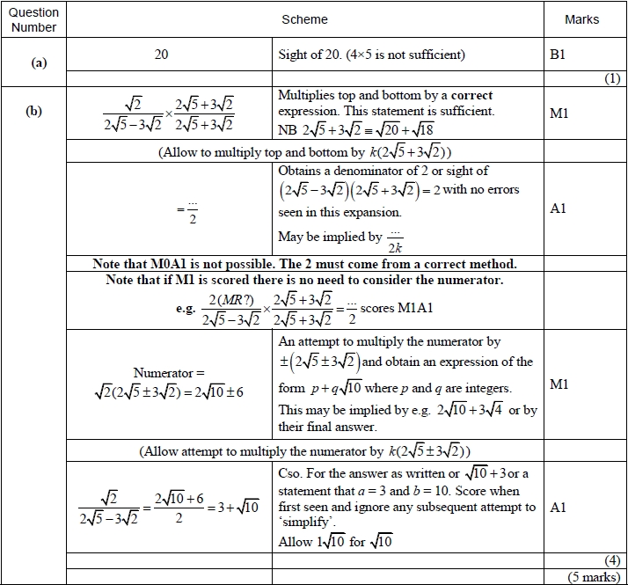

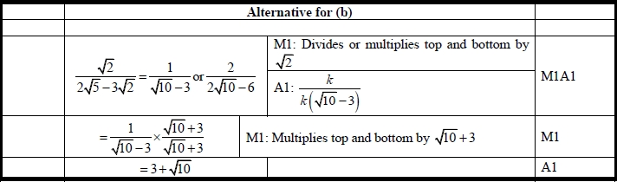

**Q8.**

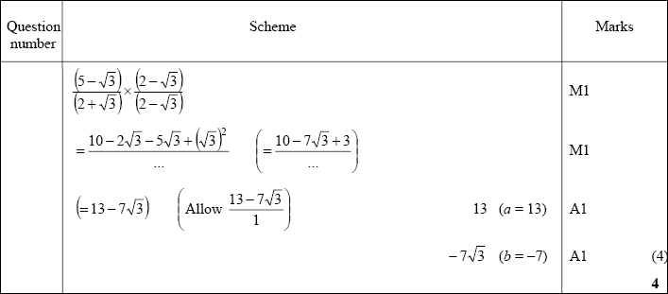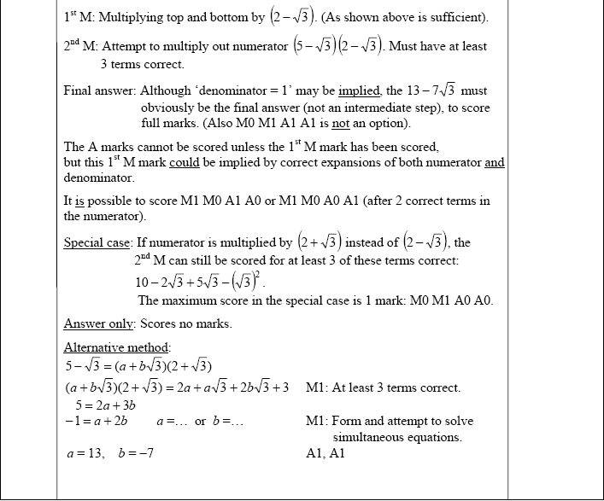

**Q9.**

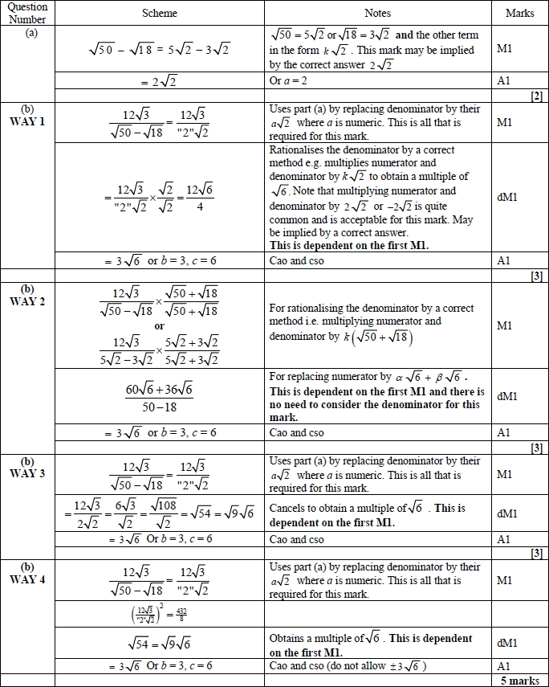

**Q10.**

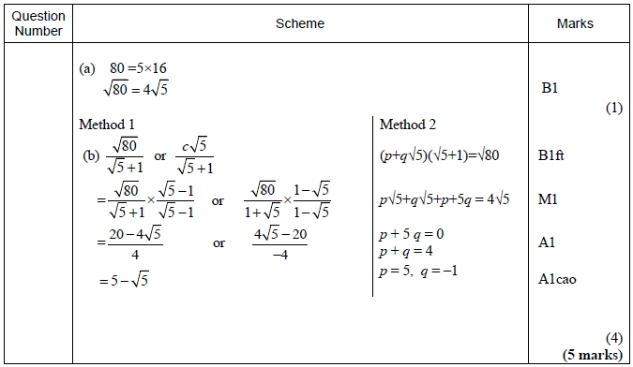

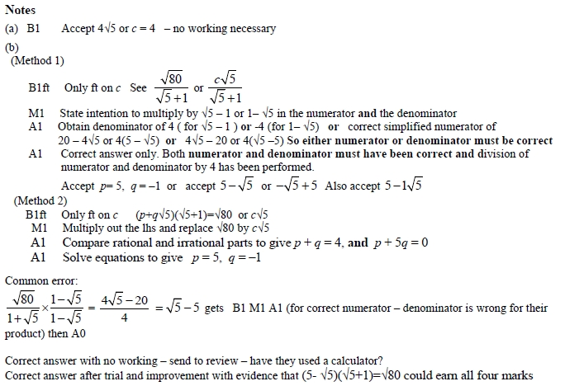

Part 2

**Q1.**  
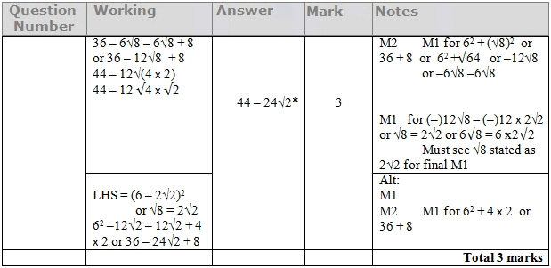

**Q2.**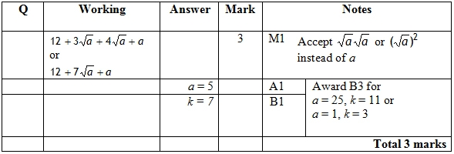

**Q3.** 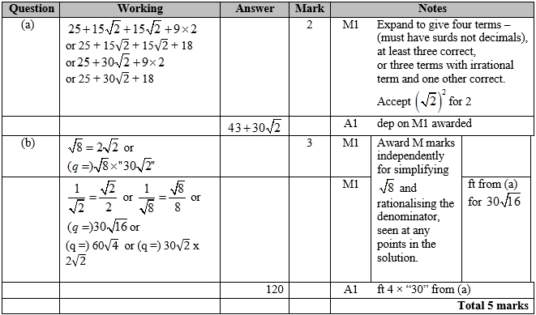

**Q4.**

Apart from a, where the mark scheme states otherwise, the correct answer, unless clearly obtained by an incorrect method, should be taken to imply a correct method.

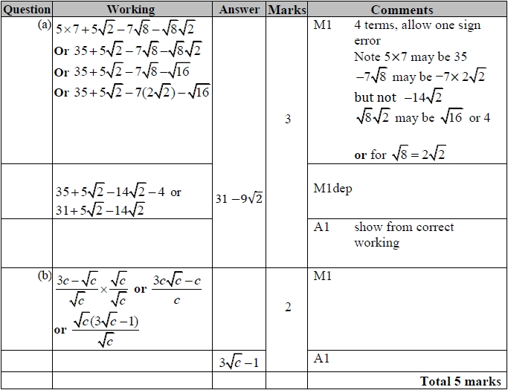

**Q5.**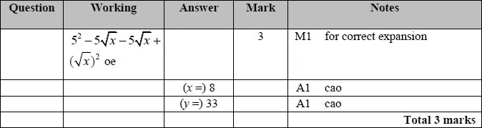

**Q6.**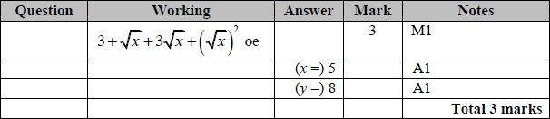

**Q7.**

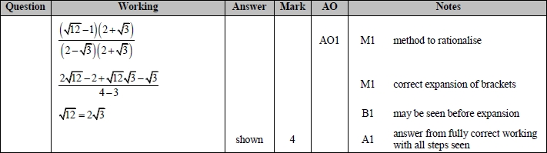

**Q8.**

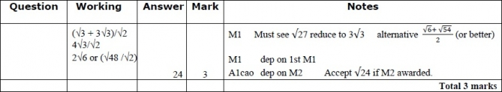

**Q9.**

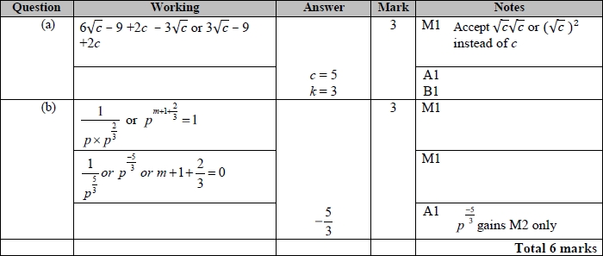

**Q10.**

Apart from b, where the mark scheme states otherwise, the correct answer, unless clearly obtained by an incorrect method, should be taken to imply a correct method.

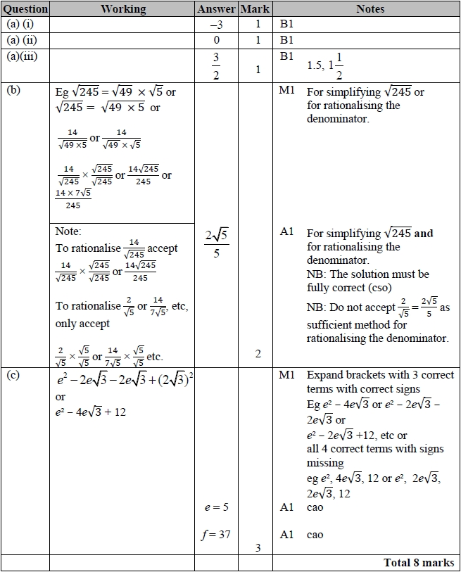

**Q11.**

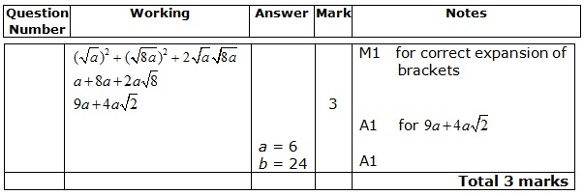

**Q12.**

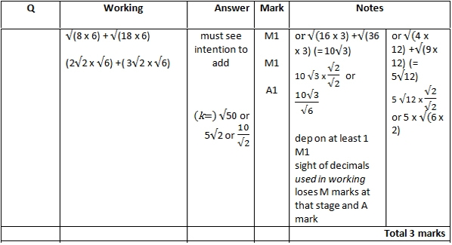

**Q13.**

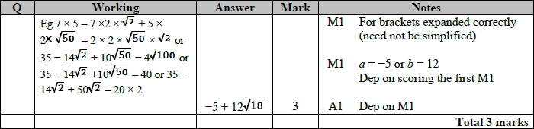

**Q14.**

