

**Foundation IGCSE (9 – 1) Revision Pack**

**Inequalities**

**Name --------------------------------**

**Questions**

**Q1.**

(a)  Complete the table of values for 2*x* + *y* = 4

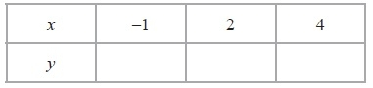

**(2)**

(b)  On the grid, draw the graph of 2*x* + *y* = 4 for values of *x* from −1 to 4

**(2)**

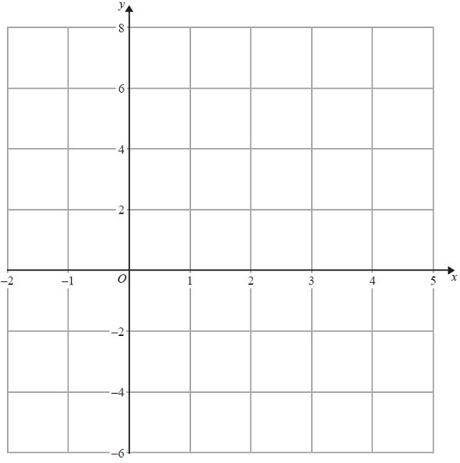

(c)  Show, by shading on the grid, the region which satisfies **all three** of the inequalities

*x* ≥ −1, *y* ≥ 2 and 2*x* + *y* ≤ 4

Label the region **R**.

**(2)**

**(Total for Question is 6 marks)**

**Q2.**

(a)  On the grid, draw the graph of

(i)  *x* = 2

(ii)  *y* = 3

(iii)  *y* = 3*x* + 2 for values of *x* from −2 to 3.

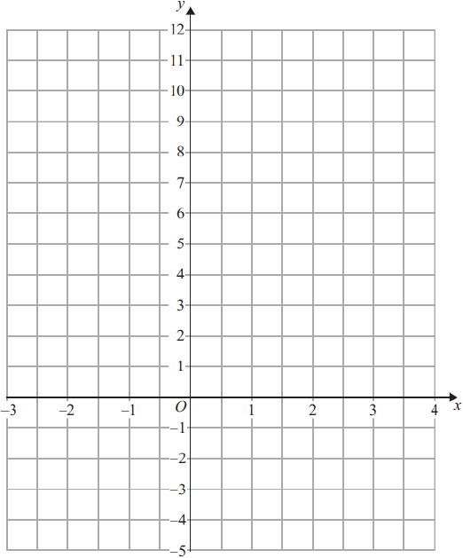

**(5)**

(b) Mark with a cross (×) a point on the grid that satisfies both the inequalities

*x* > 2 and *y* > 3*x* + 2

Label this point *P*.

**(2)**

**(Total for question = 7 marks)**

**Q3.**

(a)  On the grid, draw the graph of *y* = –2*x* + 4 for values of *x* from –1 to 5

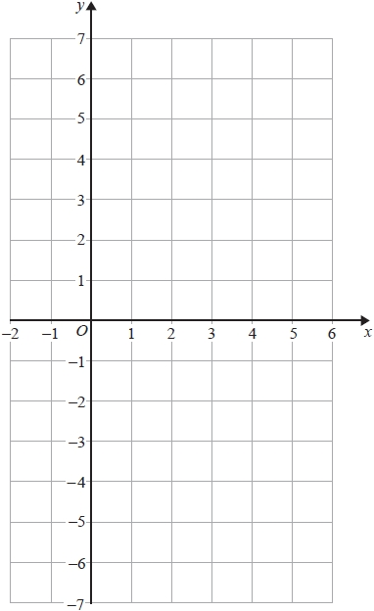

**(4)**

(b)  Show by shading on the grid, the region defined by all three of the inequalities

*y* ≤ –2*x* + 4   
*y* ≥ –4   
*x* ≥ 1

Label your region **R**.

**(3)**

**(Total for question = 7 marks)**

**Q4.**

(a)  Expand     *x*(*x* + 2)

...........................................................

**(1)**

(b)  Simplify     6*t* − 3 − 8*t* + 7

...........................................................

**(2)**

(c)  Solve the inequality     4*x* − 7 > 3

...........................................................

**(2)**

**(Total for question = 5 marks)**

**Q5.**

(a)  Factorise     3*y*2 + 2*y*

...........................................................

**(1)**

(b)  Expand and simplify     (*x* − 9)(*x* + 2)

...........................................................

**(2)**

(c)  (i)  Solve     6*k* + 5 < 20

...........................................................

(ii)  *n* is an integer and 6*n* + 5 < 20

Write down the largest possible value of *n*.

...........................................................

**(3)**

**(Total for question = 6 marks)**

**Q6.**

(a) On the grid, draw the graph of      *y* = 2*x* + 3 for values of *x* from −2 to 4

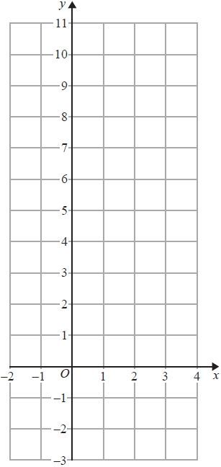

**(3)**

(b)  Show, by shading on the grid, the region that satisfies **all three** of the inequalities

*x* ≤ 3      and *y* ≥ 2      and      *y* ≤ 2*x* + 3

Label your region **R**.

**(2)**

**(Total for question = 5 marks)**

**Q7.**

(a)  Simplify    

...........................................................

**(1)**

(b)  Solve the inequality    4(*x* + 3) > 8

...........................................................

**(2)**

**(Total for Question is 3 marks)**

**Q8.**

(a)   On the grid, draw the line with equation *x* + 2*y* = 8 for values of *x* from 0 to 9

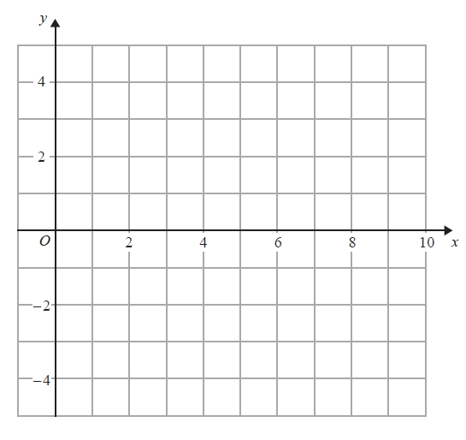

**(2)**

(b)   Show, by shading on the grid, the region defined by all three inequalities

*x* + 2*y* ≤ 8   
*x* ≥ 2   
*y* ≥ 1

Label your region **R**.

**(3)**

**(Total for Question is 5 marks)**

**Q9.**

(i) Solve the inequalities −6 < 4*x* ≤ 8

...........................................................

(ii) *n* is an integer.

Write down all the values of *n* which satisfy   −6 < 4n ≤ 8

...........................................................

**(Total for question is 4 marks)**

**Q10.**

(i) Solve the inequalities       

...........................................................

(ii) *n* is an integer.

Write down all the values of *n* which satisfy       

...........................................................

**(Total for question = 4 marks)**

**Q11.**

(a) Solve the inequalities     

............................................................

**(2)**

(b) *n* is an integer.

Write down all the values of *n* which satisfy     

............................................................

**(2)**

**(Total for question = 4 marks)**

**Q12.**

(i) Solve the inequalities −2 < *x* + 2 ≤ 5

...........................................................

(ii) On the number line, represent the solution to part (i).

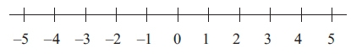

**(Total for question = 4 marks)**

**Q13.**

(a)  Solve the inequality 3*x* + 8 < 35

...........................................................

**(2)**

(b)  Write down the inequality shown on the number line.

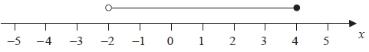

...........................................................

**(2)**

**(Total for question = 4 marks)**

**Q14.**

(a)  Solve    2*x* – 3 = 18

*x* = ...........................................................

**(2)**

(b)  Simplify fully    4*y* + 12 – 2*y* + 4

...........................................................

**(2)**

(c)  Simplify    (*t*5)3

...........................................................

**(1)**

(d)  Simplify    3*e*7*f* × 4*e*2*f*

...........................................................

**(2)**

(e)  Solve the inequality    2*q* ≥ 31 – 3*q*

...........................................................

**(2)**

–2 ≤ *n* < 3

*n* is an integer

(f)  Write down all the possible values of *n*.

........................................................................................

**(2)**

**(Total for question = 11 marks)**

**Q15.**

(a)  Solve the inequalities −4 < 3*x* + 5 ≤ 11

...........................................................

**(3)**

(b)  Write down the integer values of *x* which satisfy −4 < 3*x* + 5 ≤ 11

...........................................................

**(2)**

**(Total for question = 5 marks)**

**Q16.**

(a)  Solve the inequalities     –5 < *x* + 4 ≤ 3

...........................................................

**(2)**

(b)  *n* is an integer.   
      Write down all the values of *n* that satisfy     –3 ≤ *n* < 2

...........................................................

**(2)**

**(Total for question = 4 marks)**

**Q17.**

Solve the inequality 5*x* + 7 ≥ 22

...........................................................

**(Total for question = 2 marks)**

**Q18.**

(a)  Solve the inequality     *e* − 2 < 0

...........................................................

**(1)**

(b)  Solve the inequality     5 − 3*e* < 4

...........................................................

**(2)**

(c)  Write down the integer value of *e* that satisfies both of the inequalities

*e* − 2 < 0     and     5 − 3*e* < 4

...........................................................

**(1)**

**(Total for question = 4 marks)**

**Q19.**

(a)  Solve the inequality    4*x* + 13 ≥ 27

...........................................................

**(2)**

(b)  On the number line, represent the inequality    *y* ≥ −1



**(1)**

*n* is an integer.

(c)  Write down all the values of *n* that satisfy    −3 < *n* ≤ 2

...........................................................

**(2)**

**(Total for question = 5 marks)**

**Q20.**

(a)  Solve 5*y* + 17 = 10

*y* = ...........................................................

**(2)**

(b)  Solve 5(*q* – 3) = 12 – *q*  
       Show clear algebraic working.

*q* = ...........................................................

**(3)**

(c)  Solve the inequality 3 – 7*t* ≥ 31

...........................................................

**(2)**

**(Total for question = 7 marks)**

**Q21.**

(a)  Work out the value of  *y*2 – 3*y*  when  *y* = –5

...........................................................

**(2)**

(b)  Simplify  

...........................................................

**(2)**

(c)  Write down the inequality shown on the number line.



...........................................................

**(2)**

**(Total for question = 6 marks)**

**Q22.**

*M* = 2*t*2 − 7*t*

(a)  Work out the value of *M* when *t* = −3

*M* = ...........................................................

**(2)**

(b)  Solve    4(*x* + 3) = 9*x* − 10

Show clear algebraic working.

*x* = ...........................................................

**(3)**

*y* is an integer.   
−2 < *y* ≤ 3

(c)  Write down all the possible values of *y*.

...........................................................

**(2)**

**(Total for question = 7 marks)**

**Q23.**

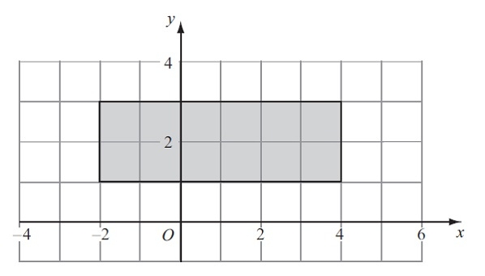

Write down inequalities to define fully the shaded region.

      ..............................................................................................................................................

**(Total for question = 3 marks)**

**Q24.**

Show, by shading on the grid, the region defined by all three of the inequalities

*x* ≤ 5  
  
*y* ≥ 3  
  
*y* ≤ *x*

Label your region **R**.

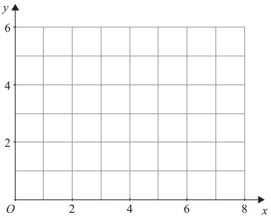

**(Total for question = 3 marks)**

**Q25.**

(a)



An inequality is shown on the number line.

Write down this inequality.

...........................................................

**(2)**

(b)  (i)  Solve the inequality 2(*y* − 3) ≥ 1

...........................................................

(ii)  Write down the lowest **integer** which satisfies this inequality.

..................................

**(4)**

**(Total for Question is 6 marks)**

**Mark Scheme**

Q1.

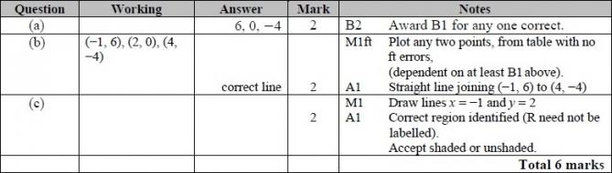

**Q2.**

The correct answer, unless clearly obtained by an incorrect method, should be taken to imply a correct method.

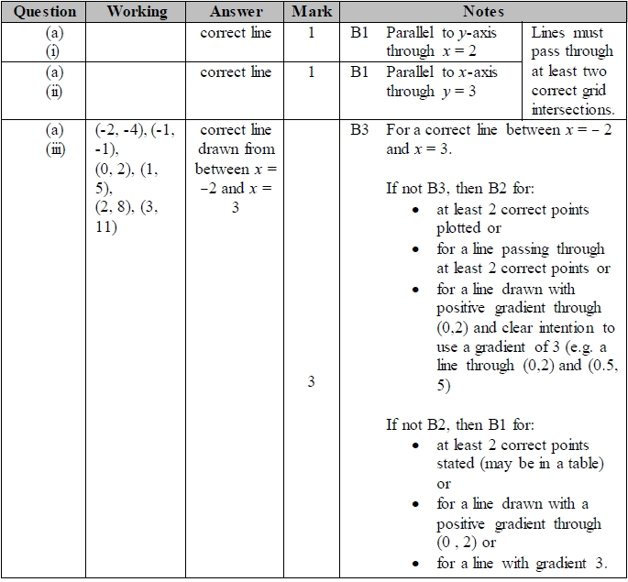

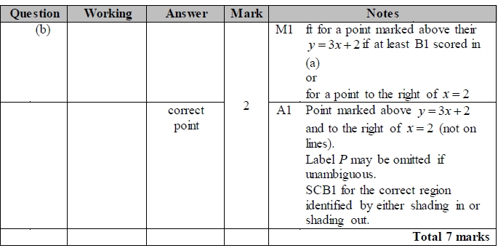

**Q3.**

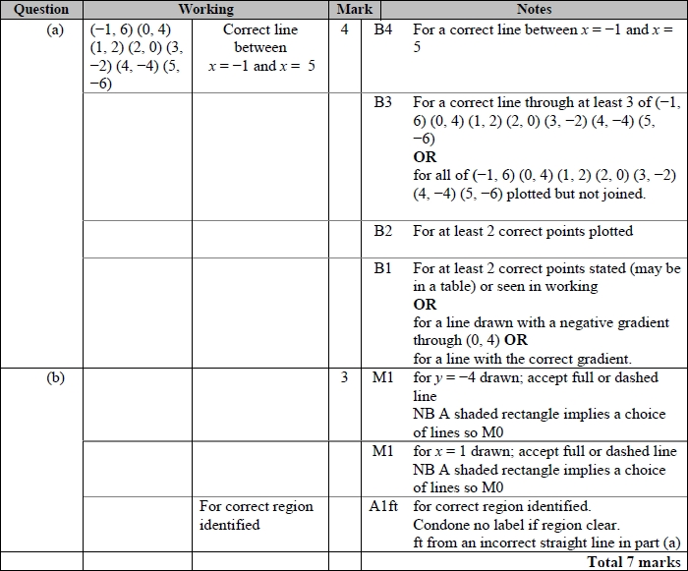

**Q4.**

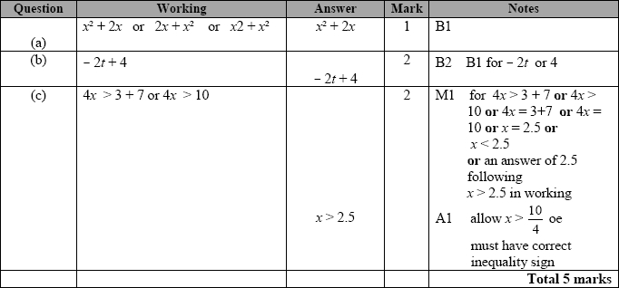

**Q5.**

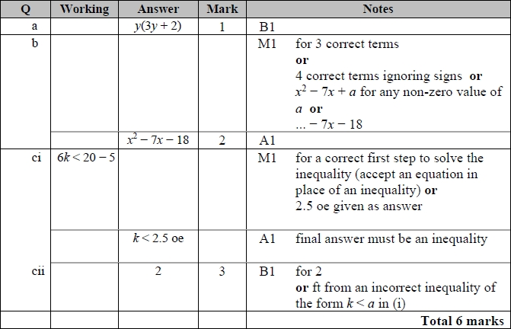

**Q6.**

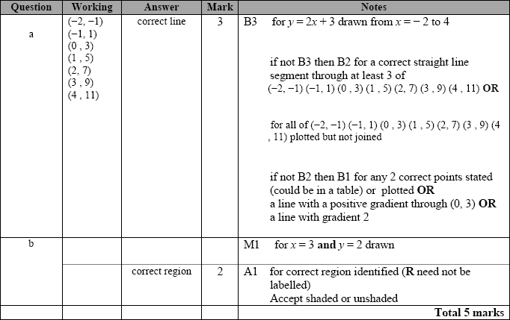

**Q7.**

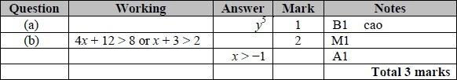

**Q8.**

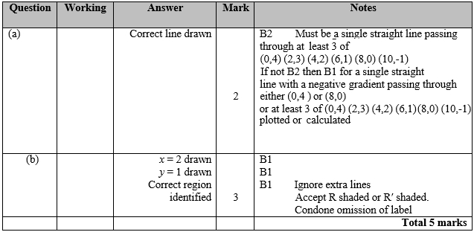

**Q9.**

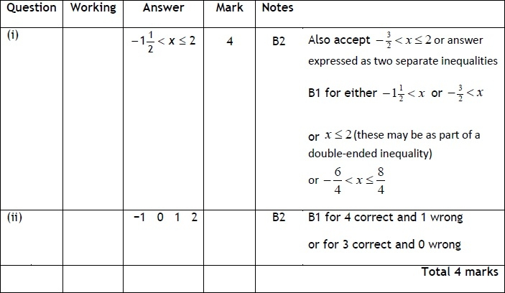

**Q10.**

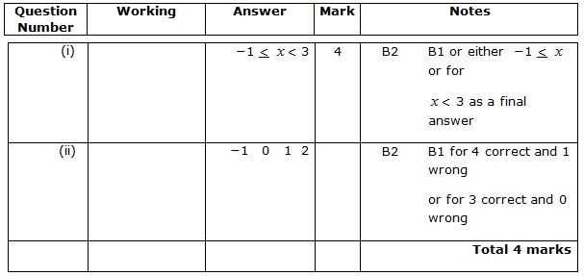

**Q11.**

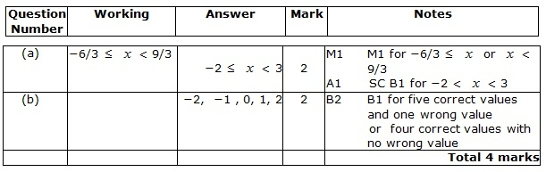

**Q12.**

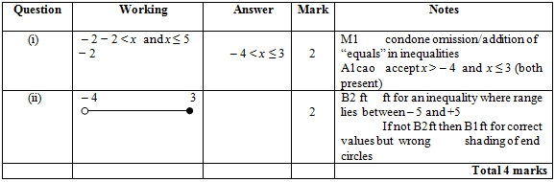

**Q13.**

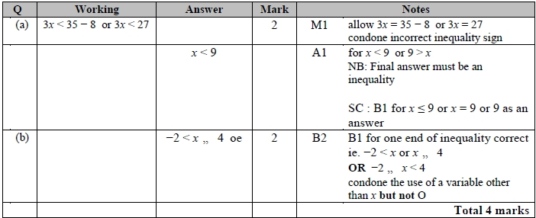

**Q14.**

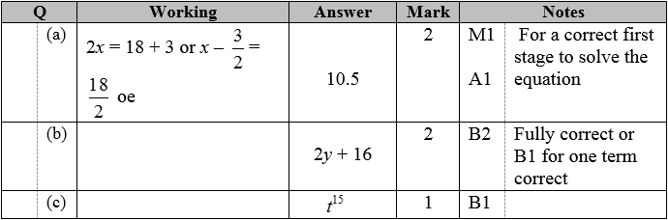

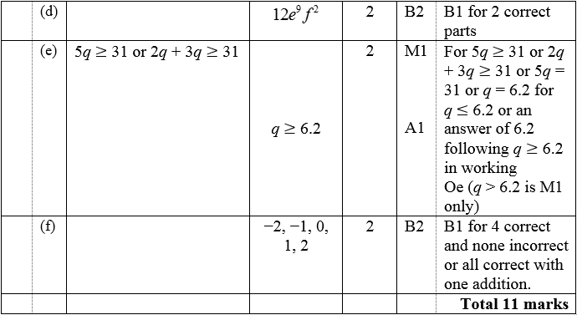

**Q15.**

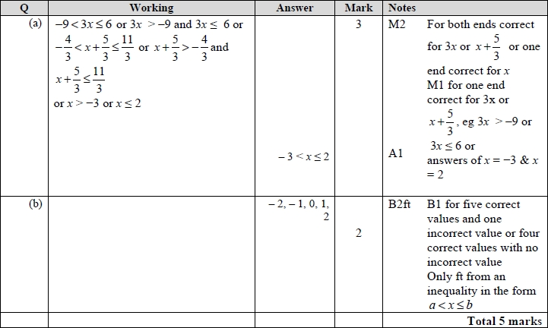

**Q16.**

Apart from question 18c where the mark scheme states otherwise, the correct answer, unless clearly obtained by an incorrect method, should be taken to imply a correct method.

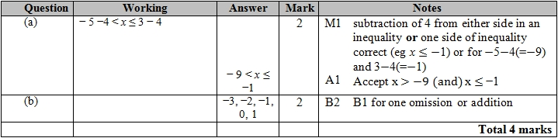

**Q17.**

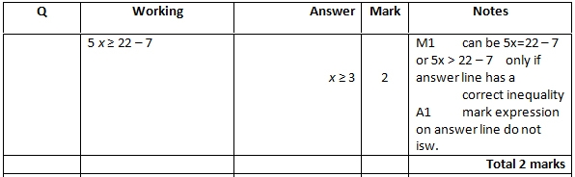

**Q18.**

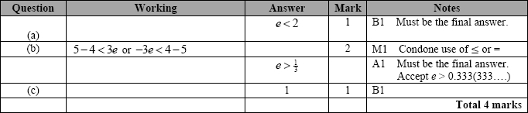

**Q19.**

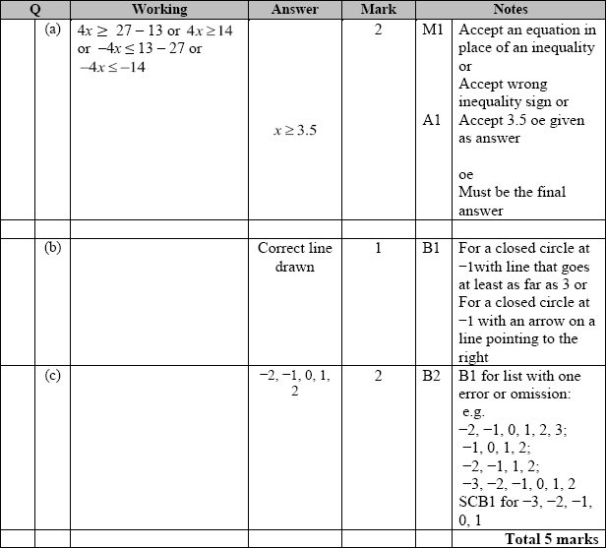

**Q20.**

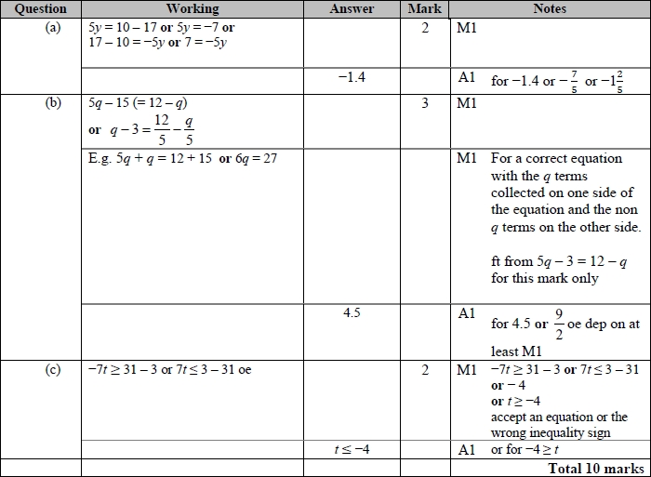

**Q21.**

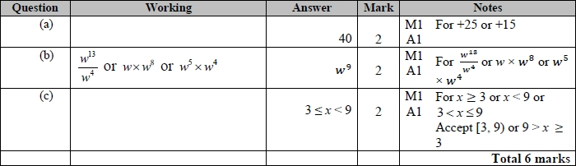

**Q22.**

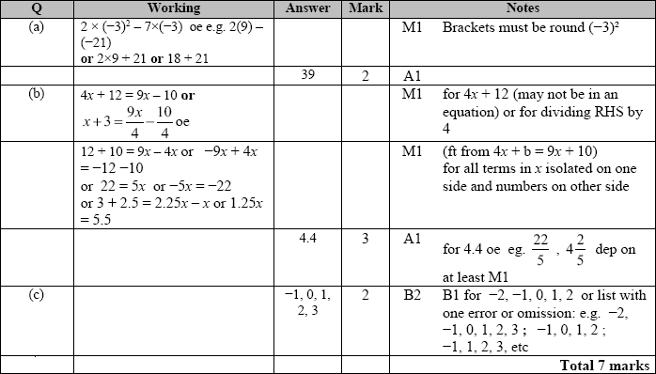

**Q23.**

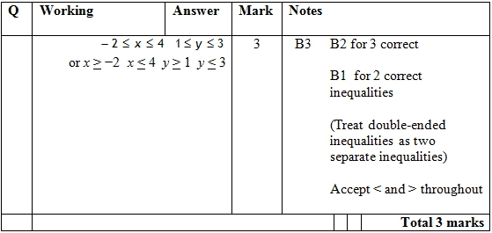

**Q24.**

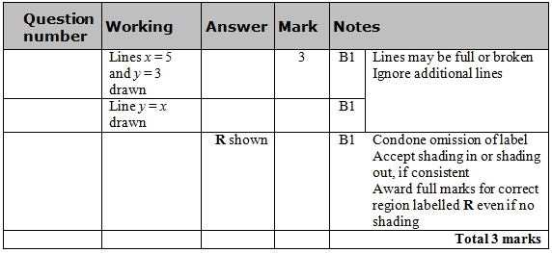

**Q25.**

