**Greek Festivals – 8 Mark Practice**

**Source A – a description of the Pyrrhic Dance by the Greek philosopher, Plato.**

“It consists in imitating, on the one hand, movements that evade all kinds of blows and missiles by leaning to one side, giving way completely, jumping up high or dipping low then again striving to imitate the opposites to these, aggressive postures involved in striking with missiles arrows and javelins and with all sorts of blows.”

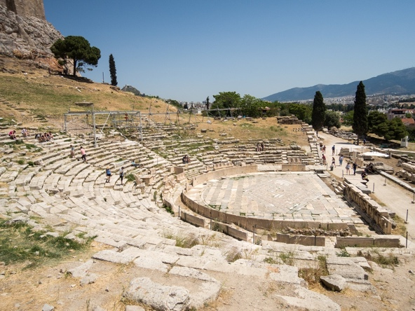**Source B – the remains of the theatre of Dionysus on the side of the Acropolis in Athens.**

Q) Which festival do you think you would have enjoyed attending more: the Great Panathenaea or the City Dionysia? Use **Source A** and **Source B** as a starting point **and** your own knowledge in your answer. **[8]**