**The Iliad – Book 4**

**Read lines 1-72**

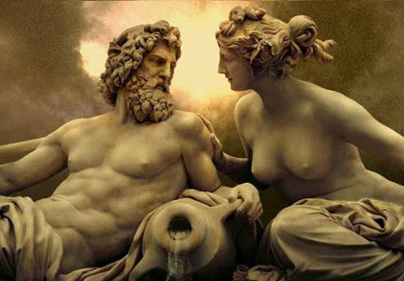How do Zeus and Hera justify their points of view?



Perhaps we should make peace between the Achaeans and Trojans:

I can’t possibly go along with this!

You’re impossible to please!

You better return the favour someday!

I won’t get in your way in the future.

Let’s yield to one another.

Do you think either (or both) have any justification in their arguments?

What do you make of Athena’s depiction in this opening?

**Read lines 73-148**

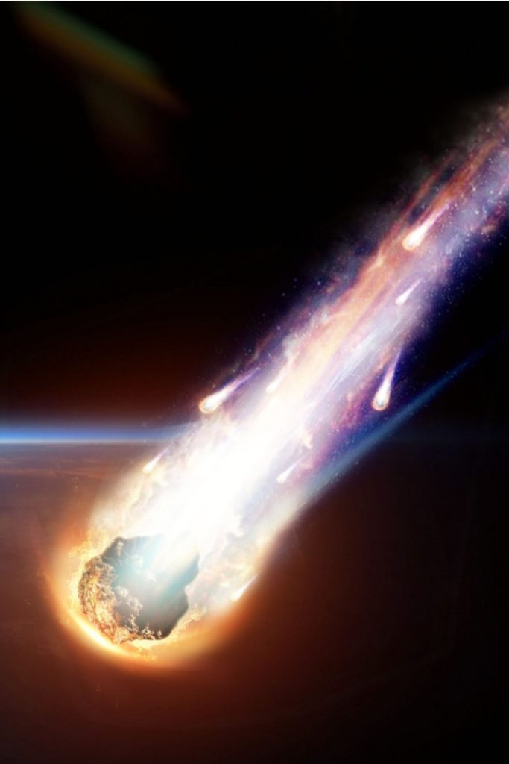Surround this picture with visual and audible quotes from Athena’s descent to earth.

What might have tempted Pandarus to take a shot at Menelaus?

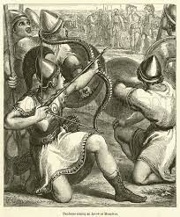

How does Homer use retardation to build up to Pandarus’ fateful shot? Create the longest flow diagram you are able.

He unsheathed his polished bow…

Reread Menelaus’ spear-throw at Paris (3.356-360) and compare the flight of the spear to the flight of Pandarus’ arrow:

|  |  |
| --- | --- |
| **Menelaus’ Spear** | **Pandarus’ Arrow** |
|  |  |

**Read lines 149-219**

List all the consequences Agamemnon predicts will occur if Menelaus dies:



Surround this picture with quotes that show Machaon is a highly reputable doctor:

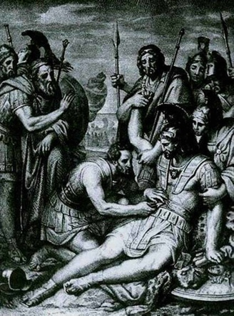

**Read lines 220-421**

Select four quotes that demonstrate what Agamemnon is like as a leader and explain what they show us:

|  |  |
| --- | --- |
| **Quote:** | **Explanation:** |
|  |  |
|  |  |
|  |  |
|  |  |

Fill in the following on behalf of Agamemnon:

|  |
| --- |
| Highly Commended Achaean  *Idomeneus*  Awarded to: _____________________  Ancient Greek and Roman Gods, Characters and Creatures Clip Art by Phillip  Martin, Alexander the Great  Reason: ________________  ______________________  ______________________  ______________________  Signed: *Agamemnon* |

|  |
| --- |
| Highly Commended Achaean  *Ajax and Teucer*  Awarded to: _____________________  Ancient Greek and Roman Gods, Characters and Creatures Clip Art by Phillip  Martin, Alexander the Great  Reason: ________________  ______________________  ______________________  ______________________  Signed: *Agamemnon* |

|  |
| --- |
| Highly Commended Achaean  *Nestor*  Awarded to: _____________________  Ancient Greek and Roman Gods, Characters and Creatures Clip Art by Phillip  Martin, Alexander the Great  Reason: ________________  ______________________  ______________________  ______________________  Signed: *Agamemnon* |

|  |
| --- |
| Cause for Concern  *Odysseus*  Individual: _____________________  Clipart - GreekSoldier | Greek soldier, Soldier drawing, Roman soldiers  Reason: ________________  ______________________  ______________________  ______________________  Signed: *Agamemnon* |

|  |
| --- |
| Cause for Concern  *Diomedes*  Awarded to: _____________________  Clipart - GreekSoldier | Greek soldier, Soldier drawing, Roman soldiers  Reason: ________________  ______________________  ______________________  ______________________  Signed: *Agamemnon* |

Whose response do you think is better: Odysseus’ or Sthenelus’?

**Odysseus**

**Sthenelus**

**Read lines 422-544**

Rank the following similes in order of your preference. Consider what effect each is being used to illustrate:

* Ocean waves
* Sheep in the yard
* Two mountain rivers meeting
* A felled poplar

Write in the following tombstones what we learn about these warrior’s death. Use one colour to illustrate vivid detail, another to show pathos.

**Simoisius**

**Echepolus**

**Elephenor**

**Diores**

**Leucus**

**Democoon**

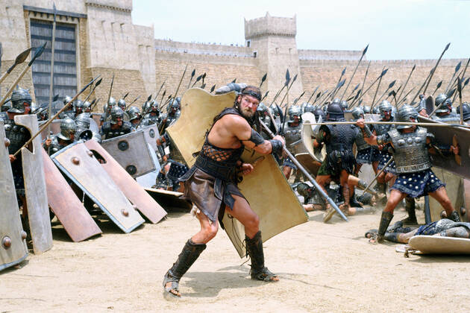

**Peiros**

How do Athena and Apollo urge on the opposing sides of the fight?

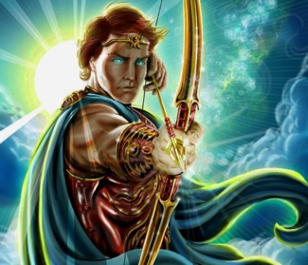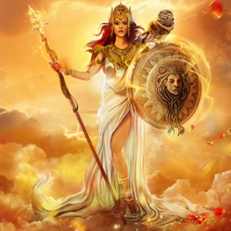

**Athena**

**Apollo**

What effects do you think Homer wants to achieve with his digression on Simoisius?