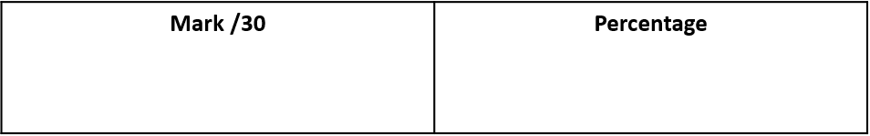

Name ……………………………………………………..

Date ……………………………..

**Energy HW**

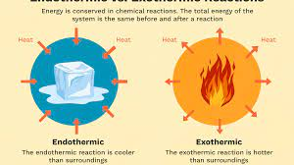

**Q1.** This question is about energy changes.

(a)  Which of these items uses an endothermic reaction? Tick (**✓**) **one** box.

|  |  |
| --- | --- |
| Hand warmer |  |
| Sports injury pack |  |
| Self-heating can |  |

**(1)**

**Figure 1** shows the reaction profile for an exothermic reaction.

**Figure 1**

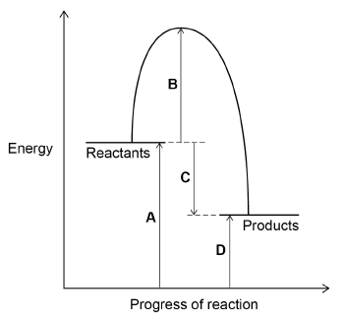

(b)  Which letter represents the activation energy for the reaction? Tick (**✓**) **one** box.

|  |  |  |  |  |  |  |  |
| --- | --- | --- | --- | --- | --- | --- | --- |
| **A** |  | **B** |  | **C** |  | **D** |  |

**(1)**

(c)  Which letter represents the overall energy change for the reaction? Tick (**✓**) **one** box.

|  |  |  |  |  |  |  |  |
| --- | --- | --- | --- | --- | --- | --- | --- |
| **A** |  | **B** |  | **C** |  | **D** |  |

**(1)**

(d)  Complete the sentence.

Choose the answer from the box.

|  |
| --- |
| **lower than      the same as      higher than** |

In an exothermic reaction the energy of the products

is ____________________________ the energy of the reactants. **(1)**

(e)  A student measured the temperature at the start and at the end of a reaction.

Name the apparatus used to measure the temperature.

___________________________________________________________________ **(1)**

(f)  **Figure 2** shows the temperature at the end of the reaction.

**Figure 2**

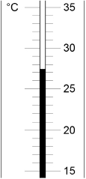

Complete the table below.

Use **Figure 2**.

|  |  |
| --- | --- |
| Temperature at start in °C | 14.3 |
| Temperature at end in °C |  |
| Change in temperature in °C |  |

**(2)**

**Q2.** The rate of chemical reactions can be changed by changing the conditions.

(a)     Methane burns in oxygen to produce carbon dioxide and water.

The activation energy for the reaction is 2648 kJ / mol.

The reaction gives out 818 kJ / mol of energy.

The figure below shows the reaction profile for this reaction.

Complete the reaction profile.

Draw arrows to represent:

•        the activation energy

•        the energy given out.

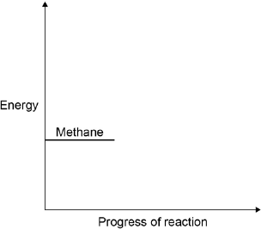

**(4)**

(b)     What percentage of the activation energy is the energy given out?

___________________________________________________________________ **(1)**

(c)     Calcium carbonate decomposes when it is heated:

The decomposition of calcium carbonate is an endothermic reaction.

How would the reaction profile for decomposition of calcium carbonate be different from the reaction profile of methane burning in oxygen?

___________________________________________________________________ **(1)**

(d)     Catalysts are used in chemical reactions in industry.

Give **two** properties of catalysts.

For each property, explain why it makes the catalyst useful in industry.

___________________________________________________________________

___________________________________________________________________

___________________________________________________________________

___________________________________________________________________

___________________________________________________________________

___________________________________________________________________

___________________________________________________________________ **(4)**

(e)     Enzymes are biological catalysts.

What type of molecule is an enzyme?

Tick **one** box.

|  |  |
| --- | --- |
| Carbohydrate |  |
| Hydrocarbon |  |
| Lipid |  |
| Protein |  |

**(1)**

(f)     If enzymes are denatured they stop working.

Give **two** ways an enzyme can be denatured.

1. _________________________________________________________________

2. _________________________________________________________________ **(2)**

(g)     An enzyme called lactase catalyses the reaction that breaks down lactose to smaller molecules.

One model used to explain how enzymes affect reactions is called the lock and key model.

Use the lock and key model to explain why lactase cannot be used to speed up **all** chemical reactions.

___________________________________________________________________

___________________________________________________________________

___________________________________________________________________

___________________________________________________________________

___________________________________________________________________

___________________________________________________________________ **(3)**

**Q3.**

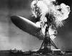

          An airship caught fire when it was coming in to land in 1937. The airship was filled with hydrogen. A spark or flame ignited the hydrogen. The hydrogen reacted with oxygen in the air to produce water.

(a)     The equation for the reaction can be represented using structural formulae for the chemicals.

                                              2 H – H + O = O → 2 H – O – H

          Use the bond energies given in the table to help you to calculate the energy change for this reaction.

|  |  |
| --- | --- |
| Bond | Bond energy in kJ per mole |
| H – H | 436 |
| O = O | 498 |
| O – H | 464 |

___________________________________________________________________

___________________________________________________________________

___________________________________________________________________

___________________________________________________________________

___________________________________________________________________

___________________________________________________________________

Energy change = __________________ kJ **(3)**

(b)     Explain, in terms of making and breaking bonds, why this reaction is exothermic.

___________________________________________________________________

___________________________________________________________________ **(1)**

(c)     Use the energy level diagram for this reaction to help you to answer these questions.

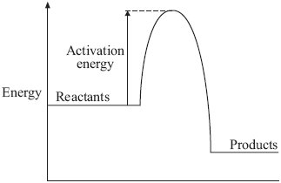

(i)      The hydrogen did **not** burn until ignited by a spark or flame.

         Explain why.

______________________________________________________________

______________________________________________________________ **(1)**

(ii)     Platinum, a transition metal, causes hydrogen to ignite **without** using a spark or flame.

         Explain why.

______________________________________________________________

______________________________________________________________

______________________________________________________________

______________________________________________________________ **(2)**

**Energy Mark schemes**

**Q1.** (a)  sports injury pack **1**

(b)  B **1**

(c)  C **1**

(d)  lower than **1**

(e)  thermometer **1**

(f)  27.4 (°C)

*allow values in the range 27.2–27.5 (°C)* **1**

(27.4–14.3 =) 13.1 (°C)

*allow correct subtraction of incorrect temperature reading* **1**

**Q2.** (a)     products below reactants **1**

correct energy profile **1**

activation energy correctly labelled **1**

energy given out correctly labelled **1**

(b)     31 (%) **1**

(c)     the products would be above the reactants **1**

(d)     catalysts increase rate of reaction

***1*** *mark for each property*

***1*** *mark for each explanation*

so products formed in less time

**or**

catalysts lower activation energy

*explanation must be linked correctly to the property to gain mark*

so lowers energy requirements

**or**

catalysts not used up in the reaction

so only an initial outlay needed

**or**

only a small amount of catalyst needed

so small initial cost

(e)     Protein

**1**

(f)     high temperatures

**1**

extremes of pH

**1**

(g)     lactase acts as the lock, lactose is the key (substrate)

**1**

lactase has an active site which will only fit lactose molecules

**1**

so lactase will not work with other molecules

**1**

**Q3.** (a)     (bonds broken) = 1370 (kJ)

**1**

          (bonds made) = 1856 (kJ)

**1**

          change in energy = (–) 486

*ecf ignore sign*

*correct answer with* ***or*** *without working =* ***3*** *marks*

**1**

(b)     energy released from forming new bonds is greater than the energy  
needed to break existing bonds

*allow the energy needed to break bonds is less than the energy released in forming bonds*

*do* ***not*** *accept energy needed to form bonds*

**1**

(c)     (i)      energy barrier needs to be overcome

**or**

         activation energy supplied / needed

*allow energy needed to start reaction* ***or*** *energy needed to break bonds*

*accept high activation energy*

**1**

(ii)     lowers activation energy(*)

**or**

         provides lower energy pathway / route(*)

*(*)****2*** *mark answers*

*allow provides alternative pathway* ***or*** *platinum / it is a catalyst for* ***1*** *mark*

**2**