

**IGCSE (9 – 1) Revision Pack**

**Gradients of a straight lines and Coordinates**

**Name --------------------------------**

**Questions**

**Q1.**

The diagram shows the straight lines *AB* and *BC* drawn on a centimetre grid.

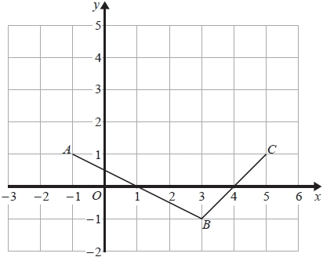

(a)  Write down the coordinates of

(i)  *C*

( ................ , ................ )

(ii)  *B*

( ................ , ................ )

**(2)**

(b)  On the grid, mark the point *D* so that *ABCD* is a kite.

**(1)**

(c)  Work out the gradient of *AB*.

...........................................................

**(2)**

**(Total for question = 5 marks)**

**Q2.**

On the grid, draw the graph of *y* = 3*x* − 5 for values of *x* from −2 to 3

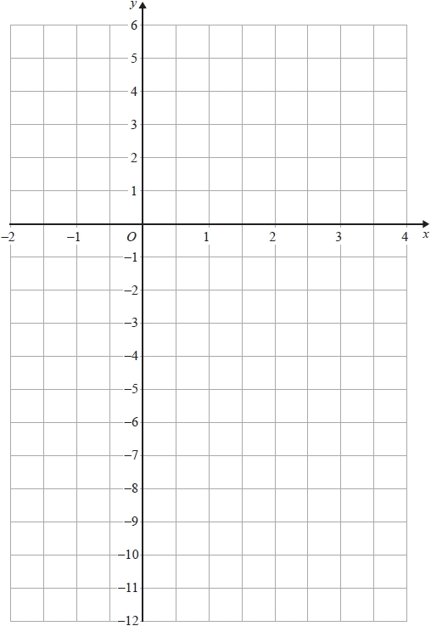

**(Total for question = 4 marks)**

**Q3.**

On the grid, draw the graph of *y* = 1 – 3*x* for values of *x* from –2 to 3

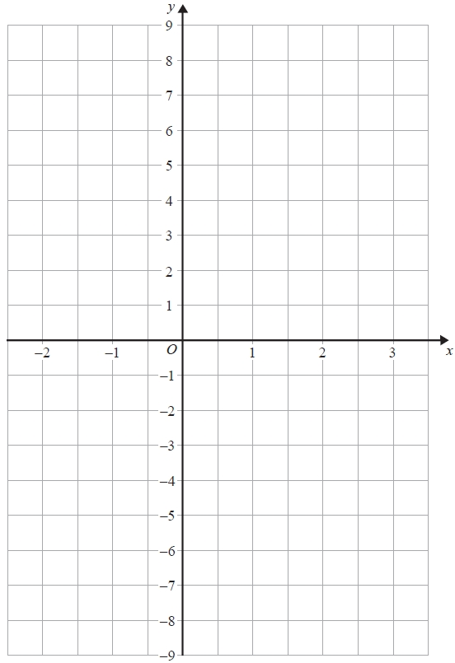

**(Total for question = 3 marks)**

**Q4.**

The diagram shows a trapezium *PQRS* and a line *AB* on a centimetre grid.

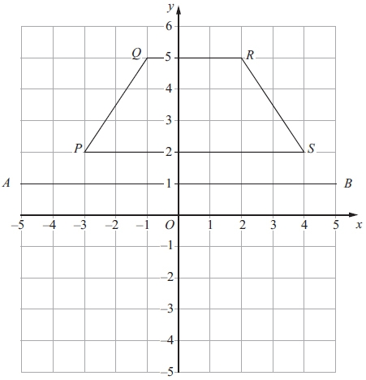

(a) Measure the length of *RS*.   
Give your answer in millimetres.

........................................................... mm

**(1)**

(b) Write down the coordinates of *Q*.

(.............................. , ..............................)

**(1)**

(c) Write down the equation of the line *AB*.

...........................................................

**(1)**

(d) Reflect the trapezium *PQRS* in the line *AB*.

**(2)**

**(Total for question is 7 marks)**

**Q5.**

Here are three straight lines **A**, **B** and **C** drawn on a grid.

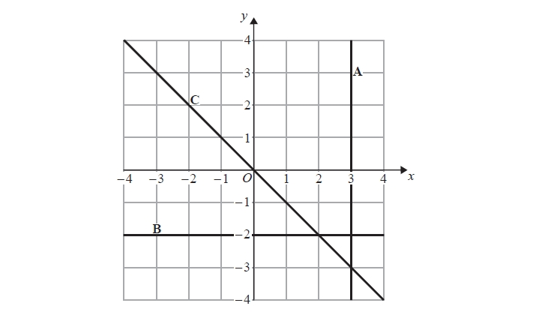

Write down an equation for each of these three straight lines.

**A**..........................................................

**B**..........................................................

**C**..........................................................

**(Total for question = 3 marks)**

**Q6.**

The diagram shows three points *P*, *Q* and *R* on a 1 cm grid.

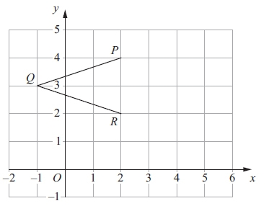

(a) Write down the coordinates of *P*.

(.............................. , .............................)

**(1)**

(b) Write down the coordinates of *Q*.

(.............................. , .............................)

**(1)**

(c) On the grid, mark the point *S* so that *PQRS* is a rhombus.

**(1)**

(d) Work out the area of the rhombus *PQRS*.

........................................................... cm2

**(2)**

(e) Write down the equation of the line *PR*.

...........................................................

**(1)**

**(Total for question = 6 marks)**

**Q7.**

On the grid, draw the graph of *y* = 2*x* − 1

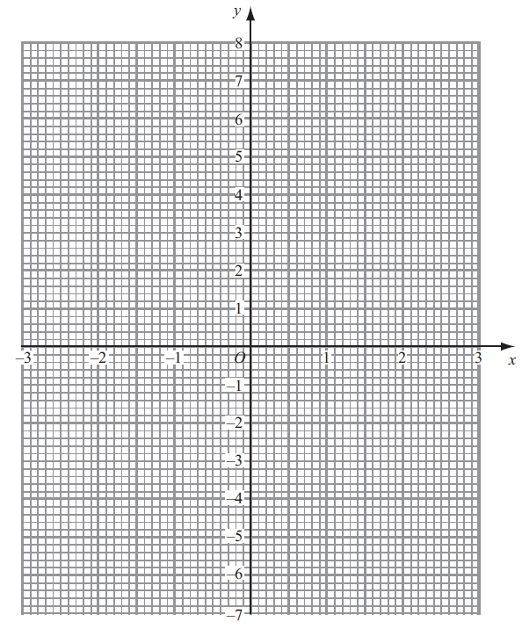

**(Total for question = 4 marks)**

**Q8.**

The diagram shows three points, *A*, *B* and *C*, on a centimetre grid.

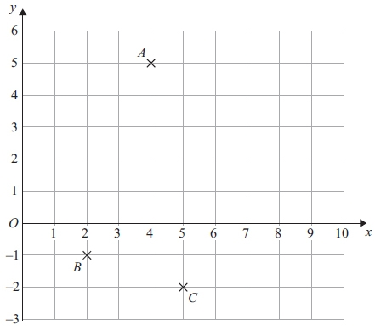

(a) Write down the coordinates of

(i) *A*,

(............................. , ..............................)

(ii) *B*.

(............................. , ..............................)

**(2)**

(b) (i) On the diagram, mark with a cross (×) the point D so that *ABCD* is a rectangle.   
Label your point *D*.

(ii) On the diagram, draw rectangle *ABCD*.

**(2)**

(c) Write down the order of rotational symmetry of rectangle *ABCD*.

...........................................................

**(1)**

(d) Find the coordinates of the midpoint of *AB*.

(............................. , ..............................)

**(2)**

**(Total for question = 7 marks)**

**Q9.** The diagram shows a quadrilateral *PQRS* on a centimetre grid.

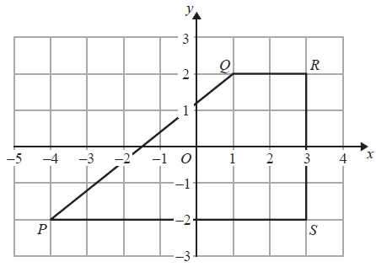

(a)   Write down the coordinates of *R*.

(........................................................... , ...........................................................)

**(1)**

(b)   Write down the coordinates of *P*.

(........................................................... , ...........................................................)

**(1)**

(c)   What is the mathematical name of the quadrilateral *PQRS*?

...........................................................

**(1)**

(d)   Measure the length of the side *PQ*.   
Give your answer in centimetres to 1 decimal place.

........................................................... cm

**(1)**

(e)   Find the perimeter of the quadrilateral *PQRS*.   
Give your answer in centimetres to 1 decimal place.

........................................................... cm

**(2)**

(f)   Work out the area of the quadrilateral *PQRS*.

........................................................... cm2

**(2)**

**(Total for Question is 8 marks)**

**Q10.**

A 6-sided polygon is shown on a grid.

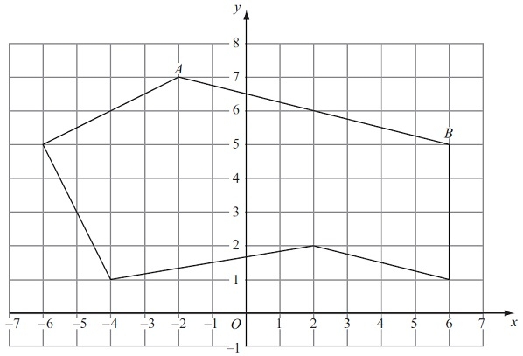

(a) Write down the mathematical name for a 6-sided polygon.

...........................................................

**(1)**

(b) On the polygon, mark with arrows (>) a pair of parallel lines.

**(1)**

(c) On the polygon, mark with crosses (×) a pair of perpendicular lines.

**(1)**

(d) Write down the coordinates of the point *A*.

(.............................. , ..............................)

**(1)**

(e) Find the coordinates of the midpoint of *AB.*.

(.............................. , ..............................)

**(2)**

**(Total for question = 6 marks)**

**Q11.**

The diagram shows points *A*, *B* and *C* on a square grid.

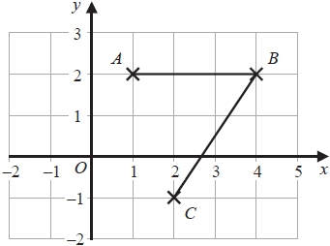

(a)  Write down the coordinates of *C*.

( ................ , ................ )

**(1)**

(b)  Measure the length of *BC*.

Give your answer in centimetres.

........................................................... cm

**(1)**

(c)  On the grid, mark with a cross  the point *D* so that *ABCD* is a parallelogram.

Label this point *D*.

**(1)**

**(Total for question = 3 marks)**

**Q12.**

The diagram shows three points *P*, *Q* and *R* on a centimetre grid.

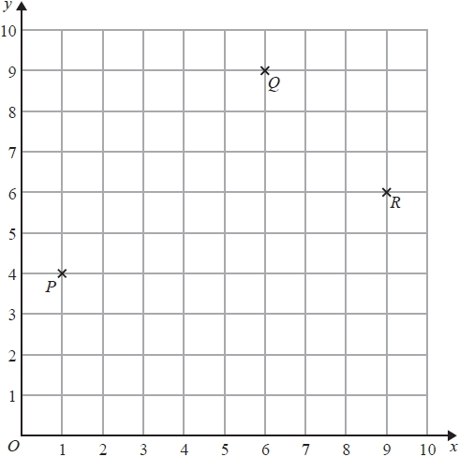

(a)  Write down the coordinates of *R*.

(........................... , ...........................)

**(1)**

(b)  Measure the distance between *P* and *R*.   
Give your answer in millimetres.

........................................................... mm

**(1)**

(c)  On the diagram, mark with a cross (×) the position of the point *S* so that *PQRS* is a rectangle.   
Label your point *S*.

**(1)**

(d)  Find the coordinates of the midpoint of *PQ*.

(........................... , ...........................)

**(2)**

**(Total for question = 5 marks)**

**Q13.**

(a)  Complete the table of values for *y* = 3*x* – 1

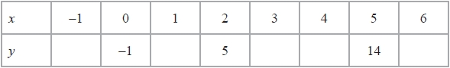

**(2)**

(b)  On the grid, draw the graph of *y* = 3*x* – 1 for values of *x* from –1 to 6

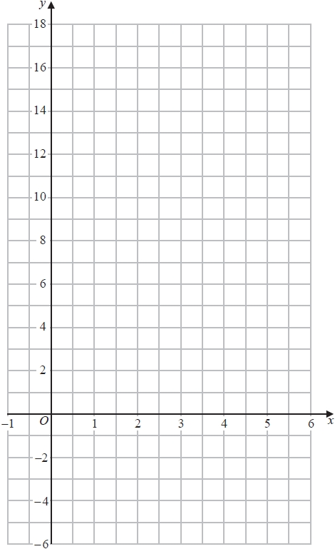

**(2)**

**(Total for question = 4 marks)**

**Q14.**

The diagram shows a 5-sided polygon *ABCDE* drawn on a centimetre grid.

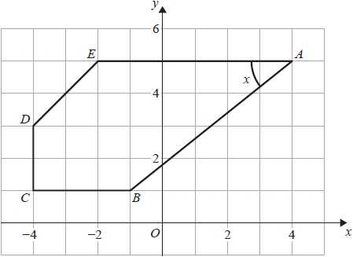

(a)  Write down the coordinates of the point *A*.

( ................ , ................ )

**(1)**

(b)  Write down the coordinates of the point *C*.

( ................ , ................ )

**(1)**

(c)  Write down the mathematical name for a 5-sided polygon.

...........................................................

**(1)**

(d)  Measure the length of the line *AB*.   
       Give your answer in centimetres to 1 decimal place.

........................................................... cm

**(1)**

(e)  Measure the size of the angle marked *x*.

........................................................... °

**(1)**

**(Total for question = 5 marks)**

**Q15.**

*B* is the point with coordinates (1, 4)   
*C* is the point with coordinates (6, 9)

Find the coordinates of the midpoint of *BC*.

(........................... , ...........................)

**(Total for question = 2 marks)**

**Q16.**

Point *A* has coordinates (−4, 9)   
Point *B* has coordinates (1, 5)

Find the coordinates of the midpoint of *AB*.

( ................ , ................ )

**(Total for question = 2 marks)**

**Q17.**

On the grid, draw the graph of *y* = 4*x* −1 from *x* = −2 to *x* = 4

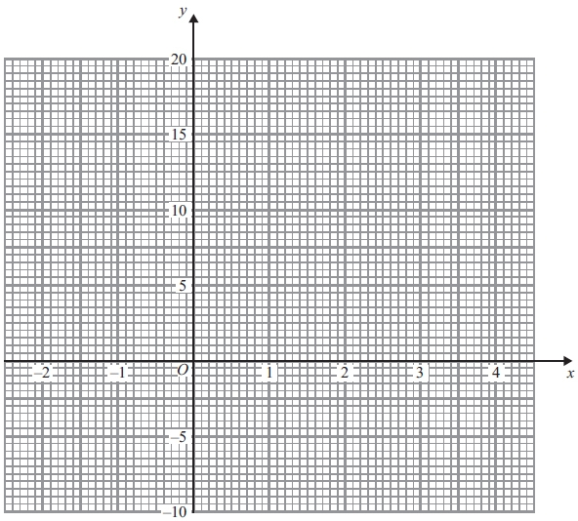

**(Total for question is 4 marks)**

**Q18.**

The diagram shows a quadrilateral *PQRS* drawn on a centimetre grid.

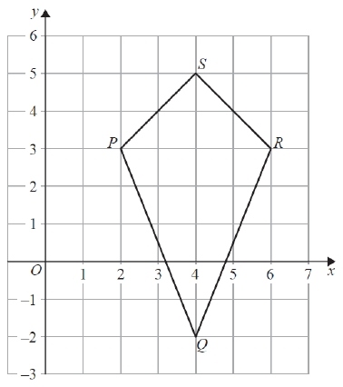

(a)  Write down the mathematical name of the quadrilateral *PQRS*.

...........................................................

**(1)**

(b)  Measure the length of *PQ*.

Give your answer in millimetres.

........................................................... mm

**(1)**

(c)  Write down the coordinates of

(i)  the point *P*,

(........................... , ...........................)

(ii)  the point *Q*.

(........................... , ...........................)

**(2)**

(d)  On the quadrilateral *PQRS*, draw the line of symmetry.

**(1)**

(e)  Work out the area of the quadrilateral *PQRS*.

........................................................... cm2

**(2)**

**(Total for question = 7 marks)**

**Q19.**

The diagram shows triangle *ABC* drawn on a centimetre grid.

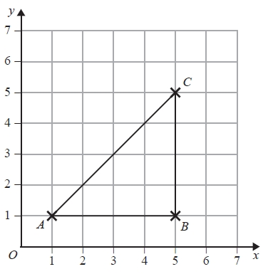

(a)  Write down the coordinates of the point *B*.

(.......................... , ..........................)

**(1)**

(b)  Measure the length of the line *AC*.

Give your answer in millimetres.

........................................................... mm

**(1)**

(c)  Find the area of triangle *ABC*.

........................................................... cm2

**(2)**

*D* is the point such that *ABCD* is a trapezium with *AD* = 3 cm.

(d)  On the grid, mark with a cross (×) the position of the point *D*  
Label your point with the letter *D*.

**(1)**

**(Total for question = 5 marks)**

**Q20.**

The diagram shows quadrilateral *ABCD* on a centimetre grid.

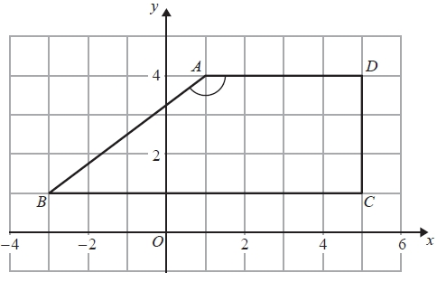

(a)   Write down the coordinates of the point *A*.

(........................................................... , ...........................................................)

**(1)**

(b)   Write down the coordinates of the point *B*.

(........................................................... , ...........................................................)

**(1)**

(c)   Write down the mathematical name for quadrilateral *ABCD*.

...........................................................

**(1)**

(d)   (i) Measure the size of angle *BAD*.

........................................................... °

(ii) Write down the mathematical name for this type of angle.

...........................................................

**(2)**

(e)   Work out the area of quadrilateral *ABCD*.

........................................................... cm2

**(2)**

**(Total for Question is 7 marks)**

**Q21.**

The point *A* has coordinates (5, −4)   
The point *B* has coordinates (13, 1)

(a)  Work out the coordinates of the midpoint of *AB*.

( ................ , ................ )

**(2)**

Line **L** has equation *y* = 2 − 3*x*

(b)  Write down the gradient of line **L**.

...........................................................

**(1)**

Line **L** has equation *y* = 2 − 3*x*

(c)  Does the point with coordinates (100, −302) lie on line **L**?   
You must give a reason for your answer.

.............................................................................................................................................

.............................................................................................................................................

.............................................................................................................................................

**(1)**

**(Total for question = 4 marks)**

**Q22.**

The diagram shows a parallelogram *PQRS* drawn on a centimetre grid.

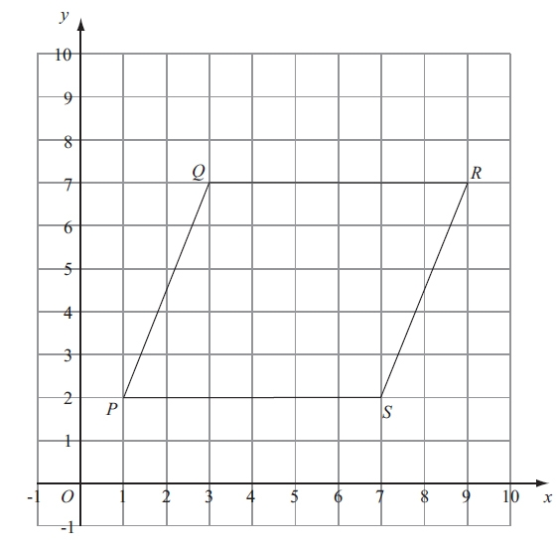

(a) Measure the length of *PQ*.

........................................................... cm

(b) Write down the coordinates of the point *R*.

(...................., .......................................)

**(1)**

(c) Work out the area of the parallelogram *PQRS*.   
Give the units of your area.

........................................   ..............................................................................

**(3)**

**(Total for question = 5 marks)**

**Q23.**

Two points, *A* and *B*, are plotted on a centimetre grid.  
 A has coordinates (1, 4) and *B* has coordinates (8, 2).

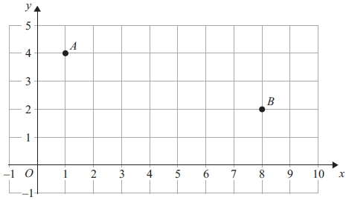

(a) Work out the coordinates of the midpoint of *AB*.

(.............................. , ..............................)

**(2)**

(b) Use Pythagoras' Theorem to work out the length of *AB*.

Give your answer correct to 3 significant figures.

............................................................cm

**(4)**

**(Total for question = 6 marks)**

**Q24.**

The diagram shows a quadrilateral on a square grid.

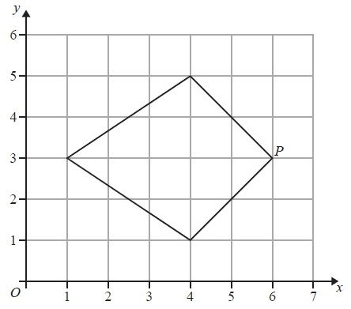

(a)  What is the mathematical name for this quadrilateral?

...........................................................

**(1)**

(b)  On the quadrilateral, draw its line of symmetry.

**(1)**

(c)  Write down the coordinates of the point *P*.

(............................... , ...............................)

**(1)**

The size of the angle at *P* is 90°

(d)  Write down the mathematical name for an angle of 90°

...........................................................

**(1)**

**(Total for Question is 4 marks)**

**Q25.**

The diagram shows a shape drawn on a centimetre grid.

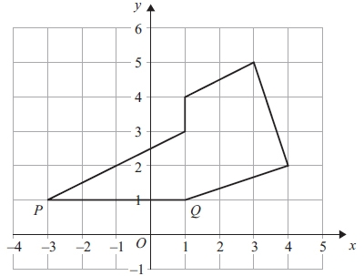

(a) On the shape, mark with crosses (×) a pair of perpendicular lines.

**(1)**

(b) On the shape, mark an obtuse angle.   
Label your angle A.

**(1)**

(c) Write down the coordinates of the point *P*.

(.............................. , ..............................)

**(1)**

(d) Write down the equation of the line *PQ*.

............................................................

**(1)**

(e) Find the area of the shape.   
Give the units of your area.

............................................................

**(3)**

**(Total for question = 7 marks)**

**Q26.**

On the grid, draw the graph of *y* = 3*x* + 2 for values of *x* from −2 to 4

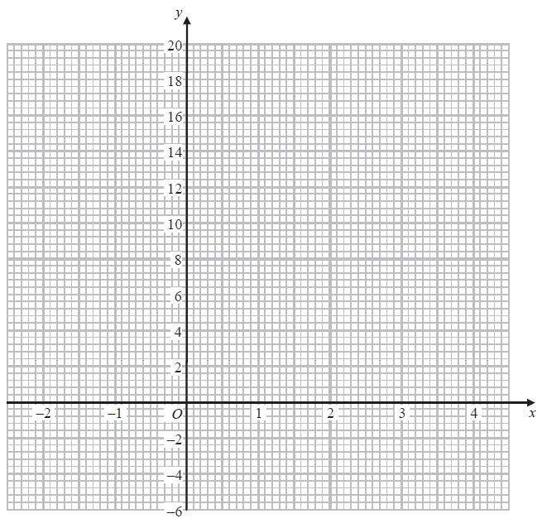

**(Total for question = 4 marks)**

**Q27.**

The diagram shows a quadrilateral *ABCD* on a grid.

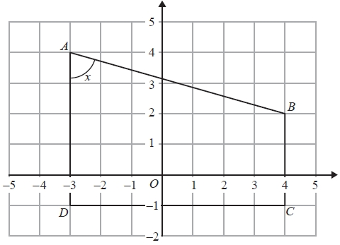

(a)  Write down the coordinates of the point

(i)  *B*

(............................. , .............................)

(ii)  *D*

(............................. , .............................)

**(2)**

(b)  Write down the mathematical name for the quadrilateral *ABCD*.

...........................................................

**(1)**

(c)  (i)  Write down the mathematical name for the angle marked *x*.

...........................................................

(ii)  Measure the size of the angle marked *x*.

........................................................... °

**(2)**

**(Total for question = 5 marks)**

**Q28.**

The diagram shows a quadrilateral *ABCD* drawn on a coordinate grid.

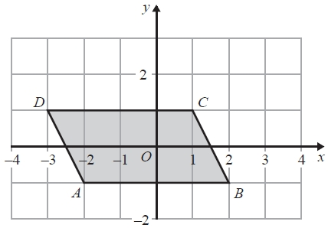

(a)  Write down the coordinates of point *B*.

( ................ , ................ )

**(1)**

(b)  Write down the mathematical name of quadrilateral *ABCD*.

...........................................................

**(1)**

(c)  On the quadrilateral, mark with arrows (>>) a pair of parallel lines.

**(1)**

(d)  On the diagram, mark an obtuse angle with the letter T.

**(1)**

**(Total for question = 4 marks)**

**Q29.**

The diagram shows a quadrilateral *ABCD* on a centimetre grid.

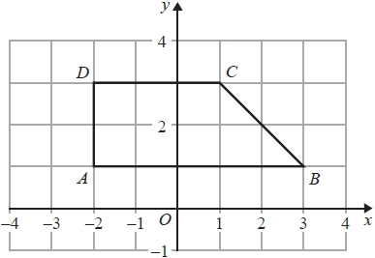

(a)  Write down the coordinates of

(i)  point *B*,

(........................... , ...........................)

(ii)  point *D*.

(........................... , ...........................)

**(2)**

(b)  Write down the equation of the line *AB*.

...........................................................

**(1)**

(c)  Work out the area of quadrilateral *ABCD*.

........................................................... cm2

**(1)**

**(Total for question = 4 marks)**

**Q30.**

The diagram shows a quadrilateral *ABCD* on a centimetre grid.

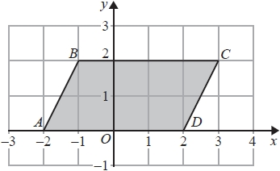

(a)  Write down the coordinates of

(i)  *C*

(........................... , ...........................)

(ii)  *B*

(........................... , ...........................)

**(2)**

(b)  Write down the mathematical name for the quadrilateral *ABCD*

...........................................................

**(1)**

(c)  Write down the order of rotational symmetry of the quadrilateral *ABCD*

...........................................................

**(1)**

(d)  Work out the area of the quadrilateral *ABCD*

........................................................... cm2

**(2)**

(e)  Find the coordinates of the midpoint of *AC*

(........................... , ...........................)

**(2)**

**(Total for question = 8 marks)**

**Q31.**

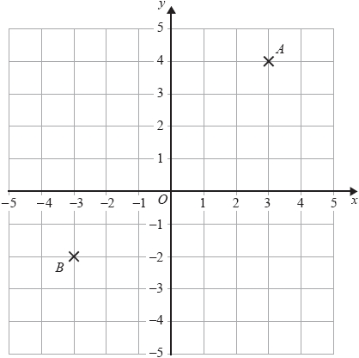

(a)  Write down the coordinates of point *B*.

( ................ , ................ )

**(1)**

(b)  On the grid, mark with a cross  the point with the coordinates (−4,1)

Label the point *P*.

**(1)**

*C* is a point so that angle *ACB* is a right angle.

(c)  Find the coordinates of a possible position for *C*.

( ................ , ................ )

**(2)**

**(Total for question = 4 marks)**

**Q32.**

The diagram shows triangle *ABC* drawn on a centimetre grid.

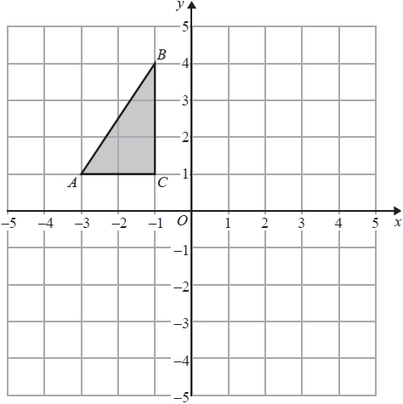

(a)  Write down the coordinates of point *A*.

(........................... , ...........................)

**(1)**

(b)  Reflect triangle *ABC* in the *x*-axis.

**(1)**

(c)  Work out the area of triangle *ABC*.   
You must include the units with your answer.

......................................   ................

**(2)**

**(Total for question = 4 marks)**

**Q33.**

On the grid, draw the graph of *y* + 2*x* = 6 for values of *x* from –2 to 4

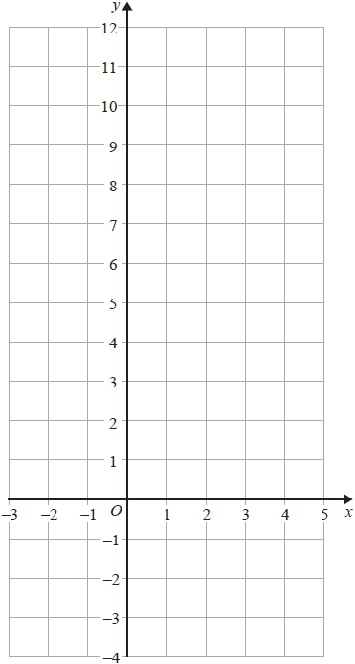

**(Total for question = 4 marks)**

**Q34.**

On the grid, draw the graph of *y* = 3*x* + 2 for values of *x* from −2 to 4

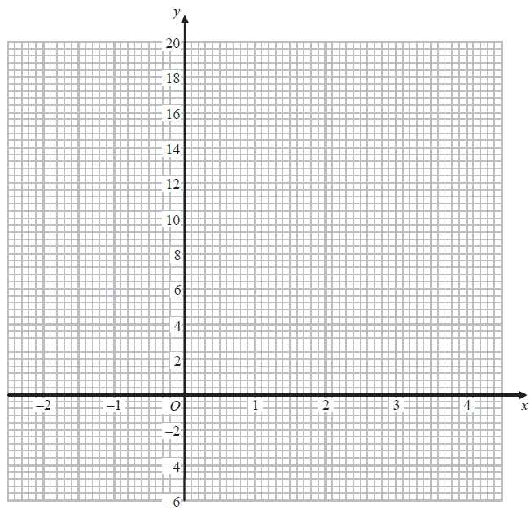

**(Total for question = 4 marks)**

**Q35.**

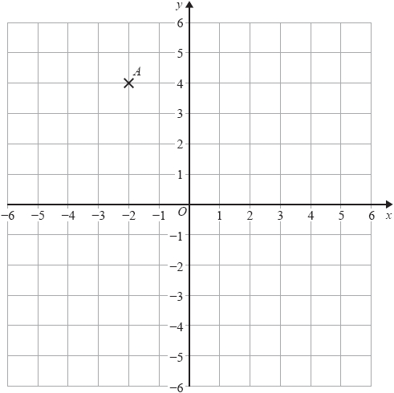

(a)  Write down the coordinates of point *A*.

( ................ , ................ )

**(1)**

(b)  Plot the point (−4,−3)

Label your point *B*.

**(1)**

(c)  On the grid, draw the line with equation    *x* = 3

**(1)**

**(Total for question = 3 marks)**

**Mark Scheme**

Q1.

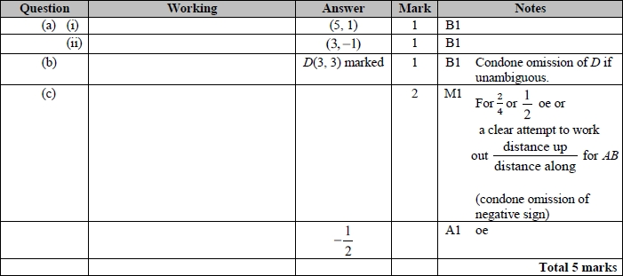

**Q2.**

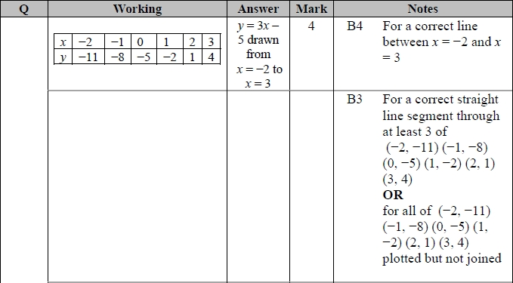

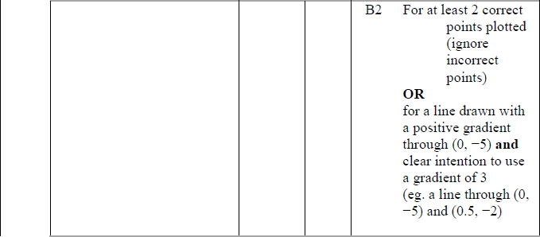

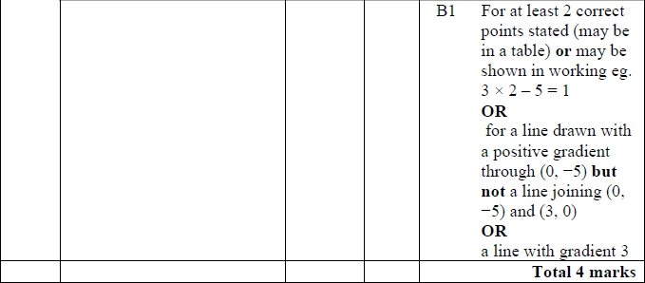

**Q3.**

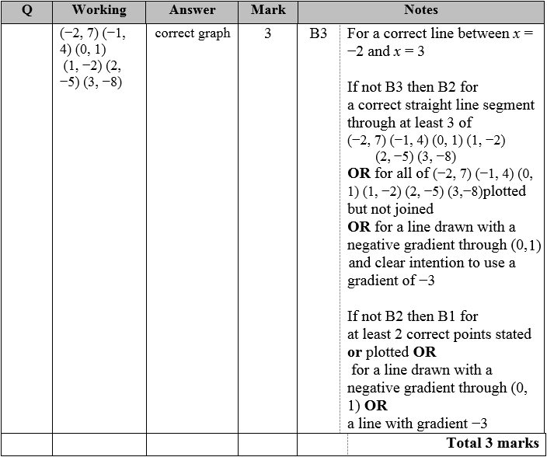

**Q4.**

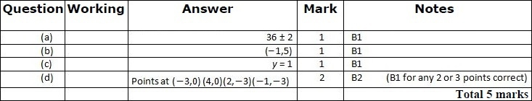

**Q5.**

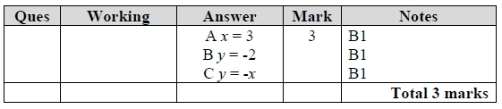

**Q6.**

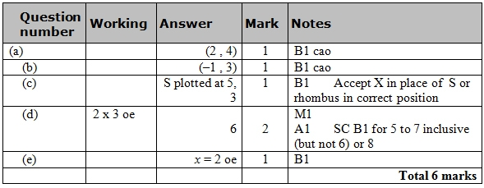

**Q7.**

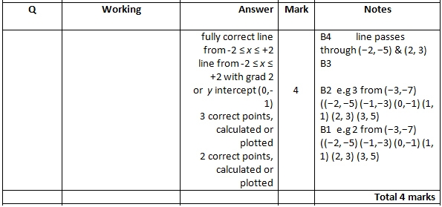

**Q8.**

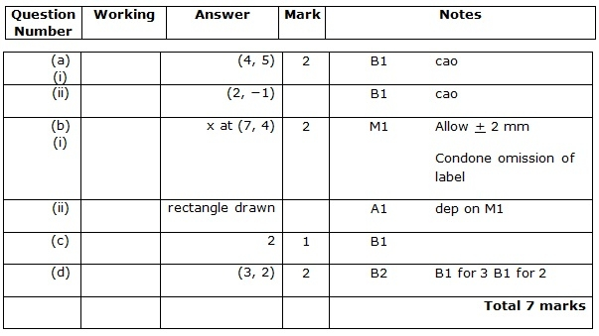

**Q9.**

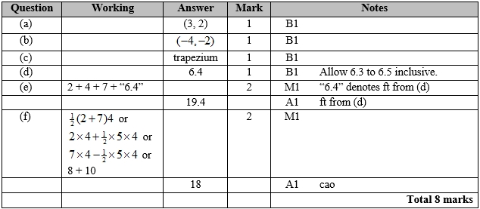

**Q10.**

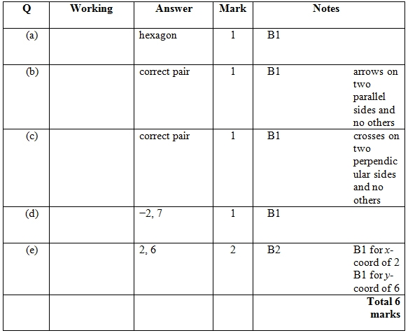

**Q11.**

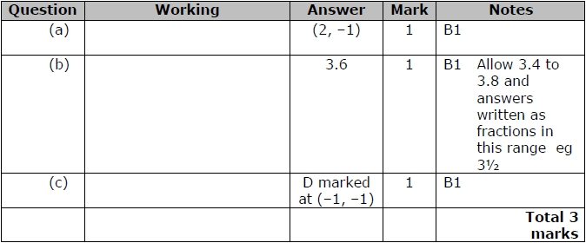

**Q12.**

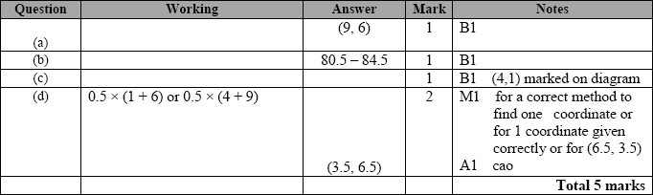

**Q13.**

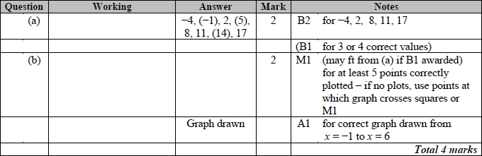

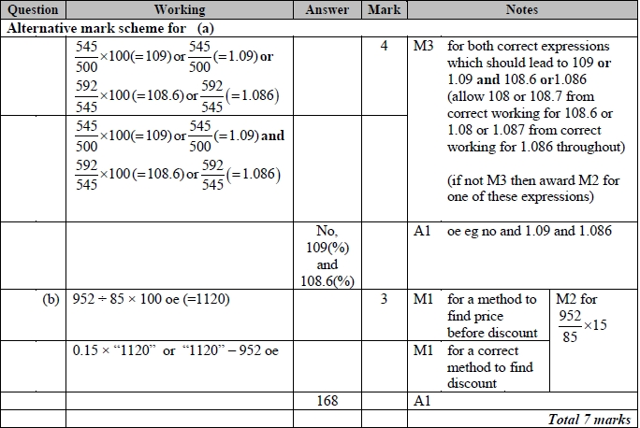

**Q14.**

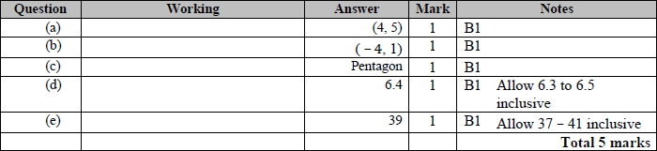

**Q15.**

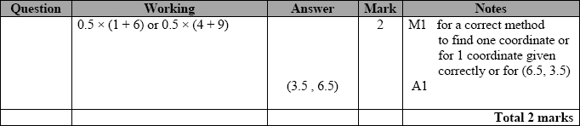

**Q16.**

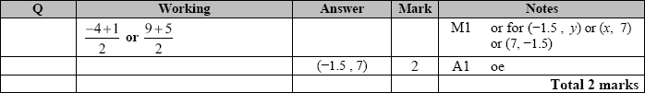

**Q17.**

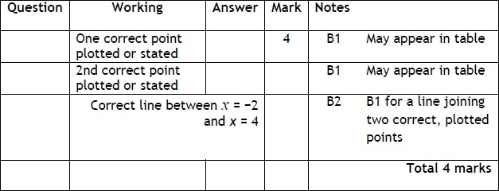

**Q18.**

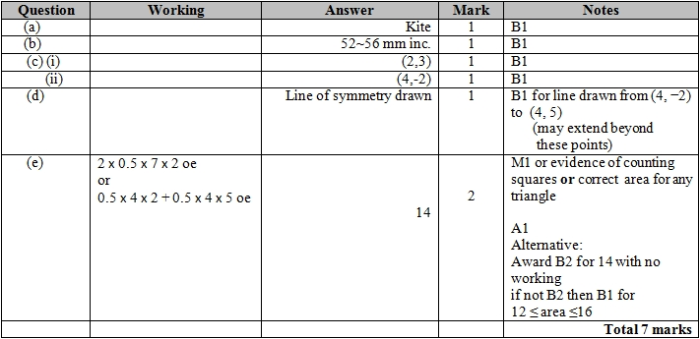

**Q19.**

For all questions, the correct answer, unless clearly obtained by an incorrect method, should be taken to imply a correct method.

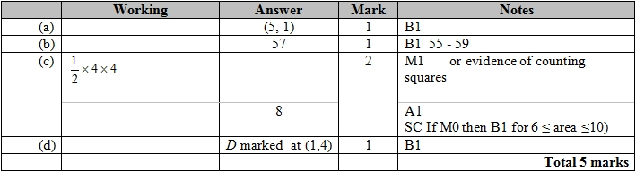

**Q20.**

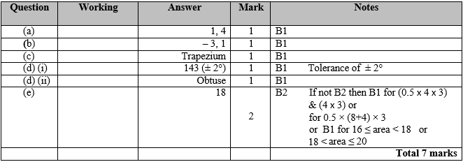

**Q21.**

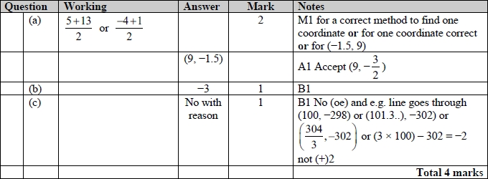

**Q22.**

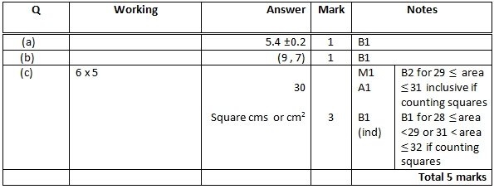

**Q23.**

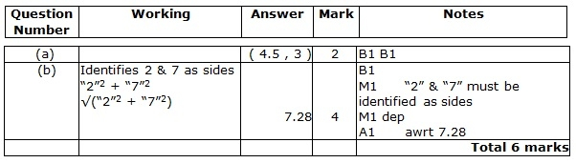

**Q24.**

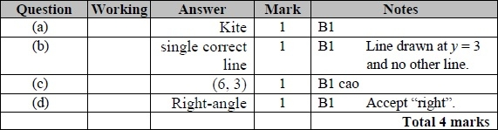

**Q25.**

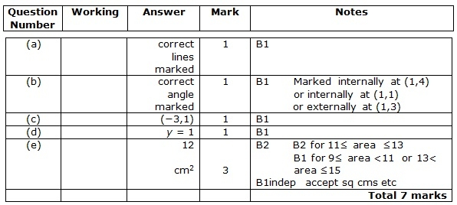

**Q26.**

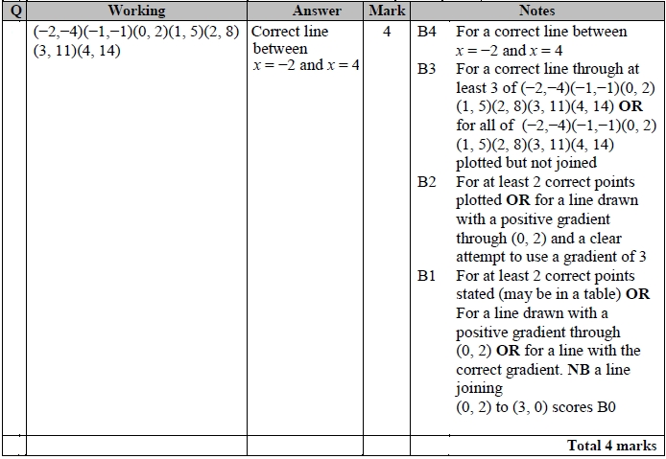

**Q27.**

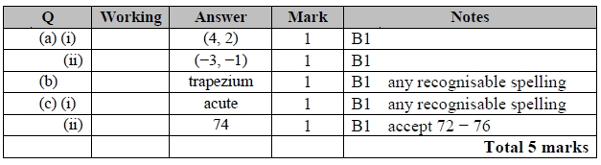

**Q28.**

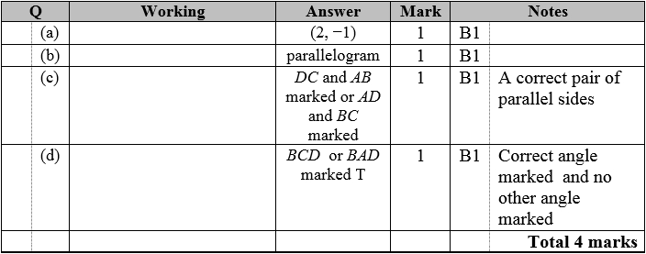

**Q29.**

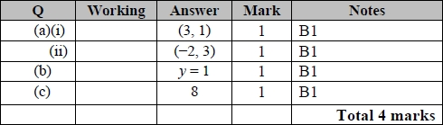

**Q30.**

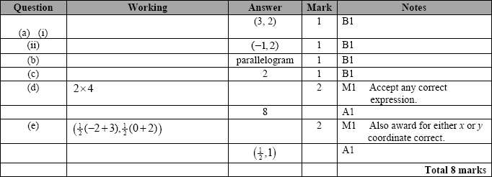

**Q31.**

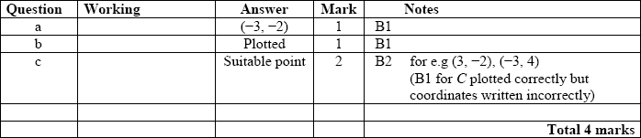

**Q32.**

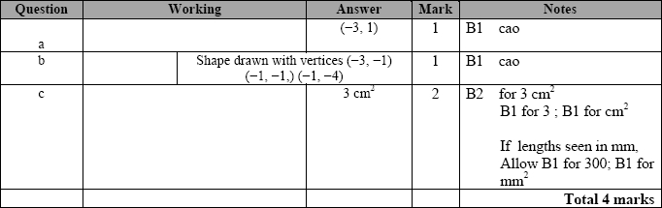

**Q33.**

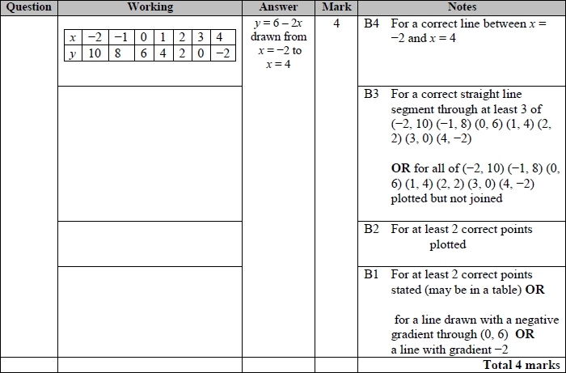

**Q34.**

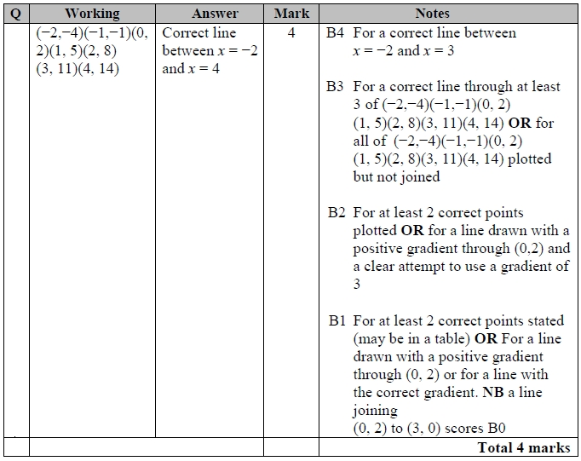

**Q35.**

