

**Higher IGCSE (9 – 1) Revision Pack**

**Inequalities and Regions (Linear)**

**Name --------------------------------**

**Questions**

**Q1.**

(a)  On the grid, draw the graph of *y* = 3*x* + 2 for values of *x* from −2 to 3

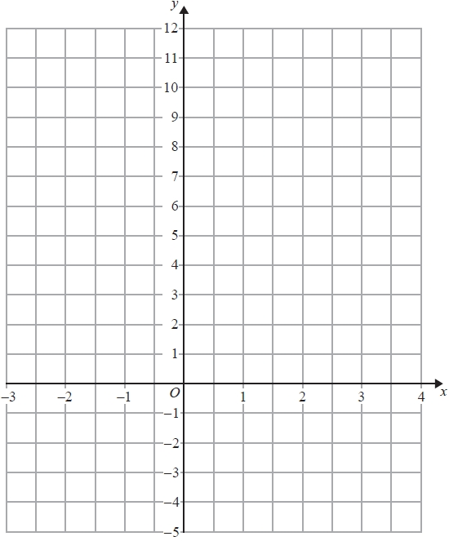

**(3)**

(b)  Mark with a cross (×) a point on the grid that satisfies both the inequalities

*x* > 2 and *y* > 3*x* + 2

Label this point *P*.

**(2)**

**(Total for question = 5 marks)**

**Q2.**

(a)  Complete the table of values for 2*x* + *y* = 4

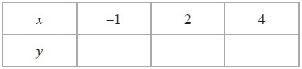

**(2)**

(b)  On the grid, draw the graph of 2*x* + *y* = 4 for values of *x* from −1 to 4

**(2)**

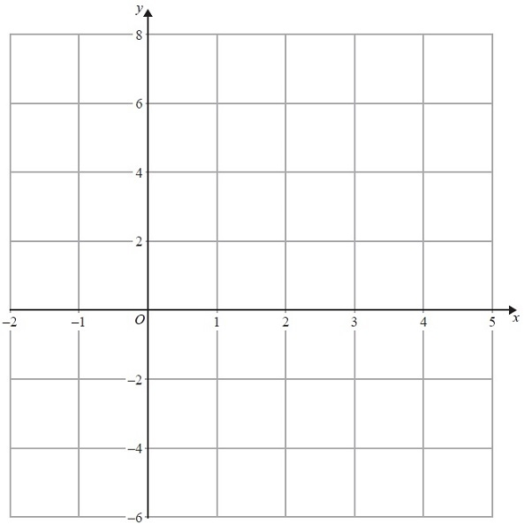

(c)  Show, by shading on the grid, the region which satisfies **all three** of the inequalities

*x* ≥ −1, *y* ≥ 2 and 2*x* + *y* ≤ 4

Label the region **R**.

**(2)**

**(Total for Question is 6 marks)**

**Q3.**

(a)  On the grid, draw the graph of *y* = –2*x* + 4 for values of *x* from –1 to 5

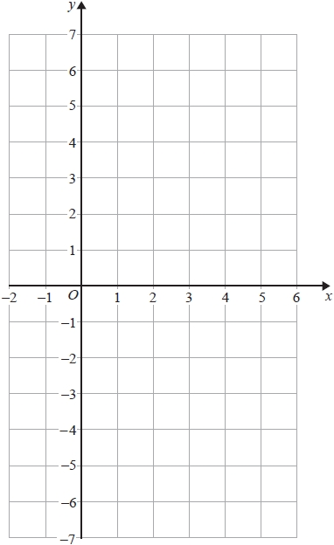

**(4)**

(b)  Show by shading on the grid, the region defined by all three of the inequalities

*y* ≤ −2*x* + 4

*y* ≥ −4

*x* ≥ 1

Label your region **R**.

**(3)**

**(Total for question = 7 marks)**

**Q4.**

(a)   On the grid, draw the line with equation *x* + 2*y* = 8 for values of *x* from 0 to 9

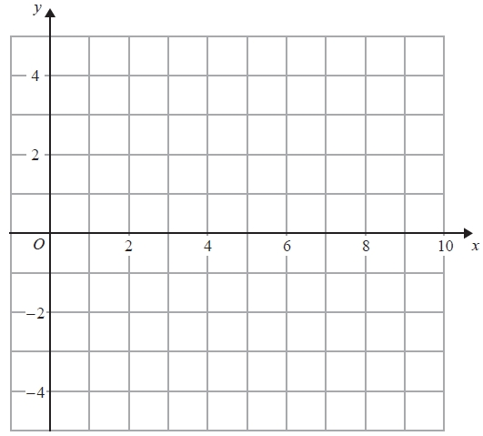

**(2)**

(b)   Show, by shading on the grid, the region defined by all three inequalities

*x* + 2*y* ≤ 8

*x* ≥ 2

*y* ≥ 1

Label your region **R**.

**(3)**

**(Total for Question is 5 marks)**

**Q5.**

On the grid, show by shading the region defined by the inequalities

*y* > 5      and      *y* < 2*x* + 1      and      *x* + *y* < 10

Label your region **R**.

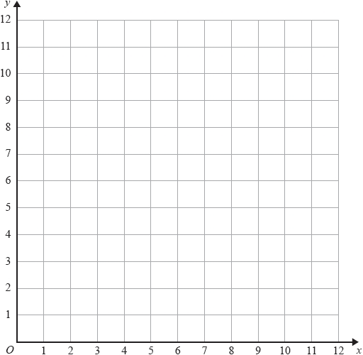

**(Total for question = 3 marks)**

**Q6.**

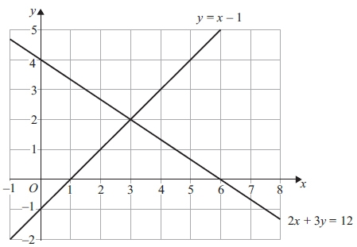

The diagram shows two straight lines.  
The equations of the lines are *y* = *x* − 1 and 2*x* + 3*y* = 12

(a) Write down the solution of the simultaneous equations



*x* = .............................., *y* = .............................

**(1)**

(b) Find an equation of the line which is parallel to the line with equation 2*x* + 3*y* = 12   
and passes through the point (0, 10)

...........................................................

**(4)**

(c) On the grid, mark with a cross (×) each point which satisfies both these inequalities   
*y* > *x* − 1 and 2*x* + 3*y* < 12 and whose coordinates are **positive integers**.

**(2)**

**(Total for question = 7 marks)**

**Q7.**

(i) Solve the inequalities −6 < 4*x* ≤ 8

...........................................................

(ii) *n* is an integer.   
Write down all the values of *n* which satisfy −6 < 4*n* ≤ 8

...........................................................

**(Total for question is 4 marks)**

**Q8.**

(i) Solve the inequalities −2 < x + 2 ≤ 5

...........................................................

(ii) On the number line, represent the solution to part (i).



**(Total for question = 4 marks)**

**Q9.**

(a)  Solve the inequality     3*x* + 8 < 35

...........................................................

**(2)**

(b)  Write down the inequality shown on the number line.

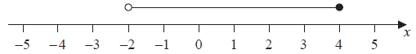

...........................................................

**(2)**

**(Total for question = 4 marks)**

**Q10.**

(a)  Solve the inequalities –4 < 3*x* + 5 ≤ 11

...........................................................

**(3)**

(b)  Write down the integer values of *x* which satisfy –4 < 3*x* + 5 ≤ 11

...........................................................

**(2)**

**(Total for question = 5 marks)**

**Q11.**

(a)  Solve the inequalities     −5 < *x* + 4 ≤ 3

...........................................................

**(2)**

(b)  *n* is an integer.   
Write down all the values of *n* that satisfy     −3 ≤ *n* < 2

...........................................................

**(2)**

**(Total for question = 4 marks)**

**Q12.**

(i) Solve the inequality 2*x* + 13 ≥ 6

...........................................................

(ii) *n* is a **negative** integer.   
Write down all the values of *n* which satisfy 2*n* + 13 ≥ 6

...........................................................

**(Total for question = 4 marks)**

**Q13.**

(a)  Solve the inequality     *e* – 2 < 0

...........................................................

**(1)**

(b)  Solve the inequality     5 – 3*e* < 4

...........................................................

**(2)**

(c)  Write down the integer value of *e* that satisfies both of the inequalities

*e* − 2 < 0          and          5 − 3*e* < 4

...........................................................

**(1)**

**(Total for question = 4 marks)**

**Q14.**

(a)  Solve the inequality   4*x* + 13 ≥ 27

...........................................................

**(2)**

(b)  On the number line, represent the inequality   *y* ≥ −1



**(1)**

*n* is an integer.

(c)  Write down all the values of *n* that satisfy  −3 < *n* ≤ 2

...........................................................

**(2)**

**(Total for question = 5 marks)**

**Q15.**

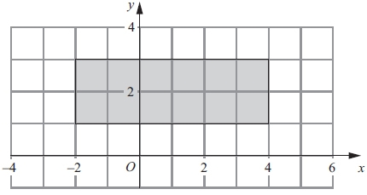

Write down inequalities to fully define the shaded region.

      ..............................................................................................................................................

**(Total for question = 3 marks)**

**Q16.**

Show, by shading on the grid, the region defined by all three of the inequalities

*x* ≤ 5  
  
*y* ≥ 3  
  
*y* ≤ *x*

Label your region **R**.

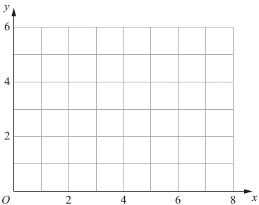

**(Total for question = 3 marks)**

**Q17.**

(a)



An inequality is shown on the number line.

Write down this inequality.

...........................................................

**(2)**

(b)  (i)  Solve the inequality 2(*y* − 3) ≥ 1

...........................................................

(ii)  Write down the lowest **integer** which satisfies this inequality.

...........................................................

**(4)**

**(Total for Question is 6 marks)**

**End of questions**