Year 2 Sociology

**Paper 3: Crime and Deviance with Theory & Methods**



Crime and Deviance

Booklet 1: Functionalist, strain and subculture theories

Name ­­ ______________________________

Specification Content:

What you need to know for **Crime and Deviance** in your Paper 3 exam.

Students are expected to be familiar with sociological explanations of the following content:

* crime, deviance, social order and social control
* the social distribution of crime and deviance by ethnicity, gender and social class, including recent patterns and trends in crime
* globalisation and crime in contemporary society; the media and crime; green crime; human rights and state crimes
* crime control, surveillance, prevention and punishment, victims, and the role of the criminal justice system and other agencies.

|  |  |  |  |  |  |
| --- | --- | --- | --- | --- | --- |
| **Questions may be based specifically on the following areas:** | | Do I have completed Notes? | Have I made revision Notes? | Have I memorised this info? | Have I practised exam style questions? |
| **Functionalist explanations of crime, deviance, social order and social control** | Work of **Durkheim** and other functionalists showing that society is based on **value consensus**. Positive functions that crime may perform such as reinforcing solidarity and adapting to change. |  |  |  |  |
| Evaluation of this theory. |  |  |  |  |
| **Merton’s strain theory** | Understanding of how **Merton** uses the idea of strain between goals of society and legitimate means to explain how this may lead to crime. |  |  |  |  |
| 5 different types of adaptation that may occur as a result of strain. Conformity, Innovation, Ritualism, Retreatism, Rebellion |  |  |  |  |
| Evaluation of this theory. |  |  |  |  |
| **Subculture as an explanation for crime.** | A.K.Cohen - subcultural deviance resulting from **status frustration** |  |  |  |  |
| Cloward and Ohlin – 3 different deviant subcultures (criminal, conflict and retreatist) |  |  |  |  |
| Evaluation of these theories. |  |  |  |  |
| **Differentiation association theory** | Sutherland |  |  |  |  |

Exam Structure:

|  |
| --- |
| **These topics will appear in paper 3 of the A’Level.** 2 hour written exam 80 marks in total (50 for this bit)   * 33.3% of A-level   Crime and Deviance: short answer and extended writing, 50 marks (4 marks, 6 marks, 10 marks, 30 marks) |

Functionalist, strain and subculture theories



For discussion……

Who breaks rules and why?

Who makes the rules?

Does everyone agree what a ‘crime’ is?

What is an offender?

How do we treat one?

What makes something a ‘crime?

What do you remember about Durkheim and Functionalism? Try to write a paragraph below including these words – value consensus, common culture, norms, social solidarity, socialisation, social control.

How do social control mechanisms work in your school?

|  |  |  |
| --- | --- | --- |
|  | *Positive sanctions* | *Negative sanctions* |
| Formal  sanctions | Certificates | Suspension |
| Informal  sanctions | Praise from teacher | Reprimand from teacher. |

What did Durkheim say about crime?

‘crime is normal….an integral part of all healthy societies’

‘To make progress, individual originality must be able to express itself. In order that the individuality of the idealist whose dreams transcend this century may find expression it is necessary that the originality of the criminal, who is below the level of his time, shall also be possible. One does not occur without the other.’

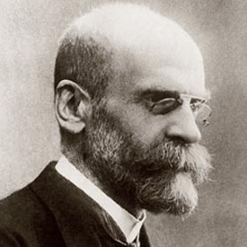

Functionalists believe that crime is **inevitable** and that it is **functional**, largely in a positive way and present in all societies.

Modern societies are in a state of ‘**anomie’** - explain what this means and why this has occurred as societies moved from being small scale societies to urban and industrial societies.____________________________________________________________________________________________________________________________________________________________________________________________________________________________________________________________________________________________________

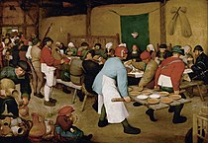Why is crime more likely in a society in a state of **anomie**?______________________________________________________________________________________________________________________________________________

This painting is called ‘The Peasant Wedding’ by Brueghal 1566-1569. Why did Durkheim think that crime would be lower in communities like this?

Is crime inevitable? Durkheim said yes, even in a ‘perfect cloister of individuals’ as it is impossible for all individuals to be alike. In a ‘society of saints’ there would still be deviance. General standards of behaviour would be so high that the slightest slip would be regarded as a serious offence.

1. Crime as functional - Durkheim

As well as being inevitable, Durkheim considers crime to be functional in 2 ways.

1. **Boundary maintenance**. To unite members together in condemnation of the wrongdoer and to reinforce commitment to shared norms and values. Explain below what this means and HOW it might be done. Use the terms ‘dramatisation of evil’ and ‘folk devil’, include media and the courts.
2. Adaptation and change – all change starts with an act of deviance. Individuals must not be totally restricted by social control or society will never change. Explain.

To support this Albert Cohen talks about deviance giving a warning that an institution in society is not functioning properly. For example, what do you think a rise in truancy might tell us?

Look at these 2 examples below and explain how each might illustrate the second function of crime for Durkheim.

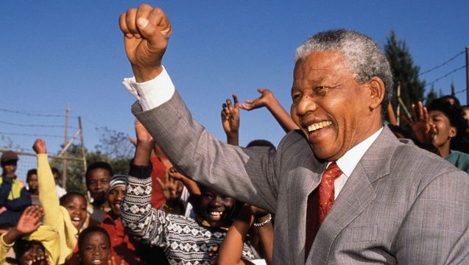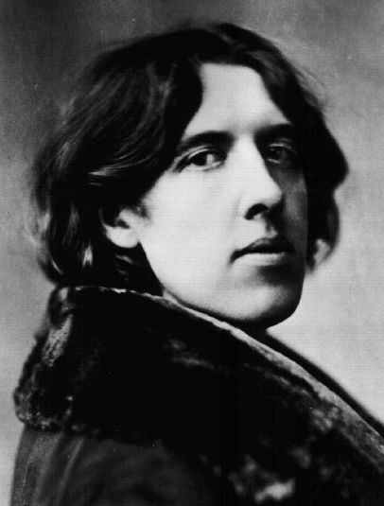

Activity – research the positive functions of crime [www.sociology.uk.net](http://www.sociology.uk.net) complete the task connected to page 72.

Make some notes below

However....

**Criticisms of Durkheim**

1. How much deviance is the right amount ?
2. Society does not create crime. Durkheim has explained what it does but this is not the cause of crime so we still do not know why crime exists.
3. Ignores how crime affects individuals
4. Crime does not always promote solidarity

**What does Durkheim do well?**

1. Gives us a convincing explanation of why crime is higher in industrial societies than traditional societies and why crime is inevitable in any society.
2. Merton and ‘strain’ theory

He continued to look at the idea of ‘anomie’ and saw a tension between people trying to reach goals of society but society not offering enough guidance about how they could do this.



Socially approved goals

Legitimate means

Can you explain how a tension between these two may lead to crime?

‘Socially approved goals’ are the things that a society encourages individuals to achieve – what might these be? Can you explain with reference to the ‘American Dream’?

‘Legitimate means’ are how the institutional structure of society allows people to achieve these goals – for example?

**Explain in more detail using page 73**

How might individuals adapt to this strain? Merton talks about 5 main ways.

|  |
| --- |
| Conformity |
| Innovation |
| Ritualism |
| Retreatism |
| Rebellion |

In a school, pupils have the **goal** of achieving academic success. If they cannot do this by **legitimate means** they may deviate from the expected behaviour. Which of the above categories would the following fall into?

1. Truancy
2. Copying homework

Can you think of examples for the other categories?

However....

This theory is criticised on several grounds 

1. Takes official statistics at face value
2. Marxist criticism
3. Assumes value consensus
4. Only accounts for crimes connected to monetary gain, what about vandalism etc?
5. Ignores role of group deviance like subcultures.

****What Merton does well.

He does explain the patterns in crime statistics.

Most crime in America is property crime as America values material wealth so highly.

Lower class crime rates are high and it is true that they have the least opportunity to get money legitimately.

1

Complete activity p 74 [www.sociology.uk.net](http://www.sociology.uk.net) **–** why do people commit crimes?

1. **Subcultural strain theories.**

What is a subculture? Can you give an example from last year?

These theories look at how a subculture may develop with different values from the mainstream as a result of the ‘strain’ discussed above. These subcultures can offer a solution to a problem so are **functional**  for their members even if not for society as a whole.

1. K. Cohen

Looked at deviance as a lower-class phenomenon. Considered the inability of those from the lower classes to achieve mainstream success goals by legitimate means such as education. He was particularly interested in juvenile delinquency. He supported, modified and developed Merton’s work. Merton had looked mainly at individuals but he was more interested in collective (group) responses. Merton did not account for crime such a vandalism which seemed not to have a purpose.

Main focus was on working class boys (what can we remember about Paul Willis……………………….?). They face anomie when operating in a middle-class school environment as they suffer from **cultural deprivation** and lack the skills needed to achieve so in school they are at the bottom of the status hierarchy. They experience what he calls ‘status frustration’ which creates feelings of guilt, resentment and shame (even though these may be unconscious).

They fix this by creating their own status hierarchy rejecting middle class values and turning to other boys in their positions to form or join a delinquent subculture.

**Alternative status hierarchy** this turns mainstream values upside down. Their values are spite, malice, hostility and contempt for those outside their subculture. They reject the success goals of the mainstream, whatever the mainstream aims for as a defence mechanism they aim for the opposite so truancy, destroying property, cheeking teachers and this is how they get status, from their peers.

 What A. K. Cohen does well.

1. Accounts for explanation of deviance which does not appear to have a purpose (Merton could only explain crime with a profit motive). This explains non-economic crime.
2. Accounts for group motivations not just individuals.

 BUT

Do working class boys start off with working class goals? Maybe they did not share these goals in the first place so would not reject them when they fail. If they did not share these goals in the first place they may not have seen themselves as failures.

Cloward and Ohlin – 3 subcultures.

They continue to build on the work of Merton. They think that working-class youths are denied the opportunities to achieve ‘money success’. Different subcultures respond differently to this challenge and Merton had only dealt with half the picture. Merton had explained deviance in terms of ‘legitimate opportunity structure’ but what about different access to ‘illegitimate opportunity structures’? The opportunity to be successful by ‘illegitimate means’ varies as much as access to legitimate means, meaning 3 different types of subculture are created.

|  |
| --- |
| Criminal subcultures |
| Conflict subcultures |
| Retreatist subcultures |

Evaluation

 What they do well

1. This theory is a good way of explaining why strain might lead to a variety of responses.

 BUT

1. Too much focus on working class crime
2. Drug trade is a mix between disorganised crime and professional mafia type subcultures. Some ‘retreatist’ users may also be professional dealers so they do not allow for crossing over between categories.

Explain how Miller and Matza may offer alternative views

## Differential Association Theory

Sutherland’s (1939) differential association theory is an influential explanation of how individuals learn to become offenders. According to Sutherland, if an individual experiences repeated attitudes that are positively associated with crime, rather than negatively (in terms of punishment), then they are more likely to engage in criminal behaviour. The way in which a person becomes an offender is through learned attitudes and imitation of criminal acts. The theory is described as ‘differential association’ as criminal behaviour can be learned from many different avenues of interactions and experiences, which might be family, peers or the media.

 **Eye on the exam…**

* 1. Outline 2 reasons why functionalists see crime as inevitable. (4)
  2. Read **Item B** below and answer the question that follows.

**Item B**

Some functionalist sociologists argue that crime and deviance are caused by the inability of some people to gain the rewards of society, for example because of educational underachievement. Those members of society whose opportunities are blocked cannot achieve the goals of society by socially approved means.

Applying material from **Item B** and your knowledge, evaluate the usefulness of functionalist approaches in understanding crime and deviance.

**[30 marks]**