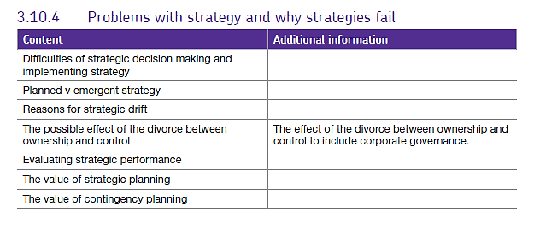Strategic planning.

This long-term planning involves a range of options available to the business in order to gain a competitive advantage. This is the stage when the strategic decisions are made to create medium - long term plans to enable the firm to achieve its objectives.

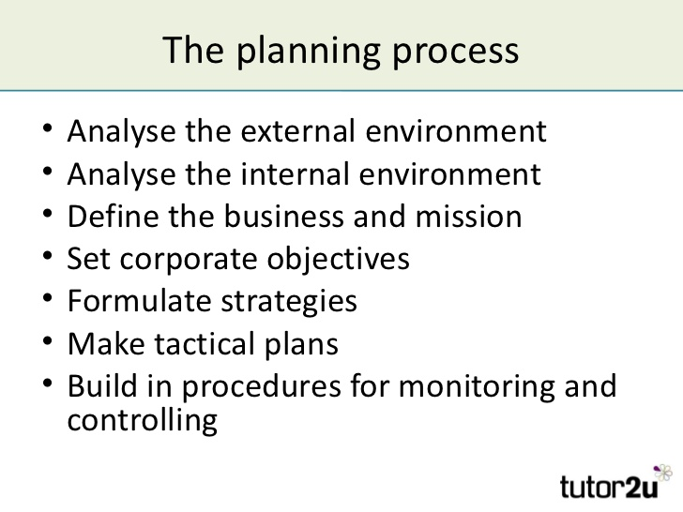Strategic decision-making approaches include looking at models such as Ansoff’s Matrix, Porter’s Generic Strategies, Bowman’s Strategic Clock and Decision Trees.

The outcomes of strategic decisions tend to be unknown because they are longer term and can be affected by many internal and external factors. For example, competitor activity, government policy, the economic environment or company culture etc.

They may involve a company moving into new areas which require additional resources, procedures and retraining. An example of a strategic decision would be choosing to expand to achieve a corporate goal of market dominance or might be about how it will compete in a way that distinguishes it from its competitors – for example, based on quality and uniqueness or in terms of cost leadership and low prices.

**Implementation of strategy**

This is when the agreed strategy is put into action, creating a framework of action plans and targets at a functional level. The implementation stage can be difficult and research shows that the people who have to implement strategies have often been left out of the planning stages, this means that the people responsible for implementing the strategy might not be informed about the reasons behind it or how it links to the objectives of the business.

# Planned versus emergent strategies

**Planned strategy** is the strategy that the organisation hopes or intends to implement and is described in detail in the organisation’s strategic plan. The planned strategy usually involves: strategic analysis, strategic choice and lastly strategic implementation. If the strategic plan is implemented successfully, then the outcome should match the original objectives for which the strategy was formulated. Planned strategy has benefits for a business:

* 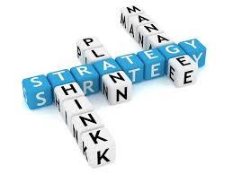It can provide a structured means of analysis and thinking about complex strategic thinking.
* It can encourage a longer-term view of strategy than might otherwise occur.
* It can be used as a means of control by regularly reviewing performance and progress against agreed targets.
* It can be a useful means of co-ordination, for example by bringing together the various functional strategies within an overall corporate strategy, or by ensuring that resources within the business are co-ordinated to put the strategy into effect.
* It can be used as a way of involving people in strategy development, therefore perhaps hoping to create ‘ownership’ of the strategy.
* Because it is fixed and known, it can be communicated simply and effectively to employees.

When an organisation’s internal and external environment is stable and predictable, the planned or intended strategy will be fine for it’s intended purpose, however, very few companies operate in a stable or predictable environment.

**Emergent strategy**

Several management theorists believe that planned strategy is unrealistic because businesses are unable to control all the external and internal factors that could impact on the planned strategy.

Mintzberg introduced the idea of *emergent strategy* where a business is constantly learning and adapting strategies to the environment they face. Emergent strategy is unplanned and emerges in response to internal and external changes which were not envisaged when the original planned strategy was formulated. Most theorists now think that, in reality given that nature of the changing business environment, emergent strategy is more useful.

This does not mean that the planned strategy is not necessary but, in many firms, highly detailed two or five year plans are now a thing of the past.

Emergent strategy assumes that the business is constantly learning and taking note of the internal and external environment. This is good because firms need to be flexible to survive.

# Strategic Drift.

Strategic drift is a situation where the company responds too slowly to change in its external and competitive environment. A company continues with a strategy which may have served it well in the past, *but it is no longer suited to the current circumstances, depending how long this goes on for, the business may mange to turn things around or may fail and cease trading.*

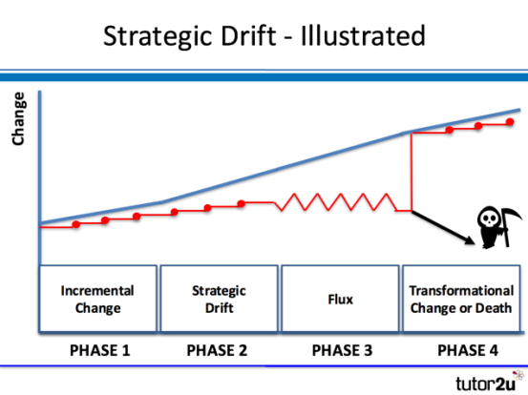There are lots of examples of firms who have been in this position, those in a state of flux include Marks and Spencer or Tesco, of those who have gone out of business, the most recent one is ToysRus but Nokia, Blockbuster and Kodak are also good examples.

There are a number of phases a firm goes through in relation to strategic drift and these are given below*:*

* **Phase 1:** The firm makes *incremental changes* that are part of its planned strategy to change in line with external or competitive environmental changes, so they can remain competitive in their market.
* **Phase 2:** Changes are happening in the firm’s environment,but the firm’s approach of means that they don’t recognise the need for change and strategic drift occurs.
* **Phase 3:** Leaders recognise the decline in the business performance and that there is a gap between what the market expects and what the business is providing and try to respond with short term strategies – a piece meal approach which leads to a state of flux, there is no clear direction and there is disagreement about what strategies are appropriate.
* **Phase 4:** At this stage, the business either fails completely and the firm closes or, if it survives, this is because it undergoes transformational change to align its strategies with the market it is in and begins to operate successfully again.

## Causes of strategic drift.

The most common causes include the following:

* Organisational culture and inflexibility or organisation structure restricts the ability of the firm to change at a necessary rate.
* Leaders of the organisation are complacent due to market dominance and carry on with strategies without realising they are no longer suitable.
* A company is reactive rather than proactive.
* The strategic plan is not reviewed regularly or monitored through results to check if it is working given to what is happening in the external and competitive environment.
* The organisation is not keeping pace with changes in technology.

## Overcoming strategic drift

Planned strategic change, often of a **transformational nature**, is the main way to overcome strategic drift. Transformational change in this context means a shift in the organisational culture of the organisation and includes a change in the underlying strategy and processes that an organisation has used in the past. A transformational change is designed to be organisation wide and takes place over time. It should address all the reasons which caused strategic drift.

# The divorce between ownership and control

In sole traders, the owner and director / manager are likely to be the same person, so these functions remain with that one person. However, in a public limited company (PLC), the owners (shareholders) vote for a Board of Directors to control the business and they in turn appoint managers to run the business on a day to day basis. In this case, the two functions of ownership and control are separated or divorced.

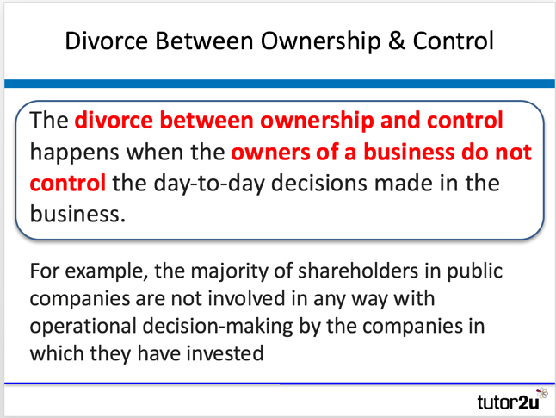The possible effect of the **divorce of ownership and control** in public limited companies tends to centre on the tension between the objectives of the owners (shareholders) and those in control (directors).

Public limited companies attract millions of shareholders, many of whom may only be interested in the dividends they can earn on their shares or the **capital gain** they can make from buying and selling shares. They often have little or no real interest in the management of the company, its long term performance, or its impact on other stakeholders. As a result of this, shareholders can put pressure on directors to opt for ‘short termist’ decision making.

The fact that directors and shareholders become more separated as the company grows in size, means that shareholders find it more difficult to access the information they need to challenge or judge the managers’ decision making. The more autonomy directors have, the more likely they are to pursue objectives that benefit themselves rather than the shareholders. For example, directors could further their own careers and power by pursuing business growth even if this is at the expense of ethical behaviour and efficiency.

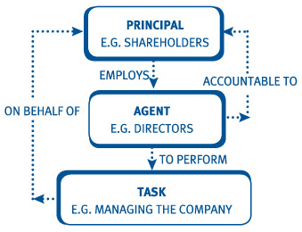

# Corporate Governance

Corporate governance is the system put in place by larger / limited companies to direct, monitor and control their activities. The purpose of this system is to bring about effective and efficient (practical) management to deliver long-term success.

## Why is corporate Governance needed and how is it organised?

The need for effective corporate governance is particularly important in quoted (or public) companies. This is because of the ["divorce between ownership and control"](http://www.tutor2u.net/business/reference/divorce-between-ownership-and-control) whereby most shareholders have no involvement in the day-to-day management of the company.

The essential elements of "best practice" corporate governance for such companies are:

* The CEO and Chairman of companies should be separated
* Boards should have at least three non-executive directors, two of whom should have no financial or personal ties to executives, this means that they are not serving their own interests – as they have no personal interest – they are working for the good of the company.
* Each board should have an audit committee composed of non-executive directors
* The owners of a company normally elect a **Board of Directors** to control the business's resources for them. Often in smaller firms, there is no difference between the Directors and the Shareholders - they are the same person or people.

## Boards of Directors

It is the Board of directors of each company that is legally responsible for the governance of the company and not the owners (shareholders) whose role in corporate governance is to appoint the directors (and the auditors where required) and to satisfy themselves that an appropriate governance structure is in place. The responsibilities of the board include:

* Setting the company’s objectives and aims
* Determining the strategy to achieve those aims and objectives
* Providing the leadership to put them into effect
* Supervising the management of the business
* Reporting to shareholders on their stewardship of the business

However, when the share ownership of the business becomes more widespread (for example when shares are sold to external investors) the original owners of the business sacrifice some of their control, other shareholders can exercise voting rights and providers of loans often have some control (security) over the assets of the business. This may lead to conflict between them as different shareholders can have varying objectives. This is known as the **principal agent problem**.

## The Principal Agent Problem

How do the shareholders of a business know that managers charged with running the business are acting in their best interests by building shareholder value?

The principal agent problem revolves around how best to get your employees to act in your interests rather than their own. Shareholders tend to want strong returns in the form of dividend payments and a rising share price, however, managers may have objectives such as power, bonuses, prestige and status. The main issues here are show below:

* Many shareholders have no day-to-day control over managers.
* Managers e.g. pension fund managers cannot dictate what CEOs and CFOs of businesses decide to do and senior executives may have little knowledge of what their managers are doing as they are removed from the process (Tesco finance example).
* Many investors are 'passive'. The biggest investors in UK-listed companies tend to be large institutional shareholders such as pension funds and insurance companies.
* What is in the best interest of the management is not necessarily the same as what is in the best interests of the shareholders.

## Dealing with the Divorce between Ownership & Control

Strategies to deal with the potential conflict between shareholders and managers include:

* Ensuring that financial rewards and incentives offered to managers are aligned with shareholder holder interests - e.g. based on the share price, dividends, profits achieved
* Implementing suitable corporate governance procedures to ensure shareholders are protected as far as possible (e.g. through non-executive directors, management remuneration committees)
* 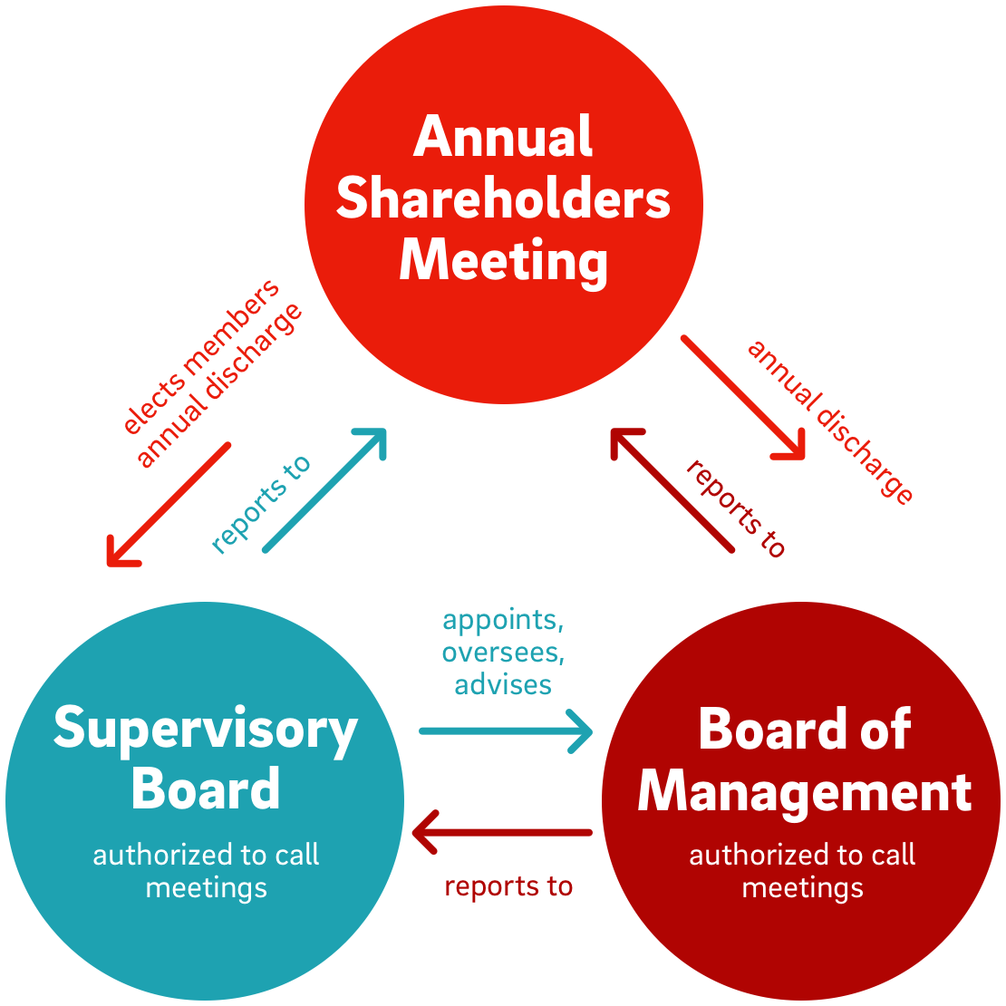Company legislation ensuring that Directors are accountable for their actions to shareholders.

## Activist Shareholders

Activist shareholders look to put pressure on existing management or force through changes to management boards. Some insist on businesses using profits to buy-back shares to increase returns to existing shareholders. An activist shareholder uses an equity stake to put pressure on existing management.

The goals of activist shareholders can range from financial (e.g. increase of shareholder value through changes in dividend decisions, plans for cost cutting or investment projects etc.) to non-financial (e.g. dis-investment from particular countries with a poor human rights record, or pressuring a business to speed up the adoption of environmentally friendly policies and build a better reputation for ethical behaviour, etc.)

<http://www.tutor2u.net/business/blog/shareholders-in-revolt-at-sports-direct-corporate-governance>

<https://www.theguardian.com/business/2016/aug/25/sports-direct-corporate-governance-criticised-investor-forum>

# Evaluating strategic performance

We have now looked at all the elements involved in choosing and implement strategies, however, the process doesn’t stop there as firms have to review and monitor the progress of their strategies to avoid strategic drift and they need to be flexible and adaptable.

The overall process we’ve looked at so far therefore is as follows:

1. Defining an organisation’s mission and objectives.
2. Analysing an organisations internal strengths and weaknesses and its external opportunities and threats (SWOT analysis).
3. The SWOT analysis informs the strategic choice stage. This is when the organisation decides on the choices available. Once the options have been decided, the broad corporate plans will begin to emerge. These plans will begin to be interpreted into meaningful functional plans and targets.
4. Strategic implementation when the plans are put into practice.

The final, 5th stage is control and evaluation.

This involves regular performance measurements against planned targets, ongoing monitoring and reviewing of internal and external issues that might affect the strategic plan and corrective actions need to be made to ensure that the strategy is appropriate to current conditions.

## The value of strategic planning

Whether the firm uses formal strategic planning or focusses on emerg*ent strategies, the process is* a continual one to ensure that business leaders are fully informed all the time, this means the evaluation phase should also be ongoing through implementation and not just at the end. The main point to remember is that strategic planning is essential if a firm is to gain or retain its competitive advantage.

The value of strategic planning can be summarised as follows:

* By following a strategic planning process, an organisation can improve business outcomes and avoid taking on unanticipated risks.
* Strategic planning provides direction for an organisation and ensures that everyone in the organisation knows where it is heading and how it intends to get there.
* Leaders have a solid understanding of their organisation and how the business environment is changing.
* The process of strategic planning is a valuable learning tool for managers that will ensure that they are well informed and able to make decisions about required changes to strategy quickly and appropriately.

# Image result for contingency planningThe value of contingency planning

Contingency planning is the planning for the unexpected. The objective is to reduce the risks and costs of such events on the organisation. In a business context, a crisis is any unexpected event that threatens the well-being or survival of the firm., there are two types of crises: those which are predictable and quantifiable and those that are totally unexpected with great implications for the business. Examples of different types of crises affecting business include:

* Physical destruction due to a natural disaster such as the earthquakes in Napal in 2015.
* Environmental disasters such as the BP oil spillage in the Gulf of Mexico in 2010.
* Major customers withdrawing their custom or going into liquidation.
* Pressure group activities or unwelcome media attention such as revelations about use of child labour in the production of Nike products.
* Workers going on strike meaning orders cannot be met.
* Competitors launching a new product.
* A severe recession or changes in the exchange rates.

Contingency planning aims to minimise the impact of foreseeable events. The process of contingency planning normally involves gathering detailed information on predictable situations and uses computer models that provide answers to ‘what if’ questions. On the other hand, crisis management is about responding to a sudden event that poses a significant threat to the organisation. It normally involves damage limitation strategies and places heavy emphasis on public relations (PR) and media relationships.

Crises of all kinds are likely to have effects on each functional area of the business. For example:

* **Marketing:** When a business’s public image is under threat, successful PR often forms a major part of managing the crisis.
* **Finance:** Crisis management usually requires immediate cash to finance advertising campaigns or clean-up operations.
* **Operations:** The business needs to ensure that customers’ needs are met – especially if the company uses just in time manufacturing.
* **Human resources:** A crisis usually requires direct, authoritarian leadership in order to issue instructions and make quick decisions, effective communication is required during this time.

If a firm is prepared for a crisis, planning means that it should be in a better place to deal with it. A reputation, once damaged, is hard to get back. Therefore, businesses must take the process of contingency planning and crisis management extremely seriously. However, the entire process is extremely costly and may seem like a waste if the contingency plans are not ultimately required.