**The *Odyssey –* Books 1-4**

Key characters

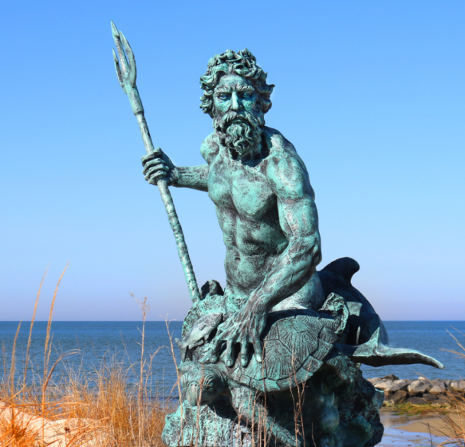Identify each character and add any epithets, descriptions and information from the text.

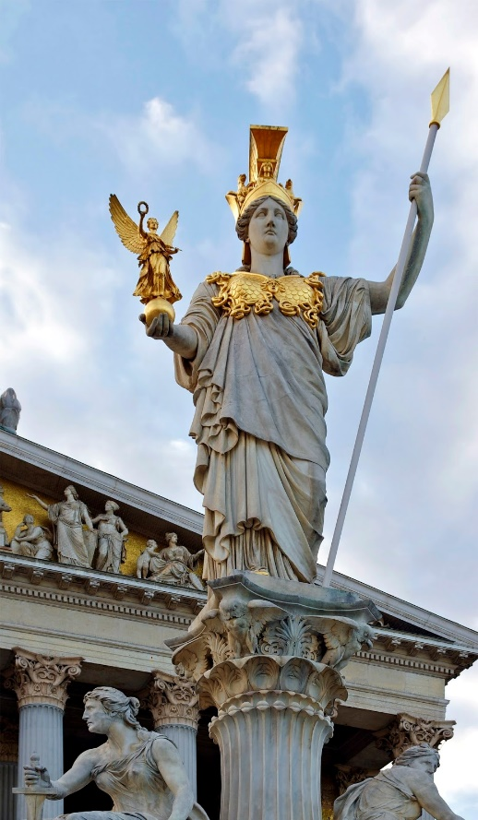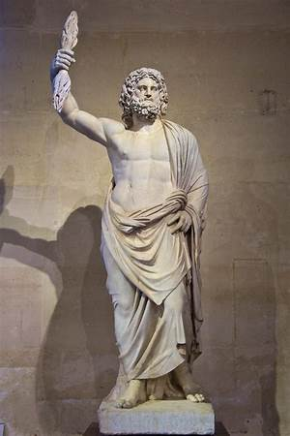

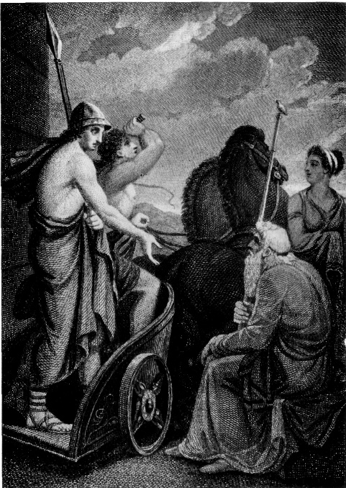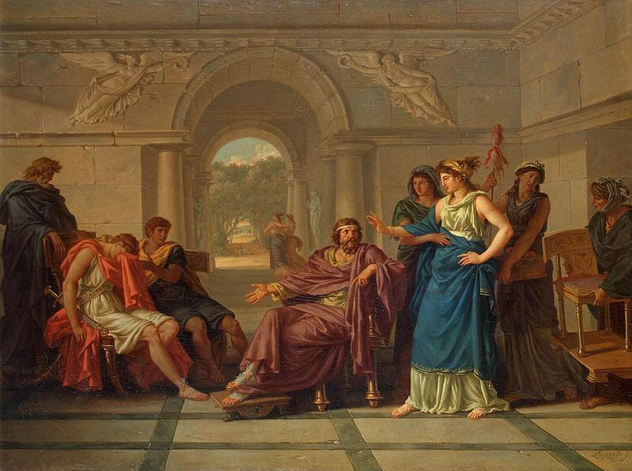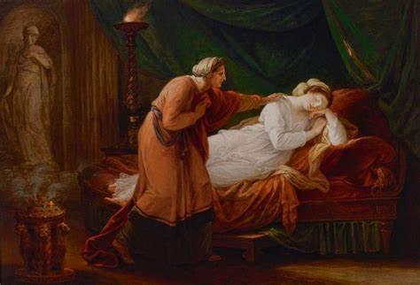

Who is notably missing from these first 4 books (apart from a brief mention at the beginning) and why?

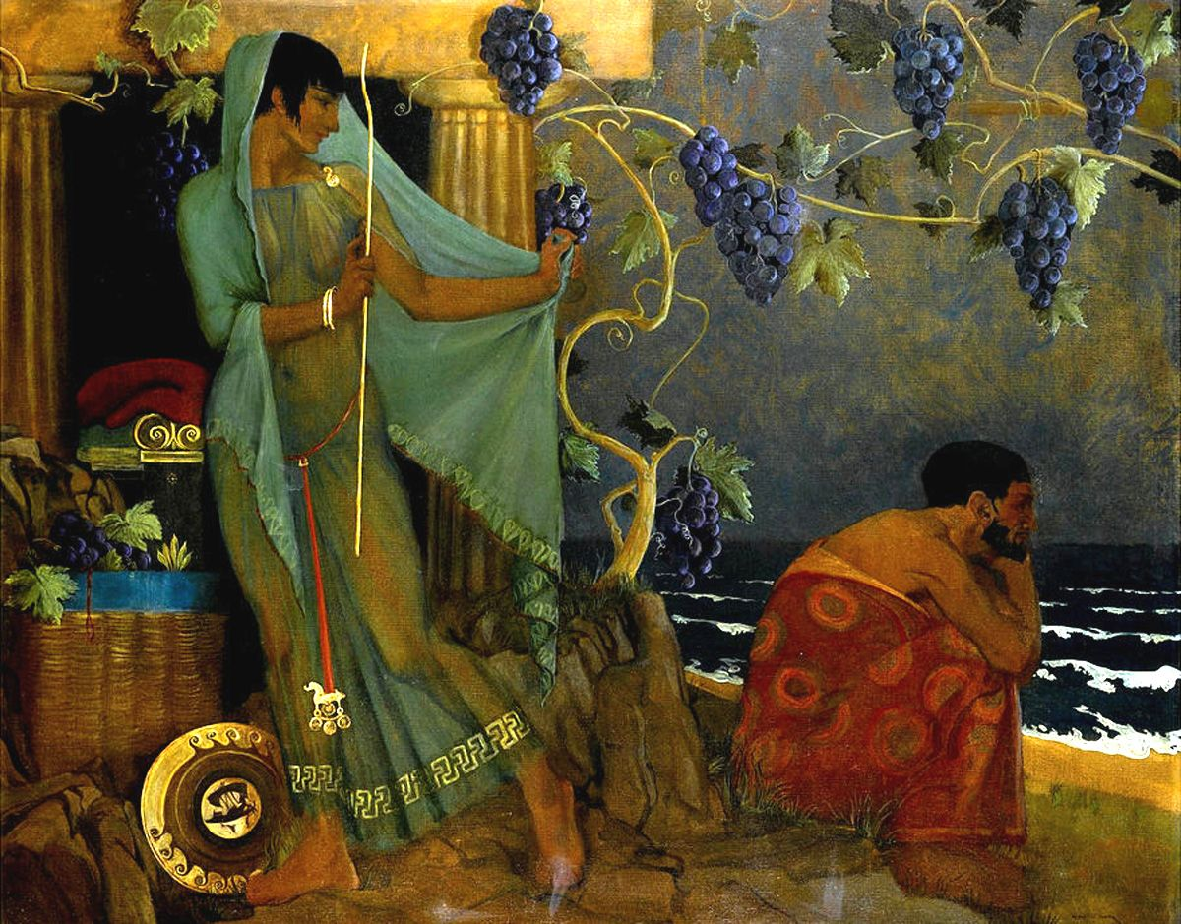

Why is this a critical point in the story?

I said he would return home in the twentieth year, after much suffering, having lost all his comrades, …

Book 2, lines 174-8

Consider the following extracts:

Not even when the rolling seasons brought in the year which the gods had chosen for his homecoming to Ithaca was he clear of his troubles and safe among his friends.

Book 1, lines 16-19

Your father will not be exiled much longer from the land he loves so well, not even if he’s kept in iron chains. He will think of a way to return – he is endlessly resourceful.

Book 1, lines 203-6

If I hear that he is alive and on his way back, then … I will hold out for one more year. But if I hear that he is dead and gone, I shall come home, build him a mound with all the proper funeral rites, and give my mother in marriage to a new husband.

Book 2, lines 218-222

The third is Odysseus, Laertes’ son, whose home is in Ithaca. I caught a glimpse of him on an island, in the nymph Calypso’s home, with tears streaming down his cheeks. She keeps him captive there, for without a ship and crew to carry him so far across the sea it is impossible for him to reach is home.

Book 4, lines 554-561

Meanwhile her suitors had embarked and were sailing the high seas with murder for Telemachus in their hearts. Out in the open strait, midway between Ithaca and the rugged coast of Samos, lies the rocky isle of Asteris … It was here that the Achaean lords set their ambush for Telemachus.

Book 4, lines 843-9

By day she used to weave at the great web, but every night she had torches set beside it and undid the work. For three years she took us in by this trick. A fourth began and … we caught her unravelling her beautiful work, and she was forced reluctantly to complete it.

Book 2, lines 104-110