GCSE Religious Studies



# Paper 2: Thematic Studies

# The Existence of God and Revelation

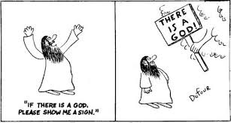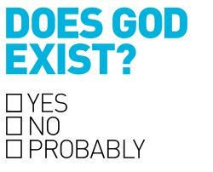





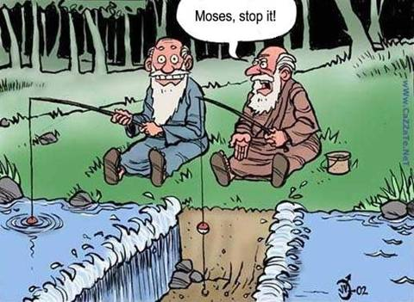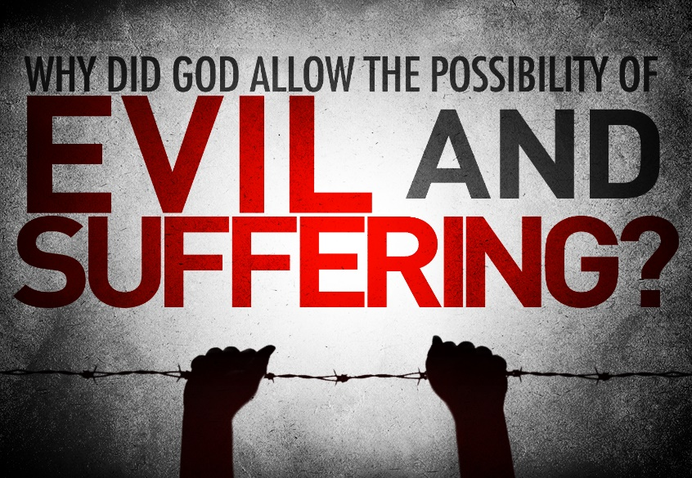

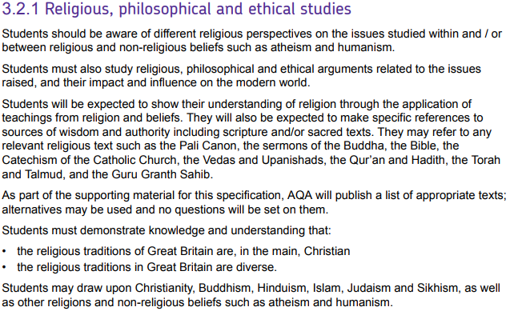

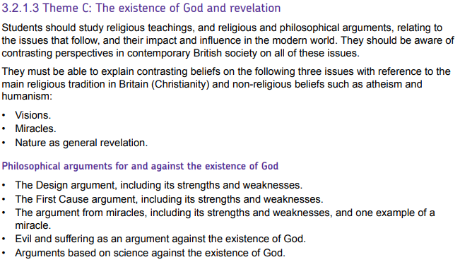

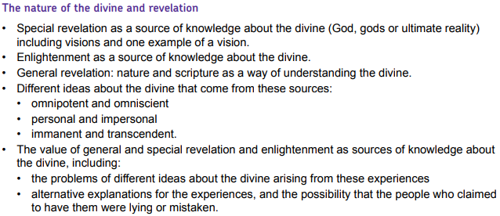

|  |  |
| --- | --- |
| **Key Term** | **Definition** |
| **Agnostic** | A person who is unsure whether God exists. |
| **Atheist** | A person who believes there is no God. |
| **Creation** | The act by which God brought about the universe. |
| **Divine** | God or something ‘of God’. |
| **Enlightenment** | The gaining of true knowledge about ultimate reality. |
| **Eternal** | Without beginning or end. |
| **Faith** | A commitment to something that goes beyond proof and knowledge. |
| **General revelation** | God making himself known through ordinary experience. |
| **Immanent** | Being present in and involved with life on Earth. |
| **Miracle** | An event performed by God; an event which breaks the laws of nature. |
| **Nature** | The physical world. |
| **Omni-benevolent** | All-loving |
| **Omnipotent** | All-powerful |
| **Omniscient** | All-knowing |
| **Personal** | Being an individual with whom people are able to have a relationship. |
| **Proof** | Evidence or argument establishing a fact or the truth. |
| **Revelation** | God making himself known to humanity. |
| **Scriptures** | The sacred writings of a religion. |
| **Special revelation** | God making himself known directly through personal experience or an unusual event. |
| **Theist** | A person who believes God exists. |
| **Transcendent** | Being outside of the universe. |
| **Ultimate reality** | The supreme, final, fundamental power in all reality |
| **Vision** | Seeing something, sometimes in a dream, that shows something about the nature of God or the afterlife. |



What is God like?

Among the world’s major religions, there are common themes regarding the nature of God. This gives us a clear concept of what we mean by the term ‘God’, a concept that is shared even by those who believe that such a God does not actually exist:

}

*“There is no one like you, Lord, there is no God but you.”* (Bible)

*“There is only one God.”* (Guru Granth Sahib)

*“He is God the One God.”* (Qur’an)

}

*“The Lord is the everlasting God.”* (Bible)

“God*the*Eternal*; He does not give birth, nor was He born.”* (Qur’an)

}

“[God is] *the Creator of the ends of the earth.”* (Bible)

*“God is the Creator of everything.”* (Qur’an)

}

*“God is spirit.”* (Bible)

*“He is formless, the all-pervading spirit.”* (Guru Granth Sahib)

}

*“God is love.”* (Bible)

*“In the name of God, the Merciful, the Compassionate.”* (Qur’an)

*“He is Merciful, Kind and Compassionate.”* (Guru Granth Sahib)

}

*“The eyes of the Lord are everywhere.”* (Bible)

*“Great is our Lord; his understanding has no limit.”* (Old Testament – Bible)

*“He is the Knower of the unseen and the visible.”* (Qur’an)

}

*“I am God the Almighty.”* Old Testament – (Bible)

*“Allah is able to do all things.”* (Qur’an)

Despite these common beliefs, religions and religious thinkers often do have different ideas about God:

An **immanent** God is present in the universe and involved with life on earth.

A **transcendent** God is beyond and outside the universe.

A **personal** God loves and cares about humans and it is possible to engage in a *relationship* with God.

An **impersonal** God is detached from humans and is more like a force than an entity that we can understand.

**Christians believe God to be immanent, transcendent and personal.**

Notes:

Can we speak meaningfully about God?

Can God be immanent and transcendent?

Arguments for the Existence of God



First Cause (Cosmological) Argument

Thomas Aquinas put forward a Cosmological Argument. He argued:

P1) Everything that begins to exist must have a cause since nothing can cause itself.

P2) There cannot be an infinite regress of causes and events.

________________________

P3) Therefore, there must have been a beginning to the chain of events.

P4) This first event must have had a cause (see P1).

________________________

C) There must exist a first, uncaused cause, which exists outside of the chain.

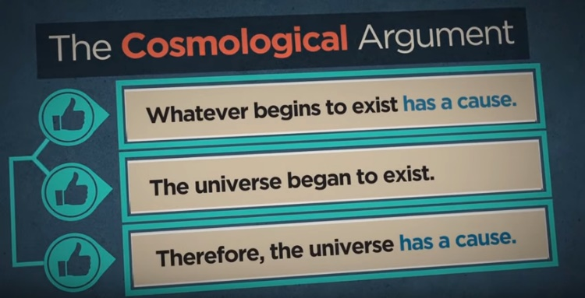This argument is sometimes simplified into what is often known as the **Kalām Cosmological Argument** (see right).

In both forms of the argument, believers argue that the cause of the universe should be understood as God.

Strengths

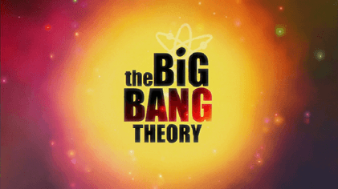

**The Big Bang theory** is the dominant scientific explanation of the origin of the universe. According to this theory, the universe began 13.7 billion years ago in a rapid explosion of all matter from a single point.

Many people assume the Big Bang theory would render the need for a creator unnecessary but, in fact, it supports the first cause argument as it confirms P3) of Aquinas’ argument. Scientists had previously believed in the **steady state theory** of the universe in which the universe had always existed. However, this was discredited by Georges Lemaitre, a Catholic priest, who first formulated what has become known as the Big Bang theory.

Many philosophers have tried to demonstrate the truth of Aquinas’ P2) using examples such as the following, put forward by Hamza Tzortzis:

*“Say you have an infinite number of balls, if I take 2 balls away, how many do you have left? Infinity. Does that make sense? Well, there should be two less than infinity, and if there is, then we should be able to count how many balls you have. But this is impossible, because the infinite is just an idea and doesn’t exist in the real world.”*

Weaknesses

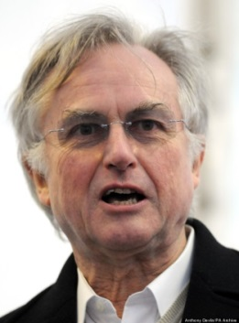

*“The cosmological argument claims that everything has a cause and then relies upon the idea of using God to stop a never-ending chain of causes. Who says God shouldn’t have a cause as well?”*

**Richard Dawkins**

---------------------------------------------------------------------------------------

The Big Crunch Theory

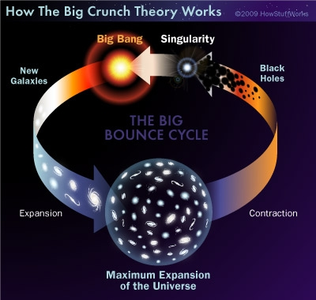

---------------------------------------------------------------------------------------



---------------------------------------------------------------------------------------

**Christopher Hitchens**

*“You may wish to be a deist, which is to say that there must be some sort of first cause for the universe. But, in order to prove that this being is God, you need to be able to show that this being is omnipotent, omniscient, benevolent. And not only are you required to show that this being has these characteristics, you need further show that this ‘god’ cares about you, knows who you are, minds what you do, answers your prayers, minds what holy days you observe, minds what you eat, all your work is still ahead of you – and good luck! There's no one who can move from the first position to the second [from deism to theism].”*

The Design (Teleological) Argument

The word ‘teleological’ is derived from the Greek word ‘telos’ which means purpose. Teleological arguments make the case that the apparent purpose that we see in the world demonstrate that there must be a designer.

Paley’s Analogy of the Watch

William Paley asks us to imagine discovering a rock and a pocket watch in an uninhabited place. Even if we knew nothing else about these objects, Paley claims that:

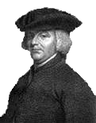

*“If you came upon a stone in an uninhabited place, you could reasonably say that it had been there since the beginning of time.”*

*******“If you came upon a pocket watch in an uninhabited place, you could not say that it had come to be there by chance.* ***The complexity of its mechanism would make you say it had a designer.****”*

Paley argues that the complexity of the watch, even if we did not know its function, would show that it had deliberately put together for a purpose. Purpose cannot simply arise by chance, it must come from the **intention** of a **designer**. Therefore, due to the complexity and apparent purpose of the watch, there must also have been a watch-maker, a designer.

Paley then argues that the universe is analogous to the watch. There are countless examples in the universe of incredibly complex things that are just right for their purpose. For examples, birds’ wings for flight, fish’s gills for breathing, the human eye for seeing. All of these things are extraordinarily intricate and, just like the watch, cannot have come to be that way by chance. Therefore, the universe must have been designed by a designer: God.

----------------------------------------------------------------------------------------------------------------------------------

Evaluation of the Teleological Argument

Weakness – The laryngeal nerve

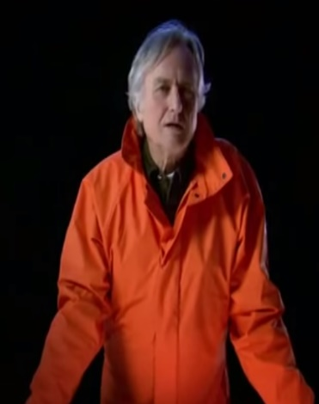The laryngeal nerve connects the brain to the larynx (voicebox). Although the voice box is positioned in the throat, usually only a few inches from the brain, the nerve takes a long, circuitous route from the brain, all the way down, around the heart, and then back up to the voicebox. This becomes exaggerated in a giraffe: a nerve that need only be a few inches long is actually over 15ft long.

Richard Dawkins believes this is strong evidence against a designer God. The laryngeal nerve, he says, makes:

*“A ridiculous detour, no intelligent designer would ever make a mistake like that.”*

Weakness – Mount Improbable

Complex life

Richard Dawkins uses his analogy of Mount Improbable to argue that a belief in a designer is an unnecessary for explaining complex life.

**Evolution**

Chance

OR

Design

Dawkins agrees that the idea that complex life could not have arisen through chance but argues that the idea of design is equally unlikely. He equates this to: *“leaping up a sheer cliff in a single bound: utterly out of the question”.*

Simple life

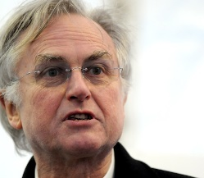

Dawkins claims that the *“gradual slope of evolution”* is a *“much more elegant”* explanation of the complexity of life. This, Dawkins argues, makes the belief in a designer God completely redundant: *“It is self-evidently futile to invent an improbable God to explain the improbability of complex life.”*

Response to Dawkins’ Mount Improbable

Many design argument advocates, such as William Dembski, respond to Dawkins’

claim that evolution makes a designer God unnecessary by pointing out that the

building blocks of evolution is DNA. People like Dembski point out that:

*“There is no entity in the known universe that efficiently stores and processes more*

*information than the DNA molecule.”*

To return to Paley’s argument therefore, DNA is incredibly complex and therefore

requires a designer. Evolution cannot explain DNA since evolution ***relies*** upon DNA.

----------------------------------------------------------------------------------------------------------------------------------

John Stuart Mill - *“Either there is no God or there exists an incompetent or immoral god"*

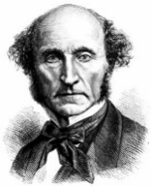Mill points out the great injustices that are present in nature. If God designed the natural order, He must have designed the atrocities that humans and animals go through as a result of natural forces. Mill concludes therefore that a designer of the world that we inhabit must either be *“an incompetent or immoral god.”*

The Planetary Fine-Tuning Argument

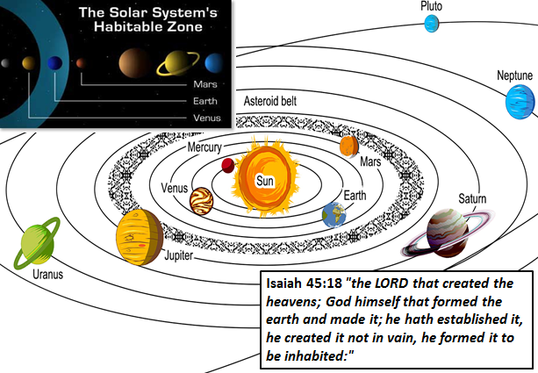Earth exists in what is known as the Habitable Zone (sometimes called the Goldilocks Zone), named as such because it is just the right distance from the sun to be able to support life.

Our best current estimates are that there are 700,000,000,000,000,000,000 (700 quintillion) known planets and none, other than Earth, are capable of supporting life because they are too hot, too cold, or their orbit is not circular enough to have a stable temperature.

However, many have pointed out that the sheer number of planets makes the chances of at least one existing in a habitable zone, not all that unlikely.

The quotation from the book of Isaiah supports that view that God must have intentionally created the Earth in this zone because is simply too unlikely to have happened by chance.

----------------------------------------------------------------------------------------------------------------------------------

The Fine-Tuning of the Universe Argument

Richard Swinburne makes the fine-tuning argument by positing a card shuffling machine. He asks us to imagine that we are presented with a machine that randomly shuffles cards. Unless the first four cards the machine deals out are the four Aces, the machine explodes killing you instantly.

**= 1/270,725**

If, he argues, the machine does then deal out the four Aces, the reasonable response would be to think the machine has been fixed in some way since it would be too lucky to believe this would have happened through chance alone.

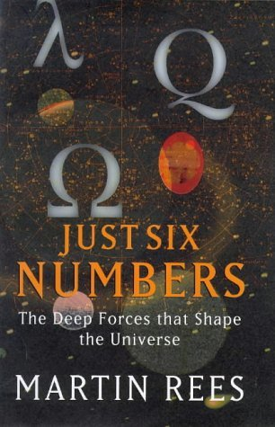The Astronomer Royal, Martin Rees, has discovered that life on Earth is extraordinarily finely tuned and that if any of the fundamental constants in the universe were changed even slightly, there could be no life sustaining universe.

One of the most striking examples is that of the cosmological constant which is finely tuned to 1:10120.

Philosophers like Swinburne therefore have argued that it is unreasonable to think that the universe would be this way by chance. Instead, it is argued, the evidence of modern physics points towards a designer God who has finely tuned the universe to sustain life.

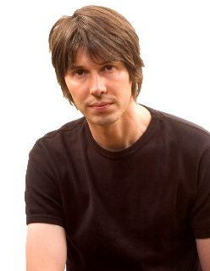 Evaluation of the Fine-Tuning Argument

Physicist Brian Cox believes there may be another explanation for the fine tuning of the universe. The theory of inflation suggests that in fact there are many universes, all with different constants.

If there are many universes, it makes it more and more likely there will be a universe with life-permitting conditions.

Although the Multiverse theory is gaining a lot of support in the scientific community, Martin Rees has conceded that:

*“The multiverse theory is plainly still no more than a tentative hypothesis.”*

Philosopher William Lane Craig believes we should apply the principle of Ockham’s Razor when considering the multiverse theory as an explanation of the fine tuning of the universe. Ockham’s Razor states that *“all else being equal, the explanation that makes the fewest assumptions is the best.”* Craig argues therefore that

*“It seems that to abolish one unobservable God, it takes an infinite number of unobservable substitutes.”*

The Argument from Miracles

There is no agreement on how a miracle should be defined. The common theme though is that a miracle involves the intervention in the world by God.

Thomas Aquinas defined a miracle as:

*“Those things which are done by*

*divine power apart from the order generally followed in things”*

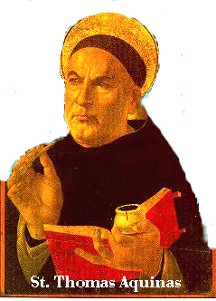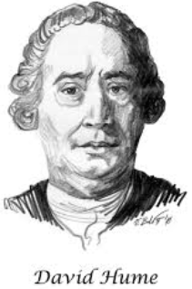David Hume defined a miracle as:

*“a transgression of a law of nature*

*by the particular volition of a deity.”*

Examples: Examples:

The argument from miracles is very straightforward. If an amazing event occurs, especially if there is no scientific explanation, it is reasonable to conclude that the event must due to supernatural, that is, caused by something transcendent, beyond nature. Only God fits this description and therefore miracles demonstrate God exists.

Miracles are a crucial aspect of Christianity, most notably the key event of Jesus’ resurrection. Miracles help bring people to faith and strengthen people’s faith by demonstrating the presence, power and love of God. In fact, the words used in the Bible to describe miracles can be translated a ‘sign’. In the case of the miracles performed by Jesus, they show us that he truly was divine:

*“The miracles I perform in my Father’s name speak for me... even though you do not believe me, believe the miracles, that you may know and understand that the Father is in me and I in the Father.”*

Evaluation of Miracles

|  |  |
| --- | --- |
| Strengths | Weaknesses |
| *“All things are possible with God.”* **Mark 9:23 (Bible)**  *“If God exists then it is only natural that he would want to make himself known to us through miracles.”* **Richard Swinburne**  *“Miracles are God’s way of showing us that He is there. If they were happening all the time then people would think they were normal and it wouldn’t make people believe.”* **Richard Harries** | *“Belief in miracles is flat contradictory, not just to the facts of science but the spirit of science.”* **Richard Dawkins**  *“Extraordinary claims require extraordinary evidence.”* **Carl Sagan**  *“Miracles are observed chiefly to abound among ignorant and barbarous nations; or if a civilized people has ever given admission to any of them, that people will be found to have received them from ignorant and barbarous ancestors.”* **David Hume**  *“Whenever you think you see a miracle you must ask yourself a simple question; What is more likely: that the laws of nature have just been suspended in my favour, or that I have made a mistake?”* **Christopher Hitchens** |

Revelation

As discussed on page 4, many religions share ideas about an **ultimate reality** that is **unchanging** and **eternal**.

Some believe that we cannot understand or even describe this ultimate reality because God is transcendent and beyond human comprehension.

Others believe that while we may not ever fully understand God, we can gain some insight into His nature through **revelation:**

 *“For now we see through a glass, darkly; but then face to face: now I know in part; but then shall I know as fully as I am known.”* **1 Corinthians 13:12**

Special Revelation

Special revelation is when people experience God in a particular event, sometimes referred to as a religious experience. It might be in the form of a dream, a **vision**, a prophecy, a miracle, ‘hearing God’s call’, or some other direct experience of God.

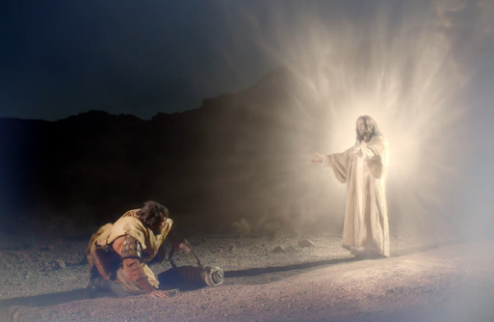

Visions

There are many examples of visions in the Bible. Perhaps the most famous is of Saul of Tarsus, a devout Jew who was a zealous persecutor of Christians. When travelling towards Damascus to arrest Christians, Saul received a vision of Jesus which completely changed his life. He became known as the apostle Paul and lived the rest of his life in total commitment to Christianity, even writing much of the New Testament.

Many people take these kinds of revelation to be good reasons for believing in God. In its simplest form, the argument is as follows:

P1) Experiencing something indicates that something is real.

P2) People have experienced God.

____________

C) God is real.

Evaluation of Special Revelation

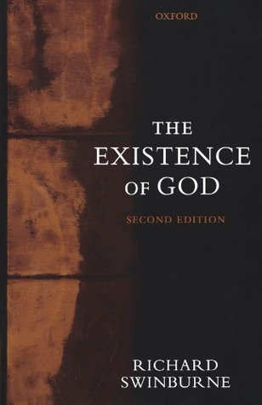*“I suggest that the overwhelming testimony of so many millions of people to occasional experience of God must, in the absence of counter-evidence, be taken as tipping the balance of evidence decisively in favour of God’s existence.”* **Richard Swinburne**

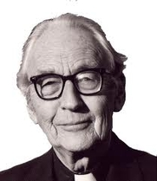----------------------------------------------------------------------------------------------------------------------------------

*“The validity of the experience is borne out in the records of the life of those who have them.”* **Frederick Copleston**

----------------------------------------------------------------------------------------------------------------------------------

 *“Only after 13 years of examination by a commission comprised of clergy, physicians and scientists did the Catholic Church pronounce the Fatima apparitions as worthy of belief...some would still question their authenticity.”* **Peter Cole**

----------------------------------------------------------------------------------------------------------------------------------

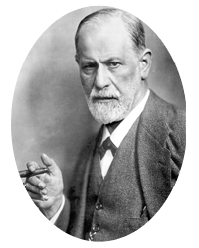*“Religious experience is an illusion and it derives its strength from the fact that it falls in with our instinctual desires.”* **Sigmund Freud**

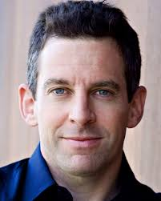----------------------------------------------------------------------------------------------------------------------------------

*“If the experiences of Buddhists are true, Christianity and Islam are absolutely false.”* **Sam Harris**

Jesus as revelation

For Christians, the clearest revelation of God’s nature is in the person of Jesus. (See page 12 of Christian Beliefs and Teachings booklet)

Enlightenment

Buddhists do not believe in God or Gods but do believe in revelation of the ultimate reality. Through living the Buddhist life and practicing meditation, Buddhists seek to rid themselves of their wrong perceptions of the world and become aware of what is ultimately true. This kind of revelation is known as **enlightenment.**

Even before achieving a state of full **enlightenment** or Nirvana, Buddhists may experience glimpses of this ultimate reality during meditation.

General Revelation

For those who do not receive a direct, personal message from God (a **special revelation**), they can come to know God through **general revelation**, that is, ordinary, everyday human experiences. Examples of general revelation include knowing God’s presence:

* in nature.
* through reason.
* in their conscience.
* through their sense of right and wrong.

These kinds of revelation are known as general because they are experiences that are available to everyone.

**Psalm 19:1-4**

***1****The heavens declare the glory of God;  
    the skies proclaim the work of his hands.****2****Day after day they pour forth speech;  
    night after night they reveal knowledge.****3****They have no speech, they use no words;  
    no sound is heard from them.****4****Yet their voice goes out into all the earth,  
    their words to the ends of the world.*

Nature as general revelation

Many believe that God is revealed through the beauty and order of the natural world. This is sometimes referred to as the **aesthetic argument** for the existence of God.

Richard Swinburne makes the case that there would be no reason for the world to be beautiful if there were no God and the fact of the extraordinary beauty in the world is evidence that a God has created it that way:

*“If there is a God, there is more reason to expect a beautiful world than an ugly one. There is no particular reason for expecting a beautiful rather than an ugly world. In consequence, if the world is beautiful, that fact would be evidence for God's existence.”*

Christians also believe that the wonder of creation gives an insight into what the creator is like, just as a painting gives an insight into the artist. They believe that the world shows God to be, as well as other things, creative and powerful.

Scripture as a way of understanding God

Religious scriptures tell what God is like (see page 4), how God has acted in the past, and how God wants people to live. The Bible is an extensive collection of writings containing poetry, myth, history, law, letters and prophecy which contain revelations about God.

Although not all Christians interpret the Bible in the same way (see pages 4&5 of the Religion and Life booklet for examples), they do believe the Bible to be in some way **inspired** by God and therefore very useful for revealing truths about the divine.

Arguments Against the Existence of God

Problem of Evil and Suffering

J. L. Mackie proposed what he called the ‘inconsistent triad’.

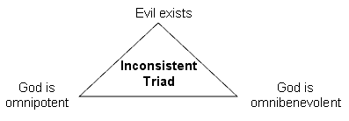

Moral Evil: Suffering caused by humans

Natural Evil: Suffering not caused by humans

{

Mackie contends that only two of these sides can be true at once:

* If God were **omnibenevolent** He would **want** a world without evil.
* If God were **omnipotent** He **could create** a world without evil.
* Therefore, if God were both omnibenevolent AND omnipotent, there would be a world without evil.
* However, evil exists.
* Therefore, God cannot be both omnipotent and omnibenevolent. This contradicts the Christian concept of God.

**(Refer to pages 8 & 9 in your Christian Beliefs and Teachings booklet for religious responses to this problem)**

Science should replace religion

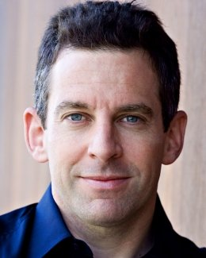

*“It is time that we admitted that faith is nothing more than the license religious people give one another to keep believing when reasons fail.”*

*“The core of science is not a mathematical modelling--it is intellectual honesty. It is a willingness to have our certainties about the world constrained by good evidence and good argument.”*

**Sam Harris**



# *“Religious believers eagerly seek a gap in present-day knowledge or understanding. If an apparent gap is found, it is assumed that God, by default, must fill it.”* Richard Dawkins

Response: Religion and Science are non-overlapping magisteria (NOMA)

*"Science tries to document the factual character of the natural world, and to develop theories that coordinate and explain these facts. Religion, on the other hand, operates in the equally important, but utterly different, realm of human purposes, meanings, and values—subjects that the factual domain of science might illuminate, but can never resolve."*

**Stephen J. Gould**

*“Science without religion is lame; religion without science is blind."*

**Albert Einstein**

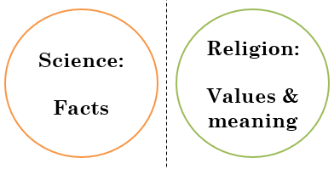

Possible exam questions

Question 1: (1 mark)

1) Which term best expresses the idea that the divine (God, gods or ultimate reality) is beyond this world?

1) What word means someone who believes there is no God?

1) What does the word ‘omniscient’ mean?

Question 2: (2 marks)

2) Give two types of general revelation.

2) Give two weaknesses of the First Cause argument for God’s existence.

2) Give two arguments against the existence of God.

Question 3: (4 marks)

3) Explain two contrasting beliefs in contemporary British society about visions.

3) Explain two contrasting religious beliefs about scripture as a way of understanding the divine.

3) Explain two contrasting arguments in contemporary British society about the existence of God.

Question 4: 5 marks

**You must** refer to scripture or sacred writings in your answer.

4) Explain two religious beliefs about miracles.

4) Explain two religious beliefs about the nature of the divine.

4) Explain two religious beliefs about special revelation.

Question 5: (12 marks)

Evaluate the statement. In your answer you should:

• refer to Christian teaching

• give developed arguments to support this statement

• give developed arguments to support a different point of view

• reach a justified conclusion.

5) ‘Without scriptures, Christians would know very little about God.’

5) ‘‘The design argument proves that God exists.’

5) ‘‘Those who claim to have special revelations are mistaken.’