Gateways School

**Organic analysis**

**Revision PPQ**

40 marks

**Name: ______________________________ Date: __________**

**Q1.**

(a)     Alcohols can be classed as primary, secondary or tertiary. Draw possible structures for a primary, a secondary and a tertiary alcohol which have the molecular formula C4H8O.  
Which of the structures you have drawn cannot be oxidised by potassium dichromate in acid solution?

___________________________________________________________________

___________________________________________________________________

___________________________________________________________________

___________________________________________________________________

___________________________________________________________________

___________________________________________________________________

___________________________________________________________________

___________________________________________________________________

**(4)**

(b)     Explain what is meant by the fingerprint region of an infra-red spectrum. State how it is used to confirm the identity of organic molecules such as the primary, secondary and tertiary alcohols of molecular formula C4H8O.

___________________________________________________________________

___________________________________________________________________

___________________________________________________________________

___________________________________________________________________

**(2)**

(c)     Each of the parts below concerns a different pair of isomers. Deduce one possible structural formula for each of the species **A** to **F**. Use, where appropriate, the table of infra-red absorption data given on the data sheet.

(i)      **A** and **B** have the molecular formula C3H8O. **A** has a broad absorption band at 3300 cm–1 in its infra-red spectrum, but **B** does not.

______________________________________________________________

______________________________________________________________

______________________________________________________________

______________________________________________________________

**(2)**

(ii)     **C** and **D** have the molecular formula C5H10. **C** has a weak absorption band at 1650 cm–1 in its infra-red spectrum, but **D** does not.

______________________________________________________________

______________________________________________________________

______________________________________________________________

______________________________________________________________

**(2)**

(iii)     **E** and **F** have the molecular formula C3H6O and both have strong absorption bands at about 1700 cm–1 in their infra-red spectra. **E** reacts with Tollens’ reagent but **F** does not.

______________________________________________________________

______________________________________________________________

______________________________________________________________

______________________________________________________________

**(2)**

**(Total 12 marks)**

**Q2.**

Butan-2-ol can be oxidised by acidified potassium dichromate(VI) to form butanone as shown by the following equation.

CH3CH2CH(OH)CH3   +   [O]   →   CH3CH2COCH3   +   H2O

(a)     State the class of alcohol to which butan-2-ol belongs.

___________________________________________________________________

**(1)**

(b)     The infrared spectrum shown below is either that of butan-2-ol or that of butanone.

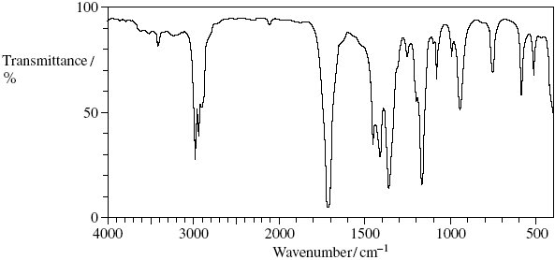

Identify the compound to which this infrared spectrum refers.

Explain your answer.

You may find it helpful to refer to the table of infrared absorption data on the back of the Periodic Table (**Table 1**).

Identity of the compound _______________________________________________

Explanation _________________________________________________________

___________________________________________________________________

___________________________________________________________________

**(3)**

(c)     Draw the displayed formula of the alcohol C4H9OH which is resistant to oxidation by acidified potassium dichromate(VI).

___________________________________________________________________

**(1)**

**(Total 5 marks)**

**Q3.**

A student used the infrared spectra of water vapour and of carbon dioxide to try to find a link between infrared radiation and global warming.

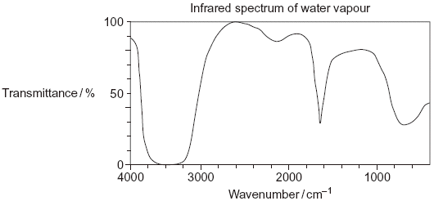

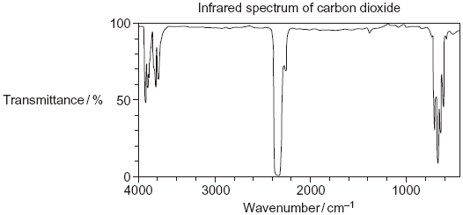

(i)      Use information from the infrared spectra to deduce **one** reason why the student concluded that water vapour is a more effective greenhouse gas than carbon dioxide.

___________________________________________________________________

___________________________________________________________________

**(1)**

(ii)      Use your knowledge of the bonds in CO2 to state why the infrared spectrum of carbon dioxide is **not** as might be predicted from the data provided in **Table 1** on the Data Sheet.

___________________________________________________________________

___________________________________________________________________

___________________________________________________________________

___________________________________________________________________

**(2)**

**(Total 3 marks)**

**Q4.**

(a)     Propanoic acid can be made from propan-1-ol by oxidation using acidified potassium dichromate(VI). Propanal is formed as an intermediate during this oxidation.

(i)      State the colour of the chromium species after the potassium dichromate(VI) has reacted.

______________________________________________________________

**(1)**

(ii)     Describe the experimental conditions and the practical method used to ensure that the acid is obtained in a high yield. Draw a diagram of the assembled apparatus you would use.

Conditions _____________________________________________________

______________________________________________________________

Apparatus

**(4)**

(iii)    Describe the different experimental conditions necessary to produce propanal in high yield rather than propanoic acid.

______________________________________________________________

______________________________________________________________

**(2)**

(b)     Propan-1-ol is a volatile, flammable liquid.   
Give **one** safety precaution that should be used during the reaction to minimise this hazard.

___________________________________________________________________

**(1)**

(c)     A student followed the progress of the oxidation of propan-1-ol to propanoic acid by extracting the organic compounds from one sample of reaction mixture.

(i)      Give a chemical reagent which would enable the student to confirm the presence of propanal in the extracted compounds.   
State what you would observe when propanal reacts with this reagent.

Reagent _______________________________________________________

Observation ____________________________________________________

______________________________________________________________

**(2)**

(ii)     Give a chemical reagent that would enable the student to confirm the presence of propanoic acid in the extracted compounds.   
State what you would observe when propanoic acid reacts with this reagent.

Reagent _______________________________________________________

Observation ____________________________________________________

______________________________________________________________

**(2)**

(d)     Predict which **one** of the compounds, propan-1-ol, propanal and propanoic acid will have the highest boiling point. Explain your answer.

Prediction __________________________________________________________

Explanation _________________________________________________________

___________________________________________________________________

___________________________________________________________________

___________________________________________________________________

___________________________________________________________________

**(3)**

**(Total 15 marks)**

**Q5.**

A sample of 2-methylpropan-2-ol was contaminated with butan-2-ol. The student separated the two alcohols using chromatography.

Identify a reagent or combination of reagents that the student could use to distinguish between these alcohols. State what would be observed for each alcohol.

Reagent(s) _____________________________________________________________

Observation with 2-methylpropan-2-ol ________________________________________

_______________________________________________________________________

_______________________________________________________________________

Observation with butan-2-ol ________________________________________________

_______________________________________________________________________

_______________________________________________________________________

**(Total 3 marks)**

**Q6.**

Which one of the following mechanisms is **not** involved in the reaction sequence below?

CH3CH3 → CH3CH2Cl → CH3CH2OH → CH2=CH2 → CH3CH2Br

**A**       electrophilic addition

**B**       electrophilic substitution

**C**       nucleophilic substitution

**D**       free-radical substitution

**(Total 1 mark)**

**Q7.**

Which one of the following statements about but-2-enal, CH3CH=CHCHO, is **not** true?

**A**       It has stereoisomers.

**B**       It shows a strong absorption in the infra-red at about 1700 cm−1.

**C**       It will turn an acidified solution of potassium dichromate(VI) green.

**D**       It can be dehydrated by concentrated sulphuric acid.

**(Total 1 mark)**