

**Higher IGCSE (9 – 1) Revision Pack**

**Limits of Accuracy (Bounds)**

**Name --------------------------------**

**Questions**

**Q1.**

(a) Correct to the nearest millimetre, the length of a side of a regular hexagon is 3.6 cm.

Calculate the upper bound for the perimeter of the regular hexagon.

...........................................................cm

**(2)**

(b) Correct to 1 significant figure, the area of a rectangle is 80 cm2  
Correct to 2 significant figures, the length of the rectangle is 12 cm.

Calculate the **lower bound** for the **width** of the **rectangle**.  
 Show your working clearly.

...........................................................cm

**(3)**

**(Total for question = 5 marks)**

**Q2.**



Calculate the upper bound of *x*(*y* – *z*)   
Show your working clearly.

...........................................................

**(Total for question = 3 marks)**

**Q3.**



*a* = 42 correct to 2 significant figures.   
*b* = 24 correct to 2 significant figures.   
*c* = 14 correct to 2 significant figures.

Work out the lower bound for the value of *y*.   
Give your answer correct to 2 significant figures.   
Show your working clearly.

...........................................................

**(Total for question = 3 marks)**

**Q4.**

An athlete runs 400 metres, correct to the nearest metre.   
The athlete takes 50.2 seconds, correct to the nearest 0.1 of a second.

Work out the upper bound of the athlete's average speed.   
Give your answer correct to 3 significant figures.

........................................................... m/s

**(Total for question = 3 marks)**

**Q5.**

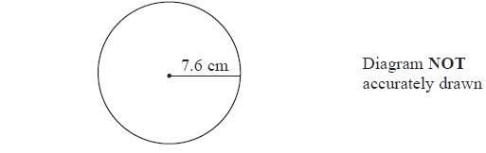

(a)   A circle has a radius of 7.6 cm.   
Work out the area of the circle.   
Give your answer correct to 3 significant figures.

........................................................... cm2

**(2)**

The radius, 7.6 cm, is correct to 1 decimal place.

(b) (i) Write down the upper bound of the radius.

........................................................... cm

(ii) Write down the lower bound of the radius.

........................................................... cm

**(2)**

**(Total for Question is 4 marks)**

**Q6.**

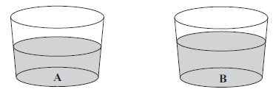

Glass **A** contains 122 millilitres of water, correct to the nearest millilitre.  
 Glass **B** contains 168 millilitres of water, correct to the nearest millilitre.

Calculate the upper bound of the difference, in millilitres, between the volume of water in  
 glass **A** and the volume of water in glass **B**.

...........................................................millilitres

**(Total for question = 2 marks)**

**Q7.**

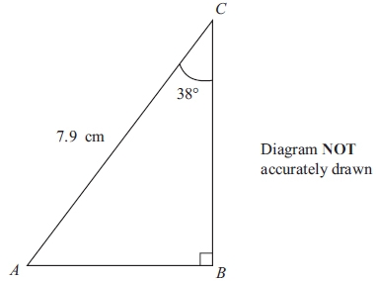

*ABC* is a triangle.  
*AC* = 7.9cm  
 Angle *B* = 90°  
 Angle *C* = 38°

(a) Calculate the length of *BC*.   
Give your answer correct to 3 significant figures.

...........................................................cm

**(3)**

(b) The size of angle *C* is 38°, correct to 2 significant figures.

(i) Write down the lower bound of the size of angle *C*.

...........................................................°

(i) Write down the upper bound of the size of angle *C*.

...........................................................°

**(2)**

**(Total for question = 5 marks)**

**Q8.**

A car travels a distance of 63.5 km, correct to the nearest 0.5 km.   
The car takes 45.8 minutes correct to 1 decimal place.

Work out the lower bound for the average speed of the car.   
Show your working clearly.   
Give your answer in km/h correct to 1 decimal place.

........................................................... km/h

**(Total for question = 4 marks)**

**Q9.**



*v* = 27.3    correct to 3 significant figures.   
*u* = 18       correct to 2 significant figures.   
*a* = 9.81    correct to 3 significant figures.

Work out the lower bound for the value of *t*.   
Show your working clearly.   
Give your answer correct to 3 significant figures.

...........................................................

**(Total for question = 3 marks)**

**Q10.**

*y* = 1.8 correct to 1 decimal place.

Calculate the lower bound for the value of 4*y* + 1

...........................................................

**(Total for question = 2 marks)**

**Q11.**

The diagram shows a solid cylinder.

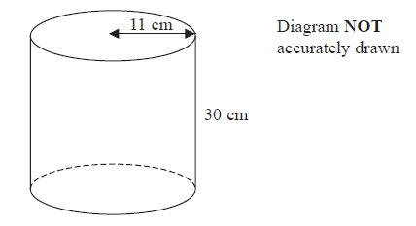

The cylinder has a height of 30 cm and a radius 11 cm.

(a)  Work out the **total** surface area of the cylinder.   
       Give your answer correct to 2 significant figures.

........................................................... cm2

**(4)**

(b)  The height of the cylinder is 30 cm, correct to the nearest centimetre.

(i)  Write down the lower bound of the height of the cylinder.

........................................................... cm

(ii)  Write down the upper bound of the height of the cylinder.

........................................................... cm

**(2)**

**(Total for question = 6 marks)**

**Q12.**

The length of a fence is 137 metres, correct to the nearest metre.

Write down

(i)  the lower bound for the length of the fence,

........................................................... metres

(ii) the upper bound for the length of the fence.

........................................................... metres

**(Total for question = 2 marks)**

**Q13.**

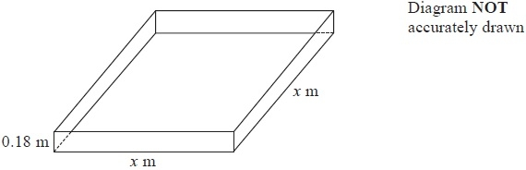

Trena wants to build a sandpit in the shape of a cuboid.   
The volume of sand in the sandpit will be 1.0 m3, correct to 1 decimal place.   
The depth of sand in the sandpit will be 0.18 metres, correct to 2 decimal places.   
The sandpit will have a square base with sides of length *x* metres.

Find the upper bound for *x*  
Give your answer correct to 3 significant figures.

upper bound = ...........................................................

**(Total for Question is 4 marks)**

**Q14.**

Correct to 2 significant figures, *a* = 58, *b* = 28 and *c* = 18

Calculate the upper bound for the value of 

Show your working clearly.

..........................................................

**(Total for question = 3 marks)**

**Q15.**

Correct to 2 decimal places, the volume of a solid cube is 42.88 cm3

Calculate the lower bound for the surface area of the cube.

...........................................................cm2

**(Total for question = 4 marks)**

**Q16.**

Rachael walks to school.   
The distance to school is 2.8 km, correct to the nearest 0.1 km.   
She walks at a speed of 5 km/h, correct to the nearest km/h.

Calculate the upper bound, in minutes, for the time Rachael takes to walk to school.

........................................................... minutes

**(Total for Question is 3 marks)**

**Q17.**

There are 1300 sheets of paper, correct to the nearest 100 sheets, in a pile.   
Each sheet is of equal thickness.   
The height of the pile is 160 mm, correct to the nearest 10 mm.

Calculate the upper bound, in millimetres, for the thickness of one sheet of paper.

........................................................... mm

**(Total for Question is 3 marks)**

**Q18.**

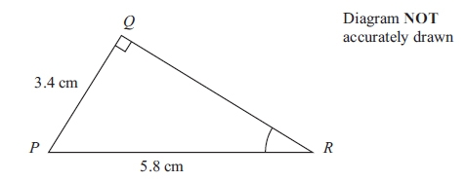

Triangle *PQR* has a right angle at *Q*.

*PQ* = 3.4 cm and *PR* = 5.8 cm.

(a) Work out the size of angle *QRP*.   
Give your answer correct to 1 decimal place.

........................................................... °

**(3)**

The length 5.8 cm, of *PR*, is correct to 2 significant figures.

(b) (i) Write down the upper bound of the length of *PR*.

........................................................... cm

(ii) Write down the lower bound of the length of *PR*.

........................................................... cm

**(2)**

**(Total for question is 5 marks)**

**Q19.**

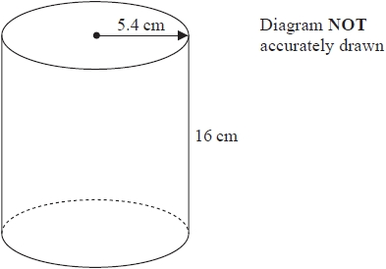

A cylinder has radius 5.4 cm and height 16 cm.

(a)  Work out the volume of the cylinder.   
Give your answer correct to the nearest whole number.

........................................................... cm3

**(2)**

The radius 5.4 cm is correct to 2 significant figures.

(b)  (i)  Write down the upper bound of the radius.

........................................................... cm

(ii)  Write down the lower bound of the radius.

........................................................... cm

**(2)**

**(Total for question = 4 marks)**

**End of questions**