**3.2.3 Group 7 – The halogens**

**AS Link:**

**3.1.1 – Atomic structure**

**3.1.3 – Bonding**

**3.1.7 – Redox**

**3.2.1 – Periodicity**

The halogens form a family of **non-metallic** elements with a well-defined trend in their properties as the relative mass increases. Halogen means ‘salt former’ because they react with many metals. They are **toxic** and have a characteristic **smell**.

They exist as **diatomic molecules**: F2**,** Cl2, Br2, I2, At2. There are **van der Waals’ forces** between the molecules. They all have a characteristic smell.

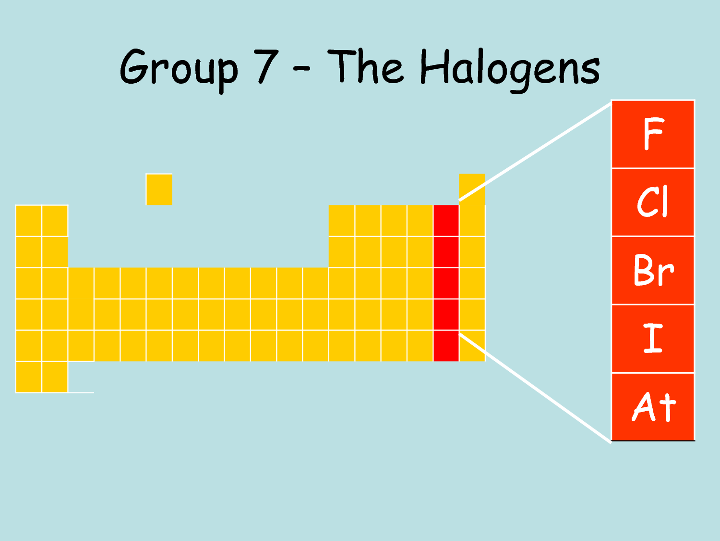

Fluorine

Fluorine has a number of **untypical properties**. This is due to the **F-F** being unexpectedly **weak** compared to the trend of the rest of the halogens. The **atom** is **small** which leads to **repulsion** between **non-bonding electrons** because they are so **close** together.

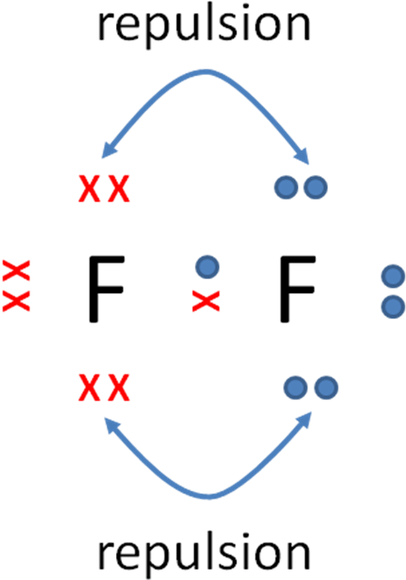

***Video clip: Halogens***

***Demo: Appearance of halogens***

**Trends in physical properties**

Electronic configuration

F 9 1s22s22p5  [He]2s22p5

Cl 17 1s22s22p63s23p5  [Ne]3s23p5

Br 35 1s22s22p63s23p63d104s24p5  [Ar]3d104s24p5

I 58 1s22s22p63s23p63d104s24p64d105s25p5  [Kr]4d105s25p5

The halogens have the following **trends going down the group**:

* **Colour** – get darker
  + Fluorine – pale yellow
  + Chlorine – pale green
  + Bromine – red-brown
  + Iodine – grey
  + Astatine – black
* **Atomic radius** – increases
  + One extra main level of elections
* **Electronegativity** – decreases
  + Electron shells increase so the shielding increases
  + Atomic radius increases
  + So the attraction to the **bonding pair in a covalent bond** decreases
* **Melting and boiling point**  – increases
  + Molecules increase in size so have more electrons making the van der Waal’s forces stronger
  + The lower the boiling point the more volatile they are
* **Physical state**  – gas to solid
  + Fluorine – gas
  + Chlorine – gas

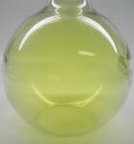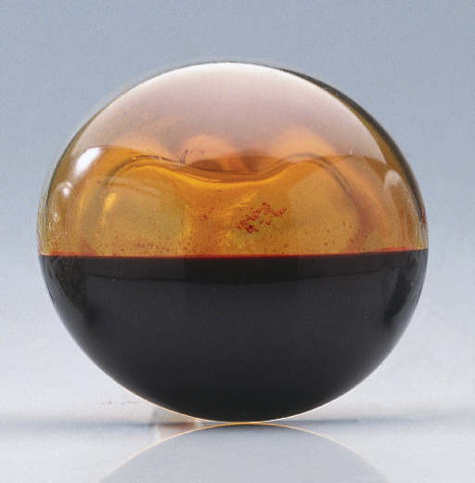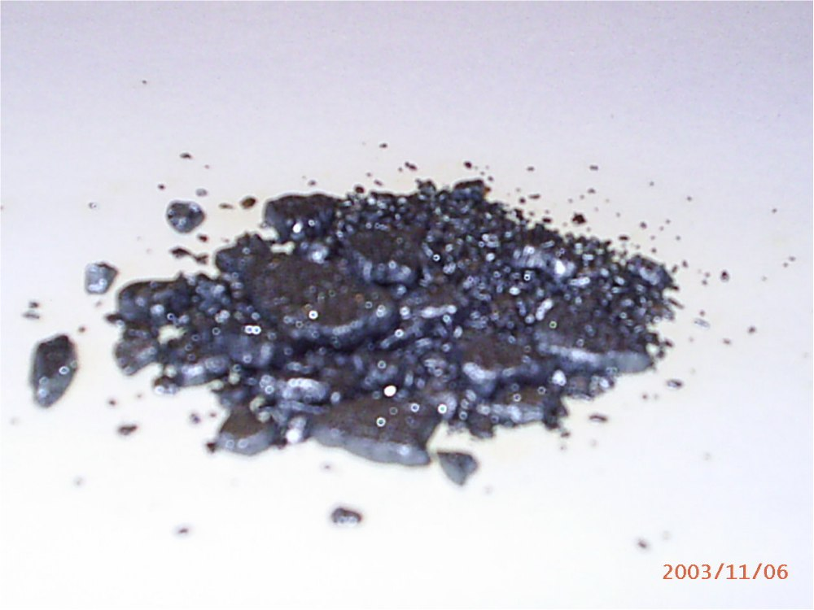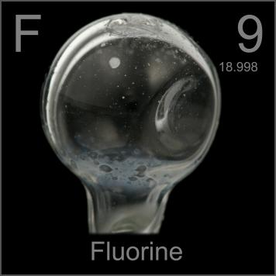

* + Bromine – liquid
  + Iodine – solid
  + Astatine – solid

**Trends in chemical properties**

Oxidising power of halogens

– the power to act as an **oxidising agent (electron acceptor)**

**Halogens** usually react by **gaining electrons** to become **negative ions**, with a charge of -1. These are redox reactions; they are **oxidising agents** and so they are **reduced**.

General equation: **X2 + 2e- → 2X-**

The trend in oxidising power is:

|  |  |
| --- | --- |
|  | **Oxidising power** of halogens **decreases down** the **group.**  Stronger oxidising agent: F2>Cl2>Br2>I2 Accepts an electron more easily  Down the group it’s **harder** to **gain an electron** as the atoms get **bigger** so the outer electrons are **further from the nucleus** and there is **more shielding**.  **So a weaker attraction for an electron.** |

Displacement reactions

Relative **oxidising strengths** can be seen in their **displacement** **reactions** with halide ions.

***Definition***: **Displacement** is when a **more reactive halogen displaces** a **less reactive halide** from its salt.

A **halogen will displace** a **halide** from solution, it will **accept an electron more easily** if it is a **stronger** **oxidising agent** (i.e. below it is the group). By adding a solution of the halogen to a solution of a halide ion a displacement reaction may take place, this is seen as a **colour change**.

*N.B. Can’t investigate fluorine in aqueous solution because it reacts with the water.*

*N.B. Iodine is almost insoluble in water, it forms a complex I3- (aq) with iodide ions.*

***Prac: Displacement of halogens***

***Sheet: Oxidising power of halogens***

***Video clip: RSC Disc 2 clip: Exciting elements – Displacement halogen with F2***

|  |  |
| --- | --- |
|  | So:   * Chlorine will **displace** **bromine** and **iodine** but not fluorine * Bromine will **displace** **iodine** but not chlorine * Iodine will **not displace** bromine or chlorine |

***Starter: 9.3.1 – Displacement reactions***

***Application: CGP161 PQ1***

***Fact recall: CGP161 Q1-4***

Application – Extraction of bromine from sea water

**Oxidation** of a **halide** **by** a **halogen** is the basis of **extracting bromine** from seawater. It contains low concentrations of **bromide ions**. The **bromine** can be extracted from it by **treating** the sea water with **chlorine**.

Cl2(aq) + 2Br-(aq) → Br2(aq) + 2Cl-(aq)

***Sheet: Extension - Bromine from seawater***

**Trends in properties halides**

Reducing power of halides

– the power to act as a **reducing agent** **(electron donor)**

**Halide ions** are **reducing agents**, **losing electrons** and so are **oxidised** **themselves** and **become halogens**.

General equation: **2X- → X2 + 2e-**

|  |  |
| --- | --- |
|  | **Reducing power** of halides **increases** **down** the **group**  Stronger reducing agent: I- > Br- > Cl-> F-  Donates an electron more easily  The **larger the ion**, the **more easily it will lose an electron** because it is lost from the **outer shell** which is **further** from the **nucleus** and there is **more shielding**.  **So a weaker attraction for an electron.** |

Reactions of solid halides with sulphuric acid

Reacting **solid sodium halides** with **conc. sulphuric acid** gives different **products** which **show** the **reducing power** of **each halide**.

Two types of reactions occur – acid-base and redox.

**Acid-base reactions**

**All halides** will **act** as **bases** when **reacted** with **acid**

General equation: **X- + H+→ HX**

**Example**

ON: -1 +6 +6 -1

NaX(s) + H2SO4(l) → NaHSO4(s) + HX(g)

*Observation: Steamy fumes*

**Redox reactions**

***Task: Which element in H2SO4 will accept electrons most readily?***

H2SO4

H +1

S +6 will attract electrons most readily – more easily reduced

O -2 won’t accept – already in noble gas configuration

Reduction products from H2SO4 have distinct observations:

SO2 (g) +4 colourless chocking gas, pungent smell

S (s) 0 yellow solid

H2S (g) -2 smell of bad eggs

Oxidation products from halides have distinct observations:

Br2 -1 orange/brown fumes

I2 -1 black solid or purple fumes

**Summary of observations:**

|  |  |  |  |
| --- | --- | --- | --- |
| **NaX** | **Observation** | **Products** | **Type of reaction** |
| NaF | Steamy fumes | HF | Acid-base (F- acting as a base) |
| NaCl | Steamy fumes | HCl | Acid-base (Cl- acting as a base) |
| NaBr | Steamy fumes | HBr | Acid-base (Br- acting as a base) |
| Pungent smell | SO2 | Redox (reduction product of H2SO4) |
| Orange/brown fumes | Br2 | Redox (oxidation product of Br-) |
| NaI | Steamy fumes | HI | Acid-base (I- acting as a base) |
| Pungent smell | SO2 | Redox (reduction product of H2SO4) |
| Yellow solid | S | Redox (reduction product of H2SO4) |
| Smell of bad eggs | H2S | Redox (reduction product of H2SO4) |
| Black solid (purple fumes) | I2 | Redox (oxidation product of I-) |

***Demo: Demonstrating reactions of solid halides***

***Sheet: Reducing power of halides***

|  |  |
| --- | --- |
|  | These results show:   * Cl– does not reduce H2SO4 * Br– reduces H2SO4 from S(+6) to S(+4) * I– reduces H2SO4 from S(+6) to S(-2)   **So iodide is strongest reducing agent.** |

***Starter: 9.3.2 – Reduction of sulphuric acid***

Equations

**Sodium fluoride**

**Acid-base** *Observation: steamy fumes* NO REDOX

Similar reaction to sodium chloride with no redox reactions but hydrogen fluoride is an extremely dangerous gas, it will etch glass.

**Sodium chloride**

**Acid-base** *Observation: steamy fumes* NO REDOX

NaCl (s) + H2SO4 (l) → NaHSO4 (s) + HCl (g)

+1 -1 +1 +6 -2 +1 +1 +6 -2 +1 -1

Cl- + H+ → HCl

**Sodium bromide**

**Acid-base** *Observation: steamy fumes*

NaBr (s) + H2SO4 (l) → NaHSO4 (s) + HBr (g)

+1 -1 +1 +6 -2 +1 +1 +6 -2 +1 -1

Br- + H+ → HBr

**Redox to produce Br2, SO2**

Oxidation *Observation: orange/brown fumes (exothermic so bromine vaporises)*

2Br– → Br2 + 2e–

Reduction *Observation: pungent smell (colourless SO2)*

SO42- + 4H+ + 2e–→ SO2 + 2H2O

Redox

2Br- + SO42- + 4H+ → SO2 + 2H2O + Br2

-1 +6 +2 0

**Sodium iodide**

**Acid-base** *Observation: steamy fumes*

NaI (s) + H2SO4 (l) → NaHSO4 (s) + HI (g)

+1 -1 +1 +6 -2 +1 +1 +6 -2 +1 -1

l- + H+ → Hl

**Redox to produce I2, SO2, S, H2S**

Oxidation *Observation: black solid (iodine)*

2I– → I2 + 2e–

Reduction *Observation: pungent smell (colourless SO2)*

SO42- + 4H+ + 2e–→ SO2 + 2H2O

Reduction *Observation: yellow solid (sulphur)*

SO42- + 8H+ + 6e–→ S + 4H2O

Reduction *Observation: bad egg smell (hydrogen sulphide)*

SO42- + 10H+ + 8e–→ H2S + 4H2O

Redox (SO2)

2I- + SO42- + 4H+ → I2 + SO2 + 2H2O

-1 +6 0 +4

Redox (S)

6I- + SO42- + 8H+ → 3I2 + S + 4H2O

-1 +6 0 0

Redox (H2S)

8I- + SO42- + 10H+ → 4I2 + H2S + 4H2O

-1 +6 0 -2

***Starter: 4.3 – Group 7 trends***

Identifying halide ions

All **metal halides** (expect fluorides) **react** with **silver ions** in aqueous solution, to form a **precipitate** of the **insoluble silver halide**. So this can be used as a test for chloride, bromide and iodide ions.

**Silver fluoride** does **not form** a **precipitate** because it is **soluble in water**.

General equation: **X- (aq) + Ag+ (aq) → AgX (s)**

**Testing for halide ions:**

* **Nitric acid** added first to **remove soluble carbonate** ions (CO32-) or **hydroxide** ions (OH-) which would interfere by **reacting with silver ions** to **form silver carbonate** or **silver hydroxide**, which are both **insoluble**.

Reactions with silver ions:

Form white precipitates – giving a false positive result

Acid reacts with these removing them

Ag+ (aq) + CO32- (aq) → Ag2CO3 (s)

Ag+ (aq) + OH- (aq) → AgOH(s)

Reactions with acid:

Ag2CO3 (s) + HNO3 (aq) → AgNO3 (aq) + CO2 (g) + H2O (l)

AgOH(s) + HNO3 (aq) → AgNO3 (aq) + H2O (l)

* **Silver nitrate solution** added next and a **coloured precipitate** forms:  
  + AgCl white ppt
  + AgBr cream ppt
  + AgI yellow ppt

The exception is silver fluoride **AgF** which is a **colourless solution**.

The colour of **silver chloride** and **silver bromide** are very similar so their **solubility in ammonia solution** is used to distinguish between them.

* **Ammonia solution (dilute & concentrated)** is added to the silver halide to test their solubility
  + Solubility trend: AgF > AgCl > AgBr > AgI

most least

***Demo: Testing for halide ions***

|  |  |  |  |
| --- | --- | --- | --- |
| **Silver fluoride** | **Silver chloride** | **Silver bromide** | **Silver iodide** |
| No precipitate |  |  |  |
| soluble in water | soluble in dilute ammonia | soluble in concentrated ammonia | insoluble in concentrated ammonia |

**Summary**

|  |  |  |  |
| --- | --- | --- | --- |
| Halide ion | Action of AgNO3(aq) | Action of dilute NH3(aq) | Action of conc. NH3(aq) |
| F–(aq) | no precipitate |  |  |
| Cl–(aq) | white precipitate | soluble | soluble |
| Ag+(aq) + Cl–(aq) → AgCl(s) | AgCl(s) + 2 NH3(aq) →  [Ag(NH3)2]+(aq) + Cl–(aq) | AgCl(s) + 2 NH3(aq) →  [Ag(NH3)2]+(aq) + Cl–(aq) |
| Br–(aq) | cream precipitate | insoluble | soluble |
| Ag+(aq) + Br–(aq) → AgBr(s) |  | AgBr(s) + 2 NH3(aq) →  [Ag(NH3)2]+(aq) + Br–(aq) |
| I–(aq) | yellow precipitate | insoluble | insoluble |
| Ag+(aq) + I–(aq) → AgI(s) |  |  |

***Starter: 9.3.4 – Halogens summary***

***Application: CGP164 PQ1-2***

***Fact recall: CGP164 Q1-3***

***Required practical 4:*** Carry out simple test tube reactions to identify cations and anions in aqueous solution

Uses of chlorine and chlorate(I)

Chlorine is a **poisonous** gas, notoriously used in World War I. However, it is **soluble** in water and in this form has become an essential part of our life in the treatment of water both for drinking and swimming pools.

|  |  |  |  |
| --- | --- | --- | --- |
|  |  |  |  |

Small quantities of chlorine have been added to drinking water and swimming pools for many years to **kill disease-causing bacteria**. **Benefits outweigh risks.**

|  |  |  |
| --- | --- | --- |
|  | **Drinking water** | **Swimming pools** |
| **Concentration** | Low (0.7 mg dm-3) | Higher |
| **Possible health hazards** | Chlorine gas is   * toxic if breathed in * irritates respiratory system   Liquid chlorine causes severe chemical burns  Forms toxic chlorinated hydrocarbons with the organic compounds in water, which are carcinogens. However, there is little evidence to show these pose long-term health risk | |
| **Benefits** | Ensure safe water  Prevents cholera outbreaks | |

Reaction with water

Under normal laboratory conditions chlorine forms a very pale green solution and an equilibrium is established:

Cl2 + H2O ↔ HCl + HClO

***Task: Work out the oxidation states for chlorine. What type of reaction is this?***

Cl2 + H2O ↔ HCl + HClO

0 -1 +1

This is an example of a **disproportionation** reaction in which **one species**, chlorine, is **simultaneously** both **oxidised** and **reduced**.

**Hydrochloric acid** is a **strong** acid (fully ionised) and **chloric(I) acid** is a **weak** acid (slightly ionised). Since both products are acids **universal indicator** will turn **red** initially but then the red colour disappears and a **colourless** solution results because chloric(I) acid is a **bleaching agent**. It is also an oxidising agent and this is how it kills bacteria.

In the presence of sunlight a different reaction takes place.

2Cl2(g) + 2H2O(l) ↔ 4H+(aq)+ 4Cl-(aq) + O2(g)

pale green colourless

So **chlorine** is **rapidly lost** from **pools in sunlight**, especially in shallow pools, so the chlorine needs replacing frequently. The green chlorine colour fades.

An **alternative** is to add **solid sodium chlorate(I).** This dissolves in water to form chloric(I) acid:

NaClO(s) + H2O ↔ Na+(aq) + OH-(aq) + HClO(aq)

In alkaline conditions this moves to the left to the chloric(I) acid is removed. To prevent this happening the water is kept slightly acidic.

Reaction with alkali

Chlorine reacts with cold, dilute sodium hydroxide to form sodium chlorate(I), NaClO. This is an oxidising agent and the active ingredient in **household bleach**, which is a **disinfectant** and is used to **sterilise**.

Cl2 + 2NaOH → NaCl + NaClO + H2O

or Cl2 + 2OH- → Cl- + ClO- + H2O

***Task: Work out the oxidation states for chlorine. What type of reaction is this?***

Cl2 + 2NaOH → NaCl + NaClO + H2O

0 -1 +1

This is also a **disproportionation** reaction.

***Starter: 9.3.3 – Chlorine & chlorate(I)***

***Sheet: Halogens PPQ1-3***

***Application: CGP161 PQ2***

***Fact recall: CGP161 Q5-7***

***Exam questions: Oxford p168-169 Q1-5***