3.5.2 (part 1) - Cash flow, budgets & profit

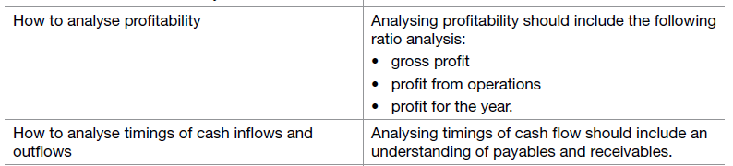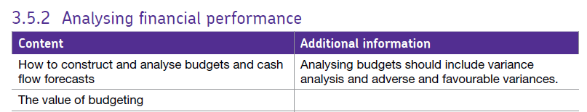

# Budgeting.

A budget is a financial plan for the future concerning the revenues and costs of a business. However, a budget is about much more than just financial numbers.

Budgetary control is the process by which financial control is exercised within an organisation. Budgets for income/revenue and expenditure are prepared in advance and then compared with actual performance to establish any variances.

## Types of budget

Remember that a budget is a **PLAN** of what the business hopes will happen.

**The Income Budget:** This is a forward plan of the sales revenue the business is likely to generate.

Knowing this is vital since the business can then ensure that it has sufficient resources such as labour and raw materials to make or provide the necessary amount of goods or services.

**Expenditure Budget:** This is the sum of several other budgets involving fixed and variable costs such as:

**Profit Budget:** The agreed planned profit of a business (or section of a business) over a period of time.

# Variance analysis.

A key word to understand when you are looking at budgets is **“variance”.** A variance arises when there is a **difference between actual and budget figures.**

Variances can be either:

* **Positive/favourable** (better than expected) or
* **Adverse/unfavourable** ( worse than expected)

To decide whether the variance is favourable or adverse you have to think about whether it’s beneficial to the business – if it is a good thing for the firm then it’s favourable, if it worsens the firm’s situation then it’s adverse.

A **favourable variance** might mean that costs were lower than expected in the budget, or revenue/profits were higher than expected.

By contrast, an **adverse variance**might arise because costs were higher than expected or revenue/profits were lower than expected

For example here we can see some favourable and adverse variances.

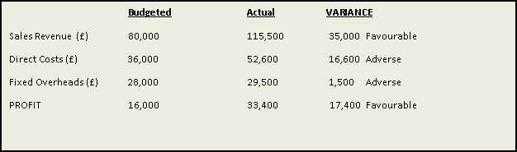

The significance of a variance will depend on factors such as:

**Budgeted Actual VARIANCE**

Sales Revenue (£) 80,000 115,500 35,000 Favourable

Direct Costs (£) 36,000 52,600 16,600 Adverse

Fixed Overheads (£) 28,000 29,500 1,500 Adverse

PROFIT 16,000 33,400 17,400 Favourable

**Budgeted Actual VARIANCE**

Sales Revenue (£) 80,000 115,500 35,000 Favourable

Direct Costs (£) 36,000 52,600 16,600 Adverse

Fixed Overheads (£) 28,000 29,500 1,500 Adverse

PROFIT 16,000 33,400 17,400 Favourable

* Whether it is positive or negative for the firm.
* Was it foreseen?
* Was it foreseeable?
* How big was the variance - in money terms and / or in percentage terms?
* The cause
* Whether it is a temporary problem or the result of a long term trend

## Are all adverse variances bad news?

Here is a point that students often find hard to understand – or believe!

An adverse variance might result from something that is good that has happened in the business.

For example, a budget statement might show higher production costs than budget (adverse variance). However, these may have occurred because sales are significantly higher than budget (favourable budget).

**Ultimately, the cause and significance of a variance that matters – why it has happened and what that means - not whether it is favourable or adverse.**

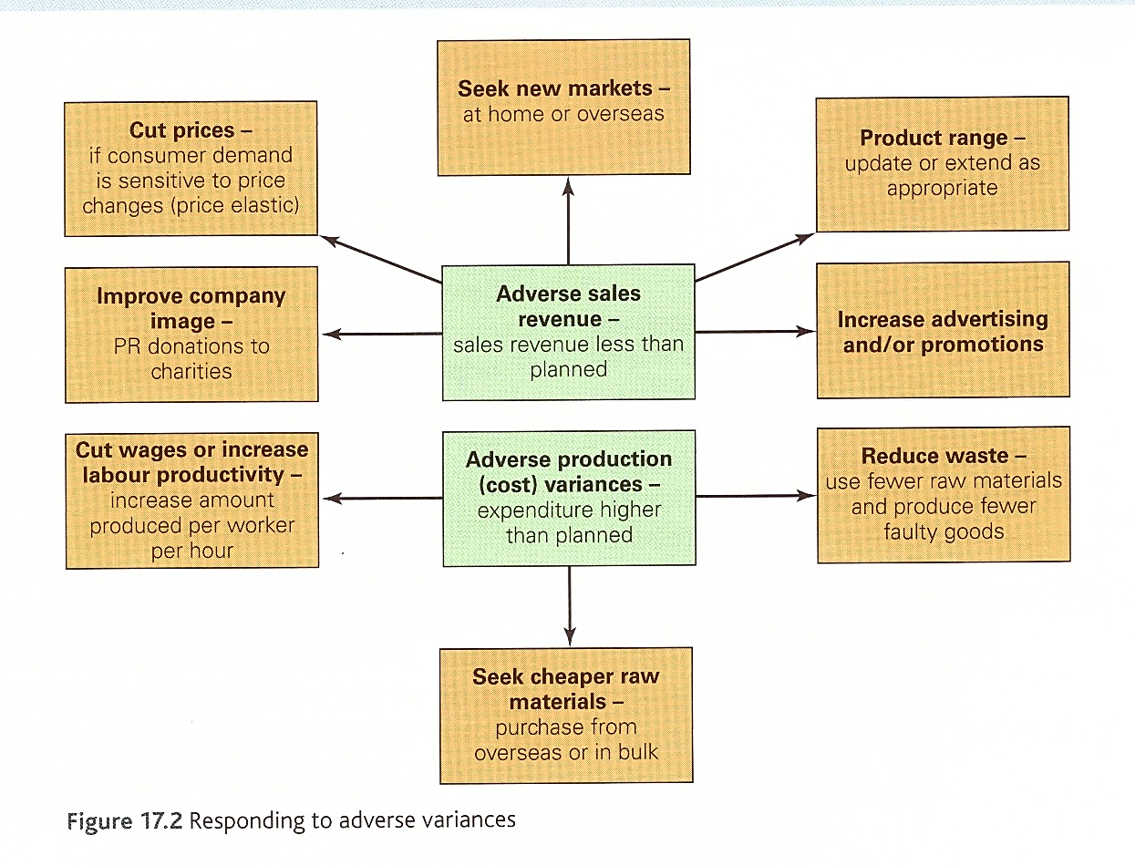

## The value of budgeting.

Managers are responsible for controllable costs within their budgets and are required to take remedial action if the adverse variances arise and they are considered excessive.

There are many management uses for budgets. For example, budgets are used to:

* Control income and expenditure (the traditional use)
* Establish priorities and set targets in numerical terms
* Provide direction and co-ordination, so that business objectives can be turned into practical reality
* Assign responsibilities to budget holders (managers) and allocate resources
* Communicate targets from management to employees
* Motivate staff
* Improve efficiency
* Monitor performance

Whilst there are many uses of budgets, there are a set of guiding principles for good budgetary control in a business. In an effective budget system:

* Managerial responsibilities are clearly defined – in particular the responsibility to adhere to their budgets
* Individual budgets lay down a plan of action
* Performance is monitored against the budget
* Corrective action is taken if results differ significantly from the budget
* Departures from budgets are permitted only after approval from senior management
* Unaccounted for variances are investigated

# Cash flow forecasting.

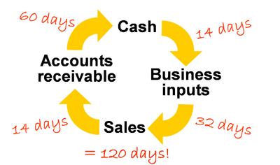**The Cash Flow Cycle – timings of cash inflow and outflow**

‘Cash is King’ is a popular business mantra. Cash is important to the business so they can pay their day to day expenses. Poor cash flow management is the leading cause of business failure in the UK. Even profitable businesses may go bankrupt if they do not manage their cash correctly. The timings of cash inflows and outflows are crucial:

There is generally a delay between cash flowing into the business and cash flowing out of the business. The extent of this delay can be made worse by the following factors:

1. **The amount of cash held at the beginning of the cycle:** It is vital that a new business start-up has sufficient cash from the beginning, maybe from the entrepreneur’s own funds or obtaining external finance such as bank loans. The early stages of a business is the most crucial phase because financial outlay will be considerable and yet the sales revenue generated from selling goods and services might still be limited. However, even mature businesses encounter cash flow problems.
2. **Length of time required to convert inputs and outputs:** If a product can be made and sold quickly, then the cash flow cycle may not create many problems at all. However, some products may take a long time to develop and manufacture. E.g. in construction business for example. House builders are vulnerable to cash flow difficulties because they must build the house before the customer will make the final payment. Meanwhile, the builder is incurring considerable expenses.
3. **Credit payments:** So far we have assumed that all transactions are in cash. However, a business may offer credit to its customers. Chasing late payment is also a major cause of cash flow problems.

Other key issues in cash flow…

It is important that you fully understand the following terms and their importance to maintaining a healthy cash flow:

*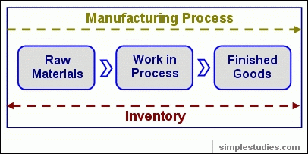***Inventories:** This is another word for stock and it is made up of three parts:

1. *Raw materials* needed to make the product or provide the service.
2. *Work in progress* – partly finished goods on the production line.
3. *Finished goods* which are ready to sell.

Having money tied up in stock can be very expensive. High inventory levels might be a problem if the stock is perishable or highly fashionable and subject to changes in tastes and preferences. A manufacturing business may work to Just in Time (JIT) so that absolute minimum levels (inventory) are required.

**Receivables:** This is the money that is *owed to* the company from customers (also called debtors).

The business may sell goods on credit so payment will be received some time after delivery. A credit term of 30 days is usual. Some creditors have a great deal longer credit terms than this; a supermarket with a great deal of bargaining power may demand a very long credit period from a supplier. Clearly it would be easier if all customers paid in cash but a business may have little choice but to offer favourable credit terms if competitors are offering credit or their customer or market demands it. However, late payment can present major cash flow problems so credit control becomes important (chasing up payment for goods sold).

**Payables:** This is the amount of money *owed by* the business to pay suppliers for goods it has bought on credit. People / organisations the business owes money to are also called creditors. Delaying payment can be a way for the business to manage cash flow but there are ethical considerations here. It would be better for the business to negotiate good credit terms from its suppliers if possible.

# Cash Flow Forecast

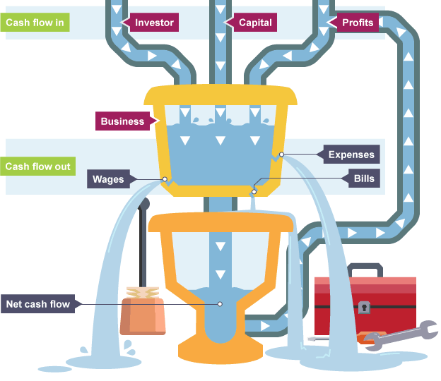A cash flow forecast is the process of estimating the expected cash inflows and cash outflows over a period of time. It is broken down month by month and consists of the following:

## Cash Inflows

* Sales Revenue through the sale of goods or services.
* Receivables – money from people / businesses who owe the business money (aka debtors).
* Owner’s capital injection (the owners own finance injected in to the business).
* Loans from the bank.
* Other sources of loans or investment.
* Interest earned on accounts held in banks or sources of income from elsewhere e.g. dividends from shares held in other companies.

## Cash Outflows

* Payables – money whom the business owes money to (aka creditors).
* Gas / electricity and other utility bills.
* Repayment of loans and the interest charged.
* Rent on buildings / lease payments on machinery.
* Labour and raw materials costs.
* Other costs to the business.

Net Cash Flow the difference between the money which came into the firm and the money which they spent.

Net cash = Cash Inflows (income) **-** Cash Outflows (expenditure)

Opening Balanceis the closing balance from the previous month.

Closing Balance is the money left after net cash flow is added to the opening balance

i.e. closing balance = opening balance + net cash flow.

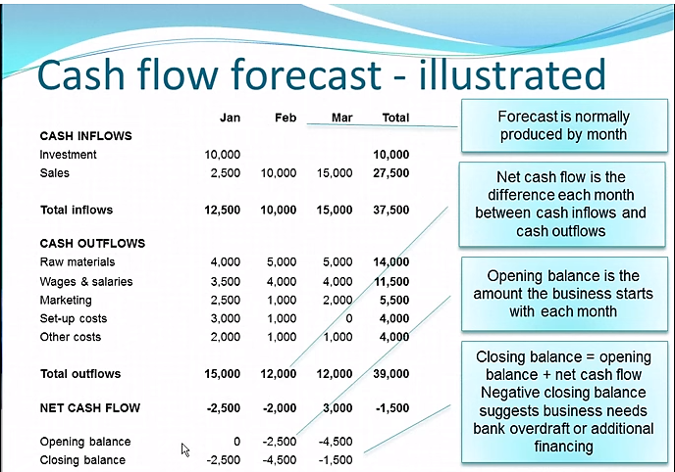

# Value of cash flow forecasting:

* **Liquidity**: This means the ability of the business to turn its assets into cash. Assets are things the business owns and cash is the most liquid asset of all. All businesses must manage their working capital (cash flow) to guarantee their survival. With too little working capital firms will go into liquidation.
* **Identifying potential cash flow problems in advance**: Once a problem is identified, appropriate action can be taken. This might mean approaching a bank for an overdraft.
* **Providing evidence in support of a request for financial assistance:** For example, a cash flow forecast can be presented to a bank when requesting an overdraft. The overdraft is where the bank agrees that the business can go overdrawn on its bank account (go into negative figures) up to an agreed amount.
* **Identifying when the firm is holding too much cash:** There is an opportunity cost involved when holding too much cash. For example, they could use the cash to pay off loans or purchase new machinery to develop the firm.

# Problems associated with cash flow forecasting

* **Changes in the economy**: Economic growth or unemployment levels might mean that customers have less (or more) spending power so the forecast may be wrong.
* **Changes in consumer tastes:** A sudden change in customer preferences will mean that the predicted sales revenue will differ from what is expected.
* **Inaccurate market research:** The cash flow forecast is only as good as the figures upon which it is based. Incorrect market research based or inappropriate sampling techniques will mean inflows and outflows may be wildly inaccurate.
* **Competition:** New competition may result in a fall in sales revenue. An existing competitor may decide to decrease price or engage in aggressive marketing in an attempt to increase market share.
* **Uncertainty:** Estimating the costs facing new firms or for major projects may be problematic. This is often the case with business start-ups because the new entrepreneur may be unfamiliar with the market.