The Odyssey – Book 22

Read lines 1-79
What surprises you about Odysseus’ first target?

Why is it both appropriate and ironic that Odysseus’ prays to Apollo?

Annotate Homer’s description of this death with the techniques listed underneath. You can explain the effect they have on the audience as well:

Antinous had just reached for his fine cup to take a draught of wine, and the golden, two-handled beaker was balanced in his hands. No thought of bloodshed entered his head. For who could guess, there in that festive company, that one man, however powerful he might be, would bring evil death and black doom on him against such odds? Odysseus took aim and shot him in the neck. The point passed clean through his tender throat. The cup dropped from his hand as he was hit and he lurched over to one side. His life-blood gushed from his nostrils in a turbid jet. His foot lashed out and kicked the table from him; his food was scattered on the ground, and bread and meat lay there in the dirt.
When the suitors saw the man collapsed, there was uproar in the hall. They sprang from their chairs and rushed in confusion about the room, searching the solid walls on every side. But not a shield or sturdy spear was there to lay hands on.

Foreboding Gory Detail Abrupt Action

Shock Rhetorical Question
How do the suitors address Odysseus and what does that remind us about?

How are the following phrases full of dramatic irony?
Quote | Suitor’s Understanding | Audience’s Understanding
“The match that was to seal your fate is over”
“Now for another target that no man has yet hit”
“You have killed the greatest nobleman in Ithaca”

Summarise Eurymachus’ reaction to Odysseus’ reveal and Odysseus’ response:
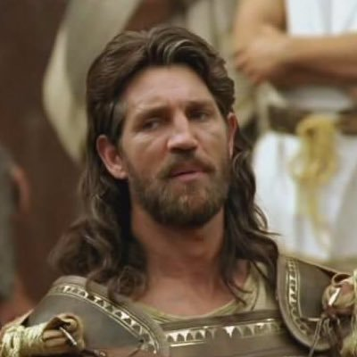

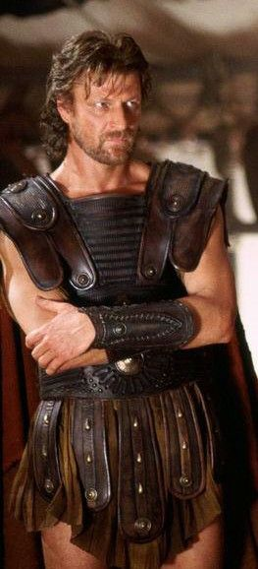
Check out
Eurymachus’ twitter account for a chuckle. Read from the bottom up:
https://twitter.com/eurymachus_



Explain how the mood of the suitors shifts in this passage:






Read lines 80-134
What parallels can you find between the deaths of Antinous and Eurymachus?

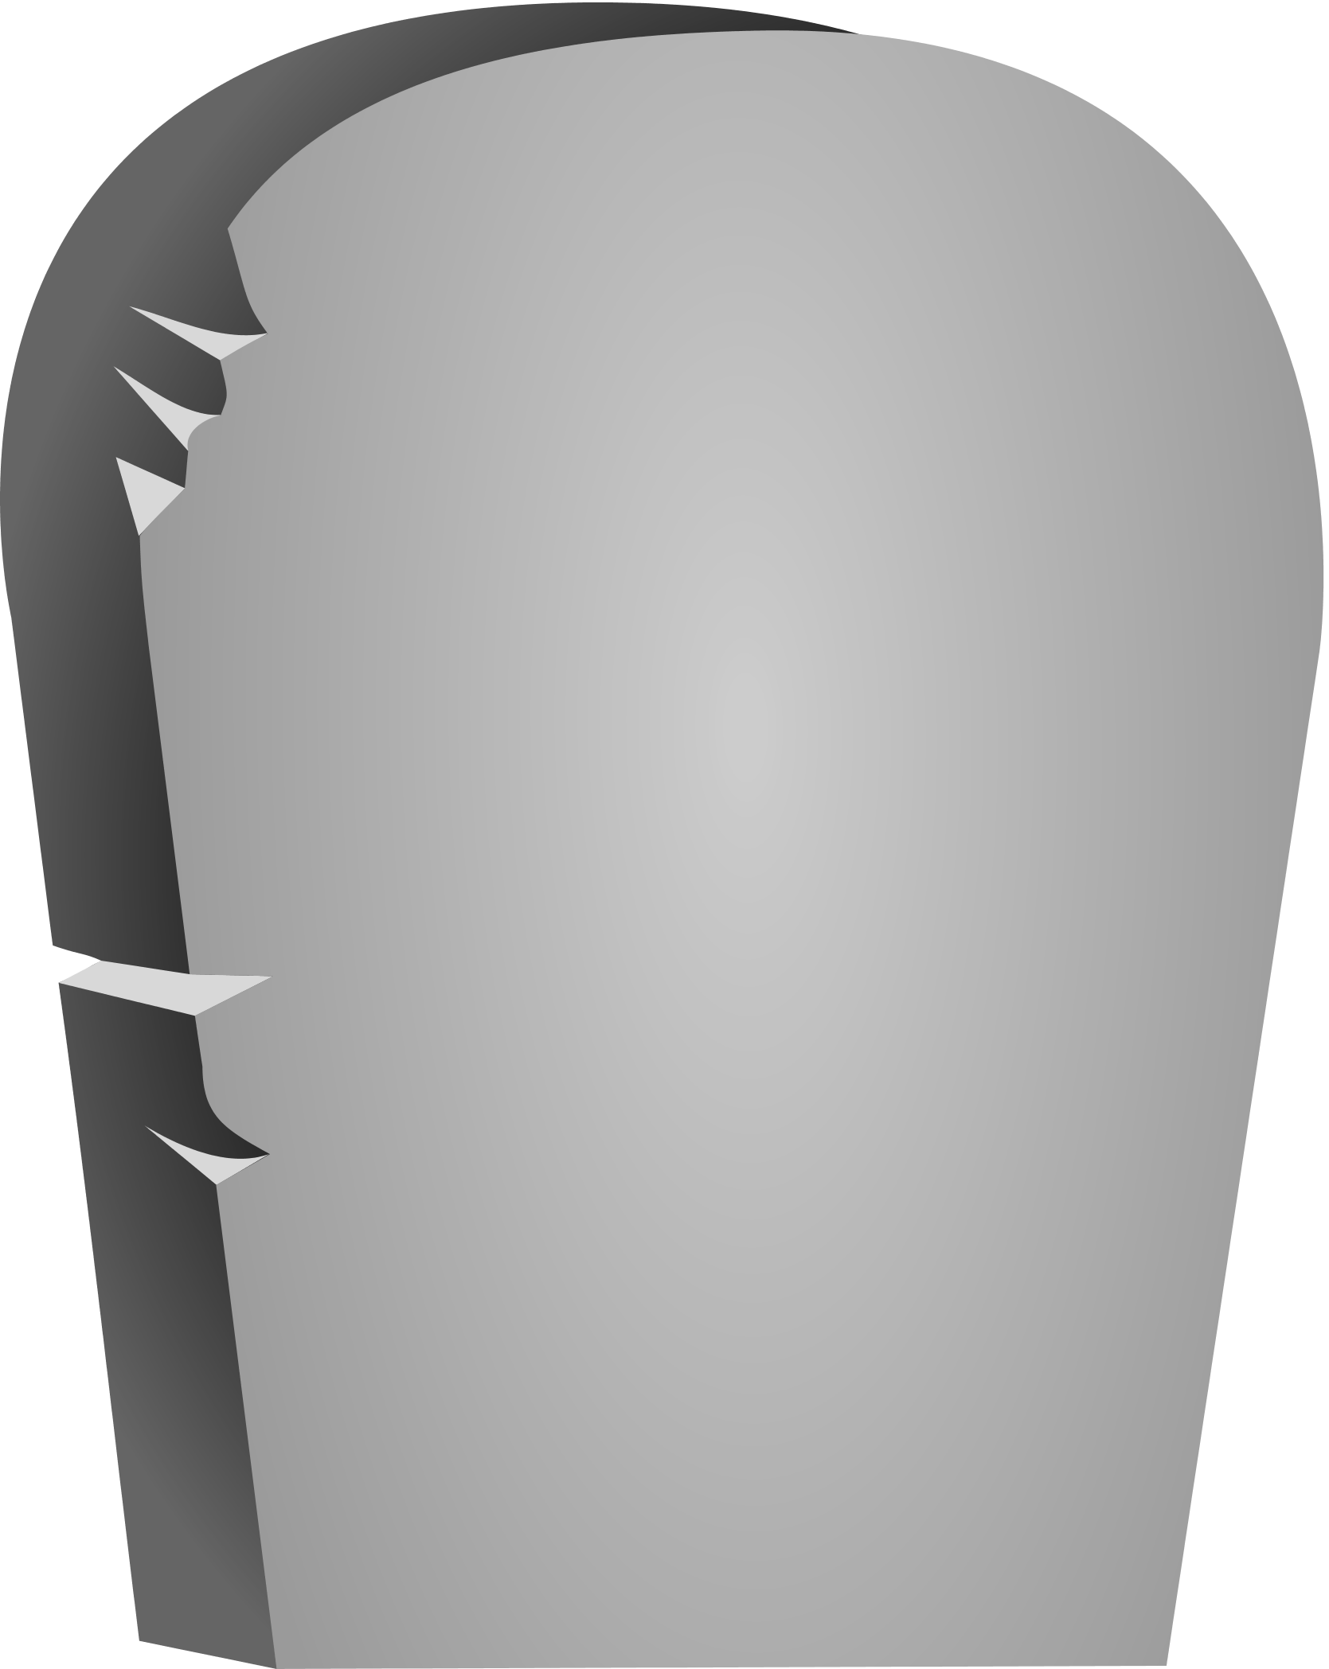
θεοις καταχθενοις
Eurymachus

θεοις καταχθενοις
Antinous

How does Telemachus ‘level up’ against Amphinomus?



What do you think of the way Homer has Telemachus leave the spear in Amphinomus’ body?

θεοις καταχθενοις (theois katachthenois) means ‘to the gods beneath the earth’ and is the Ancient Greek equivalent to our RIP.
Read 16.400-405 and 18.119-157. How does this suitor differ from the others? What do you make of the manner of his death?
θεοις καταχθενοις
Amphinomus

What is strange about the fact that Telemachus needs to go and fetch more weapons? What does this suggest about the nature of the Odyssey as a story?

Why does Telemachus pick out double the number of spears as helmets and shields?

When Telemachus returns and Odysseus’ arrows are spent, how does Odysseus turn into a hero like those in the Trojan War?

Read lines 135-202
“…one of the household women here is responsible for this dangerous turn in battle. Or else it’s Melanthius’ work.” What does this show us about Odysseus’ estimation of the goatherd?

What mistake did Telemachus make?

Complete this storyboard for Melanthius as a villain:
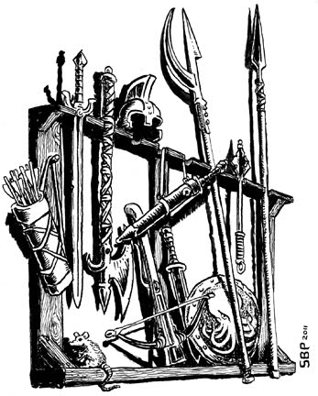   | 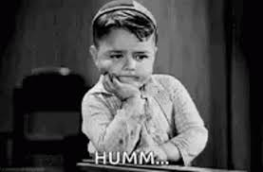 | 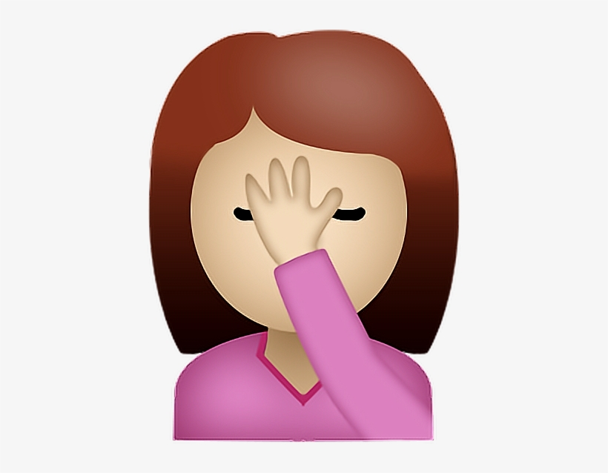
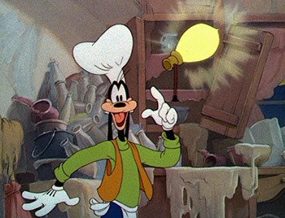 | 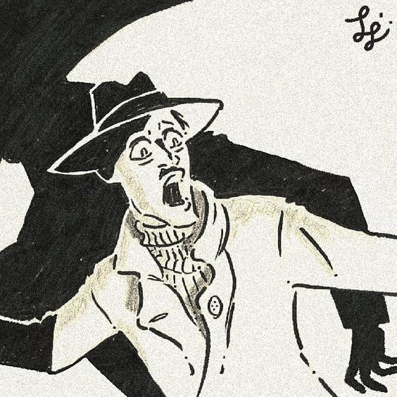 | 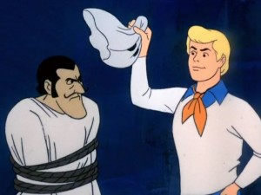

Why do you think Homer has Telemachus stay and Eumaeus and Philoetius go and tackle Melanthius?

Read lines 203-241
Read 2.225-285. Why does this help explain why Athene chooses the disguise of Mentor a second time? What effect does considering these two instances together have?

Why do you think that the suitors do not even attempt to convince “Mentor” to join them? What do they say they will do to “him”?

Underneath this picture, summarise Athena’s rebuke of Odysseus:
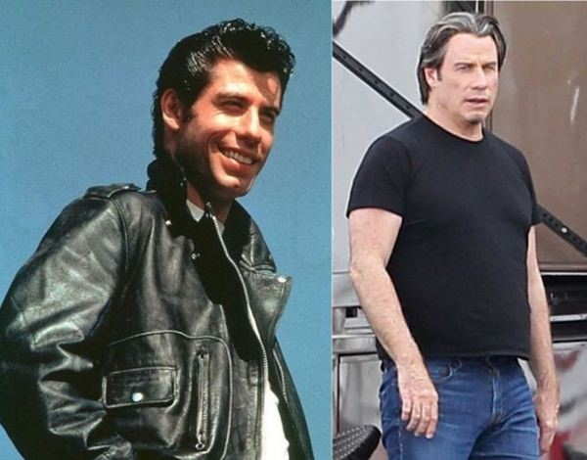
Trojan War Odysseus

Back in Ithaca

Why do you think that Athena leaves rather than fighting by Odysseus’ side?

Read lines 242-309
How does Agelaus encourage the suitors once more?
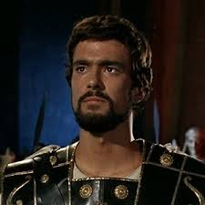

Summarise the exploits of the heroes:
Key:

Damage
Dealt

Damage
Received

Stinging
Rebuke
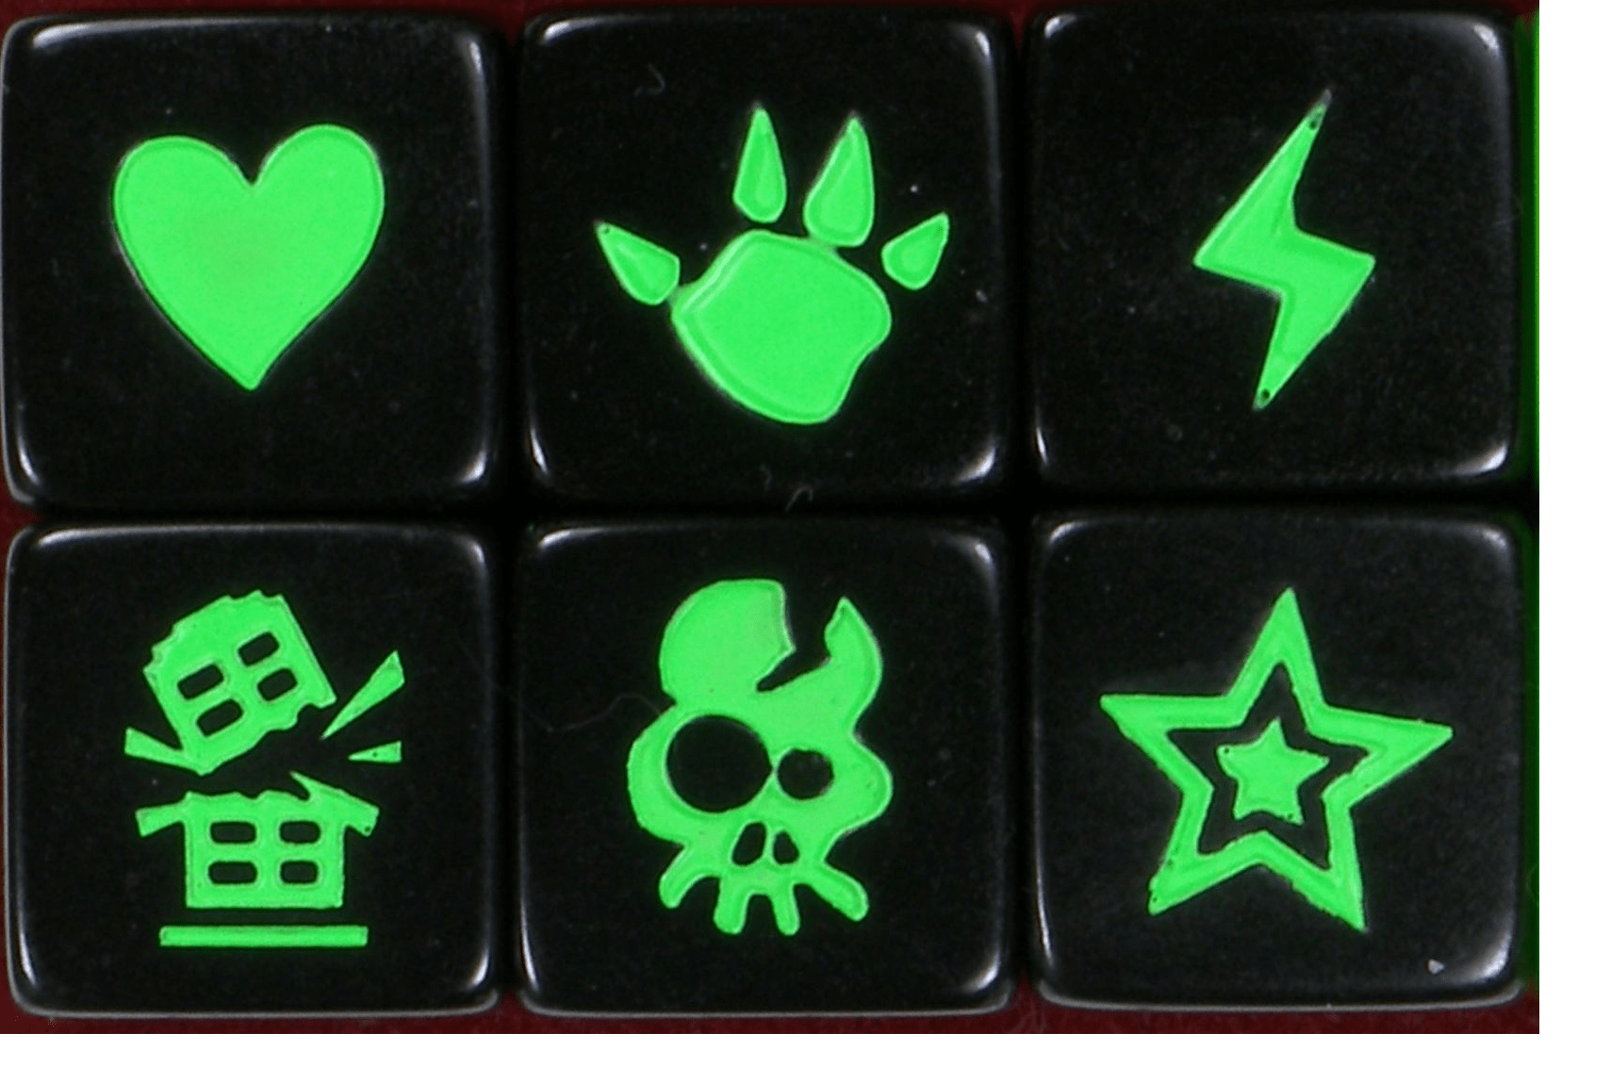
Odysseus:

Telemachus:

Eumaeus:

Philoetius:
What phrases indicate that Athena is helping Odysseus and his men?

How does Homer use these similes to end the fight?
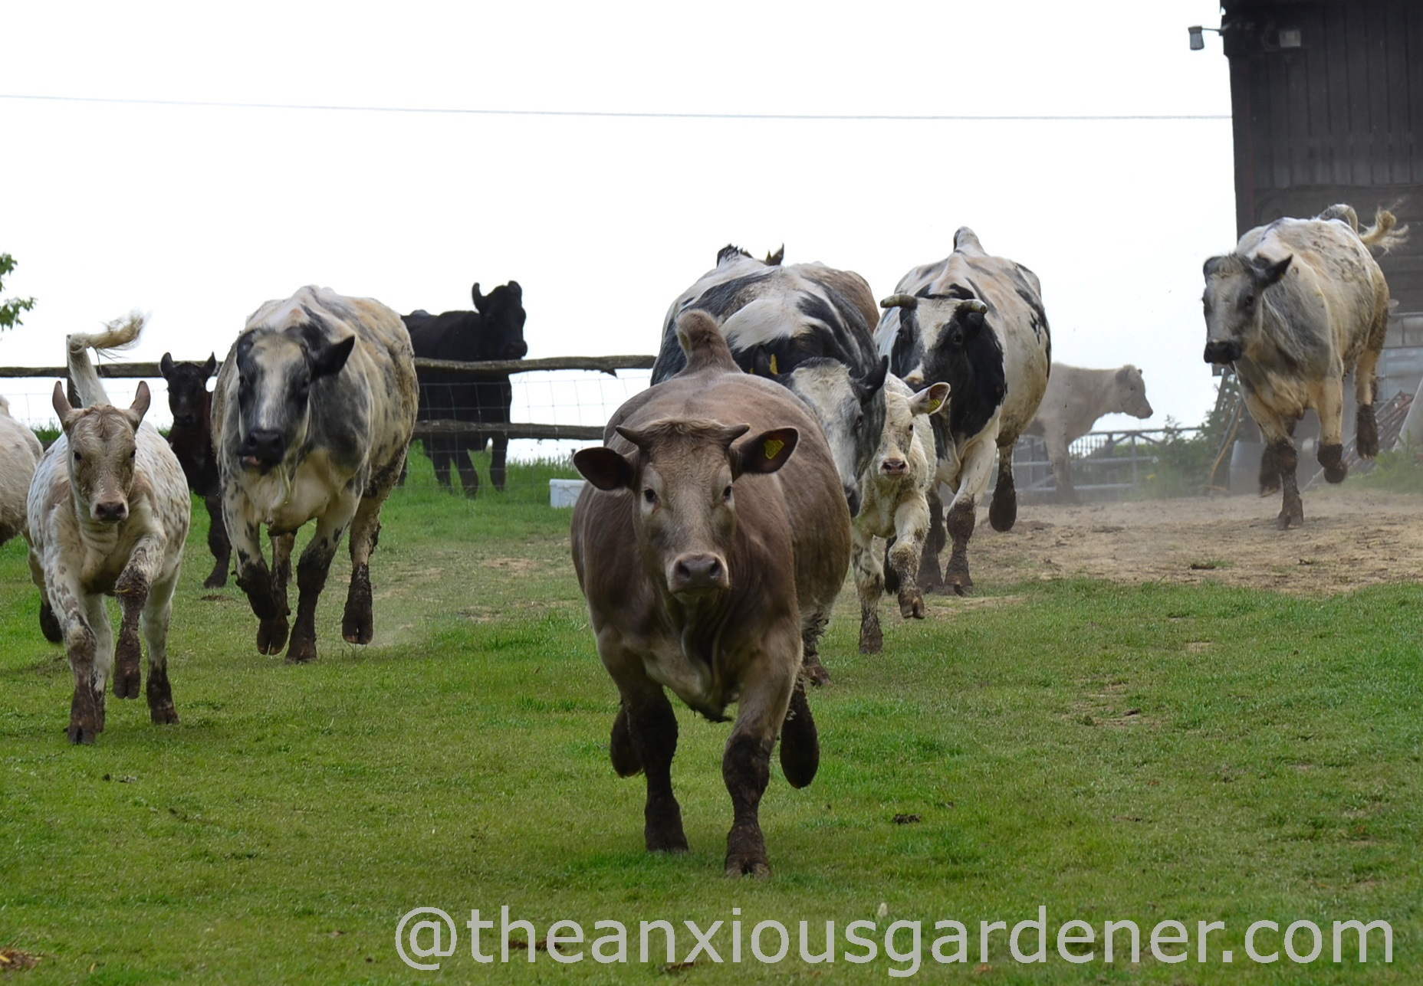
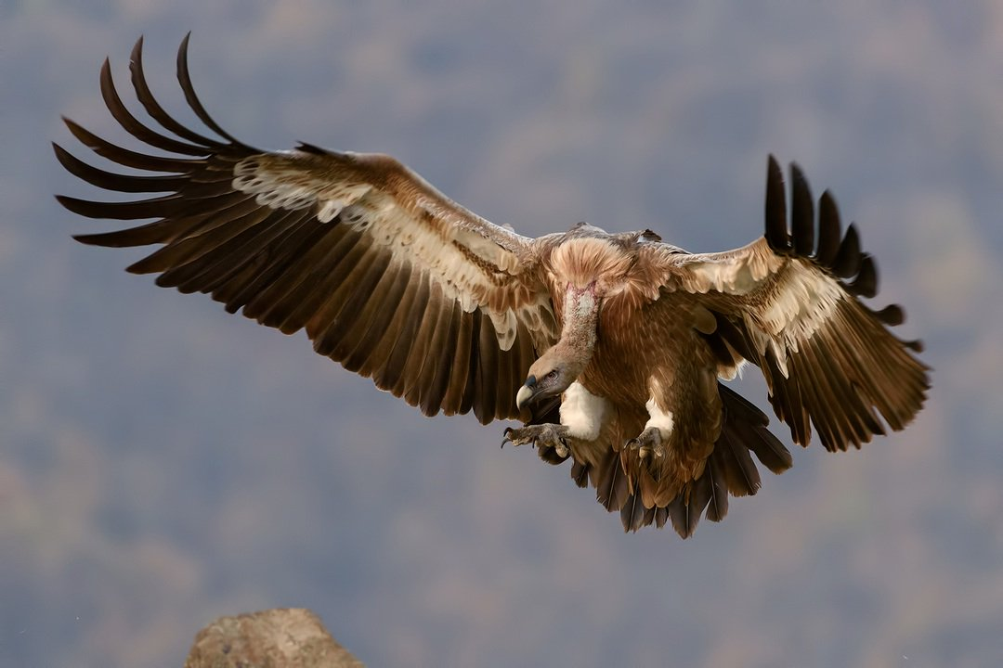
Attack!!!

Run!!!

Read lines 310-377

How do Leodes, Phemius and Medon plead for their lives and how does Odysseus respond to each?


Leodes:

Phemius:

Medon:
Read lines 378-500

Rank the cattle/vultures, dead fish and gory lion Homeric similes in order of your preference. Explain each choice (you might like them all):

How is this passage bookended with a disagreement between Eurycleia and Odysseus?

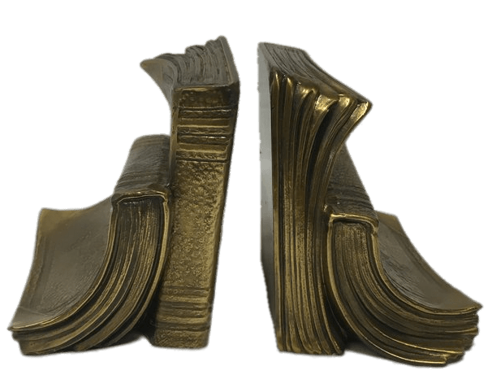
Start End

Read 19.491-502. How does it seem that Odysseus is inconsistent here?

‘Don’t wake her yet.’ Why do you think Penelope is not brought back into the story yet?

What adjectives would you use to describe the maids in this passage? Support these with quotes (you cannot use adjectives that also appear in your quotes):

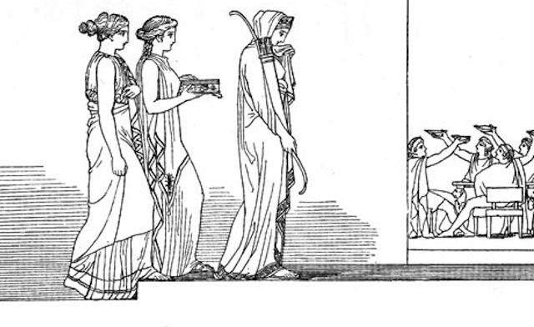

Do you feel sorry for the maids?

What three things do they do to Melanthius?

Why do you think Homer does not have him die in the fight?

‘The first thing I want,’ the calculating Odysseus replied, ‘is a fire in this hall.’ Explain why this was his number one priority.

Appendix – aristeia
The aristeia, one man’s heroic combat against a number of formidable opponents, is typical of Homer (cf. Diomedes’ aristeia, Iliad 5). Below are typical elements of the aristeia. Go through Book 22 and see how Odysseus’ aristeia matches these attributes:

Typical Element | Appearance in Book 22
An arming scene

Enthusiasm for battle

Exhortation from a god

Individual combats and counter-attacks
Moments of weakness and slight wounds
Use of similes

Scene of triumph

However, there are a few deviations from the typical aristeia:
Typical Element | Change in Book 22
Battlefield setting

Hand-to-hand combat by a single hero
Ritual gloating over the dead
Climatic final duel

