**L6 Further Mathematics November Test**

**Part one**

**Questions**

**Q1.**

f(*z*) = *z*3 −8*z*2 + *pz* − 24

where *p* is a real constant.

Given that the equation f(*z*) = 0 has distinct roots



(a)  solve completely the equation f(*z*) = 0

**(6)**

(b)  Hence find the value of *p*.

**(2)**

**(Total for question = 8 marks)**

**Q2.**

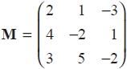

(a)  Find **M**–1 giving each element in exact form.

**(2)**

(b)  Solve the simultaneous equations

2*x* + *y* – 3*z* = –4

4*x* – 2*y* + *z* = 9

3*x* + 5*y* – 2*z* = 5

**(2)**

(c)  Interpret the answer to part (b) geometrically.

**(1)**

**(Total for question = 5 marks)**

**Q3.**

Given that 4 and 2i − 3 are roots of the equation

*x*3 + *ax*2 + *bx* − 52 = 0

where *a* and *b* are real constants,

(a)   write down the third root of the equation,

**(1)**

(b)   find the value of *a* and the value of *b*.

**(5)**

**(Total for question = 6 marks)**

**Q4.**  
(a) Show, using the formulae for *r* and *r*2 , that



(6*r*2 + 4*r* − 1) = *n*(*n* + 2)(2*n* + 1)

**(5)**



(b) Hence, or otherwise, find the value of (6*r*2 + 4*r* − 1).

**(2)**

**(Total 7 marks)**

**Q5.**

The cubic equation

3*x*3 + *x*2 – 4*x* + 1 = 0

has roots



Without solving the cubic equation,



(a)  determine the value of

**(3)**



(b)  find a cubic equation that has roots giving your answer in the form

*x*3 + *ax*2 + *bx* + *c* = 0, where *a*, *b* and *c* are integers to be determined.

**(3)**

**(Total for question = 6 marks)**

**Q6.**



Given that **M** = (**A** + **B**)(2**A** − **B**),

(a) calculate the matrix **M**,

**(6)**

(b) find the matrix **C** such that **MC** = **A**.

**(4)**

**(Total 10 marks)**

**Q7.**



Find, in the form *a* + *ib* where *a*, *b*



(a)  *z*

**(2)**

(b)  *z*2

**(2)**

Given that *z* is a complex root of the quadratic equation *x*2 + *px* + *q* = 0, where *p* and *q* are real integers,

(c)  find the value of *p* and the value of *q*.

**(3)**

**(Total for question = 7 marks)**

**Part one total marks: 49**

**Part two**

**Q8.**

A system of three equations is defined by

*kx* + 3*y* – *z* = 3   
3*x* – *y* + *z* = –*k*  
–16*x* – *ky* – *kz* = *k*

where *k* is a positive constant.

Given that there is no unique solution to all three equations,

(a)  show that *k* = 2

**(2)**

Using *k* = 2

(b)  determine whether the three equations are consistent, justifying your answer.

**(3)**

(c)  Interpret the answer to part (b) geometrically.

**(1)**

**(Total for question = 6 marks)**

**Q9.**



(a)  Using the formula for write down, in terms of *n* only, an expression for



**(1)**

(b)  Show that, for all integers *n*, where *n* > 0



where the values of the constants *a*, *b* and *c* are to be found.

**(4)**

**(Total for question = 5 marks)**

**Q10.**

A complex number *z* is given by

*z* = *a* + 2i

where a is a non-zero real number.

(a)  Find *z*2 + 2*z* in the form *x* + i*y* where *x* and *y* are real expressions in terms of *a*.

**(4)**

Given that *z*2 + 2*z* is real,

(b)  find the value of *a*.

**(1)**

Using this value for *a*,

(c)  find the values of the modulus and argument of *z*, giving the argument in radians, and giving your answers to 3 significant figures.

**(3)**

(d)  Show the points *P*, *Q* and *R*, representing the complex numbers *z*, *z*2 and *z*2 + 2*z* respectively, on a single Argand diagram with origin *O*.

**(3)**

(e)  Describe fully the geometrical relationship between the line segments *OP* and *QR*.

**(2)**

**(Total for question = 13 marks)**

**Mark Scheme**

Q1.

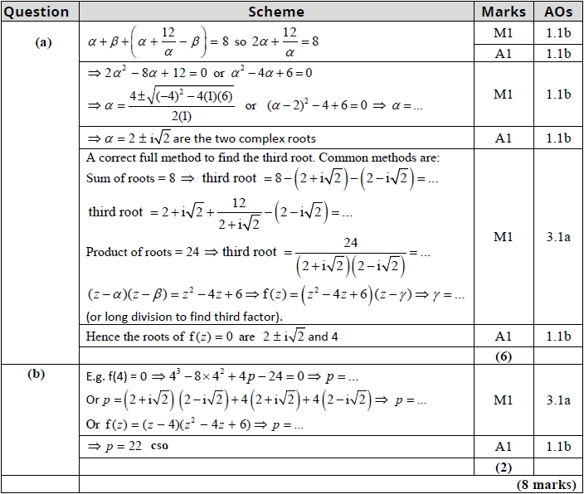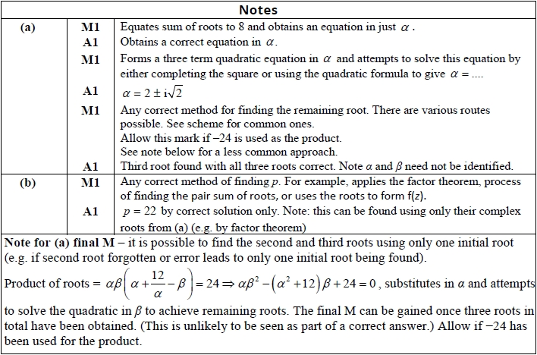

**Q2.**

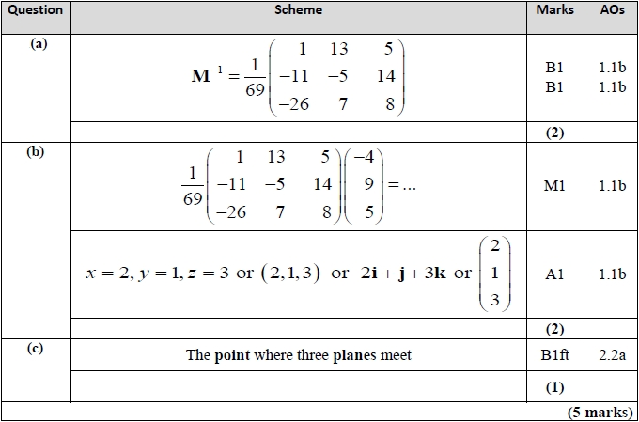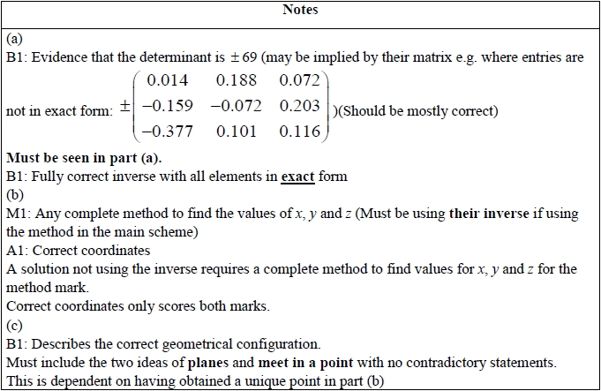

**Q3.**

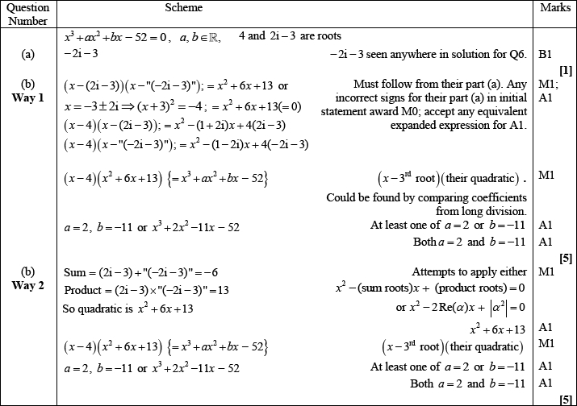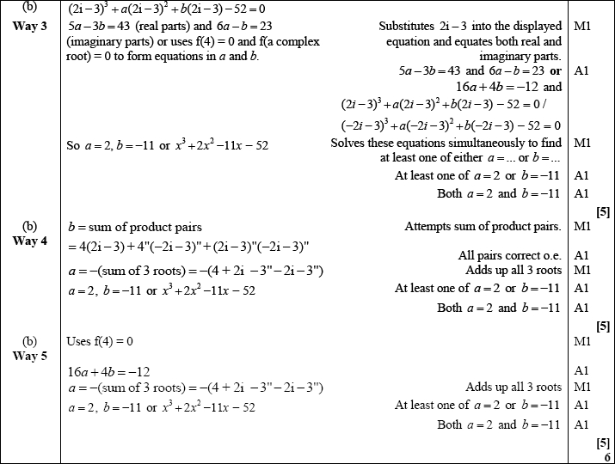

Q4.

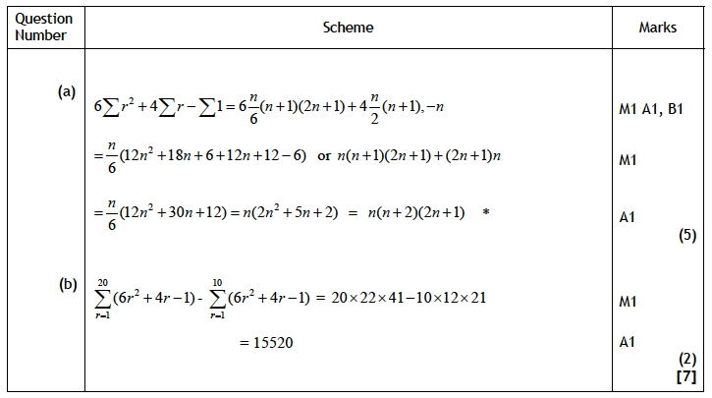

**Q5.**

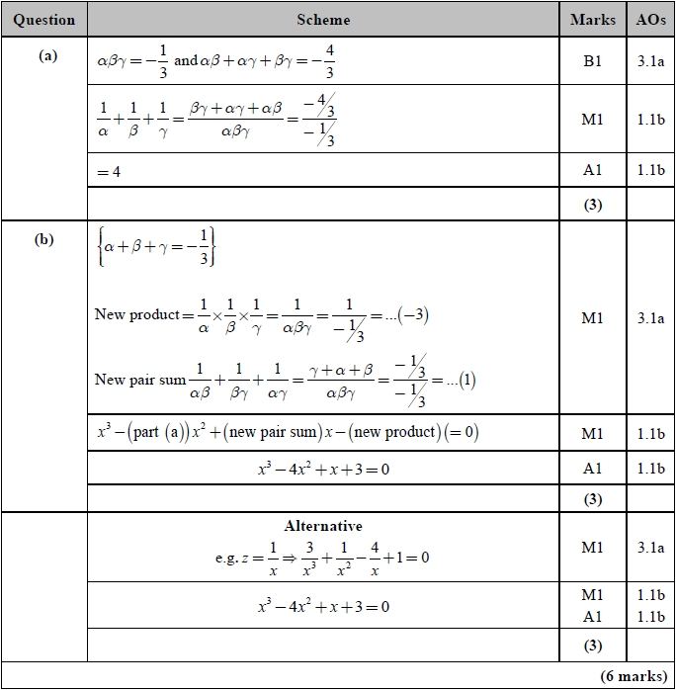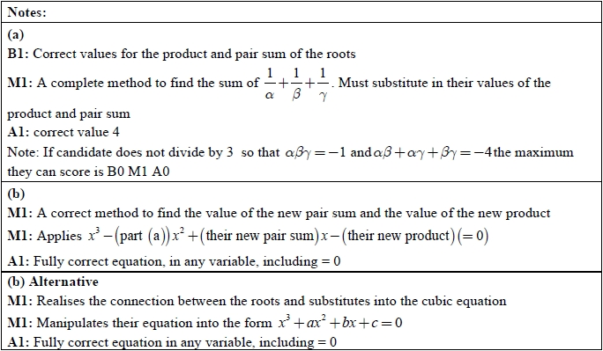

**Q6.**

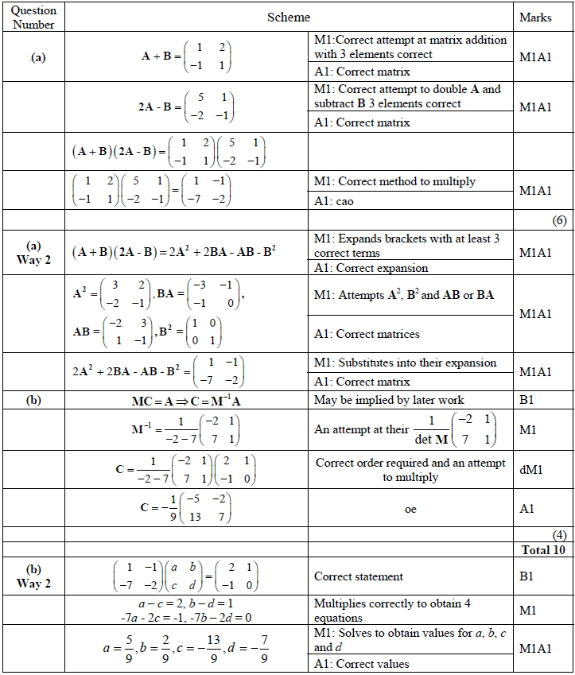

**Q7.**

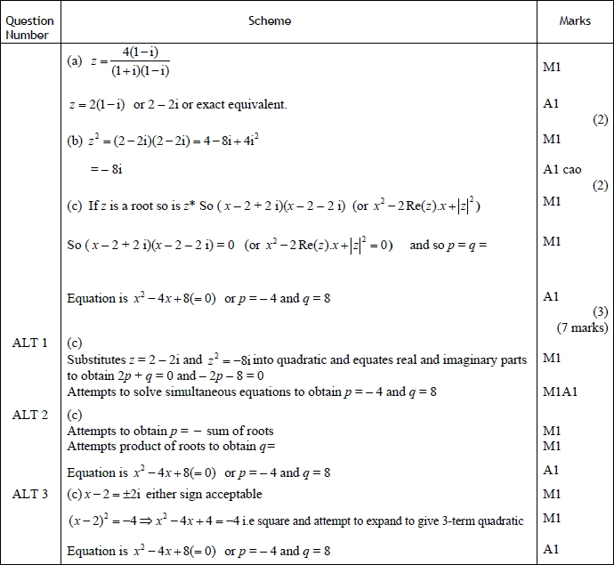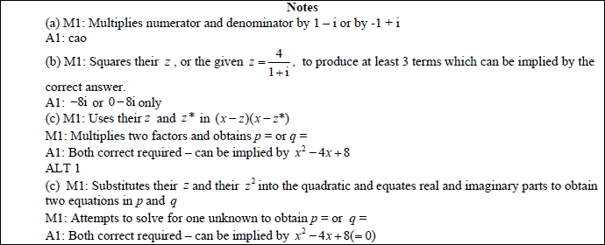

**Q8.**

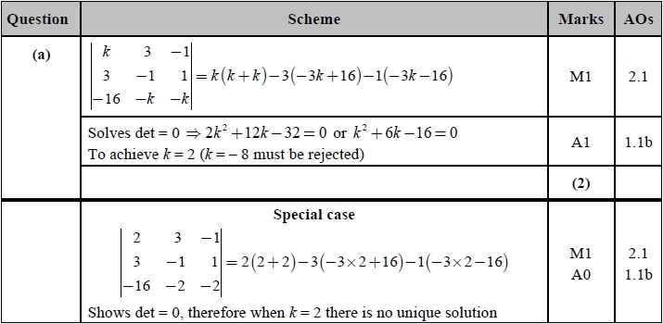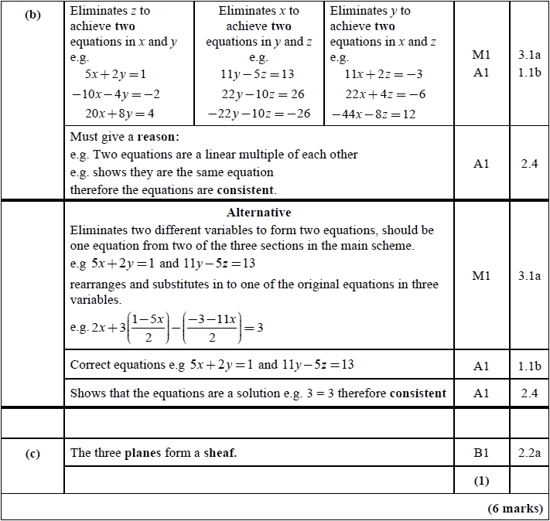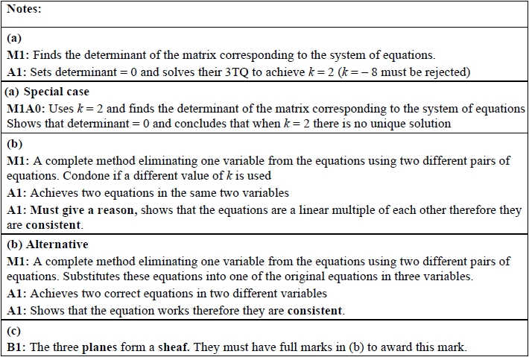

**Q9.**

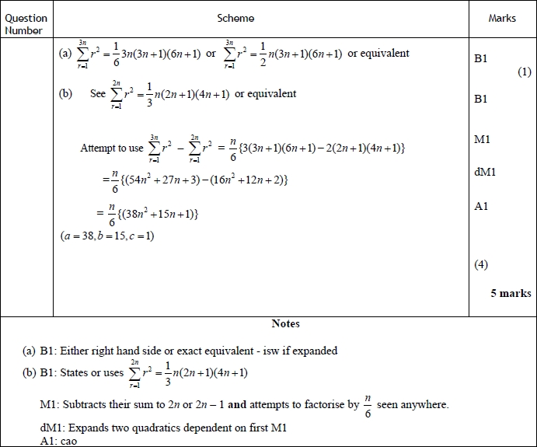

**Q10.**

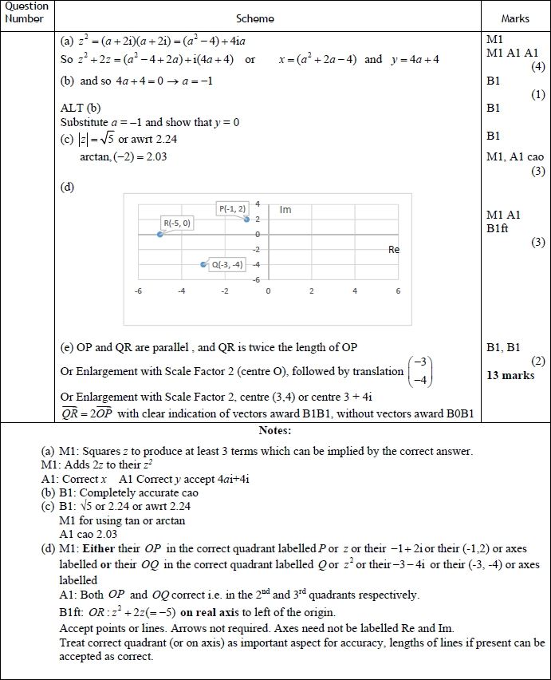

Total marks: 73