|  |
| --- |
| Name: _______________________________________________ |
|  |
|  |
|  |
|  |
| **Oxygen dissociation curves** |
|  |
| **Date:** |
|  |
|  |
|  |
|  |
| **Time:** 16 minutes |
|  |
| **Total marks available:** 16 |
|  |
| **Total marks achieved:** ______ |
|  |
|  |
|  |
|  |
|  |
|  |
|  |
|  |
|  |
|  |
|  |
|  |
|  |
|  |
|  |
|  |
|  |
|  |
|  |
|  |
|  |
|  |
|  |
|  |
|  |
|  |

**Questions**

**Q1.**

Deer mice, *Peromyscus maniculations*, are small mammals.

The photograph shows a deer mouse.

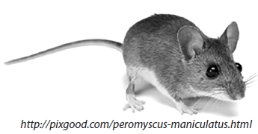

Red blood cells in deer mice contain haemoglobin to transport oxygen in the blood.

(i)  Describe the structure of haemoglobin.

**(2)**

.............................................................................................................................................

.............................................................................................................................................

.............................................................................................................................................

.............................................................................................................................................

*(ii)  Deer mice can live at high altitude or at low altitude.

The graph shows the oxygen dissociation curves for haemoglobin in deer mice that live at high altitude and for deer mice that live at low altitude.

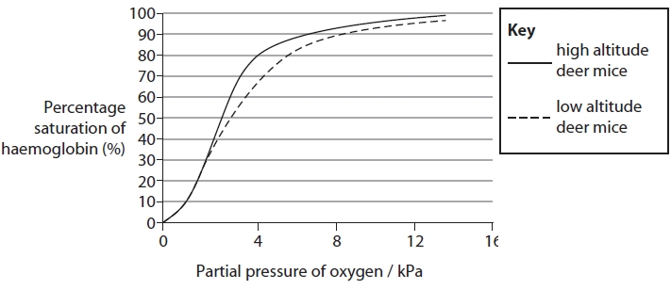

Compare and contrast the shape of these oxygen haemoglobin dissociation curves.

**(6)**

.............................................................................................................................................

.............................................................................................................................................

.............................................................................................................................................

.............................................................................................................................................

.............................................................................................................................................

.............................................................................................................................................

.............................................................................................................................................

.............................................................................................................................................

.............................................................................................................................................

.............................................................................................................................................

.............................................................................................................................................

.............................................................................................................................................

**Q2.**

In mammals, the mother and fetus have separate circulatory systems. Materials are exchanged between the two circulatory systems in the placenta.

The graph shows the oxygen dissociation curves for adult and fetal haemoglobin.

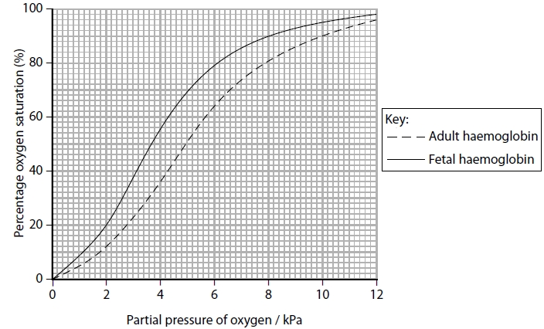

(i)  Calculate the percentage increase in oxygen saturation between adult haemoglobin and fetal haemoglobin at an oxygen concentration of 4 kPa.

**(2)**

Answer ...........................................................

(ii)  Explain why fetal haemoglobin ensures the transfer of oxygen from the maternal to the fetal circulation.

**(2)**

.............................................................................................................................................

.............................................................................................................................................

.............................................................................................................................................

.............................................................................................................................................

The oxygen dissociation curve for myoglobin is different from that for adult haemoglobin.

(iii)  Draw a line on the graph to show the dissociation curve for myoglobin.

**(1)**

(iv)  The table shows the results of an investigation to measure the myoglobin content in the muscle tissue of two different mammals.

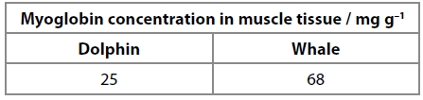

Explain why the difference in myoglobin concentration affects the time mammals can spend underwater.

**(3)**

.............................................................................................................................................

.............................................................................................................................................

.............................................................................................................................................

.............................................................................................................................................

.............................................................................................................................................

.............................................................................................................................................

**(Total for question = 8 marks)**